**IOT Report**

**Name:** Hamza Iqbal

**Date:** 16-09-23

**Objective:**

The objective of this project is to establish an IoT system utilizing an ESP32 microcontroller to collect temperature, humidity, and distance data from sensors. This data is then transmitted to a Grafana dashboard via MQTT protocol. The project also involves the use of Docker for efficient container management on a Linux server. The data transmission is facilitated through a local hotspot.

**Requirements:**

* ESP32 microcontroller
* Temperature and humidity sensor (e.g., DHT22)
* Ultrasonic sensor (e.g., HC-SR04)
* MQTT broker (e.g., Mosquito)
* Grafana installation
* Docker installed on the Linux server.
* Linux operating system
* Local hotspot for data transmission

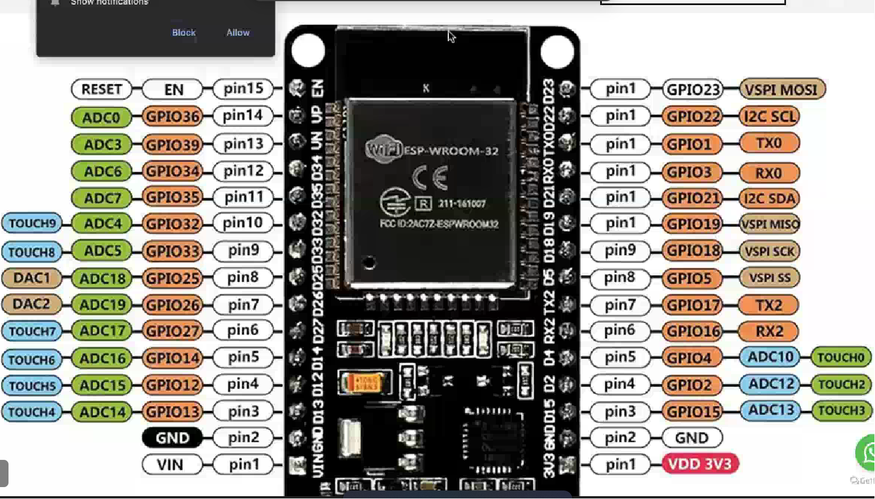

**Procedure:**

* **Hardware:**

Connect the temperature and humidity sensor (DHT22) to the ESP32 as per the datasheet instructions. Connect the ultrasonic sensor (HC-SR04) to the ESP32, typically requiring two GPIO pins for trigger and echo. Ensure proper power and ground connections for both sensors and the ESP32.

* **Programming:**

**Code :** For ultrasonic sensor.

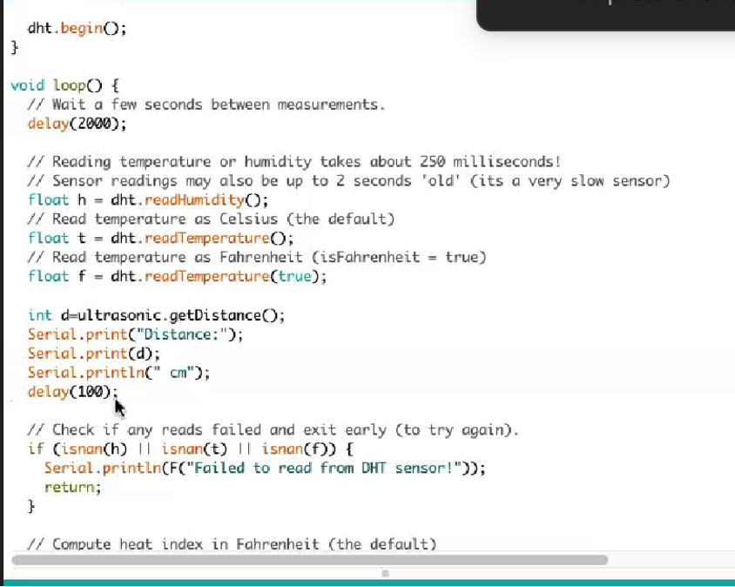

**Code:** For temperature and humidity

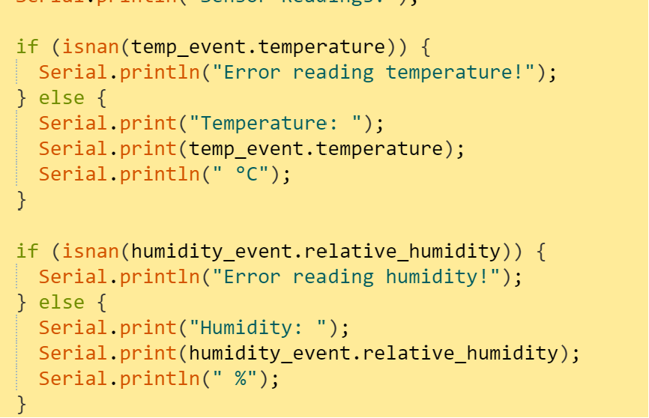

* **MQTT Broker Setup:**

Install Mosquito MQTT broker on your Linux server. Configure Mosquito to listen on a specific port (e.g., 1883). Create MQTT topics for temperature, humidity, and distance data.

* **Setting Up an MQTT-Based IoT Data Pipeline with Docker Containers:**
* **Install and Configure Mosquito MQTT Broker:**

1. Create a Docker container for the Mosquito MQTT broker.
2. Configure MQTT broker settings and ports within the container.

* **Install Grafana and Connect to MQTT Broker:**

1. Create a Docker container for Grafana.
2. Configure Grafana to connect to the MQTT broker.
3. Set up Grafana's data source to communicate with InfluxDB.

* **Create a Container for InfluxDB:**

1. Set up a Docker container for InfluxDB to store MQTT data.
2. Define InfluxDB configurations and expose necessary ports.

* **Implement MQTT Data Relay Script:**

1. Create a Python or Node.js script to receive MQTT data from ESP32.
2. Configure the script to push the data into the InfluxDB container.

* **Deploy Containers with Docker Compose:**

1. Run the containers using Docker Compose with the docker-compose up -d command.
2. Ensure all containers start without errors.

* **Verify Container Status:**

1. Confirm the status of all containers using docker-compose ps.

* **Testing and monitoring:**

• Confirm that the ESP32 is publishing data to the MQTT broker via the local hotspot.

• Verify that data is being stored in the InfluxDB database.

• Access the Grafana dashboard through a web browser to visualize the sensor data.

* 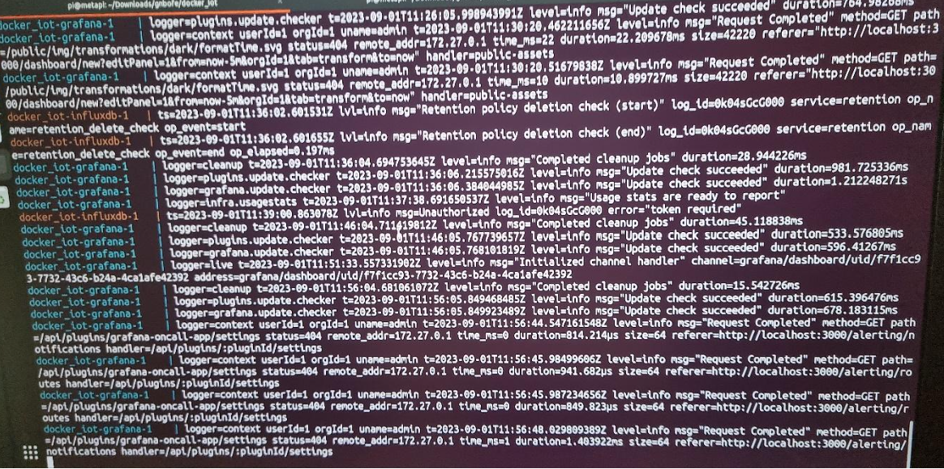**Visualizations:**

* **Insights:**

**•** Docker provides an efficient and scalable solution for managing containers, ensuring smooth deployment and operation of the IoT system.

• Mosquitto MQTT broker facilitates seamless communication between the ESP32 and the Grafana dashboard.

• InfluxDB serves as a reliable database for storing and retrieving sensor data.

* **Conclusion:**

The project has successfully established an IoT system, integrating sensors with an ESP32 microcontroller. The data collected (temperature, humidity, and distance) is transmitted to a Grafana dashboard via MQTT protocol. Docker containerization enhances the system's scalability and manageability. The utilization of a local hotspot for data transmission ensures remote monitoring and visualization on a Linux server. This comprehensive setup lays a solid foundation for further IoT applications and data-driven.