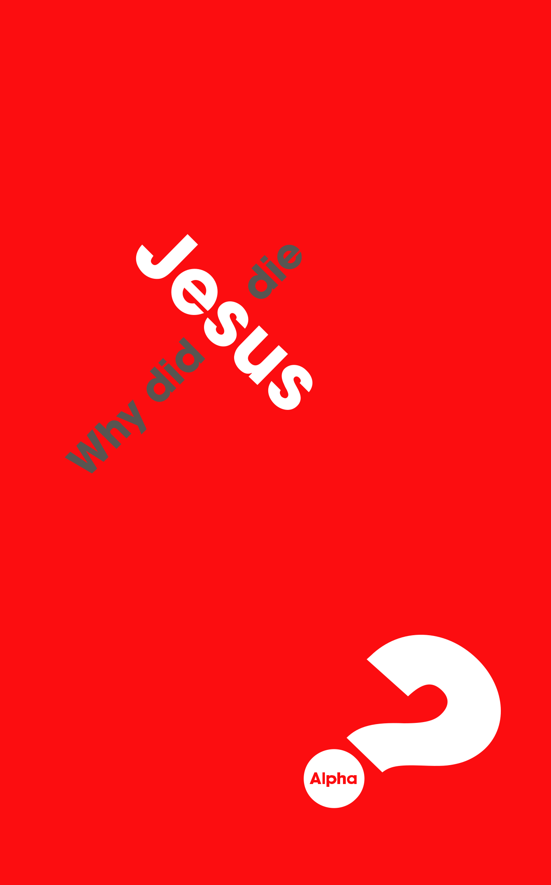
Session 3
ALPHA GUIDE

Why is the cross the symbol of Christianity?

‘… the Son of God… loved me and gave himself for me’


(GALATIANS 2:20)

1. THE PROBLEM

‘All have sinned and fall short of the glory of God.’ (Romans 3:23).

- Pollution of sin (Mark 7:20–23)

- Power of sin (John 8:34)

- Penalty for sin (Romans 6:23)

- Partition of sin (Isaiah 59:2)

2. THE SOLUTION

- ‘The self-substitution of God’ (1 Peter 2:24)

- Agony of the cross (Isaiah 53:6)

20

SESSION 3 WHY DID JESUS DIE?

3. THE RESULT

The cross shows:

  - You are infinitely valuable to God

  - Jesus is the supreme example of love (John 15:13)

  - God is not aloof from suffering

  - The powers of evil have been defeated: the resurrection wasn’t the reversal of a defeat; it was the manifestation of a victory

- The partition has been removed (2 Corinthians 5:19)

  - Reconciliation with God and in other relationships

- The penalty has been paid

  - Justified (‘Just-as-if-I’d never sinned’)

- The power of sin has been broken

  - If the Son sets you free, you really will be free’ (John 8:36, NLT)

- The pollution has been removed

  - ‘… the blood of Jesus cleanses us from all sin.’ (1 John 1:7)

  - When you are forgiven, you want to forgive

21

ALPHA GUIDE


RECOMMENDED READING

The Cross of Christ

John Stott

Searching Issues

Nicky Gumbel

Mud, Sweat and Tears

Bear Grylls

22

