Reproducing VADER and Testing Sentiment Robustness on New Short Text Data
COMP8240 Assessment 3 Project Final Report
Applications of Data Science
4 November 2026

Abstract
This project examines the reproducibility and transfer of VADER using its released evaluation resources, a newer sentiment benchmark, and controlled short texts. Both an archived implementation and a maintained implementation were executed on all 23,703 original evaluation texts. The archived version reproduces the published tweet-like and editorial correlations to three decimal places; movie and product correlations differ. A classification audit shows substantial sensitivity to the conversion of human intensity ratings and the averaging convention for F1. On DynaSent, archived macro-F1 is 0.549 on the 3,600-item Round 1 test set and 0.523 on the 720-item Round 2 test set. Maintained code produces very similar results, with paired confidence intervals spanning zero for its improvement. A new 288-text diagnostic corpus covers negation, modification, capitals, punctuation and contrast. Its score changes expose lexical coverage failures, but independent human validation remains incomplete. A preserved within-session assistant-judge pilot is reported separately from human reference evidence. The completed experiments support partial replication and limited transfer, with explicit boundaries on the claims that the constructed data can support.
Review-draft status. Independent human annotation of the constructed corpus and verification of the student’s public project repository remain pending. No human ratings, consent records, or annotation agreement statistics have been invented. The accompanying source package records completed experiments and the exact remaining dependencies.

1 Paper description and justification

1.1 Research problem
Short texts often express sentiment through context rather than isolated positive and negative words. Negation can reverse an apparent evaluation. Capitals and exclamation marks may strengthen a judgement, while a contrasting clause can change which part of a sentence carries the overall assessment. A replication therefore needs to preserve these signals and distinguish numerical execution from agreement with human interpretation.
Pang and Lee (2008) situate sentiment analysis within the computational study of opinions and subjectivity. Wilson et al. (2005) distinguish a word’s prior polarity from its contextual polarity. This distinction motivates checking negation and contrast alongside lexical coverage in the present project.
The selected paper is Hutto and Gilbert (2014). VADER combines a human-rated sentiment lexicon with contextual heuristics. It returns positive, neutral and negative components and a compound sentiment score. The components are output summaries rather than calibrated probabilities of the three classes. No task-specific classifier training is required for the experiments in this project.
The source paper evaluates both intensity association and three-class decisions on social-media-like texts, movie snippets, product snippets and editorials. Its reported tweet-like correlation is 0.881 and its reported overall F1 is 0.96. These quantities address different questions: correlation concerns association with human intensity, whereas F1 depends on reference classes, decision thresholds and aggregation. The present project treats their reconstruction separately.

1.2 Why this paper is suitable
The work appeared at the peer-reviewed International AAAI Conference on Web and Social Media. The historical CORE2023 entry places ICWSM in category A (Computing Research and Education Association of Australasia, 2023). This ranking is a contextual quality indicator; the empirical case for the project rests on accessible executable resources and measurable claims. The author repository supplies an archived implementation, lexical resources and the released evaluation data (Hutto, 2026). The availability of these artefacts permits direct comparison with published values.
CPU execution without model training makes the project feasible. Separate archived and maintained implementations permit a version comparison without assuming that current code reproduces the 2014 system.
This project follows the novel-project route through independently selecting and justifying the VADER paper, author code and original evaluation data. The unit’s overall criteria define this route through project selection and justification (2026). DynaSent provides a transfer benchmark, while the constructed corpus supplies newly created experimental material.
Three research questions organise the investigation:
- How closely does archived code reproduce the published intensity and classification results on the released original corpora?
- How well do archived and maintained VADER transfer to the official test splits of a newer three-class benchmark?
- Do controlled textual changes produce sentiment changes that agree with independent human judgements?
The first two questions have observed results. The third currently has behavioural diagnostics and an assistant-judge pilot, while its planned independent human reference evaluation remains outstanding.

2 Original datasets and evaluation

2.1 Released data and input format
The replication uses the author’s archived files, rather than reconstructing corpora from current websites. The released collections contain 4,200 tweet-like texts, 10,605 movie snippets, 3,708 product snippets and 5,190 editorial snippets. The tweet-like collection includes 4,000 adapted social texts and 200 constructed grammatical tests. The original paper attributes the other collections to movie reviews, product reviews and opinion articles respectively. Their sentence-level intensity annotations are the VADER release annotations; document-level labels from the source reviews are not substituted.
The ground-truth input is a tab-separated record with an item identifier, a mean human intensity rating, and the text. Splitting each line at the first two tabs retains the remainder as text. A schematic record is shown in Table 1. IDs are preserved as strings, including any formatting that would be lost by conversion to numbers. Each file is checked against its recorded SHA-256 and expected item count before evaluation.
Field | Meaning
id | Released text identifier, retained unchanged
human_mean | Mean sentence intensity supplied in the archive
text | Complete input string, including case and punctuation
Table 1. Original record format. The parser reads id \t human_mean \t text. Numeric predictions and IDs are exported separately from third-party source texts.
An actual tweet-like record has ID 1, mean intensity 2.726315789, and a text beginning “Somehow I was blessed with”. This prefix illustrates the text field while the complete input remains available through the checksummed archive. The parser retains the full original string.
The original paper describes 20 screened human raters per evaluation text. This must be distinguished from the separate word-rating process used to construct the lexicon. Reusing released mean ratings reproduces the available reference signal; it does not repeat the original annotation study or establish its inter-rater reliability anew. The project also does not reproduce all comparison systems from the paper. Its replication target is the VADER result within each released collection.

2.2 Scores and metrics
For the compound score, the adjusted valence sum $v$ is mapped into a bounded range by
$$c=\frac{v}{\sqrt{v^{2}+15}}.$$
Classification uses the documented inclusive thresholds: $c≥0.05$ is positive, $c≤−0.05$ is negative, and values between them are neutral. These settings remain fixed throughout the new-data evaluation.
Pearson’s correlation is computed between each compound prediction and the released human mean. A positive linear rescaling of the human ratings leaves this correlation unchanged. Consequently, dividing all human means by four can change class labels while leaving the correlation result intact. This distinction is central to the protocol audit.
For each class $k$, precision and recall use the corresponding true-positive, false-positive and false-negative counts. The main three-class score is
$$F_{1,macro}=\frac{1}{3}\sum_{k=1}^{3}{\frac{2TP_{k}}{2TP_{k}+FP_{k}+FN_{k}}}.$$
All three classes are included and undefined terms receive zero. Accuracy, per-class precision/recall/F1 and confusion matrices accompany macro-F1. Weighted F1 instead weights the class scores by their reference support; it can conceal poor minority-class performance (scikit-learn developers, 2026). The published overall F1 is retained under its original name until its aggregation has been established.

3 Replication of original work

3.1 Environment and implementation control
The fresh experiments ran on 4 November 2026 using Python 3.12.14 under Linux, without a GPU. The numerical environment used NumPy 2.3.5, Pandas 2.2.3, SciPy 1.17.0, scikit-learn 1.8.0 and Matplotlib 3.10.8. The source revision is 44fc044c; the complete commit identifier, resource checksums and execution metadata are preserved in the source package.
The archived implementation is the compatibility port embedded in the submitted Assessment 2 notebook. Python 2 syntax was adapted for Python 3 and the archived lexicon is decoded using Latin-1. Its source checksum is verified before loading. The port and the sentiment rules were not modified to improve agreement with the paper. Maintained code and its resources were retrieved from the same pinned repository revision as the comparison implementation.
All 23,703 original items were scored by both implementations. The scripts export per-item compound scores, corpus summaries and a metadata record. The final repository needs to be publicly accessible to the marker.

3.2 Use of unit methods and tools
The work incorporates scripted Internet retrieval and checksums, Pandas/NumPy data checks, SciPy/scikit-learn evaluation, Matplotlib figures, and LaTeX/BibTeX document preparation. Pinned source revisions and recorded dependencies support reproducibility, consistent with the emphasis on accessible code and documented experimental procedures in Pineau et al. (2021). The project repository is intended to contain the report, created data, generation/evaluation scripts and execution instructions; its public publication remains outstanding.

3.3 Observed correlation results
Table 2 presents the fresh run. Archived tweet-like correlation is 0.881166, which rounds to the reported 0.881. Archived editorial correlation is 0.491511, which rounds to 0.492. The movie result is 0.416477 rather than 0.451, an absolute difference of 0.034523. The product result is 0.570896 rather than 0.565, a smaller absolute difference of 0.005896. These outcomes constitute a partial replication.
Corpus | Texts | Paper r | Archived r | Maintained r | Paper F1 | Provisional macro-F1
Tweet-like | 4,200 | 0.881 | 0.881166 | 0.872217 | 0.96 | 0.7467
Movie | 10,605 | 0.451 | 0.416477 | 0.427597 | 0.61 | 0.4055
Product | 3,708 | 0.565 | 0.570896 | 0.589628 | 0.63 | 0.5131
Editorial | 5,190 | 0.492 | 0.491511 | 0.502898 | 0.55 | 0.5206
Table 2. Original-data replication. Published correlation and F1 are transcribed from the VADER row in Table 4 of the source paper. Provisional macro-F1 uses human mean/4 and the fixed three-class thresholds; it is a separately defined metric rather than a relabelling of the published F1.
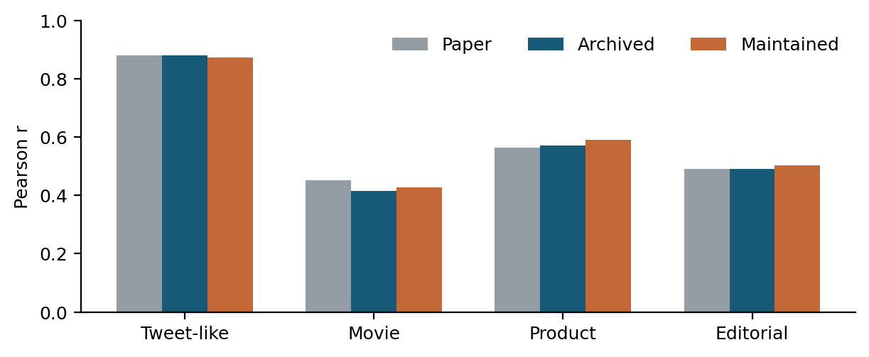
Figure 1. Reported and reproduced intensity correlations. Maintained code does not consistently move every collection closer to the original published value.
The maintained implementation produces correlations of 0.872217, 0.427597, 0.589628 and 0.502898 in the same corpus order. It improves the movie correlation relative to the archived run, but moves tweet-like and product values further from their published targets. Therefore, replacing archived code with maintained code would change the replication question rather than resolve it automatically.
Resource comparison finds 7,502 unique archived lexicon entries and 7,506 maintained entries: four additions, no removals, and two changed valences among shared entries. The implementations also differ in rule processing. This audit establishes that version choice matters, but does not isolate the causal effect of lexicon changes from rule changes. Checksummed inputs and fixed counts reduce the risk of accidental local substitutions; they cannot establish that the released artefacts exactly match every intermediate resource used for the original paper.

3.4 Classification protocol audit
Under the notebook’s provisional policy, archived tweet-like macro-F1 is 0.746696. This is substantially below the paper’s overall F1 of 0.96. The audit evaluates predefined alternatives for converting the human mean $h$: the notebook policy $h/4$, the unscaled released mean $h$, and the VADER-style nonlinear mapping $h/\sqrt{h^{2}+15}$. Each uses the same fixed class thresholds. Macro and weighted aggregation are then reported separately.
Corpus | h/4 macro | h macro | h weighted | Paper F1
Tweet-like | 0.747 | 0.714 | 0.958 | 0.96
Movie | 0.405 | 0.397 | 0.585 | 0.61
Product | 0.513 | 0.446 | 0.615 | 0.63
Editorial | 0.521 | 0.430 | 0.544 | 0.55
Table 3. Archived classification sensitivity. Columns vary reference-score scale and F1 averaging, not the VADER threshold. The raw-mean/weighted tweet-like value rounds to 0.96, but this numerical resemblance does not establish the original evaluation protocol.
The change in neutral support is especially informative. For tweet-like texts, $h/4$ yields 297 neutral reference items, whereas the unscaled policy yields only 40. Under the latter policy, weighted F1 is 0.957756 and accuracy is 0.940000; macro-F1 is still only 0.713843. A high weighted score can therefore coexist with much weaker performance when each class receives equal weight.
The raw-mean/weighted result reproduces the rounded headline F1 numerically, but does not justify claiming a recovered protocol. The paper describes normalised thresholds and overall metrics, while these alternative choices produce different reference partitions. Moreover, the same alternative does not exactly recover the other collections. The appropriate outcome is an explicit sensitivity result and an unresolved protocol difference, rather than a claim that the original research contains an error. No threshold was selected to maximise test scores.

3.5 Examples from the original data
Table 4 adds qualitative evidence from the released tweet-like corpus. Items 4 and 35 agree with the derived reference class. Item 266 has a positive human mean but receives zero from both implementations, consistent with difficulty capturing implicit positive context. For item 431, archived code returns a positive score despite a negative reference; maintained code returns a negative score.
ID | Text | Human mean | Archived c | Maintained c | Ref. class
4 | LMAO, AMAZING! | 2.8571 | +0.8398 | +0.8398 | positive
35 | Anger is ugly. | -1.0105 | -0.7906 | -0.7906 | negative
266 | Daydreaming about spring. | 1.1789 | +0.0000 | +0.0000 | positive
431 | Not a good day | -1.8144 | +0.4404 | -0.3412 | negative
Table 4. Observed original-data examples. Reference classes use the explicitly provisional human-mean/4 policy and fixed thresholds. Items were selected after evaluation to illustrate agreement and disagreement; they do not estimate error prevalence.
A controlled diagnostic changes only the initial capital in item 431: “not a good day” receives $−0.3412$ from both versions. The archived negation helper checks tokens directly, and this example exposes sensitivity to the capitalised negator. This post-hoc probe is excluded from aggregate results and does not by itself explain the remaining corpus-level correlation differences.

4 Construction and preparation of new data

4.1 Existing benchmark: DynaSent
DynaSent provides English negative, neutral and positive labels. Its first round contains naturally occurring review sentences; the second contains crowdsourced adversarial sentences. The creators designed challenging evaluation splits and validated items with multiple human judgements (Potts et al., 2021). This project uses the official version 1.1 Round 1 and Round 2 test files, containing 3,600 and 720 sentences respectively. Each split is balanced across the three classes: 1,200 items per class in Round 1 and 240 in Round 2.
The pinned release revision is 707b6208. Parsing checks confirm no empty text, invalid label, duplicate identifier, or duplicate normalised text within either test split. Normalisation changes only whitespace, affecting 104 Round 1 strings and 31 Round 2 strings. Case, punctuation, negation and word order are retained. Stop-word removal or aggressive regular-expression cleaning would remove signals used by the model.
A minimal data example has fields text_id, sentence and gold_label. One released item, r2-0019256, contains the sentence “The art exhibit has a lot to offer.” and a positive reference label. Reference labels come from the release and are never overwritten by model output. Official training and development data are not used for model fitting or threshold selection in this project.
There is one normalised exact-text overlap between Round 1 and the original corpora, and none for Round 2. The headline benchmark evaluation retains the official test split and records this overlap. This small overlap qualifies a claim of complete data independence, even though no classifier training occurs. The benchmark is also a selected challenge set, so its scores should not be interpreted as population estimates for all recent English writing.

4.2 Project route and benchmark role
The independently chosen VADER paper, code and original corpora form the basis of the novel project. The supplied overall criteria require replication and newly created data; they do not impose a first-ever application requirement on each existing benchmark. DynaSent is used as transfer evidence. Prior work by Wang et al. (2026) uses VADER among its weak-supervision sources and evaluates DynaSent, so this report makes no first-use claim. The 288-text controlled corpus is the project’s newly created data, with human validation still pending.

4.3 New controlled corpus
The constructed dataset contains 48 families and 288 unique English texts. Each family has six conditions: a base sentence, negation, a degree modifier, capitals, three exclamation marks, and a contrast clause. Four domains contain 12 families each: apps, transport, university services and customer service. Within each domain, four base families were drafted to express a positive attitude, four a negative attitude and four a neutral description.
This targeted design follows the behavioural-testing rationale of Ribeiro et al. (2020): specific linguistic capabilities are inspected alongside aggregate performance. The tests are implemented in the project’s own scripts.
The corpus was authored with the ChatGPT/Codex assistant on 4 November 2026. This provenance is recorded for every item. The base-tone metadata expresses drafting intentions and is not a human reference label. An intended positive word can be absent from the lexicon, and a seemingly factual service description can contain a word with a context-free valence. Such cases were retained rather than rewritten after seeing predictions.
For example, a family begins with “The shopping app is frustrating.” Its variants include “not frustrating”, “extremely frustrating”, an uppercase sentiment word, exclamation marks and a favourable refund clause after “but”. Neutral families supply controls: adding capitals to a time or a room number should not automatically create an emotional assessment. Some neutral modifier variants adjust descriptive precision rather than sentiment intensity; their interpretation therefore needs human checking.
The family split was fixed before scoring: twelve families (72 texts) for development and 36 families (216 texts) for held-out evaluation, with no family overlap. Model settings remain fixed. Keeping related variants together limits leakage between partitions; AI authorship and templated wording still limit generalisability.

4.4 Independent annotation procedure and status
Two blank, independently randomised annotation sheets have been prepared. Readers see an opaque item ID and text, with no design tone, family label, condition, prediction or other reader’s judgement. The protocol requests a class, an integer intensity from $−4$ to $+4$, confidence and an optional note. A development pilot precedes the held-out rating. The guidelines distinguish sentiment from a merely factual event and allow uncertainty about mixed clauses.
After actual independent ratings are collected, raw agreement and Cohen’s kappa (Cohen, 1960) will be computed before discussion. An adjudication sheet will preserve both original ratings and a final class; unresolved cases will remain ambiguous and their counts will be reported. Held-out class metrics will use resolved labels. Intensity agreement will use the mean of the two independent ratings, while confidence intervals will resample whole families.
Artstein and Poesio (2008) explain how agreement coefficients depend on their chance model and category distributions. Class counts and raw agreement will therefore accompany kappa, rather than treating one coefficient as sufficient evidence of annotation quality.
At the time of this draft, both human rating columns are empty. No human kappa, constructed-data human accuracy, or correlation with human intensity is available. The validation script returns a pending status rather than interpreting blank entries as neutral. Completing this procedure is necessary to answer the third research question as originally proposed.

5 Results on new data

5.1 Benchmark transfer
Table 5 reports the observed benchmark results. Archived macro-F1 is 0.548928 on Round 1 and 0.522994 on Round 2. Maintained values are 0.551640 and 0.522928. Accuracy is 0.561111 and 0.526389 for archived code, and 0.563889 and 0.526389 for maintained code. Both versions exceed the all-neutral baseline of one-third accuracy and one-sixth macro-F1 on these balanced splits.
Test split | Version | n | Accuracy | Macro-F1 | 95% interval
Round 1 | Archived | 3,600 | 0.5611 | 0.5489 | [0.533, 0.566]
Round 1 | Maintained | 3,600 | 0.5639 | 0.5516 | [0.536, 0.568]
Round 2 | Archived | 720 | 0.5264 | 0.5230 | [0.485, 0.561]
Round 2 | Maintained | 720 | 0.5264 | 0.5229 | [0.485, 0.560]
Table 5. Observed DynaSent test results. Percentile intervals use 2,000 paired sentence bootstrap samples with seed 8240. All inputs, labels and thresholds are fixed; no development-set selection or classifier training is performed.
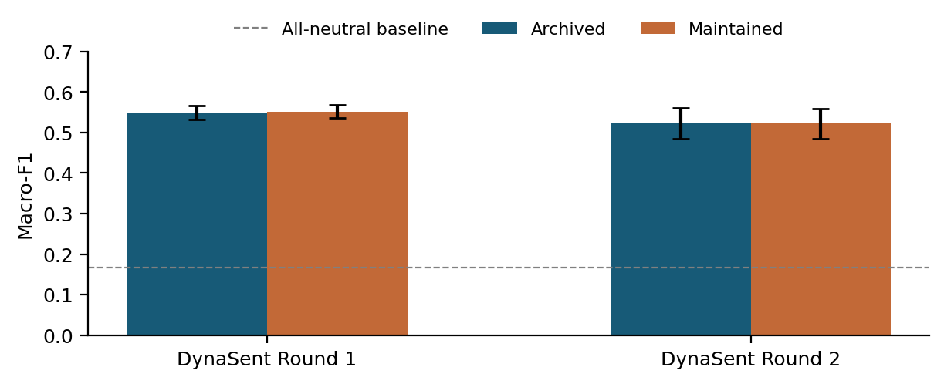
Figure 2. Macro-F1 with 95% bootstrap intervals. The two VADER implementations have similar performance on each official test split. The baseline predicts neutral for every item.
The paired maintained-minus-archived macro-F1 interval is $\left[−0.0022,0.0078\right]$ for Round 1 and $\left[−0.0079,0.0084\right]$ for Round 2. Both contain zero. The observed implementation differences are small relative to sampling variation on these sets, so the results do not support a confident improvement claim for maintained VADER. The intervals describe resampling uncertainty for the observed test data, not uncertainty over all possible collection processes.
Dror et al. (2018) emphasise matching statistical comparisons to the task, metric and experimental design. Here, paired resampling preserves the shared test examples when comparing implementations.
Class-specific performance gives more detail than the headline score. Archived Round 2 negative recall is 0.408, compared with 0.617 for positive items (Table 6). Of 240 negative examples, 87 are predicted positive and 55 neutral. These counts suggest that negative judgements involving context remain difficult. The confusion pattern also prevents an interpretation in which the model merely finds the correct sentiment but slightly miscalibrates intensity.
Class | Precision | Recall | F1
Negative | 0.544 | 0.408 | 0.467
Neutral | 0.554 | 0.554 | 0.554
Positive | 0.493 | 0.617 | 0.548
Table 6. Archived VADER on DynaSent Round 2. Each reference class has 240 items.
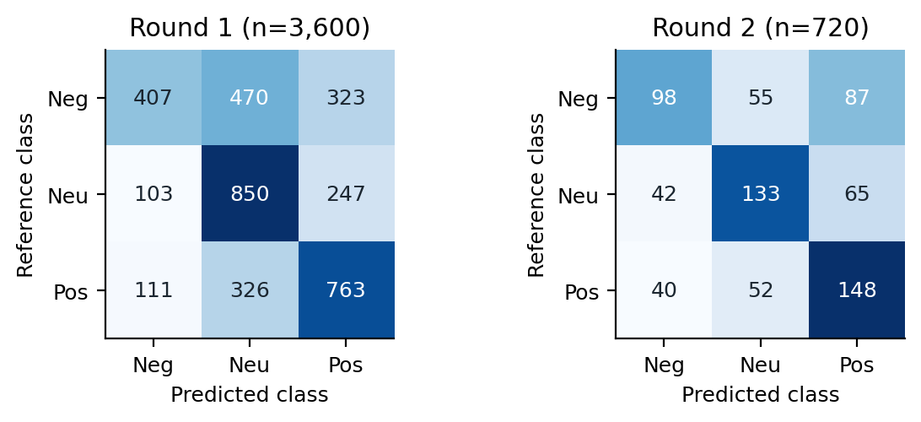
Figure 3. Archived VADER confusion matrices. Rows are released human reference classes and columns are predictions. Round 1 has many negative items labelled neutral; Round 2 also has substantial negative-to-positive confusion.
These classification results must not be compared numerically with the original Pearson correlations as if they shared a scale of correctness. Even comparisons with original provisional macro-F1 require care: the original reference classes were derived from intensity ratings, whereas DynaSent supplies categorical labels. Different domains, collection procedures and reference policies can all contribute to the score change. The experiments show transfer limitations without identifying any single cause as definitive.

5.2 Controlled behavioural diagnostics
Table 7 describes archived score changes on held-out families. Positive-design families move downward under negation by a mean of 0.704; negative-design families move upward by a mean of 0.688. Modifier, capital and punctuation conditions generally strengthen the score in the base direction. Contrast moves the mean toward the newly introduced opposing evaluation.
Variant | Pos. Δ | Check | Neg. Δ | Check
Negation | -0.704 | 10/12 | +0.688 | 11/12
Modifier | +0.041 | 10/12 | -0.052 | 11/12
Capitals | +0.095 | 10/12 | -0.122 | 11/12
Punctuation | +0.111 | 10/12 | -0.142 | 11/12
Contrast | -0.833 | 12/12 | +0.809 | 12/12
Table 7. Held-out constructed diagnostics: mean variant-minus-base compound change and count satisfying the drafting-direction check. Each tone has 12 families. Checks use AI-authored design hypotheses and are not human accuracy measurements. Positive and negative refer to intended base tones.
The incomplete direction-check counts are informative. Two positive-design held-out bases are not strengthened by the intensity variants, while one negative-design family also fails these checks. For instance, the base about a reliable delivery team receives a zero archived compound score. By contrast, a factual help-desk closing-time sentence receives 0.4019, and its negated version does not express a negative service opinion in the same straightforward way. The lexicon can activate on a word’s context-free association even when the full sentence is intended as a neutral fact.
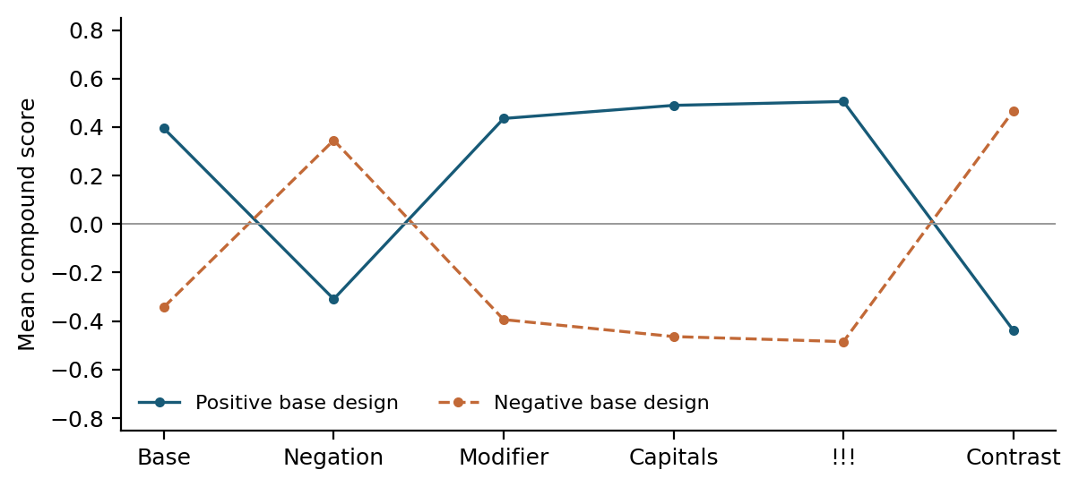
Figure 4. Archived mean compound scores for the 24 held-out families drafted with positive or negative base tones. Maintained scores have identical means in this plot. Lines show numerical model behaviour. Their direction does not establish agreement with independent human interpretation.
The results therefore distinguish rule execution from semantic success. A punctuation rule cannot intensify a sentiment token that the model never recognises; an active lexical entry can also induce sentiment in a neutral description. The 288 inputs and their predictions make these cases inspectable, but assigning a human-correctness score requires the outstanding reference ratings. The examples are qualitative illustrations selected after scoring, so they do not estimate the prevalence of each failure type in natural language.

5.3 LLM as judge pilot
The evaluation includes two 60-item within-session assistant judgements. The DynaSent sample contains 20 items from each released gold class, selected with seed 8240. The constructed sample contains all six variants from ten held-out families. Judge-input files contain IDs and texts, while labels, VADER scores and condition names are omitted. The prompt requests one class, a supporting phrase, confidence and a brief explanation per item.
The judge was the ChatGPT/Codex assistant in the current conversation. The interface did not expose an exact serving-model snapshot, temperature or decoding seed. It was not an external API experiment. Inputs, responses, prompt and provenance limitations are preserved, allowing exact rescoring of the recorded outputs. Re-running a closed model to regenerate identical outputs is a separate and unresolved reproducibility problem.
System on the same 60 items | Accuracy | Macro-F1
Archived VADER | 0.500 | 0.498
Maintained VADER | 0.483 | 0.484
Assistant judge | 0.883 | 0.883
Table 8. Exploratory comparison on the same balanced 60-item DynaSent sample. The assistant result comes from preserved within-session textual judgements.
On the sampled DynaSent items, the assistant agrees with the released human class in 53 of 60 cases: accuracy 0.883333, macro-F1 0.882784 and kappa 0.825. Archived VADER has macro-F1 0.498074 on these same items. The judge macro-F1 bootstrap interval is $\left[0.792,0.952\right]$. This small exploratory comparison is consistent with useful contextual interpretation, but supports no broad claim that the assistant replaces human annotation.
The seven judge mismatches include ambiguous fragments and differences between inferred event valence and the dataset’s overall sentiment label. For example, the judge treats a threatening action as negative while the released item is neutral. A fragment is assigned neutral despite a positive released label. These differences illustrate why a plausible explanation is not a substitute for agreement with a declared reference policy.
On the constructed sample, archived and maintained VADER each agree with the assistant on 44 of 60 labels (0.733333). This is model-to-model agreement only. The assistant also authored the constructed corpus and retained broader conversation context. Thus the constructed trial is not independently blinded, and shared authorship may make the examples easier for the judge. Liu et al. (2023) motivate structured model-based assessment and identify potential evaluator bias, but their generation-quality experiments do not validate this sentiment-classification adaptation. Comparison with actual constructed-data human labels remains pending.

6 Ethical considerations

6.1 Data, participation and attribution
The Australian Code emphasises responsible research practice, transparent reporting, proper acknowledgement and sound handling of research information (NHMRC et al., 2018). Applied here, these principles require clear data provenance, preservation of unfavourable results, separation of evidence from plans, and accurate attribution of reused code and annotations. A failed or incomplete replication is reported as such rather than repaired through undisclosed changes.
Documenting the constructed corpus’s motivation, composition, creation process and intended uses follows the transparency rationale of Gebru et al. (2021). Its manifest and annotation guidelines record these properties and the outstanding human-validation limitation.
The original study used crowdsourced judgements. Their quality-control methods and aggregated references are part of the published study, but this project does not establish new consent or review the original recruitment. The replication uses the released artefacts and avoids re-identifying authors of the adapted texts. Public availability is treated as a source-access property rather than automatic permission for unrestricted redistribution.
The upstream VADER code includes an MIT notice, which is retained. DynaSent’s repository and datasheet discuss its release and potential inherited Yelp terms (Potts et al., 2026). The public project should distribute retrieval instructions, IDs and derived scores rather than a replacement copy of the full source collections. The local judge input records contain a small evaluation sample; publication of those texts should follow the source conditions. No API keys or credentials belong in the report or repository.
The proposed new annotation uses volunteers. Actual participation should follow course guidance, with informed agreement, freedom to stop and no unnecessary personal information in public files. Anonymous reader codes are sufficient for the computational audit. Consent records and contact details should remain private. No institutional ethics approval or completed recruitment is claimed in this report.

6.2 Model bias and interpretation
VADER’s lexicon and rules represent particular language and rating conventions. An English short-text evaluation does not establish reliability for other languages, dialects, groups or specialised decisions. The constructed corpus covers only four service-related domains and a restricted set of sentence forms. AI-assisted drafting can add stereotyped wording and favour examples that match the drafter’s own interpretation. Maintaining negative, neutral and ambiguous cases reduces selective reporting, while independent annotation is needed to test these assumptions.
Sentiment output should also be interpreted at the appropriate level. A label about a review sentence does not establish the writer’s psychological state, intent, trustworthiness or future behaviour. The false positives in factual service descriptions make such inferences particularly weak. The present evaluation supports analysis of declared text-level sentiment tasks rather than individual profiling or consequential automated decisions.
The assistant judge adds a different source of bias. Its training-data overlap with a known public benchmark cannot be excluded, and the current interface does not provide the controls needed for an independently repeatable model trial. Its explanations may be persuasive even where its label disagrees with the reference. Keeping human gold unchanged, recording low-confidence judgements and reporting mismatches limits the risk of treating fluency as correctness.

6.3 Research integrity and AI assistance
Generative AI assisted corpus drafting, software preparation, the textual judge pilot and report writing. Computational values in the report are exported from executed scripts and preserved result files. Authorship provenance and judge limitations are disclosed. Human annotation was not simulated, and missing measurements are not replaced by estimates presented as observations.
The student remains responsible for checking the source papers, interpreting the results and verifying the submitted text under the assessment’s open-AI policy. The unchanged Assessment 1 and 2 files remain background evidence; their planned work is not automatically described as completed. The DynaSent novelty claim was revised when contrary evidence was found. These choices keep the final argument consistent with the available experimental record.

7 Conclusions and reflections
Archived VADER can be executed successfully on all released original texts, and two of the four published correlations reproduce to three decimal places. Movie and product values differ, while maintained code changes performance without resolving every discrepancy. The classification audit demonstrates that reference-score conversion and F1 averaging materially affect conclusions. A rounded headline match under one alternative policy is insufficient to establish full replication of the original protocol.
On the official DynaSent tests, both implementations achieve similar macro-F1, around 0.55 in Round 1 and 0.52 in Round 2. They exceed a constant-class baseline but retain substantial class-specific errors. This is evidence of limited transfer under fixed settings. It does not imply a general score for all modern short text or isolate domain shift as the only cause of failure.
The constructed corpus provides an inspectable set of 288 related inputs and reveals interactions between lexical coverage and contextual rules. The within-session judge pilot offers additional exploratory interpretation, with preserved outputs and explicit reproducibility limits. Independent human annotation of the constructed texts remains the main unfinished scientific dependency. Completing it will permit kappa, human-reference class metrics, intensity correlation and paired family-level analysis, answering the third research question on its intended basis.
Data identity, reference policy, version selection and the distinction between human and model judgement determine which conclusions the numbers can support. The supplied scripts make these decisions auditable.

References
2026. COMP8240 overall goal and assessment criteria. Unit iLearn guidance, Session 2.
Ron Artstein and Massimo Poesio. 2008. Survey article: Inter-coder agreement for computational linguistics. Computational Linguistics, 34(4):555–596.
Jacob Cohen. 1960. A coefficient of agreement for nominal scales. Educational and Psychological Measurement, 20(1):37–46.
Computing Research and Education Association of Australasia. 2023. CORE2023 conference rankings: ICWSM. Historical ranking, accessed 4 November 2026.
Rotem Dror, Gili Baumer, Segev Shlomov, and Roi Reichart. 2018. The hitchhiker’s guide to testing statistical significance in natural language processing. In Proceedings of the 56th annual meeting of the association for computational linguistics (volume 1: Long papers), pages 1383–1392. Association for Computational Linguistics.
Timnit Gebru, Jamie Morgenstern, Briana Vecchione, Jennifer Wortman Vaughan, Hanna Wallach, Hal Daumé III, and Kate Crawford. 2021. Datasheets for datasets. Communications of the ACM, 64(12):86–92.
C. J. Hutto. 2026. VADER sentiment analysis: Author code and original study resources. Pinned revision 44fc044c; accessed 4 November 2026.
C. J. Hutto and Eric Gilbert. 2014. VADER: A parsimonious rule-based model for sentiment analysis of social media text. In Proceedings of the international AAAI conference on web and social media, volume 8, pages 216–225.
Yang Liu, Dan Iter, Yichong Xu, Shuohang Wang, Ruochen Xu, and Chenguang Zhu. 2023. G-Eval: NLG evaluation using GPT-4 with better human alignment. In Proceedings of the 2023 conference on empirical methods in natural language processing, pages 2511–2522. Association for Computational Linguistics.
NHMRC, Australian Research Council, and Universities Australia. 2018. Australian code for the responsible conduct of research.
Bo Pang and Lillian Lee. 2008. Opinion mining and sentiment analysis. Foundations and Trends in Information Retrieval, 2(1–2):1–135.
Joelle Pineau, Philippe Vincent-Lamarre, Koustuv Sinha, Vincent Lariviere, Alina Beygelzimer, Florence d’Alché-Buc, Emily Fox, and Hugo Larochelle. 2021. Improving reproducibility in machine learning research (a report from the NeurIPS 2019 reproducibility program). Journal of Machine Learning Research, 22(164):1–20.
Christopher Potts, Zhengxuan Wu, Atticus Geiger, and Douwe Kiela. 2021. DynaSent: A dynamic benchmark for sentiment analysis. In Proceedings of the 59th annual meeting of the association for computational linguistics and the 11th international joint conference on natural language processing (volume 1: Long papers), pages 2388–2404. Association for Computational Linguistics.
Christopher Potts, Zhengxuan Wu, Atticus Geiger, and Douwe Kiela. 2026. DynaSent version 1.1: Data release and datasheet. Pinned revision 707b6208; accessed 4 November 2026.
Marco Tulio Ribeiro, Tongshuang Wu, Carlos Guestrin, and Sameer Singh. 2020. Beyond accuracy: Behavioral testing of NLP models with CheckList. In Proceedings of the 58th annual meeting of the association for computational linguistics, pages 4902–4912. Association for Computational Linguistics.
scikit-learn developers. 2026. F1 score: Metric definition and averaging options. Accessed 4 November 2026; experiments use scikit-learn 1.8.0.
Jiaxu Wang, Bowen Rong, Chengcheng Li, Huiying Xu, and Xinzhong Zhu. 2026. MSRA-CCL: Multi-source reliability-aware aggregation and cross-domain consistency learning for weakly supervised sentiment classification. Electronics, 15(18):4230.
Theresa Wilson, Janyce Wiebe, and Paul Hoffmann. 2005. Recognizing contextual polarity in phrase-level sentiment analysis. In Proceedings of human language technology conference and conference on empirical methods in natural language processing, pages 347–354. Association for Computational Linguistics.

Source paper: https://ojs.aaai.org/index.php/ICWSM/article/view/14550.
Original released data: https://github.com/cjhutto/vaderSentiment/blob/44fc044cd877310ee8278a0eadf34bcd50d41d06/additional_resources/hutto_ICWSM_2014.tar.gz.
Student project repository: publication and URL verification pending in this review draft. The accompanying project package contains the readable scripts, dependencies, results, figures and report source needed for the completed experiments.
Dataset and datasheet: https://github.com/cgpotts/dynasent.

