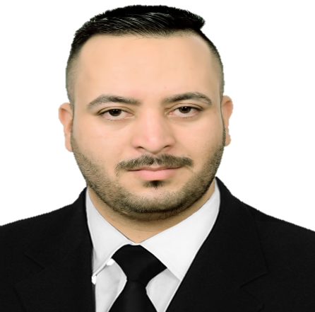 

**Hamdalla Fadil Kareem Al-Yasriy**

**Electrical Engineer, Assistant Lecturer**

**Hamdalla Al-Yasriy**

**Microsoft PowerPoint**

**Web Scraping**

**Microsoft Excel Ehexcel**

نجمةنجمةنجمةنجمة

**Skills**

Hamdalla Fadil Kareem

https://www.kaggle.com/hamdallak

+9647807401126

**Engilsh**

**Arabic**

**Medical equipment maintenance | 2019**

**Wasit Center for Nephrology and Dialysis**

**C++**

**Microsoft Word**

**E-learning**

**Visual Basic Basic**

**Matlab**

**R**

**Experience**

**Microsoft Office**

**Python**

**Administrative employee | 2020 - present**

**University of Wasit, Scholarships & Cultural Relation Dept.**

Teaching electrical machine labs in the department of Electrical Engineering

Teaching Electronics labs in the department of Electrical Engineering

Teaching computer programing in the department of Civil Engineering

**Competitive**

**Social Skills**

**Team work**

**Leadership**

**Features**

**Language**

hamdallak@uowasit.edu.iq

Iraq, Wasit, Kut

**Contact**

**University of wasit, College of Engineering**

**Faculty Member | 2016 - Present**

**Education**

**B.Sc. in the Sciences of Computer Engineering**

**College of Engineering, Wasit University | 2012 - 2016**

Department of Electrical engineering

Department of Electrical Engineering

**College of Engineering, Wasit University | 2018- 2020**

**M.Sc. in the Sciences of Electrical Engineering**

Active learner and passionate towards acquiring new skills. My main interests are Electrical engineering, artificial intelligence and data science and I am always looking for new challenge.

Profile