Project Overview
Project Title:
Gesture-Controlled Hazardous Environment Reconnaissance Vehicle

Problem Statement
Hazardous environments such as fire scenes, chemical spill zones, nuclear facilities, and explosive disposal sites pose extreme risks to human personnel. Direct human entry into these environments to assess conditions can result in serious injury or death. There is a clear need for a remotely operated vehicle capable of entering these zones, collecting environmental data, and transmitting it to an operator at a safe distance.

Proposed Solution
This project presents a gesture-controlled reconnaissance vehicle designed for deployment in hazardous environments. The system consists of two subsystems — a wireless gesture glove worn by the operator and a sensor-equipped ground vehicle — communicating via infrared transmission. The vehicle collects real-time environmental data and streams it to a cloud dashboard via ThingSpeak, while the operator retains full remote control including an emergency kill switch accessible from any browser.

Real World Application
This system draws direct inspiration from real-world hazardous environment robotics:
EOD (Explosive Ordnance Disposal) robots
Nuclear facility inspection vehicles
Chemical plant leak detection systems
Fire scene reconnaissance platforms
Search and rescue ground vehicles
Mobile Weather Station
Like real EOD robots such as the iRobot PackBot, this vehicle maintains a wired telemetry link for reliable data transmission from the hazardous zone — a deliberate design choice prioritising communication reliability over full wireless operation.

System Overview
The project is divided into two physical subsystems and one software layer:
Subsystem 1 — Gesture Glove (Controller) The operator wears a glove housing a Raspberry Pi Pico 2 microcontroller and MPU-6050 six-axis inertial measurement unit. Tilt gestures detected by the MPU-6050 are mapped to directional commands and transmitted wirelessly via an extracted IR LED. The glove operates entirely on a 9V battery through a voltage regulator, requiring no tether to the operator.
Subsystem 2 — Reconnaissance Vehicle The vehicle is built on a repurposed RC car chassis driven by a single DC motor and steered by an SG90 servo motor, both controlled through an L293D motor driver. An Arduino Uno R3 serves as the main microcontroller, receiving gesture commands from the glove via an HX1838 IR receiver. The vehicle carries a sensor payload monitoring temperature, humidity, obstacle proximity, motion, and ambient sound levels. An RGB LED and active buzzer provide local hazard indication. The Arduino connects to the operator's laptop via USB, serving as the gateway for IoT data transmission.
Software Layer — Python Bridge A Python script running on the operator's laptop reads sensor data from the Arduino via serial communication and uploads it to ThingSpeak every 15 seconds. The same script polls ThingSpeak every 2 seconds for operator commands — including emergency kill switch, manual alarm trigger, and temperature threshold adjustment — and forwards them to the Arduino via serial. This creates a complete bidirectional IoT pipeline between the vehicle and the cloud.

Key Features
Gesture control Tilt-based directional commands via MPU-6050
Dual control modes Gesture glove primary, IR remote backup override
Diagonal gestures Combined tilt detected for simultaneous drive + steer
Auto-stop Vehicle halts automatically when obstacle within 13cm
Hazard scoring Composite 0-100 hazard score calculated via ThingSpeak MATLAB
RGB hazard indicator Green / yellow / red based on environmental conditions
Buzzer latch Alarm persists until manually cleared by operator
Remote kill switch Emergency stop triggered from ThingSpeak dashboard
Adjustable threshold Temperature alarm threshold set remotely via ThingSpeak
Manual alarm Operator can trigger buzzer remotely from dashboard
MATLAB visualizations Heat index, dew point, hazard score, correlation plots

System Block Diagram
┌─────────────────────┐ ┌──────────────────────────────────┐
│ GESTURE GLOVE │ │ VEHICLE │
│ │ │ │
│ MPU-6050 │ │ HX1838 IR receiver │
│ Pico 2 │──IR──►│ Arduino Uno R3 │
│ IR LED │ │ L293D + DC motor + servo │
│ 9V + PSU │ │ DHT11, HC-SR04, PIR, sound │
│ │ │ RGB LED, buzzer, LED │
└─────────────────────┘ └──────────────┬───────────────────┘
│ USB serial
┌──────────────▼───────────────────┐
┌────────────────────────── │ PYTHON BRIDGE │
│ │ reads serial → parses data │
│ │ uploads to ThingSpeak │
│ │ polls ThingSpeak for commands │
│ │ sends commands to Arduino │
│ └───────────────────────────────────┘
│
▼
┌────────────────────────────────────────────────────────────────┐
│ THINGSPEAK DASHBOARD │
│ │
│ field1 Temperature field5 Sound │
│ field2 Humidity field6 Kill switch │
│ field3 Distance field7 Manual alarm │
│ field4 Motion field8 Temp threshold │
│ │
│ MATLAB: Heat index · Dew point · Hazard score · Graphs │
└────────────────────────────────────────────────────────────────┘

Components
- Glove controller: Pico 2 · wireless · power bank powered
- Raspberry Pi Pico 2: Main controller
- MPU-6050: Gesture sensing (I2C)
- IR transmitter: Sends direction codes
- USB power bank: Powers glove wirelessly
- Breadboard (small): Component mounting
- Jumper wires Male-male + male-female
- Resistor (100 Ω): IR transmitter current limit
- Vehicle: Arduino Uno R3 · USB tethered · battery powered motors
- Arduino Uno R3: Main controller
- IR receiver (HX1838): Receives gesture codes
- L293D motor driver IC: Controls DC motor
- SG90 servo motor: steering
- HC-SR04: Obstacle detection
- DHT11: Temperature + humidity
- HC-SR501 PIR: Motion detection
- Sound sensor module: Ambient noise level
- Active buzzer: Local hazard alerts
- 9V battery + DC connector Powers motors via L293D
- Breadboard (830 pt): Component mounting
- Jumper wires Male-male + male-female
- Resistors(220 Ω): current limiting
- Connection:
- Laptop tether USB-A extension cable 3–5 m operating radius
- USB-B cable Arduino to extension
- Software:
- Python bridge + cloud Python (venv)
- Serial bridge script pyserial
- Read Arduino serial port requests
- ThingSpeak account Dashboard + alerts
- MicroPython Pico 2 firmware
- Custom App

System Architecture
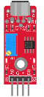
Vehicle: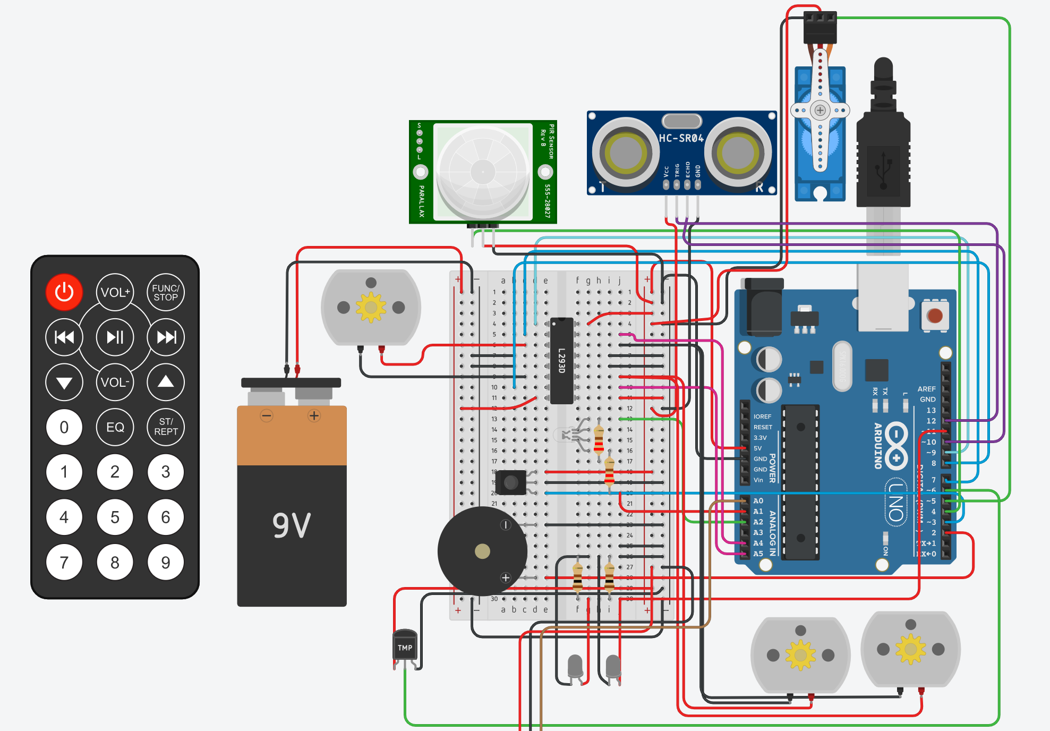

Glove:
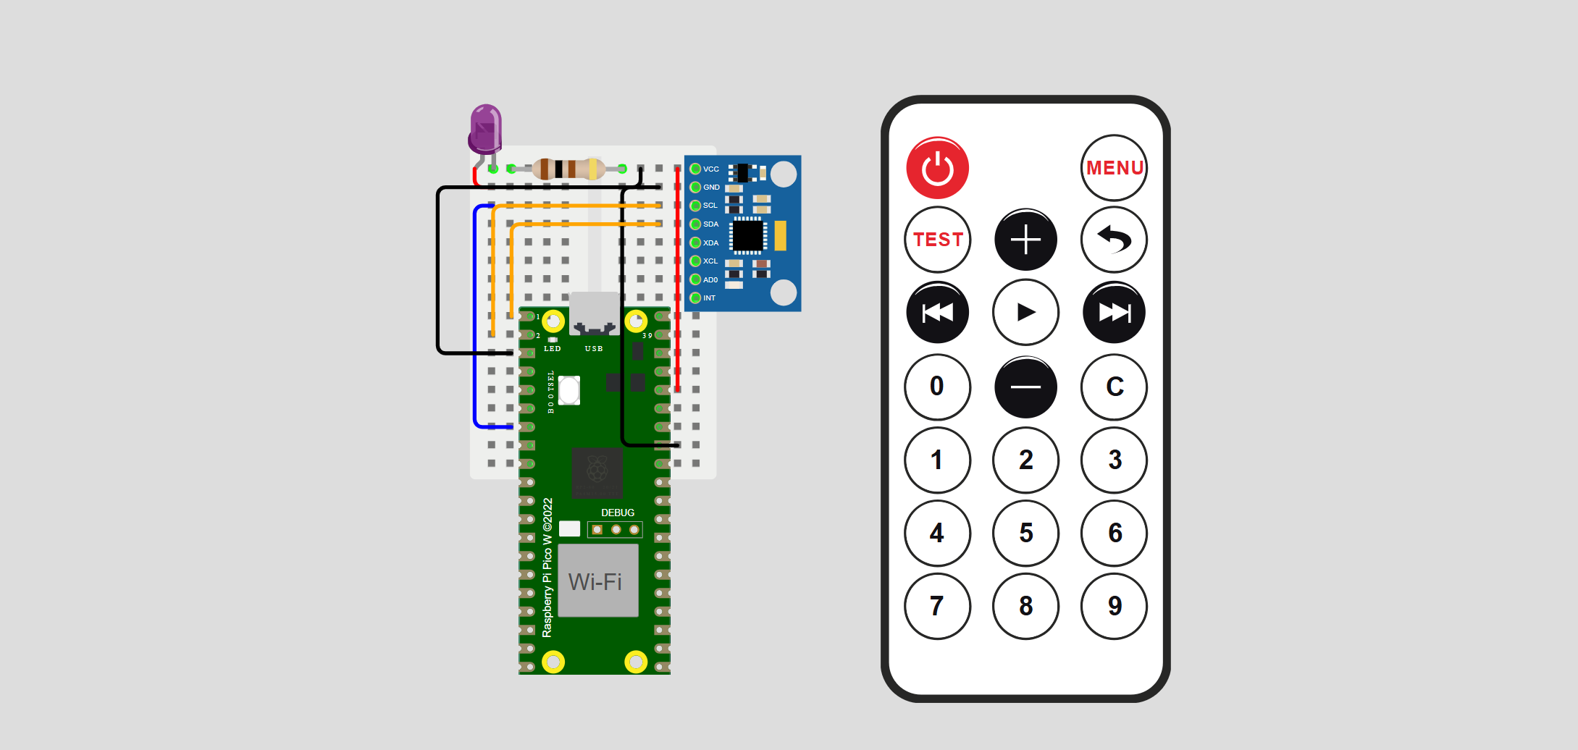

Weekly Progress Log
Week 1: Glove controller build + test
Planned: To make the glove circuit and write the software code for the gesture control
Work Done: Tested the glove circuitry
Soldered the Pico headers
Writing the software code
Figuring out the appropriate commands to transmit form IR Led
Adjusted the MPU X-Y coordinates for a smooth feel
Problems Encountered: Struggled to find an appropriate IR transmitter and learn its
functionalities from scratch
Low range of communication from the IR transmitter
Fixes:
Salvaged an IR led from an old TV remote
Added a transistor to the circuit to increase the range of the LED

Week 2: Sensor Payload + Python Bridge + ThingSpeak
Planned: Learn how each sensor works and utilize it to its strengths
Propose the system layout
Start with software coding for the Arduino and the python bridge
Work Done:

Week 3: Vehicle drive System Build + Test
Planned: Design the vehicle outline and chassis
Integrate motor control with the axle and build the steering system
Work Done: Create the motor axle for the rear wheels
Built the motor circuitry with the L293D IC and adjusted direction commands
Designed and executed the build of the axle for the front wheels and integrated it with the Servo
Test the servo turning radius for a suitable and stable steering system
Problems Encountered: Unstable turning
Not enough power on rear wheels
Timer conflicts and few minor faults in the code
Fixes: Fixed the turning radius of the wheels
Added a triple motor power system along with gears
Code debugging and change in the pin connections

Challenges and Solutions
- Servo jitter → damaged gear → replaced
- 1.5V motor not running → L293D needs 4.5V min
- IR LED not separate → extracted from TV remote
- Tethered vehicle → reframed as realistic EOD design
- Timer2 conflict → avoided analogWrite on pin 11
- DHT11 NaN → added isnan check + 2s interval
- pulseIn blocking → added 30ms timeout
- autoStop overriding KILL → split into two flags

Future Improvements
- Camera module for visual feedback
- DHT22 for better accuracy
- Wireless tether elimination
- Gas sensor for chemical hazard detection
- GPS for position logging

