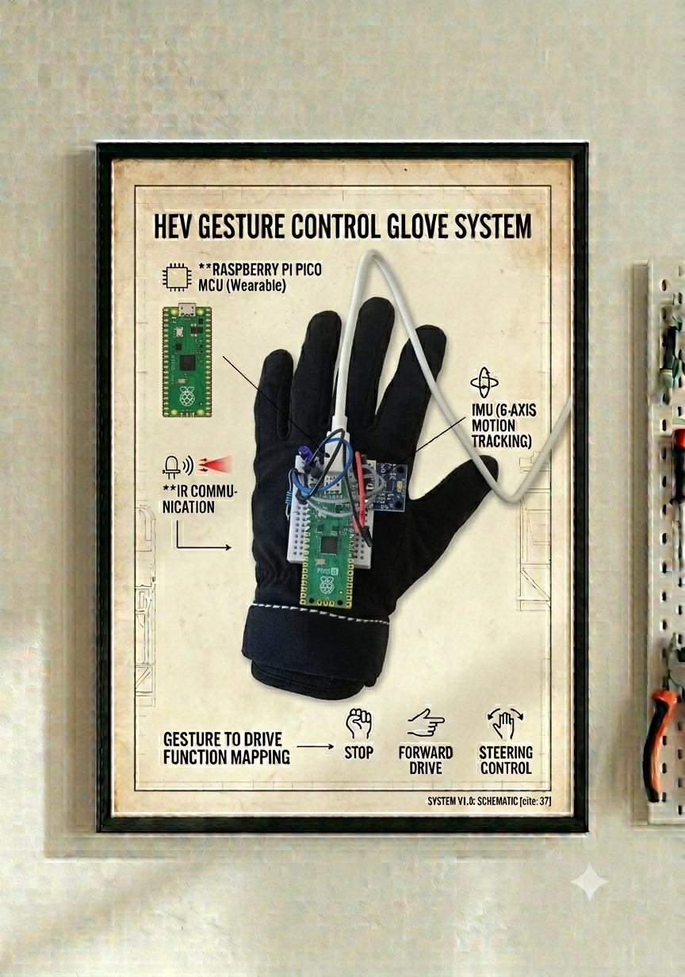
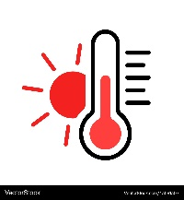
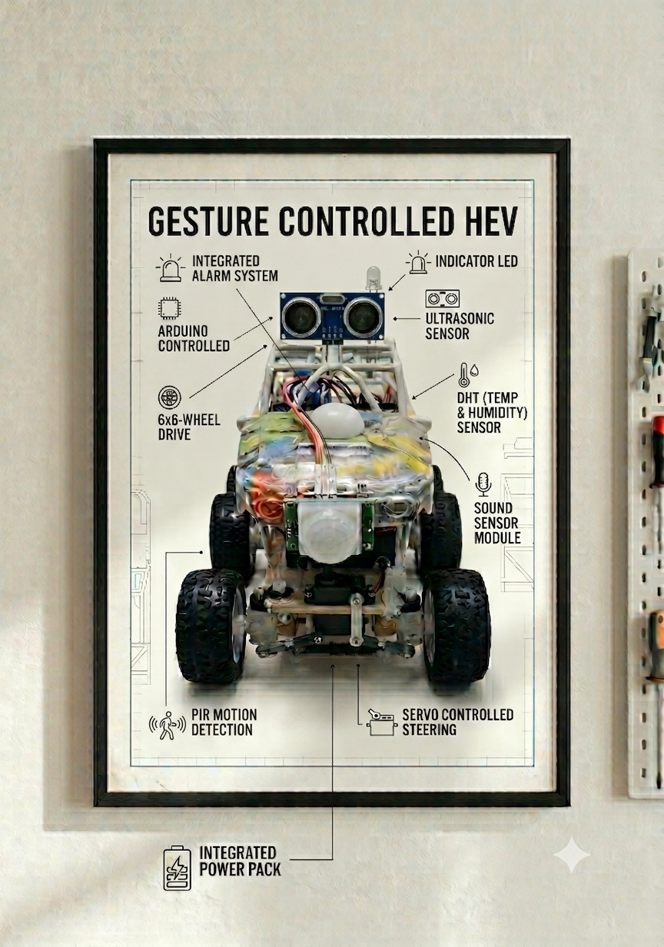
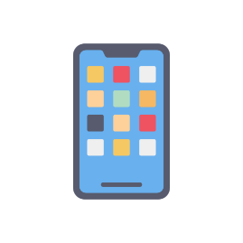


INTEGRATED WEB APP
- Dashboard
- Clean Data Visuals
- Control from App

HEAT INDEX, DEW POINT & HAZARD SCORES
WIFI CONNECTIVITY & THINGSPEAK IoT CAPABILITIESVITY

