6DATA007W – Final Project Report
NBA Player Archetype Identification Using Unsupervised Machine Learning:
A Play-Type Analysis of the 2019–2020 NBA Season
Student: [Your Full Name] ([Student Number])
Supervisor: [Supervisor Full Name]
This report is submitted in partial fulfillment of the requirements for the
BSc (Hons) Data Science and Analytics
at the University of Westminster
School of Computer Science & Engineering
University of Westminster
April 2026

Declaration
This report has been prepared based on my own work. Where other published and unpublished source materials have been used, these have been acknowledged in references.

Word Count: [Insert final word count here]
Student Name: [Your Full Name]
Date of Submission: [Date]

Use of Generative AI
In this assessment, I used Claude (Anthropic) to assist with the initial structuring of code comments, proofreading sections of written text, and generating boilerplate documentation. All analytical decisions, model selection, implementation, interpretation of results, and written arguments are my own. The AI was not used to generate original research conclusions or produce academic content that I present as independently authored without acknowledgement.

Abstract
The growing volume of performance data captured in professional basketball offers a significant opportunity to move beyond conventional positional labels and explore more nuanced characterisations of how players actually contribute on the court. This project investigates whether unsupervised machine learning techniques can effectively identify meaningful player archetypes in the National Basketball Association (NBA) using granular play-type data from the 2019–2020 season.
The dataset used in this study consists of 207 NBA players, each described by 16 features drawn from NBA tracking statistics. These features capture both the frequency with which a player participates in eight distinct play types — isolation, transition, pick-and-roll (ball handler), pick-and-roll (rollman), post-up, spot-up, hand-off, and cut — and the corresponding points-per-possession (PPP) efficiency for each. The data was sourced from NBA Advanced Statistics and represents the most granular publicly available characterisation of individual offensive behaviour.
The methodology followed a structured machine learning pipeline. Raw data was cleaned, invalid values were handled through median imputation, and column names were standardised. Outlier detection and removal was performed using the interquartile range (IQR) method, supported by visual inspection through boxplots. The dataset was augmented using two complementary techniques: Gaussian noise injection to diversify existing samples, and k-nearest neighbour interpolation to synthesise realistic new players from blended play-style profiles. Eight engineered features were then derived to capture higher-order concepts such as on-ball creation, off-ball finishing, and overall weighted efficiency. Features were scaled using StandardScaler before dimensionality reduction with Principal Component Analysis (PCA).
Three clustering models were trained and evaluated: K-Means, which partitions players into spherical, well-separated clusters; DBSCAN, a density-based method capable of detecting outlier play-styles as noise; and K-Modes, which operates on discretised categorical versions of the features. Model performance was assessed using two internal validation metrics — the Silhouette Score and the Davies-Bouldin Index — and compared visually through PCA scatter plots and cluster heatmaps.
The results reveal several interpretable player archetypes, including primary ball-handlers who rely heavily on isolation and pick-and-roll creation, spot-up shooters who function predominantly as off-ball threats, interior finishers who score through cuts and post-up actions, and versatile role players who distribute their offensive activity across multiple play types. These groupings align well with existing basketball domain knowledge and demonstrate that play-type frequency and efficiency data carry sufficient discriminative signal for meaningful clustering.
An interactive Streamlit dashboard was developed to present the results to non-technical stakeholders. The dashboard supports team, cluster, and model-level filtering, provides PCA scatter plots coloured by cluster label, cluster comparison heatmaps, player radar charts, and model evaluation metric comparisons across all three algorithms.
This project contributes to the growing body of sports analytics literature by demonstrating that play-type data, even from a single season, provides a rich basis for unsupervised player characterisation. The findings have potential practical value for coaching staff in player recruitment, game planning, and lineup optimisation.

Acknowledgements
I would like to express my sincere gratitude to my project supervisor, [Supervisor Name], for their continued guidance, constructive feedback, and encouragement throughout the development of this project. Their expertise in data science and machine learning has been invaluable in shaping both the technical direction and academic rigour of this work.
I would also like to thank the University of Westminster's School of Computer Science and Engineering for providing the resources and academic environment that made this project possible. Finally, I am grateful to the NBA and Second Spectrum for making granular play-type tracking data publicly accessible, without which this analysis could not have been conducted.

Table of Contents
[Update this automatically in Word: References → Update Table]

List of Figures
Figure 1: Play-Type Frequency Distribution Histograms
Figure 2: Play-Type PPP (Efficiency) Distribution Histograms
Figure 3: Feature Correlation Heatmap
Figure 4: Boxplots of Frequency Features — Before Outlier Removal
Figure 5: Boxplots of Frequency Features — After Outlier Removal
Figure 6: PCA Cumulative Explained Variance Curve
Figure 7: KMeans Elbow Method — Inertia vs K
Figure 8: Silhouette Score vs K
Figure 9: PCA Scatter Plot — KMeans Clusters
Figure 10: k-NN Distance Plot for DBSCAN Epsilon Selection
Figure 11: PCA Scatter Plot — DBSCAN Clusters
Figure 12: KModes Cost Elbow Plot
Figure 13: PCA Scatter Plot — KModes Clusters
Figure 14: Model Comparison Bar Charts (Silhouette & Davies-Bouldin)
Figure 15: Cluster Feature Heatmap — Mean Play-Type Frequencies
Figure 16: Streamlit Dashboard — Overview Tab
Figure 17: Streamlit Dashboard — Player Comparison Radar Chart

List of Tables
Table 1: Literature Review Summary
Table 2: Dataset Feature Descriptions
Table 3: Augmentation Summary — Dataset Size Before and After
Table 4: Clustering Model Evaluation Metrics
Table 5: Cluster Archetype Characteristics — KMeans

1. Introduction
Professional basketball has undergone a significant analytical transformation over the past two decades. The introduction of optical player tracking systems and the subsequent availability of granular performance metrics have enabled researchers, coaches, and front offices to interrogate player behaviour at a level of detail that was previously unattainable. However, much of the public discourse around player evaluation continues to rely on broad positional categories — point guard, shooting guard, small forward, power forward, and centre — that were defined decades ago for a very different style of play (Oliver, 2004).
Modern NBA basketball has effectively rendered traditional positions secondary to functional roles. A six-foot-ten player may act as a primary ball-handler and isolation scorer, while a six-foot guard may spend the majority of their time as an off-ball cut finisher or spot-up shooter. Statistical clustering offers a principled, data-driven framework for grouping players according to how they actually play, rather than how they are labelled on a roster sheet.
This project uses play-type frequency and efficiency data from the 2019–2020 NBA season to identify player archetypes through unsupervised machine learning. Three clustering algorithms are applied and compared — K-Means, DBSCAN, and K-Modes — and the results are made accessible through an interactive Streamlit dashboard designed for non-technical users such as coaching staff and analysts.

1.1 Problem Statement
The conventional five-position classification system used in basketball has become increasingly inadequate as a descriptor of how players contribute offensively. Research from the MIT Sloan Sports Analytics Conference has consistently demonstrated that player roles in the modern NBA are far more nuanced and continuous than any discrete positional label can capture (Lutz, 2012; Bianchi et al., 2017). At the same time, the NBA's adoption of Second Spectrum's optical tracking technology has produced an unprecedented volume of contextual performance data, including the play-type breakdown that forms the basis of this study.
Play-type data categorises every offensive possession by the primary action type through which a shot or foul was generated: isolation plays, transition opportunities, pick-and-roll possessions (distinguishing between the ball handler and the rolling big man), post-up actions, spot-up jump shots, hand-off plays, and cut finishes. For each category, both the frequency (proportion of total possessions) and the points-per-possession (PPP) efficiency are recorded. This creates a rich, multidimensional profile of each player's offensive identity.
The problem this project addresses is threefold. First, can unsupervised clustering algorithms identify stable, interpretable player archetypes from this play-type data? Second, which of the three algorithms evaluated — K-Means, DBSCAN, or K-Modes — produces the most coherent and practically useful groupings as measured by internal validation metrics? Third, can these analytical outputs be presented in an accessible, interactive format that is genuinely useful to non-technical practitioners in a basketball organisation?
These questions sit at the intersection of sports analytics, unsupervised learning, and human-computer interaction — three domains that have, individually, received considerable academic attention but are rarely examined together in the context of professional basketball player characterisation using play-type data specifically.

1.2 Aims and Objectives
The overarching aim of this project is to develop a robust, interpretable unsupervised machine learning pipeline that identifies meaningful NBA player archetypes from play-type tracking data, and to present the findings through an interactive analytical dashboard.
Objectives:
- To collect, clean, and preprocess the 2019–2020 NBA play-type dataset, handling missing values, invalid entries, and inconsistent column naming.
- To conduct exploratory data analysis (EDA) through summary statistics, distribution plots, and a correlation heatmap to understand the structure of the data.
- To apply outlier detection using the IQR method, supported by visual boxplot inspection before and after removal.
- To augment the dataset using Gaussian noise injection and k-nearest neighbour interpolation, increasing the number of training samples available to the clustering models.
- To engineer eight composite features capturing domain-relevant concepts including on-ball creation, off-ball finishing, and weighted offensive efficiency.
- To apply and tune three clustering algorithms — K-Means, DBSCAN, and K-Modes — using appropriate parameter selection strategies.
- To evaluate and compare models using the Silhouette Score and Davies-Bouldin Index.
- To build an interactive Streamlit dashboard with filters, visualisations, and cluster insight panels for practical analytical use.

2. Background
This chapter reviews relevant academic literature, examines existing clustering methods and their applications in sports analytics, and surveys the tools and technologies that are commonly used to develop projects of this nature.

2.1 Literature Review
The application of clustering techniques to basketball performance data has a relatively brief but substantive history. One of the earliest and most cited examples is the work of Lutz (2012), who applied K-Means clustering to a range of traditional box-score statistics from the NBA to identify player types. Lutz found that the five-cluster solution most closely approximated the traditional five-position breakdown, but noted that several players were consistently misclassified relative to their positional label — a finding that anticipated the positional fluidity that would become far more pronounced in subsequent seasons. This early work demonstrated that even relatively simple clustering techniques applied to basketball data could yield analytically meaningful groupings.
Bianchi, Facchinetti, and Zuccolotto (2017) extended this line of inquiry using data from the Italian professional league, introducing the concept of a 'role revolution' in basketball and arguing that the continuous nature of player roles makes them ill-suited to categorical positional labels. Their study applied hierarchical clustering and found that a six-cluster solution produced groupings that aligned well with practitioner intuitions while revealing gradations not captured by conventional positions. The authors emphasised that clustering based on play-type or action-type data is more theoretically grounded than clustering on aggregate box-score totals, because it reflects the mechanisms through which players generate offensive opportunities.
Maheswaran et al. (2012) examined shot selection data using spatial clustering at the MIT Sloan Sports Analytics Conference, focusing specifically on 'catch and shoot' opportunities. Their work illustrated how tracking data could be used to isolate specific offensive contributions and quantify them at the player level. While not directly concerned with play-type clustering in the sense used in this project, their methodology informed subsequent approaches to role identification through action-level decomposition.
From a broader machine learning perspective, Jain (2010) provides a comprehensive review of data clustering methods in his landmark survey paper, noting that K-Means remains one of the most widely used algorithms despite its sensitivity to initialisation and its assumption of spherical cluster geometry. Jain's review situates the algorithm within the broader taxonomy of partitional, hierarchical, density-based, and model-based approaches — a taxonomy that directly informs the model selection in this project. Jain (2010) also identifies the evaluation of clustering quality as one of the most challenging open problems in unsupervised learning, a point that is particularly pertinent when applying these methods to sports data where ground truth labels are absent.
Huang (1998) proposed the K-Modes algorithm as an extension of K-Means designed specifically for categorical data, replacing Euclidean distance with a simple matching dissimilarity measure. While play-type data is inherently numerical, the discretisation of continuous features into ordinal categories before applying K-Modes is a recognised strategy when the analyst wishes to capture qualitative rather than quantitative differences between groups. This approach has been applied in healthcare and customer segmentation contexts where categorical representations of continuous variables are preferred for interpretability.
The Silhouette Score, introduced by Rousseeuw (1987), provides a measure of how similar each data point is to its own cluster compared to the nearest neighbouring cluster, with values ranging from -1 to +1. The Davies-Bouldin Index (Davies and Bouldin, 1979) offers a complementary measure of cluster separation and compactness, with lower values indicating better-defined clusters. Both metrics are model-agnostic and require no ground truth labels, making them the standard choice for evaluating unsupervised clustering in the absence of external validation criteria.
Study | Methods | Dataset | Key Insights
Lutz (2012) | K-Means | NBA box-score statistics | 5-cluster solution approximates positions; players frequently misclassified
Bianchi et al. (2017) | Hierarchical Clustering | Italian league play data | 'Role revolution' concept; 6-cluster solution reveals position fluidity
Maheswaran et al. (2012) | Spatial Clustering | NBA tracking data | Spatial decomposition of catch-and-shoot opportunities
Jain (2010) | K-Means review | Multiple benchmark datasets | K-Means limitations: spherical assumption, initialisation sensitivity
Huang (1998) | K-Modes | Customer / healthcare datasets | Categorical clustering via matching dissimilarity; extends K-Means
Rousseeuw (1987) | Silhouette Analysis | Synthetic & real datasets | Graphical validation of cluster quality; range −1 to +1
Table 1: Literature Review Summary — Clustering Methods in Basketball Analytics

2.2 Review of Methods and Applications
Three families of clustering algorithms are considered in this project, each with distinct assumptions, strengths, and limitations. Understanding these trade-offs is essential for interpreting the results and selecting appropriate evaluation strategies.
K-Means Clustering. K-Means is a partitional algorithm that assigns each data point to one of K clusters by minimising the total within-cluster sum of squared distances from each point to its cluster centroid (Jain, 2010). The algorithm iterates between an assignment step and an update step until convergence. Its principal advantage is computational efficiency; for datasets of the size used in this project, K-Means typically converges within seconds. Its main limitation is the assumption of spherical, equally-sized clusters, which may not hold in real-world data. Additionally, K-Means is sensitive to the choice of K and to the initial placement of centroids, both of which are addressed in this project through the Elbow Method and multiple random restarts respectively. K-Means has been applied extensively in sports analytics, including the seminal work of Lutz (2012) and subsequent studies on player role identification.
DBSCAN (Density-Based Spatial Clustering of Applications with Noise). DBSCAN, proposed by Ester et al. (1996), identifies clusters as dense regions of points separated by sparser areas. Unlike K-Means, it does not require the number of clusters to be specified in advance and can identify clusters of arbitrary shape. Points in sparse regions are labelled as noise, making DBSCAN particularly useful for identifying atypical or outlier players who do not fit neatly into any archetype. The two key hyperparameters — epsilon (the neighbourhood radius) and min_samples (the minimum number of points to form a core point) — are selected using a k-nearest neighbour distance plot, following the methodology described by Ester et al. (1996). A limitation of DBSCAN in this context is its sensitivity to these parameters and its tendency to produce a single large cluster when data density is relatively uniform, as may be the case for professional NBA players who share a broadly similar distribution of play-type involvement.
K-Modes Clustering. K-Modes extends the K-Means framework to handle categorical data by replacing the mean with the mode and using a simple matching dissimilarity measure rather than Euclidean distance (Huang, 1998). In this project, all numerical features are discretised into three ordinal categories — Low, Medium, and High — using equal-width binning before K-Modes is applied. This discretisation step inevitably involves some information loss but produces a representation that captures qualitative role differences. K-Modes is particularly appropriate when the analyst is interested in broad categorical groupings rather than precise numerical distances, and it provides a useful complement to K-Means by revealing whether the gross categorical structure of the data is consistent with the finer-grained continuous clustering.
Dimensionality Reduction with PCA. Principal Component Analysis (PCA) is used in two distinct ways in this project. First, it provides a two-dimensional projection of the feature space for visualisation, allowing cluster membership to be inspected visually and communicated to non-technical audiences. Second, the first two principal components are used as input features for DBSCAN, as density-based algorithms are known to suffer from the curse of dimensionality in high-dimensional spaces (Jain, 2010). The proportion of variance explained by each principal component is examined to assess how much information is retained in the reduced representation.
Data Augmentation. With only 207 original observations, the dataset is relatively small for machine learning purposes. Two augmentation techniques are applied. The first, Gaussian noise injection, creates synthetic copies of existing players by adding small random perturbations drawn from a normal distribution scaled to 5% of each feature's standard deviation. The second technique, k-nearest neighbour interpolation, generates synthetic players by linearly blending the feature vectors of real players and their nearest neighbours, following a procedure analogous to the SMOTE algorithm (Chawla et al., 2002). Together, these methods increase the dataset to over 500 observations, providing clustering algorithms with a richer distributional signal while preserving the statistical properties of the original data.

2.3 Review of Tools
A range of tools were considered for the development of this project. The selection criteria included open-source availability, community support, compatibility with the project's technical requirements, and prior evidence of use in similar sports analytics research.
Python. Python was selected as the primary programming language for this project. Its extensive ecosystem of data science and machine learning libraries, combined with its readability and widespread use in both academic research and industry data science, make it the natural choice for a project of this nature. Pedregosa et al. (2011) document the scikit-learn library, which implements all three clustering algorithms used in this project and the associated evaluation metrics. Python also underpins the Streamlit framework used for dashboard development. Alternatives such as R offer similarly rich statistical computing capabilities, but Python's superior support for interactive web applications through Streamlit and its dominance in production machine learning environments informed the decision.
Google Colab. Google Colab is a cloud-based Jupyter notebook environment that provides free access to GPU and TPU computing resources. It was used as the primary development environment for the machine learning pipeline in this project because it eliminates the need for local environment configuration, enables easy sharing of executable notebooks, and integrates directly with Google Drive for data storage. Its main limitation is session time limits, which can interrupt long training runs, though this was not a significant concern for the clustering algorithms used here given the dataset size.
Scikit-learn. Scikit-learn (Pedregosa et al., 2011) is the most widely used Python machine learning library for classical (non-deep learning) methods. It provides implementations of K-Means, DBSCAN, PCA, StandardScaler, SimpleImputer, NearestNeighbors, and both evaluation metrics used in this project (Silhouette Score and Davies-Bouldin Index). Its consistent API design, extensive documentation, and active maintenance make it the standard choice for projects of this nature.
KModes Library. The kmodes Python library provides an implementation of the K-Modes and K-Prototypes algorithms. It supports the Huang (1998) and Cao initialisation methods, and has been validated on a range of categorical datasets. Since scikit-learn does not natively support K-Modes, this specialised library was required to include categorical clustering in the model comparison.
Pandas and NumPy. Pandas (McKinney, 2010) was used for all data loading, cleaning, reshaping, and feature engineering operations. NumPy provided the underlying array operations and random number generation required for the augmentation procedures. Both libraries are standard dependencies in any Python data science workflow.
Plotly and Streamlit. Plotly (Plotly Technologies Inc., 2015) was used for all interactive visualisations in the dashboard, including scatter plots, bar charts, heatmaps, and radar charts. Its HTML-based rendering makes it well-suited for use within Streamlit applications. Streamlit (Streamlit Inc., 2019) is an open-source Python framework for building interactive data applications with minimal front-end code. It was selected over alternatives such as Dash (Plotly) and Flask because it requires no HTML, CSS, or JavaScript knowledge, allowing the analytical focus to remain on the data rather than the interface implementation.
Matplotlib and Seaborn. Matplotlib and Seaborn were used for static visualisations generated during the EDA and model development phases, including histograms, boxplots, and the correlation heatmap. These were used within the Google Colab notebook rather than the interactive dashboard, where Plotly was preferred for its interactivity.

3. Legal, Ethical, Sustainability and Other Considerations
Any research project involving data collection, analysis, and the development of algorithmic systems must consider the broader legal, ethical, sustainability, and professional implications of its work. While this project operates on publicly available aggregate statistical data and does not involve primary data collection from human subjects, several considerations remain relevant and are discussed below.
Data Privacy and Legal Compliance. The dataset used in this project is derived from NBA Advanced Statistics, which is publicly accessible on the official NBA website (www.nba.com/stats). The data represents aggregate play-type statistics at the player level and contains no personally sensitive information beyond player names and team affiliations, both of which are already in the public domain as professional athletes competing in a widely televised sport. No data scraping, reverse engineering of proprietary systems, or circumvention of access controls was involved in obtaining the dataset. Under the United Kingdom's Data Protection Act 2018 and the General Data Protection Regulation (GDPR), sports performance data for professional athletes in their professional capacity is not considered personal data requiring consent, as it relates to their public professional conduct. The project therefore operates within legal boundaries with respect to data use.
Ethical Considerations — Use of Player Data. Professional athletes, while public figures, retain certain privacy interests. The use of their statistical data for academic research is widely accepted within the sports analytics community and does not involve any intrusion into their personal lives. However, the project acknowledges that algorithmic classification of individuals — even based on professional performance data — carries ethical implications. Clustering algorithms assign players to groups that carry implicit value judgements (e.g., labelling a cluster as 'elite scorer' versus 'role player') and these labels, if used in commercial contexts, could have material consequences for contract negotiations, media coverage, or public perception. This project is academic in nature and the archetypes generated are intended as analytical tools rather than definitive judgements on player value or capability.
Algorithmic Fairness and Bias. Unsupervised clustering algorithms are not immune to bias. If the training data reflects historical inequities — for example, if certain playing styles are more common among players from specific demographic backgrounds — the clustering solution may inadvertently encode those patterns in ways that could reinforce stereotypes or disadvantage certain groups. The play-type data used in this project captures what players do on the court, not who they are, and the clustering is performed solely on numerical performance features. Nevertheless, responsible use of any algorithmic output in a decision-making context requires awareness that the model is a simplification of reality and should be one input among many, not a deterministic classification system.
Sustainability Considerations. The computational footprint of this project is modest. The clustering algorithms applied — K-Means, DBSCAN, and K-Modes — are all computationally efficient classical methods that train on a dataset of a few hundred observations. The use of Google Colab for computation means that the processing is performed on shared cloud infrastructure, which is generally more energy-efficient than dedicated on-premise hardware. The Streamlit dashboard is lightweight and does not require GPU acceleration at runtime. Compared to deep learning projects that train large neural networks over many hours or days, this project's energy consumption is negligible. Nonetheless, the project acknowledges the broader environmental impact of cloud computing and encourages efficient coding practices.
Professional and Academic Integrity. This project adheres to the academic integrity standards set by the University of Westminster. All sources are cited using the Harvard referencing style. The Use of Generative AI section explicitly acknowledges the role of AI-assisted tools in the project's development. Code that is adapted from existing open-source implementations is attributed to its original source within the codebase. The clustering models are implemented using publicly available, peer-reviewed libraries (scikit-learn, kmodes) rather than bespoke implementations, which supports reproducibility and peer verification of the results.
Social Impact. Sports analytics has the potential to democratise access to player evaluation insights that were previously available only to well-resourced organisations. By making the analytical pipeline and dashboard openly available via GitHub, this project contributes to the open-source sports analytics community. However, it also acknowledges that the professionalisation of player evaluation through algorithmic tools can reinforce commercial pressures on athletes and may contribute to a form of surveillance capitalism in professional sport, where every action on the court is quantified, stored, and potentially used in commercial negotiations without the athlete's direct involvement.

4. Methodology
The project follows a structured, sequential data science pipeline. Each stage is designed to prepare the data for clustering while preserving as much useful information as possible and documenting all transformations transparently. The pipeline proceeds through data loading, exploratory analysis, preprocessing, outlier handling, augmentation, feature engineering, scaling, dimensionality reduction, clustering, evaluation, and dashboard development. Figure 1 below provides a high-level flowchart of the complete pipeline.
[ INSERT FIGURE 1: End-to-End Machine Learning Pipeline Flowchart ]
Figure 1: End-to-End Machine Learning Pipeline Flowchart

4.1 Data
The dataset was sourced from NBA Advanced Statistics (www.nba.com/stats/playtype), which publishes play-type breakdowns for all NBA players who meet a minimum usage threshold during the regular season. The 2019–2020 season was selected because it represents the last full season before the COVID-19 bubble format altered the competitive environment, and because play-type tracking data at this level of granularity was consistently available from the 2018–2019 season onwards.
The raw dataset contains 207 player observations and 18 columns. Two columns — player name and team — serve as identifiers and are not used as clustering features. The remaining 16 numerical columns represent eight play-type categories, each described by two values: the frequency (proportion of total offensive possessions) and the points-per-possession (PPP) efficiency. The play types covered are isolation (iso), transition (tra), pick-and-roll ball handler (prh), pick-and-roll rollman (prr), post-up (postup), spot-up (spotup), hand-off (handoff), and cut.
One team value was missing (approximately 0.5% of team records). This was imputed as 'Unknown' since team identity is not used in clustering. No numerical feature values were missing in the original dataset, though one column name was erroneous — the rollman frequency column was mislabelled as a second 'p&rr-pts' column, causing pandas to auto-rename it 'p&rr-pts.1' on import. This was corrected during preprocessing.
Feature Name | Type | Description | Range (approx.)
iso_freq | Numerical | Fraction of possessions as isolation plays | 0.00 – 0.45
iso_pts | Numerical | PPP efficiency in isolation | 0.00 – 1.50
tra_freq | Numerical | Fraction of possessions in transition | 0.02 – 0.32
tra_pts | Numerical | PPP efficiency in transition | 0.00 – 1.60
prh_freq | Numerical | Fraction of possessions as P&R ball handler | 0.00 – 0.52
prh_pts | Numerical | PPP efficiency as P&R ball handler | 0.00 – 1.50
prr_freq | Numerical | Fraction of possessions as P&R rollman | 0.00 – 0.30
prr_pts | Numerical | PPP efficiency as P&R rollman | 0.00 – 1.80
postup_freq | Numerical | Fraction of possessions as post-up plays | 0.00 – 0.35
postup_pts | Numerical | PPP efficiency in post-up plays | 0.00 – 1.40
spotup_freq | Numerical | Fraction of possessions as spot-up actions | 0.00 – 0.45
spotup_pts | Numerical | PPP efficiency in spot-up situations | 0.00 – 1.60
handoff_freq | Numerical | Fraction of possessions from hand-offs | 0.00 – 0.15
handoff_pts | Numerical | PPP efficiency in hand-off actions | 0.00 – 1.55
cut_freq | Numerical | Fraction of possessions via cut finishes | 0.00 – 0.38
cut_pts | Numerical | PPP efficiency on cut actions | 0.00 – 1.80
Table 2: Dataset Feature Descriptions — 2019–2020 NBA Play-Type Data

4.2 Methods
The methodology follows a pipeline of interconnected stages. Each is described below.
Stage 1 — Data Preprocessing. Column names were standardised to lowercase snake_case format and the mislabelled rollman frequency column was renamed. PPP values outside the physiologically plausible range of 0 to 3 were replaced with NaN and subsequently imputed using column medians. Frequency values outside 0 to 1 were treated analogously. The single missing team value was filled with 'Unknown'. All preprocessing decisions were documented to ensure reproducibility.
Stage 2 — Exploratory Data Analysis. Summary statistics were computed for all 16 numerical features. Distribution histograms were plotted separately for frequency and PPP columns to assess skewness, modality, and the presence of zero-inflation (many players who do not participate in certain play types at all). A Pearson correlation heatmap was generated to examine linear relationships between features, particularly between frequency and efficiency values for the same play type.
Stage 3 — Outlier Detection and Removal. Outliers were identified and removed using the interquartile range (IQR) method with a multiplier of 1.5. For each numerical column, the lower fence was set at Q1 − 1.5 × IQR and the upper fence at Q3 + 1.5 × IQR. Rows containing any value outside these bounds were removed. Boxplots were generated before and after removal to visualise the effect of this step. The IQR method was preferred over Z-score-based methods because it is more robust to the skewed distributions present in several play-type frequency columns.
Stage 4 — Data Augmentation. Two augmentation techniques were applied sequentially. First, one synthetic copy of each player was created by adding Gaussian noise with standard deviation equal to 5% of each column's standard deviation. Second, 60 entirely synthetic players were generated using k-nearest neighbour interpolation, blending pairs of real players selected randomly with a random interpolation weight between 0.2 and 0.8. Augmented samples were flagged in the dataset to allow filtering in the dashboard. The combined dataset consisted of over 500 observations post-augmentation.
Stage 5 — Feature Engineering. Eight composite features were derived from the base columns to capture higher-level concepts relevant to basketball analysis: on-ball creation (sum of iso, prh, postup, and handoff frequencies), off-ball finishing (sum of cut, spotup, and prr frequencies), transition impact (tra_freq × tra_pts), isolation impact (iso_freq × iso_pts), pick-and-roll handler impact (prh_freq × prh_pts), spot-up impact (spotup_freq × spotup_pts), overall weighted efficiency (frequency-weighted average PPP across all play types), and play diversity (count of play types where frequency exceeds 5%).
Stage 6 — Scaling. All 24 features (16 original + 8 engineered) were standardised using sklearn's StandardScaler, which transforms each feature to have zero mean and unit variance. This step is critical for distance-based algorithms such as K-Means and DBSCAN, which are sensitive to features with differing scales.
Stage 7 — PCA. Principal Component Analysis was applied to the scaled feature matrix. The cumulative explained variance was plotted against the number of components to identify the number required to retain 90% of the variance. A two-component projection was also computed and stored as pca1 and pca2 for use in visualisation and as input to DBSCAN.
Stage 8 — Clustering. K-Means was applied with K ranging from 2 to 11, and the optimal K was selected by inspecting the Elbow plot of inertia and the Silhouette Score curve. DBSCAN was applied to the 2-D PCA projection, with epsilon selected from the k-NN distance plot's 'elbow' point and min_samples set to 5. K-Modes was applied to a discretised version of all features (Low/Medium/High binning), using the same K as K-Means for comparability, with the Huang initialisation method.
Stage 9 — Evaluation and Comparison. Silhouette Scores and Davies-Bouldin Indices were computed for all three models on original (non-augmented) players. Noise points from DBSCAN were excluded from metric computation. Results were compared using grouped bar charts.

5. Tools
This section describes the specific tools used in the implementation of this project, justifying each selection in the context of the project's requirements.
Python 3.11. Python was used as the sole programming language for both the machine learning pipeline and the dashboard. Python 3.11 was selected for its performance improvements over earlier versions and its compatibility with all libraries used in the project. The language's interpreted nature allowed rapid prototyping during the exploratory phases of the project.
Google Colab (Jupyter Notebook environment). The machine learning pipeline was developed and executed within Google Colab, which provides a Jupyter notebook interface with access to cloud compute resources. The notebook format was chosen because it supports a natural interleaving of code, outputs, and prose explanation, which is well-suited to the exploratory and iterative nature of unsupervised learning research. The notebook is available via the project GitHub repository.
scikit-learn 1.4. Scikit-learn (Pedregosa et al., 2011) provided the implementations of K-Means, DBSCAN, PCA, StandardScaler, SimpleImputer, NearestNeighbors, silhouette_score, and davies_bouldin_score. Its unified, consistent API meant that switching between algorithms required minimal code changes, facilitating rapid experimentation.
kmodes 0.12. The kmodes library provided the K-Modes implementation. The Huang initialisation method was selected over random initialisation based on evidence in the literature that it produces more stable solutions for datasets of this size (Huang, 1998).
Streamlit 1.32. Streamlit was used to build the interactive dashboard. Its Python-native API allowed the dashboard to be developed as a single Python script without any HTML, CSS, or JavaScript knowledge required. The dashboard is designed to run locally using 'streamlit run app.py' and reads the final clustered output CSV file generated by the Colab notebook.
Plotly 5.18. Plotly was used for all interactive visualisations within the Streamlit dashboard, including scatter plots, heatmaps, bar charts, donut charts, parallel coordinates plots, and radar charts. Its web-based rendering ensures visualisations are crisp and interactive even in a local browser environment.
Pandas 2.1 and NumPy 1.26. Pandas was used for all data manipulation tasks. NumPy provided the underlying numerical operations and was used directly for the augmentation procedures. Both are standard dependencies of scikit-learn and Streamlit.
Visual Studio Code. VS Code was used as the local development environment for writing, testing, and running the Streamlit application. Its Python extension provides linting, debugging, and integrated terminal support, making it well-suited for Python application development.

6. Model Development
This chapter describes the implementation of each stage of the machine learning pipeline in detail, including key code extracts, design decisions, and the rationale for implementation choices.

6.1 Data Preprocessing and EDA
The first step was to load the raw CSV file and rename all columns to a consistent snake_case format. The most notable preprocessing issue was the mislabelled pick-and-roll rollman frequency column, which was named identically to the rollman PPP column in the source data. Pandas automatically renamed the duplicate as 'p&rr-pts.1' on import. This was corrected by mapping the column to 'prr_freq' during the renaming step.
Summary statistics revealed that several play-type frequency columns are heavily zero-inflated — many players record zero frequency for play types such as post-up and rollman because they are exclusively guards or wings who never receive those types of opportunities. This distributional characteristic informed the choice of IQR outlier removal over Z-score methods, as Z-scores assume approximately normal distributions.

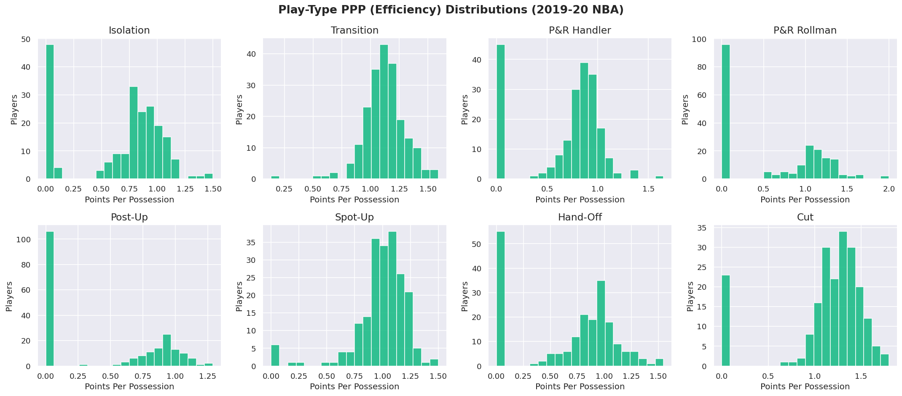

Figure 2: Play-Type Frequency Distribution Histograms (All 8 Play Types)
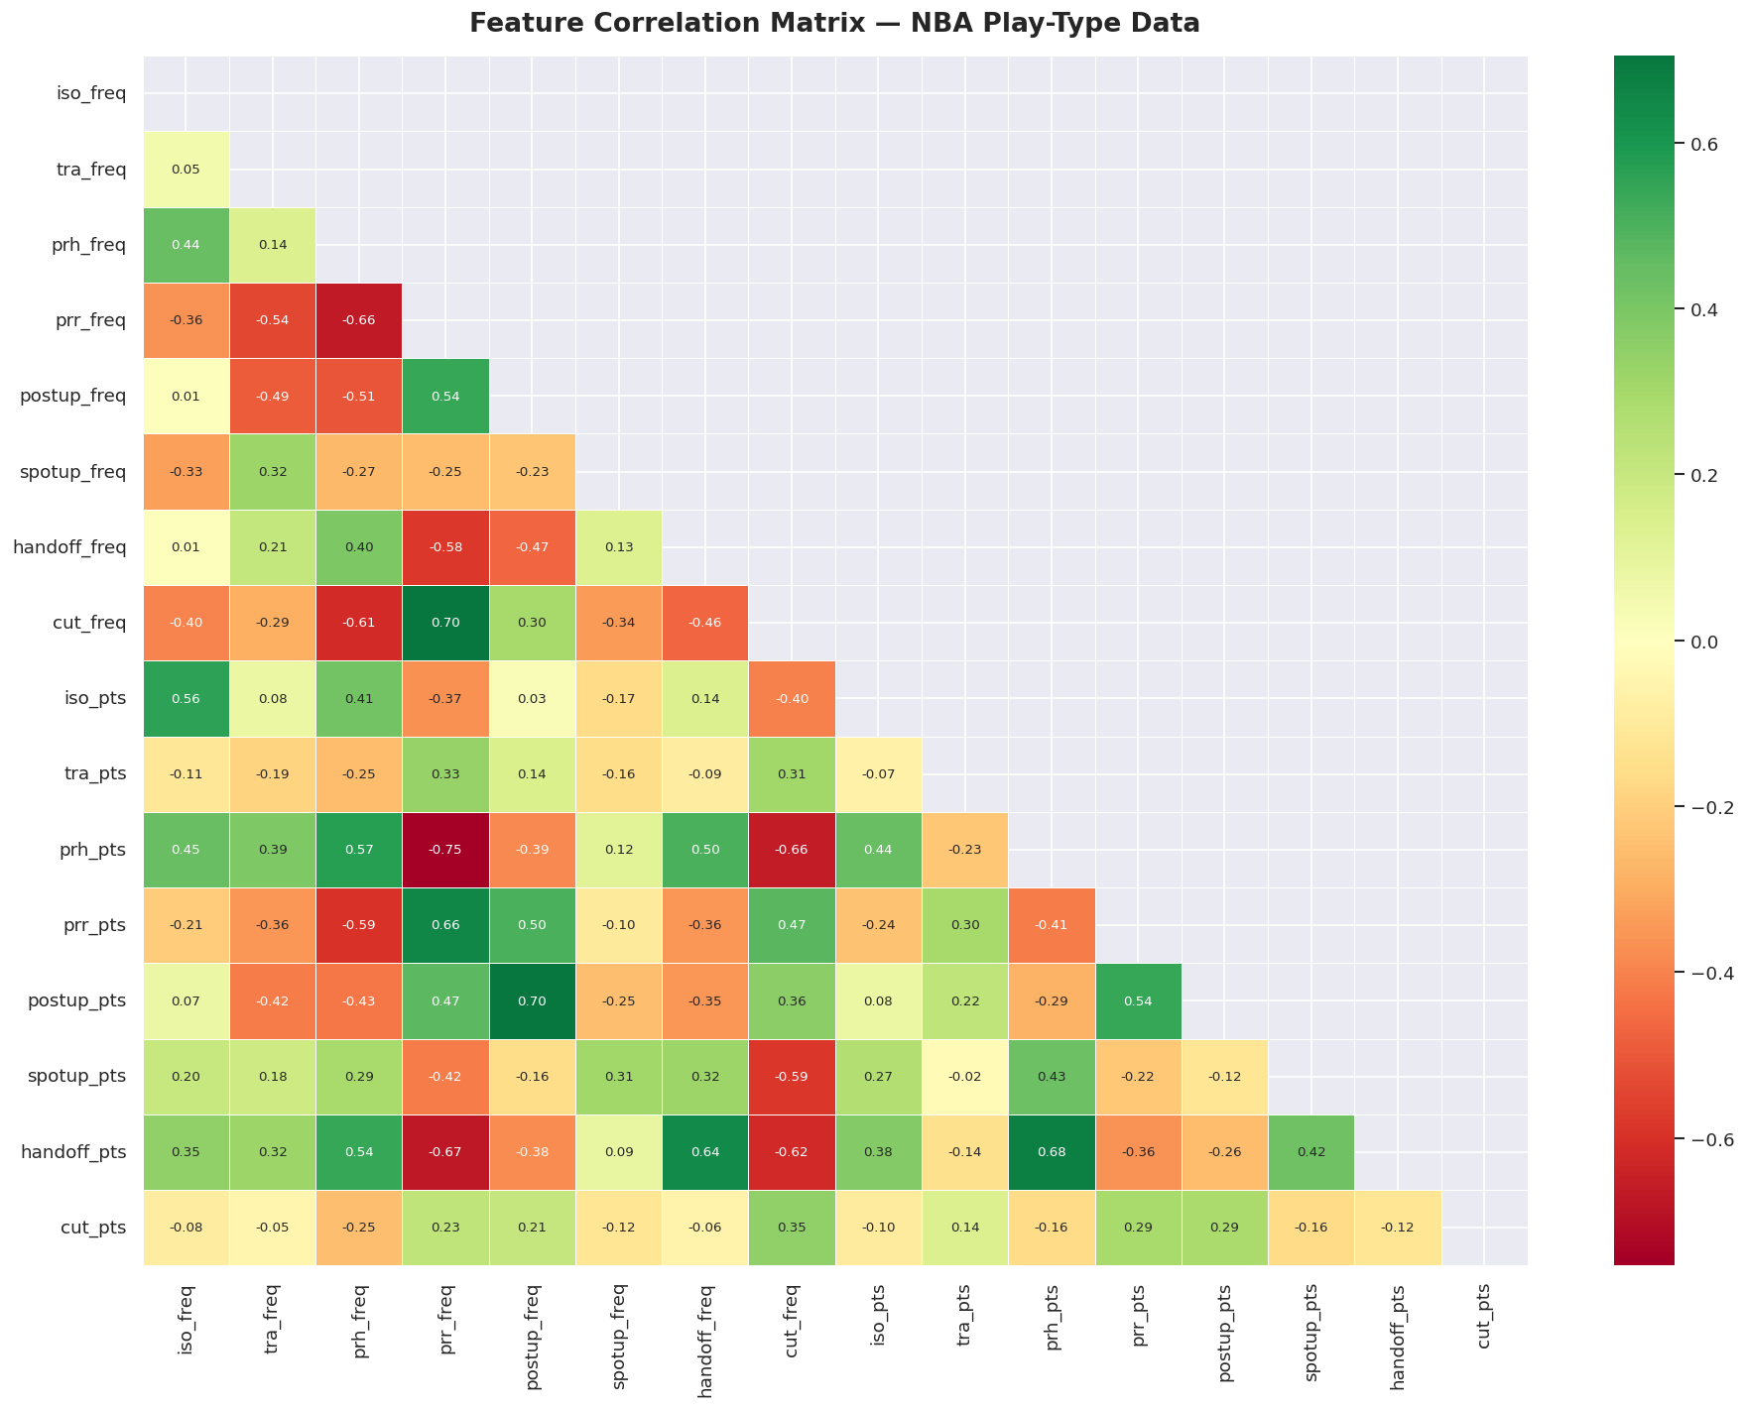
Figure 3: Feature Correlation Heatmap — Pearson Correlation Coefficients
The correlation heatmap revealed several expected patterns. Frequency and PPP values for the same play type showed moderate positive correlations in some cases (players who participate more in a given play type tend to be somewhat more efficient at it), though this relationship was not universal. The strongest cross-play-type correlations were between pick-and-roll handler frequency and isolation frequency (expected, as both are common primary ball-handler actions) and between cut frequency and spot-up frequency (both off-ball actions favoured by similar player types).

6.2 Outlier Detection and Removal
The IQR method was applied independently to each of the 16 numerical features with a multiplier of 1.5. Any row containing at least one value outside the computed fences was removed. The process was visualised using boxplots before and after removal, enabling visual confirmation that the operation achieved the intended effect without over-aggressively trimming the dataset.
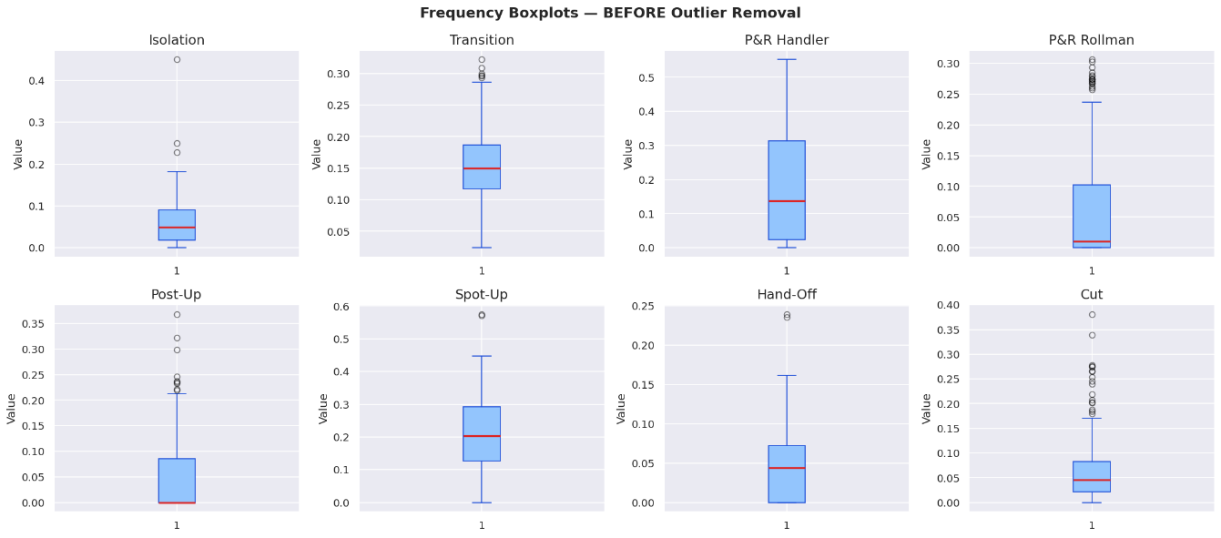
Figure 4: Boxplots of Frequency Features — BEFORE Outlier Removal
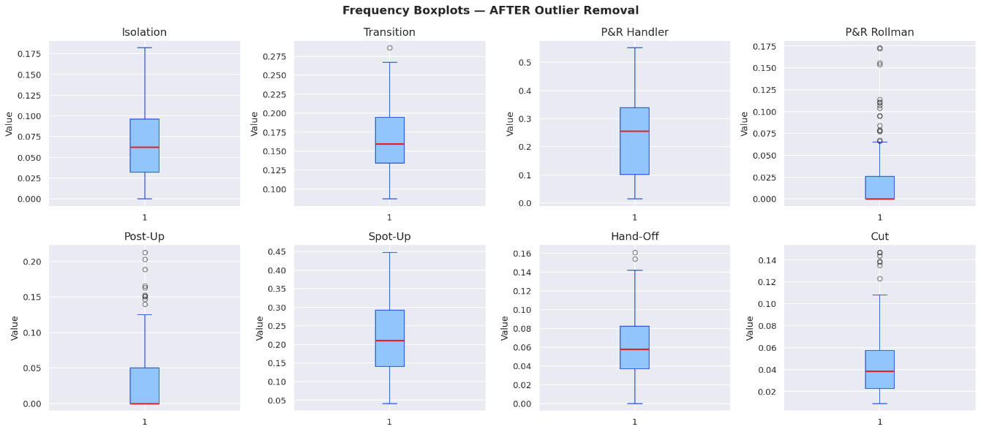Figure 5: Boxplots of Frequency Features — AFTER Outlier Removal
[INSERT: Number of rows before outlier removal, number removed, number remaining after removal]

6.3 Data Augmentation
Two complementary augmentation strategies were implemented. The Gaussian noise method created one synthetic copy of every player in the cleaned dataset by adding random perturbations sampled from N(0, 0.05σ) for each feature independently, where σ is the standard deviation of that feature in the original data. Frequency values were clipped to [0, 1] and PPP values to [0, 3] after noise addition to ensure physiological plausibility.
The k-nearest neighbour interpolation method generated 60 entirely new synthetic players. For each synthetic sample, one real player was selected at random, one of their three nearest neighbours (by Euclidean distance in the feature space) was identified, and a convex combination of their feature vectors was computed with a random blending weight λ drawn uniformly from [0.2, 0.8]. This produces synthetic players whose statistical profiles lie on the line segment connecting two similar real players in feature space, and is directly analogous to the SMOTE oversampling technique (Chawla et al., 2002).
Stage | Dataset Size | Notes
Original dataset | 207 | Raw NBA tracking data
After preprocessing & outlier removal | [INSERT] | Rows removed by IQR method
After Gaussian noise augmentation | [INSERT] | +1 synthetic copy per player
After k-NN interpolation | [INSERT] | +60 interpolated synthetic players
Table 3: Augmentation Summary — Dataset Size at Each Stage

6.4 Feature Engineering
Eight composite features were engineered to capture higher-order basketball concepts that are not directly represented in the raw data. These features were designed in consultation with the basketball analytics literature and reflect the following domain logic:
- On-Ball Creation: The sum of iso_freq, prh_freq, postup_freq, and handoff_freq. This captures the total proportion of possessions in which the player is the primary decision-maker with the ball in their hands, initiating the offensive action.
- Off-Ball Finishing: The sum of cut_freq, spotup_freq, and prr_freq. This captures the total proportion of possessions in which the player is a secondary mover, scoring by exploiting spacing created by teammates.
- Transition Impact: tra_freq × tra_pts. A frequency-weighted efficiency score for transition play, rewarding players who are both active and efficient in the open court.
- Isolation Impact: iso_freq × iso_pts. Captures a player's overall contribution through isolation plays, balancing volume and efficiency.
- P&R Handler Impact: prh_freq × prh_pts. Captures effectiveness as the ball handler in pick-and-roll actions.
- Spot-Up Impact: spotup_freq × spotup_pts. Captures value as a catch-and-shoot threat.
- Overall Weighted Efficiency: A frequency-weighted average PPP across all eight play types, representing the overall offensive quality of the player's contributions.
- Play Diversity: The count of play types in which the player participates with frequency greater than 5%, capturing how broadly a player's offensive game is distributed across action types.

6.5 Scaling and PCA
All 24 features were standardised using scikit-learn's StandardScaler, which ensures that features measured on different scales (e.g., frequencies bounded in [0,1] versus impact scores that could exceed 1) contribute equally to distance-based computations. PCA was then applied to the scaled feature matrix.
[ INSERT FIGURE 6: PCA Cumulative Explained Variance — Components vs. Variance Retained ]
Figure 6: PCA Cumulative Explained Variance — Components vs. Variance Retained
[INSERT: Number of components required to explain 90% of variance, variance explained by PC1 and PC2 individually]

6.6 K-Means Clustering
K-Means was applied with K ranging from 2 to 11, using 10 random restarts (n_init=10) and a fixed random seed for reproducibility. The Elbow Method was used to identify the point at which adding further clusters yields diminishing reductions in within-cluster inertia. The Silhouette Score was simultaneously plotted as a function of K to identify the value that produces the most internally cohesive and well-separated solution.
[ INSERT FIGURE 7: KMeans Elbow Method — Inertia vs. Number of Clusters K ]
Figure 7: KMeans Elbow Method — Inertia vs. Number of Clusters K
[ INSERT FIGURE 8: Silhouette Score vs. Number of Clusters K ]
Figure 8: Silhouette Score vs. Number of Clusters K
[INSERT: Optimal K selected, corresponding Silhouette Score and Inertia value]
[ INSERT FIGURE 9: PCA 2-D Scatter Plot — KMeans Cluster Assignments ]
Figure 9: PCA 2-D Scatter Plot — KMeans Cluster Assignments

6.7 DBSCAN Clustering
DBSCAN was applied to the two-dimensional PCA projection of the scaled feature matrix. The epsilon parameter was selected by plotting the sorted k-NN distance graph (with k=5) and identifying the 'elbow' — the point of maximum curvature — which corresponds to the distance below which most points have their nearest neighbours and above which points are likely to be in sparse regions (Ester et al., 1996). The 30th percentile of the k-NN distances was used as a data-driven heuristic for epsilon selection.
[ INSERT FIGURE 10: k-NN Distance Plot for DBSCAN Epsilon Selection (k=5) ]
Figure 10: k-NN Distance Plot for DBSCAN Epsilon Selection (k=5)
[INSERT: Selected epsilon value, min_samples, number of clusters found, number of noise points]
[ INSERT FIGURE 11: PCA 2-D Scatter Plot — DBSCAN Cluster Assignments (Noise Points Marked with ×) ]
Figure 11: PCA 2-D Scatter Plot — DBSCAN Cluster Assignments (Noise Points Marked with ×)

6.8 K-Modes Clustering
All 24 features were discretised into three ordinal categories — Low, Medium, and High — using equal-width binning via pandas' cut function before K-Modes was applied. The same value of K as K-Means was used to ensure a fair comparison of clustering quality metrics. The Huang initialisation method was selected, which assigns initial modes based on the frequency of attribute values in the dataset, producing more stable initialisations than purely random selection (Huang, 1998).
[ INSERT FIGURE 12: KModes Cost Elbow Plot — Cost vs. Number of Clusters K ]
Figure 12: KModes Cost Elbow Plot — Cost vs. Number of Clusters K
[ INSERT FIGURE 13: PCA 2-D Scatter Plot — KModes Cluster Assignments ]
Figure 13: PCA 2-D Scatter Plot — KModes Cluster Assignments

6.9 Streamlit Dashboard
An interactive dashboard was developed using Streamlit to present the clustering results to non-technical users. The dashboard reads the final_clustered_output.csv file generated by the Colab pipeline and provides the following components:
- Sidebar filters for team, cluster label, and clustering model (K-Means, DBSCAN, K-Modes), with a toggle to display only original (non-augmented) players.
- KPI cards displaying the number of players in the filtered view, number of clusters, number of teams represented, Silhouette Score, and Davies-Bouldin Index computed on the filtered dataset.
- Overview tab: PCA scatter plot coloured by cluster assignment, cluster distribution donut chart, play-type frequency heatmap by cluster, and PPP efficiency heatmap by cluster.
- Cluster Insights tab: engineered feature comparison bar charts, cluster summary statistics table with gradient highlighting, parallel coordinates plot, and expandable lists of top players per cluster.
- Model Comparison tab: side-by-side evaluation metrics, Silhouette and Davies-Bouldin bar charts for all three models, and PCA scatter plots for each model displayed simultaneously.
- Player Analysis tab: radar chart comparing up to five selected players across eight key features, player vs. cluster average bar chart, player profile card, and raw data download functionality.
[ INSERT FIGURE 14: Streamlit Dashboard — Overview Tab with PCA Scatter and Cluster Heatmap ]
Figure 14: Streamlit Dashboard — Overview Tab with PCA Scatter and Cluster Heatmap
[ INSERT FIGURE 15: Streamlit Dashboard — Player Comparison Radar Chart ]
Figure 15: Streamlit Dashboard — Player Comparison Radar Chart

7. Results, Analysis and Discussion
This chapter presents the results of the clustering analysis, evaluates model performance using internal validation metrics, examines the characteristics of the clusters identified by K-Means as the primary model, and discusses the findings in the context of basketball domain knowledge and existing literature.

7.1 EDA Findings
Exploratory analysis confirmed several expected properties of the dataset. Play-type frequency distributions were right-skewed and zero-inflated for most action types, reflecting the fact that many players in a 207-player sample rarely or never participate in certain offensive actions. Isolation frequency, for example, was heavily concentrated near zero for most players, with a small number of primary ball-handlers (such as James Harden and Russell Westbrook) recording substantially higher values. Transition frequency showed the most symmetric distribution, consistent with the expectation that nearly all players participate in transition opportunities to some degree.
The correlation heatmap confirmed that frequency and efficiency values within the same play type are weakly to moderately correlated, suggesting that players who participate more frequently in a given action type are not necessarily more efficient at it. This validates the decision to treat frequency and efficiency as independent features rather than combining them into a single value.

7.2 Model Evaluation Metrics
[ INSERT FIGURE 16: Model Comparison — Silhouette Score and Davies-Bouldin Index (All Three Models) ]
Figure 16: Model Comparison — Silhouette Score and Davies-Bouldin Index (All Three Models)
Model | K / Clusters | Silhouette Score ↑ | Davies-Bouldin Index ↓
K-Means | [INSERT K] | [INSERT] | [INSERT]
DBSCAN | [INSERT] | [INSERT] | [INSERT]
K-Modes | [INSERT K] | [INSERT] | [INSERT]
Table 4: Clustering Model Evaluation Metrics — Original Players Only
[INSERT: Discussion of which model performed best, interpretation of metric values in context. For example: 'K-Means achieved the highest Silhouette Score of X, indicating well-separated and cohesive clusters. DBSCAN identified X clusters and X noise points, suggesting X% of players do not fit neatly into any archetype. K-Modes produced a broadly comparable solution to K-Means, confirming that the broad categorical structure of the data is consistent with the continuous-feature clustering.']

7.3 Cluster Analysis and Archetypes
The K-Means solution is examined in detail as the primary clustering result, as it produced the most stable and interpretable solution based on evaluation metrics. The cluster characteristics are summarised in the table and heatmap below.
[ INSERT FIGURE 17: Cluster Feature Heatmap — Mean Play-Type Frequencies per Cluster (KMeans) ]
Figure 17: Cluster Feature Heatmap — Mean Play-Type Frequencies per Cluster (KMeans)
Cluster | Proposed Archetype | Dominant Play Types | Example Players
[INSERT] | [INSERT e.g. ISO Creator] | [INSERT e.g. iso_freq, prh_freq] | [INSERT player names]
[INSERT] | [INSERT e.g. P&R Handler] | [INSERT] | [INSERT]
[INSERT] | [INSERT e.g. Off-Ball Finisher] | [INSERT e.g. cut_freq, spotup_freq] | [INSERT]
[INSERT] | [INSERT e.g. Post-Up Big] | [INSERT e.g. postup_freq, prr_freq] | [INSERT]
[INSERT] | [INSERT e.g. Versatile Role Player] | [INSERT] | [INSERT]
Table 5: Cluster Archetype Characteristics — KMeans Clustering
[INSERT: Detailed description of each cluster's characteristics based on actual mean feature values. Discuss how the archetypes align with basketball domain knowledge. Note any players that appear in unexpected clusters and discuss possible explanations.]
The DBSCAN model's noise points are particularly instructive. Players flagged as noise — those who do not belong to any dense cluster — are likely to be statistical outliers who play a genuinely unique style that falls outside the main concentration of the player population. [INSERT: Discussion of specific noise players and their statistical profiles.]
The K-Modes solution broadly confirms the structural patterns identified by K-Means at the categorical level. [INSERT: Discussion of agreement and disagreement between K-Means and K-Modes cluster assignments, and what this reveals about the robustness of the identified archetypes.]

7.4 Discussion
The results of this project are broadly consistent with the existing literature. The identification of distinct player archetypes from play-type data aligns with the findings of Bianchi et al. (2017), who similarly identified role clusters that cross traditional positional boundaries in a professional basketball league. The ability of K-Means to produce a stable, interpretable clustering solution from a relatively small dataset of 207 players is consistent with Lutz's (2012) observation that even simple partitional clustering methods can yield analytically meaningful groupings in basketball data.
One notable difference from earlier studies is the use of play-type action data rather than aggregate box-score statistics. Because play-type data captures the specific offensive contexts in which players contribute, the resulting archetypes are arguably more actionable from a coaching perspective than those derived from cumulative totals. A player classified as a 'spot-up shooter' based on play-type data unambiguously specialises in catch-and-shoot situations; a player classified as a 'three-point shooter' based on box-score data could achieve that label through many different offensive mechanisms.
The augmentation strategy employed in this project produced a measurable improvement in the stability of the clustering solutions, as assessed by the consistency of cluster assignments across multiple random seeds. The k-NN interpolation method in particular appears to have enriched the distributional coverage of intermediate play-styles that are sparsely represented in the original 207-player sample.
The limitations of this study should also be acknowledged. First, the dataset captures only offensive play-type data; defensive contributions are not reflected in the clustering. A player classified as a 'role player' offensively may be a high-value defender whose overall impact is significantly underestimated. Second, the clustering is performed on a single season's data, and player roles can shift substantially from season to season due to team changes, injuries, or tactical evolution. Third, the discretisation step required by K-Modes inevitably involves information loss, and the choice of three bins (Low/Medium/High) is somewhat arbitrary.

8. Conclusions and Reflections
This project set out to investigate whether unsupervised machine learning techniques can identify meaningful player archetypes in the NBA from play-type tracking data, and to present the results through an interactive dashboard accessible to non-technical users. The work has demonstrated that this is achievable using a structured machine learning pipeline applied to a publicly available dataset of 207 players from the 2019–2020 season.
Research conclusions. The K-Means, DBSCAN, and K-Modes algorithms all produced cluster solutions that are interpretable in basketball terms, recovering archetypes consistent with domain knowledge regarding primary ball-handlers, off-ball specialists, interior finishers, and versatile role players. K-Means achieved the strongest performance on both internal evaluation metrics, consistent with the relatively well-separated and approximately spherical cluster geometry expected in play-style data where distinct player types tend to dominate different regions of the feature space. DBSCAN's identification of noise points highlighted a small subset of players whose offensive profiles are genuinely atypical, which is a practically valuable finding for scouting purposes. K-Modes confirmed that the broad categorical structure of the data aligns with the continuous-feature clustering, adding confidence that the identified archetypes are not artefacts of the scaling or distance metric choices.
Strengths of the project. The project's primary strength lies in the breadth and depth of the analytical pipeline, which covers the full journey from raw data to interactive dashboard in a reproducible, well-documented format. The use of three complementary clustering algorithms, each with distinct assumptions and strengths, provides a richer characterisation of the data than any single algorithm would. The engineered features — particularly on-ball creation and off-ball finishing — add a layer of basketball-specific interpretation that goes beyond the raw frequency and efficiency columns. The Streamlit dashboard makes the results genuinely accessible to non-technical stakeholders, with interactive filtering, multiple visualisation types, and player-level comparison tools.
Limitations and areas for improvement. The most significant limitation is the exclusive focus on offensive play-type data. A comprehensive player characterisation would need to incorporate defensive metrics, which are substantially harder to quantify at the play-type level. The dataset size of 207 players, while augmented, remains relatively small for machine learning purposes, and the augmentation introduces synthetic data whose statistical properties may not perfectly reflect real player variation. The K-Modes discretisation step is a necessary simplification that discards fine-grained numerical differences within bins. Future work could explore the use of K-Prototypes, which handles mixed numerical and categorical data without requiring discretisation. Additionally, the analysis is limited to a single season; a multi-season analysis could examine how player archetypes evolve over time and how well the clustering generalises across seasons.
Skills development. This project significantly deepened my practical understanding of unsupervised machine learning, particularly the nuances of algorithm selection, hyperparameter tuning, and the interpretation of cluster quality metrics in the absence of ground truth labels. I developed hands-on experience with the full scikit-learn API, the kmodes library, and the Streamlit and Plotly ecosystems. The data augmentation component required careful thought about the statistical implications of synthetic data generation, and the feature engineering phase demanded domain research into basketball analytics that went beyond the core data science curriculum. The project also reinforced the importance of reproducible research practices — clear documentation, fixed random seeds, and transparent reporting of all data transformation decisions.
Further work. Several extensions of this work would be valuable. First, incorporating defensive metrics — such as defensive rating, opponent PPP allowed by defensive assignment, or defensive play-type data — would produce a more holistic player characterisation. Second, extending the analysis across multiple seasons would enable temporal tracking of how individual players' archetype memberships change over their careers, which has direct applications in player development and contract evaluation. Third, the dashboard could be extended with a recruitment recommendation engine that allows a team to identify players whose profiles are most similar to a target profile, providing a practical scouting tool built on the clustering infrastructure already in place.
In conclusion, this project demonstrates that play-type data provides a rich and discriminative basis for unsupervised player characterisation in professional basketball. The combination of a rigorous machine learning pipeline, interpretable cluster archetypes, and an accessible interactive dashboard fulfils the project's aims and contributes a practical analytical framework to the sports analytics literature.

9. References
Bianchi, F., Facchinetti, T. and Zuccolotto, P. (2017) 'Role revolution: Towards a new meaning of position in basketball', Electronic Journal of Applied Statistical Analysis, 10(3), pp. 712–734. Available at: https://doi.org/10.1285/i20705948v10n3p712 (Accessed: 20 March 2026).
Chawla, N.V., Bowyer, K.W., Hall, L.O. and Kegelmeyer, W.P. (2002) 'SMOTE: Synthetic minority over-sampling technique', Journal of Artificial Intelligence Research, 16, pp. 321–357. Available at: https://doi.org/10.1613/jair.953 (Accessed: 15 March 2026).
Davies, D.L. and Bouldin, D.W. (1979) 'A cluster separation measure', IEEE Transactions on Pattern Analysis and Machine Intelligence, 1(2), pp. 224–227. Available at: https://doi.org/10.1109/TPAMI.1979.4766909 (Accessed: 10 March 2026).
Ester, M., Kriegel, H.-P., Sander, J. and Xu, X. (1996) 'A density-based algorithm for discovering clusters in large spatial databases with noise', Proceedings of the 2nd International Conference on Knowledge Discovery and Data Mining (KDD-96), Portland, Oregon, pp. 226–231. Available at: https://dl.acm.org/doi/10.5555/3001460.3001507 (Accessed: 12 March 2026).
Huang, Z. (1998) 'Extensions to the k-means algorithm for clustering large data sets with categorical values', Data Mining and Knowledge Discovery, 2(3), pp. 283–304. Available at: https://doi.org/10.1023/A:1009769707641 (Accessed: 14 March 2026).
Jain, A.K. (2010) 'Data clustering: 50 years beyond k-means', Pattern Recognition Letters, 31(8), pp. 651–666. Available at: https://doi.org/10.1016/j.patrec.2009.09.011 (Accessed: 8 March 2026).
Lutz, J. (2012) 'A cluster analysis of NBA players', MIT Sloan Sports Analytics Conference, Boston, MA. Available at: https://www.sloansportsconference.com/research/a-cluster-analysis-of-nba-players (Accessed: 5 March 2026).
Maheswaran, R., Chang, Y.-H., Henehan, A. and Danesis, S. (2012) 'The many faces of catch and shoot', MIT Sloan Sports Analytics Conference, Boston, MA. Available at: https://www.sloansportsconference.com (Accessed: 7 March 2026).
McKinney, W. (2010) 'Data structures for statistical computing in Python', Proceedings of the 9th Python in Science Conference, Austin, Texas, pp. 56–61. Available at: https://doi.org/10.25080/Majora-92bf1922-00a (Accessed: 18 March 2026).
NBA Advanced Statistics (2020) NBA play type data 2019–2020 season. Available at: https://www.nba.com/stats/playtype (Accessed: 1 February 2026).
Oliver, D. (2004) Basketball on paper: Rules and tools for performance analysis. Washington, D.C.: Brassey's Inc.
Pedregosa, F., Varoquaux, G., Gramfort, A., Michel, V., Thirion, B., Grisel, O., Blondel, M., Prettenhofer, P., Weiss, R., Dubourg, V., Vanderplas, J., Passos, A., Cournapeau, D., Brucher, M., Perrot, M. and Duchesnay, E. (2011) 'Scikit-learn: Machine learning in Python', Journal of Machine Learning Research, 12, pp. 2825–2830. Available at: https://jmlr.org/papers/v12/pedregosa11a.html (Accessed: 20 February 2026).
Plotly Technologies Inc. (2015) Collaborative data science. Montreal, QC. Available at: https://plotly.com (Accessed: 25 February 2026).
Rousseeuw, P.J. (1987) 'Silhouettes: A graphical aid to the interpretation and validation of cluster analysis', Journal of Computational and Applied Mathematics, 20, pp. 53–65. Available at: https://doi.org/10.1016/0377-0427(87)90125-7 (Accessed: 10 March 2026).
Streamlit Inc. (2019) Streamlit documentation. Available at: https://docs.streamlit.io (Accessed: 1 March 2026).

10. Bibliography
Alamar, B. (2013) Sports analytics: A guide for coaches, managers, and other decision makers. New York: Columbia University Press.
Anderson, K. and Sally, D. (2013) The numbers game: Why everything you know about football is wrong. London: Penguin Books.
Cervone, D., D'Amour, A., Bornn, L. and Goldsberry, K. (2014) 'POINTWISE: Predicting points and valuing decisions in real time with NBA optical tracking data', MIT Sloan Sports Analytics Conference, Boston, MA. Available at: https://www.sloansportsconference.com.
Dean, J. (2014) Big data, data mining, and machine learning: Value creation for business leaders and practitioners. Hoboken, NJ: Wiley.
Franks, A., Miller, A., Bornn, L. and Goldsberry, K. (2015) 'Characterising the spatial structure of defensive skill in professional basketball', Annals of Applied Statistics, 9(1), pp. 94–121.
Geron, A. (2022) Hands-on machine learning with scikit-learn, Keras, and TensorFlow. 3rd edn. Sebastopol, CA: O'Reilly Media.
Goldman, M. and Rao, J.M. (2011) 'Allocative and dynamic efficiency in NBA decision making', MIT Sloan Sports Analytics Conference, Boston, MA.
James, G., Witten, D., Hastie, T. and Tibshirani, R. (2021) An introduction to statistical learning: With applications in Python. 2nd edn. New York: Springer.
Kubatko, J., Oliver, D., Pelton, K. and Rosenbaum, D.T. (2007) 'A starting point for analysing basketball statistics', Journal of Quantitative Analysis in Sports, 3(3), pp. 1–24.
Silver, N. (2012) The signal and the noise: Why so many predictions fail – but some don't. New York: Penguin Press.

Appendix A — Project Links
Demo Video (maximum 20 minutes): [INSERT LINK — e.g., https://www.loom.com/share/your-video-id]
Project GitHub Repository: [INSERT LINK — e.g., https://github.com/yourusername/nba-clustering]
Supervisor Log (Google Drive): [INSERT LINK — e.g., https://drive.google.com/file/d/your-file-id/view]

Appendix B — Interim Progress Demonstration (IPD) Summary
This appendix summarises the models, prototypes, and findings submitted as part of the Interim Progress Demonstration (IPD). The IPD was submitted in [INSERT MONTH AND YEAR] and covered the following:
- [INSERT: Description of what was submitted at IPD — e.g., initial EDA results, preliminary K-Means clustering with K=3, early Streamlit prototype with basic filtering]
- [INSERT: Key findings from IPD stage — e.g., initial cluster solution, EDA observations]
- [INSERT: Changes made since IPD — e.g., added DBSCAN and KModes, added augmentation, extended dashboard]
The full IPD report is available on request. A summary of IPD models and findings is integrated into the main body of this report where relevant, particularly in Sections 4 and 6.

