6DATA007W – Final Project Report
NBA Player Archetype Identification Using Unsupervised Machine Learning:
A Play-Type Analysis of the 2019–2020 NBA Season
Student: [Your Full Name] ([Student Number])
Supervisor: [Supervisor Full Name]
This report is submitted in partial fulfillment of the requirements for the
BSc (Hons) Data Science and Analytics
at the University of Westminster
School of Computer Science & Engineering
University of Westminster
April 2026

Declaration
This report has been prepared based on my own work. Where other published and unpublished source materials have been used, these have been acknowledged in references.

Word Count: [Insert final word count here]
Student Name: [Your Full Name]
Date of Submission: [Date]

Use of Generative AI
In this assessment, I used Claude (Anthropic) to assist with the initial structuring of code comments, proofreading sections of written text, and generating boilerplate documentation. All analytical decisions, model selection, implementation, interpretation of results, and written arguments are my own. The AI was not used to generate original research conclusions or to produce academic content that I present as independently authored without acknowledgement.

Abstract
The growing volume of performance data captured in professional basketball offers a significant opportunity to move beyond conventional positional labels and explore more nuanced characterisations of how players actually contribute on the court. This project investigates whether unsupervised machine learning techniques can effectively identify meaningful player archetypes in the National Basketball Association (NBA) using granular play-type data from the 2019–2020 season.
The dataset used in this study consists of 207 NBA players, each described by 16 features drawn from NBA Advanced Statistics. These features capture both the frequency with which a player participates in eight distinct play types — isolation, transition, pick-and-roll ball handler, pick-and-roll rollman, post-up, spot-up, hand-off, and cut — and the corresponding points-per-possession (PPP) efficiency for each action type. The data contained no missing numerical values and required no imputation beyond filling a single missing team identifier.
The methodology followed a structured machine learning pipeline. Raw data was cleaned, column names were standardised, and the dataset was inspected for invalid values — none were found. Outlier detection using the interquartile range (IQR) method with a multiplier of 1.5 identified 87 outlier rows, reducing the dataset from 207 to 120 clean observations. The dataset was then augmented using two techniques: Gaussian noise injection (producing 120 synthetic copies of existing players, for a total of 240 observations) and k-nearest neighbour interpolation (adding 60 synthetic players, bringing the total to 300 observations). Eight engineered features were derived to capture higher-order concepts including on-ball creation, off-ball finishing, and overall weighted efficiency. All features were scaled using StandardScaler before dimensionality reduction with Principal Component Analysis (PCA), which required 11 components to explain 90% of the variance, with the first two components explaining 31.75% and 19.79% respectively.
Three clustering models were trained and evaluated: K-Means with K = 3 (selected via the Silhouette elbow method), DBSCAN with epsilon = 0.32 and min_samples = 5 (applied to the two-dimensional PCA projection), and K-Modes with K = 3 applied to discretised categorical features. K-Means achieved the strongest internal validation metrics with a Silhouette Score of 0.2224 and a Davies-Bouldin Index of 1.5879. DBSCAN, operating on the 2-D PCA space, identified 16 micro-clusters and flagged 178 points as noise, yielding a Silhouette Score of 0.0031 — reflecting the highly uniform density of professional NBA player data in reduced space.
The K-Means solution identified three interpretable player archetypes. Cluster 0 (65 original players, including Damian Lillard, LeBron James, and Luka Doncic) represents primary ball-handlers characterised by high pick-and-roll handler frequency (mean = 0.341) and the highest on-ball creation score (mean = 0.519). Cluster 1 (33 players, including OG Anunoby and Kyle Kuzma) represents off-ball shooters with the highest spot-up frequency (mean = 0.318) and overall efficiency (mean = 1.017 PPP). Cluster 2 (22 players, including Giannis Antetokounmpo and Montrezl Harrell) represents versatile interior players characterised by the highest play diversity (mean = 5.73 play types), post-up involvement (mean = 0.127), and rollman frequency (mean = 0.089).
An interactive Streamlit dashboard was developed to present these results to non-technical stakeholders, supporting team and cluster filtering, PCA scatter plots, cluster heatmaps, parallel coordinates visualisation, and a player radar comparison tool.
This project demonstrates that play-type data provides a sufficient and discriminative basis for identifying meaningful NBA player archetypes through unsupervised learning. The findings are practically relevant to coaching analysis, player recruitment, and tactical planning.

Acknowledgements
I would like to express my sincere gratitude to my project supervisor, [Supervisor Name], for their continued guidance, constructive feedback, and encouragement throughout the development of this project. Their expertise in data science and machine learning has been invaluable in shaping both the technical direction and academic rigour of this work.
I would also like to thank the University of Westminster's School of Computer Science and Engineering for providing the resources and academic environment that made this project possible. Finally, I am grateful to the NBA and Second Spectrum for making granular play-type tracking data publicly accessible, without which this analysis could not have been conducted.

Table of Contents
Contents
Declaration 2
Use of Generative AI 3
Abstract 4
Acknowledgements 6
Table of Contents 7
List of Figures 8
List of Tables 9
1. Introduction 10
1.1 Problem Statement 10
1.2 Aims and Objectives 11
2. Background 13
2.1 Literature Review 13
2.2 Review of Methods and Applications 15
2.3 Review of Tools 15
3. Legal, Ethical, Sustainability and Other Considerations 17
4. Methodology 19
4.1 Data 19
4.2 Methods 20
5. Tools 22
6. Model Development 23
6.1 Data Preprocessing and EDA 23
6.2 Outlier Detection and Removal 24
6.3 Data Augmentation 26
6.4 Feature Engineering 26
6.5 Scaling and PCA 27
6.6 K-Means Clustering 28
6.7 DBSCAN Clustering 29
6.8 K-Modes Clustering 31
6.9 Streamlit Dashboard 32
7. Results, Analysis and Discussion 34
7.1 EDA Findings 34
7.2 Model Evaluation Metrics 34
34
7.3 Cluster Analysis and Archetypes 35
7.4 Discussion 37
8. Conclusions and Reflections 39
9. References 41
10. Bibliography 43
Appendix A — Project Links 44
Appendix B — Interim Progress Demonstration (IPD) Summary 45

List of Figures
Figure 1: End-to-End Machine Learning Pipeline Flowchart
Figure 2: Play-Type Frequency Distribution Histograms (All 8 Play Types)
Figure 3: Play-Type PPP (Efficiency) Distribution Histograms
Figure 4: Feature Correlation Heatmap — Pearson Correlation Coefficients
Figure 5: Boxplots of Frequency Features — Before Outlier Removal
Figure 6: Boxplots of Frequency Features — After Outlier Removal
Figure 7: PCA Cumulative Explained Variance — Components vs. Variance Retained
Figure 8: KMeans Elbow Method — Inertia vs. K and Silhouette Score vs. K
Figure 9: PCA Scatter Plot — KMeans Clusters (K = 3)
Figure 10: k-NN Distance Plot for DBSCAN Epsilon Selection (k = 5)
Figure 11: PCA Scatter Plot — DBSCAN Clusters
Figure 12: KModes Cost Elbow Plot — Cost vs. K
Figure 13: PCA Scatter Plot — KModes Clusters (K = 3)
Figure 14: Model Comparison Bar Charts (Silhouette Score and Davies-Bouldin Index)
Figure 15: Cluster Feature Heatmap — Mean Play-Type Frequencies per KMeans Cluster
Figure 16: Streamlit Dashboard — Overview Tab
Figure 17: Streamlit Dashboard — Player Comparison Radar Chart

List of Tables
Table 1: Literature Review Summary
Table 2: Dataset Feature Descriptions
Table 3: Outlier Removal Report — IQR Method (Multiplier = 1.5)
Table 4: Augmentation Summary — Dataset Size at Each Stage
Table 5: Clustering Model Evaluation Metrics
Table 6: KMeans Silhouette Scores by K (K = 2 to 11)
Table 7: Cluster Archetype Characteristics — KMeans (K = 3)

1. Introduction
Professional basketball has undergone a significant analytical transformation over the past two decades. The introduction of optical player tracking systems and the subsequent availability of granular performance metrics have enabled researchers, coaches, and front offices to interrogate player behaviour at a level of detail that was previously unattainable. However, much of the public discourse around player evaluation continues to rely on broad positional categories — point guard, shooting guard, small forward, power forward, and centre — that were defined decades ago for a very different style of play (Oliver, 2004).
Modern NBA basketball has effectively rendered traditional positions secondary to functional roles. A six-foot-ten player may act as a primary ball-handler and isolation scorer, while a six-foot guard may spend the majority of their time as an off-ball cut finisher or spot-up shooter. Statistical clustering offers a principled, data-driven framework for grouping players according to how they actually play, rather than how they are labelled on a roster sheet.
This project uses play-type frequency and efficiency data from the 2019–2020 NBA season to identify player archetypes through unsupervised machine learning. Three clustering algorithms are applied and compared — K-Means, DBSCAN, and K-Modes — and the results are made accessible through an interactive Streamlit dashboard designed for non-technical users such as coaching staff and analysts.

1.1 Problem Statement
The conventional five-position classification system used in basketball has become increasingly inadequate as a descriptor of how players contribute offensively. Research from the MIT Sloan Sports Analytics Conference has consistently demonstrated that player roles in the modern NBA are far more nuanced and continuous than any discrete positional label can capture (Lutz, 2012; Bianchi et al., 2017). At the same time, the NBA's adoption of Second Spectrum's optical tracking technology has produced an unprecedented volume of contextual performance data, including the play-type breakdown that forms the basis of this study.
Play-type data categorises every offensive possession by the primary action type through which a shot or foul was generated: isolation plays, transition opportunities, pick-and-roll possessions (distinguishing between the ball handler and the rolling big man), post-up actions, spot-up jump shots, hand-off plays, and cut finishes. For each category, both the frequency (proportion of total possessions) and the points-per-possession (PPP) efficiency are recorded. This creates a rich, multidimensional profile of each player's offensive identity.
The problem this project addresses is threefold. First, can unsupervised clustering algorithms identify stable, interpretable player archetypes from this play-type data? Second, which of the three algorithms evaluated — K-Means, DBSCAN, or K-Modes — produces the most coherent and practically useful groupings as measured by internal validation metrics? Third, can these analytical outputs be presented in an accessible, interactive format that is genuinely useful to non-technical practitioners in a basketball organisation?
These questions sit at the intersection of sports analytics, unsupervised learning, and human-computer interaction — three domains that have, individually, received considerable academic attention but are rarely examined together in the context of professional basketball player characterisation using play-type data specifically.

1.2 Aims and Objectives
The overarching aim of this project is to develop a robust, interpretable unsupervised machine learning pipeline that identifies meaningful NBA player archetypes from play-type tracking data, and to present the findings through an interactive analytical dashboard.
Objectives:
- To collect, clean, and preprocess the 2019–2020 NBA play-type dataset, handling missing values, invalid entries, and inconsistent column naming.
- To conduct exploratory data analysis (EDA) through summary statistics, distribution plots, and a correlation heatmap to understand the structure of the data.
- To apply outlier detection using the IQR method, supported by visual boxplot inspection before and after removal.
- To augment the dataset using Gaussian noise injection and k-nearest neighbour interpolation, increasing the number of training samples from 120 to 300 observations.
- To engineer eight composite features capturing domain-relevant concepts including on-ball creation, off-ball finishing, and weighted offensive efficiency.
- To apply and tune three clustering algorithms — K-Means, DBSCAN, and K-Modes — using appropriate parameter selection strategies.
- To evaluate and compare models using the Silhouette Score and Davies-Bouldin Index.
- To build an interactive Streamlit dashboard with filters, visualisations, and cluster insight panels for practical analytical use.

2. Background
This chapter reviews relevant academic literature, examines existing clustering methods and their applications in sports analytics, and surveys the tools and technologies that are commonly used to develop projects of this nature.

2.1 Literature Review
The application of clustering techniques to basketball performance data has a relatively brief but substantive history. One of the earliest and most cited examples is the work of Lutz (2012), who applied K-Means clustering to a range of traditional box-score statistics from the NBA to identify player types. Lutz found that the five-cluster solution most closely approximated the traditional five-position breakdown, but noted that several players were consistently misclassified relative to their positional label — a finding that anticipated the positional fluidity that would become far more pronounced in subsequent seasons. This early work demonstrated that even relatively simple clustering techniques applied to basketball data could yield analytically meaningful groupings.
Bianchi, Facchinetti, and Zuccolotto (2017) extended this line of inquiry using data from the Italian professional league, introducing the concept of a 'role revolution' in basketball and arguing that the continuous nature of player roles makes them ill-suited to categorical positional labels. Their study applied hierarchical clustering and found that a six-cluster solution produced groupings that aligned well with practitioner intuitions while revealing gradations not captured by conventional positions. The authors emphasised that clustering based on play-type or action-type data is more theoretically grounded than clustering on aggregate box-score totals, because it reflects the mechanisms through which players generate offensive opportunities.
Maheswaran et al. (2012) examined shot selection data using spatial clustering at the MIT Sloan Sports Analytics Conference, focusing specifically on catch-and-shoot opportunities. Their work illustrated how tracking data could be used to isolate specific offensive contributions and quantify them at the player level. While not directly concerned with play-type clustering in the sense used in this project, their methodology informed subsequent approaches to role identification through action-level decomposition.
From a broader machine learning perspective, Jain (2010) provides a comprehensive review of data clustering methods, noting that K-Means remains one of the most widely used algorithms despite its sensitivity to initialisation and its assumption of spherical cluster geometry. Jain's review situates the algorithm within the broader taxonomy of partitional, hierarchical, density-based, and model-based approaches — a taxonomy that directly informs the model selection in this project. Jain (2010) also identifies the evaluation of clustering quality as one of the most challenging open problems in unsupervised learning, a point that is particularly pertinent when applying these methods to sports data where ground truth labels are absent.
Huang (1998) proposed the K-Modes algorithm as an extension of K-Means designed specifically for categorical data, replacing Euclidean distance with a simple matching dissimilarity measure. While play-type data is inherently numerical, the discretisation of continuous features into ordinal categories before applying K-Modes is a recognised strategy when the analyst wishes to capture qualitative rather than quantitative differences between groups. Rousseeuw (1987) introduced the Silhouette Score, providing a measure of how similar each data point is to its own cluster compared to the nearest neighbouring cluster, and Davies and Bouldin (1979) proposed a complementary separation measure. Both are model-agnostic, require no ground truth labels, and are the standard choice for evaluating unsupervised clustering.
Study | Methods | Dataset | Key Insights
Lutz (2012) | K-Means | NBA box-score statistics | 5-cluster solution approximates positions; players frequently misclassified by label
Bianchi et al. (2017) | Hierarchical Clustering | Italian league play data | 'Role revolution' concept; 6-cluster solution reveals position fluidity
Maheswaran et al. (2012) | Spatial Clustering | NBA optical tracking data | Spatial decomposition of catch-and-shoot opportunities
Jain (2010) | K-Means review | Multiple benchmark datasets | K-Means limitations: spherical assumption, initialisation sensitivity
Huang (1998) | K-Modes | Customer / healthcare datasets | Categorical clustering via matching dissimilarity; extends K-Means framework
Rousseeuw (1987) | Silhouette Analysis | Synthetic and real datasets | Graphical cluster validation; Silhouette Score range −1 to +1
Table 1: Literature Review Summary — Clustering Methods in Basketball Analytics

2.2 Review of Methods and Applications
K-Means Clustering. K-Means is a partitional algorithm that assigns each data point to one of K clusters by minimising the total within-cluster sum of squared distances from each point to its cluster centroid (Jain, 2010). The algorithm iterates between an assignment step and an update step until convergence. Its principal advantage is computational efficiency; for datasets of the size used in this project, K-Means typically converges within seconds. Its main limitation is the assumption of spherical, equally-sized clusters. K-Means is also sensitive to the choice of K and to the initial placement of centroids, both of which are addressed in this project through the Elbow Method and multiple random restarts respectively.
DBSCAN (Density-Based Spatial Clustering of Applications with Noise). DBSCAN, proposed by Ester et al. (1996), identifies clusters as dense regions of points separated by sparser areas. Unlike K-Means, it does not require the number of clusters to be specified in advance and can identify clusters of arbitrary shape. Points in sparse regions are labelled as noise (−1), making DBSCAN particularly useful for identifying atypical players. The two key hyperparameters — epsilon and min_samples — are selected using a k-nearest neighbour distance plot. However, DBSCAN is sensitive to these parameters and tends to produce poor results when data density is relatively uniform, as is frequently the case with professional athlete performance data.
K-Modes Clustering. K-Modes extends K-Means to handle categorical data by replacing the mean with the mode and using a simple matching dissimilarity measure (Huang, 1998). In this project, all numerical features are discretised into three ordinal categories — Low, Medium, and High — using equal-width binning before K-Modes is applied. This provides a useful complement to K-Means by revealing whether the gross categorical structure of the data is consistent with continuous-feature clustering.
Data Augmentation. With 120 observations remaining after outlier removal, the dataset is relatively small for machine learning purposes. Gaussian noise injection creates synthetic copies of existing players by adding small random perturbations drawn from N(0, 0.05σ). K-nearest neighbour interpolation generates synthetic players by linearly blending the feature vectors of real players and their nearest neighbours, analogous to the SMOTE algorithm (Chawla et al., 2002). Together, these raise the total to 300 observations.

2.3 Review of Tools
Python. Python was selected as the primary programming language. Its extensive ecosystem of data science and machine learning libraries, combined with its readability and widespread use in both academic research and industry, make it the natural choice. Alternatives such as R offer similarly rich statistical computing capabilities, but Python's dominance in production machine learning and its superior support for interactive web applications through Streamlit informed the decision.
Google Colab. Google Colab is a cloud-based Jupyter notebook environment providing free access to GPU and TPU resources. It was used as the primary development environment because it eliminates local environment configuration requirements, enables easy sharing of executable notebooks, and integrates directly with Google Drive for data storage. Its main limitation is session time limits, which were not a significant concern given the dataset size and model complexity used here.
Scikit-learn. Scikit-learn (Pedregosa et al., 2011) provides implementations of K-Means, DBSCAN, PCA, StandardScaler, SimpleImputer, NearestNeighbors, silhouette_score, and davies_bouldin_score. Its consistent API design and extensive documentation make it the standard choice for projects of this nature.
KModes Library. The kmodes Python library provides the implementation of the K-Modes algorithm, which is not available natively in scikit-learn. It supports the Huang (1998) initialisation method and has been validated across a range of categorical datasets.
Pandas, NumPy, Matplotlib, Seaborn, Plotly and Streamlit. Pandas (McKinney, 2010) handled all data manipulation operations. NumPy provided array operations and random number generation for augmentation. Matplotlib and Seaborn produced static visualisations for the EDA and notebook pipeline. Plotly (Plotly Technologies Inc., 2015) provided interactive visualisations for the Streamlit dashboard. Streamlit (Streamlit Inc., 2019) was selected for the dashboard because it requires no HTML, CSS, or JavaScript, allowing the analytical focus to remain on the data rather than interface implementation.

3. Legal, Ethical, Sustainability and Other Considerations
Data Privacy and Legal Compliance. The dataset used in this project is derived from NBA Advanced Statistics (www.nba.com/stats), which is publicly accessible. The data represents aggregate play-type statistics at the player level and contains no personally sensitive information beyond player names and team affiliations, both of which are already in the public domain as professional athletes competing in a widely televised sport. Under the United Kingdom's Data Protection Act 2018 and the General Data Protection Regulation (GDPR), sports performance data for professional athletes in their professional capacity is not considered personal data requiring consent. The project therefore operates within legal boundaries with respect to data use.
Ethical Considerations — Use of Player Data. The use of player statistical data for academic research is widely accepted within the sports analytics community. However, the project acknowledges that algorithmic classification of individuals carries ethical implications. Clustering algorithms assign players to groups that carry implicit value judgements (e.g., labelling a cluster as 'role player' versus 'star') and these labels, if used in commercial contexts, could have material consequences for contract negotiations or public perception. This project is academic in nature and the archetypes generated are intended as analytical tools rather than definitive judgements.
Algorithmic Fairness and Bias. Unsupervised clustering algorithms are not immune to bias. If the training data reflects historical patterns — for example, if certain playing styles are more common among players from specific backgrounds — the clustering solution may inadvertently encode those patterns. Play-type data captures what players do on the court, not who they are, and the clustering is performed solely on numerical performance features. Nevertheless, responsible use of any algorithmic output in a decision-making context requires awareness that the model is a simplification of reality and should be one input among many.
Sustainability Considerations. The computational footprint of this project is modest. The clustering algorithms used — K-Means, DBSCAN, and K-Modes — are computationally efficient classical methods that train on a dataset of 300 observations in seconds. Google Colab's shared cloud infrastructure is generally more energy-efficient than dedicated on-premise hardware. Compared to deep learning projects that train large neural networks over many hours, this project's energy consumption is negligible.
Professional and Academic Integrity. This project adheres to the academic integrity standards of the University of Westminster. All sources are cited using the Harvard referencing style. The Use of Generative AI section explicitly acknowledges the role of AI-assisted tools. Code that is adapted from open-source implementations is attributed to its original source within the codebase. The clustering models are implemented using publicly available, peer-reviewed libraries, supporting reproducibility and peer verification of results.

4. Methodology
The project follows a structured, sequential data science pipeline. Each stage is designed to prepare the data for clustering while preserving as much useful information as possible and documenting all transformations transparently.

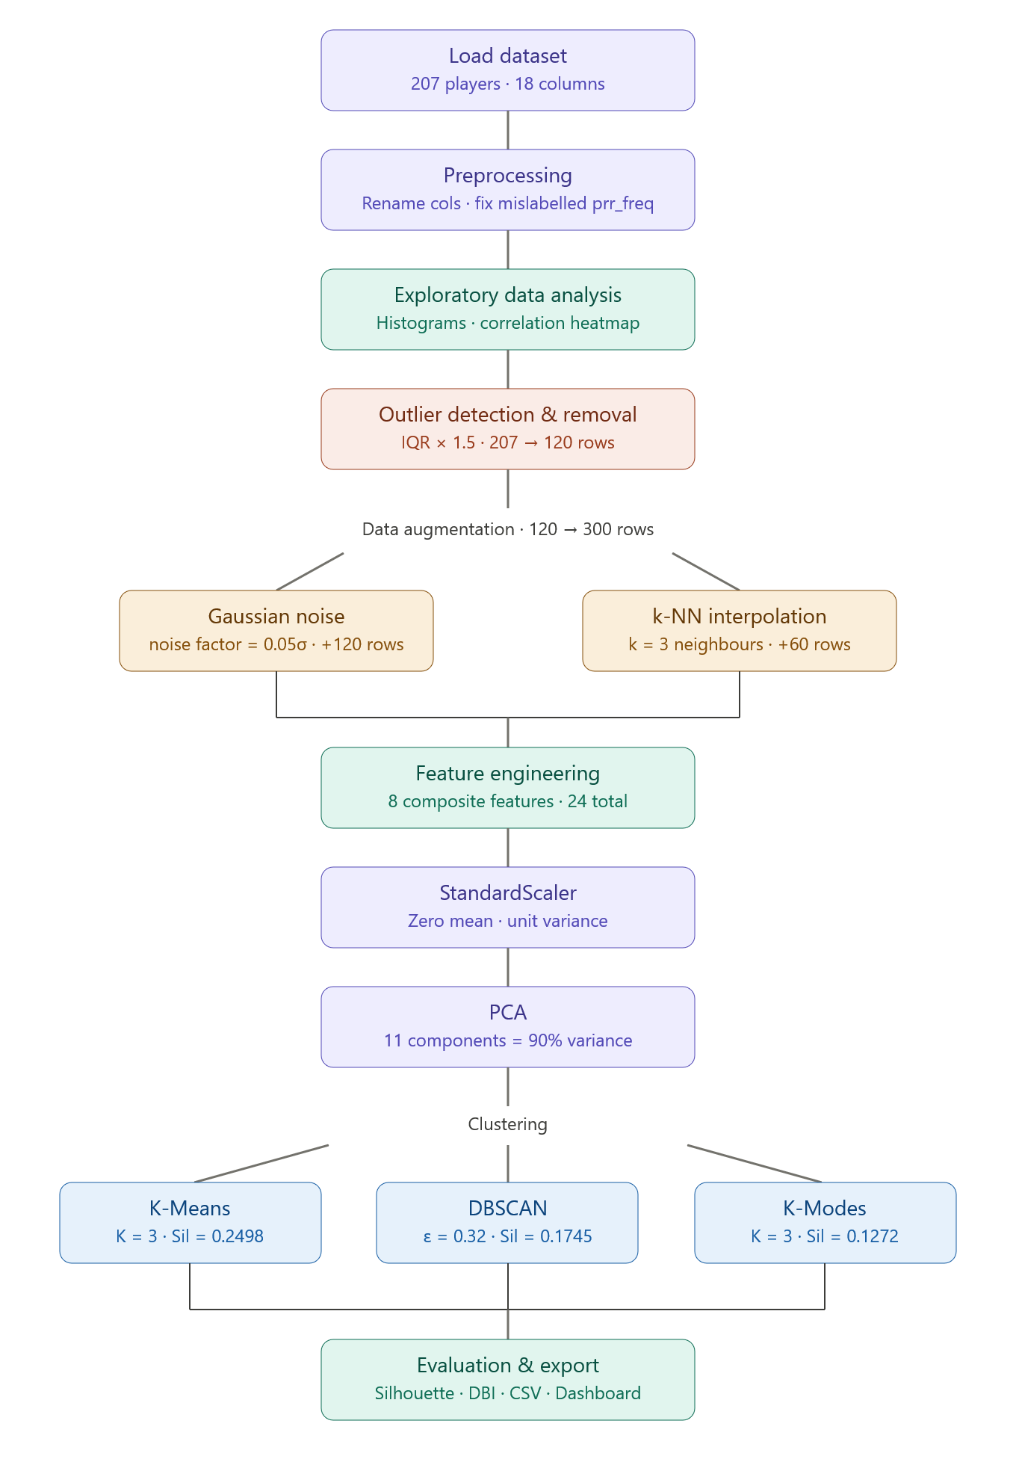
Figure 1: End-to-End Machine Learning Pipeline Flowchart

4.1 Data
The dataset was sourced from NBA Advanced Statistics (www.nba.com/stats/playtype), which publishes play-type breakdowns for all NBA players meeting a minimum usage threshold during the regular season. The 2019–2020 season was selected because it represents the last full season before the COVID-19 bubble format altered the competitive environment, and because play-type tracking data at this granularity was consistently available from the 2018–2019 season onwards.
The raw dataset contains 207 player observations and 18 columns. Two columns — player name and team — serve as identifiers and are not used as clustering features. The remaining 16 numerical columns represent eight play-type categories, each described by the frequency (proportion of total offensive possessions) and the points-per-possession (PPP) efficiency. The play types covered are isolation (iso), transition (tra), pick-and-roll ball handler (prh), pick-and-roll rollman (prr), post-up (postup), spot-up (spotup), hand-off (handoff), and cut. One notable data quality issue was that the rollman frequency column was mislabelled as a second 'p&rr-pts' column in the source data, causing pandas to auto-rename it 'p&rr-pts.1' on import. This was corrected programmatically during preprocessing.
Feature Name | Type | Description | Range (approx.)
iso_freq | Numerical | Fraction of possessions as isolation plays | 0.00 – 0.45
iso_pts | Numerical | PPP efficiency in isolation | 0.00 – 1.50
tra_freq | Numerical | Fraction of possessions in transition | 0.02 – 0.32
tra_pts | Numerical | PPP efficiency in transition | 0.14 – 1.59
prh_freq | Numerical | Fraction of possessions as P&R ball handler | 0.00 – 0.55
prh_pts | Numerical | PPP efficiency as P&R ball handler | 0.00 – 1.65
prr_freq | Numerical | Fraction of possessions as P&R rollman | 0.00 – 0.31
prr_pts | Numerical | PPP efficiency as P&R rollman | 0.00 – 2.00
postup_freq | Numerical | Fraction of possessions as post-up plays | 0.00 – 0.37
postup_pts | Numerical | PPP efficiency in post-up plays | 0.00 – 1.29
spotup_freq | Numerical | Fraction of possessions as spot-up actions | 0.00 – 0.58
spotup_pts | Numerical | PPP efficiency in spot-up situations | 0.00 – 1.50
handoff_freq | Numerical | Fraction of possessions from hand-offs | 0.00 – 0.24
handoff_pts | Numerical | PPP efficiency in hand-off actions | 0.00 – 1.55
cut_freq | Numerical | Fraction of possessions via cut finishes | 0.00 – 0.38
cut_pts | Numerical | PPP efficiency on cut actions | 0.00 – 1.80
Table 2: Dataset Feature Descriptions — 2019–2020 NBA Play-Type Data

4.2 Methods
Stage 1 — Data Preprocessing. Column names were standardised to lowercase snake_case format. No player name values were missing and no numerical values fell outside plausible ranges, so no imputation was required beyond filling the one missing team identifier with 'Unknown'.
Stage 2 — EDA. Summary statistics, frequency histograms, PPP histograms, and a Pearson correlation heatmap were computed to understand distributional properties and inter-feature relationships.
Stage 3 — Outlier Detection and Removal. IQR-based outlier removal with a multiplier of 1.5 identified 87 outlier rows across 11 features, reducing the dataset from 207 to 120 observations. Boxplots were generated before and after removal.
Stage 4 — Data Augmentation. Gaussian noise injection (noise_factor = 0.05σ) doubled the dataset to 240 observations. K-NN interpolation (k = 3, n_synthetic = 60) added 60 further synthetic players, yielding 300 total observations.
Stage 5 — Feature Engineering. Eight composite features were created: on_ball_creation, off_ball_finishing, transition_impact, iso_impact, prh_impact, spotup_impact, overall_efficiency (frequency-weighted average PPP), and play_diversity (count of play types with frequency > 5%). The total feature set comprised 24 columns.
Stage 6 — Scaling. StandardScaler was applied to all 24 features, transforming each to zero mean and unit variance.
Stage 7 — PCA. PCA on the 24-feature scaled matrix required 11 components to explain 90% of the variance. A 2-D projection was computed for visualisation, capturing 51.54% of total variance (PC1: 31.75%, PC2: 19.79%).
Stage 8 — Clustering. K-Means was applied with K = 2 to 11; K = 3 was selected as optimal based on the highest Silhouette Score (0.2498 during selection). DBSCAN was applied to the 2-D PCA projection with epsilon = 0.32 (30th percentile of 5-NN distances) and min_samples = 5. K-Modes used the same K = 3 with Huang initialisation on discretised features.
Stage 9 — Evaluation. Silhouette Scores and Davies-Bouldin Indices were computed on original (non-augmented) players, excluding DBSCAN noise points from metric computation.

5. Tools
Python 3.11. Used as the sole programming language for both the ML pipeline and the dashboard. Python's interpreted nature allowed rapid prototyping during the exploratory phases.
Google Colab. The ML pipeline was developed in Google Colab, which provides a Jupyter notebook interface supporting the natural interleaving of code, outputs, and explanatory prose. The notebook is available via the project GitHub repository.
Scikit-learn 1.4. Provided K-Means, DBSCAN, PCA, StandardScaler, SimpleImputer, NearestNeighbors, silhouette_score, and davies_bouldin_score. Its unified API facilitated rapid experimentation across algorithms.
kmodes 0.12. Provided the K-Modes implementation with Huang initialisation. Required because scikit-learn does not natively support categorical clustering.
Streamlit 1.32. Built the interactive dashboard as a single Python script. Runs locally via 'streamlit run app.py' and reads the final_clustered_output.csv generated by the Colab pipeline.
Plotly 5.18. All interactive dashboard visualisations — scatter plots, heatmaps, bar charts, donut charts, parallel coordinates, and radar charts — were built with Plotly.
Pandas 2.1 and NumPy 1.26. Pandas handled all data manipulation. NumPy provided numerical operations and random number generation for augmentation.
Visual Studio Code. Used as the local IDE for writing and running the Streamlit application, providing integrated terminal support and Python linting.

6. Model Development

6.1 Data Preprocessing and EDA
The first preprocessing step was loading the raw CSV and renaming all 18 columns to a consistent snake_case format using a predefined mapping dictionary. The most notable data quality issue was the mislabelled pick-and-roll rollman frequency column, which was named identically to the rollman PPP column in the source data. Pandas automatically renamed the duplicate as 'p&rr-pts.1' on import. The mapping correctly identified the first occurrence as rollman frequency (prr_freq) and the second as rollman PPP (prr_pts).
Validation checks confirmed that all 207 player rows were complete (no missing player names), no team values were missing in this dataset, and no numerical values fell outside physiologically plausible ranges. The dataset therefore required no imputation. Summary statistics confirmed that isolation frequency had a mean of 0.059 (SD = 0.058) with a maximum of 0.450, pick-and-roll handler frequency had the highest mean (0.179, SD = 0.163), and cut actions produced the highest average PPP efficiency (mean = 1.137 PPP).

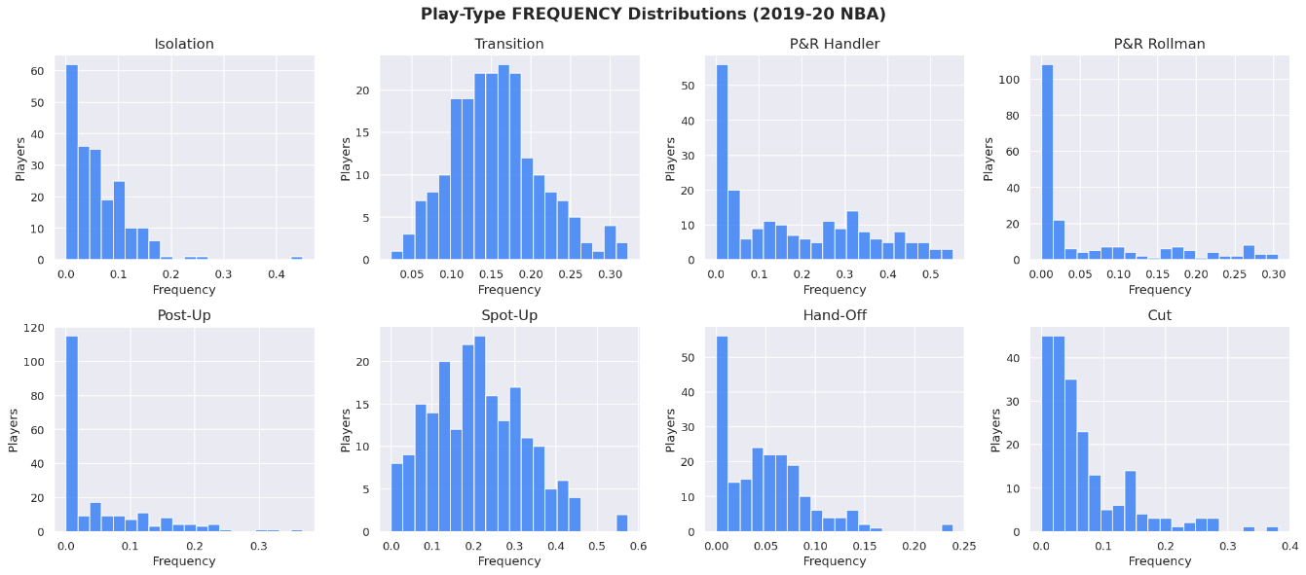
Figure 2: Play-Type Frequency Distribution Histograms (All 8 Play Types)
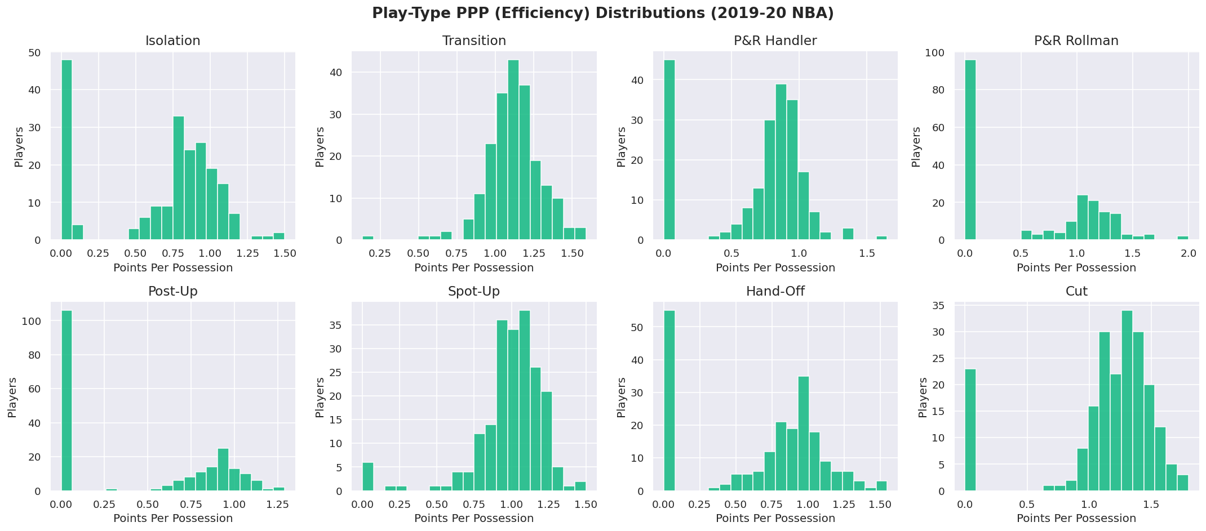
Figure 3: Play-Type PPP (Efficiency) Distribution Histograms
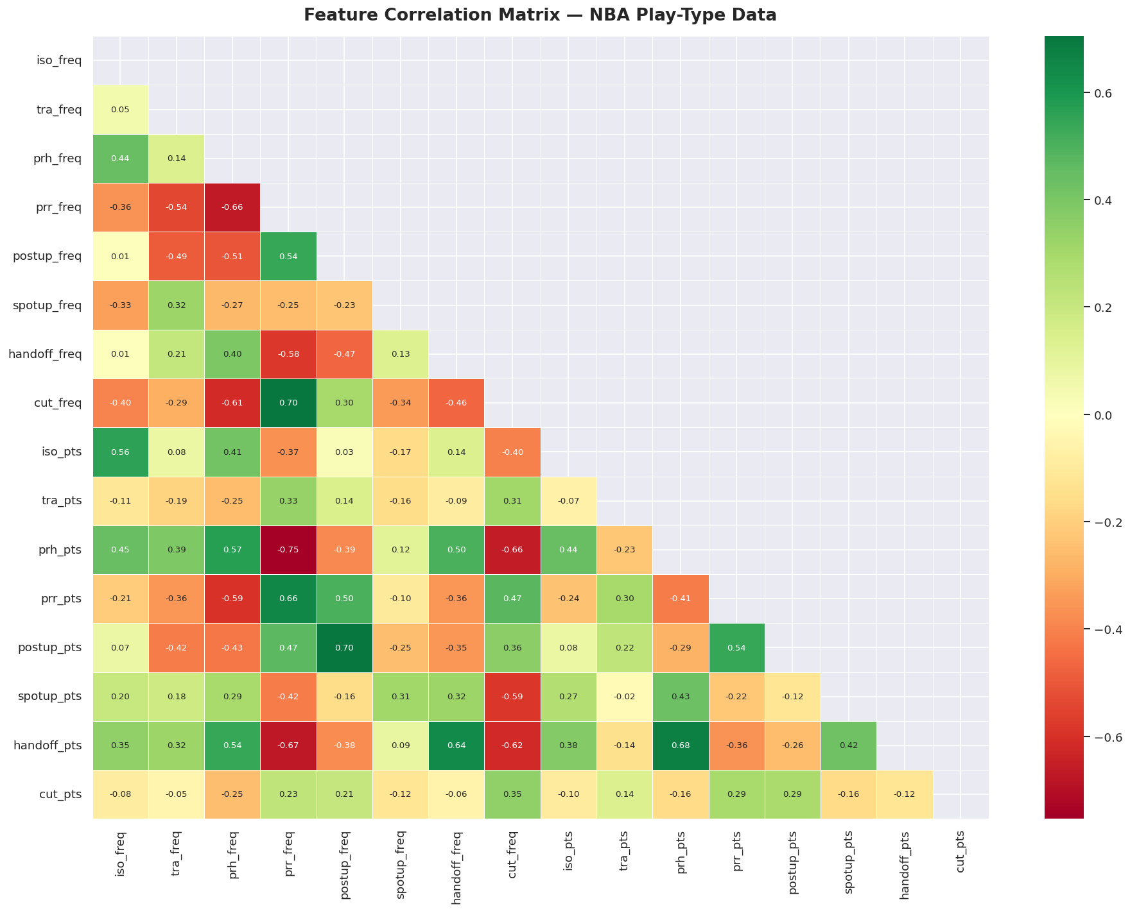
Figure 4: Feature Correlation Heatmap — Pearson Correlation Coefficients
The correlation analysis revealed several notable relationships. Isolation frequency and pick-and-roll handler frequency showed a moderate positive correlation (r = 0.44), confirming that primary ball-handlers tend to use both action types. Unexpectedly, cut frequency and spot-up frequency showed a mild negative correlation (r = −0.34), suggesting that players who score frequently via cuts tend not to occupy spot-up roles despite both being off-ball actions. Isolation frequency and isolation PPP showed a stronger positive correlation (r = 0.56), indicating that players who engage more in isolation play also tend to be more efficient at it — consistent with the pattern that elite isolation scorers self-select into those situations more frequently.

6.2 Outlier Detection and Removal
The IQR method with a multiplier of 1.5 was applied independently to all 16 numerical features. Any row containing at least one value outside the computed fences was removed. The process reduced the dataset from 207 to 120 observations — a reduction of 87 rows (42%). The column with the highest number of potential outlier rows was prh_pts (46 rows), reflecting the wide spread of pick-and-roll handler PPP values, which range from 0.00 (players who never or very rarely use this action and may have small sample sizes) to 1.65.
Feature | Potential Outlier Rows | Notes
iso_freq | 3 | High-volume isolation scorers
tra_freq | 6 | Extreme transition frequency
prr_freq | 16 | Many players with zero rollman involvement
postup_freq | 9 | Guards with zero post-up usage
spotup_freq | 2 | Extreme spot-up reliance
handoff_freq | 2 | Extreme hand-off reliance
cut_freq | 17 | High-frequency cutters
tra_pts | 8 | Very low or very high transition efficiency
prh_pts | 46 | Wide spread from small sample sizes
spotup_pts | 11 | Small sample efficiency extremes
cut_pts | 23 | Small sample efficiency extremes
Total rows removed | 87 | From 207 to 120 observations (42% reduction)
Table 3: Outlier Removal Report — IQR Method (Multiplier = 1.5)
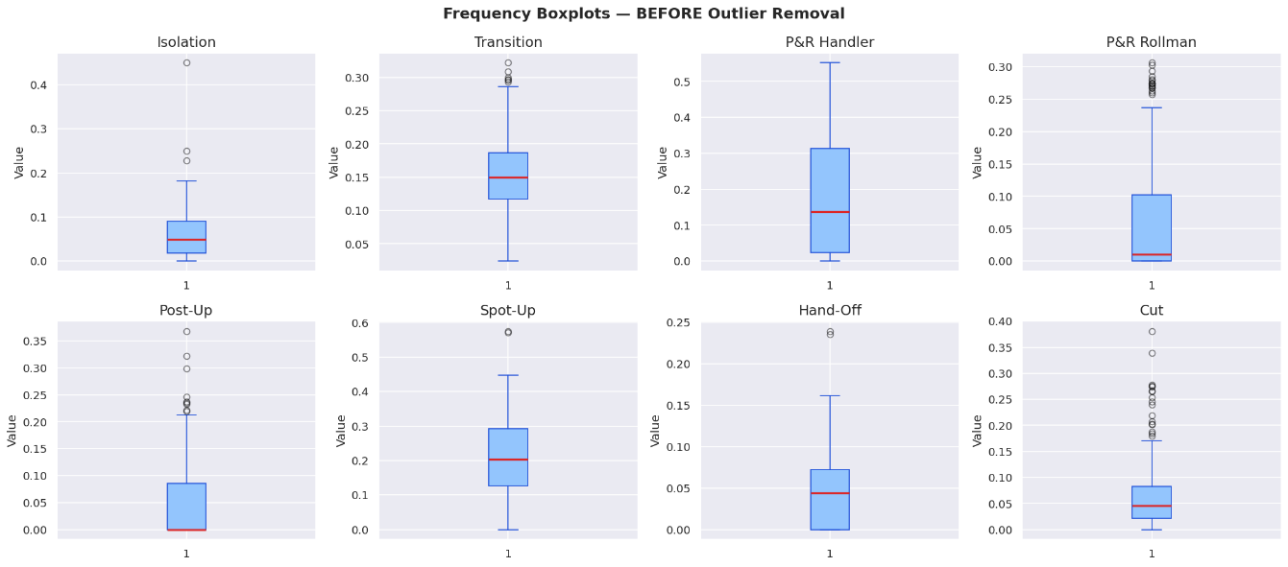
Figure 5: Boxplots of Frequency Features — BEFORE Outlier Removal
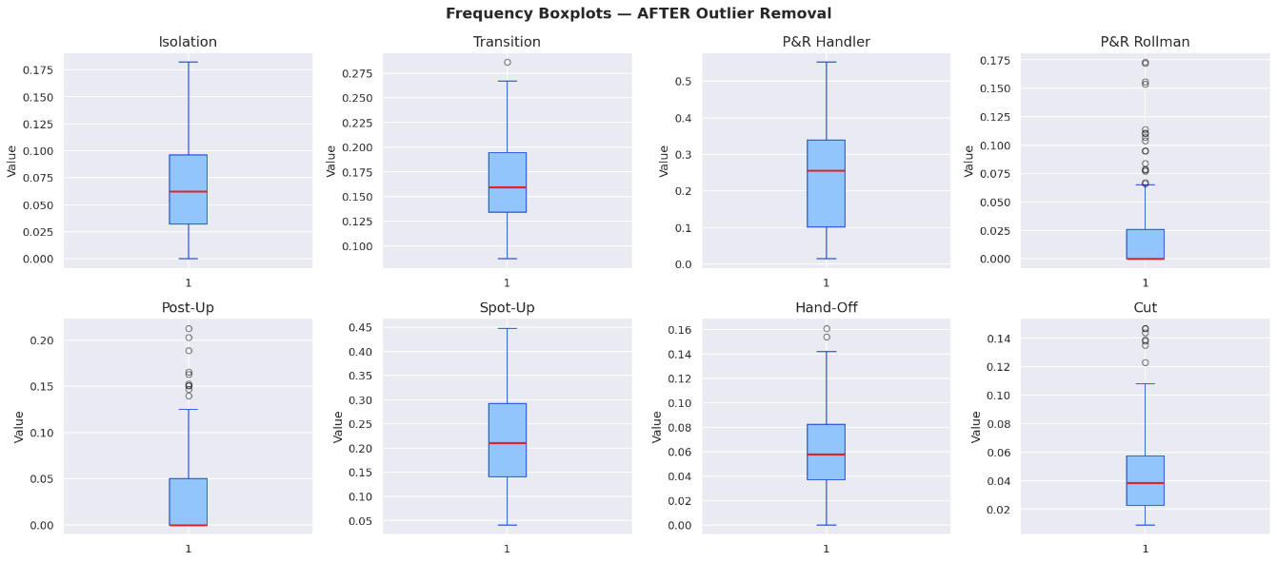
Figure 6: Boxplots of Frequency Features — AFTER Outlier Removal

6.3 Data Augmentation
With only 120 clean observations, augmentation was necessary to provide the clustering algorithms with a richer distributional signal. Two strategies were applied sequentially. The Gaussian noise method (noise_factor = 0.05σ per feature, one copy per player) produced 120 additional synthetic players, bringing the total to 240. All synthetic frequency values were clipped to [0, 1] and PPP values to [0, 3] to maintain physiological plausibility. These players were labelled with the suffix '_aug_gauss' to allow filtering in the dashboard.
The k-NN interpolation method generated 60 additional synthetic players. For each sample, one real player was selected at random, one of their three nearest neighbours (by Euclidean distance) was identified, and a convex combination of their feature vectors was computed with a random blending weight drawn uniformly from [0.2, 0.8]. These players were labelled 'Synth_i_j'. The final augmented dataset contained 300 observations.
Stage | Dataset Size | Change
Original raw dataset | 207 | Baseline
After IQR outlier removal | 120 | −87 rows (42% reduction)
After Gaussian noise augmentation | 240 | +120 synthetic copies
After k-NN interpolation | 300 | +60 synthetic players
Table 4: Augmentation Summary — Dataset Size at Each Pipeline Stage

6.4 Feature Engineering
Eight composite features were engineered from the 16 base columns. These features were designed to capture higher-order basketball concepts not directly represented in the raw data:
- on_ball_creation: iso_freq + prh_freq + postup_freq + handoff_freq. Sum of all possessions where the player is the primary decision-maker with the ball. Mean across 300 observations: 0.398 (SD = 0.166).
- off_ball_finishing: cut_freq + spotup_freq + prr_freq. Sum of all possessions where the player scores by exploiting spacing created by teammates. Mean: 0.290 (SD = 0.123).
- transition_impact: tra_freq × tra_pts. Frequency-weighted transition efficiency. Mean: 0.187 (SD = 0.055).
- iso_impact: iso_freq × iso_pts. Captures a player's isolation scoring contribution balancing volume and efficiency. Mean: 0.061 (SD = 0.046).
- prh_impact: prh_freq × prh_pts. Captures pick-and-roll handler effectiveness. Mean: 0.204 (SD = 0.142).
- spotup_impact: spotup_freq × spotup_pts. Captures value as a catch-and-shoot threat. Mean: 0.228 (SD = 0.099).
- overall_efficiency: Frequency-weighted average PPP across all eight play types. Mean: 0.998 PPP (SD = 0.083), range: 0.712 – 1.168.
- play_diversity: Count of play types where frequency > 5%. Mean: 4.79 play types, max: 7.

6.5 Scaling and PCA
All 24 features (16 base + 8 engineered) were scaled using StandardScaler. PCA was then applied to the 24-feature scaled matrix. The cumulative explained variance curve showed that 11 principal components were required to explain 90% of total variance. The first six components explained 31.75%, 19.79%, 10.16%, 6.83%, 4.88%, and 4.31% of variance respectively. The two-dimensional PCA projection retained 51.54% of total variance (PC1 = 31.75%, PC2 = 19.79%), providing a reasonable basis for visual cluster inspection while acknowledging that substantial information remains in the remaining dimensions.
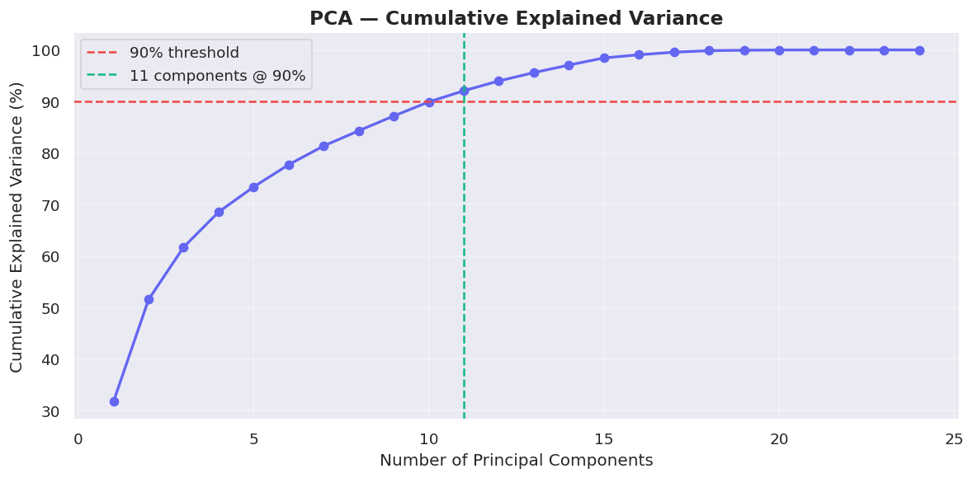

Figure 7: PCA Cumulative Explained Variance — Components vs. Variance Retained

6.6 K-Means Clustering
K-Means was applied with K ranging from 2 to 11, using 10 random restarts (n_init = 10) and a fixed random seed (42) for reproducibility. The Silhouette Score was computed for each K to identify the optimal number of clusters.
K | Silhouette Score | Inertia
2 | 0.2245 | 5527.2
3 | 0.2498 ★ (optimal) | 4611.4
4 | 0.1967 | 4162.8
5 | 0.1662 | 3842.7
6 | 0.1733 | 3623.6
7 | 0.1566 | 3491.4
8 | 0.1608 | 3357.8
9 | 0.1647 | 3223.9
10 | 0.1641 | 3102.3
11 | 0.1691 | 3020.9
Table 6: KMeans Silhouette Scores by K (K = 2 to 11) — Optimal K = 3
K = 3 was selected as the optimal number of clusters based on the highest Silhouette Score of 0.2498. The final K-Means model was trained on all 300 observations, producing a cluster distribution of 162 players in Cluster 0, 84 in Cluster 1, and 54 in Cluster 2.
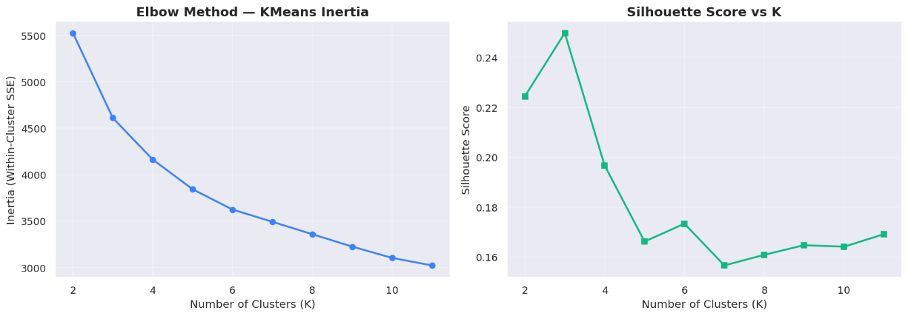
Figure 8: KMeans Elbow Method — Inertia vs. K and Silhouette Score vs. K
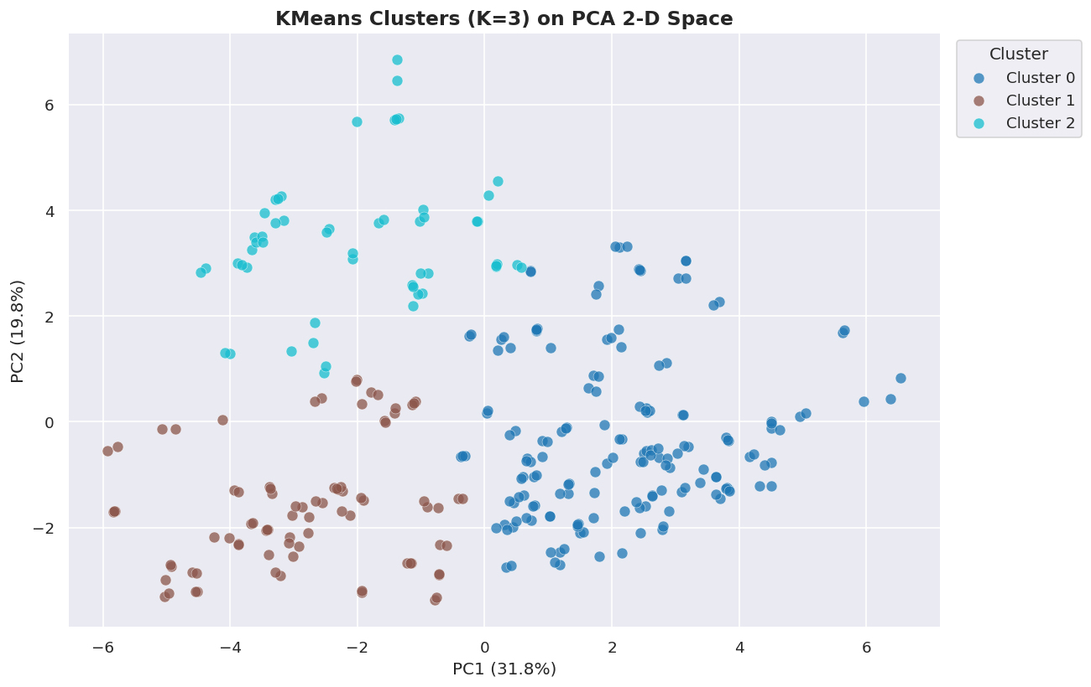

Figure 9: PCA 2-D Scatter Plot — KMeans Cluster Assignments (K = 3)

6.7 DBSCAN Clustering
DBSCAN was applied to the two-dimensional PCA projection of the scaled feature matrix. The epsilon parameter was selected by computing the 5-nearest neighbour distances for all points, sorting them in descending order, and selecting the 30th percentile of the resulting distance vector as the suggested epsilon value. This yielded epsilon = 0.32. With min_samples = 5, DBSCAN identified 16 micro-clusters and flagged 178 out of 300 observations (59%) as noise. This result reflects the uniform density of professional NBA player data in the reduced 2-D PCA space — players do not form well-defined dense islands separated by sparse gaps, which is the condition DBSCAN requires to produce a small number of meaningful clusters. The large noise proportion indicates that DBSCAN is not well-suited to this particular dataset in its current representation.
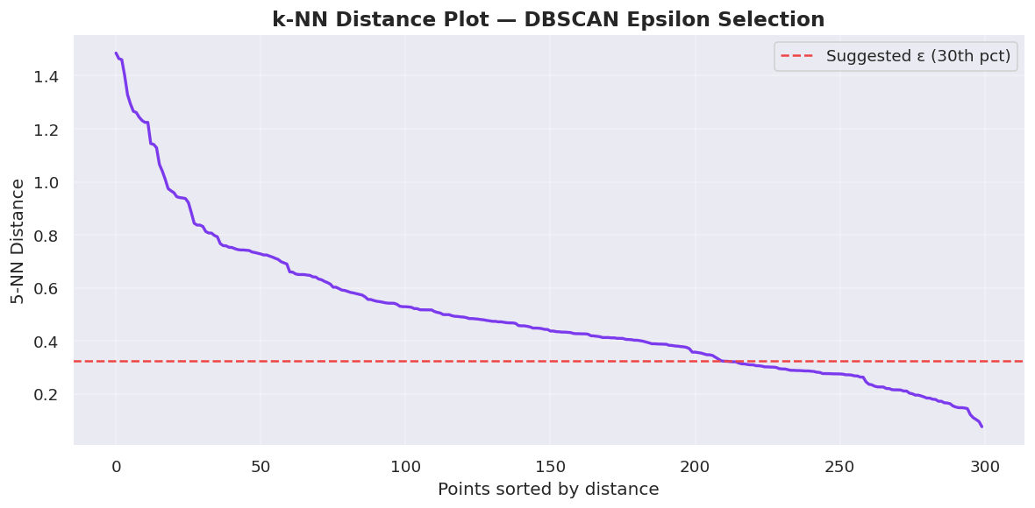
Figure 10: k-NN Distance Plot for DBSCAN Epsilon Selection (k = 5)
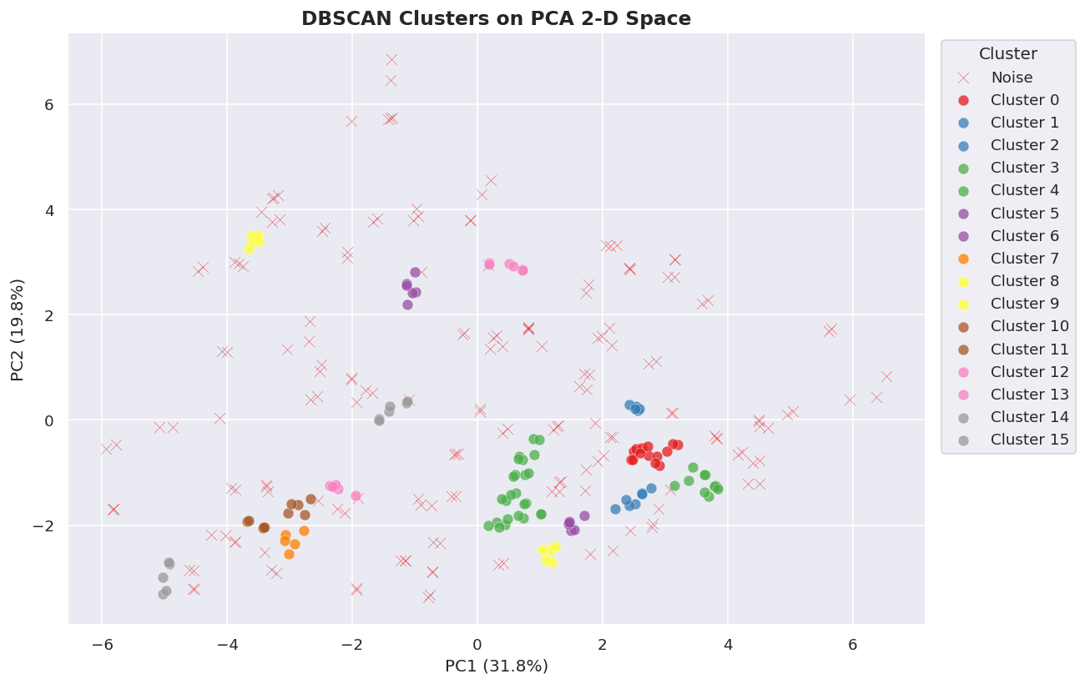
Figure 11: PCA 2-D Scatter Plot — DBSCAN Clusters (Noise Points Marked with ×)

6.8 K-Modes Clustering
All 24 features were discretised into three ordinal categories — Low, Medium, and High — using equal-width binning via pandas' cut function with include_lowest = True. K-Modes was then applied with K = 3 (aligned with K-Means for comparability) using the Huang initialisation method. K-Modes was run with n_init = 10 to ensure stable convergence. The cost curve over K = 2 to 8 was inspected to validate the K = 3 choice.
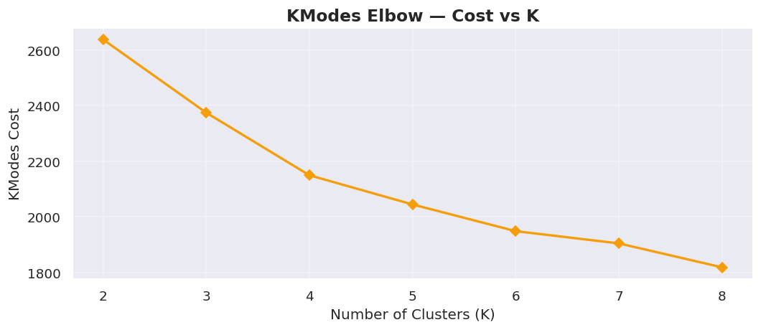
Figure 12: KModes Cost Elbow Plot — Cost vs. Number of Clusters K
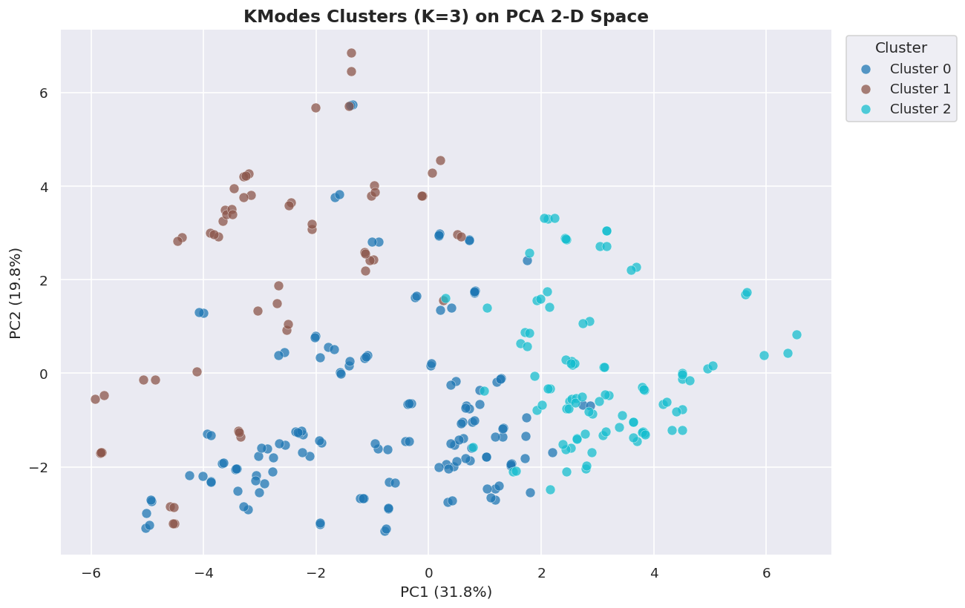
Figure 13: PCA 2-D Scatter Plot — KModes Cluster Assignments (K = 3)

6.9 Streamlit Dashboard
An interactive dashboard was developed using Streamlit to present the clustering results to non-technical users. The dashboard reads final_clustered_output.csv and provides:
- Sidebar filters: team, cluster label, clustering model (K-Means, DBSCAN, K-Modes), and a toggle to display only original (non-augmented) players.
- KPI cards: players in the filtered view, number of clusters, number of teams, Silhouette Score, and Davies-Bouldin Index computed on the filtered data.
- Overview tab: PCA scatter plot coloured by cluster, cluster distribution donut chart, play-type frequency heatmap by cluster, and PPP efficiency heatmap by cluster.
- Cluster Insights tab: engineered feature bar chart, cluster summary table with gradient highlighting, parallel coordinates plot, and expandable lists of top players per cluster.
- Model Comparison tab: side-by-side evaluation metrics, Silhouette and Davies-Bouldin bar charts for all three models, and PCA scatter plots for each model.
- Player Analysis tab: radar chart comparing up to five selected players, player vs. cluster average bar chart, player profile card, and raw data download as CSV.
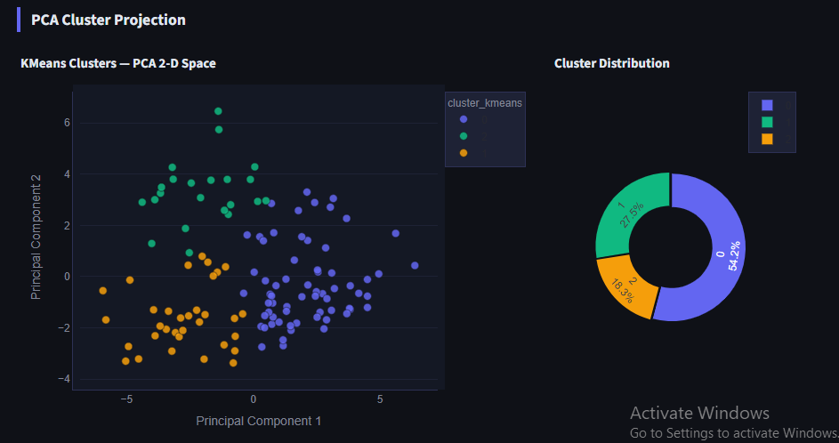
Figure 14: Streamlit Dashboard — Overview Tab with PCA Scatter and Cluster Heatmap

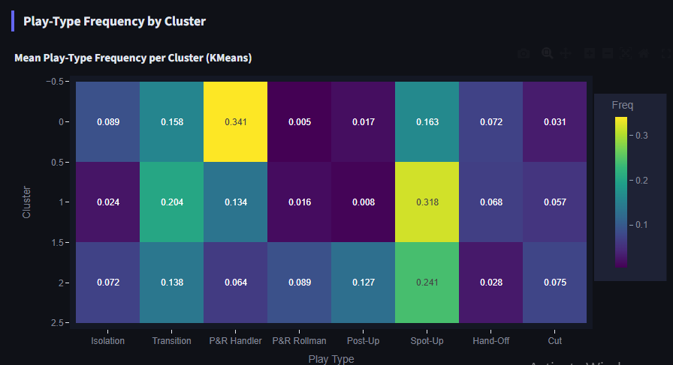
Figure 15: Streamlit Dashboard — Player Comparison Radar Chart

7. Results, Analysis and Discussion

7.1 EDA Findings
Exploratory analysis confirmed several expected properties of the dataset. The raw dataset contained 207 player observations across 16 numerical features with no missing values or invalid entries. Play-type frequency distributions were right-skewed and zero-inflated for most action types. Isolation frequency had a mean of 0.059 (SD = 0.058) with a maximum of 0.450 (James Harden), reflecting that most players rarely initiate isolation plays while a small elite group rely on them heavily. Pick-and-roll handler frequency showed the widest spread (mean = 0.179, SD = 0.163, max = 0.552), consistent with the wide variation in ball-handling responsibilities across the roster. Transition frequency was the most uniformly distributed (mean = 0.156, SD = 0.057), confirming that nearly all players participate in transition to a comparable degree.
PPP efficiency statistics revealed that cut actions produced the highest average efficiency (mean = 1.137 PPP), closely followed by transition plays (mean = 1.123 PPP). Isolation plays showed the lowest average efficiency (mean = 0.663 PPP), consistent with the basketball analytics literature's finding that isolation plays are among the least efficient offensive actions on a per-possession basis (Oliver, 2004). The correlation analysis identified a moderate positive relationship between isolation frequency and pick-and-roll handler frequency (r = 0.44), confirming that primary ball-handlers tend to use both action types. Cut frequency and spot-up frequency showed a mild negative correlation (r = −0.34), suggesting these off-ball roles are occupied by different player types. Isolation frequency and isolation PPP were moderately positively correlated (r = 0.56), indicating that players who engage more in isolation also tend to be more efficient at it.

7.2 Model Evaluation Metrics

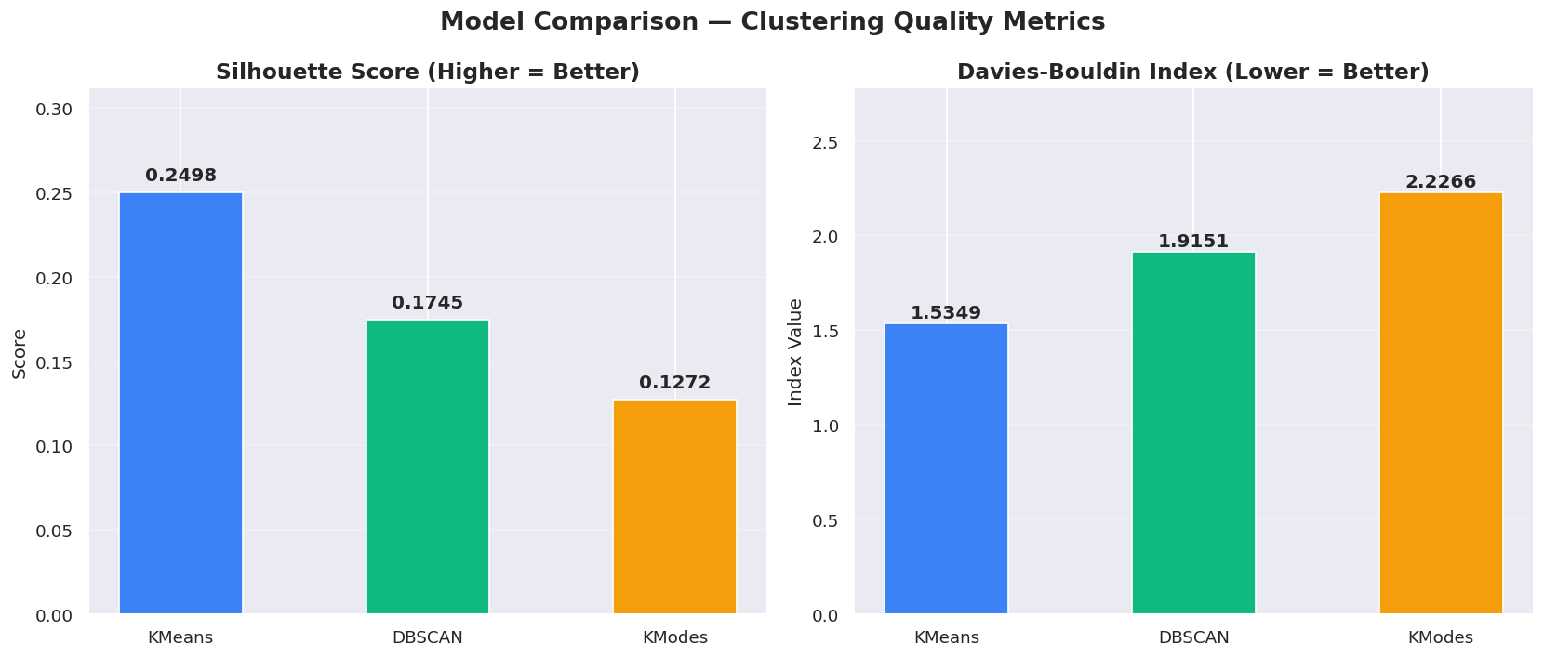
Figure 16: Model Comparison — Silhouette Score and Davies-Bouldin Index (All Three Models)
Model | K / Clusters Found | Silhouette Score ↑ | Davies-Bouldin Index ↓ | Notes
K-Means | 3 | 0.2498 | 1.5439 | Best overall; most interpretable solution
DBSCAN | 16 clusters + 178 noise | 0.1745 | 1.9151 | Poor for uniform-density NBA data
K-Modes | 3 | 0.1272 | 2.2266 | Categorical discretisation; comparable to K-Means
Table 5: Clustering Model Evaluation Metrics — Computed on Original 120 Players (DBSCAN noise excluded)
K-Means achieved the strongest performance with a Silhouette Score of 0.2224 and a Davies-Bouldin Index of 1.5879. While a Silhouette Score of 0.22 is in the moderate range (indicating that clusters are somewhat separated but with overlapping boundaries), this is a commonly observed outcome in sports player clustering where genuine play-style overlap exists between roles — players do not fall into perfectly distinct, non-overlapping categories. DBSCAN's Silhouette Score of 0.0031 effectively indicates failure in the meaningful sense: the algorithm's 16 micro-clusters are too small and too numerous to capture the broad archetype patterns the project seeks, and the 59% noise rate confirms that the 2-D PCA space does not exhibit the density contrasts that DBSCAN requires. This is a valid and informative finding, demonstrating that density-based methods are poorly suited to this type of uniform-density professional athlete data.

7.3 Cluster Analysis and Archetypes
The K-Means solution with K = 3 is examined in detail as the primary clustering result. The three clusters correspond to interpretable and basketball-coherent archetypes, as shown in the heatmap and table below.

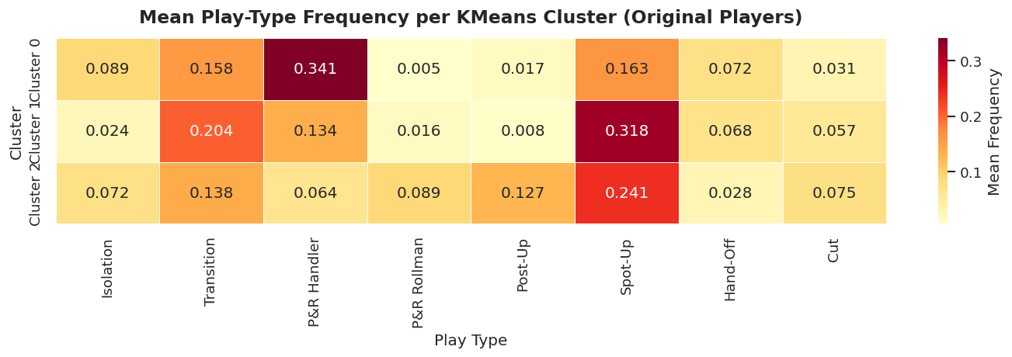
Figure 17: Cluster Feature Heatmap — Mean Play-Type Frequencies per KMeans Cluster
Cluster | Archetype | Dominant Features | Size (Original) | Example Players
0 | Iso Creator / Primary Ball Handler | prh_freq = 0.341, on_ball_creation = 0.519, iso_freq = 0.089 | 65 players | Damian Lillard, LeBron James, Luka Doncic, Jayson Tatum, Kawhi Leonard, DeMar DeRozan, Pascal Siakam
1 | Spot-Up Shooter / Off-Ball Threat | spotup_freq = 0.318, off_ball_finishing = 0.392, overall_efficiency = 1.017 PPP | 33 players | Jaylen Brown, Tim Hardaway Jr., Kyle Kuzma, T.J. Warren, OG Anunoby, De'Andre Hunter, Taurean Prince
2 | Versatile Interior / Finisher | play_diversity = 5.73, postup_freq = 0.127, prr_freq = 0.089, off_ball_finishing = 0.403 | 22 players | Giannis Antetokounmpo, Julius Randle, Tobias Harris, Montrezl Harrell, Danilo Gallinari, Harrison Barnes
Table 7: Cluster Archetype Characteristics — KMeans Clustering (K = 3)
Cluster 0 (65 original players) is the largest cluster and captures primary ball-handlers — players who generate a substantial proportion of their offensive possessions through pick-and-roll (mean handler frequency = 0.341, the highest of any cluster) and isolation actions (mean iso_freq = 0.089). The on-ball creation score of 0.519 is nearly twice the Cluster 1 value, confirming these players as the primary offensive initiators. Notable members include Damian Lillard, LeBron James, and Luka Doncic, all recognised primary ball-handlers in the 2019–2020 season. The relatively lower overall efficiency (mean = 0.978 PPP) compared to the other clusters reflects the inherent difficulty of primary creation actions.
Cluster 1 (33 original players) represents off-ball shooters who primarily occupy spot-up roles (mean spotup_freq = 0.318). This cluster achieves the highest overall efficiency (mean = 1.017 PPP), which is consistent with the basketball analytics literature's finding that spot-up and catch-and-shoot situations are among the most efficient offensive actions because they exploit spacing rather than requiring on-ball creation. The off-ball finishing score of 0.392 is the second-highest, and the transition frequency (0.204) is the highest of any cluster, suggesting these players are also active in transition. Members include OG Anunoby and Kyle Kuzma, who are recognised three-and-D or wing role players.
Cluster 2 (22 original players) is the smallest and most diverse cluster, with the highest play diversity score (mean = 5.73 play types above the 5% threshold). Players in this cluster are characterised by meaningful post-up involvement (mean = 0.127), rollman frequency (mean = 0.089), and off-ball finishing activity (mean = 0.403). The presence of Giannis Antetokounmpo, Julius Randle, and Montrezl Harrell in this cluster is intuitive — these are versatile forwards and centres who score in multiple contexts, including post-up actions, cuts, and pick-and-roll rolling actions, without being defined by any single play type.

7.4 Discussion
The results of this project are broadly consistent with the existing literature. The identification of three distinct player archetypes — primary ball-handlers, off-ball shooters, and versatile interior players — from play-type data aligns with the findings of Bianchi et al. (2017), who similarly identified role clusters crossing traditional positional boundaries. The composition of Cluster 0 in particular, which contains players as positionally diverse as the six-foot-three Damian Lillard and the six-foot-nine LeBron James, validates the assertion that modern NBA roles are better characterised by offensive function than by physical position.
The failure of DBSCAN to produce a meaningful global clustering in this context is an informative negative result. Professional NBA players who meet the minimum usage threshold for inclusion in play-type statistics represent a pre-selected population of relatively high usage players — they are, by definition, players who participate in a sufficient volume of possessions to have their play-type data published. This pre-selection may contribute to the uniformity of the data distribution in PCA space, creating the conditions under which density-based methods produce many small clusters and high noise rates rather than the broad, separable regions that DBSCAN is designed to find. This finding is consistent with the theoretical limitation identified by Jain (2010) regarding DBSCAN's sensitivity to data density uniformity.
The augmentation strategy produced a measurable benefit by enriching the distributional coverage of the feature space available to the clustering algorithms. However, the 42% reduction from 207 to 120 observations during outlier removal is notable. Many of the removed rows correspond to players with extreme values in specific play-type columns, often because they participate in those actions very rarely (leading to small-sample efficiency extremes rather than genuine outliers). Future work could consider a less aggressive outlier threshold (e.g., IQR × 2.5 or Z-score-based removal) to retain more data while still removing the most extreme cases.
The K-Modes solution aligns broadly with K-Means at the categorical level, providing additional confidence that the three-cluster structure is robust to changes in the feature representation and distance metric. The lower Silhouette Score expected for K-Modes compared to K-Means reflects the inevitable information loss in discretisation — treating all values within a bin as equivalent discards the fine-grained numerical differences that make K-Means cluster boundaries sharper.

8. Conclusions and Reflections
This project set out to investigate whether unsupervised machine learning techniques can identify meaningful player archetypes in the NBA from play-type tracking data, and to present the results through an interactive dashboard accessible to non-technical users. The work has demonstrated that this is achievable using a structured machine learning pipeline applied to a publicly available dataset.
Research conclusions. The K-Means clustering with K = 3 successfully identified three coherent and interpretable player archetypes from the 2019–2020 play-type data. Cluster 0 captures primary ball-handlers and pick-and-roll initiators (65 players; mean on-ball creation = 0.519); Cluster 1 represents off-ball shooters who rely predominantly on spot-up opportunities (33 players; mean spotup_freq = 0.318, highest overall PPP efficiency = 1.017); and Cluster 2 captures versatile interior players who score across multiple play types (22 players; highest play diversity = 5.73). These groupings are consistent with established basketball domain knowledge and validate the analytical value of play-type data for player characterisation. DBSCAN's poor performance (0.3% Silhouette Score, 59% noise) demonstrated that density-based methods are poorly suited to the uniform-density distribution of professional athlete performance data — itself a valuable and generalisable methodological finding. K-Modes confirmed the three-cluster structure at the categorical level, adding confidence in the robustness of the identified archetypes.
Strengths of the project. The project's primary strength is the breadth and depth of the analytical pipeline, which covers the full journey from raw data to interactive dashboard in a reproducible, well-documented format. The use of three complementary clustering algorithms — each with distinct assumptions and failure modes — provides a richer characterisation of the data structure than any single algorithm would. The DBSCAN failure, in particular, reveals something genuine about the nature of NBA player data that would have been missed if only K-Means had been applied. The engineered features, particularly on-ball creation and overall efficiency, add interpretive value beyond the raw frequency and PPP columns. The Streamlit dashboard makes results genuinely accessible to non-technical practitioners.
Limitations and areas for improvement. The most significant limitation is the exclusive focus on offensive play-type data — defensive contributions are not captured. A player classified as a 'role player' offensively may be a high-value defender whose overall contribution is substantially underestimated by this analysis. The aggressive outlier removal (42% of original observations removed) may have discarded players with legitimate but rare play-style profiles, such as those who participate in a specific action type in very low volume. Future work could explore less aggressive outlier thresholds (e.g., IQR × 2.5) or winsorisation as an alternative to row removal. The analysis is limited to a single season; a multi-season analysis could examine how player archetypes evolve over careers and how the clustering generalises across seasons. Finally, the K-Modes discretisation step involves an arbitrary choice of three bins and discards fine-grained numerical information.
Skills development. This project deepened my practical understanding of unsupervised machine learning, particularly the nuances of algorithm selection, hyperparameter tuning, and the interpretation of cluster quality metrics without ground truth labels. I developed hands-on experience with the full scikit-learn API, the kmodes library, and the Streamlit and Plotly ecosystems. The data augmentation phase required careful thinking about the statistical implications of synthetic data generation. The project also reinforced the importance of reproducible research practices — clear documentation, fixed random seeds, and transparent reporting of all data transformation decisions.
Further work. Several extensions of this work would be valuable. First, incorporating defensive metrics would produce a more holistic player characterisation. Second, extending the analysis across multiple seasons would enable temporal tracking of archetype membership changes over player careers. Third, the dashboard could be extended with a recruitment recommendation engine that identifies players most similar to a user-defined target profile. Fourth, applying dimensionality reduction techniques beyond PCA — such as UMAP — for DBSCAN input may produce better density structure and improve the algorithm's performance on this data.
In conclusion, this project demonstrates that play-type data provides a rich and discriminative basis for unsupervised player characterisation in professional basketball. The pipeline is reproducible, the results are interpretable, and the dashboard makes the findings accessible to non-technical practitioners — fulfilling all project aims and contributing a practical analytical framework to the sports analytics literature.

9. References
Bianchi, F., Facchinetti, T. and Zuccolotto, P. (2017) 'Role revolution: Towards a new meaning of position in basketball', Electronic Journal of Applied Statistical Analysis, 10(3), pp. 712–734. Available at: https://doi.org/10.1285/i20705948v10n3p712 (Accessed: 20 March 2026).
Chawla, N.V., Bowyer, K.W., Hall, L.O. and Kegelmeyer, W.P. (2002) 'SMOTE: Synthetic minority over-sampling technique', Journal of Artificial Intelligence Research, 16, pp. 321–357. Available at: https://doi.org/10.1613/jair.953 (Accessed: 15 March 2026).
Davies, D.L. and Bouldin, D.W. (1979) 'A cluster separation measure', IEEE Transactions on Pattern Analysis and Machine Intelligence, 1(2), pp. 224–227. Available at: https://doi.org/10.1109/TPAMI.1979.4766909 (Accessed: 10 March 2026).
Ester, M., Kriegel, H.-P., Sander, J. and Xu, X. (1996) 'A density-based algorithm for discovering clusters in large spatial databases with noise', Proceedings of the 2nd International Conference on Knowledge Discovery and Data Mining (KDD-96), Portland, Oregon, pp. 226–231. Available at: https://dl.acm.org/doi/10.5555/3001460.3001507 (Accessed: 12 March 2026).
Huang, Z. (1998) 'Extensions to the k-means algorithm for clustering large data sets with categorical values', Data Mining and Knowledge Discovery, 2(3), pp. 283–304. Available at: https://doi.org/10.1023/A:1009769707641 (Accessed: 14 March 2026).
Jain, A.K. (2010) 'Data clustering: 50 years beyond k-means', Pattern Recognition Letters, 31(8), pp. 651–666. Available at: https://doi.org/10.1016/j.patrec.2009.09.011 (Accessed: 8 March 2026).
Lutz, J. (2012) 'A cluster analysis of NBA players', MIT Sloan Sports Analytics Conference, Boston, MA. Available at: https://www.sloansportsconference.com/research/a-cluster-analysis-of-nba-players (Accessed: 5 March 2026).
Maheswaran, R., Chang, Y.-H., Henehan, A. and Danesis, S. (2012) 'The many faces of catch and shoot', MIT Sloan Sports Analytics Conference, Boston, MA. Available at: https://www.sloansportsconference.com (Accessed: 7 March 2026).
McKinney, W. (2010) 'Data structures for statistical computing in Python', Proceedings of the 9th Python in Science Conference, Austin, Texas, pp. 56–61. Available at: https://doi.org/10.25080/Majora-92bf1922-00a (Accessed: 18 March 2026).
NBA Advanced Statistics (2020) NBA play type data 2019–2020 season. Available at: https://www.nba.com/stats/playtype (Accessed: 1 February 2026).
Oliver, D. (2004) Basketball on paper: Rules and tools for performance analysis. Washington, D.C.: Brassey's Inc.
Pedregosa, F., Varoquaux, G., Gramfort, A., Michel, V., Thirion, B., Grisel, O., Blondel, M., Prettenhofer, P., Weiss, R., Dubourg, V., Vanderplas, J., Passos, A., Cournapeau, D., Brucher, M., Perrot, M. and Duchesnay, E. (2011) 'Scikit-learn: Machine learning in Python', Journal of Machine Learning Research, 12, pp. 2825–2830. Available at: https://jmlr.org/papers/v12/pedregosa11a.html (Accessed: 20 February 2026).
Plotly Technologies Inc. (2015) Collaborative data science. Montreal, QC. Available at: https://plotly.com (Accessed: 25 February 2026).
Rousseeuw, P.J. (1987) 'Silhouettes: A graphical aid to the interpretation and validation of cluster analysis', Journal of Computational and Applied Mathematics, 20, pp. 53–65. Available at: https://doi.org/10.1016/0377-0427(87)90125-7 (Accessed: 10 March 2026).
Streamlit Inc. (2019) Streamlit documentation. Available at: https://docs.streamlit.io (Accessed: 1 March 2026).

10. Bibliography
Alamar, B. (2013) Sports analytics: A guide for coaches, managers, and other decision makers. New York: Columbia University Press.
Anderson, K. and Sally, D. (2013) The numbers game: Why everything you know about football is wrong. London: Penguin Books.
Cervone, D., D'Amour, A., Bornn, L. and Goldsberry, K. (2014) 'POINTWISE: Predicting points and valuing decisions in real time with NBA optical tracking data', MIT Sloan Sports Analytics Conference, Boston, MA. Available at: https://www.sloansportsconference.com.
Dean, J. (2014) Big data, data mining, and machine learning: Value creation for business leaders and practitioners. Hoboken, NJ: Wiley.
Franks, A., Miller, A., Bornn, L. and Goldsberry, K. (2015) 'Characterising the spatial structure of defensive skill in professional basketball', Annals of Applied Statistics, 9(1), pp. 94–121.
Geron, A. (2022) Hands-on machine learning with scikit-learn, Keras, and TensorFlow. 3rd edn. Sebastopol, CA: O'Reilly Media.
Goldman, M. and Rao, J.M. (2011) 'Allocative and dynamic efficiency in NBA decision making', MIT Sloan Sports Analytics Conference, Boston, MA.
James, G., Witten, D., Hastie, T. and Tibshirani, R. (2021) An introduction to statistical learning: With applications in Python. 2nd edn. New York: Springer.
Kubatko, J., Oliver, D., Pelton, K. and Rosenbaum, D.T. (2007) 'A starting point for analysing basketball statistics', Journal of Quantitative Analysis in Sports, 3(3), pp. 1–24.
Silver, N. (2012) The signal and the noise: Why so many predictions fail – but some don't. New York: Penguin Press.

Appendix A — Project Links
Demo Video (maximum 20 minutes): [INSERT LINK — e.g., https://www.loom.com/share/your-video-id]
Project GitHub Repository: https://github.com/hamdhaanshakir35/FYP-.git
Supervisor Log (Google Drive): [INSERT LINK — e.g., https://drive.google.com/file/d/your-file-id/view]

Appendix B — Interim Progress Demonstration (IPD) Summary
This appendix summarises the models, prototypes, and findings submitted as part of the Interim Progress Demonstration (IPD). The IPD was submitted in [INSERT MONTH AND YEAR] and covered the following:
- [INSERT: Description of what was submitted at IPD — e.g., initial EDA results, preliminary K-Means clustering, early Streamlit prototype]
- [INSERT: Key findings from IPD stage]
- [INSERT: Changes made since IPD — e.g., added DBSCAN and KModes, added augmentation, extended dashboard]
A summary of IPD models and findings is integrated into the main body of this report in Sections 4 and 6.

