**Group 1**

1. **Ahmad Rafi Hamdi (244107060159)**
2. **Aiska Oca Amalia (244107060035)**
3. **Nafilah Firyal Hana (244107060047)**

**Link Github :**

**Case Study 1**

Academic admins in the department need to record and analyze student achievements at SIAKAD. Each achievement has data in the form of student name, NIM, type of achievement (e.g. 1st Place, Hope Champion, etc.), level of achievement (Local, National, International), and year of achievement. Create a program with the following main menu features:

1. Add student achievement with input validation at the achievement level (only accept Local, National, International scores) and achievement year (only accept years between 2010 and the current year).
2. Displays a list of all achievements that have been recorded, complete with Name, NIM, Type, Level, and Year.
3. 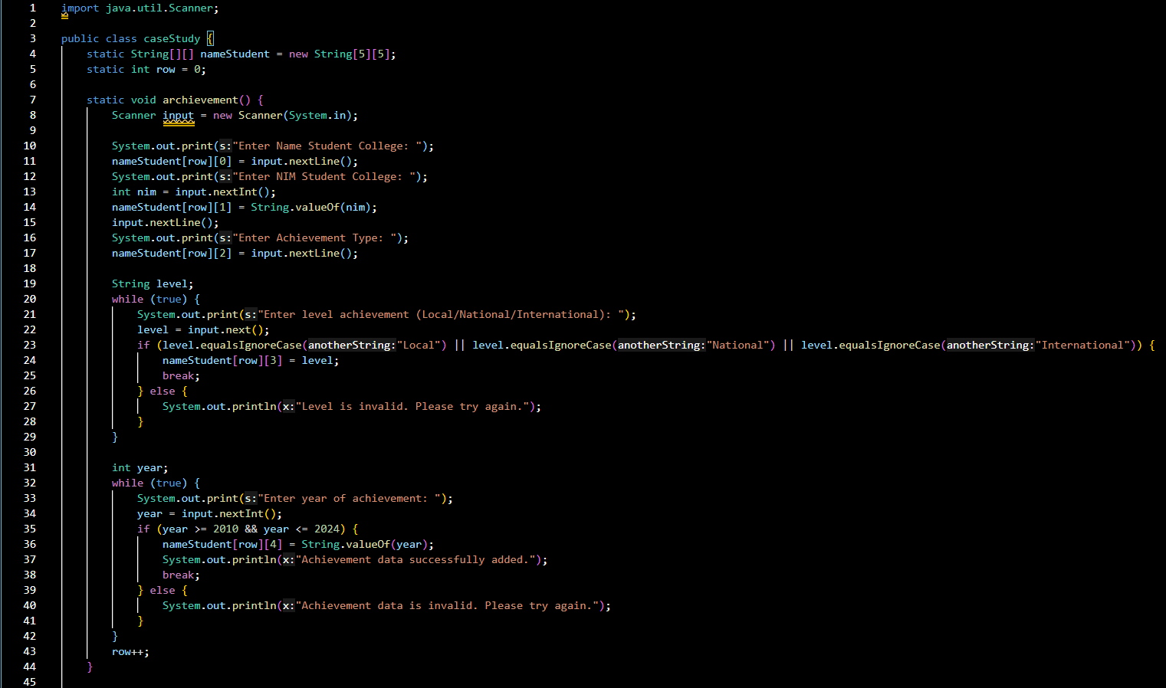Analyze student achievement based on the type of achievement selected by the user, by displaying the Name, NIM, Level, and Year of the appropriate achievement.

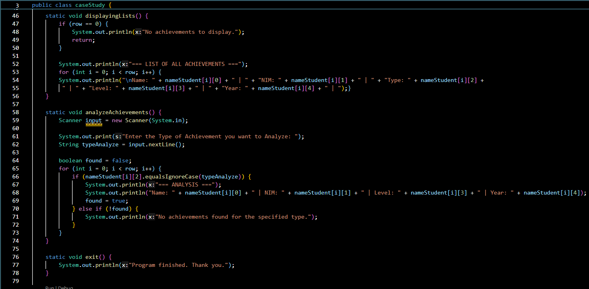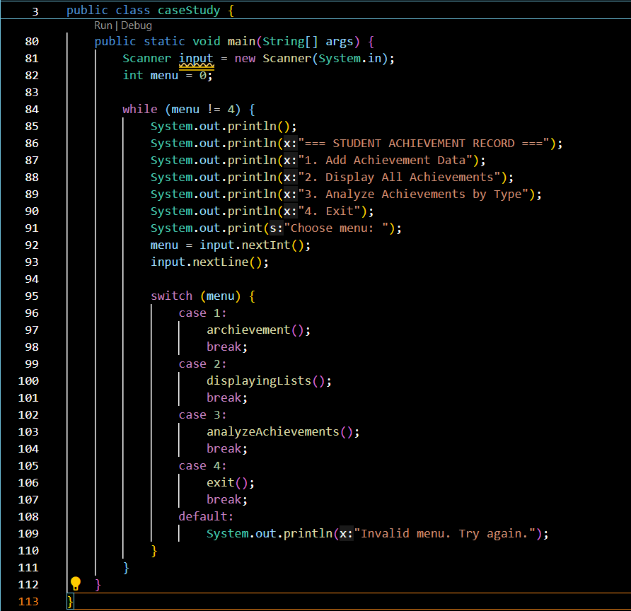

**The output**

