Quick—TECH TEAM

The idea is about book store which suitable for all ages.

We discuss about it.

* 1-What problem are we solving?

-make blind person read , the read is hard , and the book is very cheap prices ,

* 2- Why are we solving this problem?

- base audions is very large and they have big problem about books shortage in market

* 3- What is the problem scale?

- world wide

* 4 - Who are we designing for?

- blind , and all readers

* 5- What age group are we designing for? Why?

cheldern, adult , teenage to make them good readers

* 6 - What are their needs and goals? Why?

- to gain knowlage from that by reading or hearing

* 7- What are their desires when using the product?

Gain knowledge

* 8 - What do we do differently than the market?

- audio books , the color is very quiet and comfort for your eye , many language for the books

Priority matrix

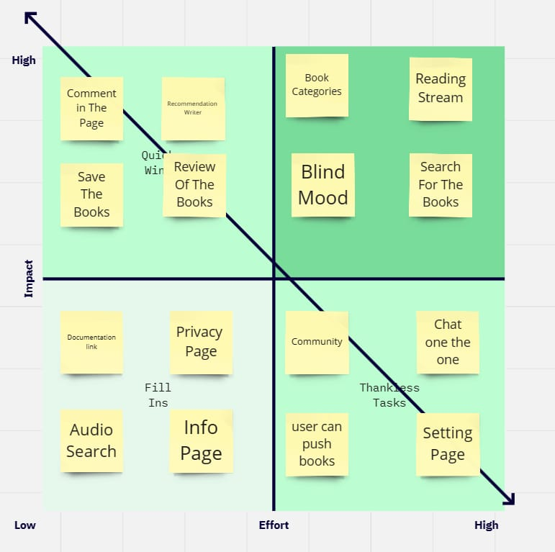

Figma design

<https://www.figma.com/file/d7nUKBu0tEPb08cveLGJtz/Audio-Books?type=design&node-id=34-37&mode=design&t=h1S4rgqTq6vnnoaR-0>

final project source code

<https://github.com/hamdy-farg/final-project.git>