Five steps of test-driven development

There are 5 steps in the TDD flow:

1. Read, understand, and process the feature or bug request.
2. Translate the requirement by writing a unit test. If you have hot reloading set up, the unit test will run and fail as no code is implemented yet.
3. Write and implement the code that fulfills the requirement. Run all tests and they should pass, if not repeat this step.
4. Clean up your code by refactoring.
5. Rinse, lather and repeat.

Figure 1 shows these steps and their agile, cyclical, and iterative nature: 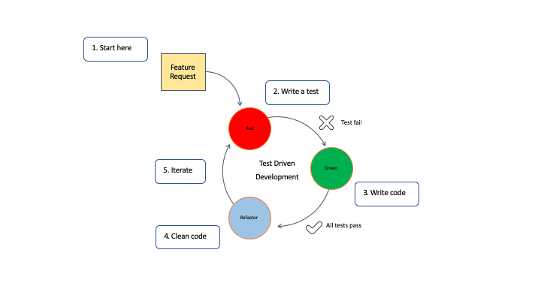

This workflow is sometimes called Red-Green-Refactoring, which comes from the status of the tests within the cycle.

* The red phase indicates that code does not work.
* The green phase indicates that everything is working, but not necessary in the most optimal way.
* The blue phase indicates that the tester is refactoring the code, but is confident their code is covered with tests which gives the tester confidence to change and improve our code.