Sensing Distance
The sensor on the wheel encoder module should be spaced about 0.1" (2.54mm) away or less from the encoder wheel for best sensing results. The geometry of the encoder module is laid out such that it must read the band of white/black transitions on the encoder disk at a diameter of 1.875" (see diagram below).
Below is a diagram showing the proper mounting position of the quadrature encoder modules to the encoder disk. The middle of the sensors should lie on a 1.875" diameter, where the sensor in the middle of the board lines up with the center of the encoder wheel. Legend: Black squares (sensors), Green rectangle (encoder module board), Red bands (encoder disk bands).
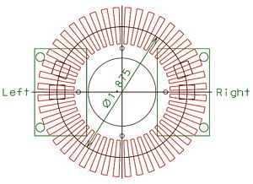

Encoder Pinout
Below is the pinout for the quadrature encoder modules:
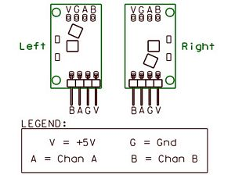

Encoder Truth Table
Below is a graph of the states of the quadrature wheel encoder which can be used to develop an algorithm for decoding the pulse train.
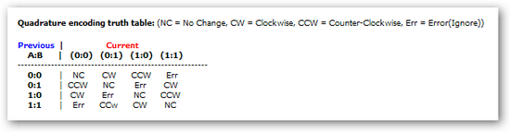

Encoder Digital Output Graph
Below is a graph of quadrature encoder module output (using our laser engraved 44 spoke encoder disks). Notice transistions are approximately 90 degrees out of phase.
