SiteForge ERP — Role Guides
Step-by-step guides for each role, from sign-in to end of day, with screenshots.
Role · One-line duty · Guide

Project Director · Full oversight — approve/certify everything, manage users, review audit · [director.md](director.md)
Financial Controller · Money — approvals within limits, AR/AP, payroll, retention, payables · [controller.md](controller.md)
Field Superintendent · Field data — daily reports, timesheets, POs, change orders, receiving · [field-superintendent.md](field-superintendent.md)
Tradesperson Lead · Narrow — log own time, view drawings/timeline, submit site reports · [tradesperson-lead.md](tradesperson-lead.md)

How the app is organised
The left sidebar is split into COMPANY (whole business) and PROJECT (one selected project,
chosen from the selector in the top bar). The SYSTEM section holds Settings/Users/History.
Each guide shows which of these you can see.

Where the screenshots live
docs/screenshots/guides/<role>/ — one PNG per screen. They are captured from the real app
(signed in as that role against sample data), so what you see on screen will match these images
after your own data is loaded.

Shared basics (every role)
- Sign in — username + password on the login screen.

- Notifications — the 🔔 button shows compliance alerts, budget alerts and system messages.
Dismiss individual items with ✕ or Mark all read.
- Theme/language — ⚙ Settings → Appearance → dark/light, font, size, and English/العربية.
- Select a project — the dropdown in the top bar; PROJECT views only appear after you pick one.

Approval concepts (who can decide what)
- Only Directors and Controllers can approve/reject.
- Segregation of duties: you cannot approve something you submitted yourself.
- Limits of authority: Directors are unlimited; Controllers are capped per table (default
AED 100k) and Field Superintendents are capped (AED 25k) — an over-limit item is refused.
- Evidence: above a per-table threshold an approval needs an attached document first (📎).
- Every decision is written to an immutable audit log (🕓 timeline).
Continue to your role's guide for the full day-by-day walkthrough.

Project Director — Day Guide
The Project Director has full access: approve and certify every record, manage users, watch the
audit trail, and run the financial/management views. You are the only role that can approve anything
without a money cap, and the only one who can manage users and see the full history.
You can open: Dashboard, Projects, Expenses, Budget, Workers, Compliance, Settings, Users,
History, Approvals, Financial Accounts, Suppliers & Contractors, Management Exceptions, and — inside
a project — Overview, BOQ, Drawings, Timeline, Materials/POs, Payments, Parties, Change Orders,
Timesheets, Payroll, Audit, Reports, Progress Billing (IPC), Site Reports, Payment Requests, Payslips,
Receiving/GRN, Retention, and Measurement & Certificates.

1. Start of day — see the whole business
- Sign in. You land on the Company Dashboard (KPIs: cash, pending approvals, overruns, alerts).
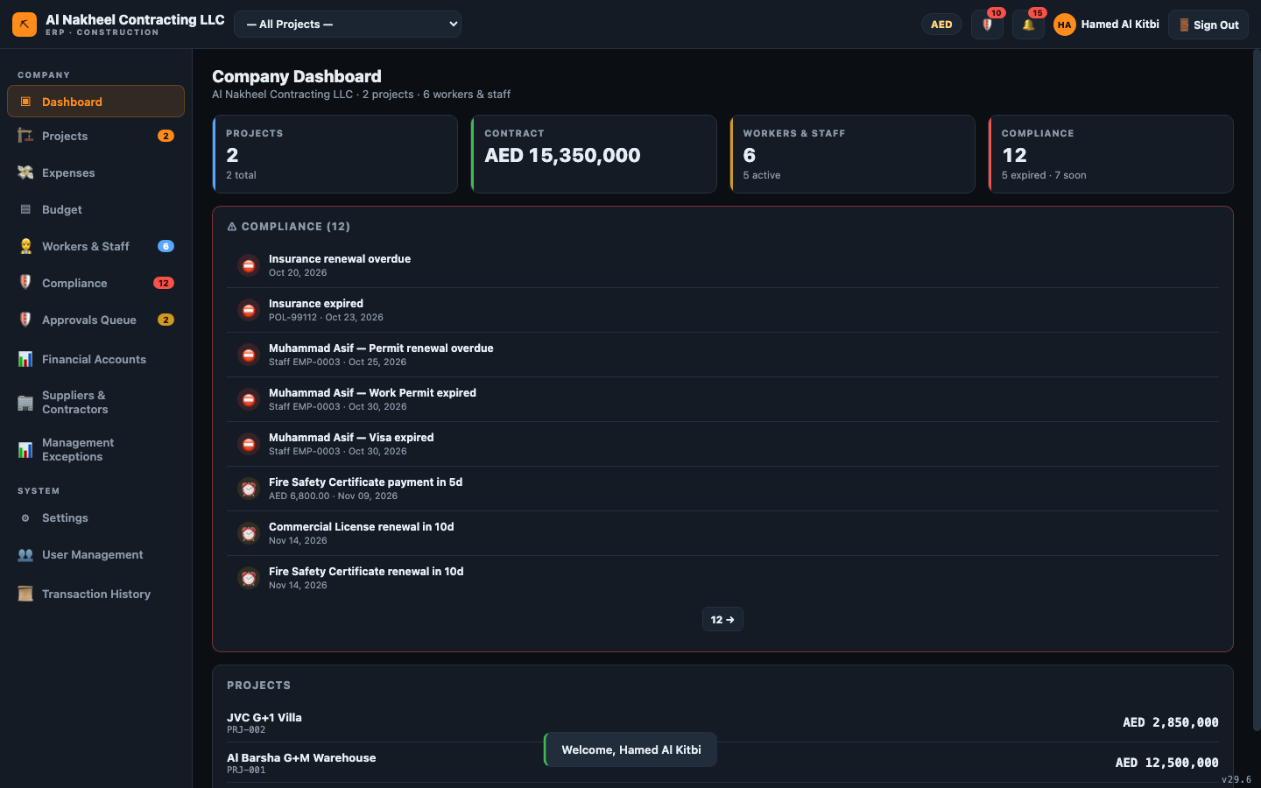
- Open 🔔 Notifications and clear or act on compliance/budget alerts (dismiss with ✕ or
Mark all read).
- Open 🛡️ Approvals Queue — this is your main morning task (step 2 below).

2. Clear the approvals queue
- Open Approvals Queue. Use the tabs to triage: Inbox: All / For me / By me / Overdue.
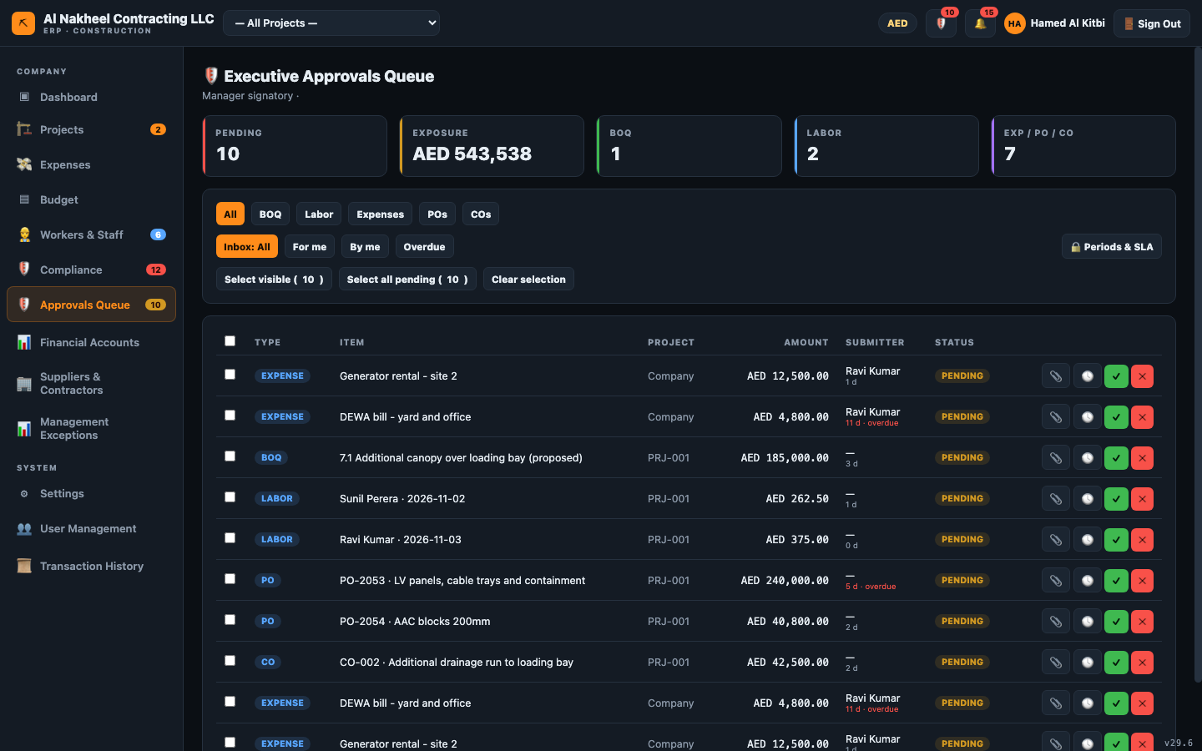
- For each pending item:
- 🕓 opens the decision history; 📎 opens evidence attachments.
- If the amount needs evidence and none is attached, the system refuses — attach the document
first (📎 → Add evidence).
- ✓ Approve or ✕ Reject (rejection requires a reason).
- You cannot approve something you submitted yourself (segregation of duties).
- Repeat until the queue is empty.

3. Financial health
- Open Financial Accounts → Receivables, Payables, Balance Sheet, Profit & Loss.
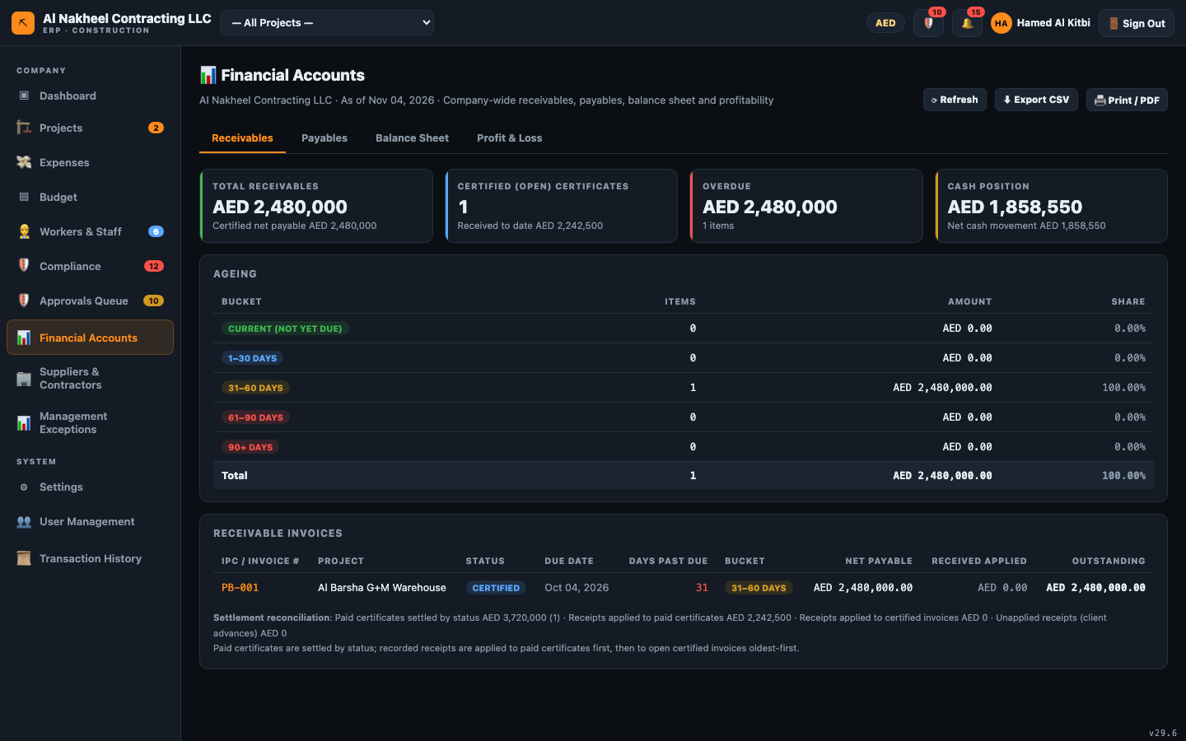
- Check the Balance Sheet — it shows retained/released retention netted, and must show the
green "Balanced" badge (assets = liabilities + equity).
- Open Management Exceptions for the red flags: overdue approvals, unlinked costs, duplicate
supplier invoices, committed-but-undelivered POs, open retention.
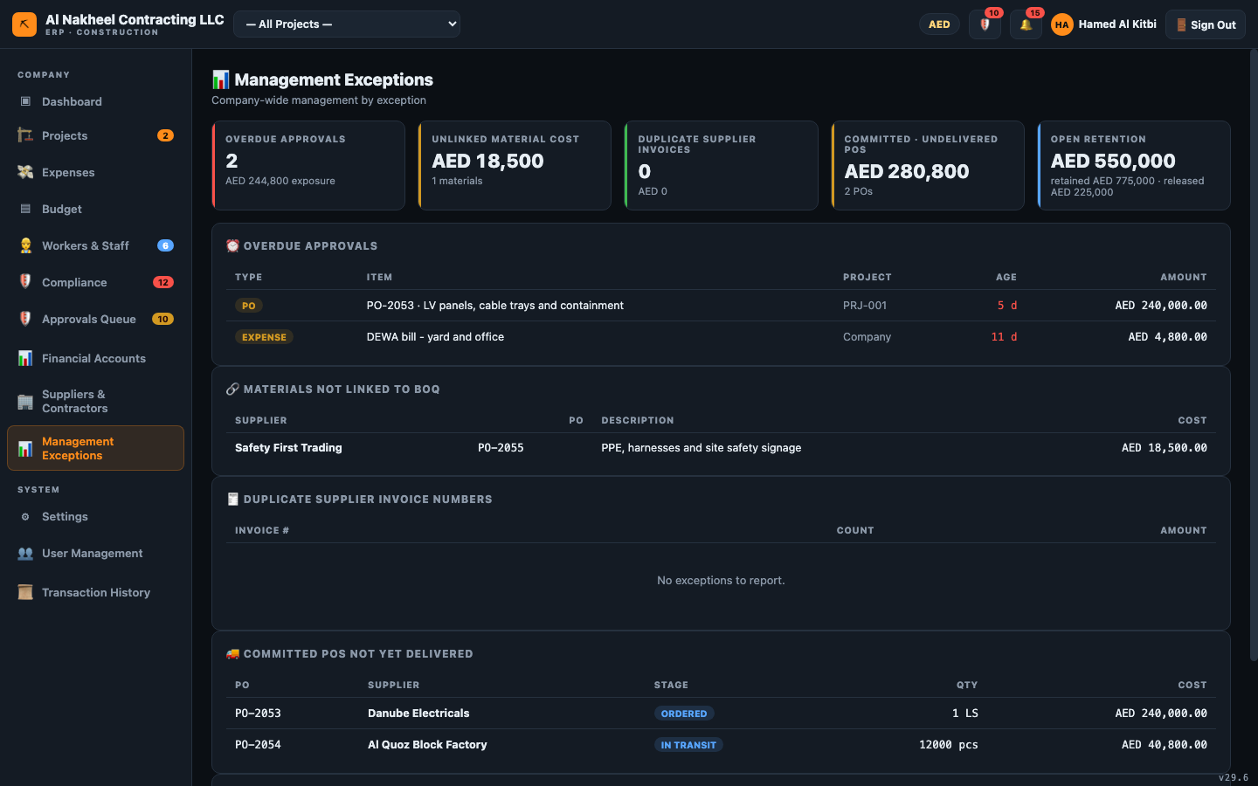

4. Suppliers, budget, people
- Suppliers & Contractors — maintain the company-wide vendor master and link suppliers to
projects (bank/TRN/terms live here).
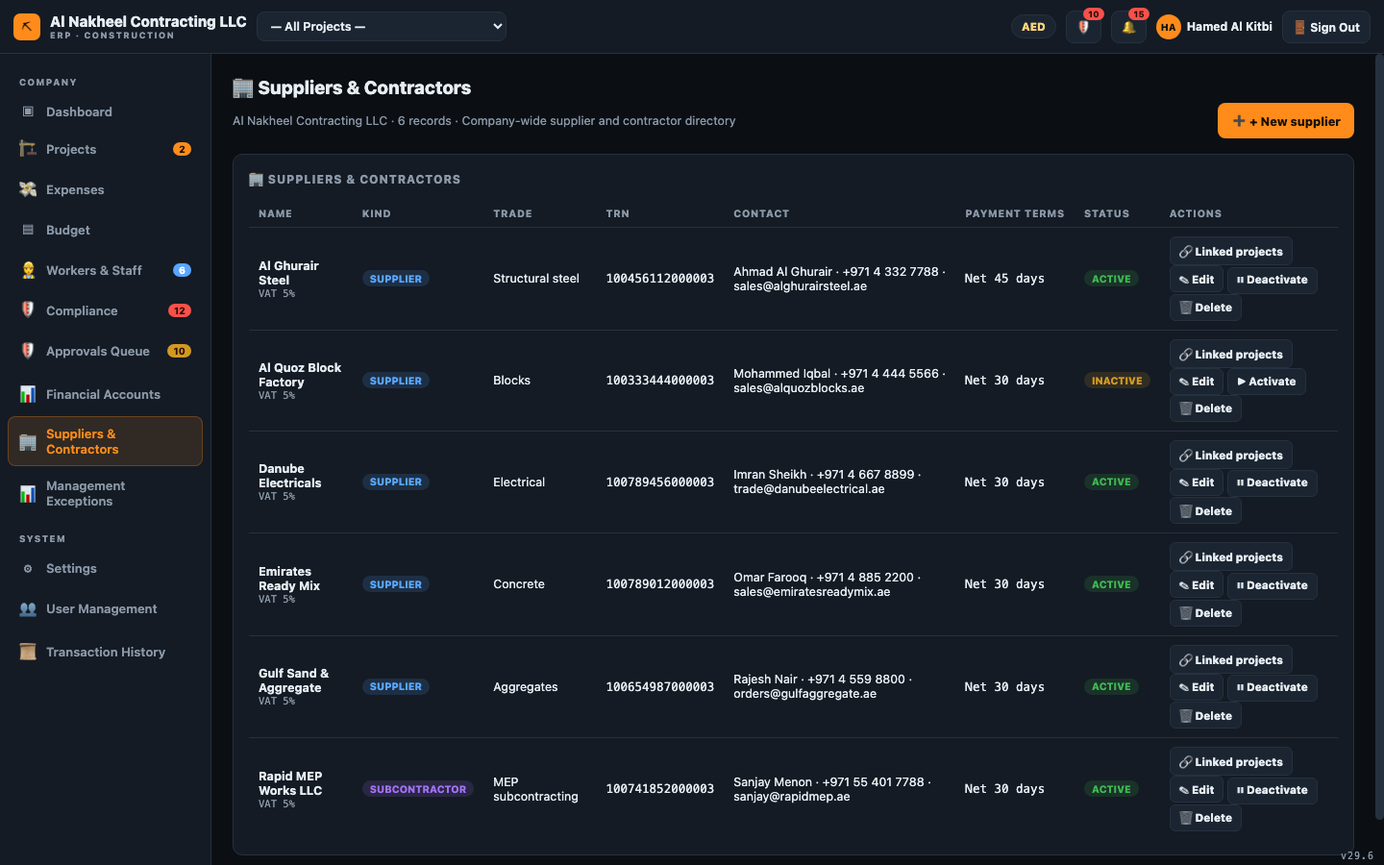
- Company Budget and Expenses — review spend vs budget and approve expenses.
- Workers & Staff — maintain the register (salary, loan balance, permits).
- Compliance — check expiring permits/visas and act on overdue items.

5. Work a project (pick one from the top bar)
- Open a project → Overview for the project KPIs.
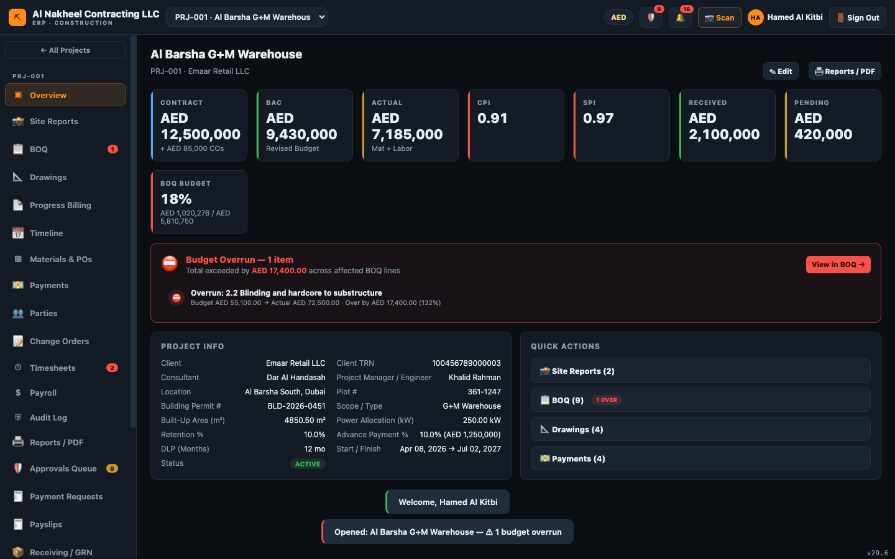
- BOQ — review budget vs actual vs committed (POs still Ordered/In Transit show as
committed, not actual).
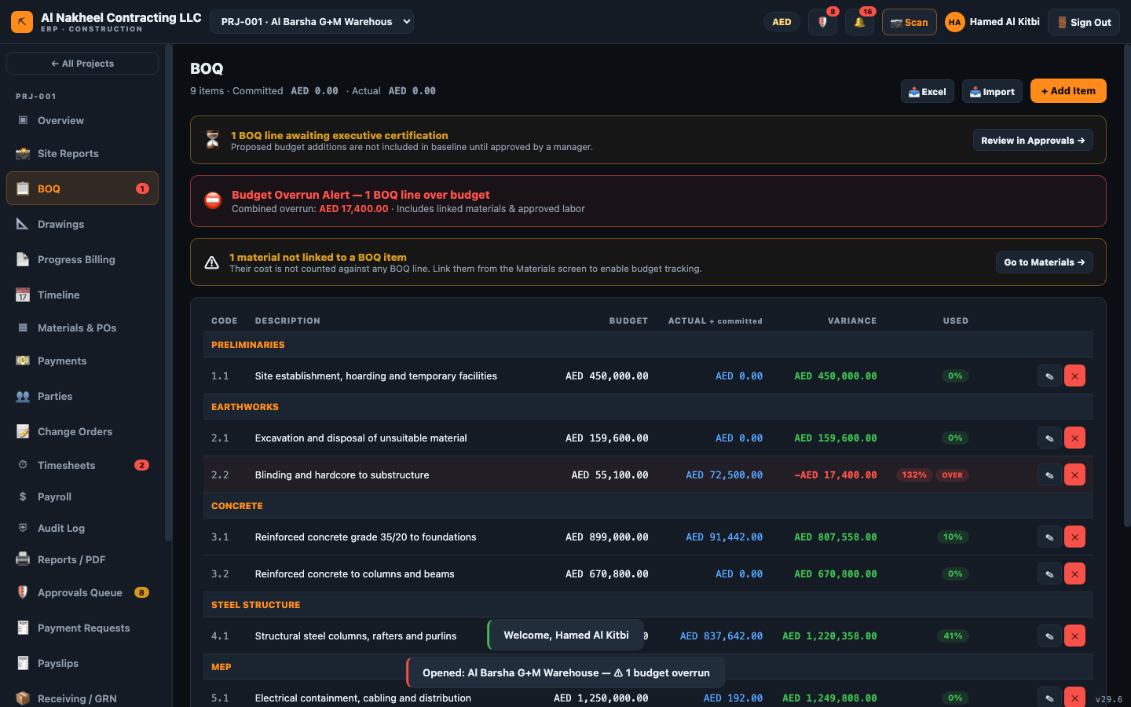
- Progress Billing (IPC) — create/certify IPCs. Certifying syncs the receivable into Payments.
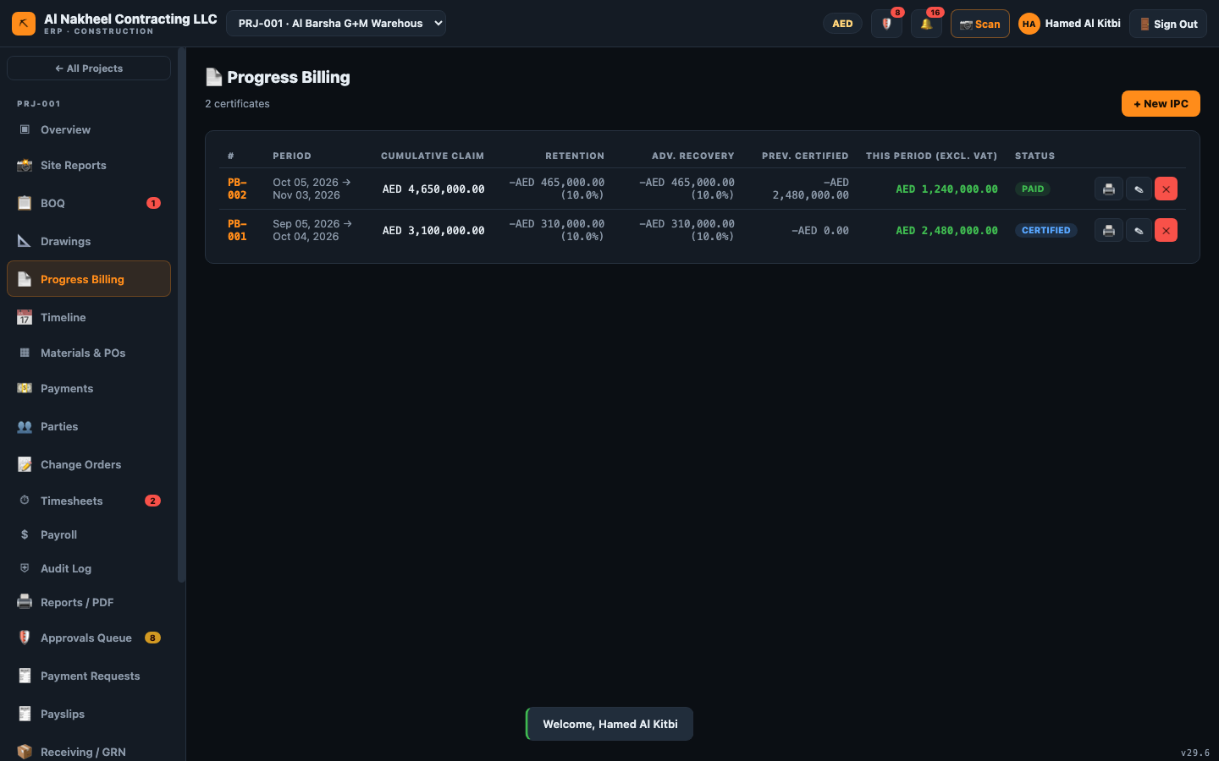
- Materials & POs — approve POs; on a delivered/approved PO press 🧾 to convert it into a
supplier payable invoice (5% VAT, 30-day terms). A goods receipt is required first (3-way match).
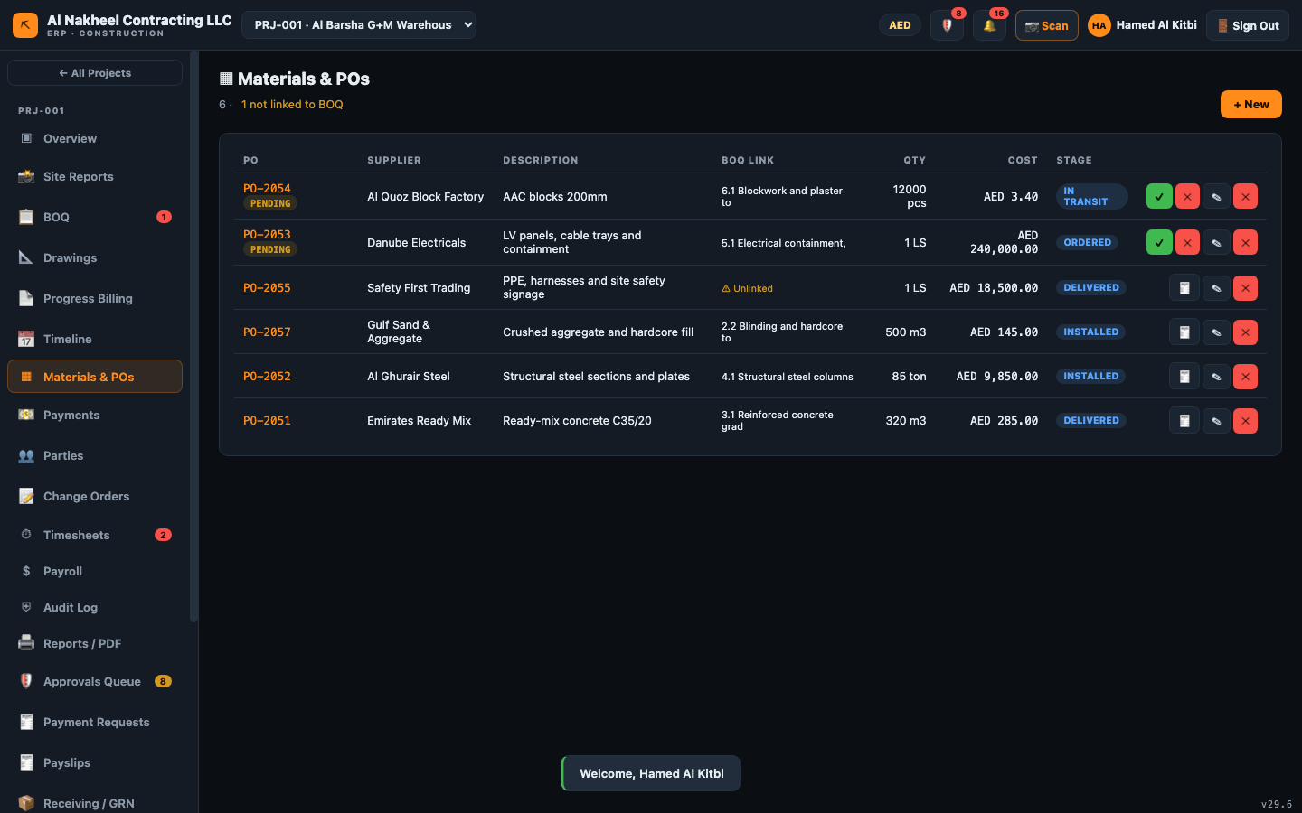
- Change Orders — approve them; an approved CO auto-creates a Variations BOQ line.
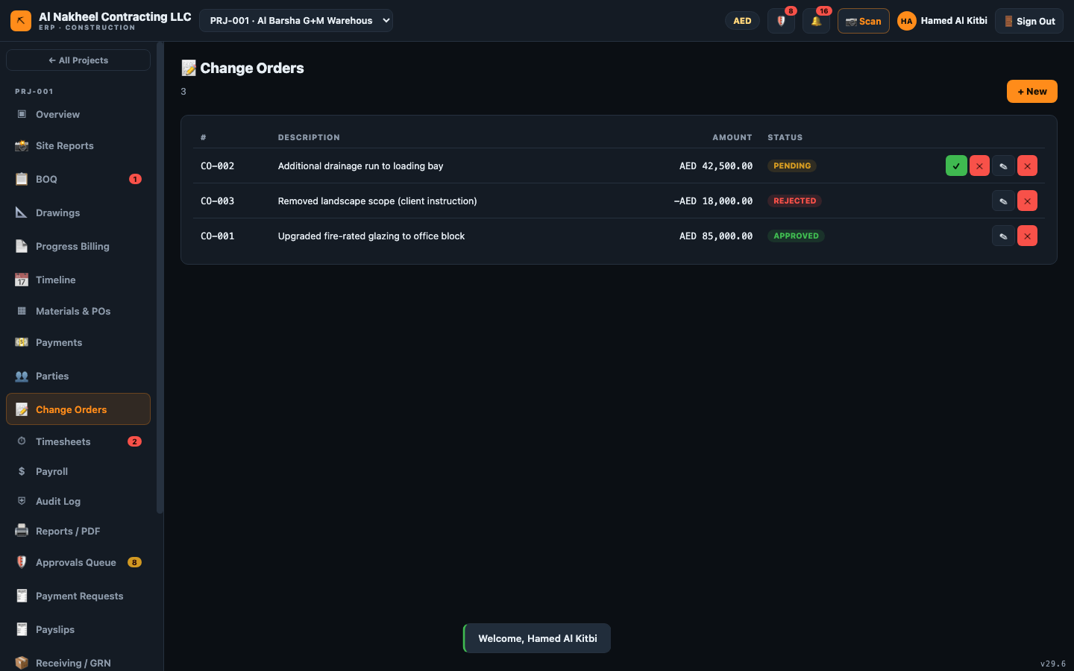
- Payment Requests — approve subcontractor/supplier claims (submit → approve → mark paid).
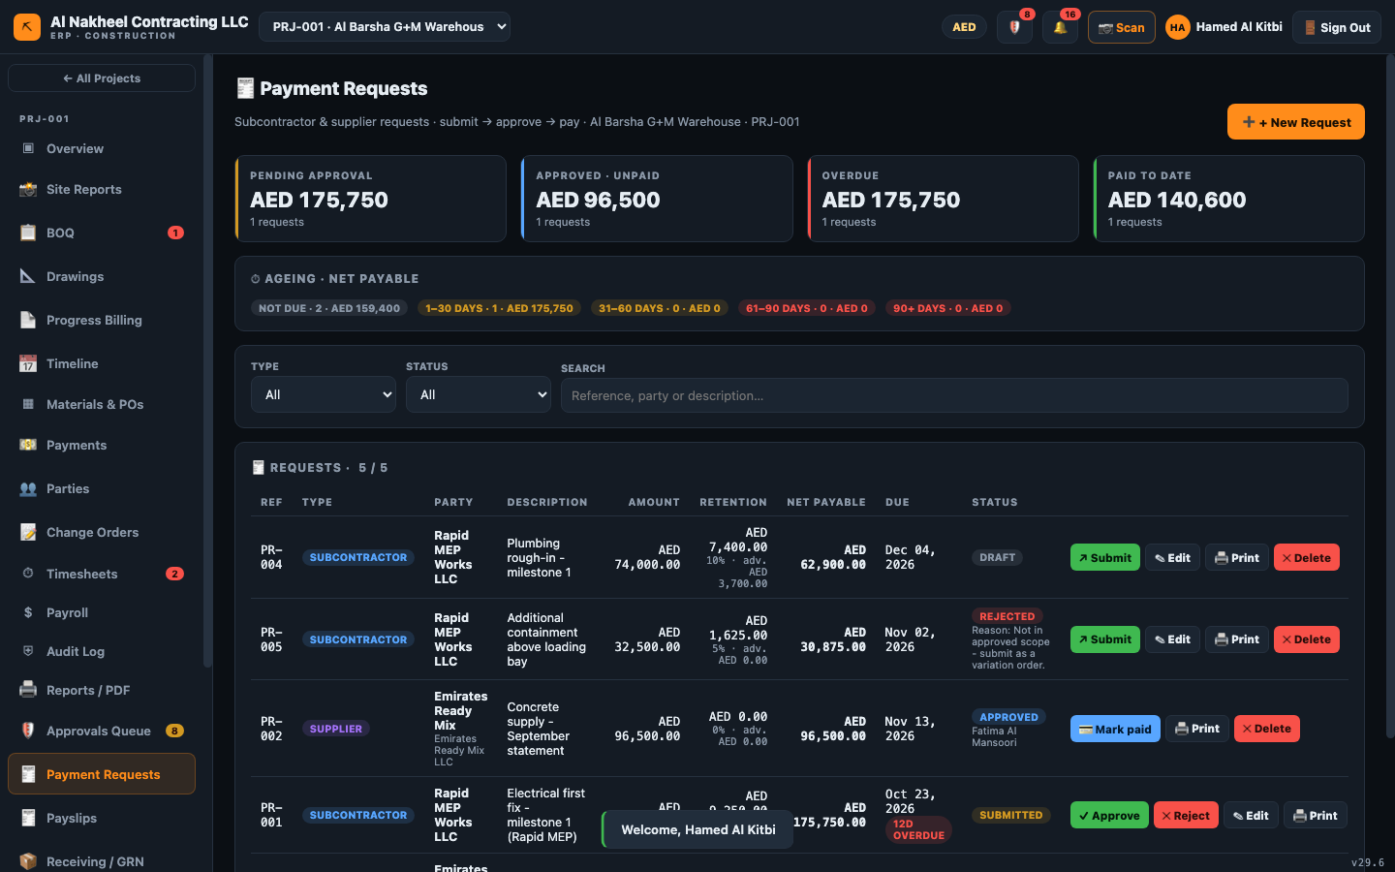

6. Field & labour
- Timesheets — review submitted labour; approve.
- Payroll — run the Unified Monthly Payroll (basic + 1.5× approved OT − loan) which updates
each worker's loan balance and posts the salaries expense.
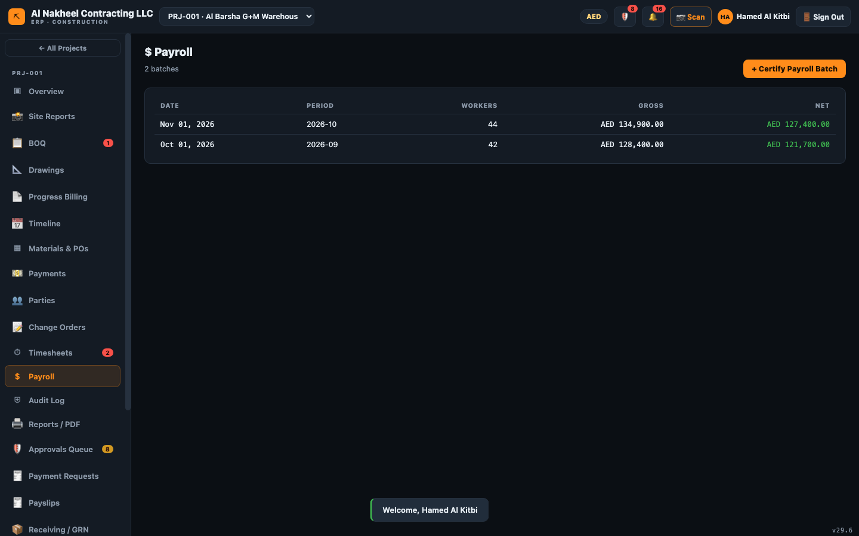
- Payslips — generate per-worker slips and print/PDF.
- Site Reports — review daily reports with photo evidence.
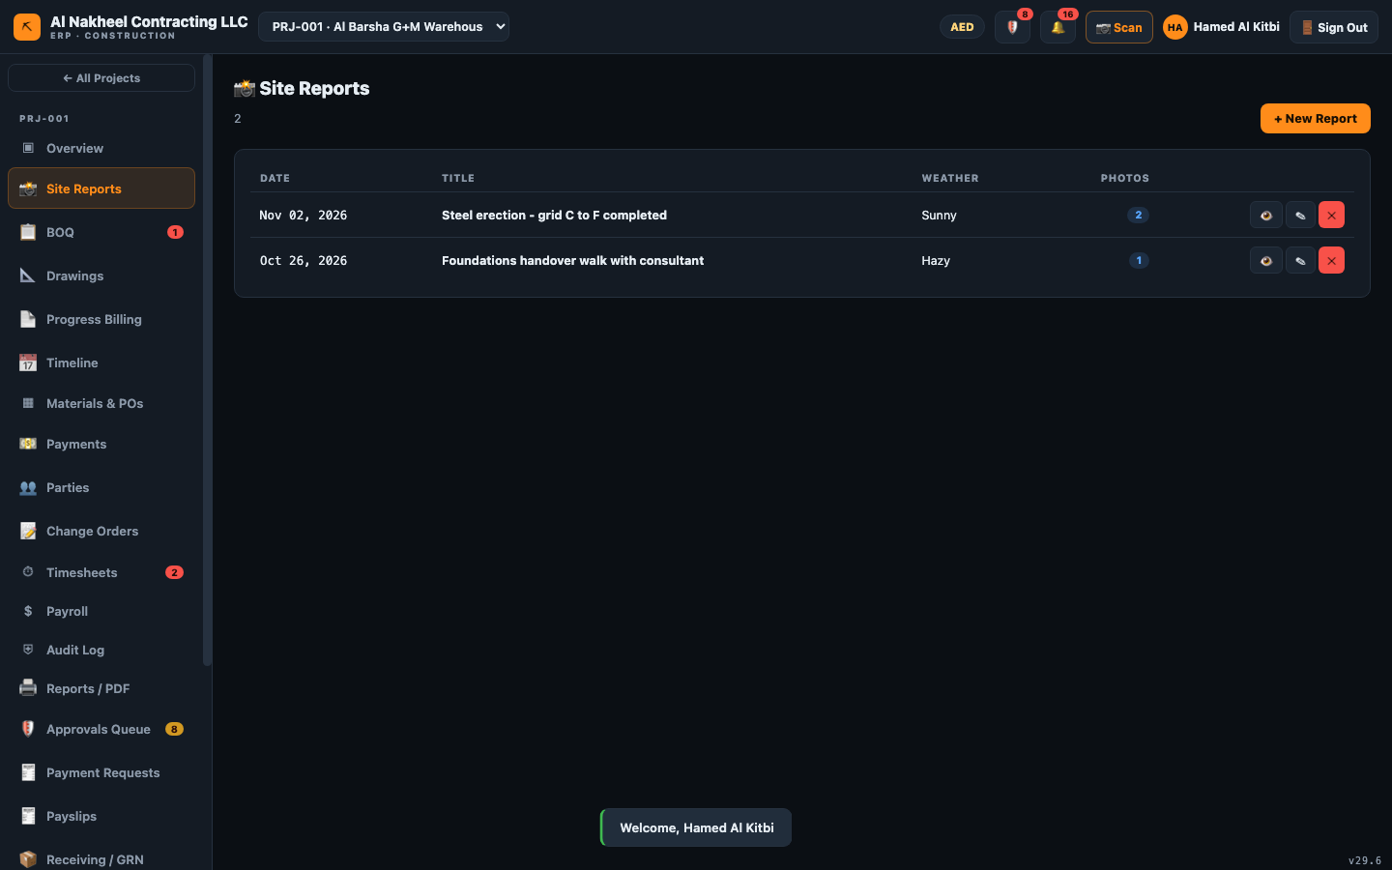

7. Receiving, retention, certificates
- Receiving / GRN — record goods received against POs (this unblocks PO billing and payment).
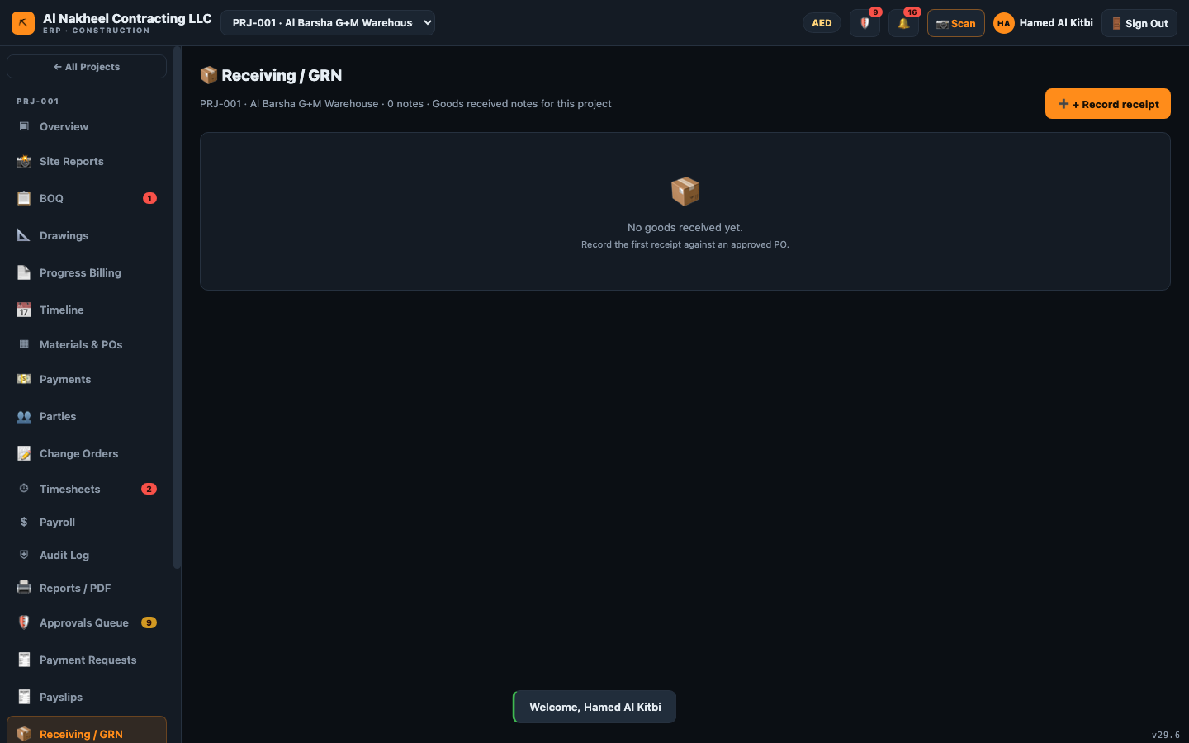
- Retention — release retention per project (amount ≤ open, reason required).
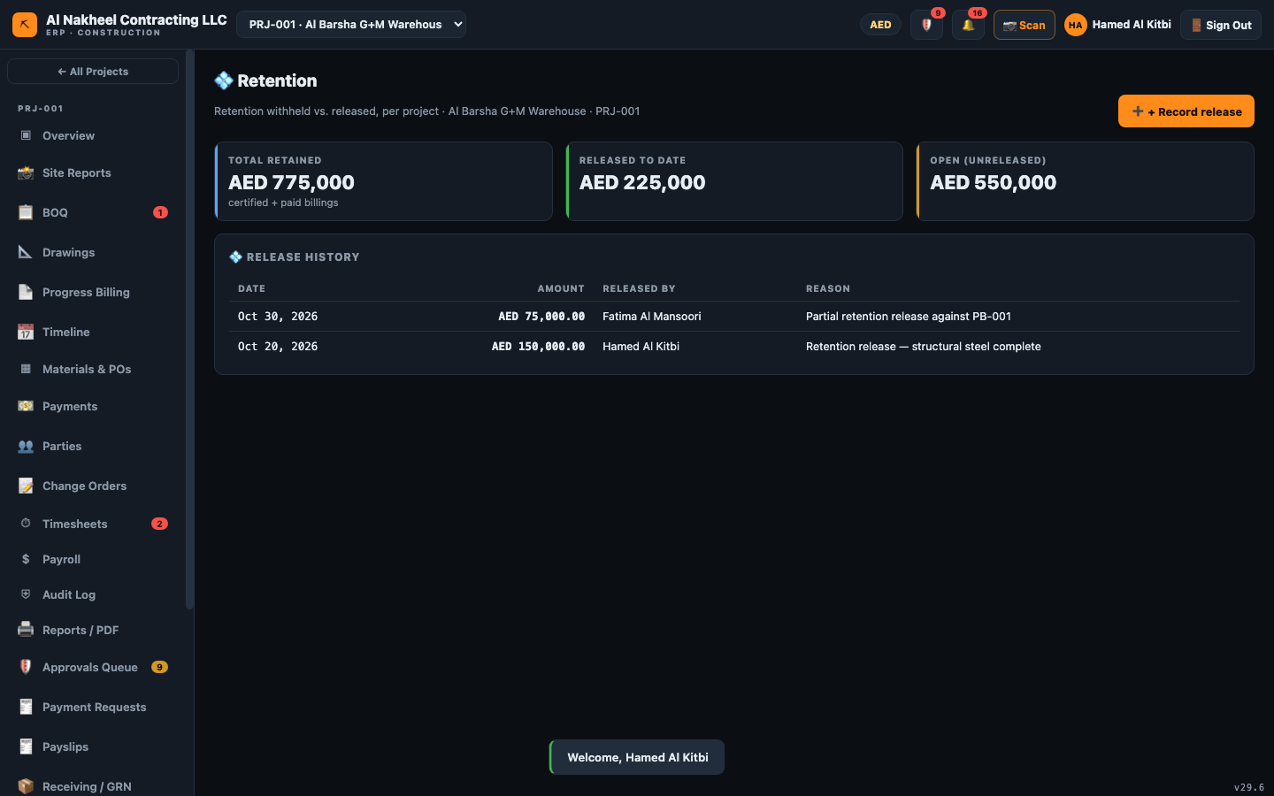
- Measurement & Certificates — measure BOQ quantities, certify, and generate a subcontractor
payment request.
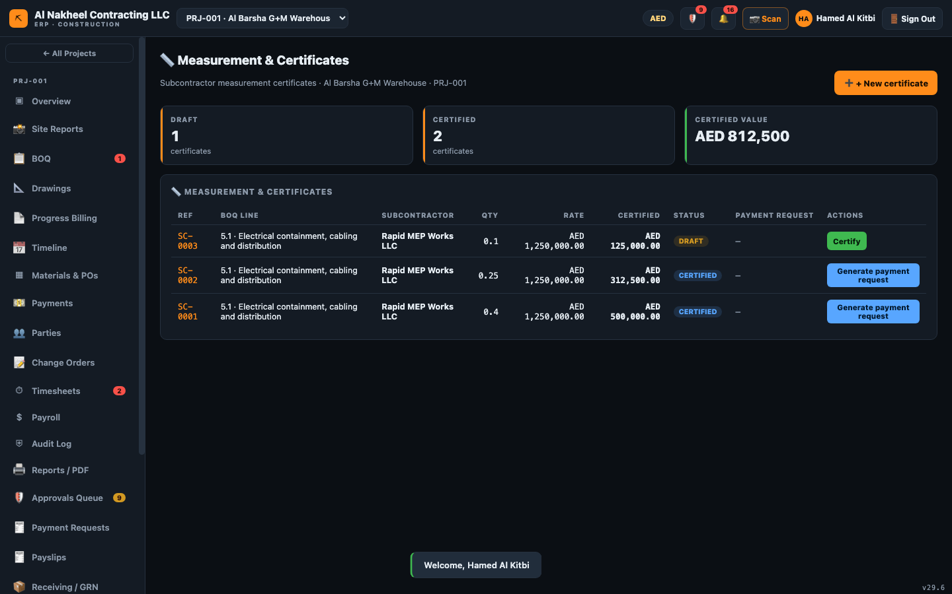

8. Month-end & governance
- Open 🔒 Periods & SLA (in the Approvals header) → close the month to lock writes, set the
approval SLA in days.
- Users — add/disable users, assign roles, reset passwords.
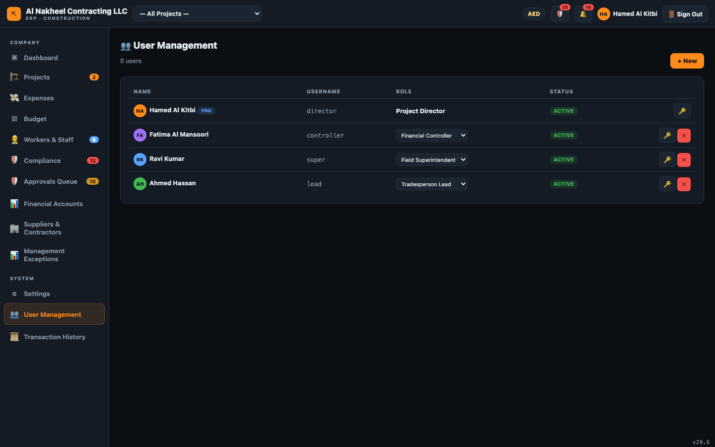
- History — review the full audit trail (who did what, when).
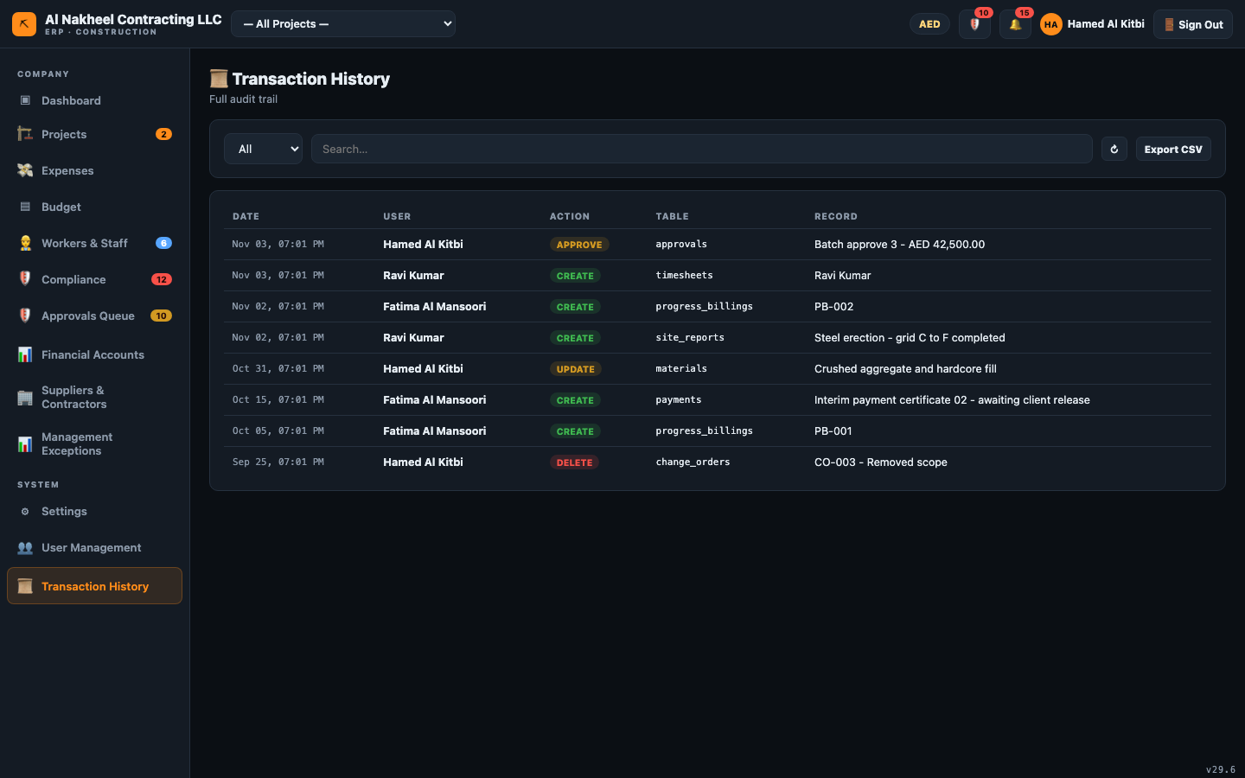
- Settings — branding (logo), language, theme.

9. End of day
- Confirm the approvals queue is empty (or items are delegated/flagged).
- Check the Balance Sheet "Balanced" badge and the Management Exceptions screen for anything red.
- If it's month-end, close the period; if it's payroll day, certify the payroll run.

Financial Controller — Day Guide
The Financial Controller owns the money: approvals (within your limit), receivables/payables,
payroll, retention and payment requests. You can approve and reject, but your limit of authority is
capped per table (default AED 100,000) — anything larger is refused unless a Director approves it.
You cannot manage users or view the full history.
You can open: Dashboard, Projects, Expenses, Budget, Workers, Compliance, Settings, Approvals,
Financial Accounts, Suppliers & Contractors, Management Exceptions, and — inside a project — Overview,
BOQ, Drawings, Timeline, Materials/POs, Payments, Parties, Change Orders, Timesheets, Payroll, Audit,
Reports, Progress Billing, Site Reports, Payment Requests, Payslips, Receiving/GRN, Retention, and
Measurement & Certificates. *(No Users, no History.)*

1. Start of day
- Sign in → Company Dashboard.
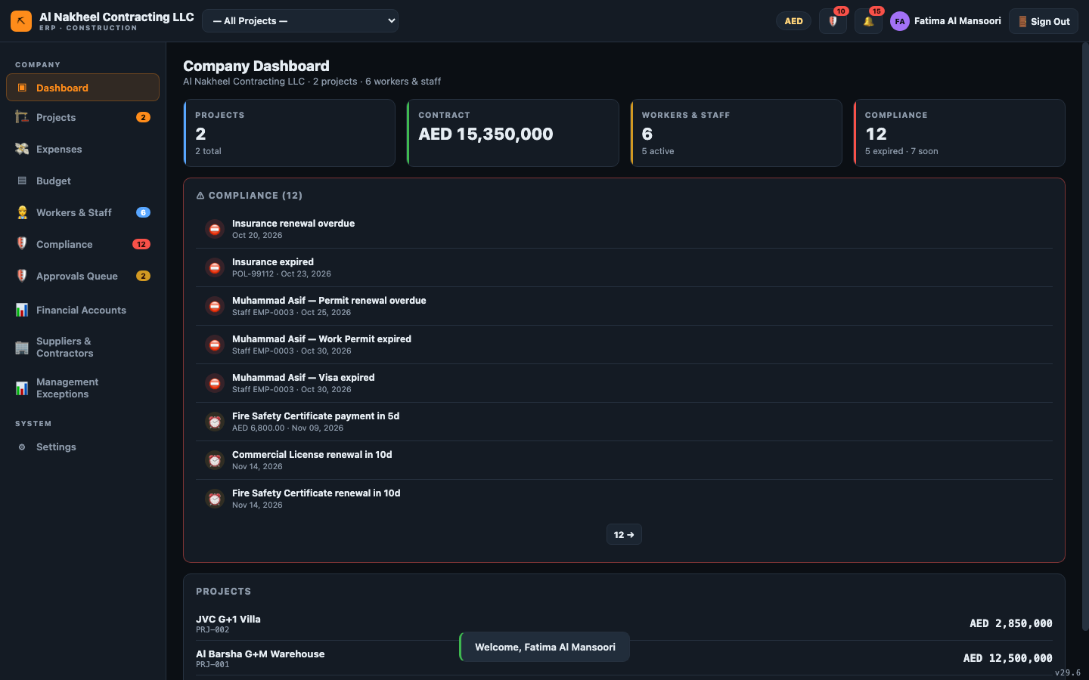
- Clear the 🔔 notifications (dismiss compliance/budget alerts or Mark all read).

2. Approvals (within your limit)
- Open 🛡️ Approvals Queue → For me / Overdue tabs.
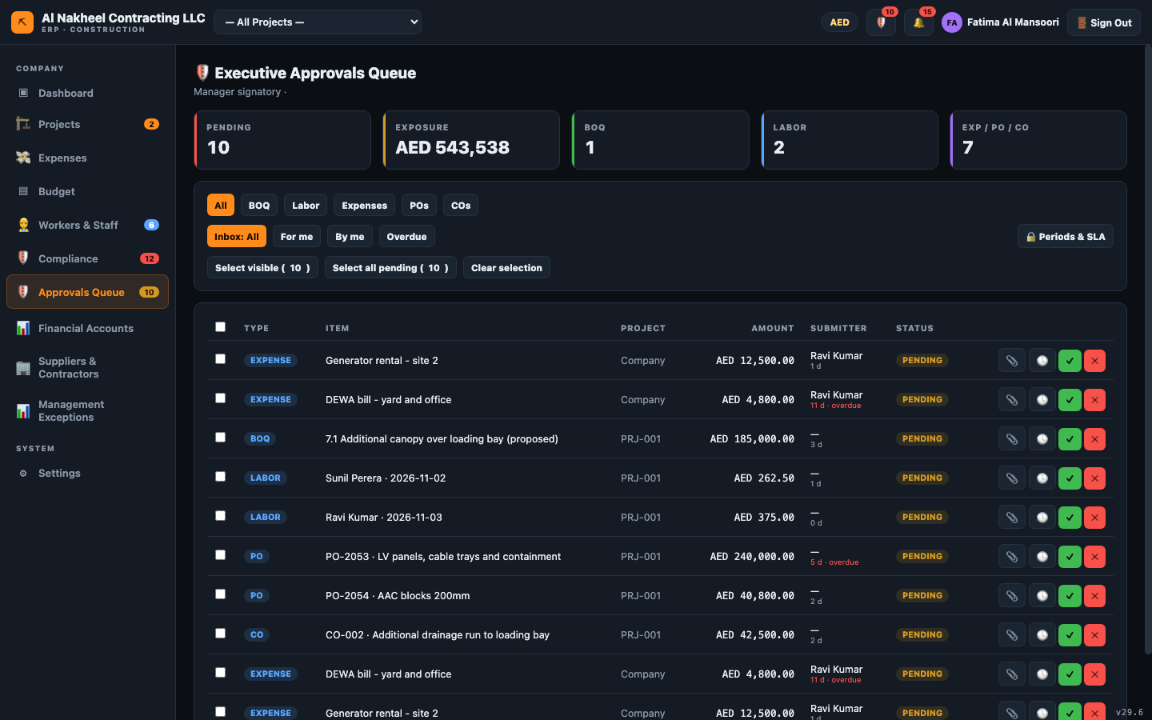
- Review each item (🕓 history, 📎 evidence). Attach evidence when the amount requires it.
- ✓ Approve or ✕ Reject (with reason). An item above your limit is refused — a Director
must sign it. You also cannot approve your own submission.

3. Financial accounts (your core screen)
- Open Financial Accounts: Receivables, Payables, Balance Sheet, Profit & Loss.
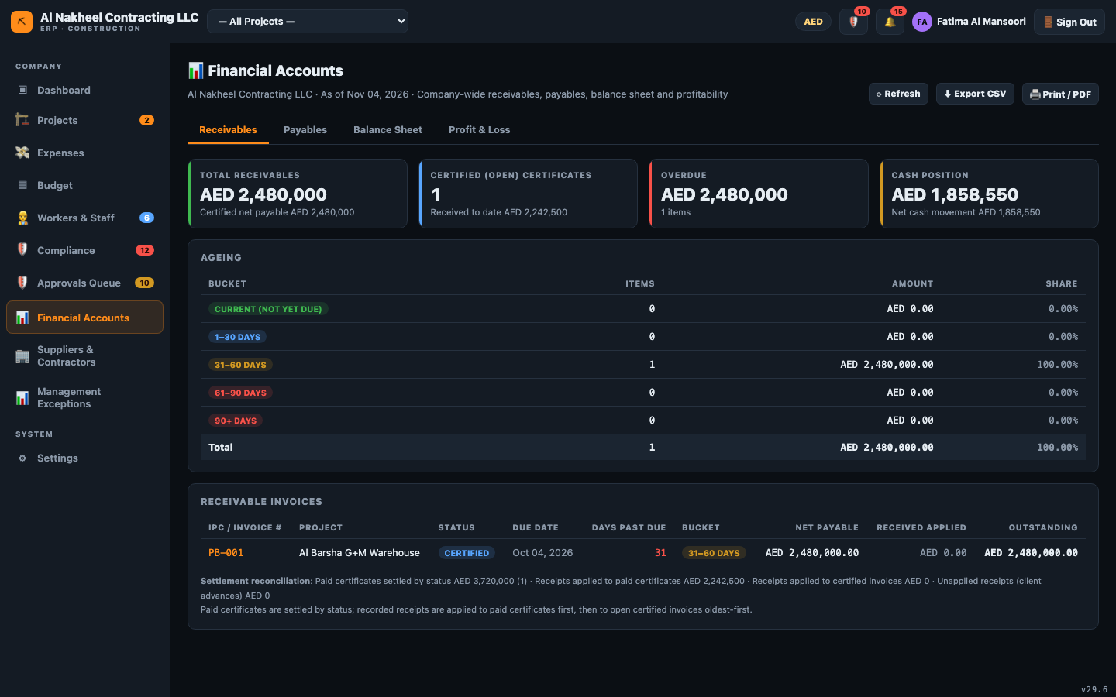
- Enter/verify opening balances (Balance Sheet → Opening balances).
- Confirm the balance sheet shows the green Balanced badge.

4. Payables & cash
- Payment Requests — approve subcontractor/supplier claims within your limit, then mark them paid.
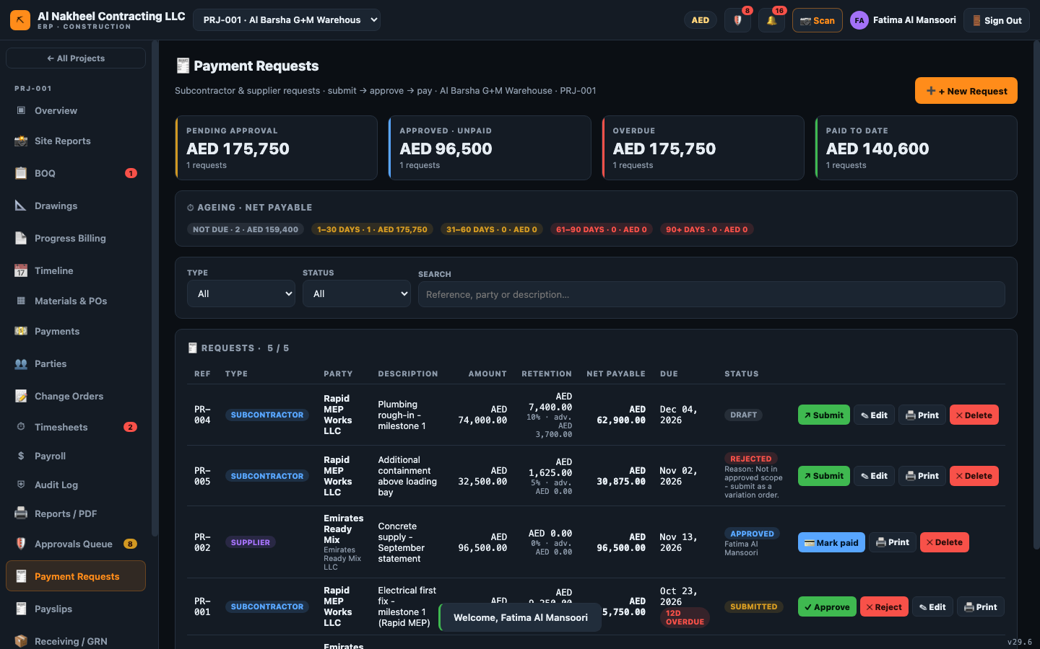
- Payments — record receipts/payments; marking a supplier invoice paid is blocked until its
PO has a matching goods receipt.
- Suppliers & Contractors — maintain the vendor master (bank/TRN/terms).
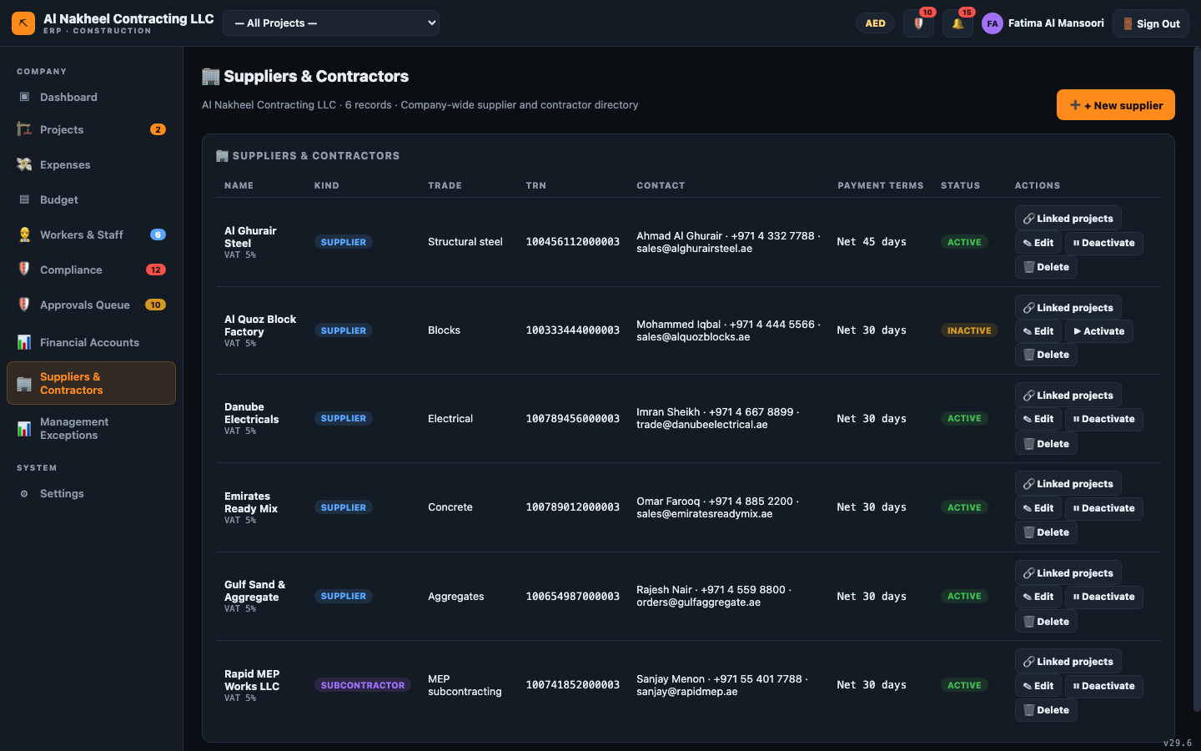

5. Payroll & people
- Payroll — run the unified monthly payroll (basic + 1.5× approved OT − loan), which updates
worker loan balances and posts the salaries expense.
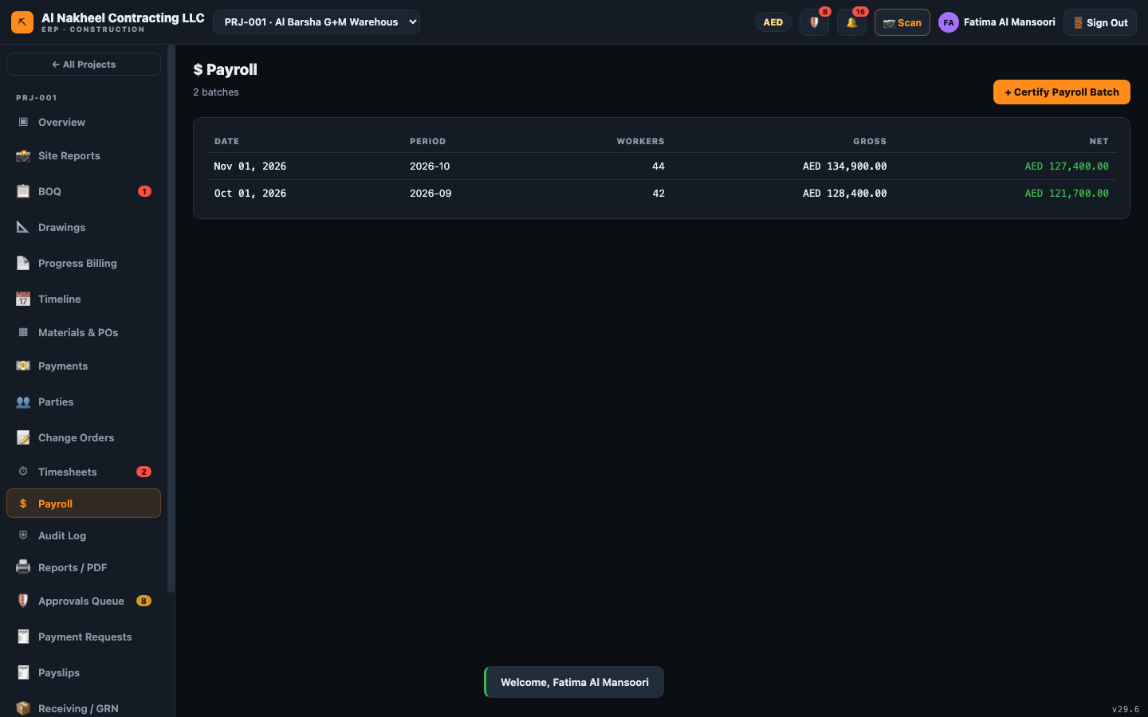
- Payslips — generate and print per-worker slips.
- Workers & Staff — review the register (salary, loans).
- Expenses and Company Budget — approve and review spend vs budget.

6. Project close-out
- Progress Billing (IPC) — certify IPCs (this syncs the receivable into Payments).
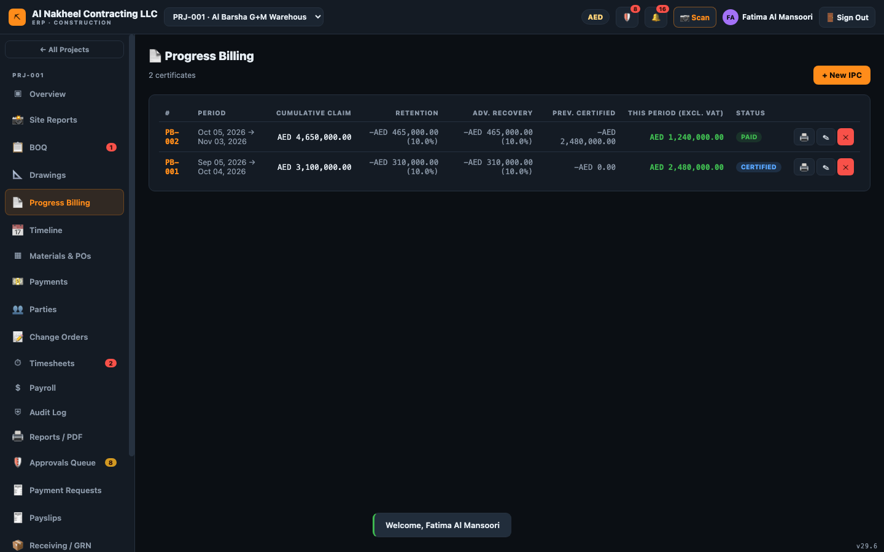
- Materials & POs — approve POs; convert delivered POs to supplier bills (🧾, requires GRN).
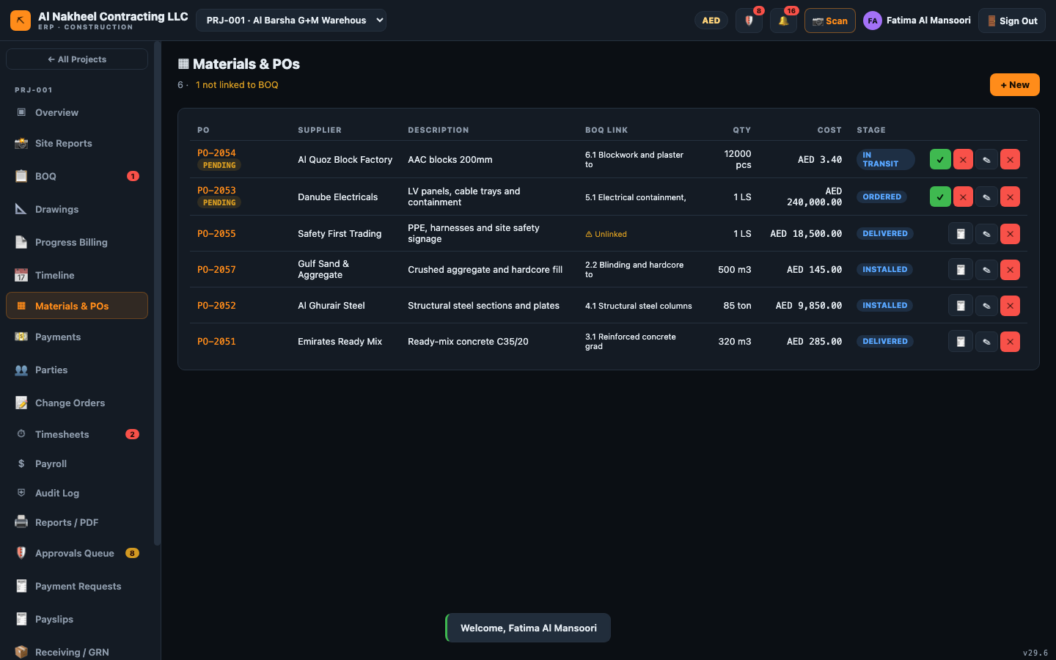
- Receiving / GRN — record goods received (unblocks billing/payment).
- Retention — release retention per project (≤ open, reason required).
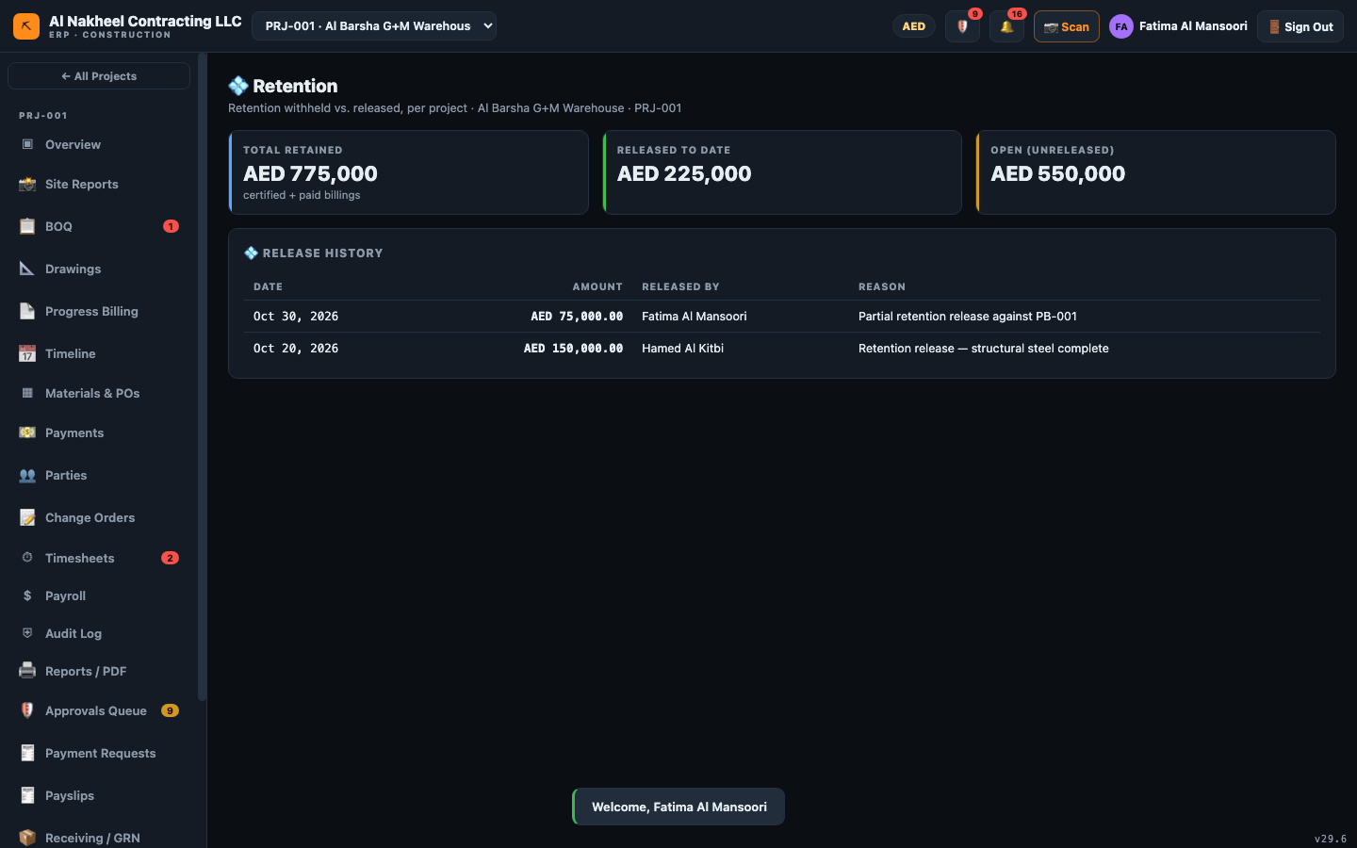
- Measurement & Certificates — certify measured quantities and generate subcontractor payment
requests.

7. Oversight
- Management Exceptions — review red flags (duplicate invoices, unlinked costs, overdue approvals,
committed-not-delivered POs, open retention).
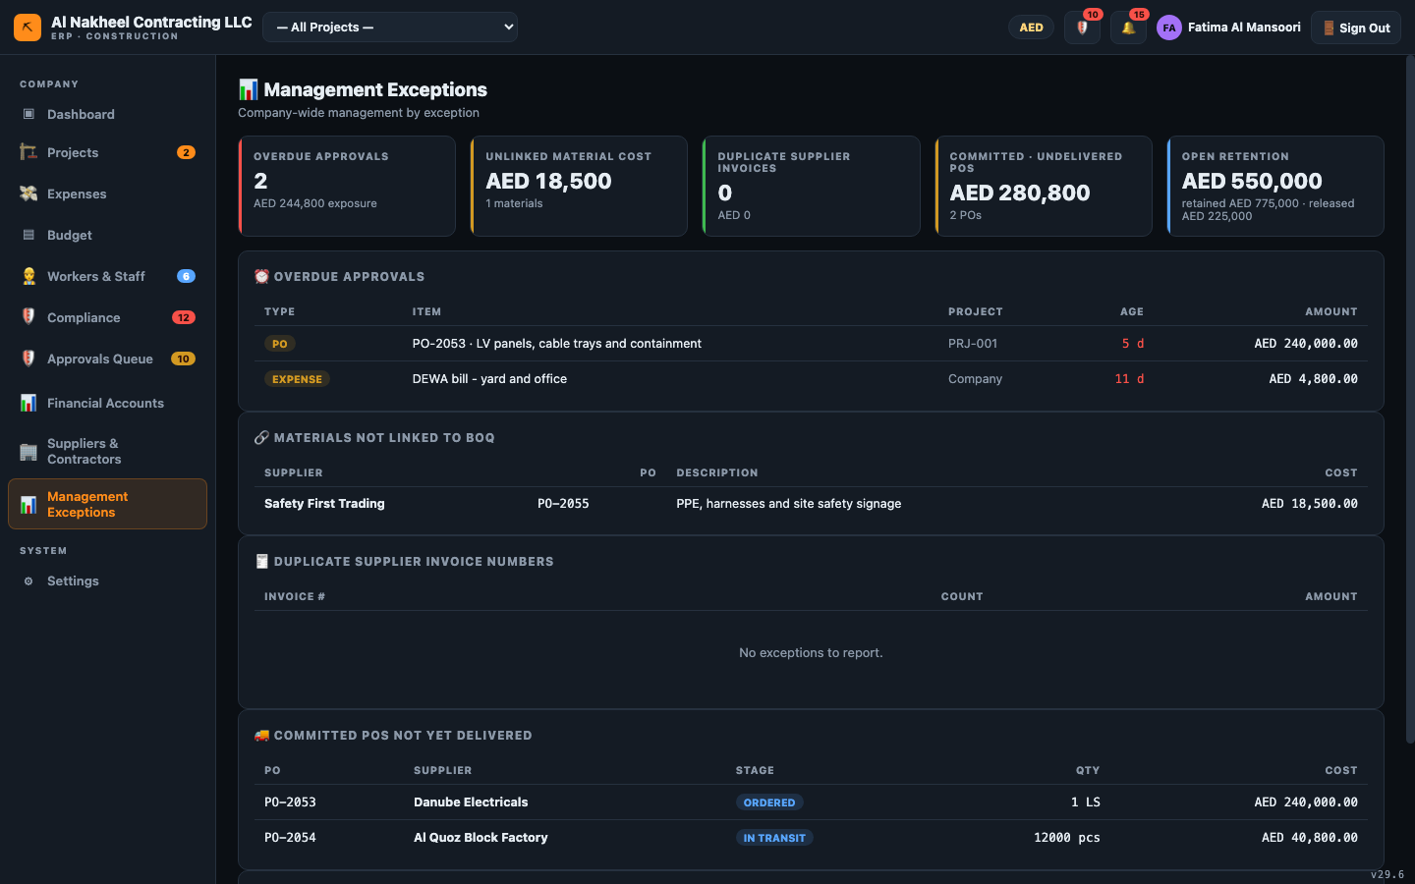

8. End of day
- Confirm approvals cleared (or escalated to a Director for over-limit items).
- Reconcile the balance sheet; note any open retention to release.
- At month-end, close the period from 🔒 Periods & SLA (if you have been granted director rights
to do so — otherwise ask the Director).

Field Superintendent — Day Guide
The Field Superintendent records what happens on site and submits it for approval. You do the
field data entry — daily reports, timesheets, purchase orders, change orders, payment requests and
goods receipts — but you do not approve/certify (managers do). You have no access to the financial
accounts, payroll, retention, payslips or the approvals queue.
You can open: Dashboard, Projects, Workers, Compliance, Settings, and — inside a project — Overview,
BOQ, Drawings, Timeline, Materials/POs, Payments, Parties, Change Orders, Timesheets, Audit, Reports,
Site Reports, Payment Requests, and Receiving/GRN.

1. Start of day
- Sign in → Company Dashboard (alerts for permits/visas/compliance that need your attention).
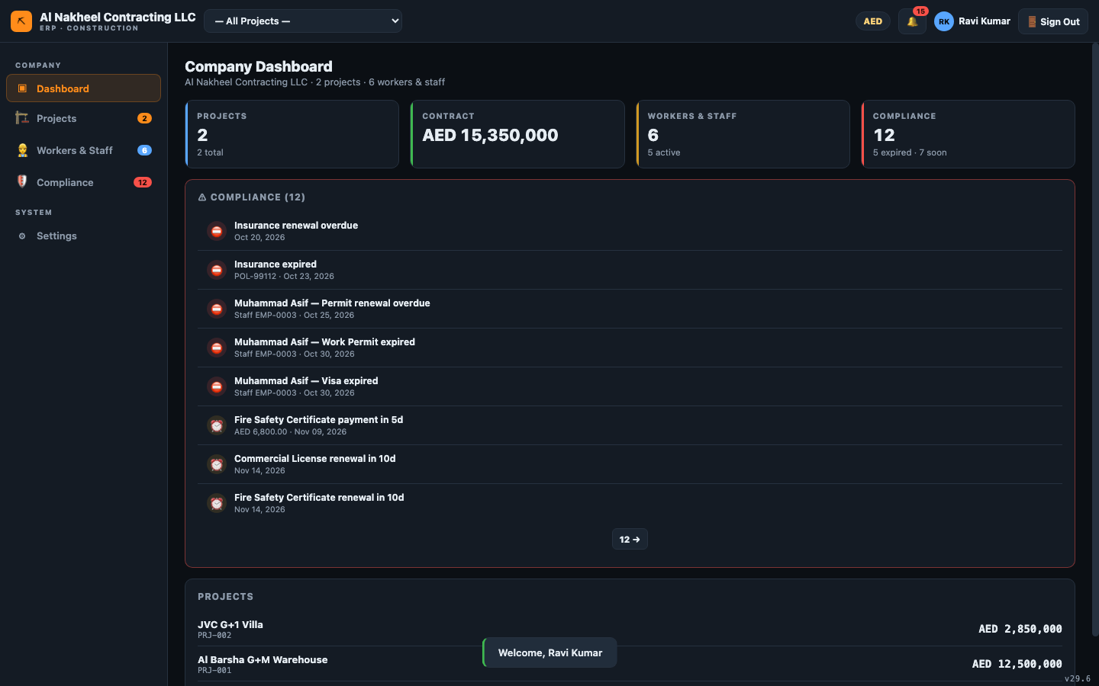
- Clear the 🔔 notifications; act on compliance alerts (expiring permits, documents).

2. Pick your project
- Choose the project from the top bar → Overview.
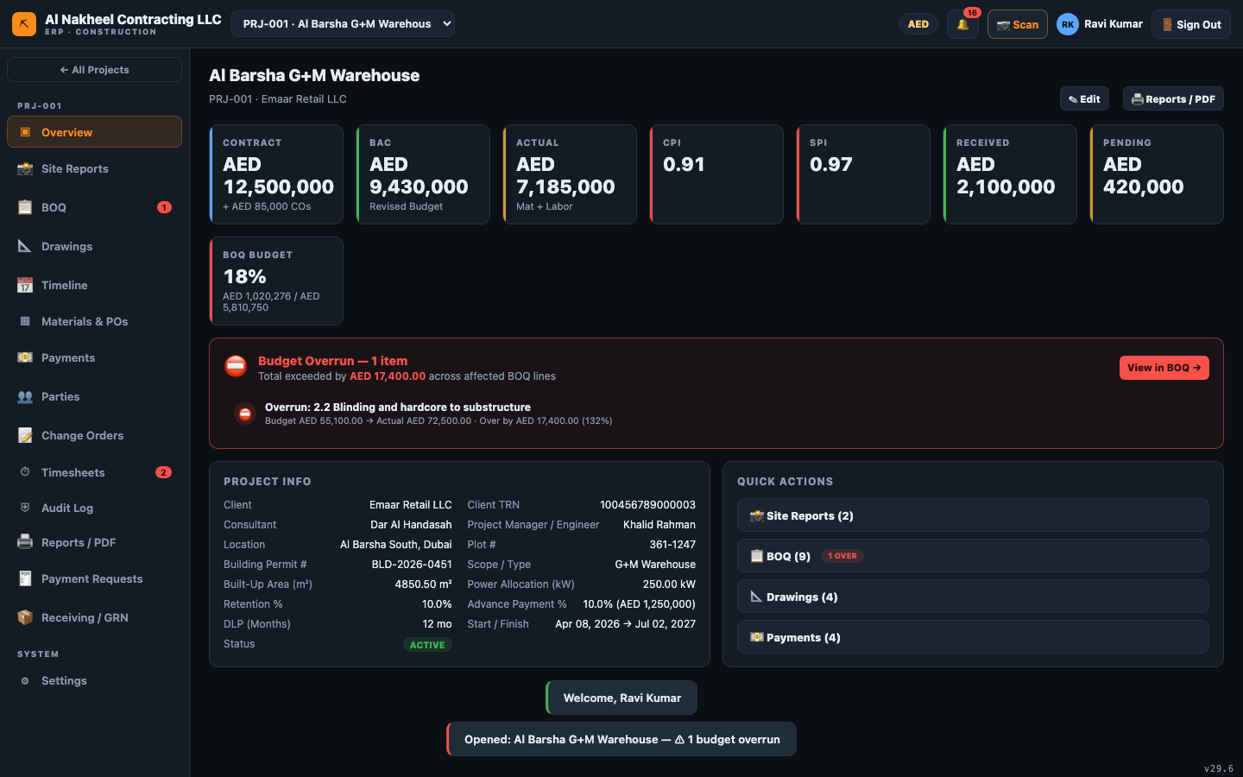

3. Log the day's work
- Site Reports → + New Report → date, weather, workforce, activities, issues, safety, and
attach photos (they upload to cloud storage).
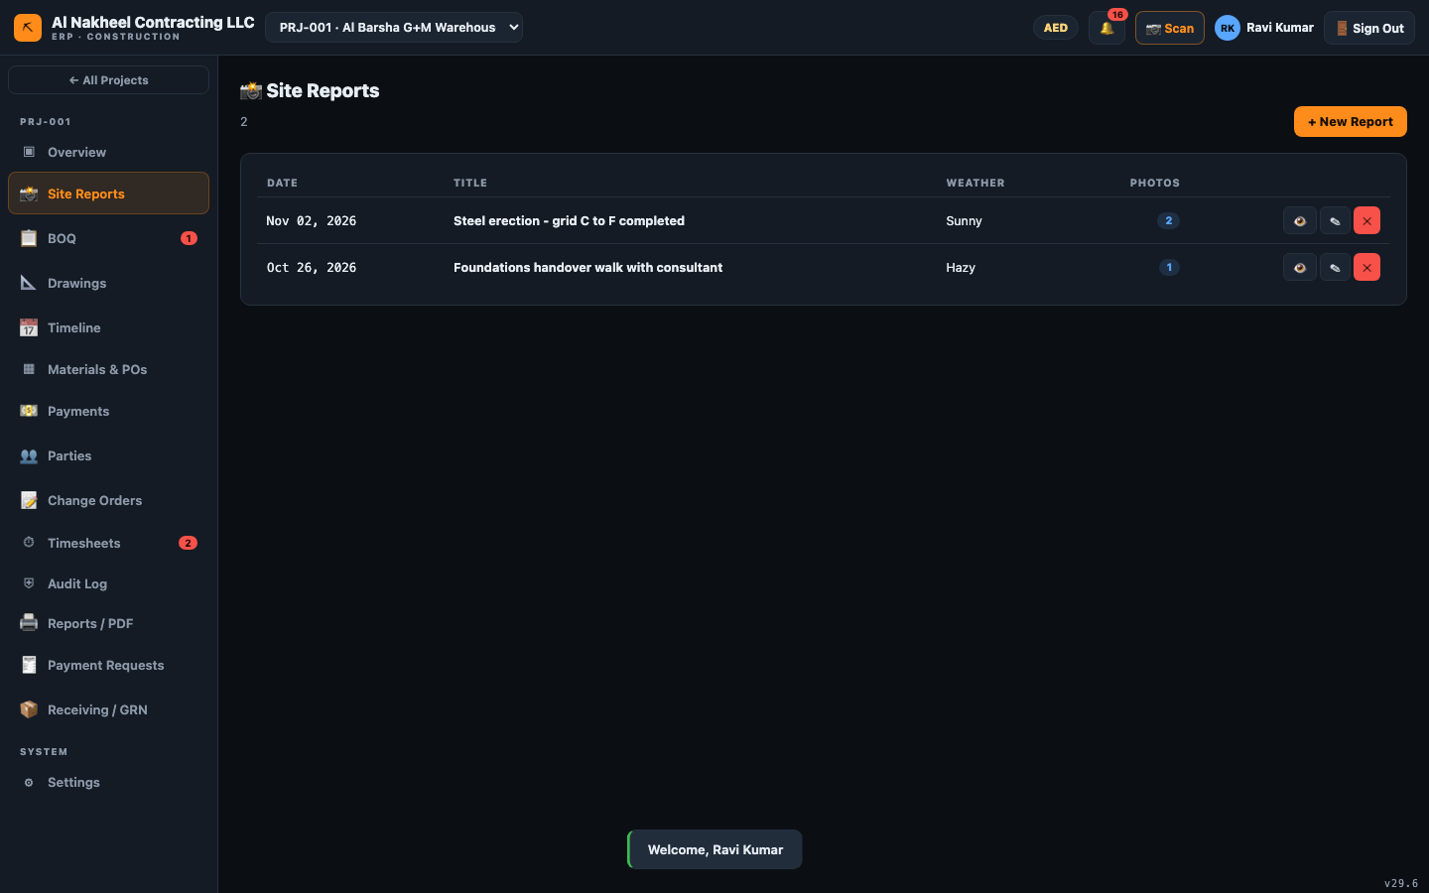
- Timesheets → + New → pick the worker (linked to the staff register), BOQ line, date,
regular + OT hours. Submitting sets it to pending for a manager to approve.
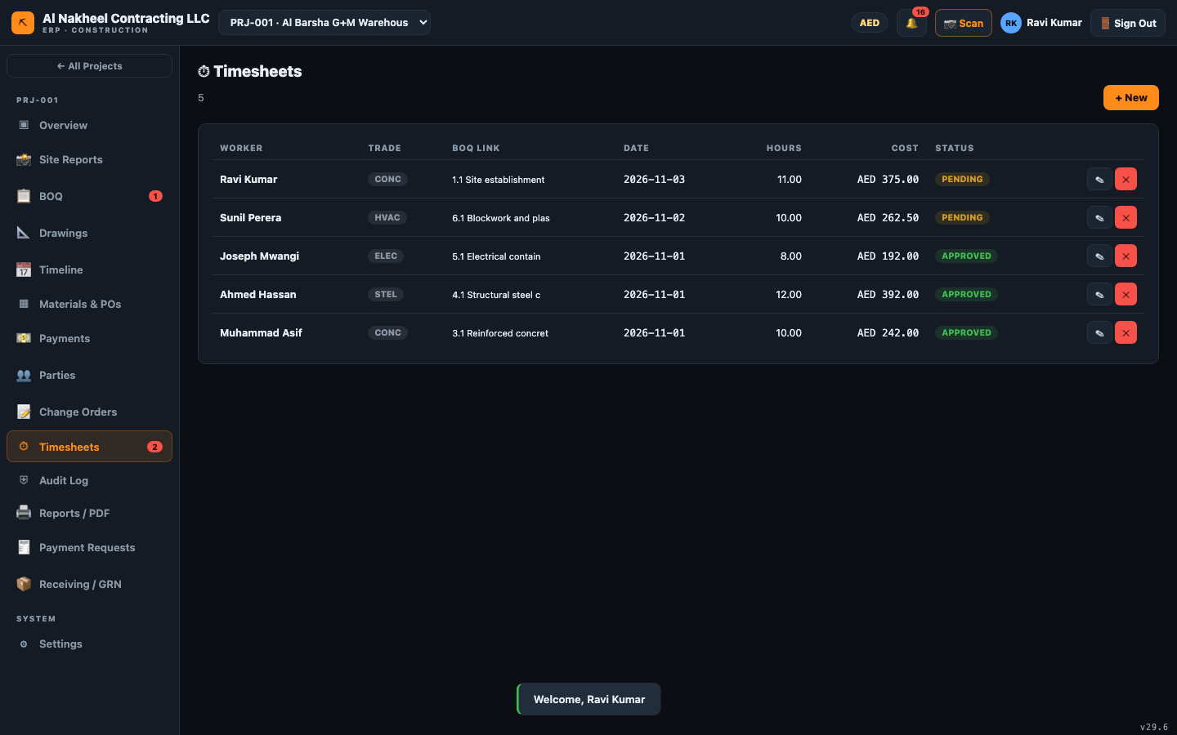

4. Procurement & receiving
- Materials & POs → + New to raise a purchase order. It saves as pending until a manager
approves it.
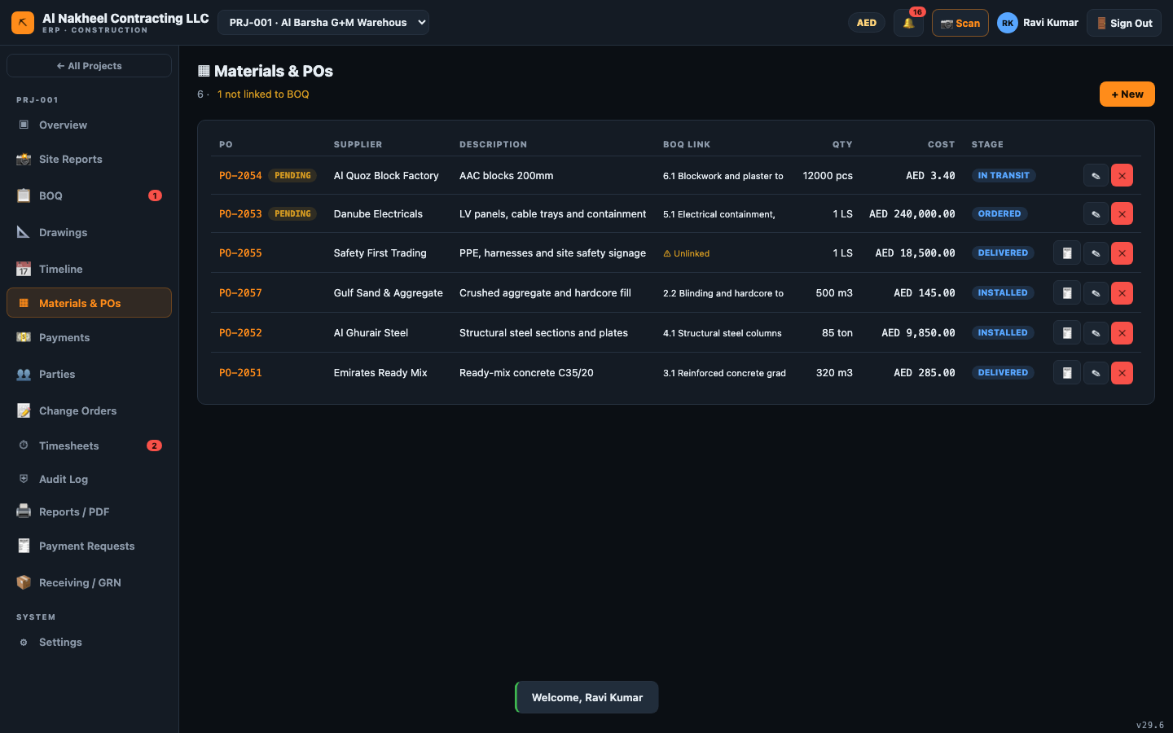
- Receiving / GRN → + Record receipt when goods arrive (links the PO and records the quantity
received — this is what later unblocks billing).
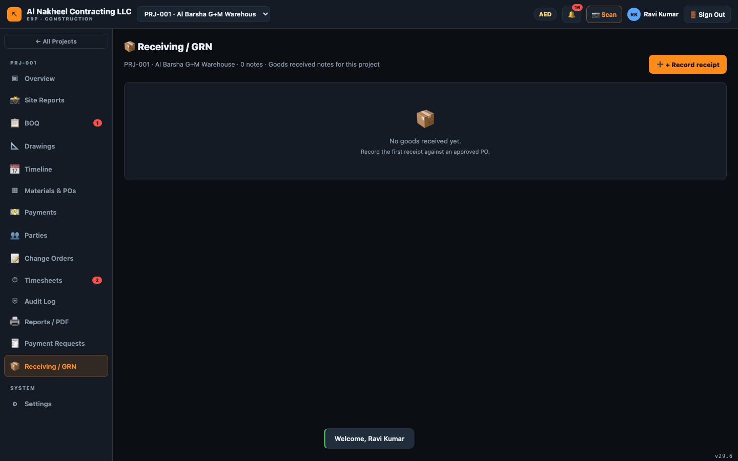

5. Variations & payment requests
- Change Orders → + New to raise a variation (pending until approved; approval auto-adds a
BOQ variation line).
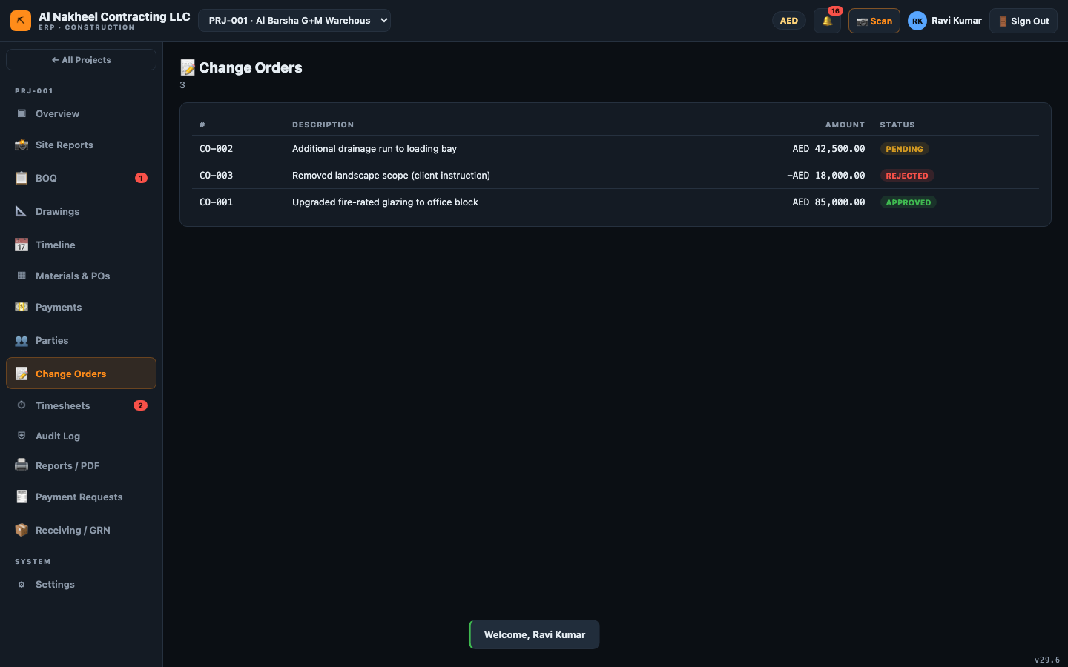
- Payment Requests → + New to raise a subcontractor/supplier claim for a manager to approve.
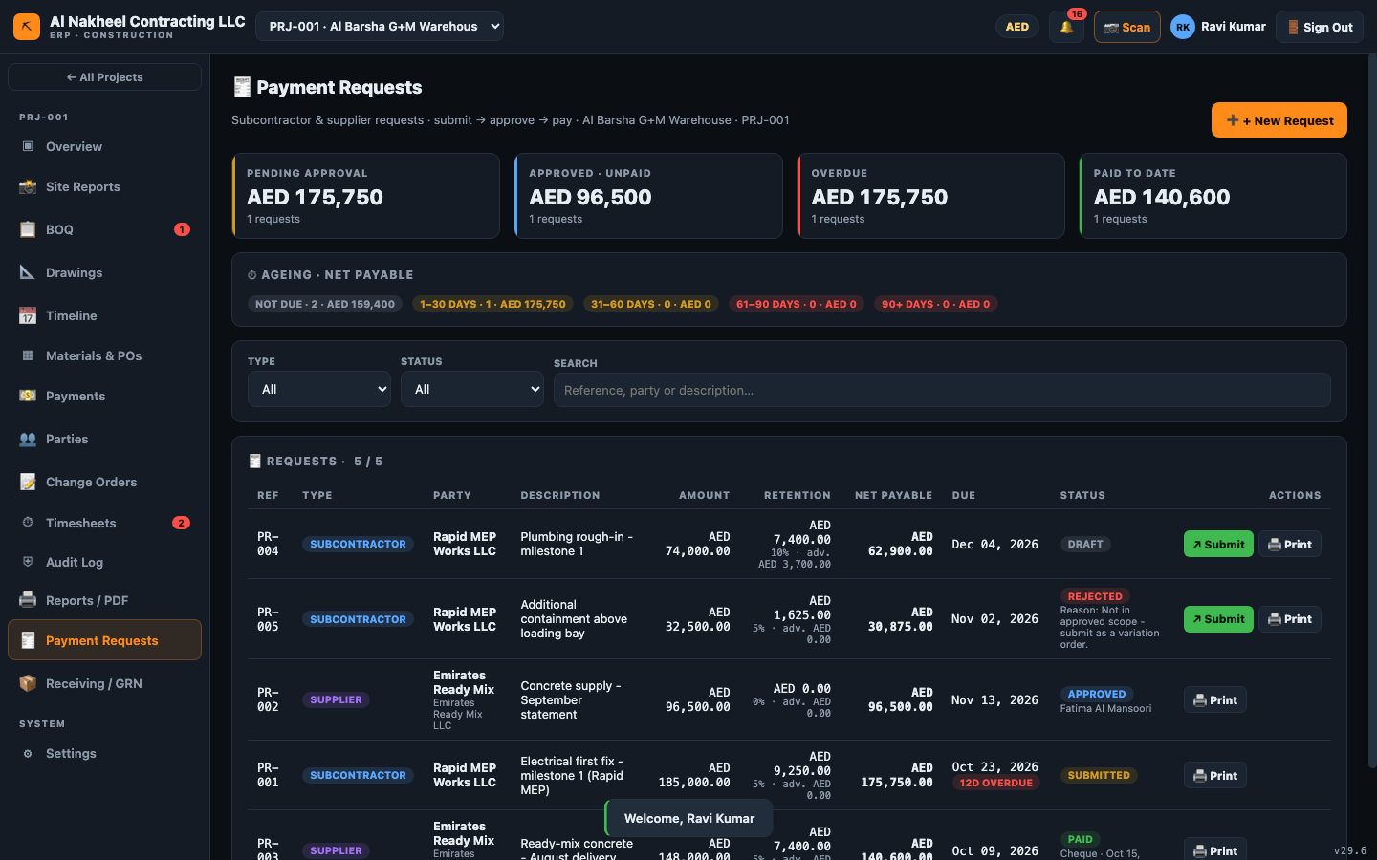

6. Track progress
- BOQ — view budget/actual/committed per line.
- Drawings and Timeline — view drawings/revisions and the schedule.
- Reports — print project reports/PDF.

7. End of day
- Submit the daily site report (with photos) before leaving.
- Confirm timesheets and any POs/COs are submitted (not left in draft).
- Check the 🔔 panel for anything you dismissed that actually needs a manager's action.

Tradesperson Lead — Day Guide
The Tradesperson Lead has the narrowest access: you log your own work and view the information you
need on site. You cannot see the BOQ, approvals, finance, payroll or payment data.
You can open: Projects, and — inside a project — Overview, Drawings, Timeline, Materials/POs,
Timesheets, Settings, and Site Reports.

1. Start of day
- Sign in → Projects list; pick your project from the top bar.
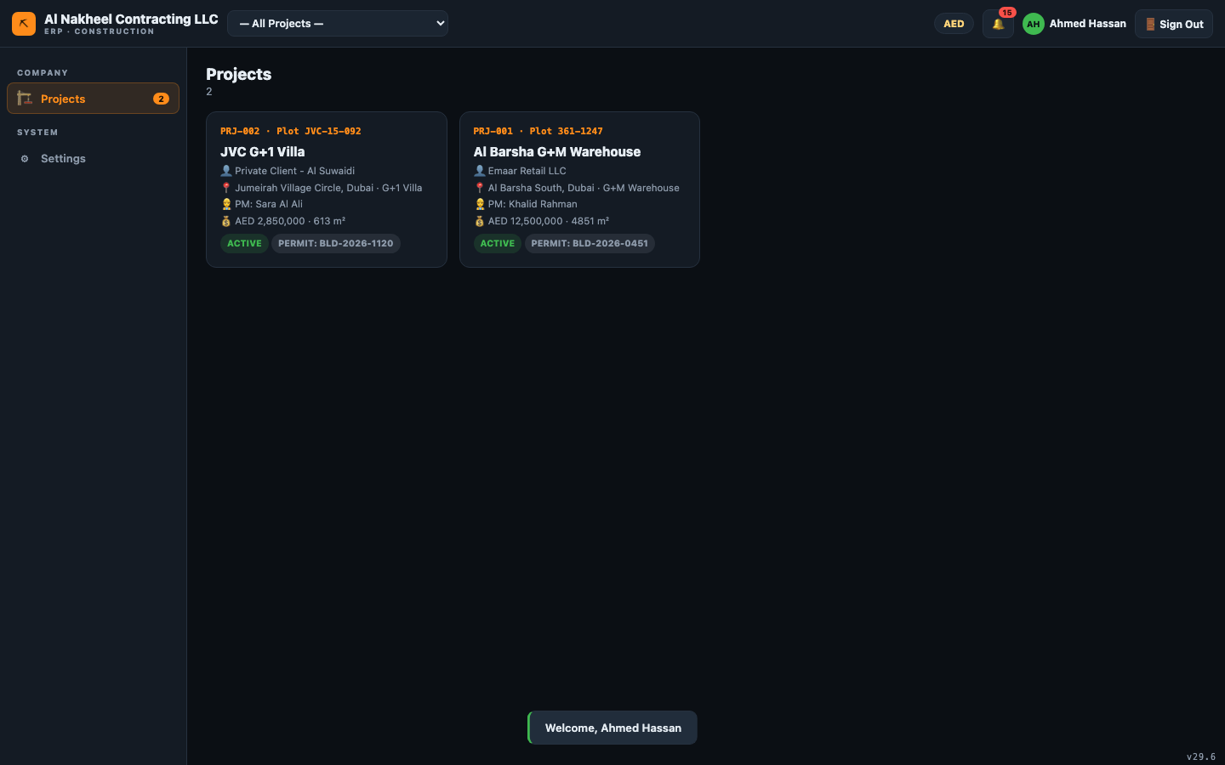
- Open Overview to see the project snapshot.
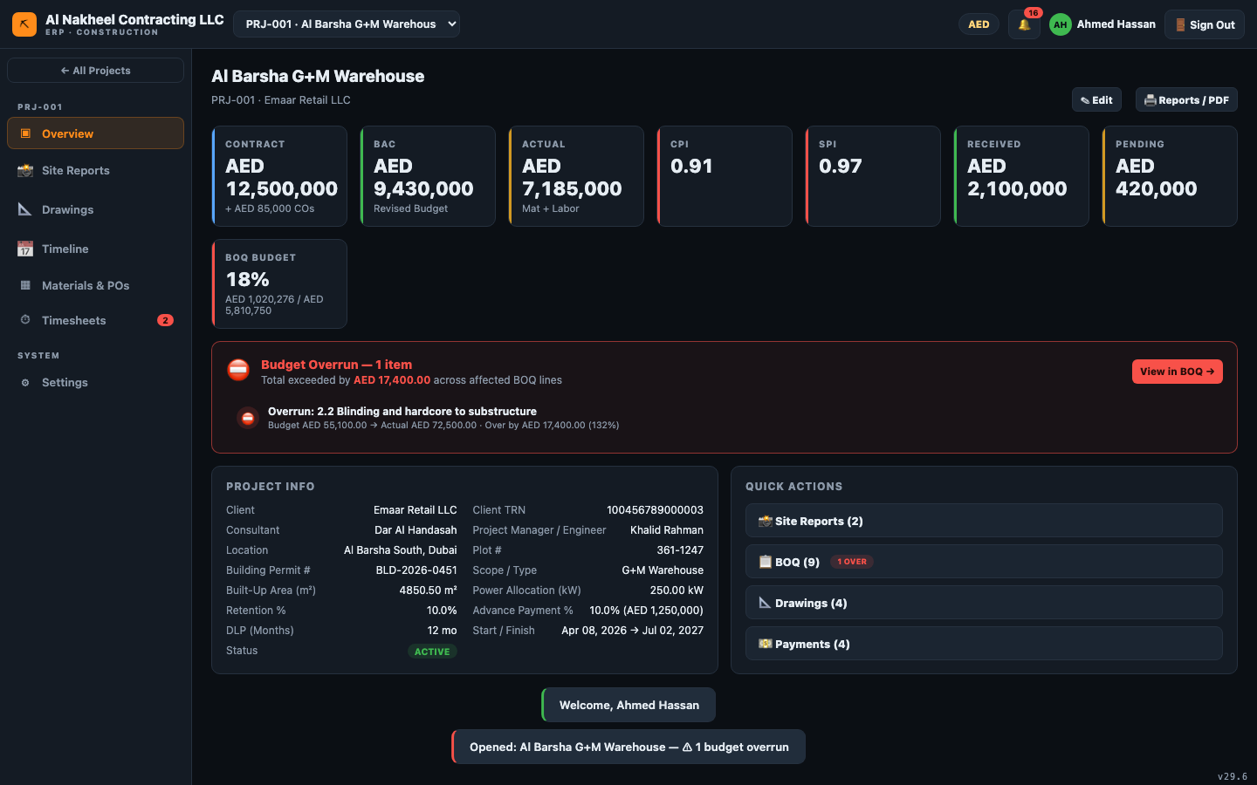

2. Log your labour
- Timesheets → + New → choose your name (worker select), the BOQ/activity, date, regular and
OT hours. Submitting marks it pending for a manager to approve.
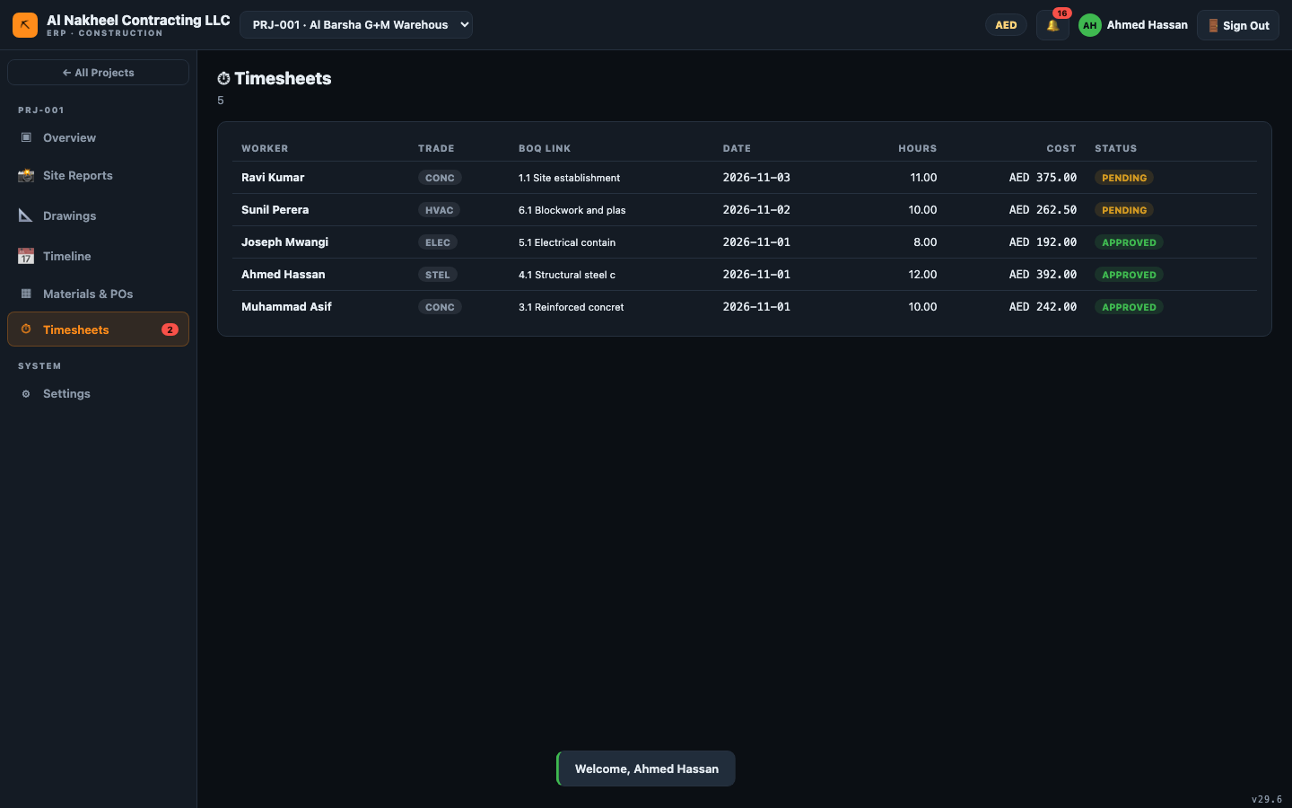

3. Check drawings & schedule
- Drawings — view the latest drawings/revisions.
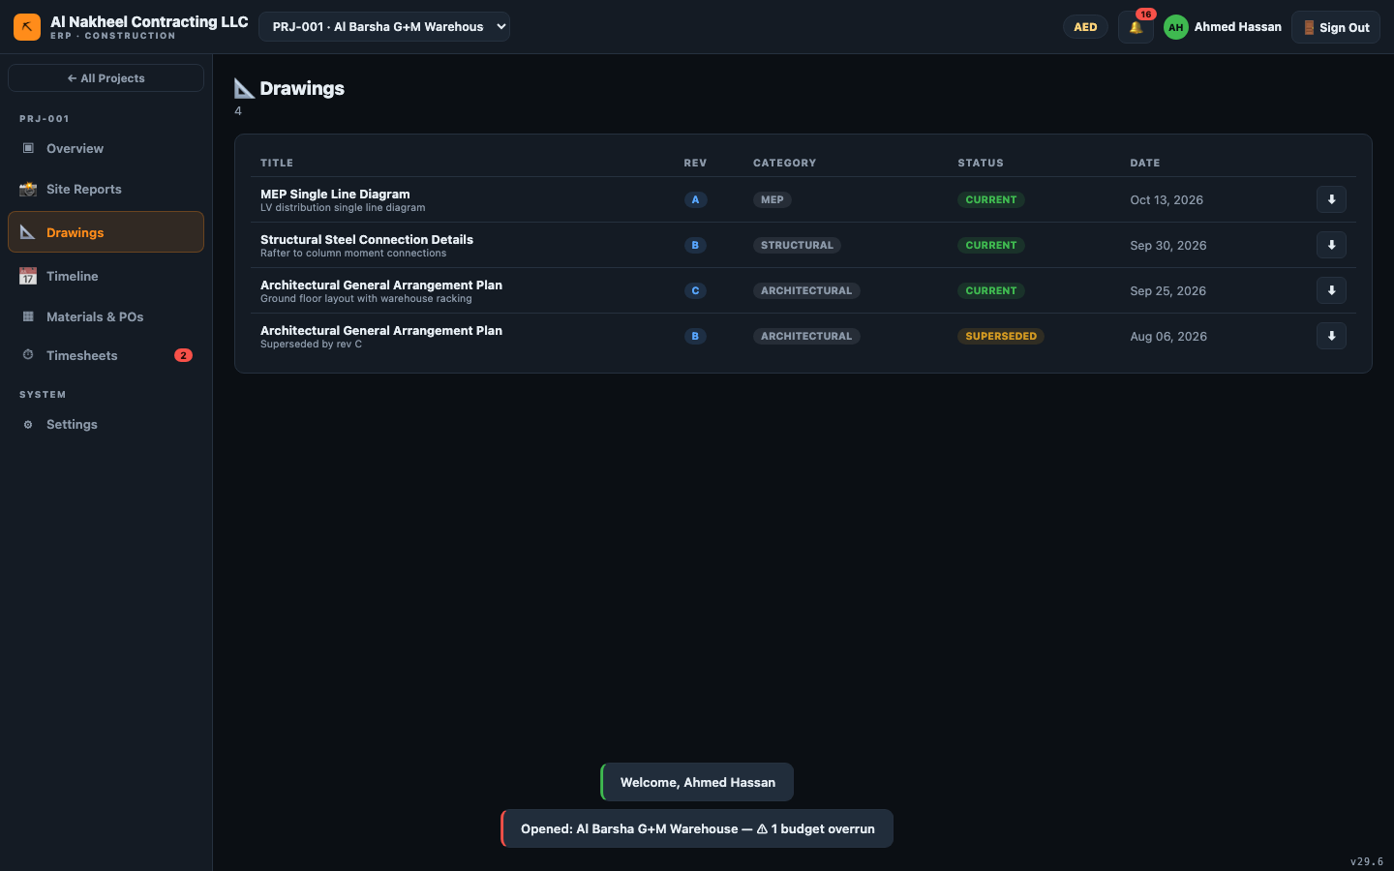
- Timeline — check today's and upcoming tasks.
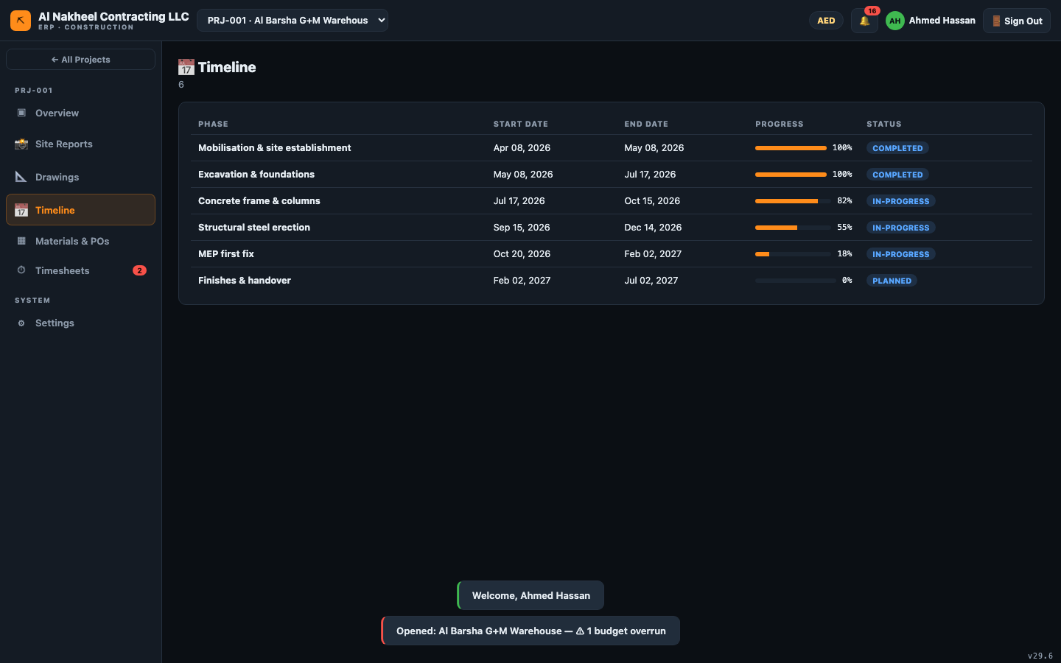

4. Materials
- Materials — view purchase orders and their stage (Ordered / In Transit / Delivered / Installed)
so you know what material is expected on site.
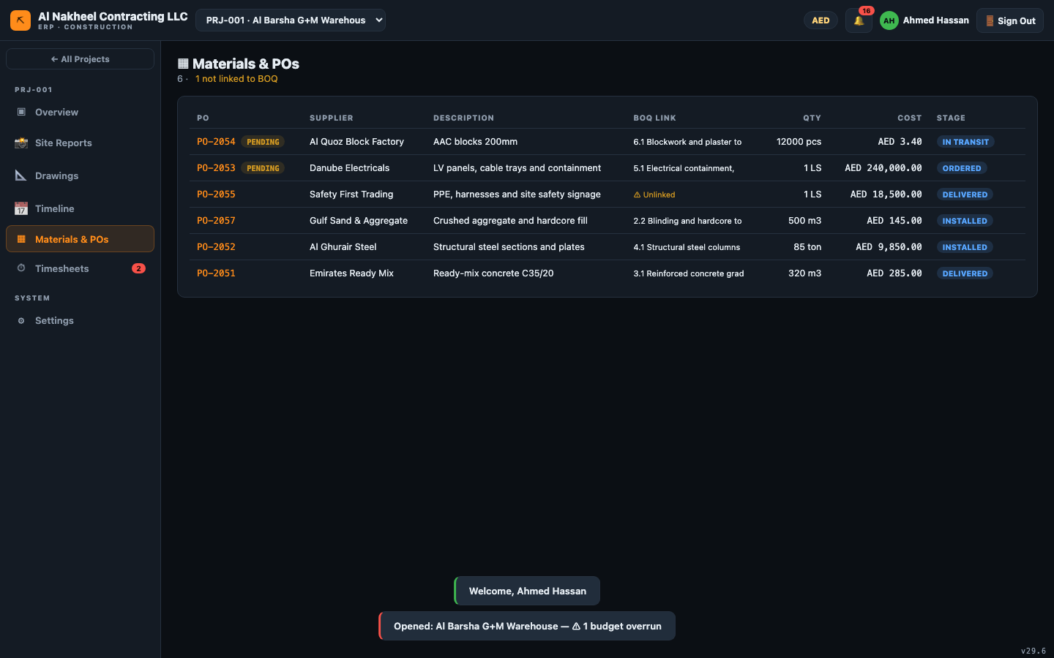

5. Site report
- Site Reports → + New Report — record today's activities, issues and safety notes, and
attach photos as evidence.
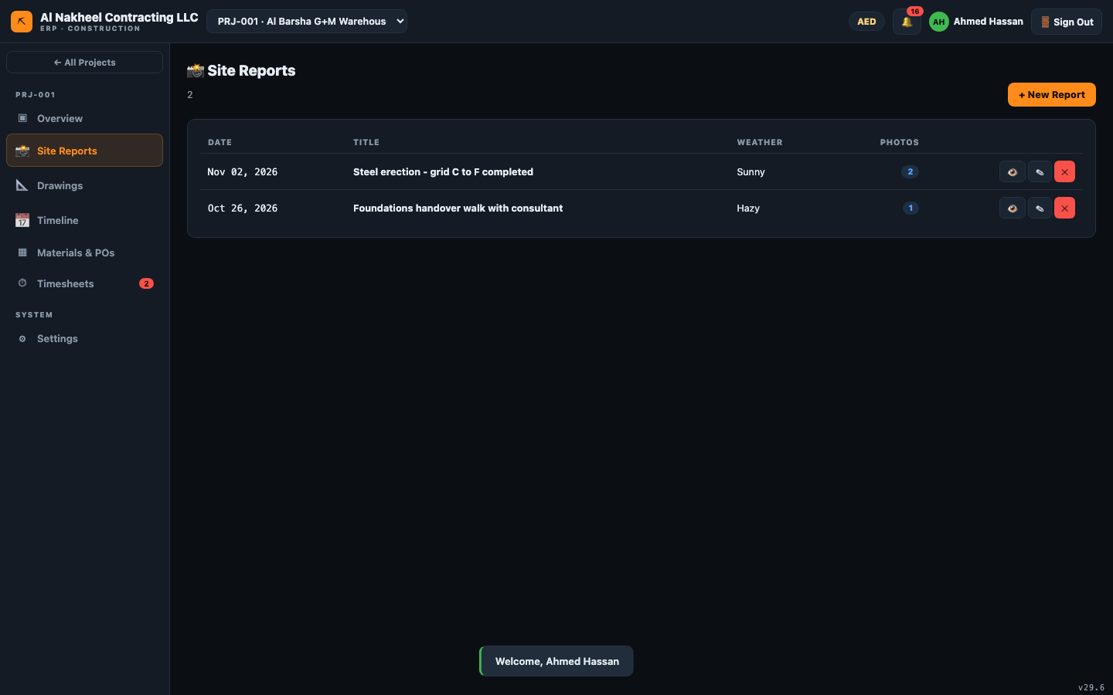

6. End of day
- Confirm your timesheet is submitted for the day.
- Submit the daily site report with photos.
- Note anything for tomorrow in the site report "Issues" field so the superintendent sees it.

