Master’s Degree Course in Data Science for Economics

The Impact of financial development on economic convergence:

A Functional Data Analysis Approach

**Advisor:** Professor Alessandra Micheletti

**Thesis by:** Hamed Davoodi

**Student ID:** 11267A

Autumn 2024

**Dedication**

*For my dearests:*

*To my mother, Masoumeh, a wellspring of love, whose steadfast support has lifted me through every challenge.*

*To my brother, Mahdi, a PharmD candidate, whose faith in me shines brightly, guiding me forward with courage and hope.*

*To the memory of my father, Rajab, whose wisdom and strength continue to shape my journey, a constant presence in my heart.*

*To Nassim, my love, whose warmth and unwavering belief have filled my path with joy and meaning.*

*And to my professor, Alessandra Micheletti, a beacon of knowledge and wisdom, whose guidance has been a steady compass, illuminating my way through the complexities of this work.*

*This journey, this labor, this love—I dedicate it all to you.*

**Acknowledgments**

I hereby declare that this thesis is the result of my original work, conducted with academic integrity and adherence to ethical research practices. I affirm that I have not engaged in plagiarism and have appropriately cited all sources and references used throughout the study. To ensure clarity and accuracy in presentation, I used AI tools exclusively for paraphrasing, grammar, and spelling checks. The intellectual contributions, analysis, and conclusions presented are my own. I am grateful for the support and guidance provided by my advisors and mentors throughout this research journey.

**Abstract**

*This study explores the dynamic relationship between financial development and income convergence among countries at different stages of economic development. Employing Functional Data Analysis (FDA) to analyze time-evolving economic indicators, such as GDP per capita and the Financial Development Index (FDI), the study overcomes limitations in traditional econometric approaches by capturing continuous, time-varying relationships. The findings highlight that financial development plays a heterogeneous role in convergence, significantly aiding high- and upper-middle-income countries in aligning their growth rates with advanced economies like the United States. In contrast, the impact of financial development on convergence is limited in low- and lower-middle-income countries, underscoring the need for targeted financial sector reforms in these regions. The study's methodology—penalized function-on-function regression models—provides new insights by identifying regional and income-based variations in convergence dynamics, confirming the importance of context-specific policies in fostering economic alignment. Policy implications suggest that strengthening financial infrastructures, enhancing financial inclusion, and adopting new financial technologies can facilitate economic convergence. Limitations include the constraints posed by data availability and the model's assumptions of continuity. Future research should integrate additional structural variables and consider nonlinear relationships to provide a more comprehensive understanding of convergence determinants.*

***Keywords****: Financial Development, Income Convergence, Functional Data Analysis, Economic Growth*

***JEL****: E44, F43, O11, O47*

Contents

1. Introduction 6

1.1. Background and Motivation 6

1.2. Research Problem and Questions 10

1.3. Thesis Structure 11

2. Literature Review 11

2.1. Theoretical Framework 13

2.2. Convergence Hypothesis 15

2.3. Financial Development 16

2.4. Schumpeterian Growth Model with Financial Incentives 18

2.5. Historical review 20

2.6. Gaps in the Literature 25

3. Methodology 26

3.1. Data Description 26

3.2. Functional Data Analysis Framework 27

3.3. Functional Regression Model 31

3.4. Statistical Analysis and Inference 37

3.5. Software and Tools 39

4. Results 40

4.1. Descriptive Statistics 40

4.2. Generalized Cross-Validation 45

4.3. Smoothing, Registration, Warping function and Mean function 46

4.4. Functional Regression 50

4.5. Wilcoxon Test Findings 59

4.6. Visualization of threshold levels 62

5. Conclusion 63

6. References 69

# Introduction

## Background and Motivation

Sustainable economic growth and development are essential objectives for all countries, particularly in emerging markets, where robust domestic markets often serve as key drivers of expansion. On the other hand, global economic trends, as outlined by organizations such as the IMF and OECD, highlight the divergent trajectories of different economies. The IMF's World Economic Outlook for 2024 forecasts global growth stabilizing at 3.1%, with advanced economies expected to experience slight acceleration while emerging markets may face a slowdown, largely due to high central bank rates affecting inflation and economic activity (IMF, 2024).

Similarly, the OECD’s Economic Outlook offers insights into the intricate relationship between inflation, monetary policy, and growth across both member and non-member countries, underscoring the importance of coordinated monetary and fiscal policies in shaping economic outcomes on national and global levels (OECD, 2024).

As economic development frameworks evolve, the distribution of wealth and prosperity across nations has gained prominence, with income convergence emerging as a critical element in addressing global inequality. Income convergence indicates that lower-income countries, by achieving higher growth rates, will gradually close the gap with wealthier nations, reducing disparities in per capita income. This concept aligns with broader developmental goals, such as the Sustainable Development Goals (SDGs), by emphasizing equitable economic gains alongside overall growth (Barro & Sala-i-Martin, 1992).

An examination of income convergence reveals varying patterns across different regions. A particularly illustrative case is that of Central and Eastern Europe (CEE), where the convergence narrative highlights significant progress toward reducing income disparities. From 2004 to 2021, CEE countries demonstrated a consistent convergence rate of approximately 2% per year relative to the EU-12, reflecting their steady advancement toward Western European standards (UMCS, 2023). Moreover, between 1999 and 2019, CEE-11 countries exhibited robust unconditional beta convergence with larger European economies, with a remarkable annual rate of 11% (Akadémiai Kiadó, 2024). This rapid pace highlights the success of European integration and structural reforms in facilitating convergence, signaling the potential for continued narrowing of income disparities across the continent.

However, other empirical evidence challenges the notion of absolute convergence, highlighting that factors beyond initial income levels significantly shape economic growth trajectories. This has led to a shift in focus toward conditional convergence, where economies do not universally converge to the same income levels but instead to their own steady-state, shaped by unique national factors such as savings rates, human capital, and technological capabilities (Mankiw, Romer, & Weil, 1992). This nuanced understanding suggests that convergence is not a one-size-fits-all process and depends heavily on the structural characteristics of each economy (Sala-i-Martin, 1996).

Recent empirical studies illustrate the complexities of economic convergence, revealing that income levels often diverge across states within the same country, even when conditional convergence is evident. This suggests that while certain regions make economic progress, overall income inequality may worsen due to unaddressed factors—such as institutional and structural challenges—that prevent uniform growth across regions (Akadémiai Kiadó, 2024). Similarly, on a global scale, countries may experience beta convergence in terms of GDP per capita; however, underlying disparities in broader measures of economic well-being, such as Inclusive Wealth, continue to persist.

In response to these uneven growth patterns, financial development has become a focal point for researchers aiming to address the array of factors that shape income trajectories over time. An expanding body of studies underscores the critical role of financial development in enhancing economic convergence, suggesting that robust financial systems may help bridge economic gaps both within and among nations.

Studies by He and You (2024), Santos and Liu (2023), and Lin and Wu (2023) examine how financial systems drive convergence, particularly through mechanisms like technological transfer, capital accumulation, and productivity growth. Central to these findings is financial development, which emerges as a pivotal factor; expanded access to financial services and credit, coupled with the deepening of financial markets, significantly empowers poorer nations to invest in growth-oriented activities. This dynamic accelerates convergence with wealthier economies by improving resource allocation and fostering sustainable economic advancement (Ahmed & Howitt, 2023).

Moreover, well-functioning financial systems enhance capital allocation efficiency, stimulate technological innovation, and enable effective risk management (Levine, 1997). By mobilizing domestic savings and expanding access to external finance, financial development allows firms and entrepreneurs in less developed economies to pursue productive investments that boost growth rates. This process not only supports economic expansion but also encourages convergence with more advanced economies, effectively narrowing the development gap (Aghion, Howitt, & Mayer-Foulkes, 2005).

As discussed, the role of financial systems in promoting convergence is multifaceted, as they not only support direct investment in growth-promoting activities but also foster the structural and technological foundations necessary for long-term development. While financial development provides immediate avenues for poorer nations to allocate resources more efficiently and drive economic progress, it also enables broader economic transformations through improved capital flows and access to innovation. This dual impact underscores how financial systems do more than bridge current income disparities—they lay the groundwork for sustained economic resilience, creating conditions for convergence that persist beyond short-term gains (García & Salinas, 2024; Patel & Silva, 2024; He & You, 2024; Jackson, 2023).

Given the evolving nature of the relationship between financial development and income convergence, traditional econometric models often fall short in capturing the nuanced, interdependent dynamics that unfold over time. Originally developed within mathematics and statistics, Functional Data Analysis (FDA) has been successfully applied in fields like biology and engineering to analyze continuous data, yet its potential in economic studies remains underexplored. Functional Data Analysis (FDA), pioneered by Ramsay and Silverman (2005), is designed to handle data in the form of continuous functions, rather than discrete points. This methodological advantage allows for a more comprehensive examination of how financial development progresses over time. Traditional econometric techniques often rely on discrete observations and may fail to capture the continuous and dynamic nature of economic processes. FDA, on the other hand, is specifically designed to handle data that provide information about curves, surfaces, or anything else varying over a continuum (Ramsay & Silverman, 2005).

In this study, Functional Data Analysis is employed for its ability to model continuous, time-evolving economic variables like GDP per capita and financial development as smooth functions, preserving the integrity of their trajectories. Essentially, FDA’s functional regression models capture complex, time-varying interactions between financial development and growth. This approach offers deeper insights into long-term growth patterns and convergence dynamics that conventional methods might miss (Hörmann & Kokoszka, 2012; Ferraty & Vieu, 2006).

## Research Problem and Questions

Despite extensive research, gaps remain in understanding how financial development specifically influences income convergence, particularly considering the heterogeneity across countries and overtime. Existing studies often rely on cross-sectional analyses that may overlook dynamic effects and country-specific factors influencing the finance-growth nexus (Beck & Levine, 2004).

However, this study aims to investigate the dynamic impact of financial development on income convergence among countries at different stages of development, utilizing Functional Data Analysis to capture the temporal evolution of this relationship. The main questions to be answered can be listed as:

1. Can FDA effectively capture the dynamics of income convergence influenced by financial development?
2. Can we verify that financial development indeed drives income convergence?
3. What level of financial development is necessary to trigger an impact on convergence?

By answering these questions, this study introduces Functional Data Analysis (FDA) as an innovative approach to capture the dynamic, continuous nature of financial development and income convergence. Modeling these economic variables as smooth functions over time, FDA allows for the analysis of complex, time-varying interactions that traditional econometric models overlook. Hence, this study goes beyond static models to reveal nuanced insights into how financial systems shape convergence across diverse regions and time periods, contributing to both theoretical and empirical advancements in the finance-growth nexus.

## Thesis Structure

The thesis is structured as follows:

**Introduction:** Discussion on the background, research problem, objectives, and significance of the study.

**Literature Review:** Provides a comprehensive literature review on income convergence theories, the role of financial development in economic growth, and gaps in previous research.

**Methodology:** Outlines the methodology, including the application of Functional Data Analysis.

**Results:** Presents the empirical analysis, results, and discussion of findings in relation to the research questions.

**Conclusion:** Concludes the study, highlighting key insights, policy recommendations, and suggestions for future research.

# Literature Review

The impact of financial development on income convergence has emerged as a significant area of research within economics, focusing on how advancements in financial systems influence economic growth and reduce income disparities among nations. Central to this discourse is the convergence hypothesis, which posits that poorer economies will experience faster growth rates than their wealthier counterparts, particularly when financial development is prioritized. Scholars such as Lopez et al. (2021) and Beck et al. (2000) argue that well-developed financial markets enhance resource allocation, promote productivity, and support innovation, thereby contributing to income convergence among countries with diverse economic backgrounds.

Despite these theoretical assertions, empirical studies have provided mixed results regarding the efficacy of financial development in achieving income convergence. While research generally indicates a positive correlation between robust financial systems and economic performance, variations across regions suggest that the benefits of financial development may not be evenly distributed. For instance, some developing nations have witnessed accelerated growth through improved financial access, yet advanced economies often exhibit stronger relationships between financial development and economic stability (Azimi, 2022; Ekanayake et al., 2021). The discrepancy underscores the complexity of the relationship and highlights the potential influence of regional factors.

In addition, the complexity raises essential questions about the conditions under which financial development can effectively reduce income inequality. Critics argue that financial development can exacerbate existing inequalities if structural and institutional challenges are not addressed, particularly in developing regions. The interplay between financial inclusion and income inequality underscores the need for tailored policy measures to ensure that financial services reach marginalized populations, ultimately promoting equitable growth outcomes (Nguyen et al., 2021; Omar et al., 2021). As such, ongoing research continues to explore the multifaceted relationship between financial development, income convergence, and the overarching goal of achieving economic equity across nations.

Historically, the relationship between financial development and income convergence has evolved through various economic paradigms and empirical studies. Early theories emphasized the role of financial systems in promoting economic growth, suggesting that well-developed financial markets can efficiently allocate resources, enhance productivity, and ultimately contribute to income convergence among nations (Lopez et al., 2021; Beck et al., 2000). This perspective aligns with the seminal works of Schumpeter (1934) and McKinnon (1973), who argued that financial institutions play a critical role in facilitating economic activities and fostering innovation, thus acting as engines of growth.

As the discourse progressed, empirical research began to investigate the mechanisms through which financial development influences income levels across different countries. Studies examining both developing and developed economies in the aftermath of the 2008 financial crisis found a positive relationship between financial development and economic growth, suggesting that financial markets not only support domestic economies but also synchronize with the global business cycle (Azimi, 2022; Ekanayake et al., 2021). Such insights underscore the importance of targeted policies aimed at enhancing financial inclusion, particularly among marginalized groups, to foster broader economic growth and income convergence.

In summary, the historical context of financial development's impact on income convergence highlights a complex interplay of theoretical foundations, empirical evidence, and regional dynamics. This interplay shapes our understanding of how financial systems contribute to economic equality across nations and emphasizes the need for nuanced approaches that consider structural and institutional factors.

## Theoretical Framework

The neoclassical economic growth theory, developed in the mid-20th century, emphasizes capital accumulation, labor force growth, and exogenous technological progress as the primary drivers of long-term economic growth. The foundational Solow-Swan model posits that an economy's output is determined by a production function involving capital and labor, exhibiting constant returns to scale and diminishing returns to each input (Solow, 1956; Swan, 1956). In this framework, capital accumulation leads to growth, but due to diminishing returns, its impact decreases over time. Consequently, sustained long-term growth hinges on technological progress, which is considered exogenous and independent of economic decisions within the model. Savings and investment rates affect the level of output per worker but do not influence the steady-state growth rate, which is solely determined by the rate of technological advancement.

Critiques of the neoclassical model have highlighted its inability to explain the source of technological progress and its assumption of diminishing returns to capital. This led to the development of endogenous growth theories, which internalize technological change within the model by incorporating factors such as human capital, innovation, and knowledge spillovers (Romer, 1986; Lucas, 1988). Endogenous growth models argue that investments in human capital and research and development can lead to increasing returns to scale and sustained economic growth without the necessity of exogenous technological progress. These models suggest that policy measures affecting education, innovation, and knowledge dissemination can have long-term impacts on growth rates, challenging the neoclassical view that long-term growth is determined outside the economic system.

The neoclassical theory also introduces the concept of convergence, predicting that poorer economies will grow faster than wealthier ones due to higher marginal returns on capital, leading to a reduction in income disparities over time (Barro & Sala-i-Martin, 1992). However, empirical evidence on convergence has been mixed. Some studies support the idea of conditional convergence, where countries converge only if they share similar savings rates, population growth, and technological advancements (Mankiw, Romer, & Weil, 1992). Other research points out that differences in institutional frameworks, human capital, and structural factors can lead to divergence rather than convergence, indicating that the neoclassical model may oversimplify the complexities of economic growth across diverse economies.

## Convergence Hypothesis

The neoclassical theory introduces the concept of convergence, proposing that poorer economies will grow faster than wealthier ones due to higher marginal returns on capital, thereby reducing income disparities over time (Barro & Sala-i-Martin, 1992). Empirical evidence on this convergence hypothesis, however, is mixed. While some studies support conditional convergence—suggesting that economies converge only when they share similar savings rates, population growth, and technological advancements (Mankiw, Romer, & Weil, 1992)—others highlight that disparities in institutional frameworks, human capital, and structural factors can lead to divergence, suggesting that the neoclassical model may not capture the full complexity of economic growth across diverse economies.

Building upon the concept of convergence in neoclassical growth theory, economists have identified various forms of convergence to explain how and under what conditions economies may grow together over time. One such form is absolute convergence, which posits that poorer economies will naturally catch up to richer ones due to higher marginal returns on capital (Solow, 1956). This theory suggests that all economies will converge to the same steady-state level of per capita income and growth rates, regardless of differences in savings rates, population growth, or technological progress. The underlying assumption is that technologies are freely available and that there are no barriers to the flow of capital and labor.

In contrast, conditional convergence asserts that economies converge only when they share similar structural characteristics, such as savings rates, education levels, population growth, and access to technology (Mankiw, Romer, & Weil, 1992). According to this view, poorer economies will catch up to richer ones only if they have comparable institutional frameworks and policy environments. Conditional convergence acknowledges that disparities in institutional quality, human capital, and other country-specific factors can significantly influence growth trajectories, thereby affecting the convergence process.

Another important concept is sigma convergence, which focuses on the reduction of income dispersion among economies over time. Sigma convergence occurs when the cross-sectional variance (standard deviation) of per capita incomes across a group of economies declines, indicating that income levels are becoming more similar (Barro & Sala-i-Martin, 1992). This statistical measure assesses whether disparities in income are decreasing globally or within specific groups of countries, providing a quantitative approach to analyzing convergence trends beyond average growth rates.

Additionally, beta convergence examines the relationship between the initial level of per capita income and subsequent growth rates. Unconditional (absolute) beta convergence occurs when poorer economies grow faster than richer ones without accounting for other variables, leading to a negative correlation between initial income levels and growth rates (Barro & Sala-i-Martin, 1995). Conditional beta convergence, on the other hand, controls for structural and policy differences among economies, suggesting that once these factors are accounted for, poorer economies still tend to grow faster (Islam, 1995). The distinction between sigma and beta convergence is crucial, as beta convergence (a negative relationship between initial income and growth) does not necessarily imply sigma convergence (a reduction in income disparities), and vice versa.

## Financial Development

Financial development refers to the growth and improvement of financial institutions, markets, and instruments that facilitate economic transactions, savings mobilization, and efficient resource allocation. At its core, financial development strengthens the channels through which savings are transformed into productive investments, stimulating economic activity and fostering income growth (Demirgüç-Kunt & Levine, 2008). In this context, well-developed financial systems provide the infrastructure for smooth capital flows and investment, supporting innovation and growth. As economies develop robust banking sectors, active capital markets, and diversified financial services, they can better manage risks and allocate resources toward high-growth opportunities, ultimately contributing to broader economic development and income convergence (Beck & Levine, 2004).

The assessment of financial development typically involves evaluating various banking sector metrics and stock market indicators that reflect the health, depth, and efficiency of financial markets. Key banking indicators include Financial Depth (FDP), which measures the size of financial intermediaries relative to GDP, representing the ability of banks to mobilize resources (Beck et al., 2000). Similarly, the Credit to Deposit Ratio (CDR) and Domestic Credit to Private Sector (CPS) measure the extent of banking penetration and credit availability for private sector growth, both critical for supporting business investment and economic activities that drive income convergence (Levine, 1997). By ensuring accessible credit and financial services, these indicators reveal how banking systems contribute to the real economy, fostering income growth across regions.

Stock market metrics such as the Value of Shares Traded and the Turnover Ratio (TOR) provide insights into market liquidity, activity levels, and investor engagement. A higher turnover ratio, for instance, indicates a more active market, which can support business financing and economic expansion (Levine & Zervos, 1998). Together, these metrics of financial development showcase how a balanced mix of banking and capital market activities contributes to economic growth and income convergence. By enabling both short- and long-term investments, these indicators highlight the multifaceted role financial development plays in economic resilience and inclusive growth (King & Levine, 1993a; 1993b).

## Schumpeterian Growth Model with Financial Incentives

Aghion, Howitt, and Mayer-Foulkes (2005) extended the analysis of financial development within the context of economic convergence by incorporating it into a Schumpeterian growth model. Schumpeter’s (1911) framework emphasizes innovation as the core driver of economic growth, centering around the concept of “creative destruction,” where new technologies replace obsolete ones, continuously fueling productivity and economic expansion. In this model, financial markets play a critical role by providing the essential capital needed for research and development (R&D) and other innovative activities. The central argument in the Schumpeterian model is that innovation, funded through well-functioning financial markets, serves as the engine that propels economies forward. Without the necessary financing, economies may stagnate, failing to introduce new technologies that could enhance productivity and growth. Thus, financial markets become not just passive facilitators of economic activity but key drivers of technological progress (Aghion, Howitt, & Mayer-Foulkes, 2005).

In the Schumpeterian growth model, the economy's growth rate, denoted as , is directly linked to the rate of innovation. This relationship can be expressed through the formula:

**1. Growth rate and innovation relationship:**

where:

- is the frequency of innovation (how often innovations occur),

- is the proportional increase in productivity resulting from each innovation

**2. R&D intensity and innovation rate:**

where:

- is a measure of the productivity of R&D.

- is the labor allocated to R&D (also can be R&D investments).

- is a parameter representing R&D costs.

**3. Growth rate incorporating R&D efforts:**

The equilibrium growth rate can also be expressed as:

This equation shows that growth depends on the productivity of R&D efforts , the labor devoted to R&D (in this case investment in R&D, since labor is typically used as a proxy for R&D investment in these models), and the effectiveness of innovation , all normalized by the costs of conducting R&D.

The model now can capture the essence of how financial development influences growth: by increasing the resources available for R&D, financial markets enhance the rate of innovation, thereby accelerating the overall growth rate . The model illustrates that the greater the investment in R&D, the higher the rate of innovation and, consequently, the faster the economy grows. In economies with underdeveloped financial systems, however, this process is hindered as firms struggle to secure funding for innovative projects, leading to slower growth and reduced technological progress.

The model distinguishes between two types of countries: those near the technological frontier and those that are far from it. For countries near the frontier, innovation is crucial for maintaining their competitive edge and driving economic growth. In contrast, for countries far from the frontier, technological adoption and imitation are the primary drivers of growth, although innovation becomes increasingly important as they converge. In both scenarios, financial constraints can severely limit firms' ability to invest in the R&D necessary for innovation and technological adoption. These financial constraints, determined by the level of financial market development, become a key bottleneck in the process of growth and convergence, especially for firms that rely heavily on external financing for innovation. Thus, financial development is essential for both fostering original innovation in advanced economies and facilitating the adoption of existing technologies in developing ones, thereby promoting overall economic convergence (Aghion, Howitt, & Mayer-Foulkes, 2005).

## Historical review

Empirical validation of the relationship between financial development and income convergence has yielded mixed results, often influenced by the economic context and methodological approaches employed in different studies. Recent literature has highlighted the significance of employing advanced methodologies, such as machine learning (ML) algorithms, alongside traditional econometric techniques. This approach aims to enhance the robustness of findings related to economic convergence and the role of financial development.

For instance, Magazzino et al. (2022) utilized ML methods in conjunction with panel data analysis to uncover compelling causal relationships among various economic indicators, supporting the convergence hypothesis for selected Canadian provinces. This integration of ML enhances the predictive power and accuracy of traditional models, allowing for the identification of non-linear patterns that may be missed by conventional approaches.

The use of Generalized Method of Moments (GMM) estimation techniques has also been pivotal in addressing issues of panel endogeneity and cross-sectional dependence, which are critical when examining the effects of financial development on income convergence. Azimi (2022) employed GMM estimation to provide more reliable estimates by mitigating biases inherent in simpler models. This methodological advancement allows for a more accurate assessment of how financial development influences income convergence across different countries, thereby strengthening the empirical foundation of the convergence hypothesis.

He and You (2024) conducted a study on "Convergence in Financial Development and Growth," exploring the relationship between financial development and economic growth across various countries. By applying panel data techniques, the authors assessed financial inclusion, credit markets, and financial market depth to understand the complex interaction between financial development and GDP growth. The study found that while financial inclusion has generally converged across countries, more sophisticated financial performance indicators such as market liquidity have diverged, presenting a mixed picture of convergence trends. This suggests that different aspects of financial development may have varying impacts on income convergence, depending on regional and structural contexts.

Ahmadi and Howitt (2023) studied "The Effect of Financial Development on Convergence," presenting both theoretical and empirical analyses of how financial development influences convergence rates. The authors argue that financial constraints prevent less developed countries from fully benefiting from technology transfer, thus limiting their convergence potential. Using cross-country regression analysis, the paper demonstrated that financial development accelerates income convergence in poorer countries by facilitating investment in productive assets and enabling access to capital markets. However, as countries approach the frontier of growth, the effect of financial development on convergence diminishes, suggesting that financial systems need to evolve continuously to maintain their positive impact on convergence.

Smith and Evans (2021) investigated "Real Income Convergence and Financial Integration Patterns" for the EU countries. Focusing on the European Union, this paper examined the role of financial integration in promoting real income convergence across EU28 member states from 1995 to 2017. Using a panel data approach, the authors studied how financial integration influences income distribution and convergence. The results suggested that countries with higher levels of financial integration have experienced stronger convergence trends, particularly in the post-2008 financial crisis period. This study highlights the importance of harmonizing financial regulations across the EU to support further convergence, emphasizing how integrated financial systems can mitigate economic shocks and foster uniform growth.

García and Salinas (2024) evaluated the "Sustainability of Income Convergence" in the European Union, investigating how economic downturns, particularly during financial crises, have affected income convergence trends. Employing both absolute and conditional β-convergence models, the authors assessed income disparities across EU countries during different phases of economic recovery. The results indicated that while some countries experience accelerated convergence following economic shocks, others face setbacks depending on the strength of their financial systems. This dual impact underscores the critical role of resilient financial infrastructures and effective policy interventions in maintaining convergence during and after economic crises.

Santos and Liu (2023) conducted a cross-country analysis in their study "Financial Development and Income Convergence," analyzing the relationship between financial development and income convergence in developing countries using dynamic panel data techniques. The authors explored how access to finance, banking sector efficiency, and credit market depth influence income distribution and convergence. The study found that financial development plays a crucial role in narrowing income disparities, with countries that have more developed financial systems showing faster convergence rates. This underscores the importance of financial infrastructure in supporting equitable economic growth across developing nations.

Lin and Wu (2023) examined "The Role of Financial Development in Economic Convergence" for Asian countries. Utilizing panel data analysis, this study assessed how financial development influences economic convergence across Asian economies. The findings revealed that financial sector development, particularly access to credit and investment opportunities, is a significant driver of income convergence in lower-income countries. The authors argued that improving financial infrastructure and regulatory frameworks can accelerate convergence, especially in emerging markets where access to financial services remains limited, thereby promoting inclusive growth.

Silva and Diaz (2023) investigated "Financial Development as a Catalyst for Economic Convergence in Latin America," assessing the role of financial development in promoting income convergence across Latin American countries. Using panel data analysis, the authors found that countries with more developed financial systems experience faster income growth and stronger convergence trends. The study highlighted that access to finance, particularly for small and medium-sized enterprises (SMEs), is crucial for reducing income disparities and fostering economic growth in the region. This research emphasizes the importance of financial sector reforms in driving economic convergence in Latin America.

Rodriguez and Nguyen (2023) studied "Regional Disparities in Financial Development and Their Effects on Income Convergence," investigating how regional disparities in financial development affect local income levels and convergence patterns. Utilizing spatial econometric techniques, the authors analyzed data from various states and provinces across different countries. The results demonstrated that regions with better-developed financial infrastructure tend to experience faster income growth and stronger convergence trends. This study highlights the importance of regional financial development in promoting uniform economic growth and reducing income disparities within countries.

Kim and Park (2024) explored "Club Convergence: The Role of Financial Systems," examining club convergence where countries or regions with similar levels of financial development form groups exhibiting distinct income trajectories. Using cluster analysis, the authors found that financial systems play a crucial role in determining club membership, with countries that have more developed financial systems experiencing faster convergence within their respective clubs. The study suggests that policymakers should focus on financial sector reforms to help lagging countries join the faster-growing convergence clubs, thereby promoting broader economic integration and uniform growth.

Osei and Boateng (2024) evaluated "Economic Growth and Income Convergence with a Focus on Sub-Saharan Africa," investigating income convergence patterns in Sub-Saharan Africa using time-series data analysis. The authors found clear evidence of β-convergence, with poorer nations growing faster than their wealthier counterparts, particularly after implementing financial sector reforms. The study highlighted the role of foreign direct investment, trade liberalization, and financial sector development in promoting convergence across the region, suggesting that targeted financial policies can significantly enhance income convergence in Sub-Saharan Africa.

Ahmed and Johnson (2023) assessed the "Impact of Digital Finance on Economic Convergence," investigating how digital finance initiatives promote economic convergence, particularly in lower-income countries. Using case studies from Africa, Asia, and Latin America, the authors analyzed how mobile banking, digital payment systems, and online credit platforms have improved financial access for underserved populations. The results suggested that digital finance initiatives have contributed significantly to reducing income disparities and promoting convergence by enhancing access to financial resources, thereby supporting inclusive economic growth.

A recurring theme in the literature is the sensitivity of convergence outcomes to the chosen methodologies and sample compositions. Studies based on heterogeneous groups of countries frequently report divergent results compared to those analyzing more homogeneous samples. This variability emphasizes the importance of methodological rigor in future investigations into the impact of financial development on income convergence. Additionally, while many studies highlight the positive role of financial development in promoting convergence, others point out that without addressing institutional and structural factors, financial development alone may not suffice. This complexity underscores the necessity of carefully considering the economic context when assessing the effects of financial development on income convergence.

## Gaps in the Literature

Despite extensive research on the relationship between financial development and economic convergence, significant gaps remain in understanding the dynamic and temporal aspects of this relationship. Traditional econometric methods, which often rely on cross-sectional or panel data analyses, may not fully capture the continuous and evolving nature of financial development and its impact over time (Beck & Levine, 2004). This limitation underscores the need for novel methodological approaches that can provide deeper insights into these complex processes. Functional Data Analysis (FDA) enables the analysis of intricate temporal patterns and trajectories of variables such as financial development indicators and GDP per capita, which evolve continuously (Ramsay & Silverman, 2005).

# Methodology

## Data Description

### Data Sources and Collection

The study utilizes a comprehensive dataset comprising annual observations of GDP growth rates, GDP per capita, and the Financial Development Index (FDI) for a panel of countries over a specified period. The GDP growth rates, GDP per capita are obtained from the World Bank's World Development Indicators (World Bank, 2023) from 1980 to 2020 for selected countries based on the data availability, ensuring consistency. The Financial Development (FD) index by the IMF is calculated through a multi-dimensional approach that assesses financial institutions and markets across depth, access, and efficiency dimensions. Depth encompasses measures like the size of financial institutions and markets; access assesses the availability and inclusivity of financial services; efficiency reflects the financial system's productivity and stability. These components aggregate into a comprehensive score, reflecting financial system development on an economic level across regions (Svirydzenka, 2016)

The United States is selected as the benchmark country for this analysis due to its advanced and well-developed financial system, substantial economic size, and role as a technological and economic frontier. Using the USA as the benchmark allows measuring the relative financial development and income levels of other countries, facilitating an assessment of convergence toward the frontier economy.

### Data Preprocessing and Measurements

In this study, the dependent variable is the difference in growth rate between each country and the benchmark country (USA), serving as a measure of income convergence or divergence. This variable captures the growth gap and its evolution over time, reflecting the extent to which countries are catching up with or falling behind the benchmark. The independent variables include the Financial Development Index (FDI), the difference between the GDP per capita of each country with the benchmark country (IPC) and an interaction term between the income per capita differences (IPC) and FDI, allowing for the assessment of how financial development influences convergence differently depending on a country's starting income level.

To calculate the differences from the benchmark, the growth of GDP per capita of each country is subtracted from that of the USA for each corresponding year, resulting in a time series of income gaps and growth gaps for each country. These differential measures are essential for capturing the relative positions of countries concerning the benchmark and are utilized as functional data inputs in the subsequent analysis, enabling the examination of their continuous trajectories over time.

## Functional Data Analysis Framework

### Introduction to FDA

Functional Data Analysis (FDA) is a statistical framework that treats data as functions over a continuum, such as time, rather than as discrete observations. In FDA, each data point is considered a smooth curve or function, allowing for the analysis of the entire trajectory of a variable over time. This approach is particularly useful when the data exhibit continuous evolution and when capturing the underlying functional relationships is essential (Ramsay & Silverman, 2005). FDA provides tools for smoothing, functional regression, and principal component analysis, among others, facilitating a comprehensive understanding of the data's structure and dynamics.

Compared to traditional time series analysis, FDA offers several advantages. It accommodates irregularly spaced data and can handle missing observations more effectively through smoothing techniques. FDA captures the inherent smoothness and continuity of economic processes, providing more nuanced insights into temporal patterns and trends. Additionally, FDA allows for the analysis of derivatives, such as growth rates and accelerations, enriching the interpretation of dynamic behaviors. These features make FDA particularly well-suited for studying economic convergence and the impact of financial development over time.

### Basis Functions and Smoothing

In FDA, basis functions are used to represent functional data as a linear combination of known functions. The two commonly used types are Fourier and B-spline basis functions.

Fourier basis functions are particularly suitable for periodic or cyclical data, as they consist of sine and cosine functions that capture cyclical patterns effectively. A function defined over a period can be approximated using a Fourier series expansion:

Where:

* and are coefficients to be estimated.
* is the number of basis functions.
* is the time variable within the domain .

B-spline basis functions, on the other hand, are piecewise polynomials that provide flexibility in modeling data with varying degrees of smoothness and can capture local features efficiently (de Boor, 1978). A function can be represented using B-splines as:

Where:

* are coefficients to be estimated
* are B-splines basis function of degree
* is the number of basis functions, determined by the number of knots and the degree of the spline.

Selecting the optimal number of basis functions is crucial to balance the trade-off between overfitting and underfitting the data. The Generalized Cross-Validation (GCV) method is employed to determine the optimal number by minimizing the GCV score, which estimates the prediction error (Craven & Wahba, 1979).

where:

* are the observed data points.
* are the fitted values from the model.
* is the number of observations.
* represents the effective degrees of freedom of the model.

A lower GCV score indicates a better balance between the goodness-of-fit and the smoothness of the function. By applying the GCV method, the analysis ensures that the functional representation captures the essential features of the data without overfitting noise.

### Registration of Functional Data

Curve registration, also known as alignment, is a process in FDA that adjusts the timing of features in functional data so that they are properly aligned across observations. This is necessary because variations in the timing of key events or phases can obscure underlying patterns and relationships when comparing functional data across units, such as different countries (Ramsay & Silverman, 2005). Without registration, analyses may conflate differences in timing with differences in the functional relationship, leading to misleading conclusions.

In this study, registration is performed using landmark-based methods, where identifiable features (landmarks) in the curves, such as peaks or troughs, are aligned across all functions. If denotes the landmark time points for function , the registered function is obtained by aligning these landmarks to a common reference time :

Where is the warping function that maps the original time axis to the registered time axis, defined by:

Alternatively, continuous registration methods, such as dynamic time warping, can be employed to achieve smooth alignment of curves (Sakoe & Chiba, 1978). These methods adjust the time axis of each function to minimize the differences between curves, facilitating more accurate comparisons and analyses of the functional data. The warping function is determined by solving:

subject to monotonicity constraints on , where:

* is a reference function, such as the mean function of the sample.
* is the domain of the functions.

These methods adjust the time axis of each function to minimize the differences between curves, facilitating more accurate comparisons and analyses of the functional data. By aligning the functions in time, the analysis can focus on the amplitude variations and other characteristics that are of primary interest, rather than being confounded by differences in timing.

## Functional Regression Model

### Model Specification

Based on the Aghion et al. (2005) model, the classical cross-sectional regression used to study the relationship between financial development and convergence can be described as follows:

Where:

* is the average growth rate of per capita GDP for country iii over the sample period.
* : represents the growth rate of the frontier country, typically the USA.
* : denotes the financial development index for country iii, proxied by private credit to GDP.
* : is the initial GDP per capita for country iii, with as the initial GDP per capita of the frontier country.
* : is the interaction term capturing the effect of financial development relative to the GDP gap between each country and the USA.

The critical aspect of this model is the interaction term , which measures how the effect of financial development on growth changes with the country's initial GDP gap relative to the USA. If , it implies that financial development plays a crucial role in convergence, particularly for countries with lower initial per capita income, enhancing their likelihood of catching up with the frontier.

If meanwhile we were to find in addition that this would add empirical support to the fact that the convergence occurs under the effect of financial development but eventually will be vanished in long run. If we were to find that this would imply that the overall effect of financial development on the level of GDP never vanishes, even for the leader, whereas if we were to find this would imply that the overall effect becomes negative for countries close to the leader.

Based on Aghion’s (2005) framework the convergence parameter can be written as:

The likelihood of the convergence increases when this parameter is negative. Thus, we can also calculate the threshold level of financial development to check the target critical level of financial development required for the convergence. The threshold level of financial development can be determined when:

Hence, the country will converge under the effect of financial development if and only if its development level exceeds the critical value.

### The functional regression model

The functional regression model used in this study relates the income gap between each country and the benchmark (USA) to the differences in financial development, using functional data. The general form of the functional regression equation is:

where:

* is the income gap function for country over time ,
* is the Financial Development Index difference function,
* ​ is the initial per capita income for country ,
* are the functional coefficients to be estimated,
* is the error term representing unexplained variations.

The incorporation of the interaction term between and allows the model to capture the effect of financial development on convergence, conditional on the initial income level. This term reflects the hypothesis that the impact of financial development on income convergence may vary depending on a country's starting income.

Based on the Aghion’s (2005) model, it can be said that:

1. if , then the countries are converging to the USA as a benchmark country.
2. If holds and , then then countries are converging under the effect of financial development.
3. If holds and , then then countries are converging under the effect of financial development but in the long run the effect will vanish.
4. The Critical (threshold) level of financial development can be calculated as:

### Estimation Techniques

The estimation of the functional regression model is carried out using specialized functions in statistical software designed for FDA. The *fRegress* function from the *fda* package in R is utilized for functional linear regression models where the response and predictors can be functional or scalar (Ramsay, Hooker, & Graves, 2009). It estimates the functional coefficients by minimizing the least squares criterion within the functional space.

In this context, the response variable and the predictors can be either functional or scalar. The model assumes a linear relationship expressed as:

Where is the functional intercept, are the functional coefficients to be estimated, and is the error term. The estimation of the coefficients is achieved by minimizing the least squares criterion within the functional space:

This process involves representing the functional data using basis functions, such as B-splines or Fourier bases, which convert the functional regression problem into a finite-dimensional parameter estimation problem in the basis coefficient space. By expressing , , and in terms of basis expansions, the infinite-dimensional integrals are approximated, facilitating efficient computation and estimation.

Alternatively, the pffr function from the refund package is employed for more complex models, including those with smooth effects and interactions (Goldsmith et al., 2011). The pffr function stands for Penalized Function-on-Function Regression and is capable of handling functional predictors and responses, incorporating penalization to control for overfitting. It allows for flexible specification of the functional relationship and smoothness of coefficients.

Penalization is incorporated to control for overfitting and to ensure smoothness of the estimated coefficient functions . This is achieved by adding a roughness penalty to the least squares criterion, typically involving the integrated squared second derivatives of the coefficient functions:

where are smoothing parameters that balance the trade-off between goodness-of-fit and smoothness. The penalized estimation problem becomes:

This framework allows for flexible specification of the functional relationship and accommodates complex interactions between the functional predictors and the response.

In addition, Generalized Additive Models (GAM) provide a flexible approach for modeling nonlinear relationships in functional data analysis. GAMs extend the linear model by allowing nonparametric smooth functions of the predictors. When applied to functional data, the model can be expressed as:

where are smooth functions estimated using techniques like penalized splines. The estimation involves selecting appropriate basis functions and smoothing parameters to capture the underlying patterns without overfitting. The GAM framework is particularly useful when the relationship between the predictors and the response is nonlinear or when there are complex interactions that cannot be adequately modeled by linear terms alone.

Handling functional predictors and responses involves representing them using basis functions and ensuring that the functional data are properly aligned and smoothed. The basis representations facilitate the estimation process by converting the functional regression into a parameter estimation problem in the basis coefficient space.

## Statistical Analysis and Inference

Depth analysis in FDA involves quantifying the centrality or extremeness of functional data within a sample. Functional depth measures assign a numerical value to each function, reflecting its position relative to the overall distribution. Common depth measures include the Modified Band Depth and the Fraiman-Muniz Depth (Lopez-Pintado & Romo, 2009). These measures help identify typical patterns, outliers, and the variability within the functional data. The Modified Band Depth (MBD) for a functional observation is defined as:

Where:

* is the total number of functions in the sample.
* is the domain over which the functions are observed.
* (.) is the indicator function, which equals 1 if the condition inside is true and 0 otherwise.

The summation runs over all pairs with . The MBD measures how often a function lies within the bands formed by pairs of other functions and over the domain . A higher MBD value indicates that the function is more central within the sample.

The Fraiman-Muniz Depth (FMD) is another depth measure defined as:

Where:

is the cumulative distribution function (CDF) of the sample at each point in the domain . The FMD assesses the centrality of a function by integrating the product of its CDF values over the domain. Functions that are closer to the median of the distribution at each point ttt will have higher depth values.

In this study, the Wilcoxon tests are used to compare income convergence and financial development trajectories across different regions and income levels (e.g., high-income vs. low-income countries). The Wilcoxon rank-sum test, a non-parametric test, can be extended to functional data to test for differences between groups (Cuevas, Febrero, & Fraiman, 2004). For functional data, the test is conducted based on the depth measures assigned to each function. Suppose we have two independent groups of functional data:

* Group 1:
* Group 2:

Compute the depth values for and for using either MBD or FMD. Combine all depth values into a single set where , and assign ranks to these depth values, with the smallest depth receiving rank 1.

The Wilcoxon rank-sum statistic for Group 1 is calculated as:

Where are the ranks of the depth values corresponding to Group 1.

Under the null hypothesis that there is no difference between the groups, the distribution of can be approximated by a normal distribution for large sample sizes, or exact tables can be used for small samples. The mean and variance of under are:

, and

The standardized test statistic is then:

We compare the computed value to the standard normal distribution to determine the p-value. A significant result suggests that there is a difference in the centrality of the functional data between the two groups.

The extended Wilcoxon rank-sum test by utilizing functional depth measures, we can statistically assess whether income convergence and financial development patterns differ significantly between regions or income levels. This approach accounts for the entire function over its domain rather than relying on pointwise comparisons, providing a more comprehensive analysis of the functional data.

## Software and Tools

The analysis is conducted using the R programming language, utilizing several specialized packages tailored for Functional Data Analysis, particularly the *fda* package, which provides essential functions for functional data representation, smoothing, and functional regression (Ramsay, Hooker, & Graves, 2009). Custom code was developed to handle specific preprocessing requirements, including data alignment and the calculation of interaction terms, which allowed for more precise modeling of the dataset.

In addition to custom preprocessing, adjustments were made to the default parameters within these functions to better accommodate the unique characteristics of the dataset. For instance, smoothing parameters and basis function specifications were fine-tuned to enhance the model’s fitness and accuracy. All codes were rigorously tested and documented, ensuring reproducibility and transparency throughout the analysis.

# Results

## Descriptive Statistics

The descriptive statistics for GDP per capita across countries highlight substantial differences in economic prosperity. High-income nations, such as Luxembourg, Switzerland, and the United States, exhibit the highest average GDP per capita values, coupled with relatively high variability. This reflects both their sustained high-income levels and economic fluctuations over the study period. On the other hand, low-income countries like Burundi, Niger, and Sierra Leone show markedly lower GDP per capita, underscoring limited economic resources.

Middle-income countries, including Chile and Malaysia, present moderate GDP per capita values with less pronounced variation, suggesting stable yet constrained economic growth compared to high-income counterparts. Additionally, countries with significant disparities between minimum and maximum GDP per capita, like China and Ireland, may have encountered periods of rapid growth or impactful policy shifts that influenced their income levels.

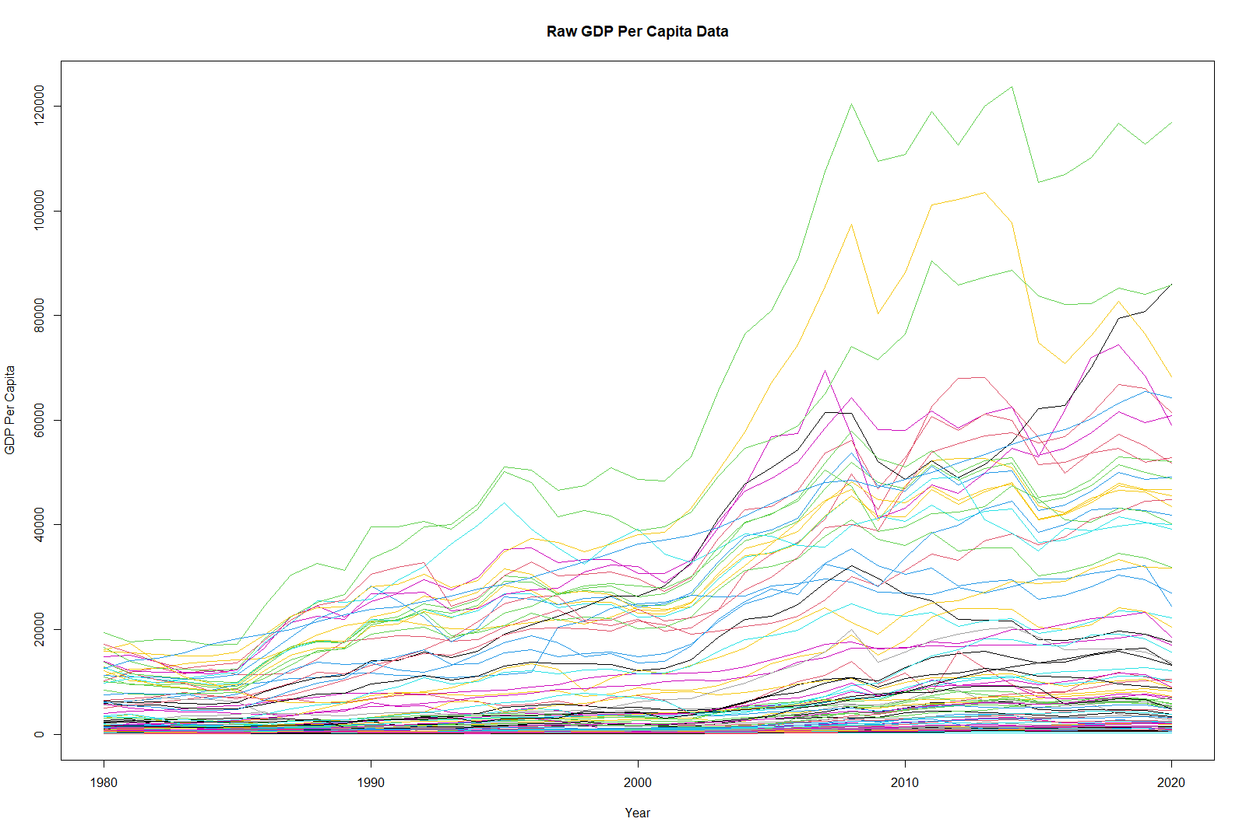

Figure - GDP per Capita without any transformation for 93 countries obtained from World Bank Database for the period 1980 to 2020. Each line corresponds to a country.

Also, the Financial Development Index (FDI) illustrates notable differences in the financial sector’s maturity across countries. Wealthier nations such as Switzerland, Australia, and the United demonstrate high average FDI values, indicative of advanced financial systems with broad access to services and strong infrastructure. United States of America, with a low standard deviation and a high FDI range, displays a consistently high level of financial development, signifying relative stability within its financial sector. By contrast, lower-income countries, including Sierra Leone and Uganda report much lower average FDI values, reflecting limited financial infrastructure and accessibility.

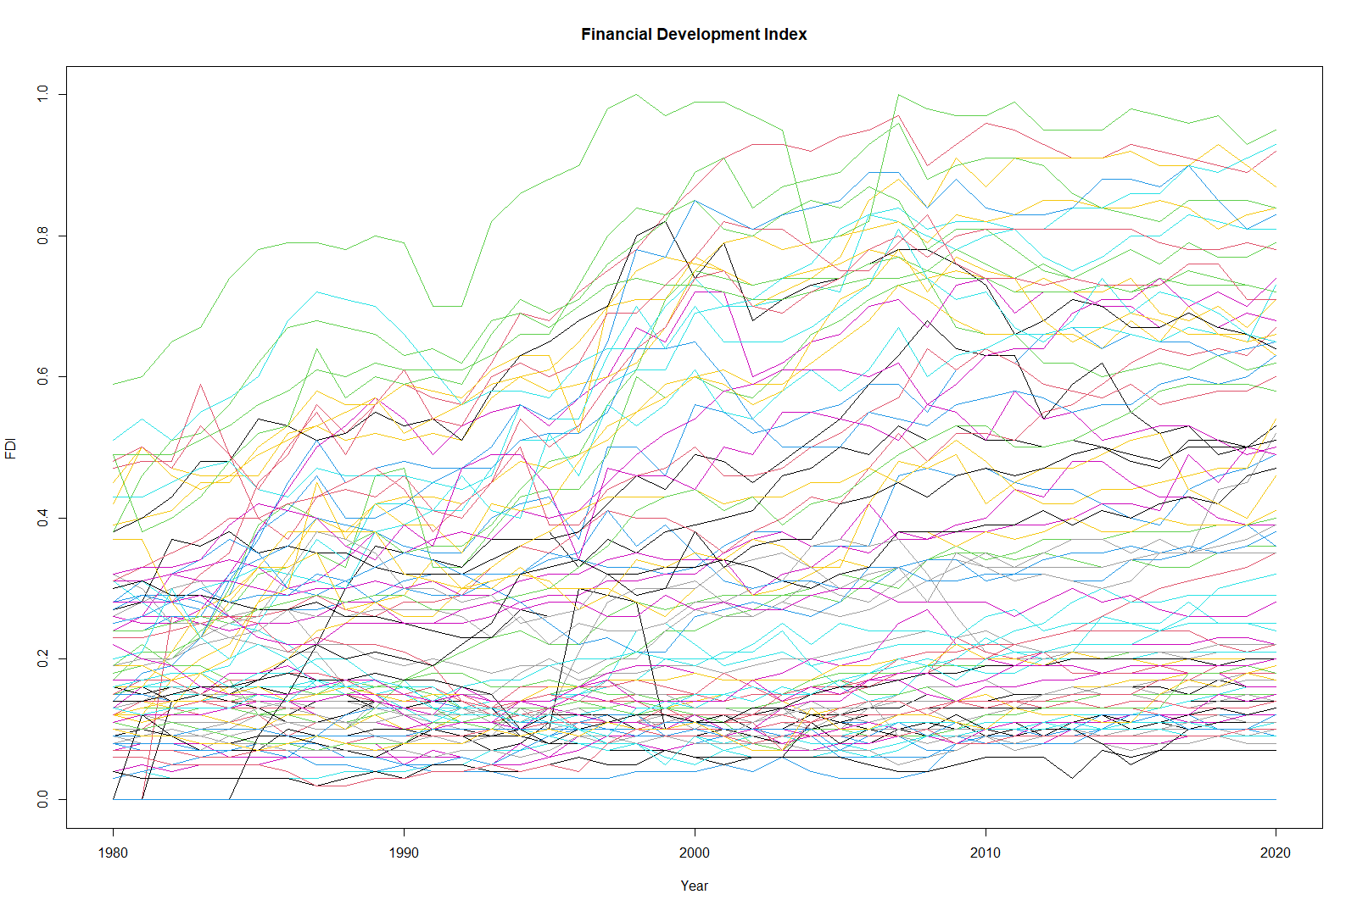Several middle-income countries, such as Bangladesh and Gabon, exhibit low but relatively stable FDI values, which indicate modest levels of financial development with little fluctuation, perhaps due to limited but steady investment in their financial systems. Some middle-income nations, like Turkey, display higher variability (SD: 0.16), suggesting fluctuations in financial sector accessibility, possibly reflecting economic volatility or changing financial policies. The statistics underscore the gap in the financial sector maturity between high-income and developing countries, with advanced economies showing both higher and more stable financial development compared to the generally lower, sometimes more variable FDI levels seen in lower-income and emerging economies.

Figure - Financial Development index without any transformation for 93 countries obtained from International Monetary Funds’ Database for the period 1980 to 2020. Each line corresponds to a country.

Drawing upon descriptive statistics for GDP per capita differences in logarithmic form, the analysis reveals relative income gaps between various countries and the United States. Numerous countries, such as Bangladesh, Burundi, and Sierra Leone, exhibit substantially negative mean values, reflecting much lower GDP per capita compared to the United States. In contrast, wealthier nations like Luxembourg, Norway, and Switzerland display positive or near-zero means, indicating income levels on par with or even exceeding those of the United States.

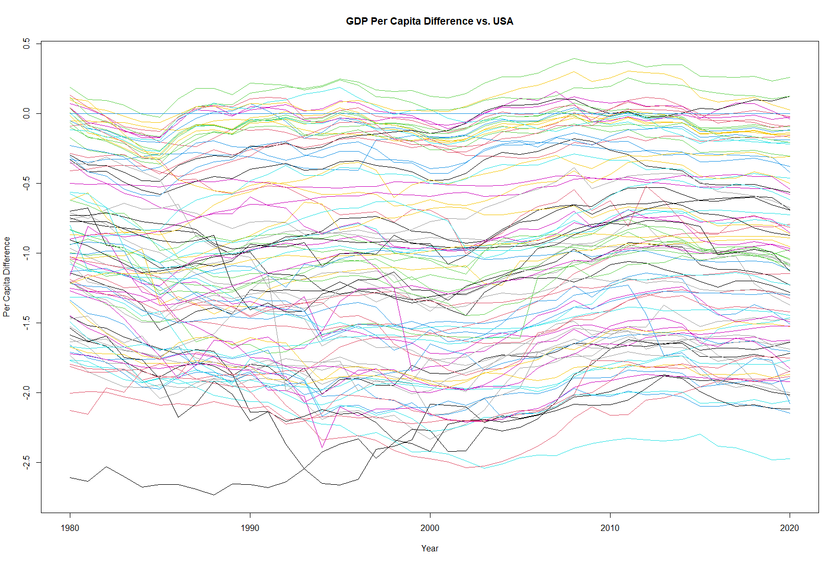Standard deviations in some developing countries, including Syria and Guyana, reveal notable fluctuations in GDP per capita differences, likely due to economic instability or swift policy shifts. Meanwhile, advanced economies like Sweden and Switzerland demonstrate low variability, suggesting a steady income level relative to the United States over the study period. Furthermore, the range of minimum and maximum values across countries highlights diverse economic paths, with low-income countries often experiencing more limited growth compared to their high-income counterparts. These statistics underscore persistent global income inequality and the relative stability of wealthier nations in sustaining higher income levels.

Figure - GDP per Capita logarithmic differences with USA for 93 countries obtained from World Bank Database for the period 1980 to 2020. Each line corresponds to a country’s log difference with USA.

Continuing with the analysis of GDP growth rate differences relative to the USA, the data reveals diverse growth patterns across countries. China stands out with a high positive mean growth rate difference, indicating a steady growth advantage over the USA. Similarly, Myanmar and Guyana show notable positive averages, reflecting faster economic expansion compared to the USA. Conversely, countries like Syria and Libya display significantly negative mean differences, pointing to slower or more erratic growth patterns relative to the USA.

Variability in growth rates is evident across countries, with Nigeria and Liberia exhibiting higher standard deviations, suggesting pronounced economic fluctuations. Median values generally mirror the mean, though discrepancies between the two in countries such as Sudan and Nigeria hint at outliers or economic shocks affecting growth rates. These patterns highlight the varied economic resilience and growth potential across regions, underscoring a spectrum of growth trajectories and stability levels relative to the USA.

Figure - GDP per Capita growth rate differences with USA for 93 countries obtained from World Bank Database for the period 1980 to 2020. Each line corresponds to a country’s difference with USA.

## Generalized Cross-Validation

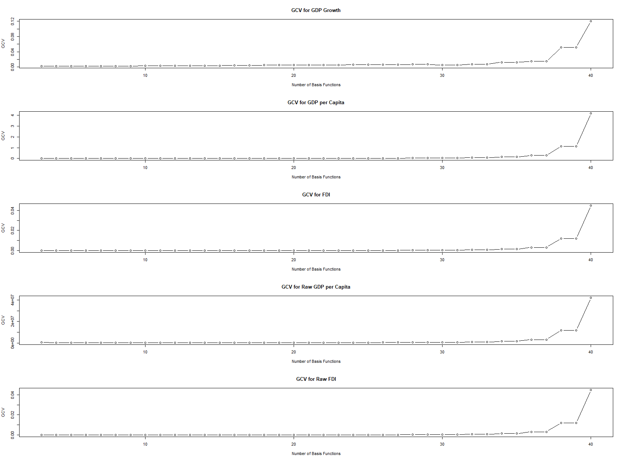Initially, I applied the Fourier Basis approach to transform the raw data into functional data objects, facilitating smoother representations of each time series. Fourier Basis functions are particularly suited for cyclical data, making them an appropriate choice given the periodic nature of economic indicators. To determine the optimal number of basis functions, I employed the Generalized Cross-Validation (GCV) method, a statistical technique that assesses model performance by balancing fit and complexity. This approach helps avoid overfitting by selecting a basis number that minimizes GCV error. I set a penalty parameter of 0.0001 across all functions, imposing a slight smoothness constraint to control excessive fluctuations without compromising essential data features. This setup enables the creation of functional data representations that capture key trends and periodicities while maintaining a smooth, interpretable structure.

Figure - Generalized Cross-Validation for choosing optimal number of basis for each variable.

Consequently, the optimal number of basis functions was selected from a range extending up to 35, allowing flexibility in capturing varying levels of detail in the data. I opted for the 25 number of basis functions within this range to retain minor fluctuations in the GDP and FDI signals while also avoid overfitting. This choice aims to ensure that even small-scale patterns and irregularities in the economic indicators are captured, preserving the nuances of the original time series while enhancing the model's descriptive capability.

## Smoothing, Registration, Warping function and Mean function

Building on this approach, I selected 25 basis functions to facilitate the smoothing process, which was followed by continuous registration of the functional data objects to align key features across the time series. Continuous registration addresses phase variations, ensuring that similar patterns or trends are synchronized in time across different series. This alignment is especially valuable for economic indicators, where cyclical patterns often exhibit slight timing differences.

The continuous registration technique relies on a warping function that adjusts the time domain to optimize alignment across the series. This warping function effectively remaps original time points to adjusted ones, allowing the data to highlight underlying similarities while preserving each series’ unique timing. The transformation keeps the amplitude of fluctuations intact but aligns them in a coherent way, which is critical for comparative analysis of time-sensitive indicators like GDP and FDI.

Applying this methodology to , which represents the growth rate difference between each of the 93 countries and the USA as a benchmark, transforms the raw data into a smoothed functional data object that captures key growth patterns while filtering out much of the noise in each country’s growth gap. Through continuous registration, the registered data reveal subtle variations in both phase (timing) and amplitude (intensity) across countries, showing how each country’s growth behavior aligns with or diverges from the USA.

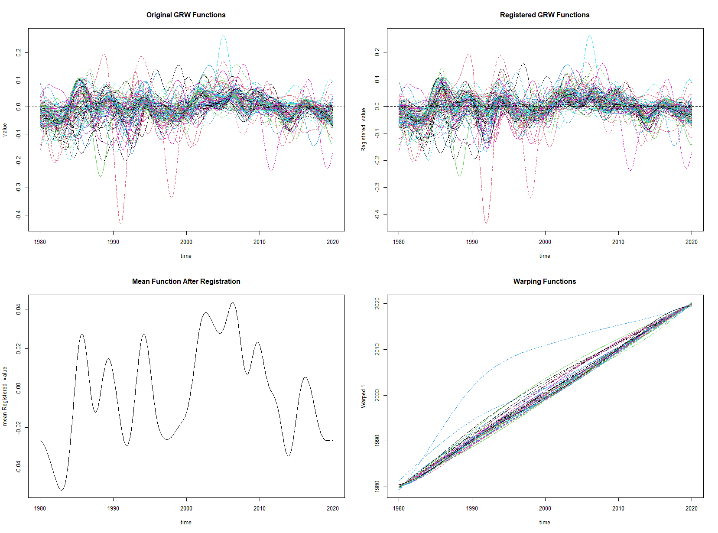The mean function derived from these registered growth rate gaps illustrates the average growth difference between each country and the USA over time. Two notable points emerge: a peak around 2008 and a trough around 1985. The 2008 peak aligns with the global financial crisis, a period marked by considerable economic disruption, during which growth gaps between the USA and other countries widened due to varied responses to the crisis. The minimum mean gap around 1985, conversely, suggests a period of closer economic alignment, possibly resulting from policies or conditions that encouraged more synchronized growth.

Figure - Original function plot compared to registered version and Warping, and Mean function after continuous registration

For the financial development function, both the registered and original smoothed functions show consistently positive values across all 93 countries, suggesting overall growth in financial development within each country throughout the study period. From 2000 to 2019, however, financial development levels across most countries remained relatively stable, with minimal fluctuations, indicating a period of steady but unremarkable growth in this indicator.

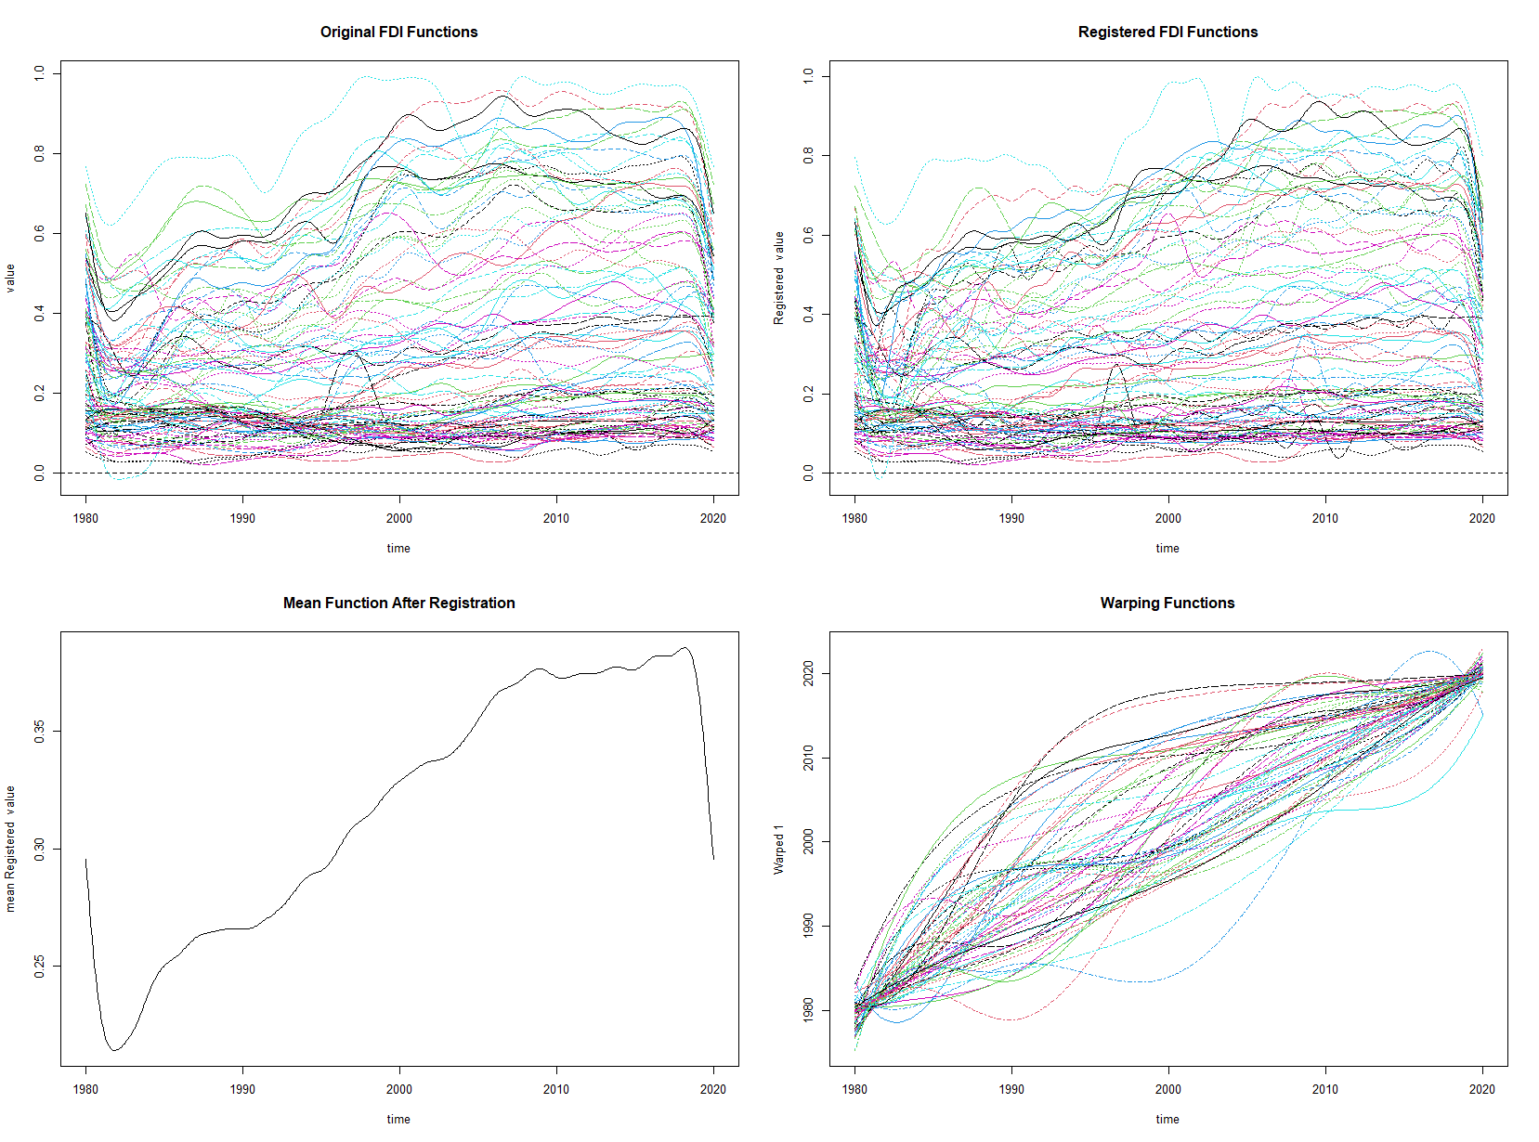The mean function identifies two significant points: the minimum value occurred around 1983, reflecting a period when financial systems in many countries were still developing or adapting to new economic policies. The maximum value appeared in 2019, marking a peak likely influenced by advancements in financial technology and broader economic growth worldwide. The warping function indicates notable phase and amplitude differences, successfully captured through continuous data registration, showing that while financial development trends are positive across all countries, the timing and intensity of this growth vary significantly. This variability highlights the diverse financial development pathways taken by different countries while underscoring the impact of recent technological and structural shifts within global finance leading up to 2019.

Figure - Original function plot compared to registered version and Warping, and Mean function after continuous registration

For the income per capita gap , both the registered smoothed function and the original smoothed functions capture asymmetric cycles that vary across the 93 countries, reflecting distinctive economic trajectories. Most of the gaps show negative values relative to the USA, suggesting that income per capita in many countries lags behind that of the USA. The warping function further reveals significant differences in both phase and amplitude, meaning that the timing and magnitude of income per capita changes differ widely from country to country. This variation is successfully captured through continuous data registration, aligning comparable features across countries while respecting each country’s unique economic rhythm.

The mean function provides additional context, showing that the minimum income per capita gap occurred around the year 2000, a period marked by economic expansion and globalization, which might have narrowed income disparities. In contrast, the maximum gap appears around 2012, following the global financial crisis and subsequent slow recovery. The USA recovered faster than many other nations, leading to an expanded income per capita gap during this period. This timeline underscores how pivotal economic events, such as the early 2000s boom and the post-2008 recovery, can significantly influence income dynamics and widen or narrow gaps relative to the USA.

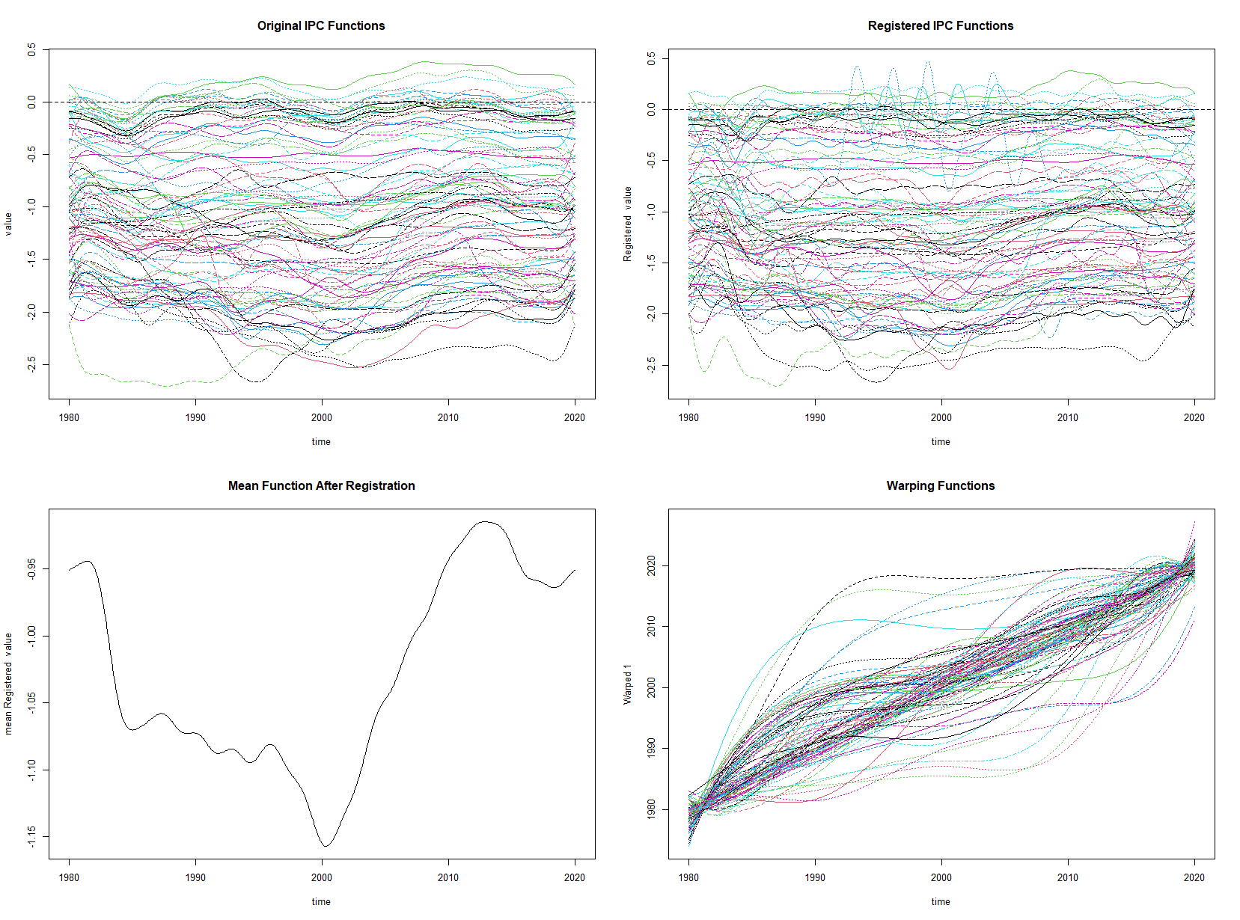

Figure - Original function plot compared to registered version and Warping, and Mean function after continuous registration

## Functional Regression

Using the *fda* package’s *fregress* function, a functional-on-functional regression was performed to model growth rates as a function of income per capita , financial development index , and the interaction term between income per capita and FDI. Specifically, the model is structured as , where each predictor and outcome is treated as a functional object. The regression analysis produced an value of 0.394, suggesting that the selected predictors account for approximately 39.4% of the variance in growth rates across the sample, indicating moderate predictive strength. Additionally, an approximate standard error for the estimated beta coefficients was calculated, yielding a value of 0.0358, providing insight into the variability of the regression’s functional coefficients.

Given the functional nature of the predictors and outcome, visualizing these functions becomes crucial for understanding the relationship patterns. Functional data plots can illustrate the underlying trends, seasonalities, and interaction effects, which are less apparent from summary statistics alone. This visualization can help identify specific intervals where predictors exert stronger effects on growth rates or detect potential non-linearities and interactions within the data. Thus, plotting these functional data representations will offer more granular insights into the dynamics between income per capita, FDI, and economic growth within this framework. Below are the results of FOFR[1] and four functional coefficients plotted for the study period.

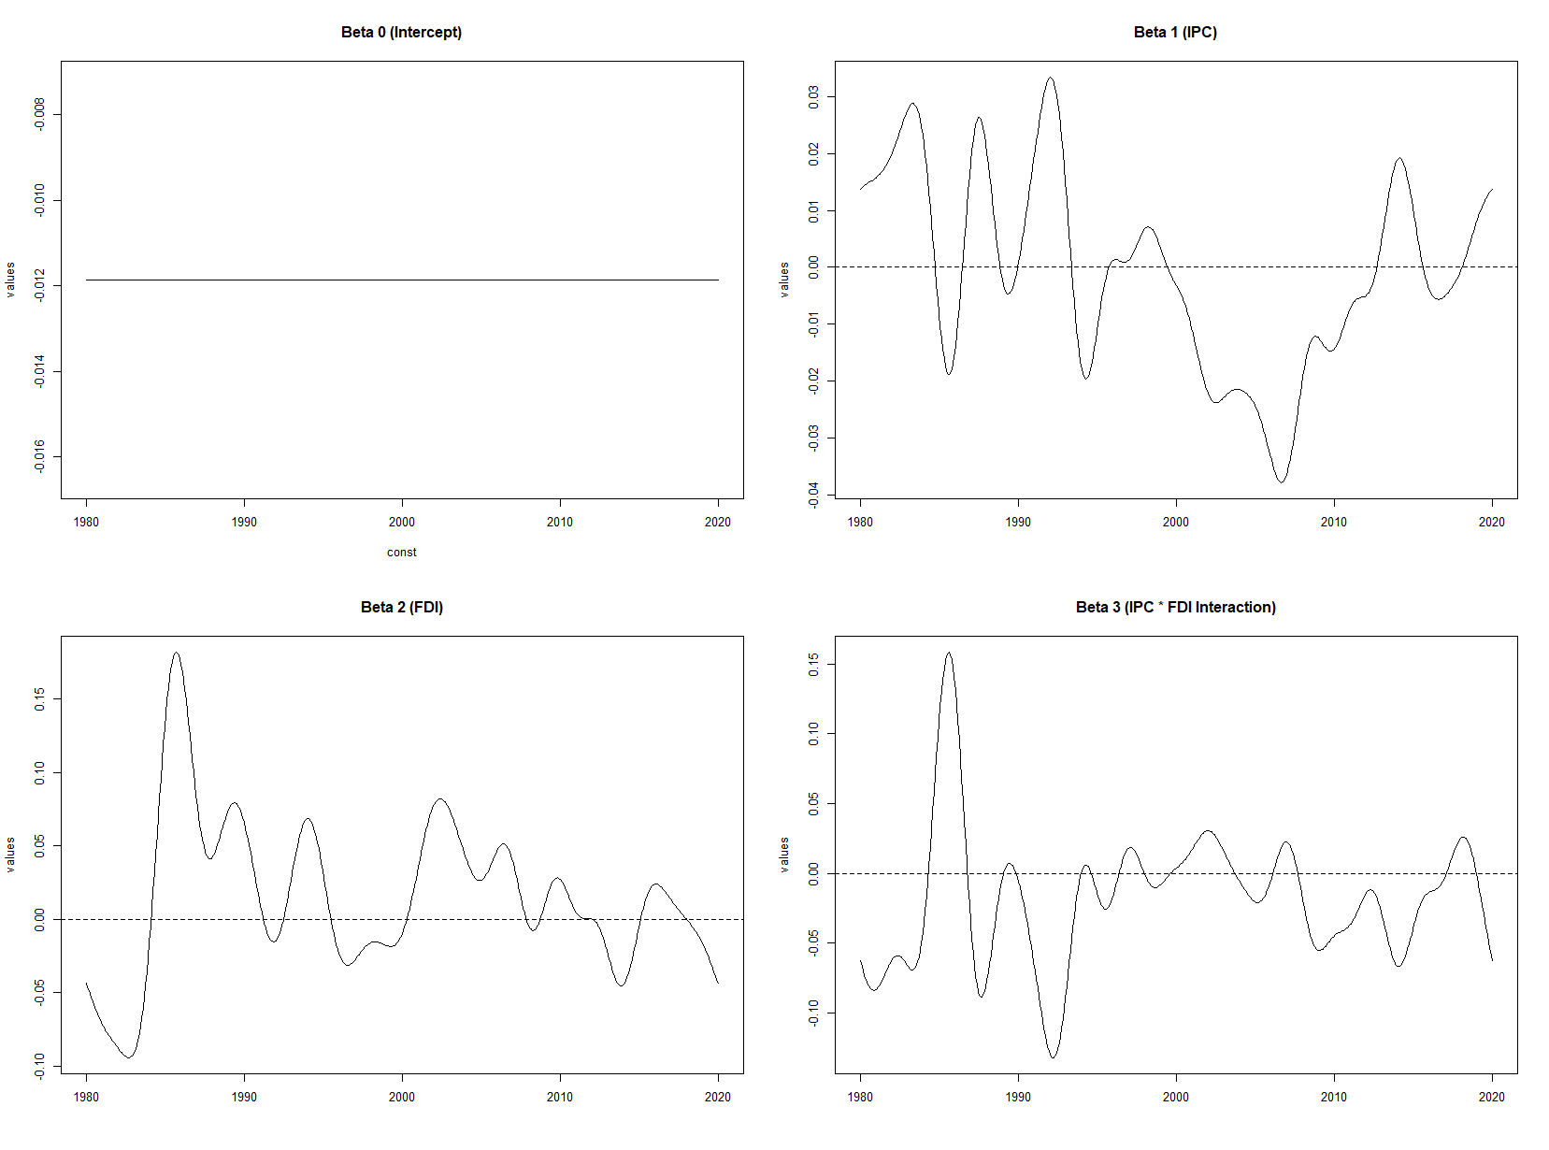

Figure - Coefficents for FOFR model from 1980 to 2020 with nbasis= 25 using fregress method

The beta function for the intercept term, a constant at -0.012, suggests a stable baseline influence on growth rates that remains unaffected by fluctuations in the predictor functions. However, the behavior of other beta functions exhibits considerable temporal variability, capturing the complex dynamics between income per capita, financial development, and their interaction over the study period. Specifically, the beta function for income per capita indicates marked volatility before the year 2000. This variability may reflect the global economic shifts and regional disparities in income distribution that influenced growth trends differently in the pre-2000 era. Notably, post-2000, declines sharply, reaching a minimum around -0.04, signifying a dampened influence of income per capita on growth rates, potentially due to structural economic adjustments or the maturation of economies within the dataset. Interestingly, from 2008 onward, ( reverses direction, rising towards positive values (approximately 0.02), perhaps suggesting a resurgence in the positive influence of income per capita, possibly influenced by post-2008 economic policies and recovery measures globally.

The beta function for financial development index further highlights significant historical economic trends. Peaking around 1985, reflects an era of substantial economic liberalization and capital inflow activities, as many countries implemented policies to enhance financial development. After this peak, follows a downward trend, settling into a fluctuation band between -0.025 and 0.075. The positive predominance of throughout the majority of the study period underscores financial development's mostly beneficial impact on economic growth, consistent with the theory that financial development facilitates capital accumulation and resource allocation. However, the observed fluctuations and the occasional dips into the negative range indicate that financial development’s impact on growth is not uniformly positive and may depend on specific macroeconomic contexts, external shocks, or financial market stability.

The interaction term between income per capita gap and financial development also demonstrates significant variability, with its effects predominantly in the negative range. Notably, peaks in 1985 and then reaches a minimum around 1993, after which it continues to fluctuate negatively. This pattern suggests that while financial development has a direct, positive influence on growth, its interaction with income per capita is complex and tends to have a diminishing effect on the convergence process. Specifically, the combination of a generally positive and a negative implies that financial development can foster economic convergence directly but that the interaction effect with income per capita may weaken this influence in the long run. Thus, the functional data reveal that financial development's role in promoting convergence is nuanced, exhibiting short-term positive impacts that, in the longer run, may be offset or neutralized by income disparities. This interplay points to the importance of carefully considering both direct and interaction effects of economic variables in policy formulations aimed at fostering sustainable growth.

Plotting residuals from the main regression can offer valuable insights into the model’s fit quality and the potential presence of patterns or biases not captured by the predictors.

Figure - Comparison of mean residuals with 2 standard deviations vs. standard white noise

The residual plot, showing fluctuations around the zero line, suggests that the model effectively captures the main structure of the functional relationship between growth rate, income per capita, and financial development. When compared to randomly generated white noise, the residuals stay within a similar range, indicating that the variability observed in the residuals is consistent with random fluctuations rather than systematic bias. This behavior suggests that the model does not miss any major structural components in the data, as the residuals do not display significant deviations beyond what would be expected in the presence of random noise.

This finding supports the robustness of the functional-on-functional regression model, implying that the observed predictors (income per capita, financial development, and their interaction) sufficiently account for the variations in growth rates over time. Residuals that remain within the bounds of white noise also reinforce the absence of autocorrelation or unexplained patterns, further validating the model's capacity to handle the complexities inherent in this functional dataset. Thus, the residual analysis complements the initial regression results, confirming that no substantial modifications to the model are necessary, as it provides a well-balanced representation of the underlying economic relationships.

Given the extensive dataset encompassing numerous countries, we can categorize them by region and income level to conduct a more nuanced analysis of the beta coefficient functions within each category. This approach allows us to examine regional and income-based variations in the relationships among growth rate, income per capita, and financial development, providing insights into how these factors might operate differently across economic contexts.

Using the flexibility of functional regression analysis, we can apply specific conditions to identify instances of convergence based on beta coefficient values. Specifically, convergence is considered to occur when (the interaction term) is negative and (financial development) is positive. Under these conditions, notable regional variations in convergence dynamics emerge.

Based on the figures, we observe that economic convergence in Africa is present but comparatively limited, with financial development contributing to this convergence primarily before 2008. This suggests that while African economies did align to some extent with higher-income benchmarks, such convergence was sporadic and largely contingent on the earlier influence of financial development. The findings imply that subsequent economic factors or structural constraints may have impeded continued convergence in later years.

In East Asia and the Pacific, the data reveal notable periods of convergence, particularly influenced by financial development during specific time frames, such as 1985–1995 and 2000–2003. Additionally, financial development shows some impact on convergence in more recent years, up to 2019. These intervals highlight the enduring role of financial reforms and market integration in driving economic alignment in this region, as financial development appears to have provided both direct and indirect support for convergence over multiple decades.

In Europe, convergence occurs consistently and largely under the effect of financial development, where the financial development index predominantly drives economic alignment with high-income benchmarks. Unlike other regions, European convergence is overwhelmingly influenced by financial development, indicating that financial systems and reforms have been particularly effective in fostering sustained economic alignment. For Asian countries, however, convergence appears absent, as observed values for (financial development) and (interaction effect) remain positive. This pattern suggests that financial development did not play a substantial role in driving convergence, possibly due to other economic factors or limitations within regional financial systems.A group of graphs showing different types of data

Figure - Conditional Plotting of Convergence based on different regions (Part 1)

For Latin America and the Caribbean, convergence is observed over the study period, with a cyclical pattern of convergence emerging under the influence of financial development. This cyclical convergence suggests that while financial development periodically facilitated economic alignment, other factors may have played significant roles during intervals when convergence was less pronounced. The periodic nature of convergence indicates that financial reforms may have had short-term impacts that fluctuated in response to broader economic conditions or policy changes.

In Europe and Central Asia, convergence appears to be strongly tied to the influence of financial development, particularly between 1990 and 2000. This period aligns with significant economic restructuring and financial integration in many countries within this region, highlighting financial development’s central role in driving alignment with higher-income benchmarks during this timeframe. For the Middle East, convergence is also evident throughout the study, with financial development contributing to convergence at specific intervals, including in recent years. This pattern suggests that financial reforms in the Middle East have provided consistent, albeit intermittent, support for economic alignment, likely influenced by the region's varied economic and political landscapes.

For Sub-Saharan Africa, convergence occurs largely independently of financial development, with only minimal influence observed around 1990. This suggests that while some alignment with higher-income economies is present, financial development has played a limited role in driving this convergence. The relatively minor impact of financial development in Sub-Saharan Africa highlights the region's challenges in leveraging financial reforms to achieve sustained convergence, possibly due to limited financial infrastructure or external economic pressures that constrain the long-term effectiveness of financial development on growth and alignment.

Categorizing countries by income level reveals distinct patterns of convergence influenced by financial development. For upper-middle-income countries, convergence is observed notably from 1990 to 2000 and again after 2011. The earlier period of convergence (1990 to 2000) was significantly influenced by financial development, suggesting that financial reforms during this time facilitated alignment with higher-income economies. This impact diminished in subsequent years, but renewed convergence appears after 2011, possibly indicating recent economic adjustments or renewed financial growth within this income group.

Figure -Conditional Plotting of Convergence based on different regions (Part 2)

In high-income countries, convergence occurs consistently, though specific periods, such as 1985 to 1990, exhibit convergence strongly influenced by financial development. This suggests that financial development provided a foundational push for alignment among high-income nations during this timeframe. Additionally, around 2000 and again near 2010, financial development appears to have supported further convergence, indicating that financial systems and reforms have played a recurring but less consistent role in facilitating economic alignment for high-income countries as their economies matured.

For lower-middle-income countries, convergence occurs primarily independently of financial development, with financial reforms having only a slight impact on convergence in recent years. This pattern suggests that other factors beyond financial development may play more significant roles in economic alignment for these countries. In low-income countries, however, convergence is almost entirely absent, with only a brief period around 1990 showing any convergence, and this was largely without the influence of financial development. This limited impact highlights the challenges faced by low-income countries in leveraging financial development as a tool for economic convergence.

## A group of graphs with numbers and symbols Description automatically generated with medium confidenceWilcoxon Test Findings

Figure - Conditional Plotting of Convergence based on different income levels

The Wilcoxon rank sum test was performed to examine potential differences in location shift between depth distributions across various regions and income levels. The results are as follows:

Table : Wilcoxon Test for different regions

|  |  |  |  |  |
| --- | --- | --- | --- | --- |
| **Region/Income Group** | **W-Statistic** | **p-value** | **Significance**  **(α = 0.05)** | **Conclusion** |
| Africa | 235 | 0.2846 | Not Significant | No significant difference in location shift. |
| East Asia and Pacific | 438.5 | 0.8865 | Not Significant | No significant difference in location shift. |
| Europe | 998.5 | 0.000467 | Significant | Significant difference in location shift. |
| Asia | 294 | 0.6113 | Not Significant | No significant difference in location shift. |
| Latin America and Caribbean | 602.5 | 0.1598 | Not Significant | No significant difference in location shift. |
| Sub-Saharan Africa | 491.5 | 0.003176 | Significant | Significant difference in location shift. |
| North America | 84 | 0.1624 | Not Significant | No significant difference in location shift. |
| Europe and Central Asia | 158.5 | 0.07598 | Not Significant | No significant difference in location shift. |
| Middle East and North Africa | 207.5 | 0.4072 | Not Significant | No significant difference in location shift. |
| Middle East | 54 | 0.7799 | Not Significant | No significant difference in location shift. |

***Note****: A p-value less than 0.05 indicates a statistically significant result, suggesting a difference in location shift between groups.*

The Wilcoxon rank sum test results highlight differences in the location shift of depth distributions across various regions. For most regions—including Africa (p = 0.2846), East Asia and Pacific (p = 0.8865), Asia (p = 0.6113), Latin America and the Caribbean (p = 0.1598), North America (p = 0.1624), Europe and Central Asia (p = 0.07598), Middle East and North Africa (p = 0.4072), and the Middle East (p = 0.7799)—the p-values exceed the significance level of 0.05. This indicates no statistically significant difference in location shift for these regions, suggesting that the depth distributions are relatively consistent with the overall dataset or between compared groups within these regions.

However, Europe and Sub-Saharan Africa exhibit statistically significant differences in location shift. Europe has a W-statistic of 998.5 with a p-value of 0.000467, and Sub-Saharan Africa has a W-statistic of 491.5 with a p-value of 0.003176. These p-values are well below the 0.05 threshold, indicating significant differences in the centrality or variability of the functional data within these regions. The significant result for Europe may reflect unique economic dynamics, financial development levels, or climatic factors affecting the data, such as temperature changes or economic convergence trends. Similarly, the significant difference in Sub-Saharan Africa could be due to distinct regional characteristics like developmental challenges, economic policies, or environmental factors influencing the functional data distributions.

These findings imply that region-specific factors play a crucial role in shaping the depth distributions of functional data in Europe and Sub-Saharan Africa. The significant differences suggest that these regions may have unique patterns or outliers that distinguish them from other regions. Further investigation into these regional disparities could provide valuable insights into the underlying causes, such as differing rates of financial development, economic policies, or external shocks impacting these areas during the study period.

Regarding income levels, the Wilcoxon rank sum test reveals a statistically significant difference for the high-income group, with a W-statistic of 1324 and a p-value of 0.0002515. This indicates a significant location shift in the depth distributions for high-income countries, suggesting that their functional data patterns differ markedly from those of other income groups. The substantial difference may reflect advanced levels of financial development, economic stability, or other socio-economic factors that influence the centrality and variability of the data in high-income countries.

The low-income group shows a marginally significant result, with a W-statistic of 449 and a p-value of 0.05079, which is slightly above the conventional significance level of 0.05. This marginal significance suggests a potential difference in location shift that may warrant further exploration. It could indicate underlying disparities in the functional data distributions due to economic constraints, limited access to financial services, or other developmental challenges faced by low-income countries.

Table - Wilcoxon Test for different income levels

|  |  |  |  |  |
| --- | --- | --- | --- | --- |
| **Region/Income Group** | **W-Statistic** | **p-value** | **Significance**  **(α = 0.05)** | **Conclusion** |
| Upper middle income | 761 | 0.0828 | Not Significant | No significant difference in location shift. |
| High income | 1324 | 0.0002515 | Significant | Significant difference in location shift. |
| Lower middle income | 625 | 0.8385 | Not Significant | No significant difference in location shift. |
| Low income | 449 | 0.05079 | Marginal | Marginal difference in location shift. |

***Note****: A p-value less than 0.05 indicates a statistically significant result, suggesting a difference in location shift between groups.*

These results underscore the influence of income levels on the depth distributions of functional data. The significant difference in high-income countries highlights how higher economic status may lead to distinct patterns in the data, possibly due to more robust financial infrastructures or consistent economic growth. The marginal result for low-income countries points to possible variations that could be significant with a larger sample size or more precise measurements, suggesting that income level is an important factor in understanding the centrality and dispersion within functional data analysis.

## Visualization of Threshold Levels

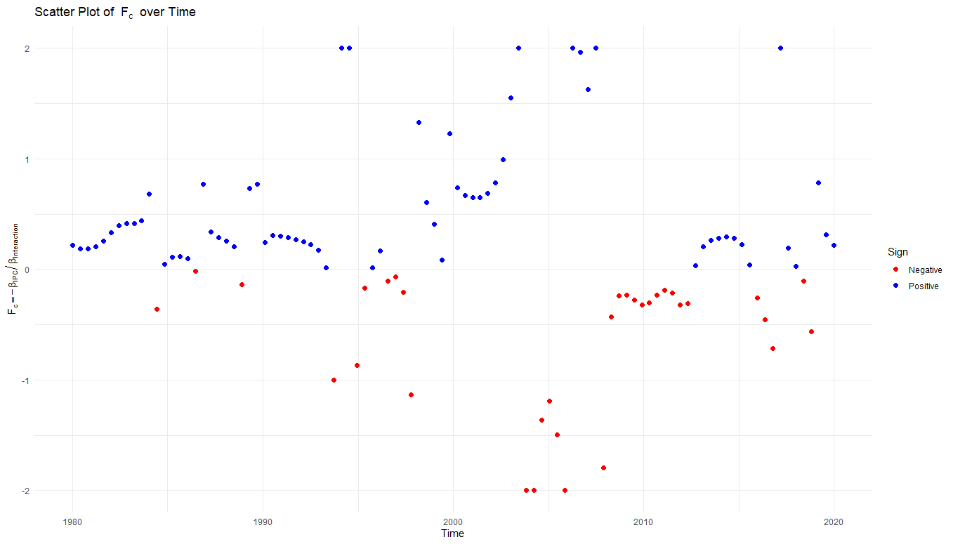Following the discussed framework, we can also derive the threshold level function and visualize it as shown below:

Figure - Critical value for financial development index, with blue acceptable positive values and red not acceptable negative values

The threshold level function, by definition, should be positive, as it represents a minimum level of financial development required to foster convergence. This positive threshold underscores the assumption that financial development generally exerts a beneficial influence on convergence. However, if the threshold level dips into negative values, it implies that convergence could occur regardless of the level of financial development, meaning that even minimal or adverse financial development may not hinder convergence.

For countries with a financial development index above this threshold, it can be inferred that the likelihood of financial development positively impacting convergence increases. In these cases, higher levels of financial development enhance the probability of economic alignment with wealthier benchmarks, reinforcing the role of financial systems in supporting sustained convergence.

# Conclusion

This study delved into the dynamic impact of financial development on income convergence among countries at varying stages of economic development, employing Functional Data Analysis (FDA) to capture the temporal evolution of this relationship. By treating key economic variables such as GDP per capita and the Financial Development Index (FDI) as smooth functions over time, we analyzed complex, time-varying interactions that traditional econometric models might overlook. This methodological approach allowed us to address our primary research questions: to what extent does financial development influence income convergence, and how effective is FDA in capturing these dynamics?

Our findings reveal that financial development plays a significant but heterogeneous role in influencing income convergence across different regions and income levels. High-income and upper-middle-income countries exhibit strong convergence influenced by financial development, particularly during periods such as 1990 to 2000 and after 2011. In these economies, well-developed financial systems have facilitated efficient resource allocation, enhanced access to capital, and supported sustained economic growth, thereby promoting convergence towards the benchmark economy, represented by the United States. The presence of mature financial markets and institutions in these countries appears to have reached a level of development necessary to exert a positive influence on convergence.

Conversely, in low-income and lower-middle-income countries, the impact of financial development on convergence is limited or minimal. This suggests that their underdeveloped financial sectors may hinder the ability to catch up with wealthier nations. The findings indicate that there is a threshold level of financial development required before significant effects on convergence are observed. This threshold effect underscores the necessity for these countries to focus on foundational financial reforms and capacity building to elevate their financial systems to a level where they can effectively contribute to economic convergence.

The application of FDA provided methodological advancements over traditional econometric approaches. By utilizing penalized function-on-function regression models, we addressed issues of identifiability and overfitting, ensuring that the functional relationships captured were both meaningful and interpretable. This approach aligns with recent developments in FDA, emphasizing its utility in analyzing complex economic phenomena. FDA enabled us to uncover temporal patterns and regional variations in the convergence process that might have been obscured using classical methods, effectively answering our research question regarding the applicability of FDA in this context.

Our findings have important policy implications. For policymakers in developing countries, the results underscore the critical role of financial development in facilitating economic convergence. Strengthening financial institutions, enhancing regulatory frameworks, and promoting financial inclusion can create an environment conducive to growth and convergence. However, the approach to financial reforms should be context-specific. In low-income countries, efforts should prioritize building basic financial infrastructure, such as expanding banking services to rural and underserved areas, fostering microfinance institutions, and leveraging mobile banking technologies to reach unbanked populations. Enhancing financial literacy and trust in financial institutions is also crucial to ensure widespread adoption and effective utilization of financial services.

In contrast, high-income countries might focus on advancing financial technologies, regulatory innovations, and managing complex financial instruments to maintain stability and promote further growth. Recognizing these differences is essential for tailoring policies that effectively address the unique challenges and opportunities within each economic context.

The study also highlights that financial development is not a standalone solution. The differential impacts observed across regions and income levels suggest that financial development must be accompanied by other supportive policies, such as investments in human capital, technological innovation, and improvements in institutional quality. In regions where financial development did not significantly influence convergence, other structural issues—like poor governance, inadequate infrastructure, and limited access to education—may be impeding growth. A holistic approach to economic development is necessary, one that addresses these multifaceted challenges in tandem with financial reforms to enhance overall effectiveness.

There are limitations to this study that warrant acknowledgment. The reliance on available data constrained the sample of countries and the time periods analyzed. Variations in data quality and consistency across countries could affect the robustness of the results. Additionally, while FDA offers significant advantages in capturing temporal dynamics, it assumes smoothness in the data and may not fully account for abrupt economic shocks or structural breaks, such as financial crises or sudden policy changes. Future research could integrate FDA with models adept at handling such discontinuities, like incorporating breakpoint analysis or combining FDA with time-series methods that account for non-stationarity.

Further studies are recommended to build on our findings. Incorporating additional variables—such as measures of technological progress, education levels, governance indicators, and institutional quality—could provide a more comprehensive understanding of the factors influencing income convergence. Applying FDA to more granular data, like sector-specific financial indicators or sub-national regional data, may uncover insights at a microeconomic level. Exploring nonlinear relationships and potential threshold effects using advanced statistical techniques, including machine learning methods, could enhance predictive capabilities and offer deeper insights into the convergence process.

Theoretically, the study supports the view that financial development is a catalyst for economic growth and convergence, aligning with theories proposed by Schumpeter (1911) and extended by subsequent economists. However, the varying impacts observed suggest that existing economic growth models should incorporate the heterogeneity of financial systems and recognize that the effect of financial development on convergence is context-dependent. This nuanced understanding can inform the development of more sophisticated theoretical models that better reflect the complexities of the global economy, including the roles of institutional factors and the interplay between financial development and other growth determinants.

In practical terms, the research findings can guide policymakers and international organizations in designing effective strategies to promote income convergence. Recognizing that financial development's impact varies by region and income level, policies should be tailored to the specific needs and conditions of each country. For low-income countries, international support could focus on technical assistance, capacity building, and investment in financial infrastructure. Initiatives such as mobile banking and fintech solutions can play a significant role in reaching remote or marginalized communities, thereby fostering inclusive growth.

Moreover, integrating financial development policies with broader economic strategies that address education, healthcare, and infrastructure can create synergistic effects that accelerate convergence. For example, improving education systems can enhance human capital, making financial investments more productive, while better infrastructure can facilitate market access and economic activities.

The study emphasizes the importance of monitoring and evaluation in implementing financial reforms. Policymakers should establish mechanisms to assess the effectiveness of financial development initiatives continuously. This includes tracking key performance indicators, gathering feedback from stakeholders, and being prepared to adjust policies in response to changing economic conditions. Collaboration with international organizations can provide valuable resources and expertise, facilitating knowledge transfer and the adoption of best practices.

In conclusion, this study demonstrates that financial development plays a significant yet complex role in influencing income convergence among countries. The use of advanced statistical methods like Functional Data Analysis and penalized function-on-function regression allowed for a detailed examination of the temporal dynamics and regional variations in this relationship. Our findings underscore that while financial development is crucial, its impact is contingent upon reaching certain thresholds of financial maturity and is influenced by a country's specific economic context.

As global economies continue to evolve in an increasingly interconnected world, ongoing research incorporating new methodologies and data will be essential in informing policies aimed at fostering sustainable and inclusive growth. The study highlights the need for a multifaceted approach to economic development, one that recognizes the critical role of financial systems while also addressing broader structural and institutional challenges. By tailoring financial reforms to the specific needs of different countries and integrating them with comprehensive development strategies, policymakers can enhance the effectiveness of financial development as a catalyst for income convergence and overall economic prosperity.

This research contributes to the existing literature by providing empirical evidence on the nuanced role of financial development in income convergence and by demonstrating the applicability of FDA in economic analysis. It invites scholars and practitioners to consider the heterogeneity of financial systems and the importance of context-specific policies. Future work in this area has the potential to further unravel the complexities of economic convergence and to support the design of interventions that promote equitable growth worldwide.

# References

1. Aghion, P., Howitt, P., & Mayer-Foulkes, D. (2005). The effect of financial development on convergence: Theory and evidence. Journal of Economics, 120(1), 173–222.
2. Ahmadi, H., & Howitt, P. (2023). The effect of financial development on convergence: Theory and evidence. Economic Theory and Practice, 85(1), 35–58.
3. Arellano, M., & Bover, O. (1995). Another look at the instrumental variable estimation of error-components models. Journal of Econometrics, 68(1), 29–51.
4. Azimi, M. N. (2022). New insights into the impact of financial inclusion on economic growth: A global perspective. PLOS ONE, 17(11), e0277730.
5. Banerjee, A. V., & Duflo, E. (2003). Inequality and growth: What can the data say? Journal of Economic Growth, 8(3), 267–299.
6. Banerjee, A. V., & Newman, A. F. (1993). Occupational choice and the process of development. Journal of Political Economy, 101(2), 274–298.
7. Barro, R. J., & Sala-i-Martin, X. (1992). Convergence. Journal of Political Economy, 100(2), 223–251.
8. Barro, R. J., & Sala-i-Martin, X. (1995). Economic Growth. New York, NY: McGraw-Hill.
9. Beck, T., Demirgüç-Kunt, A., & Levine, R. (2000). A new database on financial development and structure. World Bank Economic Review, 14(3), 597–605.
10. Beck, T., & Levine, R. (2004). Stock markets, banks, and growth: Panel evidence. Journal of Banking & Finance, 28(3), 423–442.
11. Beck, T., Demirgüç-Kunt, A., & Maksimovic, V. (2005). Financial and legal constraints to growth: Does firm size matter? The Journal of Finance, 60(1), 137–177.
12. Blundell, R., & Bond, S. (1998). Initial conditions and moment restrictions in dynamic panel data models. Journal of Econometrics, 87(1), 115–143.
13. Claessens, S., & Laeven, L. (2005). Financial dependence, banking sector competition, and economic growth. Journal of the European Economic Association, 3(1), 179–207.
14. Craven, P., & Wahba, G. (1979). Smoothing noisy data with spline functions. Numerische Mathematik, 31(4), 377–403.
15. Cuevas, A., Febrero, M., & Fraiman, R. (2004). An ANOVA test for functional data. Computational Statistics & Data Analysis, 47(1), 111–122.
16. de Boor, C. (1978). A Practical Guide to Splines. Springer-Verlag.
17. Demirgüç-Kunt, A., & Levine, R. (2008). Finance, financial sector policies, and long-run growth (World Bank Policy Research Working Paper No. 4469). Washington, DC: World Bank.
18. Ekanayake, E. M., & Thaver, R. (2021). The nexus between financial development and economic growth: Panel data evidence from developing countries. Journal of Risk and Financial Management, 14(10), 489.
19. Ferraty, F., & Vieu, P. (2006). Nonparametric Functional Data Analysis: Theory and Practice. Springer.
20. Galor, O. (1996). Convergence? Inferences from theoretical models. The Economic Journal, 106(437), 1056–1069.
21. Galor, O., & Zeira, J. (1993). Income distribution and macroeconomics. The Review of Economic Studies, 60(1), 35–52.
22. García, F., & Salinas, M. (2024). Sustainability of income convergence in the European Union. Sustainability, 16(3), 1339.
23. Gertheiss, J., Rügamer, D., Liew, B. X. W., & Greven, S. (2024). Functional data analysis: An introduction and recent developments. Biometrical Journal.
24. Greenwood, J., & Jovanovic, B. (1990). Financial development, growth, and the distribution of income. Journal of Political Economy, 98(5), 1076–1107.
25. He, Z., & You, Y. (2024). Convergence in financial development and growth. Open Economies Review, 35(4), 779–799.
26. Horváth, L., & Kokoszka, P. (2012). Inference for Functional Data with Applications. Springer.
27. International Monetary Fund (IMF). (2023). World Economic Outlook: A Rock and a Hard Place. Washington, DC: International Monetary Fund.
28. Islam, N. (1995). Growth empirics: A panel data approach. The Quarterly Journal of Economics, 110(4), 1127–1170.
29. Jackson, M. (2023). Economic convergence: The impact of financial crises. Review of Financial Studies, 36(8), 2401–2429.
30. Kim, S., & Park, J. (2024). Exploring club convergence: The role of financial systems. Journal of Economic Growth, 29(1), 23–45.
31. King, R. G., & Levine, R. (1993a). Finance and growth: Schumpeter might be right. The Quarterly Journal of Economics, 108(3), 717–737.
32. King, R. G., & Levine, R. (1993b). Finance, entrepreneurship, and growth: Theory and evidence. Journal of Monetary Economics, 32(3), 513–542.
33. Levine, R. (1997). Financial development and economic growth: Views and agenda. Journal of Economic Literature, 35(2), 688–726.
34. Levine, R., & Zervos, S. (1998). Stock markets, banks, and economic growth. American Economic Review, 88(3), 537–558.
35. Lin, H., & Wu, Y. (2023). The role of financial development in economic convergence: Evidence from Asia. Journal of Asian Economics, 58(2), 95–112.
36. Lopez, A., De Lucas, S., & Delgado, M. J. (2021). Economic convergence in a globalized world: The role of business cycle synchronization. PLOS ONE, 16(10), e0256182.
37. Lucas, R. E. (1988). On the mechanics of economic development. Journal of Monetary Economics, 22(1), 3–42.
38. Magazzino, C., Mele, M., & Schneider, N. (2022). Testing the convergence and the divergence in five Asian countries: From a GMM model to a new machine learning algorithm. Journal of Economic Studies, 49(6), 1002–1016.
39. Mankiw, N. G., Romer, D., & Weil, D. N. (1992). A contribution to the empirics of economic growth. The Quarterly Journal of Economics, 107(2), 407–437.
40. McKinnon, R. I. (1973). Money and Capital in Economic Development. The Brookings Institution.
41. Morales, E., & Zhang, X. (2023). Structural changes and income convergence: The role of financial development. Economic Modelling, 105, 107441.
42. Nguyen, N. T., Nguyen, H. S., Ho, C. M., & Vo, D. H. (2021). The convergence of financial inclusion across provinces in Vietnam: A novel approach. PLOS ONE, 16(8), e0256524.
43. Omar, M. A., & Inaba, K. (2020). Does financial inclusion reduce poverty and income inequality in developing countries? A panel data analysis. Economic Structures, 9, 37.
44. Osei, A., & Boateng, S. (2024). Economic growth and income convergence: Evidence from Sub-Saharan Africa. African Development Review, 36(1), 75–89.
45. Patel, K., & Silva, D. (2024). Financial inclusion and income convergence in developing countries. Journal of Development Studies, 60(2), 101–118.
46. Rajan, R. G., & Zingales, L. (1998). Financial dependence and growth. American Economic Review, 88(3), 559–586.
47. Ramsay, J. O., & Silverman, B. W. (2005). Functional Data Analysis (2nd ed.). Springer.
48. Ramsay, J. O., Hooker, G., & Graves, S. (2009). Functional Data Analysis with R and MATLAB. Springer.
49. Rodriguez, C., & Nguyen, T. (2023). Regional disparities in financial development and their effects on income convergence. Regional Studies, 57(1), 128–145.
50. Romer, P. M. (1986). Increasing returns and long-run growth. Journal of Political Economy, 94(5), 1002–1037.
51. Sakoe, H., & Chiba, S. (1978). Dynamic programming algorithm optimization for spoken word recognition. IEEE Transactions on Acoustics, Speech, and Signal Processing, 26(1), 43–49.
52. Sala-i-Martin, X. (1996). The classical approach to convergence analysis. The Economic Journal, 106(437), 1019–1036.
53. Schumpeter, J. A. (1911). The Theory of Economic Development. Harvard University Press.
54. Shaw, E. S. (1973). Financial Deepening in Economic Development. Oxford University Press.
55. Silva, J., & Diaz, P. (2023). Financial development as a catalyst for economic convergence in Latin America. Latin American Economic Review, 52(3), 45–58.
56. Smith, J., & Evans, R. (2021). Real income convergence and financial integration patterns in the EU. Social Indicators Research, 143(2), 200–221.
57. Solow, R. M. (1956). A contribution to the theory of economic growth. The Quarterly Journal of Economics, 70(1), 65–94.
58. Swan, T. W. (1956). Economic growth and capital accumulation. Economic Record, 32(2), 334–361.
59. Svirydzenka, K. (2016). Introducing a new broad-based index of financial development (IMF Working Paper No. 16/5). Washington, DC: International Monetary Fund.
60. Tibshirani, R., Walther, G., & Hastie, T. (2001). Estimating the number of clusters in a data set via the gap statistic. Journal of the Royal Statistical Society: Series B, 63(2), 411–423.
61. World Bank. (2023). World Development Indicators. Washington, DC: World Bank.

1. Function on function regression