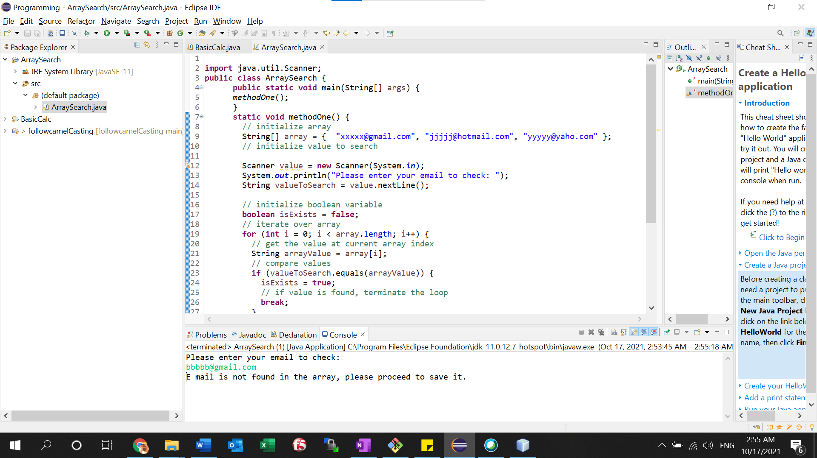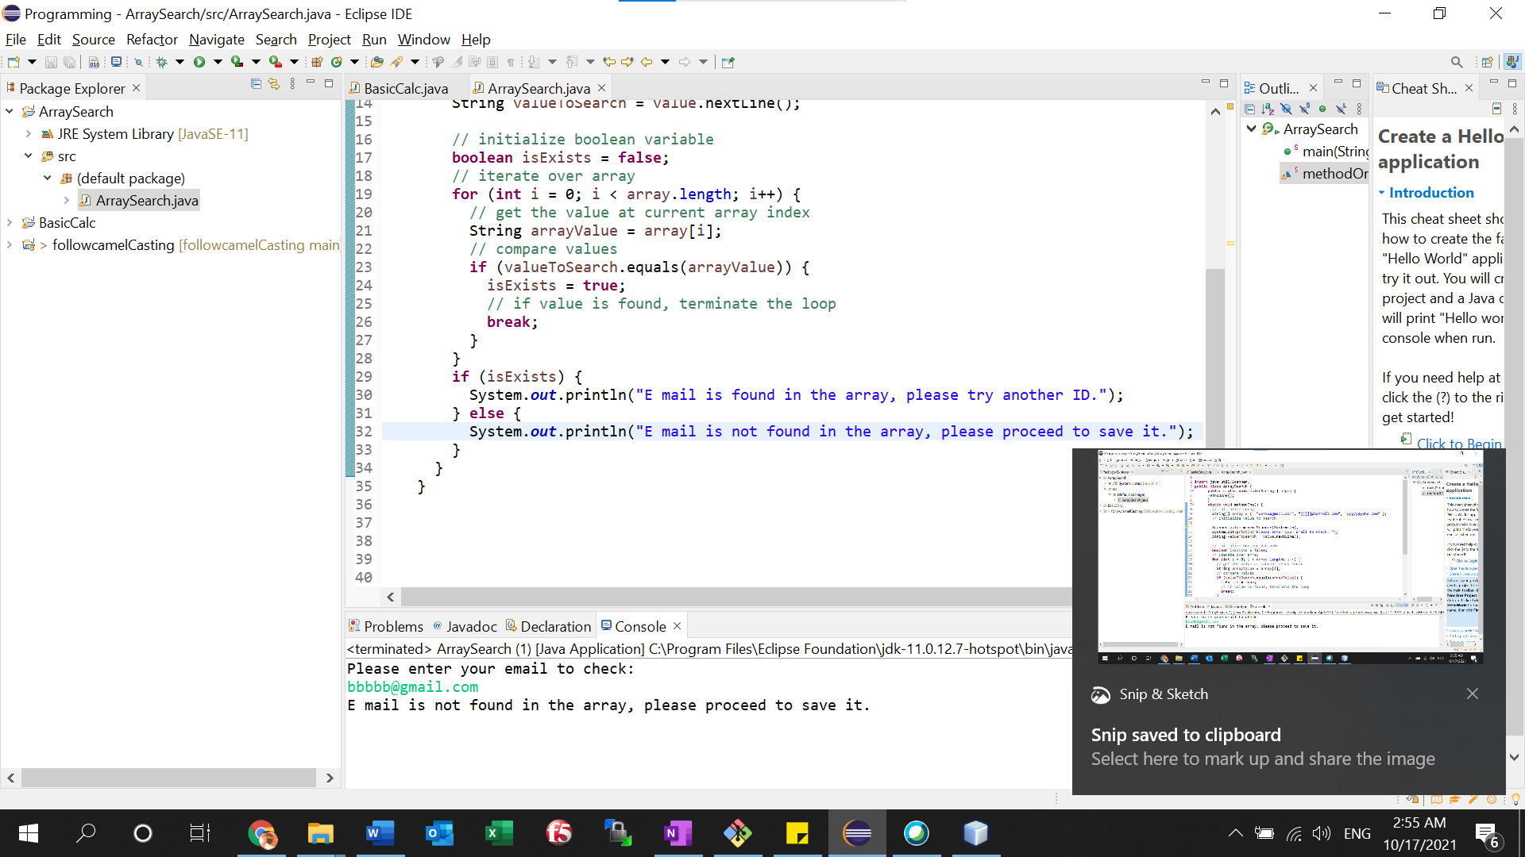

Existed emails:

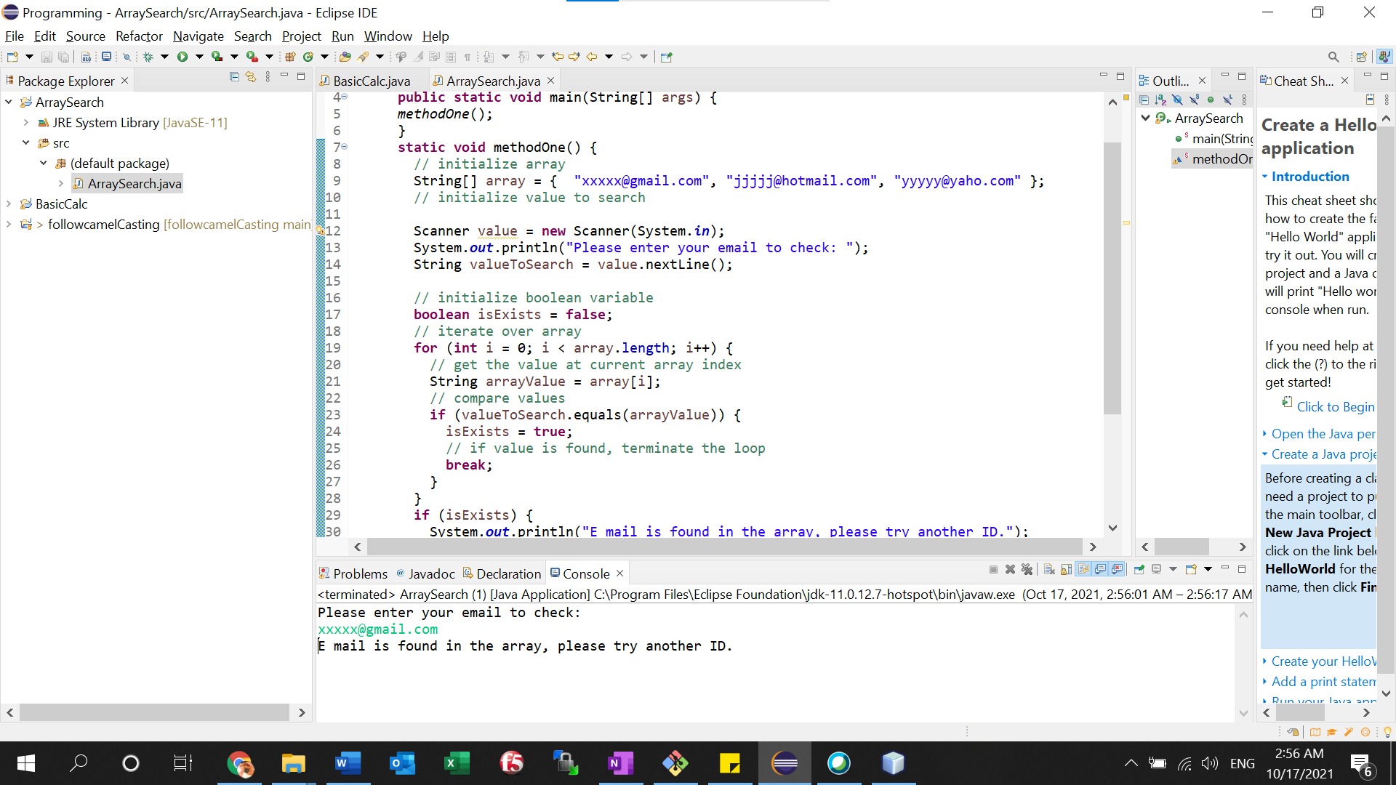

Source code:

==================================================================================================

**import** java.util.Scanner;

**public** **class** ArraySearch {

**public** **static** **void** main(String[] args) {

*methodOne*();

}

**static** **void** methodOne() {

// initialize array

String[] array = { "xxxxx@gmail.com", "jjjjj@hotmail.com", "yyyyy@yaho.com" };

// initialize value to search

Scanner value = **new** Scanner(System.***in***);

System.***out***.println("Please enter your email to check: ");

String valueToSearch = value.nextLine();

// initialize boolean variable

**boolean** isExists = **false**;

// iterate over array

**for** (**int** i = 0; i < array.length; i++) {

// get the value at current array index

String arrayValue = array[i];

// compare values

**if** (valueToSearch.equals(arrayValue)) {

isExists = **true**;

// if value is found, terminate the loop

**break**;

}

}

**if** (isExists) {

System.***out***.println("E mail is found in the array, please try another ID.");

} **else** {

System.***out***.println("E mail is not found in the array, please proceed to save it.");

}

}

}

================================================================================================