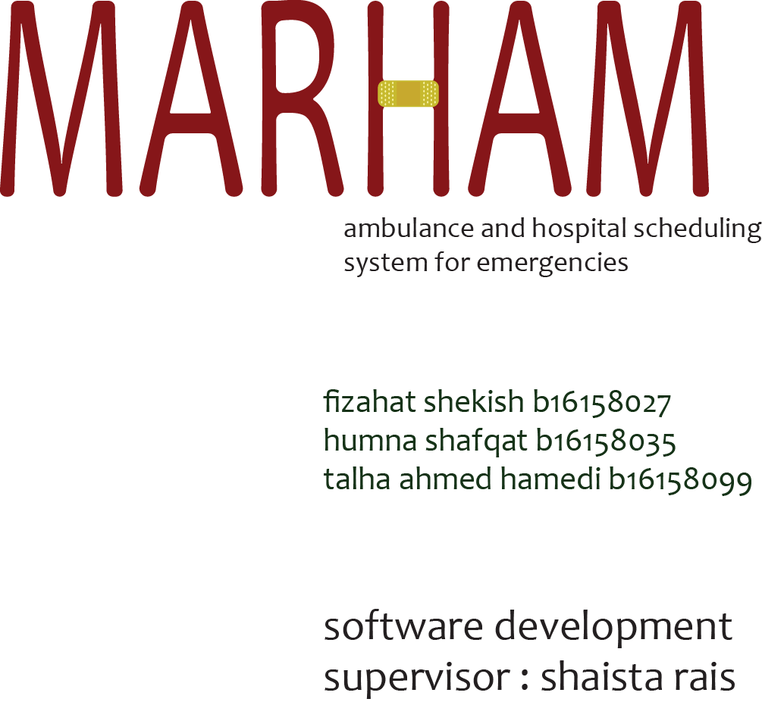

***REQUIREMENTS***

REQUIREMENT GATHERING

Requirements for the system were gathered using a questionnaire that consisted of the following questions,

* Professional details
* How much time it takes for an emergency to be catered after reaching the hospital ?
* What are the procedures to start an accidental head surgery?
* What are the requirements to full filled for any such condition?
* How long does it take if a surgery is taking place (duration of surgery)?
* For how many days the patient should stay in hospital?

REQUIREMENT ANALYSIS

Upon visit and one-to-one talk with professional doctors these questions were answered as,

* It takes easily an hour for an emergency surgery to be started considering the vitals are OK else surgery is to be delayed until vitals are normal.
* Procedures prior to surgery are
  + Taking notes and readings of vitals
  + Observation of scenario by MLO ie medico legal officer
  + OT preparations
  + Technician’s preparation
  + Anesthesia

* Surgery takes at least 3 hours to be done (average) it may take longer or some shorter time as per the condition before and during the surgery.
* Stay under observation in the hospital should be atleast one day and more upon the condition and sensitivity of the case.

***DESIGN***

DIAGRAMS

1. USE-CASE DIAGRAM

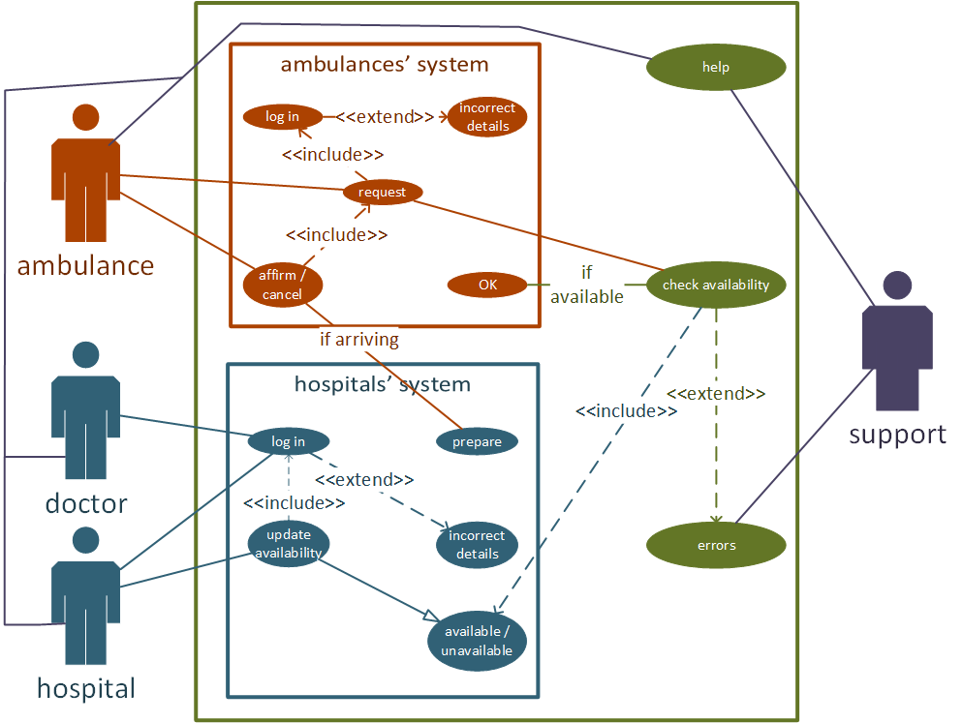

2. SEQUENCE DIAGRAM

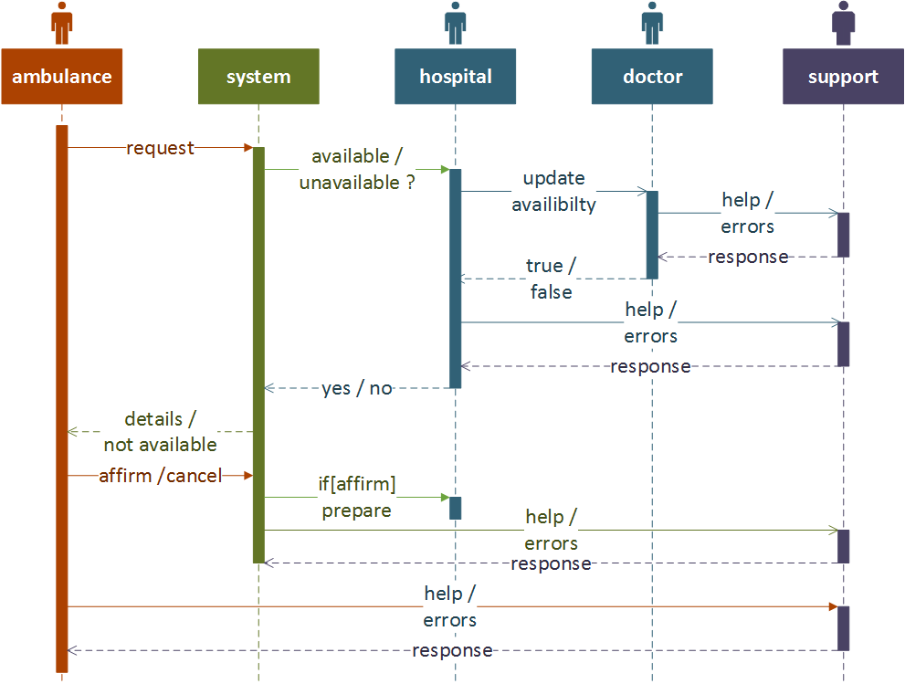

***NEXT STEP***

These designs can be implemented on any platform ie web or mobile with ease.