https://www.windowscentral.com/how-create-and-run-batch-file-windows-10

**How to create batch file on Windows 10**

The process of writing a batch (script or batch script) file isn't complicated. You only need a text editor (such as Notepad) and some knowledge using Command Prompt. In the steps below, we detail the steps for creating a simple and advanced batch file, as well as the steps to write a script to change the system settings.

**Creating simple batch file**

To create a simple batch file on [Windows 10](https://www.windowscentral.com/windows-10), use these steps:

1. Open **Start**.
2. Search for **Notepad**, and click the top result to start the app.
3. Type the following lines to create a batch file:
4. @ECHO OFF
5. ECHO Congratulations! Your first batch file executed successfully.
6. PAUSE

*[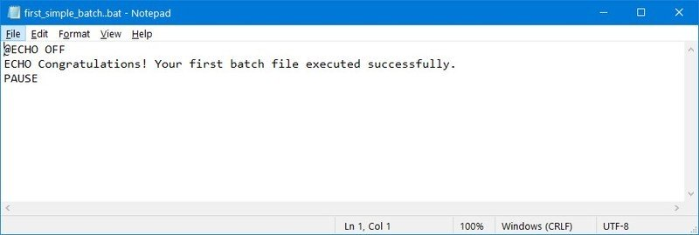](https://www.windowscentral.com/sites/wpcentral.com/files/styles/xlarge/public/field/image/2020/04/batch-cmd-file-example-win10.jpg)*Source: Windows Central

The above script outputs the phrase, "Congratulations! Your first batch file executed successfully" on the terminal screen.

*[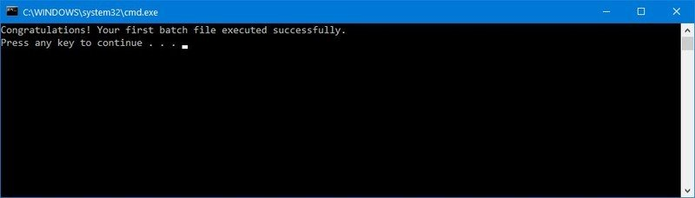](https://www.windowscentral.com/sites/wpcentral.com/files/styles/xlarge/public/field/image/2020/04/batch-file-output-cmd.jpg)*Source: Windows Central

* + **@ECHO OFF —** Disables the display prompt to show only the message on a clean line. Typically, this line goes at the beginning of the file. (You can use this command without "@," but the symbol hides the command being executed for a cleaner return.)
  + **ECHO —** Prints the desired text on the screen.
  + **PAUSE —** Prevents the console window from closing after executing the command. You can use this command at the end of the script or after a specific command when running multiple tasks, and you want to pause between them.

1. Click the **File** menu.
2. Select the **Save as** option.
3. Type a name for the script — for example, **first_simple_batch.bat**.

**Quick note:** While batch files typically use the **.bat** file extensions, you may also see scripts using the **.cmd** or **.btm** file extensions.

Once you complete the steps, you can double-click the file to run it, or you can use the [steps below](https://www.windowscentral.com/how-create-and-run-batch-file-windows-10#run_batch_file_windows10) to learn the different ways to execute a batch file on Windows 10.