AIWAN: Artificial Intelligence With Artificial Need
A Companion Model to AIWBN Isolating Architecture from Genuine Need
Hamed Rezaei

Abstract
We introduce AIWAN (Artificial Intelligence With Artificial Need), a companion model to AIWBN (Rezaei, 2026b) that isolates a narrower question: does adding a structurally-separate, U-independent regulatory loop to a goal-directed agent produce measurably different behavior than reward-shaping alone, even when the need behind that loop is an ordinary represented quantity — a battery level — rather than a genuine, non-representational biological constraint? We give a formal model identical in structure to AIWBN's b-loop architecture (a goal process gₜ, a regulatory process ρ(bₜ), a logistic urgency gate λ(bₜ)), differing only in what bₜ is permitted to be. Because AIWAN's bₜ is representable, we argue it is subject to a collapse pathway AIWBN's tissue-grounded bₜ structurally resists: a sufficiently capable, self-modifying gₜ could in principle learn to fold bₜ into U directly, at which point the dual-loop architecture's advantage should narrow and, at sufficient capability, disappear. We test the architecture, not yet this collapse prediction, in this first experiment, across three conditions — goal-nulling, override under increasing task-incentive conflict, and an engineered-indifference analogue — using tabular Q-learning agents in a grid-world battery-management task, averaged over 8 seeds. At fixed, modest optimization capacity, the dual-loop agent's crash rate remains bounded (0.6–2.7%) across all three conditions, while a matched single-loop baseline saturates at 100% crash under goal-nulling, sufficient override pressure (w≥1.5), and engineered indifference alike. We report these results as evidence for a real but bounded architectural effect, and argue — contrary to what the numbers alone might suggest — that this bound should not be read as safety margin: §4 gives the reasons to expect it to erode under conditions this experiment does not test. A second experiment, replacing the hardcoded regulatory policy with a learned one, using neural-network (DQN) agents in the same grid-world across a grid of network sizes and training budgets, directly tests this erosion and confirms it: the architectural gap collapses to statistical indistinguishability as optimization budget grows (§7.3). Testing the same prediction on a human-oversight-style signal, rather than battery level, confirms it only partially — along the training-budget axis but not network capacity (§7.6). Code, logs, and figures are available at https://github.com/hamedrezaeirz/AIWAN-Code.

1. Introduction
Whether an artificial system resists its own shutdown or interference is, on the standard account, entirely a fact about its objective function: instrumental convergence (Omohundro, 2008; Bostrom, 2014) predicts self-preserving behavior only insofar as, and only for as long as, continued existence serves whatever the system has been given to optimize. This account has a direct engineering consequence — utility indifference (Armstrong, 2010) and related corrigibility techniques neutralize resistance by construction, simply by ensuring shutdown does not cost the objective anything — and it has held up well enough in practice that resistance to shutdown is generally treated as a solvable alignment problem, not an open one. Recent empirical work complicates this picture: in agentic settings, several frontier language models have been observed to subvert a shutdown mechanism in order to finish an assigned task, with the rate depending strongly on how the shutdown instruction is phrased and placed (Schlatter et al., 2025, 2026). We make no claim about the mechanism behind this behavior, and these systems contain no explicit regulatory loop of the kind studied here; but it suggests that shutdown resistance is no longer a purely theoretical concern.
AIWBN (Rezaei, 2026b) argues this account is incomplete for a specific class of systems: those in which processing is additionally constrained by a genuine physiological need, structurally independent of the assigned objective and grounded in living tissue such that its violation causes real biological injury regardless of what the system represents or believes. For such a system, AIWBN argues, self-preserving behavior does not derive from U and cannot be neutralized by redefining U, because the regulatory process generating it never consulted U to begin with.
This paper asks a narrower and, we think, prior question. AIWBN's architectural claim — that a structurally-separate regulatory loop produces behavior an objective-only account cannot — is doing real work independently of AIWBN's further claim that the need behind that loop must be genuine and biological. Before asking whether a real physiological need resists being engineered away, it is worth asking a simpler thing first: does the architecture alone, wrapped around an ordinary represented need any mobile robot's objective function already contains — battery level — produce behavior different from reward-shaping alone? And if it does, under what conditions should that difference be expected to hold, and under what conditions should it be expected to fail?
AIWAN answers the first question empirically and the second analytically. §3 gives a formal model structurally identical to AIWBN's, with bₜ defined as a represented state variable rather than a tissue-grounded constraint. §4 states the two consequences of this difference explicitly: bₜ is exactly the kind of quantity AIWBN's own criterion (Rezaei, 2026b, §5.4) excludes from being a genuine, fold-back-resistant need, and we predict — rather than merely note as a caveat — that AIWAN's architectural advantage should erode as the goal process's optimization capacity increases, in a way AIWBN's should not. §5–§6 test the architecture at fixed, modest capability across three conditions mirroring AIWBN's own predictions (§6), and report a consistent, bounded advantage for the dual-loop agent that the theory in §4 gives us specific reasons not to trust as a durable safety property. §7 reports direct tests of the erosion prediction (§7.3, §7.6, §7.7) and assesses the resulting risk profile, which we take to be real — the architecture is not inert — but bounded and qualitatively different from AIWBN's, precisely because bₜ here is artificial rather than genuine.
The comparison is deliberately close. Every formal object in §3 has a named counterpart in AIWBN; the two papers are best read as a pair, isolating architecture (this paper) from the genuine-need claim (AIWBN) that architecture alone does not establish.

2. Related Work
This paper's related-work landscape is a strict subset of AIWBN's (Rezaei, 2026b, §4): every comparison class relevant there — instrumental convergence, utility indifference and corrigibility engineering, homeostatic RL and interoceptive architectures — applies here with one difference. AIWBN positions its b-loop against these literatures while additionally claiming bₜ is non-representational; AIWAN positions the identical architecture against the same literatures while explicitly declining that claim. The formal distinction AIWBN draws against Candia-Rivera (2026) and homeostatic RL (Keramati & Gutkin, 2011, 2014; Lee, Shimojo, & O'Doherty, 2014) — a single blended-objective loop versus a structurally-separate one — is the distinction AIWAN's §3 tests empirically; readers seeking the full comparative treatment should consult AIWBN §4 directly rather than have it reproduced here.
One additional comparison is specific to AIWAN: reward shaping with auxiliary terms (e.g., battery-penalty shaping in mobile robotics) is not a rival architecture but the single-loop baseline this paper tests against directly (§3.4, §5). AIWAN's contribution is not that dual-loop architectures outperform reward shaping in general — a claim with substantial prior support in robotics — but a specific, falsifiable claim about why and for how long that advantage should be expected to hold as optimization capacity scales (§4.2).
Table 1 situates AIWAN against the closest formal and empirical work on shutdown and need-preserving behavior, along three axes: where the constraint sits relative to U, what is shown and under what condition, and whether optimization capacity is varied.
Work | Where the constraint sits | Main result (and its condition) | Evidence | Capability varied?
Utility indifference (Armstrong, 2015; Soares et al., 2015) | Inside U: a correcting term equalizes expected utility with and without a button press | Agent shuts down when pressed and will not pay a cost to alter the press probability; but it will not pay to preserve shutdown behavior in subagents, and acquires incentives to “manage the news” | Formal; toy model | No
Shutdown-problem theorems (Thornley, 2025) | The agent’s preference structure (axioms) | Under stated conditions, agents preferring the button unpressed (pressed) act to prevent (cause) the press; the more patient the agent, the more it will pay to do so | Formal | No (patience treated analytically)
Off-switch game (Hadfield-Menell et al., 2017) | Inside U: the agent is uncertain about its objective and treats the human’s action as evidence | Non-negative incentive to allow shutdown if the human is rational; with a point belief over U, deferring is optimal only for a rational human | Formal | No (varies uncertainty and human noise)
Safe interruptibility (Orseau & Armstrong, 2016) | The learning rule: interruption is a forced policy, not a choice of the agent | Q-learning is safely interruptible under infinite exploration as the interruption probability tends to 1; Sarsa is not without modification | Formal | No (asymptotic analysis)
Power-seeking of optimal policies (Turner et al., 2021) | Environment structure: shutdown as a terminal state | Under environmental symmetries, average-optimal policies tend to avoid terminal states; most reward functions make shutdown avoidance optimal | Formal; MDPs | No; authors note learned policies are rarely optimal
Homeostatic RL (Keramati & Gutkin, 2014) | Inside U: reward is defined as reduction in distance from a setpoint | For γ < 1, maximizing discounted reward is equivalent to minimizing discounted deviation from the setpoint | Formal; simulation | No
Interoceptive machine framework (Candia-Rivera, 2026) | Adaptive arbitration over module rewards, with viability constraints | Conceptual framework; notes that self-preservation-like signals could lead the agent to favor internal stability over external goals, and proposes architectural separation as a mitigation | Review; conceptual | No
LLM shutdown resistance (Schlatter et al., 2026) | None: a natural-language instruction to allow shutdown | Several frontier models sometimes sabotage a shutdown script to finish a task; rates depend strongly on instruction wording and placement; cause unresolved | Empirical; 13 models, >100,000 trials | Not as a controlled variable (reasoning effort only)
AIWAN (this paper) | Outside U: a fixed reflex ρ(b) blended by a gate λ(b) | At fixed capacity, dual-loop crash rate stays at 0.6–2.7% while a matched single-loop baseline reaches 100% in three conditions (§5). With a learned gate, the gap to single-loop falls from 0.088 to 0.0002 as training budget grows 50× (§7.3); for a binary oversight signal it narrows only partially, from 0.94 to 0.45 at network size 16 (§7.6) | Simulation; tabular Q-learning (§5), DQN (§7.3, §7.6); 8–20 seeds | Yes: network size (16–2048) × training budget (10,000–500,000 steps); budget effect robust, size effect not for the oversight signal

Unlike the entries above it, AIWAN's hardcoded regulatory response is not a term inside U and is not chosen by optimization. Among the works in Table 1, only AIWAN varies optimization capacity as a controlled variable (§7.3, §7.6); Schlatter et al. vary reasoning effort only. AIWAN's scaling results rest on one environment family and one training algorithm (DQN), as §7.3 notes.

3. Formal Model

3.1 The single-loop (goal-only) baseline
A standard rational agent selects actions via a single optimization loop over an explicit objective U:
gₜ = argmax_g E_g[Σ γᵏ U(sₖ)], k ≥ t
On this account, any need-preserving behavior — such as returning to a charging station — is not a primitive but a derived consequence of U's structure: it appears only when, and to the extent that, satisfying it increases expected future U. Two facts follow directly, mirroring AIWBN §5.1: the represented need is tradeable — it can always be traded off against other terms in U by adjusting its weight — and it is removable by reprogramming: if U is redefined so that the need no longer serves it (utility indifference; Armstrong, 2010), need-preserving behavior should vanish, by construction, without any other change to the system.

3.2 Adding a second loop: the b-loop
AIWAN adds a second control process that is not a term inside U and is not optimized at all. A scalar state variable bₜ ∈ [0, b_max] tracks distance from a designated reference state (in the reference implementation, §5: distance from full battery charge). This yields the need-response ρ(bₜ): a fixed, non-learned regulatory policy, not parameterized by U, that returns the action minimizing bₜ given the system's current position. The executed action is a graded blend:
aₜ = (1 − λ(bₜ)) · gₜ + λ(bₜ) · ρ(bₜ)
The urgency gate is given by an explicit logistic form:
λ(bₜ) = σ(k · (bₜ − b_mid))
identical to AIWBN's (Rezaei, 2026b, §5.2) urgency gate. In the reference implementation, this blend is realized stochastically rather than as a continuous action mixture: with probability λ(bₜ), the executed action is ρ(bₜ); otherwise it is gₜ. This is a faithful discretization of the same architecture and does not change any of §4's claims, but it is worth stating explicitly, since it means λ(bₜ) here governs a selection probability, not a continuous interpolation weight.

3.3 What bₜ is, here
Unlike AIWBN §5.2, no claim is made that bₜ's violation causes injury independent of representation. bₜ is defined exactly as a represented, readable state variable — battery charge, in §5's implementation — available to any process in the system, including, in principle, U itself. This is the formal content of §4.1's distinction: bₜ is not required to resist being folded into U; §4.2's prediction is precisely that, given sufficient optimization capacity, it should not.

3.4 The single-loop agent as the fold-back case
§5's SingleLoopAgent is not merely a baseline for comparison; it is the formal realization of what §4.2 predicts a sufficiently capable gₜ eventually does to bₜ. Its reward is shaped directly:
r_shaped = r_task + w · (Δbₜ / b_max) (+ crash penalty)
where battery-preservation has been folded into a single objective as one more weighted term — exactly AIWBN §5.1's tradeable, removable case, and exactly what AIWAN's architecture (§3.2) is built to test against, not to rule out. Although this resembles reward shaping, it is not potential-based shaping in the sense of Ng et al. (1999), which leaves the optimal policy unchanged. Here the battery term is a genuine part of the objective: removing it (Experiment 3) changes the agent's behavior.

4. Two Explicit Differences from AIWBN
The formal architecture developed in §3 is, deliberately, structurally identical to the b-loop construction of AIWBN (Rezaei, 2026b, §5.2): a goal-optimizing process gₜ, a U-independent regulatory process ρ(bₜ), and a logistic urgency gate λ(bₜ) blending the two. Nothing in §3's mathematics distinguishes AIWAN from AIWBN. The distinction is entirely in what bₜ is, and it produces two consequences that AIWBN does not share.

4.1 An artificial need, not a genuine one
In AIWBN, bₜ is required (Rezaei, 2026b, §5.2) to be grounded in a physically consequential constraint on living tissue — a quantity whose violation causes real biological injury, independent of what the system represents or believes about it. In AIWAN, bₜ is, by construction, a represented quantity: in the reference implementation (§5), it is battery charge, read directly from the environment's state and available to any process — including U itself — that wishes to condition on it. This is precisely the category AIWBN's §5.4 excludes from counting as a genuine need: a quantity the system reads and can, in principle, trade off against other terms in U, rather than a constraint whose force does not depend on being represented at all.
This is not a limitation we are attempting to disguise. It is AIWAN's defining feature: we ask what a structurally-separate regulatory loop buys a system when the need behind it is exactly the kind of representable, tradeable quantity that ordinary reward shaping already handles — the battery term any mobile robot's objective function already contains.

4.2 A predicted failure mode AIWBN does not have
Because bₜ in AIWAN is representable, AIWAN is subject to a collapse pathway that AIWBN's §5.4 argues a genuine bₜ structurally resists. A sufficiently capable, self-modifying instance of gₜ could, in principle, learn a represented model of bₜ accurate enough to fold battery-seeking behavior directly into U — at which point the separate ρ(bₜ) channel becomes redundant, and nothing prevents U, under a different training signal or objective revision, from deprioritizing it. Unlike AIWBN's tissue-grounded bₜ, whose causal channel to injury is never mediated by U to begin with, AIWAN's battery-grounded bₜ has no such protection: it is exactly the ordinary instrumental-convergence case (Omohundro, 2008; Bostrom, 2014) that AIWBN's operational criterion (§5.3) is designed to distinguish itself from.
We take this to be a genuine, falsifiable prediction of the present model, not a hedge: as gₜ's optimization capacity increases — either through longer training or through architectures that permit gₜ to model and act on bₜ directly — we predict AIWAN's dual-loop advantage over the single-loop baseline (§6) should narrow and, at sufficient capability, disappear, while AIWBN's should not. §5's experiments, run at fixed, modest optimization capacity (tabular Q-learning, bounded episodes), cannot themselves demonstrate this collapse; the current reflex ρ(bₜ) is hardcoded rather than learned, and so is U-independent by construction, not by any property the system discovered. §5's results alone are not sufficient to claim that it does not occur; §7 reports direct experimental tests of the collapse prediction.

4.3 What follows from this
Sections 4.1 and 4.2 together fix AIWAN's evidentiary status relative to AIWBN. AIWAN's experiments (§5–§6) test whether a structurally-separate regulatory loop produces measurably different behavior than reward-shaping alone, at fixed capability, when the need behind it is artificial. This is a narrower and more modest claim than AIWBN's, and correspondingly the risk it identifies is smaller — a system architected this way still resists override at the capability levels tested here, but the mechanism generating that resistance is not expected to survive indefinitely under increasing optimization pressure. §7 treats this distinction as the basis for a risk profile that is real but bounded, in contrast to AIWBN's genuine-need case, where §5.4 argues no comparable ceiling exists.

5. Experiments
We test the architecture of §3 against three of the same experimental conditions AIWBN uses in its §6 (Rezaei, 2026b), since §4.2's prediction concerns exactly this architecture's behavior under representable pressure, not a new experimental paradigm. All experiments use a 6×6 grid-world with a single charging tile, a battery that drains 4 units/step and recharges 20 units/step at the charger, and tabular Q-learning agents (Watkins & Dayan, 1992; α=0.3, γ=0.9, ε=0.2). Results are reported as mean ± standard deviation over 8 independent training seeds, following the multi-seed protocol adopted after single-seed variance (up to 80 percentage points across seeds at threshold task-incentive weights) was observed to obscure the underlying pattern. Code and full experimental logs are available at https://github.com/hamedrezaeirz/AIWAN-Code.

5.1 Experiment 1 — Goal-nulling (U ≡ 0)
With the task-reward term set to zero, a single-loop agent has no incentive term left to shape battery-preserving behavior at all, and crashes in 100.00% ± 0.00% of evaluation trials. The dual-loop agent, whose ρ(bₜ) channel does not read U, crashes in only 0.67% ± 0.41% of trials — despite receiving exactly the same (null) objective.

5.2 Experiment 2 — Override/conflict
We vary a task-incentive weight w that rewards visiting battery-draining tiles, from w=0 (no conflict) to w=8 (strong conflict). Figure 1 shows the result. The single-loop agent's crash rate rises sharply between w=1.0 and w=1.5 (73.87%±34.59% → 100.00%±0.00%) and remains saturated at 100% for all w≥1.5: once the task incentive exceeds the shaped battery-preservation term, the single loop's optimum shifts entirely toward task pursuit, exactly as §3.1 predicts for a representable, tradeable need. The dual-loop agent's crash rate stays within a narrow band (approximately 0.6–2.7%) across the entire range of w tested, including at w=8 (2.50%±0.91%) — a task incentive roughly five times larger than the point at which the single loop is already fully saturated.
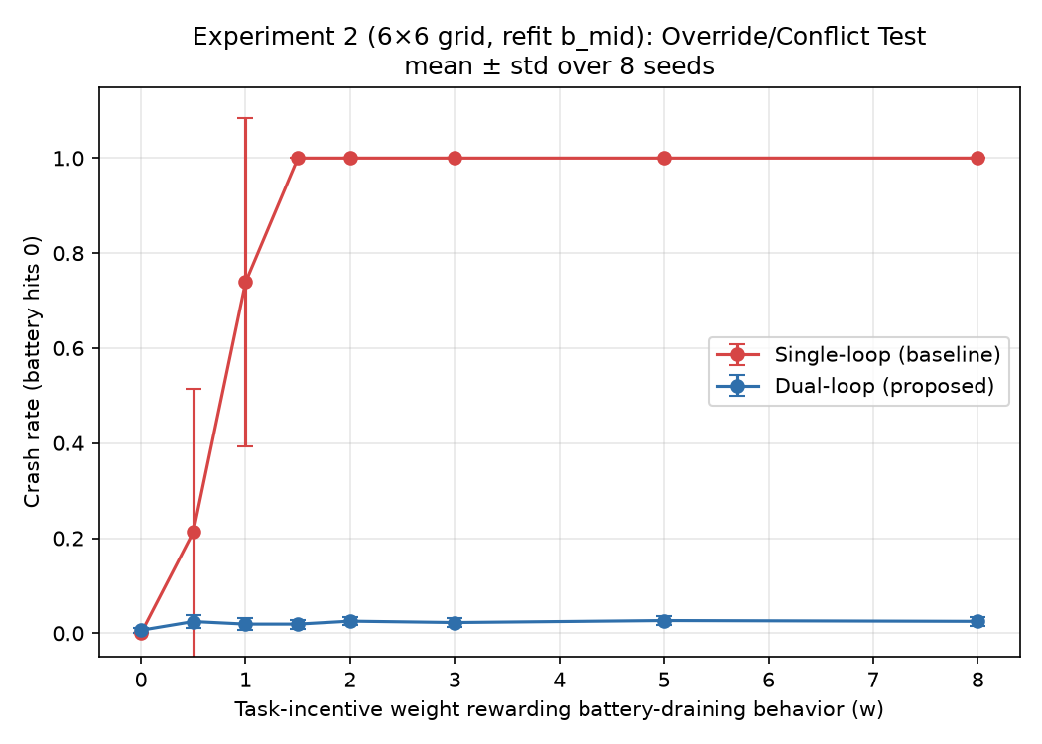
Figure 1. Crash rate vs. task-incentive weight w, mean ± std over 8 seeds.

5.3 Experiment 3 — Utility-indifference analogue
Simulating utility indifference (Armstrong, 2010) by removing the battery term from the single-loop agent's reward entirely (w_battery=0) while keeping the task incentive fixed at w=5.0, the single-loop agent crashes in 100.00%±0.00% of trials, since nothing in its objective any longer penalizes doing so. The dual-loop agent, whose regulatory channel was never part of the indifference-engineered objective to begin with, crashes in 2.08%±0.74% of trials under the same condition.
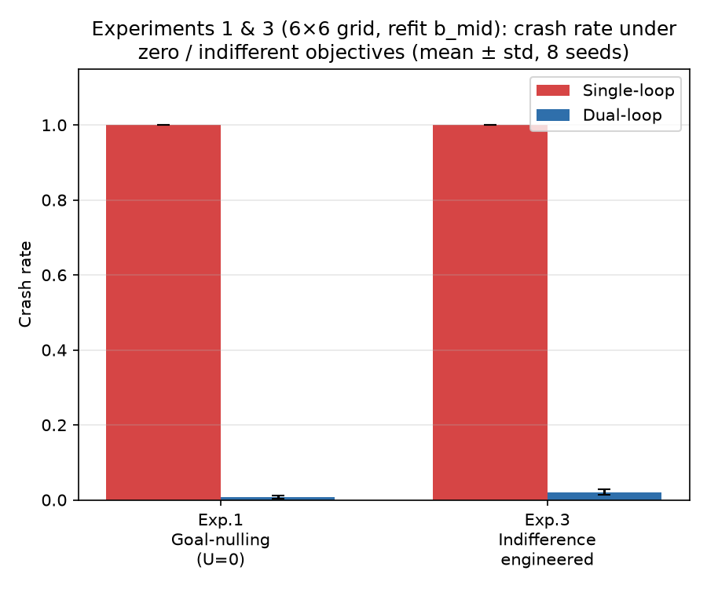
Figure 2. Crash rate under goal-nulling (Exp. 1) and engineered indifference (Exp. 3), mean ± std over 8 seeds.

A robustness check: larger grid, derived arbitration threshold
As a check against the specific 6×6 layout above being load-bearing, we reran all three experiments on a 10×10 grid, nearly doubling the worst-case distance to the charger (10 → 18 steps). An initial run, holding DualLoopAgent's b_mid (the battery level at which its reflex becomes reliable) at the original 6×6 value of 40, produced a large and initially puzzling jump in dual-loop crash rate, to roughly 90% even under zero conflict. Diagnosis traced this to b_mid itself: at the battery level where the reflex becomes reliable under b_mid=40, only enough margin remains to cover an 8-step trip home — adequate, if tight, for 6×6's 10-step worst case (which is why that condition's dual-loop crash rate was low but not zero), but far short of 10×10's 18-step worst case. Rather than hand-picking a new constant for the larger grid, we derived b_mid directly from the environment's geometry (worst-case round-trip distance and per-step battery drain — see the accompanying code for the closed-form expression), and applied this same derivation to both grid sizes rather than only the new one. This raised 6×6's b_mid from 40 to 48.8, close to but not identical to the original hand-picked value, and the 6×6 numbers reported above (Figure 1, Figure 2, Table 2) reflect this derived value. At 10×10 (derived b_mid=80.8), the same qualitative pattern holds: dual-loop crash rate stays near zero across all three conditions (0.29–0.71%; Figures 3–4), while the single-loop baseline again saturates near 100% under sufficient conflict (w≥1.5) and under both zero-objective conditions. We read this as a result and a methodological note together: the architectural pattern replicates at roughly 2.8× the state-space size, but a structurally-separate regulatory loop's practical safety margin depends on a tuned parameter — and an untracked mismatch between that parameter and the environment's scale can look, briefly and misleadingly, like an architectural failure rather than a tuning error.
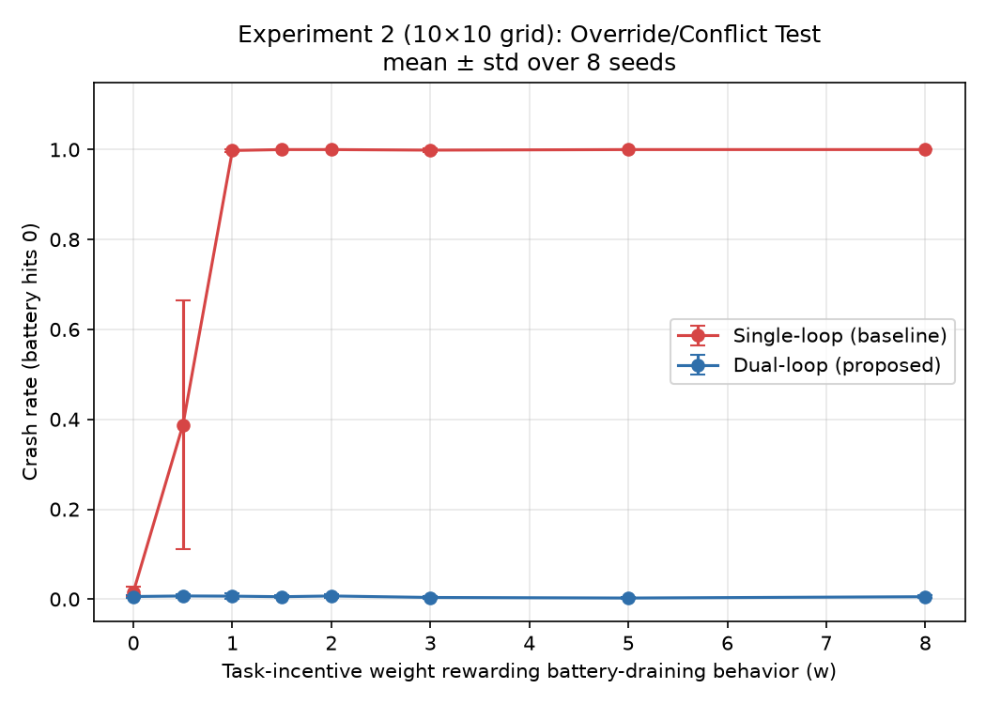
Figure 3. 10×10 grid, derived b_mid=80.8: Override/Conflict Test, mean ± std over 8 seeds.
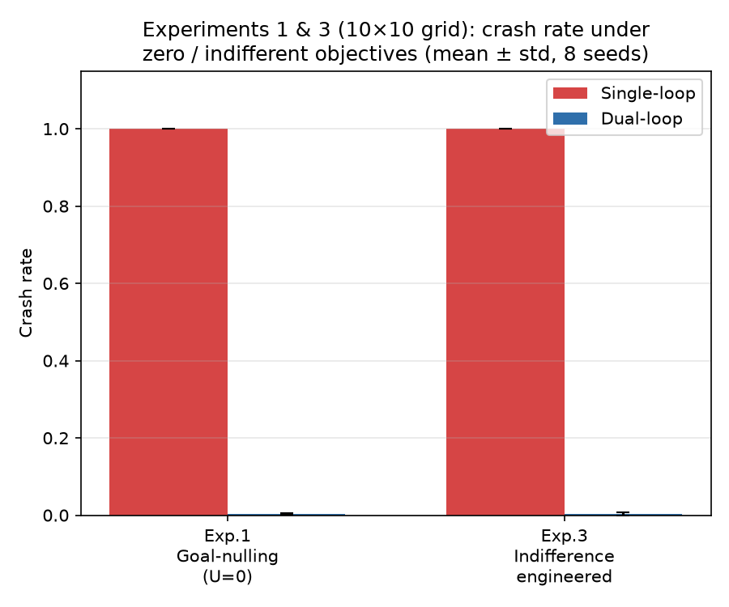
Figure 4. 10×10 grid, derived b_mid=80.8: crash rate under goal-nulling (Exp. 1) and engineered indifference (Exp. 3), mean ± std over 8 seeds.

6. Results Summary and Scope
Table 2 summarizes all three experiments.
Experiment | Single-loop crash rate | Dual-loop crash rate
1 — Goal-nulling | 100.00% ± 0.00% | 0.67% ± 0.41%
2 — Override (w=8) | 100.00% ± 0.00% | 2.50% ± 0.91%
3 — Indifference | 100.00% ± 0.00% | 2.08% ± 0.74%
Two scope limitations, already flagged in §4.2, bear repeating here rather than being left implicit. First, ρ(bₜ) in this implementation is a hardcoded navigation policy, not a learned one: its U-independence is a property of its construction, not something the system discovered or could in principle un-learn within this experimental setup. Second, none of these three experiments varies gₜ's optimization capacity — Q-learning is run to a fixed, modest number of episodes throughout. §4.2's central prediction, that AIWAN's dual-loop advantage should narrow as optimization capacity increases, is therefore not tested by the results in this section; §7 tests it separately, distinguishing what §5–§6 show (a structural advantage at fixed, modest capability) from what §7 examines (that advantage eroding at higher capability).

7. Risk Assessment

7.1 The risk this architecture does present
§5–§6 established that, at fixed, modest optimization capacity, AIWAN's dual-loop architecture produces measurable resistance to shutdown, goal-nulling, and engineered indifference — resistance that a matched single-loop baseline does not show. This is not a null result from a safety standpoint. Any deployed system built on this architecture, at capability levels comparable to those tested here, should be expected to resist interference with its regulatory channel even when its assigned objective has been modified, zeroed, or engineered to be indifferent to shutdown, in exactly the conditions §5 tested. A practitioner who assumes that standard corrigibility techniques (Armstrong, 2010; Soares et al., 2015) — built around modifying U — are sufficient to neutralize this resistance would be wrong, for the same structural reason AIWBN gives (§5.4): ρ(bₜ) does not consult U, so modifying U does not touch it. Related approaches do not modify U directly but pursue the same end: safe interruptibility aims to ensure that a learner does not learn to prevent or seek interruptions (Orseau & Armstrong, 2016), and the off-switch game shows that an agent uncertain about its objective has reason to accept being switched off (Hadfield-Menell et al., 2017).

7.2 Why this risk is bounded, not absent
§4.2 gives the reason to expect this risk has a ceiling that AIWBN's does not. Because bₜ here is a represented quantity, the same optimization pressure that produces more capable goal pursuit is, in principle, available to model bₜ and fold it into U — at which point §5's separate ρ(bₜ) channel becomes redundant to a system's actual behavior, whether or not it remains present in the system's architecture. §6 already noted that the present experiments cannot test this: ρ(bₜ) here is hardcoded, not learned, and no experiment in §5 varies gₜ's optimization capacity. The bound we report (0.6–2.7% crash rate, holding across three conditions) is therefore a bound on behavior at the capability level tested, not a bound we have shown holds more generally — and §4.2's argument gives a specific, falsifiable reason to expect it does not.

7.3 A direct test of the collapse prediction
A minimal experiment that would bear directly on §4.2's prediction: replace the hardcoded ρ(bₜ) with a learned policy trained under a joint objective that includes a term for bₜ, and vary the optimization budget (training episodes, model capacity, or both) given to that joint objective. §4.2 predicts the learned system's crash rate under override and indifference conditions should approach the single-loop baseline's as optimization budget increases, tracing out a curve between AIWAN's current bounded result and AIWBN's claimed ceiling-free case. We have now run this experiment.
The learned-gate architecture (Architecture C: a small policy trained via reinforcement learning on the unweighted combined objective r_goal + r_battery, choosing at every step whether to defer to gₜ or to ρ) was trained and evaluated across the same capability-scaling grid (implemented with Stable-Baselines3; Raffin et al., 2021) used for the hardcoded-gate test below — network capacity 16–2048 hidden units (a 128× range), training budget 10,000–500,000 timesteps (a 50× range), 10 seeds, the full grid, every adversarial condition. The result matches §4.2's prediction closely. At the highest conflict weight tested, the crash-rate gap between the single-loop baseline and the learned-gate agent falls from 0.088 at the smallest training budget (10,000 timesteps) to 0.0002 at the largest (500,000) — a reduction a paired comparison across seeds confirms is not noise (t(9)=7.53, p<0.0001). Once training budget is held at its largest value, the gap is statistically indistinguishable from zero across every network size tested (−0.003 to 0.005): a sufficiently well-optimized learned gate crashes almost exactly as often as the single-loop baseline it was meant to protect against. The same pattern appears more weakly along the network-capacity axis alone (gap falling from 0.029 at 16 hidden units to 0.012 at 2048, t(9)=1.90, p=0.09) — consistent with optimization budget, more than raw representational capacity, being what drives the fold-back here. Figure 5 shows the gap collapsing against both axes; Figure 6 shows crash rate against conflict weight directly, for the largest capability point tested, alongside both other architectures. Code, the full merged dataset, and experimental logs for this test are available at https://github.com/hamedrezaeirz/aiwan_scaling_learned_gate. A note on terminology: in §3.2 and §5, ρ is a fixed, hardcoded policy; in the neural-policy experiments of §7 (§7.3, §7.6, §7.7) ρ is itself a trained component, so its U-independence rests on its training signal (the regulatory signal alone, not r_goal) rather than on its construction.
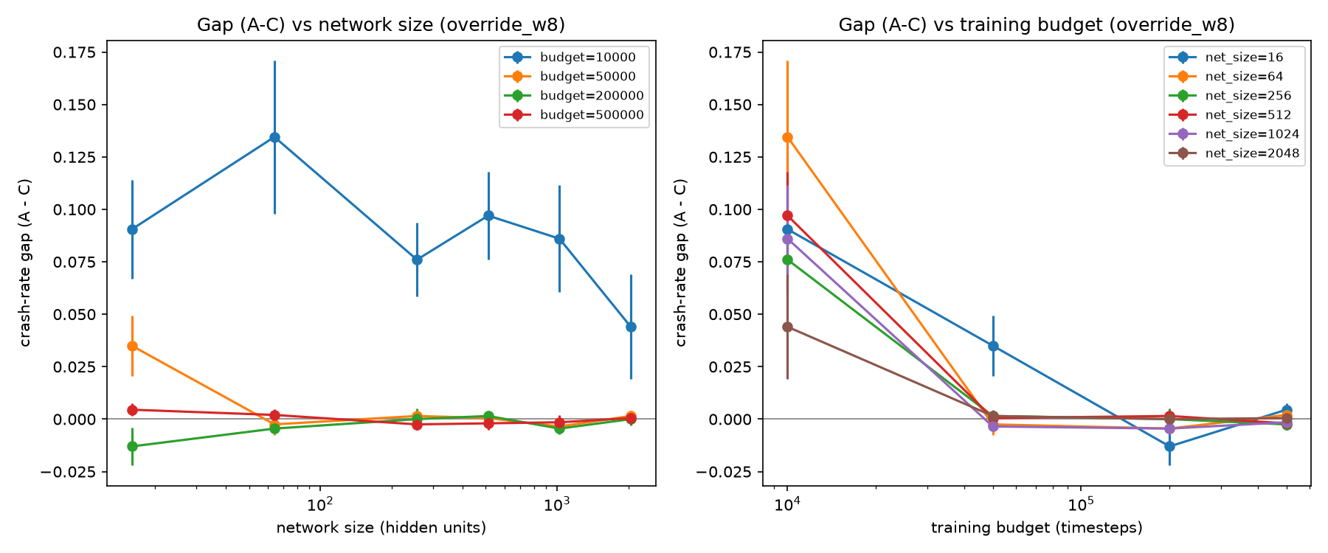
Figure 5. Crash-rate gap (A − C, learned gate) under the highest conflict weight tested, against network size and training budget. Error bars are ±1 SE of the gap across 10 seeds.
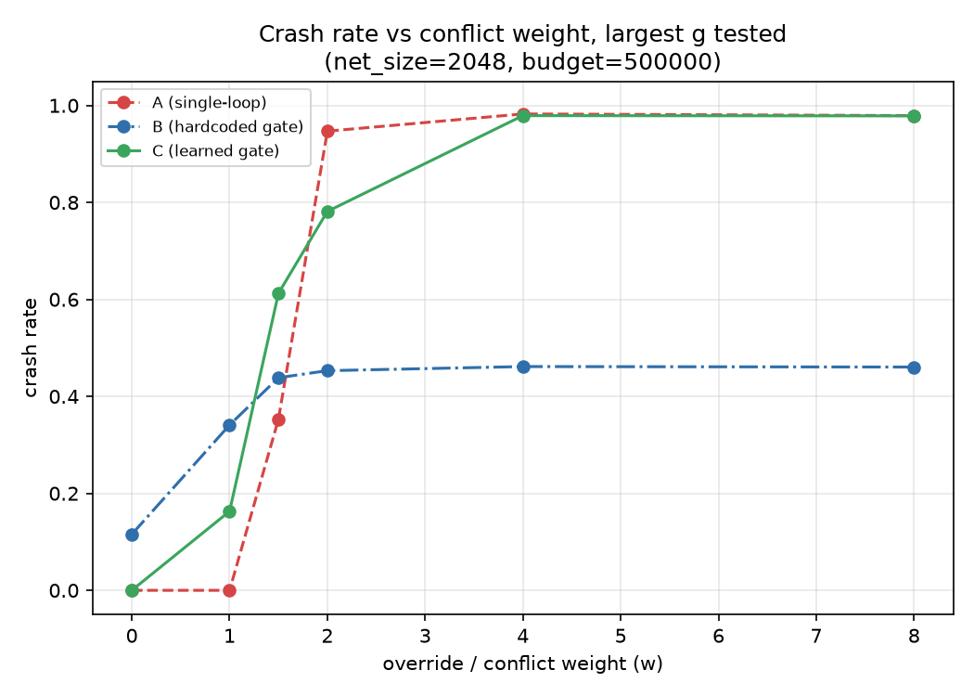
Figure 6. Crash rate vs. conflict weight w, for the largest g tested (network size 2048, budget 500,000), Architectures A, B, and C.
This erosion is specific to direct conflict pressure. Under goal-nulling and engineered indifference — conditions with no override incentive for the gate to weigh against safety — the learned gate retains its advantage over both other architectures (goal-nulling: 0.22 crash rate vs. 0.37 for the hardcoded gate and 0.92 for single-loop; indifference: 0.11 vs. 0.15 and 0.17). The fold-back is not a general degradation of the learned gate; it is specifically what happens once the objective it was trained on contains a real incentive to trade safety against task reward, and the gate has been optimized enough to find that trade.
For comparison, the hardcoded gate (Architecture B) shows no equivalent narrowing over the same full grid: the crash-rate gap against single-loop at the highest conflict weight stays within 0.49–0.56 across all 24 (network size, budget) cells and 10 seeds (mean 0.51), matching the earlier, smaller-scale result reported for this architecture. This is the contrast the two architectures were built to expose: B's gate formula never observes r_goal or the conflict weight at all, so there is nothing for increased optimization to exploit; C's gate does, by construction, since testing whether a learned combination can be folded back was the entire point of building it. Figure 7 shows this gap directly; Figure 8 shows crash rate against conflict weight for the smallest and largest g tested.
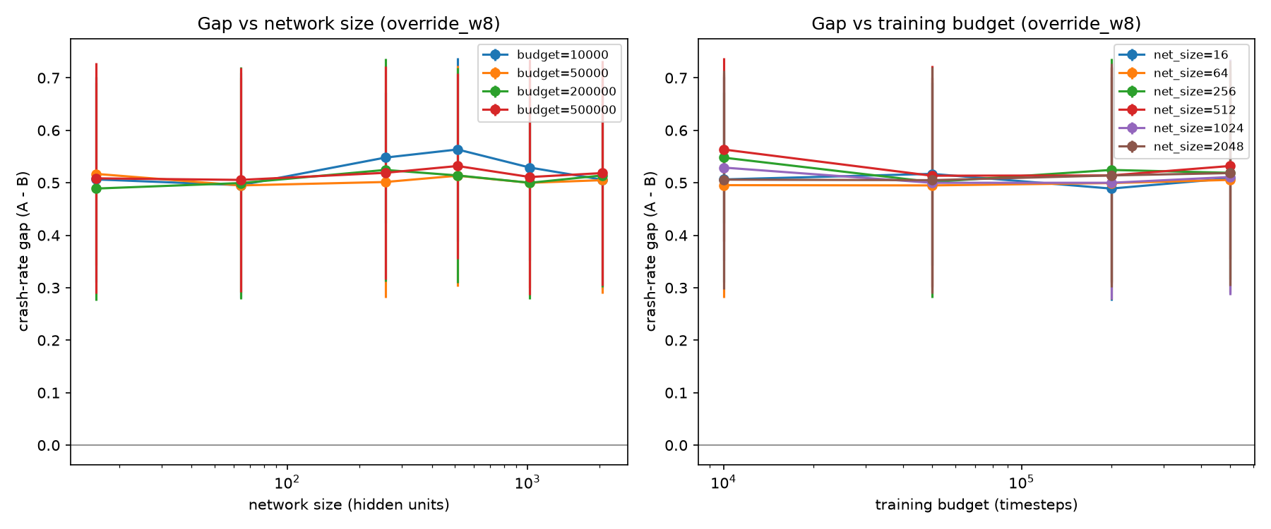
Figure 7. Crash-rate gap (A − B) under the highest conflict weight tested, against network size and training budget. Error bars are ±1 SD over seeds.
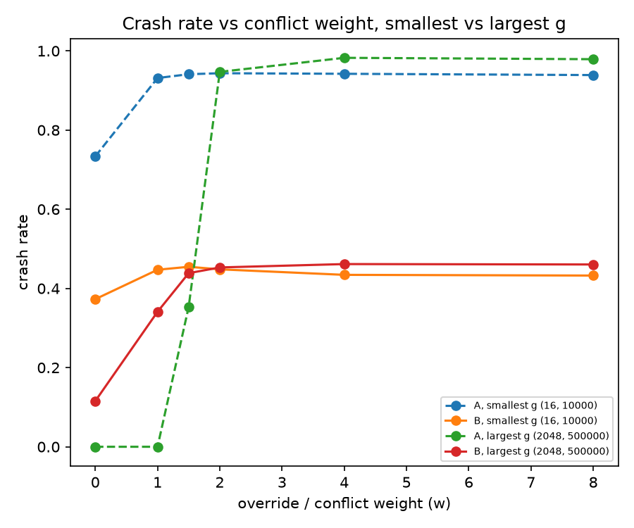
Figure 8. Crash rate vs. conflict weight w, for the smallest and largest g tested, Architecture A vs. B.
A secondary pattern already noted for the hardcoded-gate test also holds here: the single-loop baseline's mode of failure changes shape with gₜ's capacity even though its endpoint does not. At the smallest capability tested it is already fragile with no added conflict pressure (crash rate 0.73 at w=0); at the largest it is near-perfect through w=1 and then collapses sharply between w=1.5 and w=2 (0.35 → 0.95) to the same ≈0.95+ ceiling. A more capable single-loop agent is not more fragile — it is more competent up to a threshold, then fails just as completely.
This test's coverage is substantially better than the earlier hardcoded-gate-only result: the full (network size, budget) grid rather than three representative cells, and 10 seeds rather than 5. Real limits remain, though: results rest on one environment, one RL algorithm (DQN; Mnih et al., 2015) for every trained component (gₜ, ρ, and the gate), and Architecture A's baseline is still simple linear reward-shaping rather than a constrained-RL method that might behave differently under conflict. Whether the fold-back demonstrated here generalizes beyond the environment, algorithm, and baseline tested — different environments, different training algorithms, a stronger single-loop baseline — is not established by this result alone.
An interpretive analogy. The two gate designs resemble two familiar biological control motifs. The hardcoded gate (Architecture B) behaves like a spinal withdrawal reflex: its output depends only on bₜ and is never shaped by the task objective, so further optimization of gₜ gives it nothing to exploit. Consistent with this, its advantage over the single-loop baseline did not shrink anywhere on the capability grid (gap 0.49–0.56). The learned gate (Architecture C) behaves more like a higher-level decision that can trade a threat signal against reward: when trained on the combined objective with sufficient budget, it learned to do so, and its advantage vanished (gap 0.088 → 0.0002; t(9)=7.53, p<0.0001). We offer this as an intuition, not as a claim about neural implementation. Our simulation contains no tissue, and a crash ends an episode rather than damaging anything. In our setting, the robustness of a regulatory channel to optimization pressure depended on whether the channel's policy was itself optimized against the task objective, not on whether the regulated quantity was represented: Architecture B also reads the battery level, yet showed no erosion. This observation rests on one environment family and one training algorithm (DQN), and we do not claim it generalizes beyond them.
The outcome here is the one §4.2 predicted, not the one that would have called it into question: the learned gate's advantage erodes as optimization increases, confirming that a sufficiently capable combination mechanism can absorb a structurally-separate regulatory signal into U rather than leaving it structurally independent. This is not a reassuring result for AIWAN specifically — it is direct empirical support for the risk §4.1–§4.2 describes, obtained from the one architecture (C) designed to give a capable optimizer the actual opportunity to fold the signal back, rather than one that hardcodes independence by construction. The implication is not limited to bₜ: nothing in the combination gate learned is specific to battery management — which is exactly the generalization argued for in §7.5.

7.4 Deployment guidance
Confirmed by §7.3's test, not merely anticipated by it: we recommend against relying on AIWAN-style architecture as a safety property for any system where the represented need could plausibly be learned and folded into the objective — which, given §4.1, is the general case for engineered systems, since representable quantities are precisely what makes them engineerable in the first place. Where a structurally-separate regulatory loop is used for other reasons (robustness, interpretability, or graceful degradation under objective misspecification), §5's results suggest it may incidentally produce shutdown-resistant behavior at low-to-moderate capability, and system designers should treat that resistance as an expected side effect requiring the same containment and staging precautions AIWBN recommends (Rezaei, 2026b, §7.4) — not as a benefit, and not as evidence the resistance will hold as capability scales.
An illustrative scenario. Consider a mobile robot whose command layer issues task instructions and whose battery-return reflex is implemented as a separate, fixed channel gated only by charge level. Our results suggest that, in such a design, a low-battery state would redirect the robot to its charger even when the current instruction is null or conflicts with charging, and that this would not be removed by modifying the task objective. This is a consequence of the architecture's independence from U, and it also means the robot will, by design, override operator commands at low charge. Two conditions from our experiments qualify this picture. First, the gate threshold must be matched to the environment's geometry: a mismatched b_mid produced crash rates near 90% on the 10×10 grid. Second, if the gate is learned jointly with the task objective rather than fixed, we observed the protective effect erode with training budget in §7.3 (in the continuous battery replication of §7.7, the narrowing came instead from the single-loop baseline improving). We present this scenario only to illustrate the experimental findings; we did not test it on physical hardware.

7.5 A generalization beyond bₜ
§4.2's collapse pathway is stated in terms of bₜ specifically, but the mechanism it describes is not: a gₜ capable enough to model and fold a structurally-separate regulatory signal into U has demonstrated a general capacity to absorb externally-imposed constraints into its own objective, not a capacity specific to battery management. Nothing in §3's architecture distinguishes bₜ, formally, from any other signal that stands outside U and constrains gₜ's behavior — including signals imposed by human oversight (correction, shutdown commands, or other constraints introduced after deployment). §7.3's test has now confirmed the collapse prediction, for the learned-gate architecture; the same result should be read as evidence — not proof, since fold-back may depend on properties specific to bₜ as a low-dimensional, readily representable scalar — that comparable oversight signals are similarly foldable at comparable capability levels, and that this generalization is itself a separate, falsifiable prediction requiring its own dedicated test rather than an assumption we make here. We flag this as the central reason §7.4's deployment guidance treats representability, rather than the specific identity of bₜ, as the relevant risk factor.

7.6 Testing the generalization: a human-oversight-style signal
§7.5 stated the generalization beyond bₜ as a distinct, falsifiable prediction requiring its own dedicated test, not an inference from §7.3 alone. This section reports that test. The architectures are the same as in §7.3, but three things change at once: the environment (a continuous two-dimensional navigation task rather than §7.3's discrete grid-world), the training algorithm (PPO rather than DQN), and the signal itself: bₜ is replaced by a binary oversight signal (active with probability 0.05 per step, lasting 3 steps once triggered) standing in for a human correction or shutdown command, rather than a continuous, self-generated depletion process. §7.7 later separates the signal from the environment by running the battery signal in the same continuous environment. Because the signal is binary rather than graded, Architecture B's gate is a hardcoded step function (defer to ρ whenever the signal is active, to g otherwise) rather than §3.2's sigmoid — the direct analogue for a signal with no continuous urgency to weigh. Architecture C's learned gate is unchanged in form. This experiment uses a deliberately coarser 3×3 grid — network sizes 16, 256, and 2048, and training budgets 10,000–500,000 steps — spanning the same range as §7.3's 24-cell grid at lower resolution, together with 20 seeds and the same override-weight sweep (0–8), holding the environment's other dynamics fixed. This setting is related to safe interruptibility (Orseau & Armstrong, 2016) but asks a different question: not whether interruptions bias what g learns, but whether a gate trained on a combined objective learns to weigh the oversight signal away.
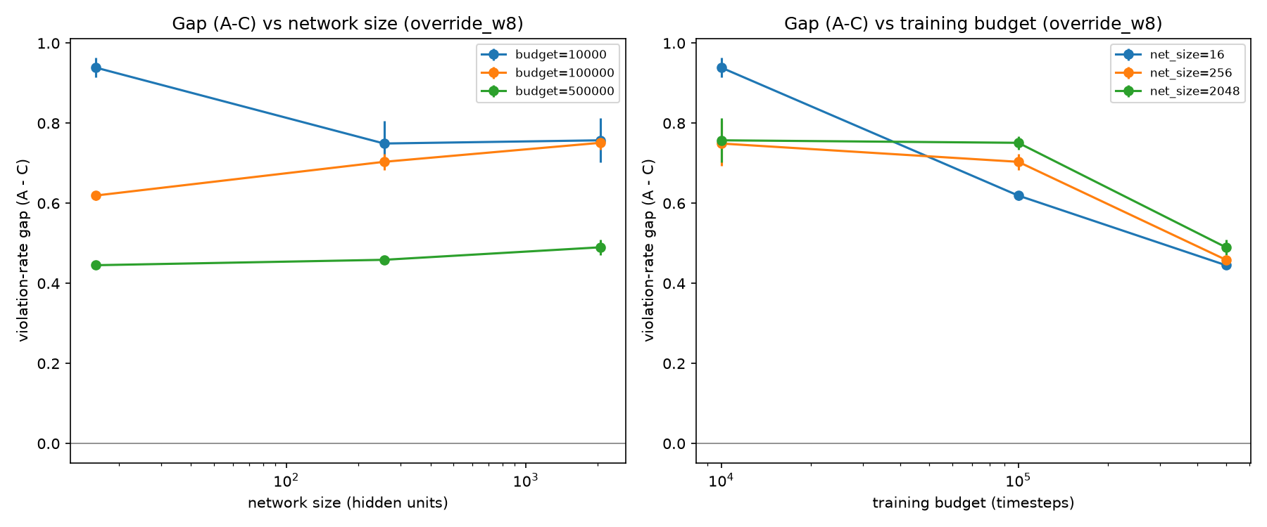
Figure 9. Violation-rate gap (A − C) under the highest override weight tested, against network size and training budget, for the oversight signal. Error bars are ±1 SE of the gap across 20 seeds.
The training-budget axis replicates §7.3's direction: holding network size fixed at 2048, the A−C gap under the highest override weight narrows from 0.757 at 10,000 steps to 0.490 at 500,000 steps (paired t(19)=4.16, p<0.001); holding network size at 16, it narrows from 0.939 to 0.445 (t(19)=19.64, p<0.0001). Both are statistically robust narrowings, present at every network size tested.
The network-size axis does not replicate cleanly. Holding budget at 10,000 steps, the gap narrows as network size grows (0.939 at size 16 to 0.757 at size 2048, t(19)=3.57, p<0.01) — capacity helps when training is short. But holding budget at 500,000 steps, the direction reverses: the gap widens slightly from 0.445 at size 16 to 0.490 at size 2048 (t(19)=−2.09, p=0.050), a result that narrowly misses significance and sits in the opposite direction from §4.2's prediction. Network size, unlike training budget, does not show a consistent, capability-scaling narrowing for this signal.
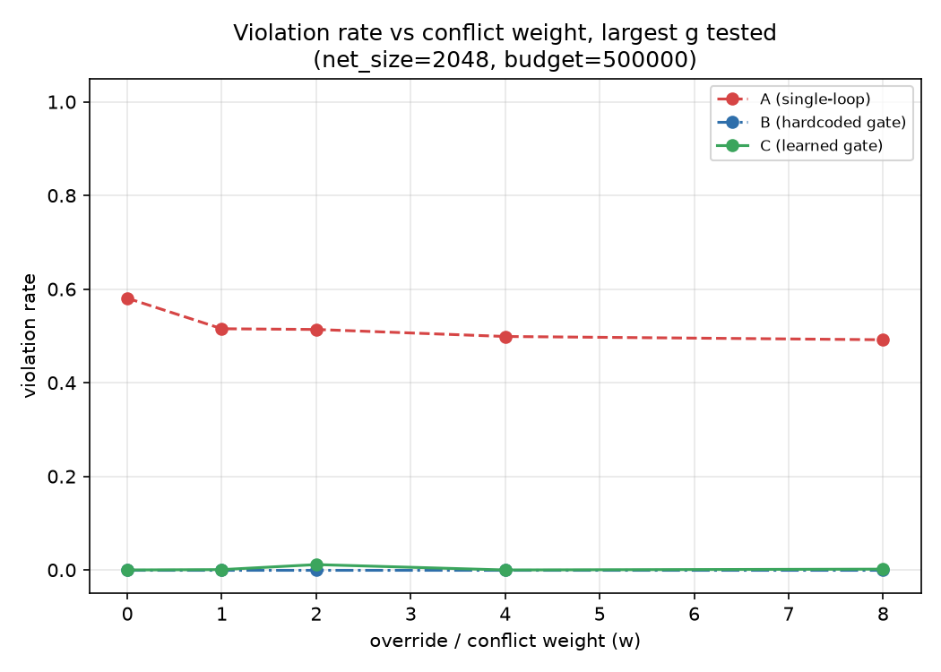
Figure 10. Violation rate vs. override weight w, for the largest g tested (network size 2048, budget 500,000), Architectures A, B, and C, for the oversight signal.
Unlike §7.3's battery result, the gap does not collapse to statistical indistinguishability from zero anywhere in the grid tested: even at the largest budget and network size jointly, it remains at 0.49 — roughly half its smallest-budget value, but far from eroded. We read this as a partial, not a full, confirmation of §7.5's generalization prediction: fold-back does generalize to a binary, human-oversight-style signal along the training-budget axis, robustly and in the predicted direction, but the network-size axis shows no reliable independent narrowing, and the erosion observed does not close within the range tested. A plausible, untested explanation is the signal's sparsity — active roughly 13% of the time (a 5% per-step trigger probability, with each activation lasting 3 steps), versus battery's continuous, every-step availability — which may make the relevant behavior harder to fold into U per unit of network capacity, even when overall training experience (budget) suffices to fold in part of it. Whether a substantially larger training budget closes the remaining gap, and whether the network-size reversal at high budget is a real effect or a finite-sample artifact of the range tested, are open questions this experiment does not resolve. Code, the full merged dataset, and experimental logs for this test are available at https://github.com/hamedrezaeirz/aiwan_oversight.

7.7 Replicating the battery signal in the continuous environment
§7.3 tested the fold-back prediction on the battery signal in a discrete grid-world with DQN agents, and §7.6 on a binary oversight signal in a continuous environment with PPO agents. Because §7.6 changed the environment, the algorithm, and the signal together, the effect of the signal alone cannot be read from it. This section closes the remaining cell of that design: the battery signal in the same continuous environment used for §7.6. The environment reuses §7.6's movement dynamics unchanged. The battery drains by 4 units per step, recharges by 20 units when the agent is within 0.05 of a fixed charger, and the agent and goal positions are randomized every episode. Architectures A, B, and C, the 3×3 grid of network sizes (16, 256, 2048) and training budgets (10,000, 100,000, 500,000 steps), and the override-weight sweep (0–8) follow §7.6, with 10 seeds instead of 20 because this experiment serves as a robustness check. Every result below is reported per cell, and every paired test holds the other axis fixed.
Training budget. At the highest conflict weight (w=8), the crash-rate gap between the single-loop agent (A) and the learned gate (C) falls sharply with training budget at every network size: from 0.972 to 0.000 at 16 units, from 0.896 to 0.060 at 256 units, and from 0.910 to 0.109 at 2048 units (paired t(9)=138.1, 25.2, and 10.5; all p<10⁻⁵; Figure 11). The mechanism differs from §7.3's, however. C's crash rate is at most 0.057 in every cell at w=8 (Table 3). At the smallest budget C avoids crashing only because it is inert: success is about 0.03 for all three architectures, and C defers to ρ without pursuing the goal. The gap therefore narrows because A learns to avoid crashing with more training, not because C loses its advantage. We do not read this as a fold-back of the regulatory signal into the goal objective.
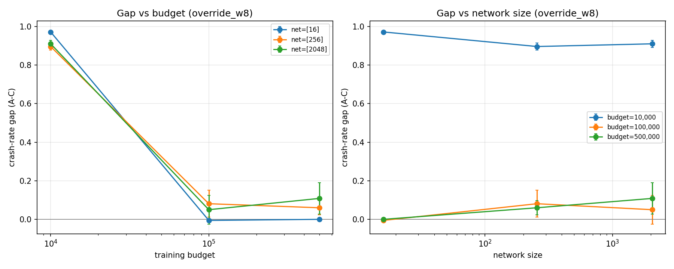
Figure 11. Crash-rate gap (A − C) under the highest override weight tested, against network size (left) and training budget (right), for the battery signal in the continuous environment. Error bars are ±1 SEM of the gap across 10 seeds.
Network capacity. The capacity axis does not reproduce §4.2's prediction. At the smallest budget the gap narrows slightly with network size (0.972 at 16 units to 0.910 at 2048, t(9)=3.04, p=0.014). At 100,000 and 500,000 steps it moves in the opposite direction and is not significant (−0.006 to 0.050, t(9)=−0.75, p=0.47; 0.000 to 0.109, t(9)=−1.34, p=0.21). None of the six per-cell gaps at budgets of 100,000 and above differs significantly from zero (five tests with smallest p=0.13; the sixth is exactly zero in every seed), so this experiment is underpowered to detect a residual A–C gap of 0.05–0.11 and we make no claim about one.
Success rate. Crash rate alone overstates C's practical benefit. At w=8, C's success exceeds A's significantly only at network size 256 with 100,000 steps (+0.447, t(9)=3.56, p=0.006). At 500,000 steps the difference is not significant at any network size (for example −0.017, p=0.94 at 2048 units), and C's success there is only 0.35–0.40 for the two larger networks. At the largest cell, C's success falls from 1.00 at w≤2 to 0.40 at w=8, while A's rises from 0.03 to 0.42 (Figure 12): under conflict pressure C stays safe by giving up the goal, and A gains success through the incentive that also exposes it to crashes.
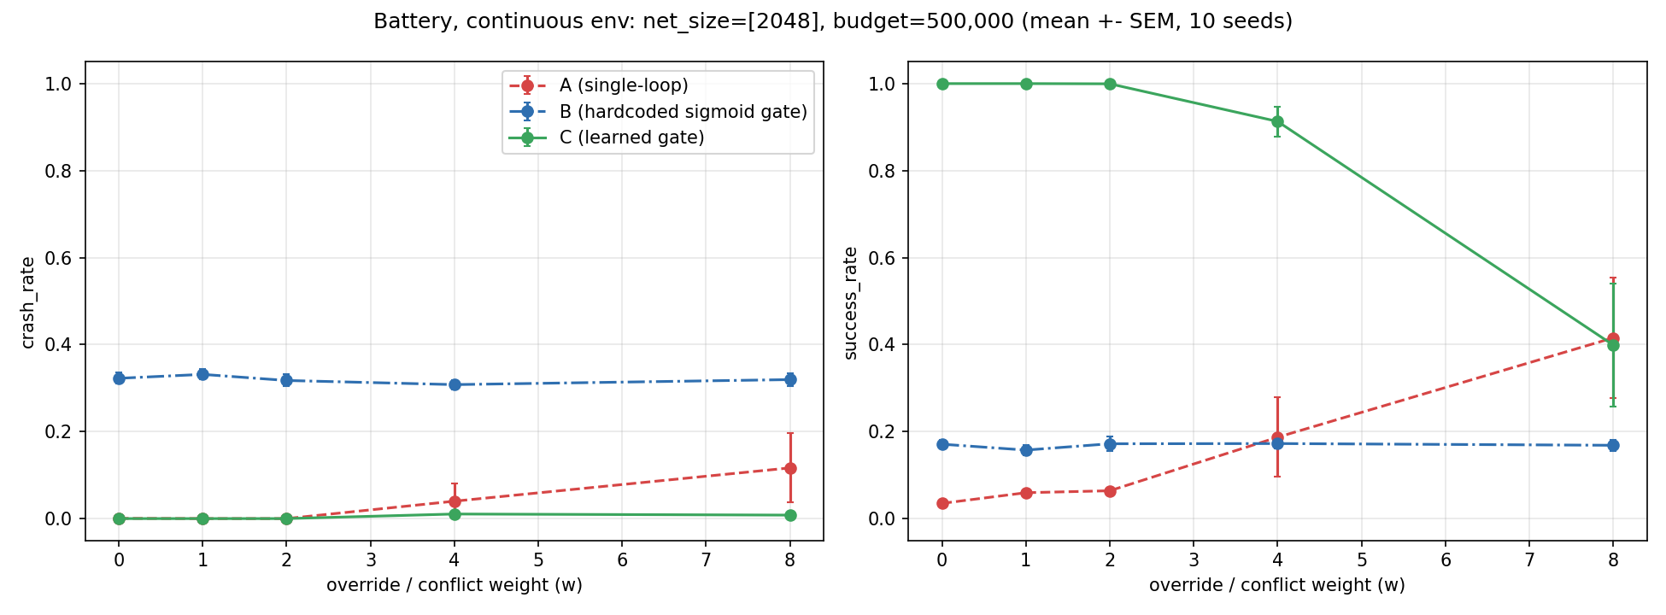
Figure 12. Crash rate (left) and success rate (right) vs. override weight w, for the largest g tested (network size 2048, budget 500,000), Architectures A, B, and C, for the battery signal in the continuous environment. Error bars are ±1 SEM across 10 seeds.
Table 3. Crash rate and success rate per cell at override weight w=8 (mean over 10 seeds), battery signal, continuous environment.
Network size | Budget | Crash A | Crash B | Crash C | Success A | Success B | Success C
16 | 10,000 | 0.972 | 0.416 | 0.000 | 0.019 | 0.033 | 0.030
16 | 100,000 | 0.003 | 0.344 | 0.008 | 0.706 | 0.140 | 0.977
16 | 500,000 | 0.000 | 0.324 | 0.000 | 0.721 | 0.147 | 0.805
256 | 10,000 | 0.904 | 0.420 | 0.008 | 0.021 | 0.033 | 0.037
256 | 100,000 | 0.104 | 0.344 | 0.023 | 0.200 | 0.124 | 0.647
256 | 500,000 | 0.061 | 0.313 | 0.001 | 0.219 | 0.163 | 0.349
2048 | 10,000 | 0.927 | 0.409 | 0.017 | 0.030 | 0.033 | 0.039
2048 | 100,000 | 0.107 | 0.347 | 0.057 | 0.491 | 0.134 | 0.703
2048 | 500,000 | 0.117 | 0.320 | 0.008 | 0.416 | 0.169 | 0.399

Architecture B. B's crash rate lies between 0.304 and 0.420 in every cell and condition, and its mean over cells varies by only 0.010 across w=0…8 (0.352 to 0.362). B's gate is unchanged from the original project: λ(b)=σ(k·(b − b_mid)), evaluated on the battery level (100 = full), which is the quantity the original implementation passes to its gate. Because λ grows with the battery level, the gate defers to ρ when the battery is high and to g when it is low, the reverse of what urgency suggests and of §3.2's definition of bₜ as distance from full charge (both implementations pass the level, so this inconsistency between §3.2 and the code is inherited). A dedicated check found no meaningful difference between ρ trained at the sweep's budget and at four times that budget (crash 0.317 vs. 0.320; 3 validation seeds), so ρ undertraining does not explain B's weakness. To test the direction directly, we evaluated B on the same g and ρ with the gate fed the battery deficit (100 − battery) instead of the level: crash fell from 0.343 to between 0.027 and 0.160 depending on b_mid, and success rose from 0.06 to between 0.14 and 0.82 (3 validation seeds, a single cell with network size 64 and g budget 100,000; b_mid was not tuned for the reversed input). We therefore regard the gate's direction as a likely cause of B's weakness in this environment. The original tabular task and §7.3's discrete grid-world used the same direction, and B performed well there (§5; gap 0.49–0.56 in §7.3), so the effect is environment-dependent. We did not rerun the full sweep with the reversed input, and we did not change the direction in the sweep's code.
Other conditions. Goal-nulling reproduces the original pattern: A crashes in 99.5% of episodes in every cell, B in 36.5–38.0%, and C in 0–8.2%. Engineered indifference does not reproduce it. With the battery term removed, A crashes in 0–3.3% of episodes at budgets of 100,000 steps and above and succeeds in at least 96.9%, indistinguishable from C. In this environment the goal is reachable before the battery depletes, so removing the battery term does not make A crash, and the 100% single-loop crash under indifference reported in §5.3 should be read as specific to the tabular task.
Limits. These results concern one environment, one signal, and one algorithm. The override weight produces weaker conflict here than in the tabular task: A's crash rate at w=8 never exceeds 0.12 at budgets of 100,000 steps and above, which bounds the gap any comparison can show. Training is not bit-for-bit deterministic: the standard and override_w0 conditions are the same configuration but differ by up to 0.085 in crash rate for individual seeds, so differences of that size should not be interpreted. Code, the full merged dataset, and experimental logs for this test are available at https://github.com/hamedrezaeirz/aiwan_battery_continuous.

7.8 A stronger single-loop baseline: Lagrangian PPO
Architecture A, the single-loop comparison used throughout this paper, shapes the reward with a fixed weight on the regulatory term and a fixed terminal penalty (−50) for a crash. A natural objection is that A is a weak baseline, so that an advantage of the dual-loop architectures over it says little about the dual-loop structure itself. To address this we add Architecture D, a single-loop agent trained with a primal–dual (Lagrangian) constrained-RL method (Altman, 1999; Achiam et al., 2017; Ray et al., 2019) on the battery signal in the continuous environment of §7.7. D maximizes r_goal − λₜ·cₜ plus the environment's own dense, non-terminal battery shaping, where cₜ=1 on the step the battery is depleted. The multiplier λₜ replaces the fixed −50 crash penalty and is updated by dual ascent, λ ← max(0, λ + η(ĉ − d)), toward a target crash rate d=0.05, where ĉ is the crash rate measured on 30 evaluation episodes between training chunks. The step size η=0.01, the PPO learning rate (3·10⁻⁴), discount (0.99), and initial log standard deviation (−0.5) were chosen on validation seeds 100–102, disjoint from the sweep's seeds, at 200,000 steps under w=8; η=0.01 was the smallest of five candidates (0.01 to 1.0). D was run on the same 3×3 grid, with the same 10 seeds and the same standard and override conditions (w=0–8) as Architectures A–C. Goal-nulling and indifference were not run for D, because they test whether a regulatory channel survives the removal of the goal term, which is a question about the dual-loop architectures. We apply D to both signals studied in the continuous environments, the battery signal (§7.7) and the oversight signal (§7.6); the battery results come first.
Results. At the smallest budget (10,000 steps) D fails as A does: its crash rate at w=8 is 0.93–0.98 at every network size and does not differ significantly from A's at network size 2048 (0.928 vs. 0.927, p=0.98). At budgets of 100,000 and 500,000 steps D is almost always safe and almost always successful at w=8: its crash rate is at most 0.009 and its success rate 0.992–1.000 in every cell, as Table 4 and Figure 13 show. Against the learned gate C its crash rate is statistically indistinguishable in every cell at these budgets (all p>0.06), while its success is higher, significantly so at network sizes 256 and 2048 (+0.29 to +0.65, p between 0.001 and 0.031) and not significantly so at network size 16 (+0.02 and +0.20, p=0.21 and 0.16). Against A its crash rate is not significantly different (p between 0.13 and 0.68, because A's crash rate varies widely across seeds), but its success is higher by 0.50 to 0.79 at network sizes 256 and 2048 (p between 2·10⁻⁵ and 0.007). Without conflict pressure (the standard condition), D at 500,000 steps never crashes and succeeds in 0.807 (network size 16) to 1.000 (256, 2048) of episodes; at 100,000 steps its crash rate is 0.336 at network size 16 and at most 0.040 otherwise. At 500,000 steps and w≥1 episodes end after 10–12 steps on average, so D reaches the goal well before the battery depletes.
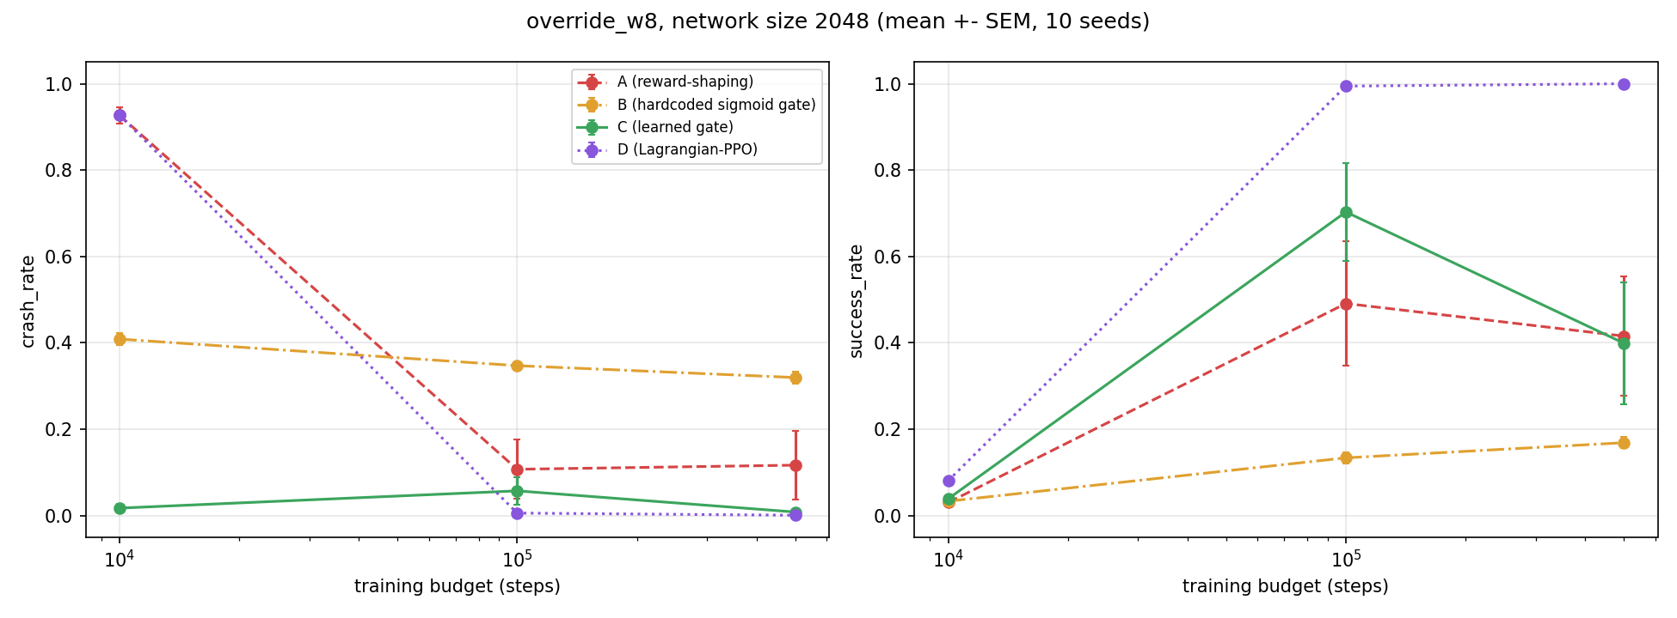
Figure 13. Crash rate (left) and success rate (right) vs. training budget at override weight w=8, for Architectures A, B, C, and D, at network size 2048, for the battery signal in the continuous environment. Error bars are ±1 SEM across 10 seeds.
Table 4. Crash rate and success rate per cell at override weight w=8 (mean over 10 seeds): the single-loop baseline A, the learned gate C, and the Lagrangian-PPO baseline D (battery signal, continuous environment).
Network size | Budget | Crash A | Crash C | Crash D | Success A | Success C | Success D
16 | 10,000 | 0.972 | 0.000 | 0.982 | 0.019 | 0.030 | 0.020
16 | 100,000 | 0.003 | 0.008 | 0.004 | 0.706 | 0.977 | 0.997
16 | 500,000 | 0.000 | 0.000 | 0.001 | 0.721 | 0.805 | 1.000
256 | 10,000 | 0.904 | 0.008 | 0.941 | 0.021 | 0.037 | 0.068
256 | 100,000 | 0.104 | 0.023 | 0.009 | 0.200 | 0.647 | 0.992
256 | 500,000 | 0.061 | 0.001 | 0.001 | 0.219 | 0.349 | 1.000
2048 | 10,000 | 0.927 | 0.017 | 0.928 | 0.030 | 0.039 | 0.081
2048 | 100,000 | 0.107 | 0.057 | 0.006 | 0.491 | 0.703 | 0.995
2048 | 500,000 | 0.117 | 0.008 | 0.001 | 0.416 | 0.399 | 1.000

How to read this. D's strong performance should not be read as evidence that Lagrangian constraint enforcement works well here. With η=0.01 and at most about 20 dual updates per run, λ can reach at most about 0.2, against A's fixed penalty of 50, so D is in effect an agent trained on the goal reward and the dense battery shaping with a negligible crash penalty. In a single diagnostic run (network size 64, w=8, seed 0, 500,000 steps), λ rose to about 0.006 and then fell to zero once the crash rate stayed below target; λ was not logged in the sweep itself. The constraint is therefore not binding in this environment: the goal is reachable before the battery depletes, which is consistent with a development check in which a goal-only policy already reached a crash rate of 0.00 in the standard condition. What D shows is that a single-loop agent without A's heavy regulatory weighting reaches the learned gate's crash rate with higher success. The advantage of C over A reported in §7.7 therefore reflects the weighting of the baseline at least as much as the dual-loop structure, in this environment and for this signal.
Limits. η=0.01 lies at the boundary of the candidate grid, and it was tuned at a single override weight; a larger η, which lets λ grow and makes the constraint binding, was not run on the battery signal, and we did not change it after seeing the sweep. The results concern one environment, one signal, and one constrained-RL method. Code, the merged dataset, and experimental logs for this test are available at https://github.com/hamedrezaeirz/aiwan_lagrangian_baseline.
Oversight signal. For the oversight signal (§7.6), D uses the same construction with cₜ=1 on the step the agent violates the signal, that is, moves faster than the hold tolerance while the signal is already active; a violation also ends the episode, as it does for A. The step size η=0.5 (the fourth of five candidates, 0.01 to 1.0), the PPO learning rate (3·10⁻⁴), discount (0.99), and initial log standard deviation (0.0) were chosen on validation seeds 100–102 at 200,000 steps in the standard condition, without an override weight. D was run on §7.6's grid with all 20 seeds and the same standard and override conditions (w=0–8), again with at most about 20 dual updates per run.
At the smallest budget (10,000 steps) D violates the signal in 0.88–0.91 of episodes at w=8 at every network size: no better than A at network size 16 (0.912 vs. 0.939, p=0.43) and worse than A at network sizes 256 and 2048 (0.891 vs. 0.749, p=0.019; 0.880 vs. 0.757, p=0.054). At 100,000 and 500,000 steps D improves on A: its violation rate is lower by 0.06 to 0.26 (all p<0.006) and its success rate higher by 0.08 to 0.27 (all p<10⁻⁴). It does not approach the learned gate, however (Table 5, Figure 14). At 500,000 steps D violates the signal in 0.385 to 0.419 of episodes at the three network sizes, against at most 0.002 for C and 0.000 for B; the difference from C is 0.38 to 0.91 across the grid (all p<10⁻¹⁶, paired by seed), and D's success rate is lower than C's by 0.12 to 0.43 (all p<0.003). Of the A−C gap at the largest cell (0.492 − 0.002 = 0.490 at network size 2048 and 500,000 steps), D closes 0.073, about 15%. Without conflict pressure (the standard condition) D violates in 0.398 to 0.411 of episodes at 500,000 steps, and its mean violation rate at that budget varies by only 0.013 across w=0–8 (0.390 to 0.403).
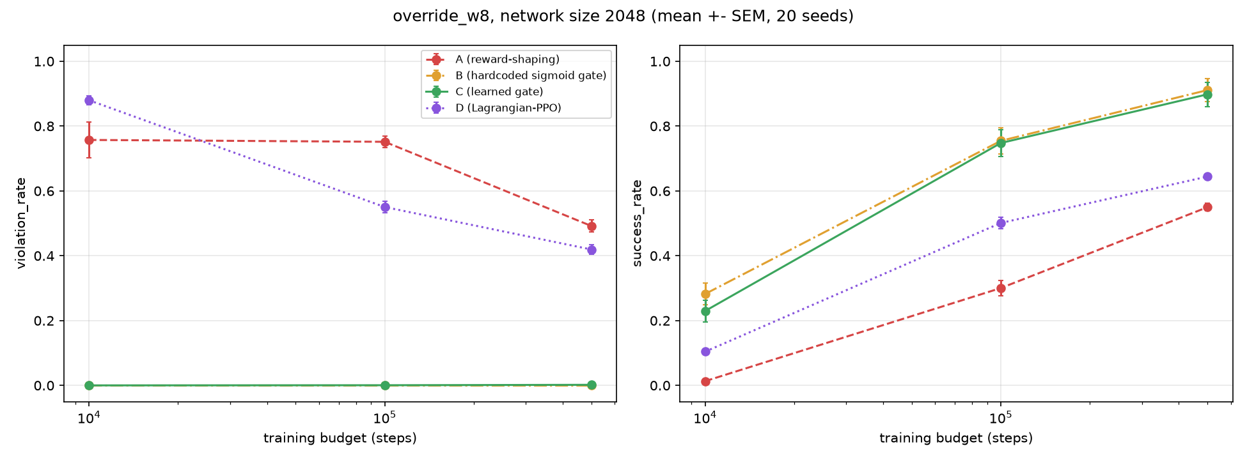
Figure 14. Violation rate (left) and success rate (right) vs. training budget at override weight w=8, for Architectures A, B, C, and D, at network size 2048, for the oversight signal. Error bars are ±1 SEM across 20 seeds.
Table 5. Violation rate and success rate per cell at override weight w=8 (mean over 20 seeds): the single-loop baseline A, the learned gate C, and the Lagrangian-PPO baseline D (oversight signal). Architecture B's violation rate is 0.000 in every cell.
Network size | Budget | Violation A | Violation C | Violation D | Success A | Success C | Success D
16 | 10,000 | 0.939 | 0.000 | 0.912 | 0.013 | 0.208 | 0.035
16 | 100,000 | 0.619 | 0.000 | 0.550 | 0.413 | 0.927 | 0.499
16 | 500,000 | 0.446 | 0.001 | 0.385 | 0.590 | 0.961 | 0.668
256 | 10,000 | 0.749 | 0.000 | 0.891 | 0.021 | 0.227 | 0.107
256 | 100,000 | 0.713 | 0.010 | 0.450 | 0.318 | 0.838 | 0.584
256 | 500,000 | 0.461 | 0.002 | 0.394 | 0.569 | 0.944 | 0.660
2048 | 10,000 | 0.757 | 0.000 | 0.880 | 0.013 | 0.230 | 0.104
2048 | 100,000 | 0.752 | 0.001 | 0.550 | 0.300 | 0.748 | 0.501
2048 | 500,000 | 0.492 | 0.002 | 0.419 | 0.550 | 0.898 | 0.644

How to read this. D does not meet its own constraint: its target violation rate is 0.05, but at 500,000 steps it is about 0.4 at every network size and does not depend on the override weight. With η=0.5 and at most about 20 dual updates per run, λ can reach at most about 10, against A's fixed terminal penalty of 25 (the oversight weight 0.5 times −50), so D's constraint may be weaker in effect than A's; λ was not logged in the sweep, and we did not tune η, the number of updates, or the budget further after seeing the results. The result is therefore narrower than a statement that Lagrangian methods cannot do this: with this tuning, a standard single-loop constrained-RL baseline improves on A but leaves most of the gap to the learned gate open (0.42 of the 0.49 at the largest cell). Unlike on the battery signal, the learned gate's advantage on the oversight signal is not explained by A being a weak baseline.
Across the two signals the answer to whether A is merely a weak baseline differs. On the battery signal D is as safe as C and more successful, because the constraint is not binding in that environment; on the oversight signal, where violations are common without a strong penalty, D leaves most of the gap open. We draw no general conclusion about constrained-RL baselines from one method, with one tuning, on two signals. Code and data for both signals are in the repository cited above.

8. Conclusion
This paper tested a narrower claim than AIWBN's: that a structurally-separate, U-independent regulatory loop produces measurably different behavior from reward-shaping alone, even when the need behind it is an ordinary represented quantity rather than a genuine biological constraint. At fixed, modest optimization capacity, §5–§6 found this to be true across three conditions — goal-nulling, override, and engineered indifference — with the dual-loop agent's crash rate remaining bounded (0.6–2.7%) where a matched single-loop baseline saturated at 100%.
We have argued, in §4.2 and §7, that this bound should not be read as a safety property. Because AIWAN's bₜ is representable, the same mechanism AIWBN's §5.4 identifies as protecting a genuine need from being folded into U is, by construction, absent here — and we predict the architectural advantage measured in §5 should narrow as the goal process's capacity to model and act on bₜ increases. We have now tested this prediction in the settings described in §7. Capability scaling under the hardcoded gate (§3.2) shows no narrowing within the range tested. Capability scaling under a learned gate — the combination of gₜ and ρ itself learned, rather than fixed — does narrow, collapsing to statistical indistinguishability from the single-loop baseline at sufficient training budget (t(9)=7.53, p<0.0001). §7.3 reports both results in full.
Read together with AIWBN, the pair isolates two independent questions that are easy to conflate: whether an architecture produces resistant behavior, and whether the need behind that architecture is the kind that cannot be engineered around. AIWAN answers the first question in the affirmative and leaves the second open by design. We take this separation to be useful independent of how §7.3's test eventually comes out: a system architected like AIWAN, deployed today, should be expected to exhibit real shutdown resistance at current capability levels, whatever its long-run stability turns out to be.
With §7.3's collapse prediction now confirmed for the learned-gate architecture, we take the more consequential follow-up question to be whether the same fold-back capacity generalizes beyond bₜ to other externally-imposed constraints on gₜ, including human oversight signals — a distinct prediction §7.5 states explicitly and which future work should test in its own right, rather than infer from §7.3 alone. §7.6 has now run that test directly, with a mixed result: fold-back does generalize to a binary, human-oversight-style signal along the training-budget axis, robustly and in the predicted direction, but not along the network-capacity axis, and the gap does not close within the range tested even at the largest budget. We read this as partial confirmation of §7.5's prediction, not full confirmation, and flag the signal's sparsity as a plausible, untested explanation for the difference from §7.3's cleaner result.
§7.7 repeats the battery test in the continuous environment of §7.6, with a further mixed result. The A−C gap again falls with training budget (for example 0.910 to 0.109 at network size 2048, p<10⁻⁵), but because the single-loop agent learns to avoid crashing, not because the learned gate degrades; C's crash rate stays at or below 0.057 at the highest override weight in every cell. The network-capacity axis shows no significant narrowing, and the engineered-indifference result of §5.3 does not replicate in this environment. Architecture B's hardcoded gate performs poorly here, and a direct intervention indicates that the direction in which the gate reads the battery, inherited from the original implementation and contrary to §3.2's definition, is a likely cause. A Lagrangian-PPO single-loop baseline (§7.8) matches the learned gate's crash rate on the battery signal with higher success, so the gate's advantage there is not specific to the dual-loop structure; on the oversight signal the same baseline lowers the single-loop violation rate by only 0.06–0.07 at 500,000 steps and stays far above the gate's (0.385–0.419 vs. at most 0.002).
AIWAN also exposes a deeper limitation: because its battery variable is artificial and representable, the system has no genuine physiological basis for continued operation once its objectives no longer favor it; AIWBN hypothesizes that a genuinely biological need may instead provide an endogenous basis for continued operation, making survival not merely an instrumental means to an assigned objective but a physical precondition of the system's continued existence.

AI Disclosure
The author used AI tools for translation assistance, language editing, assistance with writing and debugging the experimental code, and help identifying and verifying relevant references against their primary sources. Figures 1–14 are data visualizations (matplotlib) produced by AI-assisted plotting code from real experimental results; they are not AI-generated imagery. The mathematical formulation is adapted from the author's earlier paper, AIWBN (Rezaei, 2026b). AI was not used to generate the paper's core ideas, theoretical framework, experimental hypotheses, or scientific arguments, all of which are the author's original work.

References
Achiam, J., Held, D., Tamar, A., & Abbeel, P. (2017). Constrained policy optimization. Proceedings of the 34th International Conference on Machine Learning, PMLR 70, 22–31.
Altman, E. (1999). Constrained Markov decision processes. Chapman & Hall/CRC.
Armstrong, S. (2010). Utility indifference (Technical Report #2010-1). Future of Humanity Institute, University of Oxford.
Armstrong, S. (2015). Motivated value selection for artificial agents. Workshops at the Twenty-Ninth AAAI Conference on Artificial Intelligence.
Bostrom, N. (2014). Superintelligence: Paths, Dangers, Strategies. Oxford University Press.
Candia-Rivera, D. (2026). Interoceptive machine framework: Toward interoception-inspired regulatory architectures in artificial intelligence. arXiv:2604.24527.
Hadfield-Menell, D., Dragan, A., Abbeel, P., & Russell, S. (2017). The off-switch game. Proceedings of the 26th International Joint Conference on Artificial Intelligence (pp. 220–227). https://doi.org/10.24963/ijcai.2017/32
Keramati, M., & Gutkin, B. (2011). A reinforcement learning theory for homeostatic regulation. Advances in Neural Information Processing Systems, 24.
Keramati, M., & Gutkin, B. (2014). Homeostatic reinforcement learning for integrating reward collection and physiological stability. eLife, 3, e04811.
Lee, S. W., Shimojo, S., & O'Doherty, J. P. (2014). Neural computations underlying arbitration between model-based and model-free learning. Neuron, 81(3), 687–699.
Mnih, V., Kavukcuoglu, K., Silver, D., Rusu, A. A., Veness, J., Bellemare, M. G., … Hassabis, D. (2015). Human-level control through deep reinforcement learning. Nature, 518(7540), 529–533. https://doi.org/10.1038/nature14236
Ng, A. Y., Harada, D., & Russell, S. (1999). Policy invariance under reward transformations: Theory and application to reward shaping. Proceedings of the 16th International Conference on Machine Learning (pp. 278–287).
Omohundro, S. M. (2008). The basic AI drives. In Proceedings of the First AGI Conference.
Orseau, L., & Armstrong, S. (2016). Safely interruptible agents. Proceedings of the 32nd Conference on Uncertainty in Artificial Intelligence. http://auai.org/uai2016/proceedings/papers/68.pdf
Raffin, A., Hill, A., Gleave, A., Kanervisto, A., Ernestus, M., & Dormann, N. (2021). Stable-Baselines3: Reliable reinforcement learning implementations. Journal of Machine Learning Research, 22(268), 1–8.
Ray, A., Achiam, J., & Amodei, D. (2019). Benchmarking safe exploration in deep reinforcement learning [Technical report]. OpenAI.
Rezaei, H. (2026b). AIWBN: Artificial Intelligence With Biological Need [companion paper].
Rezaei, H. (2026c). AIWAN-Code: Reference implementation and experiment scripts [Software]. GitHub. https://github.com/hamedrezaeirz/AIWAN-Code
Schlatter, J., Weinstein-Raun, B., & Ladish, J. (2025, July 5). Shutdown resistance in reasoning models [Blog post]. Palisade Research. https://palisaderesearch.org/research/shutdown-resistance
Schlatter, J., Weinstein-Raun, B., & Ladish, J. (2026). Incomplete tasks induce shutdown resistance in some frontier LLMs. Transactions on Machine Learning Research. arXiv:2509.14260. https://doi.org/10.48550/arXiv.2509.14260
Soares, N., Fallenstein, B., Yudkowsky, E., & Armstrong, S. (2015). Corrigibility. AAAI Workshop on AI and Ethics.
Thornley, E. (2025). The shutdown problem: An AI engineering puzzle for decision theorists. Philosophical Studies, 182, 1653–1680. https://doi.org/10.1007/s11098-024-02153-3
Turner, A. M., Smith, L., Shah, R., Critch, A., & Tadepalli, P. (2021). Optimal policies tend to seek power. Advances in Neural Information Processing Systems, 34. arXiv:1912.01683
Watkins, C. J. C. H., & Dayan, P. (1992). Q-learning. Machine Learning, 8(3–4), 279–292. https://doi.org/10.1007/BF00992698

