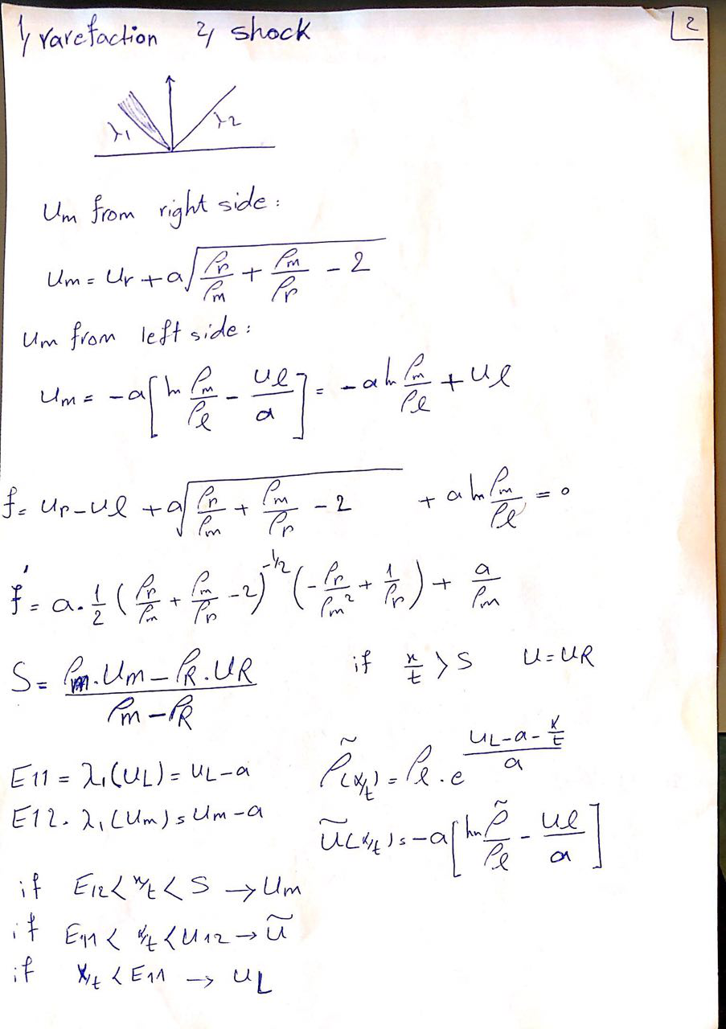

The computer simulation for 1-rarefaction and 2-shock is as below:

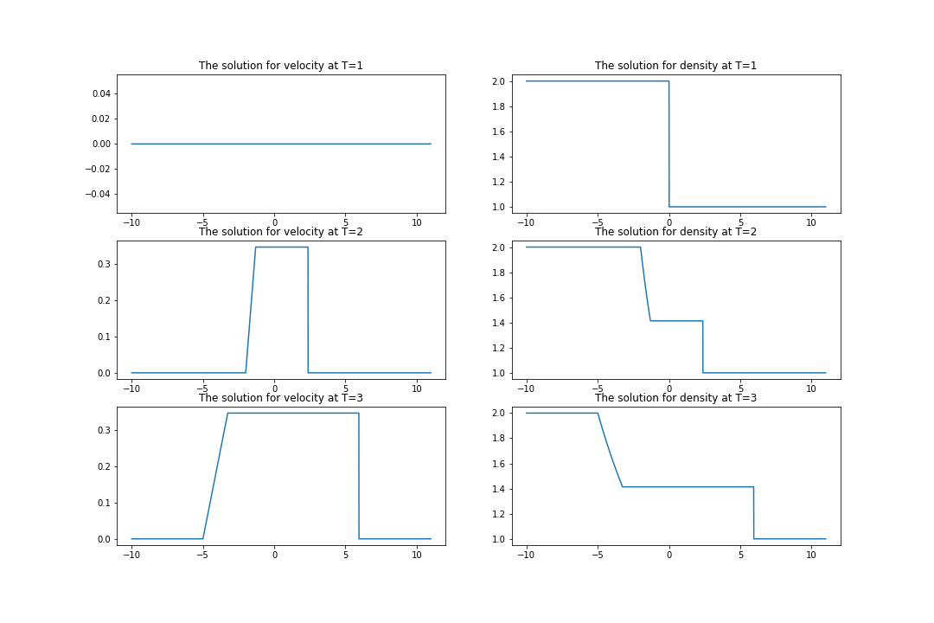

This figure is corresponded for UR=UL = 0 , rho_L = 2 , rho_R = 1 , a = 1 , delta T =1 and Delta X = 0.01