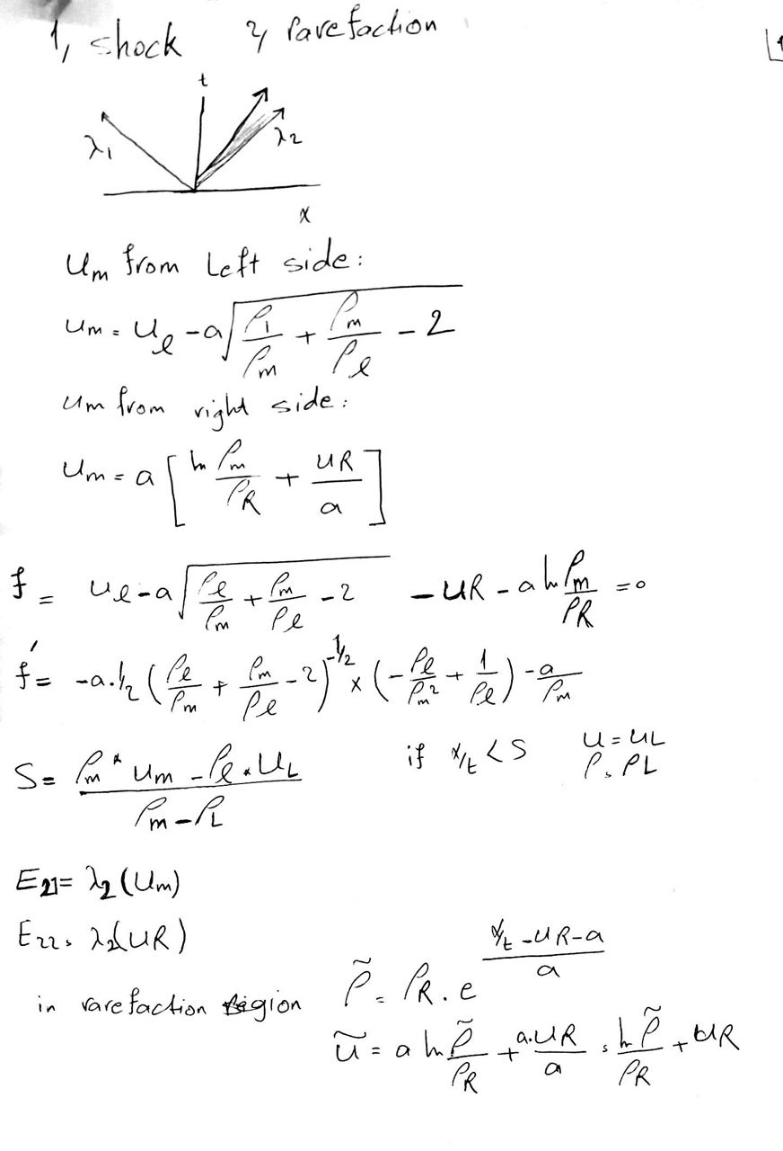

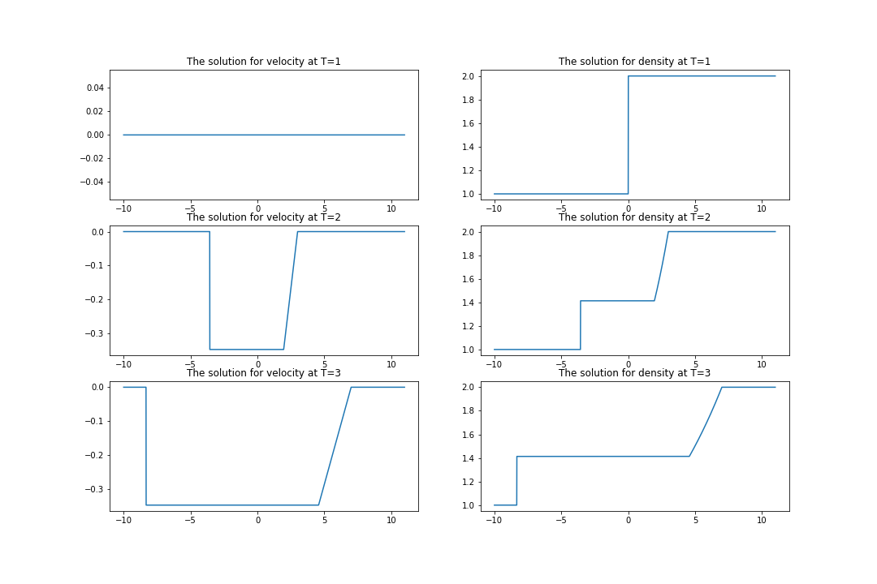

This figure is corresponded for UR=UL=0 , rho_R=2 , rho_L=1, a=1 , delta T = 1, delta X = 0.01 .