- opening the text file from editor window
- the style of comment lines is changed from middle 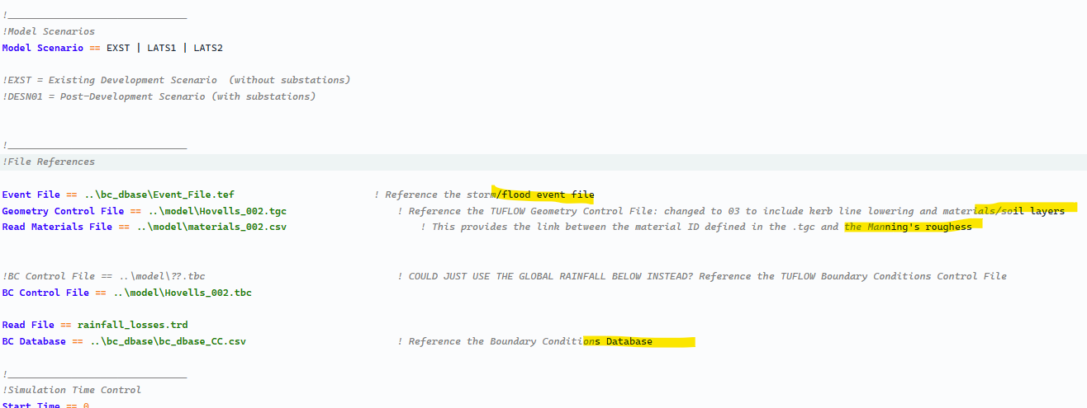

- in compare window, the highlighting function also should work
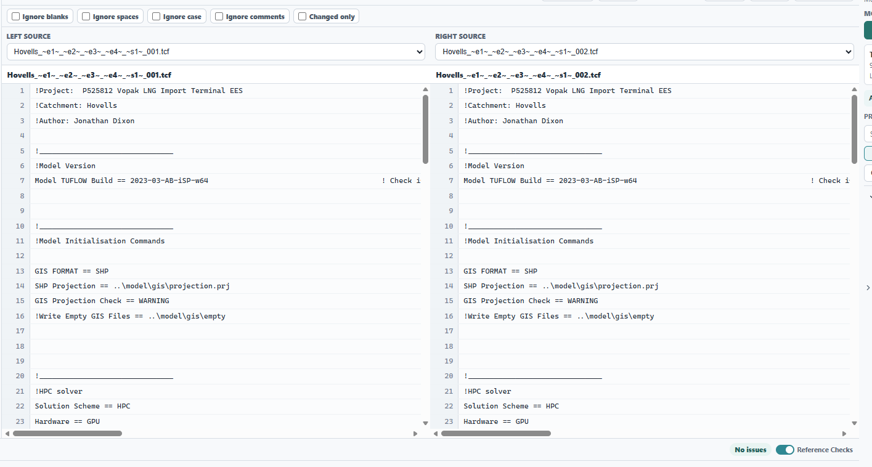
- the logic of comparing need to be investigated
- recognizing the IF block for line guide section
- show the list of variables referred in the control file
- recognizing the input and output files in project files panel based on the name
- warning message to user about ignored folders
- 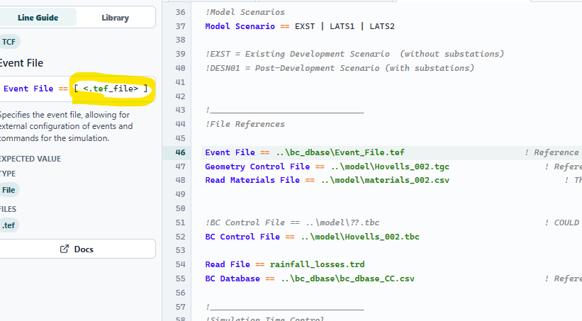
- All number is not real numbers
- Format??? Make nice formatting
- 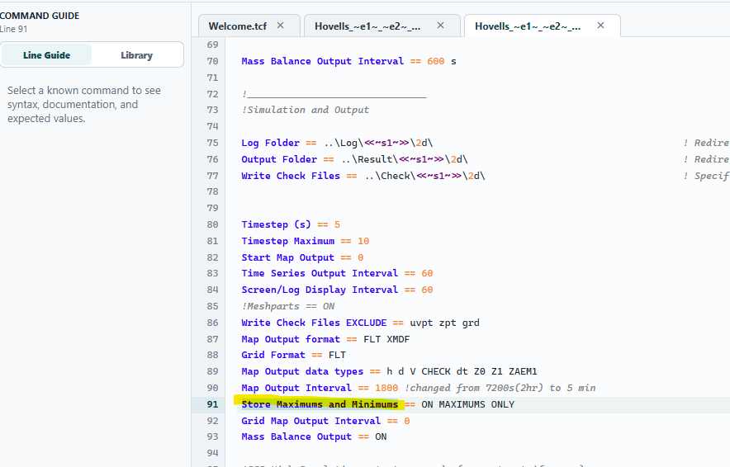
- The check reference disappears when tab lost focus and user has to do it again…
- 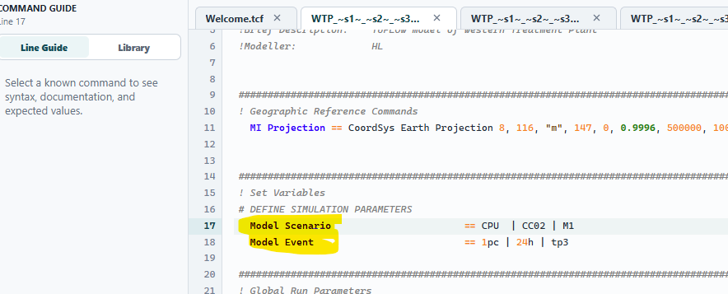
- The app also should recognize the available scenarios and event variables by above commands and by whitcards
- Log file for tracing the changes of code
- File tree with identifying references even inside scenarios

