**Model-Based System Identification, Control Design, and Fault Accommodation for a Smart, Resilient, and Circular Wastewater Treatment Architecture**

Hamed Tirandaz

Email: [hamedtirandaz@gmail.com](mailto:hamedtirandaz@gmail.com), Phone#: +989013151719

<https://hamedtirandaz.github.io/>

Abstract

Wastewater is a byproduct of water used in domestic and industrial activities. It originates from household practices (e.g., hygiene, cleaning, sanitation) and commercial operations (e.g., manufacturing, maintenance), then flows through infrastructure to treatment facilities. These plants, often more advanced than perceived, employ sophisticated systems to purify wastewater into a reusable resource, demonstrating their vital role in sustainable water management and environmental protection. Their efficiency challenges common assumptions, emphasizing the intersection of technology and ecological responsibility.

Safe and efficient operation of Wastewater treatment process (WWTP) is critical for environmental protection and public health. A wastewater treatment plant facilitates various processes (e.g., biological, chemical and physical) to treat industrial wastewater and remove pollutants. This topic recently encourages much attention in different fields to explore suitable methods to be able to remove chemical or biological elements from wastewater. Quality of waste water also plays an important role in design and construction of various treatment units. From a control perspective, extensive research has focused on developing automated WWTP systems to enhance reliability, optimize effluent quality, and reduce operational costs. As a result, integrated and plant-wide control strategies have attracted significant attention in the wastewater sector as critical solutions for addressing complex process interdependencies and sustainability challenges.

Model-Based System Identification, Control Design, and Fault Accommodation for wastewater treatment process is aimed to be investigate in this research proposal— in particular, a digital twin for WWTP system is developed. More specifically, the aim is to develop several approaches to system identification, designing novel data-driven and learning-based monitoring/control WWTP dynamical system by combining adaptive, model predictive control (MPC), and reinforcement learning, and to design fault-tolerant control scheme to address actuator/sensor faults.

Comparing and evaluating the performance of these controllers is very difficult. This is mainly because of the different control objectives, fluctuation in the influent flow rate and composition, the complexity of the biochemical phenomena involved, a very large time constant, and the absence of standard evaluation criteria due to differences in geographical regions and effluent specifications [Tejaswini2021].

Despite extensive research, WWTP control remains an open problem due to modeling uncertainties, external disturbances, and equipment faults that degrade performance over time. This project addresses these issues via a novel, hybrid control framework. This MSCA ECO-SPHERE Project proposal addresses the challenge of digitalizing WWTP through an integrated, model-based control framework enriched by data-driven enhancements. Leveraging my expertise in instrumentation, automation and control, especially in adaptive control design, system identification, and fault diagnosis and accommodation, I will develop a multi-step methodology that covers the following steps:

1. System identification:

To optimize the performance of WWTP control schemes, appropriate mathematical models capable of accurately simulating the plant dynamic behavior are essential.

Accurate continuous-time dynamical system models via advanced identification techniques will be derived for WWTP. Hence, modeling uncertainty will be investigated via applying

1. Data-driven approach: integrates data-driven modules (e.g., neural network observers) to compensate for modeling uncertainties;
2. Robust MPC scheme: Integrating continuous-time models and data-driven predictors within an MPC architecture can help to optimize aeration, chemical dosing, and sludge recycle rates. An effective and robust model predictive controllers (MPC) will be introduced to deal with system disturbances and to maintain effluent quality.
3. Fault-tolerant control: Investigate fault diagnosis and accommodation schemes to detect and mitigate actuator or sensor degradations.

The outcome will be a digital twin prototype—complete with flowcharts, block diagrams, and mathematical formulations—to guide future WWTP digitalization efforts.

1. Background and Motivation

Urbanization and population growth are projected to increase global water demand by up to 55% by 2050, significantly raising wastewater loads and placing considerable stress on existing WWTP infrastructures [world2016]. Wastewater can originate from activities of households, industry, commerce, agriculture, surface runoff, stormwater, and flows into underground sewers or seepage. Urban WWTPs are energy‑intensive, nonlinear systems that must meet stringent effluent standards under uncertain loads and aging infrastructure [Carlos2024].

All wastewater must be treated before being put into the environment. A WWTP must reliably remove nitrogen, phosphorus, pathogens, and another organic loads. WWTPs are complex nonlinear systems, and controlling the effluent quality is tremendously hard due to the complexity of physical, biochemical, biological processes, and fluctuations of input wastewater flow. After all, legal requirements for effluent treatment—such as those outlined in the European Union’s Directive 91/271 (‘Urban Wastewater’)—necessitate thorough investigation. A WWTP (Wastewater Treatment Plant) is an industrial process that does not generate direct revenue; instead, its operational costs are always to be faced against the environmental benefits.

Traditional SCADA systems rely on fixed control logic and scheduled maintenance, offering limited adaptability to disturbances, modeling uncertainties, equipment faults, or cyber-physical attacks. Some key challenges in WWTP systems includes: modeling uncertainty, external disturbances, measurement noise, nonlinearity and time variability, and component faults

**BSM1 Model Structure**

The Benchmark Simulation Model No.1 (BSM1) has been considered widely in different research in different fields [Alex2008]. BSM1 is utilized as a standard model for modeling, performance assessment, and evaluation of control strategies []. BSM1 is based on the most popular Activated Sludge Model No.1 (ASM1) expanded by the International Association on Water Pollution Research and Control [Vanrolleghem1994]. The schematic of BSM1 is presented in Fig. 1. As illustrated, the biological reactor consists of five interconnected basins (Tanks) connected in series, followed by a secondary settler. Tanks include two anoxic zones (each one with volume of 1000 m3) for pre-nitrification, followed by three aerated zones (each one with volume of 1333 m3) for nitrification. The settler (with volume of 6000 m3) has 10 feed layers. Further, two recycle flows, the first from the last Tank and the second from the underflow of the settler, complete the system. Qw is debermined by the total amount of biomass present in the system. The nitrogen removal is achieved using a denitrification step performed in the anoxic tanks and a nitrification step carried out in the aerated tanks.

To maintain the microbial community essential for nutrient removal, sludge is continuously recycled from the secondary settler back into the reactor.

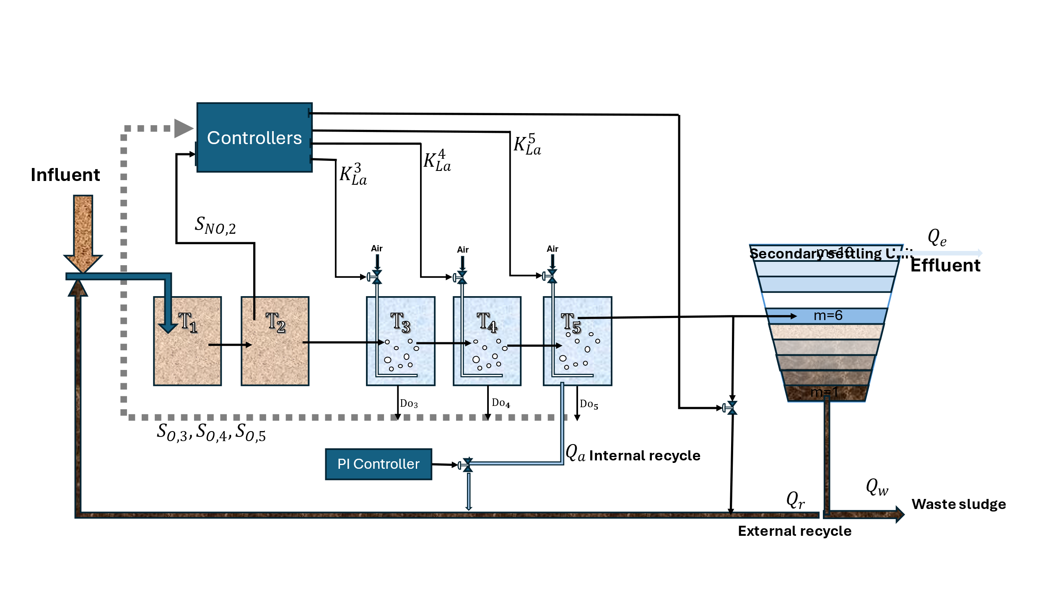

Fig . Benchmark Simulation Model 1 (BSM1).

The Dissolved Oxygen (DO) concentration is an important control variable, which significantly influences many microbiological processes occurring in the system. To maintain the desired aeration in the biological tank, a DO controller is implemented. Besides, DO level in the last tank is controlled that manipulates the aeration coefficient for this basin K5La. Besides, an outer control loop is used to verify the nitrate removal by manipulating the internal recycle flow-rate.

1. Objectives and Contributions

This proposal aims at achieving the following objectives:

1. Continuous-Time System Identification: Develop methods to identify parameterized, physically interpretable continuous-time models of activated sludge and nutrient removal processes;
2. Robust Control Design: Synthesize nonlinear and model predictive controllers that guarantee effluent quality and constraint satisfaction under disturbances and modeling errors.
3. Data-Driven Augmentation: ((chat17))
4. Fault Diagnosis and Accommodation: Design real-time fault detection and accommodation algorithms for actuators (e.g., valves, aeration blowers) and sensors, ensuring continued operation with minimal performance degradation.

Expected Contributions:

* A validated MATLAB toolbox for identification in WWTP systems.
* A fault-tolerant control layer suitable for digital twin implementation.
* Detailed flowcharts and block diagrams illustrating the integrated framework.

1. Grey-Box System Identification

The goal of this stage is to derive accurate, physically interpretable continuous-time models key WWTP subsystems, including activated sludge reactors and nutrient removal units.

1. **Continuous-Time System Identification**

Online learning such as adaptive approximation-based or neural-network based schemes are widely utilized in the literature to identify unknown terms of system dynamics [Farrell2006].

Continuous-time modeling is critical in capturing the inherent dynamics of a dynamical system, which often exhibit nonlinear and time-varying behavior. In this approach, the system dynamics is inferred directly from the input-output data. These identification schemes can facilitate the design of advanced model-based controllers such as adaptive control, and model predictive control (MPC).

1. **Data-Driven System Identification**

To complement model-based approaches, I will also explore modern data-driven system identification techniques that leverage machine learning, reinforcement learning (RL), and statistical tools to uncover dynamics without assuming a predefined model structure.

**III.1 Continuous-Time System Identification**

In this subsection, we discuss the utilized system dynamics in our research work.

**III.2 Data-driven System Identification**

Data-driven scheme for system identification is discussed in this part.

**Milestones and Timeline:**

* Month 1-3: Literature review and data acquisition on WWTP systems.
* Month 4-6: Design a continuous-time system identification, parameter estimation and validation. Submit the result in a suitable journal(s) /conference(s).
* Month 7-8: Design a data-driven approach for system identification and submit the result in a suitable journal(s) /conference(s).
* Month 9-10: Develop a MATLAB WWTP system identification toolbox, considering continuous-time, data-driven approach and a hybrid implementation of both of them.

1. Robust Control Design

At this stage, the control problem of WWTP system is investigated from two categories:

* + - 1. Adaptive and robust control: Design and simulation of an adaptive and robust adaptive feedback controller, which is robust on system disturbances and modeling uncertainties, suitable for implementation of WWTP system.
      2. **Model predictive control (MPC):** The basis of MPC is the use of an optimization algorithm to solve the control problem and the use of a model of the plant to make predications of output variables [Lopez2015]. MPC provides feedforward compensation for the measured disturbances as they occur to minimize their impact on the output. Due to the presence of strong disturbances on WWTPs, MPC has difficulties in keeping the controlled variables at their reference level. To deal with this issue, feed-forward control action is added to minimize disturbance impact on the output, as in [Shen2009].

WWTP BSM1 System Dynamics[pp1]

The concentration of dissolved oxygen greatly impacts the efficiency of the nitrogen removal process in WWTPs. An excessively high or low dissolved oxygen concentration will lead to a decrease in denitrification efficiency. Therefore, the ideal denitrification effect can be achieved by controlling the dissolved oxygen concentration at an appropriate set value. [pp1].

The dynamic models of dissolved oxygen concentration can be expressed as [pp1]:

$$\frac{dS_{O,5}\left(t\right)}{dt}=\frac{1}{V_{5}}\left(Q_{4}\left(t\right)S_{O,4}\left(t\right)+R_{5}V_{5}-Q_{5}\left(t\right)S_{O,5}\left(t\right)\right. \\ \left.+K_{La5}\left(t\right)V_{5}\left(S_{o,sat}-S_{O,5}\left(t\right)\right)\right)+r_{5},$$

$$\frac{dS_{NO,2}\left(t\right)}{dt}=\frac{1}{V_{2}}\left(Q_{1}S_{NO,1}\left(t\right)-Q_{2}S_{NO,2}\left(t\right)\right)+r_{2}$$

where $S_{O,5}\left(t\right)$ and $S_{O,4}\left(t\right)$ are the dissolved oxygen concentration of the fifth unit and the fourth unit, respectively. $S_{o,sat}$ denotes the saturation value of dissolved oxygen concentration. $S_{NO,1}\left(t\right)$ and $S_{NO,2}\left(t\right)$ are the nitrate nitrogen concentration in the first and second reactors at time t.

$K_{La5}\left(t\right)$ represents the oxygen transport coefficient of the fifth unit and $R_{5}$ and $V_{5}$ represent reaction rate and volume in the fifth unit. $Q_{1}\left(t\right)$, $Q_{2}\left(t\right)$, $Q_{4}\left(t\right)$ and $Q_{5}\left(t\right)$ denote the component flow in the first, second, fourth unit and the fifth unit, respectively. [pp1]. $r_{2}\left(t\right)$ and $r_{5}\left(t\right)$ are the reaction rate in the second and fifth reactors.

The control Objectives in MPC is to minimize energy use (aeration power) and effluent nutrient deviations, subject to safety constraints.

The MPC method requires a state-space linear model to force how the plant outputs, y(t), react to the possible variations of the control variables u(t), and to compute control moves at each time. Since, WWTPs are nonlinear systems, their operation near to a working point using linearization is approximated by a state-space model as:

$$\left\{\begin{aligned}\dot{x}=Ax\left(t\right)+Bu\left(t\right) \\ y\left(t\right)=Cx\left(t\right)+Du\left(t\right),\end{aligned}\right.$$

Where x is the state vector, and A, B, C and D are the state space matrices.

**Model Predictive Control (MPC)**

Objective:

Design a real-time Model Predictive Control (MPC) framework for the wastewater treatment process. The goal is to optimize effluent quality and energy consumption while adhering to operational constraints.

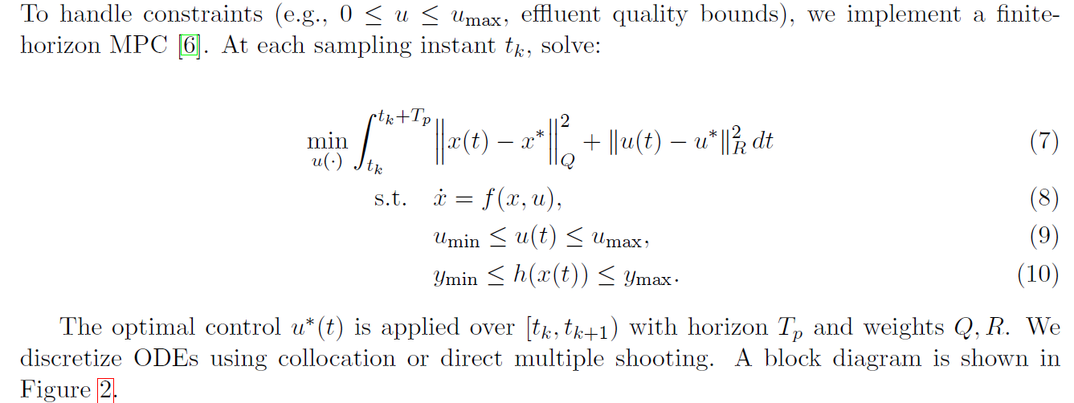

**Milestones and Timeline:**

* Month 11-12: Design and simulation of and adaptive and robust feedback controller. Submit the result in a suitable journal(s)/conference(s).
* Month 13-14: Develop and tune MPC scheme; implement on validated continuous-time models. Submit the result in a suitable journal(s) /conference(s).
* Month 15: Comparative performance analysis of designed control schemes under disturbances and modeling errors.
* Deliverable: A robust control module integrating adaptive control and MPC schemes.

1. Data-driven augmentation

Digital transformation of industry has gained emphasis in recent years in academia and industry. To complement model-based approaches, I will also explore modern data-driven system identification techniques that leverage machine learning, reinforcement learning (RL), and statistical tools to uncover dynamics without assuming a predefined model structure.

Although physics-based continuous-time models capture primary dynamics, residual uncertainties from unmodeled reactions, sensor nonlinearities, and environmental fluctuations remain. To enhance performance, we propose integrating a data-driven observer layer that learns the residual dynamics in parallel with the nominal model. This hybrid approach retains interpretability while adapting to complex behaviors [Raissi2019].

The complexity and nonlinearity inherent in wastewater treatment processes present significant challenges for traditional control strategies. Variability in influent characteristics, environmental conditions, and operational disturbances necessitate control systems that are not only robust but also adaptive. Integrating data-driven models into the control architecture offers a pathway to enhance system performance by providing real-time insights and predictive capabilities. This section proposes a framework that combines adaptive approximation and estimation techniques with data-driven modeling to optimize the control of WWTPs.

**Framework Overview**

The proposed framework consists of the following key components:

1. **Data Acquisition and Preprocessing**: Continuous collection of operational data, including influent and effluent parameters, sensor readings, and environmental variables.
2. **Adaptive Data-Driven Modeling**: Development of models that can learn and adapt to the dynamic behavior of the WWTP using techniques such as adaptive neural networks and fuzzy logic systems.
3. **Integration with Control Systems**: Embedding the adaptive models within existing control architectures, such as Model Predictive Control (MPC), to provide real-time predictions and adjustments.
4. **Fault Detection and Diagnosis**: Utilizing the adaptive models to identify and diagnose system anomalies, enabling proactive maintenance and minimizing downtime.

Certainly, integrating data-driven augmentation into the control framework of wastewater treatment plants (WWTPs) can significantly enhance their efficiency and resilience. Given your expertise in adaptive approximation and estimation, the following section outlines a methodology that leverages these skills to develop an advanced data-driven control system for WWTPs.

**Data-Driven Augmentation in Wastewater Treatment Control Systems**

**Introduction**

The complexity and nonlinearity inherent in wastewater treatment processes present significant challenges for traditional control strategies. Variability in influent characteristics, environmental conditions, and operational disturbances necessitate control systems that are not only robust but also adaptive. Integrating data-driven models into the control architecture offers a pathway to enhance system performance by providing real-time insights and predictive capabilities. This section proposes a framework that combines adaptive approximation and estimation techniques with data-driven modeling to optimize the control of WWTPs.([SAGE Journals](https://journals.sagepub.com/doi/full/10.1177/0020294020952490?utm_source=chatgpt.com), [PubMed](https://pubmed.ncbi.nlm.nih.gov/39800287/?utm_source=chatgpt.com))

**Framework Overview**

The proposed framework consists of the following key components:

1. **Data Acquisition and Preprocessing**: Continuous collection of operational data, including influent and effluent parameters, sensor readings, and environmental variables.
2. **Adaptive Data-Driven Modeling**: Development of models that can learn and adapt to the dynamic behavior of the WWTP using techniques such as adaptive neural networks and fuzzy logic systems.
3. **Integration with Control Systems**: Embedding the adaptive models within existing control architectures, such as Model Predictive Control (MPC), to provide real-time predictions and adjustments.
4. **Fault Detection and Diagnosis**: Utilizing the adaptive models to identify and diagnose system anomalies, enabling proactive maintenance and minimizing downtime.

**Adaptive Data-Driven Modeling Techniques**

Given the nonlinear and time-varying nature of WWTPs, adaptive modeling techniques are essential. Two prominent approaches include:([ResearchGate](https://www.researchgate.net/publication/257549931_Data-driven_modeling_approaches_to_support_wastewater_treatment_plant_operation?utm_source=chatgpt.com))

* **Adaptive Neural Networks**: These networks can adjust their parameters in real-time to capture the evolving dynamics of the treatment process. For instance, Elman networks trained with advanced algorithms like the Square Root Unscented Kalman Filter (SR-UKF) have demonstrated efficacy in monitoring effluent quality variables .([MDPI](https://www.mdpi.com/2073-4441/13/24/3659?utm_source=chatgpt.com))
* **Fuzzy Logic Systems**: By incorporating expert knowledge and handling uncertainty, fuzzy logic systems can model complex processes. Data-driven fuzzy models have been employed to enhance interpretability and accuracy in process monitoring .([PMC](https://pmc.ncbi.nlm.nih.gov/articles/PMC9051414/?utm_source=chatgpt.com), [MDPI](https://www.mdpi.com/2073-4441/13/24/3659?utm_source=chatgpt.com))

**Integration with Model Predictive Control (MPC)**

Incorporating adaptive models into MPC frameworks allows for:([ScienceDirect](https://www.sciencedirect.com/science/article/abs/pii/S0301479717301032?utm_source=chatgpt.com))

* **Enhanced Prediction Accuracy**: Adaptive models provide more accurate predictions of system behavior, improving the performance of MPC strategies.
* **Real-Time Adaptation**: The control system can adjust to changing process conditions, maintaining optimal performance despite disturbances.([Wikipedia](https://en.wikipedia.org/wiki/Data-driven_control_system?utm_source=chatgpt.com))
* **Fault Tolerance**: By identifying deviations from expected behavior, the system can implement corrective actions promptly.

Studies have shown that integrating statistical monitoring with dynamic simulation can enable effective model predictive control in WWTPs .([ScienceDirect](https://www.sciencedirect.com/science/article/abs/pii/S0301479717301032?utm_source=chatgpt.com))

**Fault Detection and Diagnosis**

Adaptive data-driven models play a crucial role in fault detection by:

* **Identifying Anomalies**: Detecting deviations from normal operating conditions that may indicate sensor malfunctions or process disturbances.([PubMed](https://pubmed.ncbi.nlm.nih.gov/39800287/?utm_source=chatgpt.com))
* **Diagnosing Faults**: Analyzing patterns in the data to determine the root cause of anomalies.
* **Facilitating Proactive Maintenance**: Enabling operators to address issues before they escalate, reducing downtime and maintenance costs.([ScienceDirect](https://www.sciencedirect.com/science/article/abs/pii/S0301479717301032?utm_source=chatgpt.com))

A comprehensive review of data-driven fault detection methods in wastewater treatment systems highlights the effectiveness of these approaches .([PubMed](https://pubmed.ncbi.nlm.nih.gov/39800287/?utm_source=chatgpt.com))

**Conclusion**

Integrating adaptive approximation and estimation techniques into data-driven models offers a robust approach to enhancing the control and monitoring of WWTPs. By leveraging your expertise in these areas, the proposed framework can lead to significant improvements in process efficiency, reliability, and fault tolerance. This approach aligns with the ongoing digitalization efforts in wastewater management, paving the way for smarter and more resilient treatment systems.

In this project, I will explore grey-box system identification through two complementary perspectives: continuous-time system identification (white-box modeling) and data-driven system identification (black-box modeling), both of which are essential for modeling and controlling complex wastewater treatment processes with high fidelity and adaptability. Note that considering grey-box modeling, the structure of the model is partially known from physical laws or prior knowledge, but some parameters or dynamics are unknown and are estimated from data.

By integrating these two approaches, the project aims to build hybrid models that balance physical interpretability, enabling robust monitoring, fault diagnosis, and control strategies for sustainable and intelligent wastewater management.

**Milestones and Timeline**

* Month 16-17: Design and simulation of a data-driven scheme…..

Deliverable:

* Modular grey-box system identification model library (MATLAB)

1. Fault Diagnosis and Accommodation

Fault, as the deviation of a component from its normal behavior, is an inevitable phenomenon in dynamical systems, leading to serious performance degradation or even catastrophic events such as system failure. However, utilizing efficient fault detection, isolation, identification, and accommodation schemes can mitigate fault effects and achieves the desired monitoring and control objectives. Hence, the main objective of this stage is to conduct an in-depth investigation into the analysis and design of efficient fault diagnosis and accommodation in WWTP system. In our design work, we aim to investigate both sensor and actuator fault(s). The overall framework of fault diagnosis and accommodation is given in Fig. ?.

Fault isolation

Fault detection

Fault estimation

Fault accommodation

System dynamics

Fig

Fault diagnosis

**Fault Modeling**

Actuator and sensor faults in WWTPs (e.g., valve sticking, blower degradation, sensor bias) can be modeled as additive faults in the input and output channels:

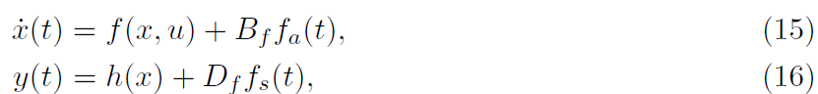

Where fa(t) and fs(t) denote respective ly actuator and sensor faults, and Bf ,Df are distribution matrices [Isermann2006].

**Residual generation:**

In model-based fault diagnosis schemes, the existence of fault in dynamical system is decided based on the violation of a residual signal from a designed detection threshold, where residual signal denotes the unwanted deviation of a sensor signal from its normal behavior caused by fault. In control theory, the unknown normal sensor output is estimated by a designed observer. Considering a sensor output y(t) and its estimation \hat y(t), we have

$$\left\{\begin{aligned}\tilde{x}=x-\hat{x} \\ \tilde{y}=y-\hat{y},\end{aligned}\right.$$

where $\tilde{x}$ and $\tilde{y}$ denote respectively the state and output residual signals. Then, a fault is detected if the sensor residual is violated from its corresponding threshold, which is

$$\left|\tilde{y}\right|>\overline{y},$$

where $\overline{y}$ denotes the fault detection threshold, which is designed based on the mathematical analysis of system dynamics under healthy operation assumption.

The next step is to isolate the detected fault. Fault isolation is the process of finding faulty component and is activated as a fault is detected. Upon detection and isolation, a reconfiguration law modifies control input to maintain system performance in faulty conditions.

**Milestones and Timeline**

* Month : Design a fault detection, isolation scheme, implement on for WWTP syste, provide analysis and simulations and finally, submit the result in a suitable journal(s) /conference(s).
* Month : Design accommodation reconfiguration law and validate closed-loop performance.

References

[Raissi2019] M. Raissi, P. Perdikaris, G. Karniadakis, “Physics-Informed Neural Networks: A Deep Learning Framework for Solving Forward and Inverse Problems Involving Nonlinear Partial Differential Equations,” Journal of Computational Physics, vol. 378, pp. 686–707, 2019.

[Isermann2006] R. Isermann, “Fault-Diagnosis Systems: An Introduction from Fault Detection to Fault Tolerance,” 2nd ed., Springer, 2006.

[world2016] World Bank, “Urbanization and Water Stress: A Global Assessment,” World Bank Publications, 2016.

[Carlos2024] Rodríguez-Alonso, Carlos, Iván Pena-Regueiro, and Óscar García. "Digital twin platform for water treatment plants using microservices architecture." Sensors 24, no. 5 (2024): 1568.

[Vanrolleghem1994] P.A. Vanrolleghem, On-line modelling of activated sludge processes: development of an adaptive sensor Ph.D. dissertation, Laboratory of Microbial Ecology, University of Gent, Gent, Belgium, 1994.

[Lopez2015] Santín López, I., 2015. *Application of control strategies in wastewater treatment plants for effluent quality improvement, costs reduction and effluent limits violations removal* (Doctoral dissertation, Universitat Autònoma de Barcelona).

[Shen2009] Shen, W., Chen, X., Pons, M.N. and Corriou, J.P., 2009. Model predictive control for wastewater treatment process with feedforward compensation. *Chemical Engineering Journal*, *155*(1-2), pp.161-174.

[Farrell2006] Farrell, J.A. and Polycarpou, M.M., 2006. *Adaptive approximation based control: unifying neural, fuzzy and traditional adaptive approximation approaches*. John Wiley & Sons.

[Alex2008] J. Alex, L. Benedetti, J. Copp, K.V. Gernaey, U. Jeppsson, I. Nopens, M.N. Pons, L. Rieger, C. Rosen, J.P. Steyer, P. Vanrolleghem, S. Winkler, Benchmark Simulation Model. 1 (BSM1). Report by the IWA Taskgroup on Benchmarking of Control Strategies for WWTPs, 2008

[Tejaswini2021] Tejaswini ESS, Panjwani S, Gara UBB, Rao SA (2021) Multi-objective optimization based controller design for improved wastewater treatment plant operation. Environ Technol Innov 23:101591. https:// doi. org/ 10. 1016/j. eti. 2021. 101591