# **Digital Twin–Driven System Identification, Resilient Control & Fault-Tolerant Strategies for Sustainable Wastewater Treatment Plants**

Hamed Tirandaz

Email: [hamedtirandaz@gmail.com](mailto:hamedtirandaz@gmail.com),

Phone: +989013151719,

Website: <https://hamedtirandaz.github.io/>

**Abstract**

Wastewater generated by domestic (household practices e.g., hygiene, cleaning, sanitation) and industrial activities (e.g., manufacturing, maintenance) poses a major challenge to environmental sustainability. wastewater treatment plants (WWTPs), often more advanced than perceived, employ sophisticated systems to purify wastewater into a reusable resource, demonstrating their vital role in sustainable water management and environmental protection. Modern WWTPs employ complex biological, chemical, and physical processes to remove pollutants, yet their nonlinear dynamics, uncertain influent, and potential component faults make control difficult. This topic recently encourages much attention in different fields to explore suitable methods to be able to remove chemical or biological elements from wastewater. From a control perspective, extensive research has focused on developing automated WWTP systems to enhance reliability, optimize effluent quality, and reduce operational costs.

This proposal presents a continuous-time, model-based framework, enriched by data-driven enhancements, to achieve resilient, efficient operation of WWTPs. In particular, a digital twin of the plant will be developed via grey-box identification (ASM1/BSM1) augmented by neural ODE estimators; a robust and adaptive controller will be designed to regulate dissolved oxygen (DO) in the last aerobic tank; modeling uncertainty will be estimated utilizing a novel neural network-based estimation scheme; and fault-tolerant schemes will be integrated to detect and accommodate multiple sensor/actuator degradations.

The outcome is a MATLAB toolbox and comprehensive digital-twin prototype—complete with flowcharts, block diagrams, continuous-time formulations, and simulation results—to guide future WWTP digitization.

Despite extensive research, WWTP control remains an open problem due to modeling uncertainties, external disturbances, and equipment faults that degrade performance over time. This project addresses these issues via a novel, hybrid control framework. This MSCA ECO-SPHERE Project proposal addresses the challenge of digitalizing WWTP through an integrated, model-based control framework enriched by data-driven enhancements. Leveraging my expertise in instrumentation, automation and control, especially in adaptive control design, system identification, and fault diagnosis and accommodation, I will develop a multi-step methodology that covers the following steps:

**1. Background and Motivation**

Urbanization and population growth are projected to increase global water demand by up to 55%, and the same wastewater loads as a result by 2050, and placing significant stress on existing WWTP infrastructures. Untreated or poorly treated effluent threatens ecosystems and public health. Conventional WWTPs rely on fixed SCADA logic and PI controllers, which struggle under influent fluctuations, modeling uncertainty, measurement noise, and evolving equipment conditions.

A WWTP must reliably remove nitrogen, phosphorus, pathogens, and another organic loads. WWTPs are complex nonlinear systems, and controlling the effluent quality is tremendously hard due to the complexity of physical, biochemical, biological processes, and fluctuations of input wastewater flow.

Key challenges include:

1. Nonlinear, time-varying dynamics (enzymatic reactions, biomass growth, nitrification/ denitrification).

2. Uncertain influent composition and flow rate (weather, industrial surges).

3. Aging sensors and actuators (blowers, valves) leading to faults or drift.

4. High energy consumption (especially for aeration) and stringent effluent limits (e.g., , , ).

Model-based control (adaptive control, MPC) can improve reliability, effluent quality, and reduce costs—but requires accurate plant models and robustness to uncertainties/faults. This research focuses on developing a continuous-time grey-box identification pipeline and designing a continuous-time MPC that directly uses physical ODEs of Tank 5 (aerobic nitrifier) to regulate DO, while embedding fault detection & accommodation for critical sensors and aeration actuators.

**2. BSM1 Model Structure**

The Benchmark Simulation Model No.1 (BSM1) has been considered widely in different research in different fields [Alex2008]. BSM1 is utilized as a standard model for modeling, performance assessment, and evaluation of control strategies. it is based on the most popular Activated Sludge Model No.1 (ASM1) expanded by the International Association on Water Pollution Research and Control [Vanrolleghem1994]. The schematic of BSM1 is presented in Fig. 1. As illustrated, it comprises:

* **Five serial (interconnected) basins (Tanks):** Tanks 1–2 are anoxic (used for pre-denitrification, each ), Tanks 3–5 are aerobic (used for nitrification, each ).
* **Secondary clarifier (settler):** , with ten feed layers and two recycle streams (one from Tank 5, one from clarifier underflow).
* **Influent:** Flows into Tank 1 with specified COD, , etc.
* **Outputs:** Effluent concentrations of BOD, total nitrogen, TSS, etc.

To sustain the microbial community essential for nutrient removal, settled sludge recycled continuously (controlled by ). from the secondary settler back into the reactor (Tank 1). Denitrification occurs in Tanks 1–2 (anoxic), nitrification in Tanks 3–5 (aerobic). **Dissolved Oxygen (DO) concentration in Tank 5** () is a key control variable, which significantly influences many microbiological processes occurring in the system; high DO promotes nitrifiers, but excess aeration wastes energy. To maintain the desired aeration in the biological tank, a DO controller is implemented. Besides, DO level in the last tank is controlled that manipulates the aeration coefficient for this basin . Besides, an outer control loop is used to verify the nitrate removal by manipulating the internal recycle flow-rate.

A digital twin must capture the ASM1 ODEs for each biological species and multiple substrates; for brevity, we focus below on the DO balance in Tank 5 as the primary continuous-time control target.

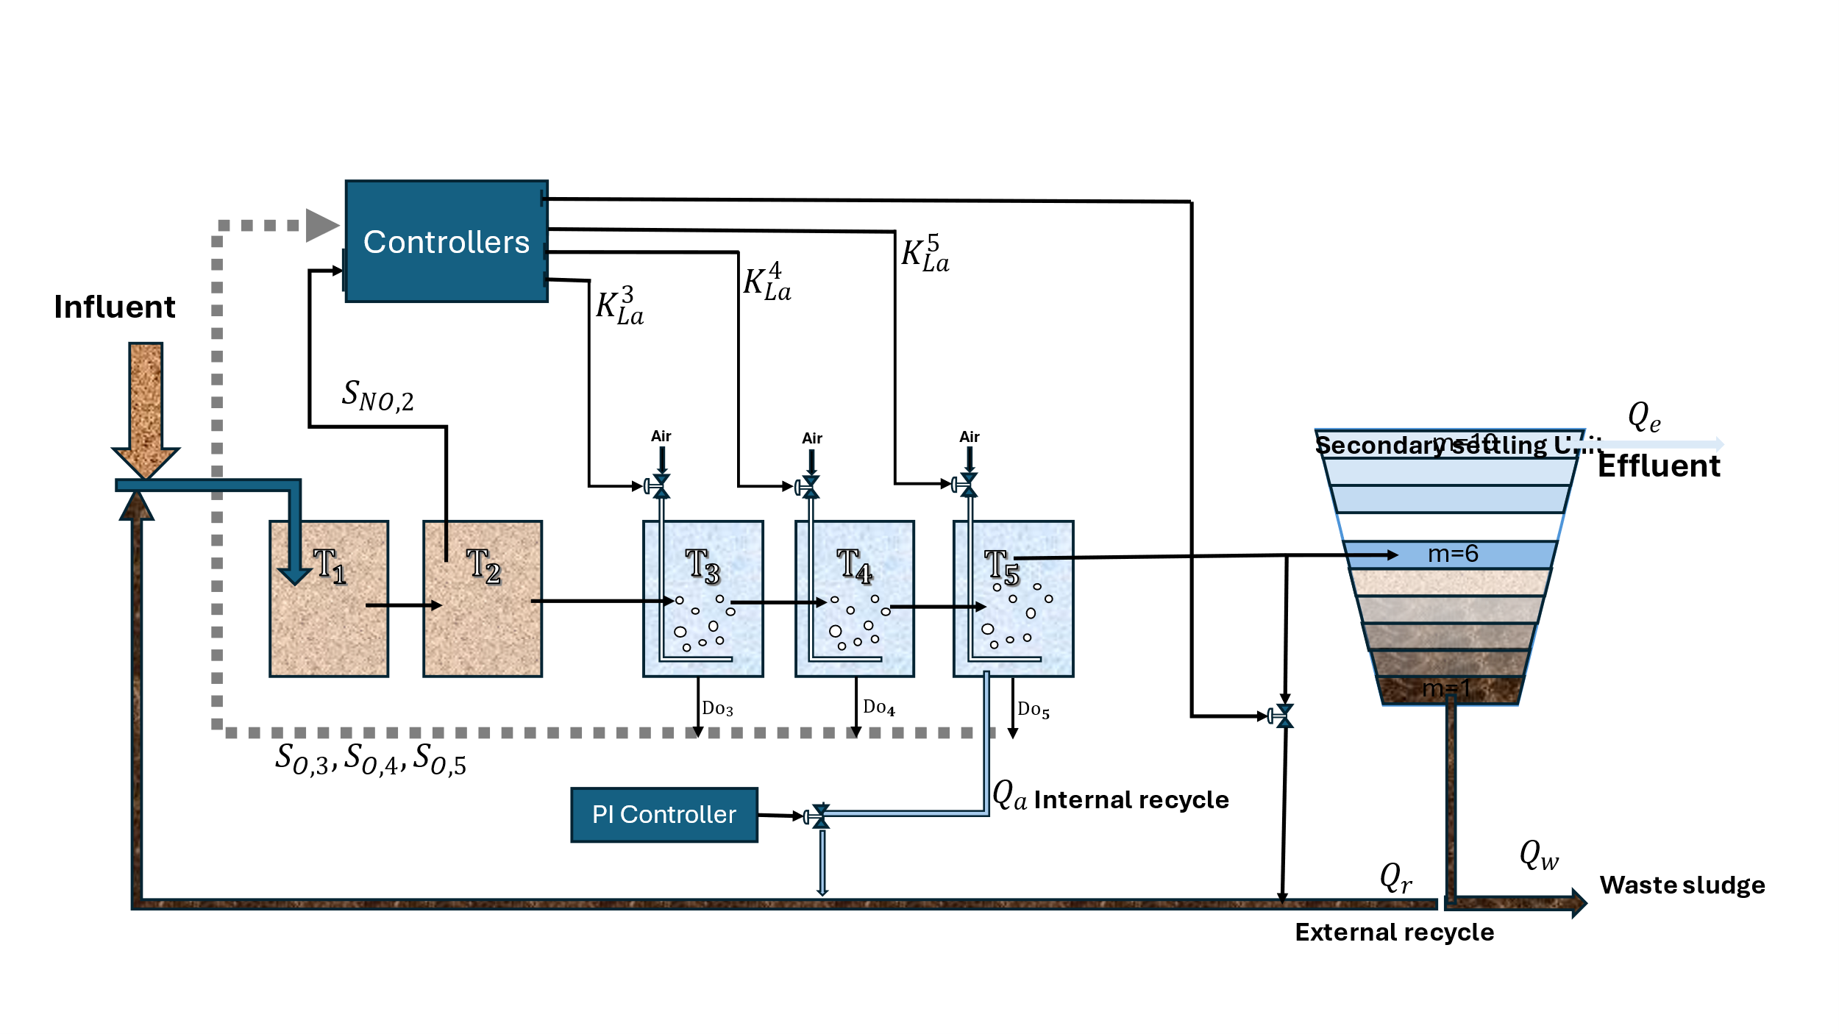

Fig 1. Schematic of Benchmark Simulation Model 1 (BSM1): two anoxic basins (1000 m each), three aerobic basins (1333 m each), secondary clarifier (6000 m), recycles . The DO in Tank 5 is maintained by controlling the aeration transfer coefficient .

To maintain the desired aeration in the biological tank, a DO controller is implemented. Besides, DO level in the last tank is controlled that manipulates the aeration coefficient for this basin K5La. Besides, an outer control loop is used to verify the nitrate removal by manipulating the internal recycle flow-rate.

**3 Mathematical Formulation of Tank 5 DO Dynamics**

**3.1 Continuous-Time DO Mass Balance**

Let:

* DO concentration in Tank 5 (mg O/L)
* DO in Tank 4 (mg O/L)
* Flow from Tank 4 to Tank 5 (m/day)
* Flow out of Tank 5 (to clarifier) (m/day)

* Aeration coefficient in Tank 5 (1/day)
* (saturation DO at given temperature)
* Oxygen uptake rate by biomass (mg O/Lday)

The mass balance ODE is:

**3.2 Linearization Around Operating Point**

Choose nominal values and define small deviations:

Assuming and are constant, the linearized dynamics are:

with:

Letting :

or in matrix form:

**4 Continuous-Time MPC Design**

**4.1 Control Objectives and Constraints**

**Objective:** Track while minimizing energy usage (via ), subject to:

* State constraints: .
* Input constraints: .

Typical values:

**4.2 Continuous-Time Optimal Control Formulation**

At each , solve:

where , and weights .

**4.3 Discretization (for Implementation)**

Using forward Euler with :

Define:

With horizon , cost becomes:

subject to:

Solve this quadratic program at each step to apply and update the horizon.

**4.4 MATLAB-Based MPC Simulation**

The implementation of the Model Predictive Controller (MPC) is carried out in MATLAB using the MPC Toolbox, applied to a simplified single-state model of the dissolved oxygen dynamics in reactor 5. The continuous-time model is discretized with a daily sampling time ( day), and the nominal operating parameters are used to derive the linearized model dynamics in deviation variables.

### Simulation Setup

The discrete-time system is defined using nominal operating conditions and linearized around a steady-state dissolved oxygen level of 2 mg/L and a nominal aeration rate of 0.15 day. The state-space model is constructed in terms of deviations from these nominal values.

The prediction and control horizons are chosen as and days, respectively. A quadratic cost function is used to penalize deviations in the dissolved oxygen level (state/output) and changes in the aeration rate (input), with relatively higher weight placed on state tracking.

Operational constraints are enforced on both the input and output in terms of their allowable deviations. The aeration rate deviation is limited between and  day, while the allowable dissolved oxygen deviation ranges from to  mg/L, corresponding to an absolute concentration range of 1.0–5.0 mg/L.

The simulation is conducted for 50 days. A reference step is introduced at day 25, where the desired dissolved oxygen concentration increases from 2 mg/L to 3 mg/L (i.e., a deviation of  mg/L). The MPC controller must adjust the aeration rate to drive the system toward the new setpoint while respecting all constraints.

### Simulation Results

Two primary time-series plots are produced:

* **Manipulated Variable (MV1)**: This plot shows the control action , representing the change in the aeration rate from its nominal value. During the initial 25 days, the controller maintains a zero deviation, holding the aeration at its nominal rate. Following the setpoint change, the controller increases the aeration rate within the allowed limits to track the higher oxygen demand.
* **Measured Output (MO1)**: This plot presents the dissolved oxygen deviation . Initially, the system remains at steady state (zero deviation), and upon the setpoint step at day 25, the controller smoothly adjusts the output to track the  mg/L deviation, converging to the desired oxygen concentration of 3 mg/L.

These results are depicted in Fig.2. The results illustrate the MPC’s ability to handle setpoint changes while ensuring constraint satisfaction. The aeration input is adjusted in a way that avoids excessive overshoot or constraint violation, demonstrating effective disturbance rejection and setpoint tracking.

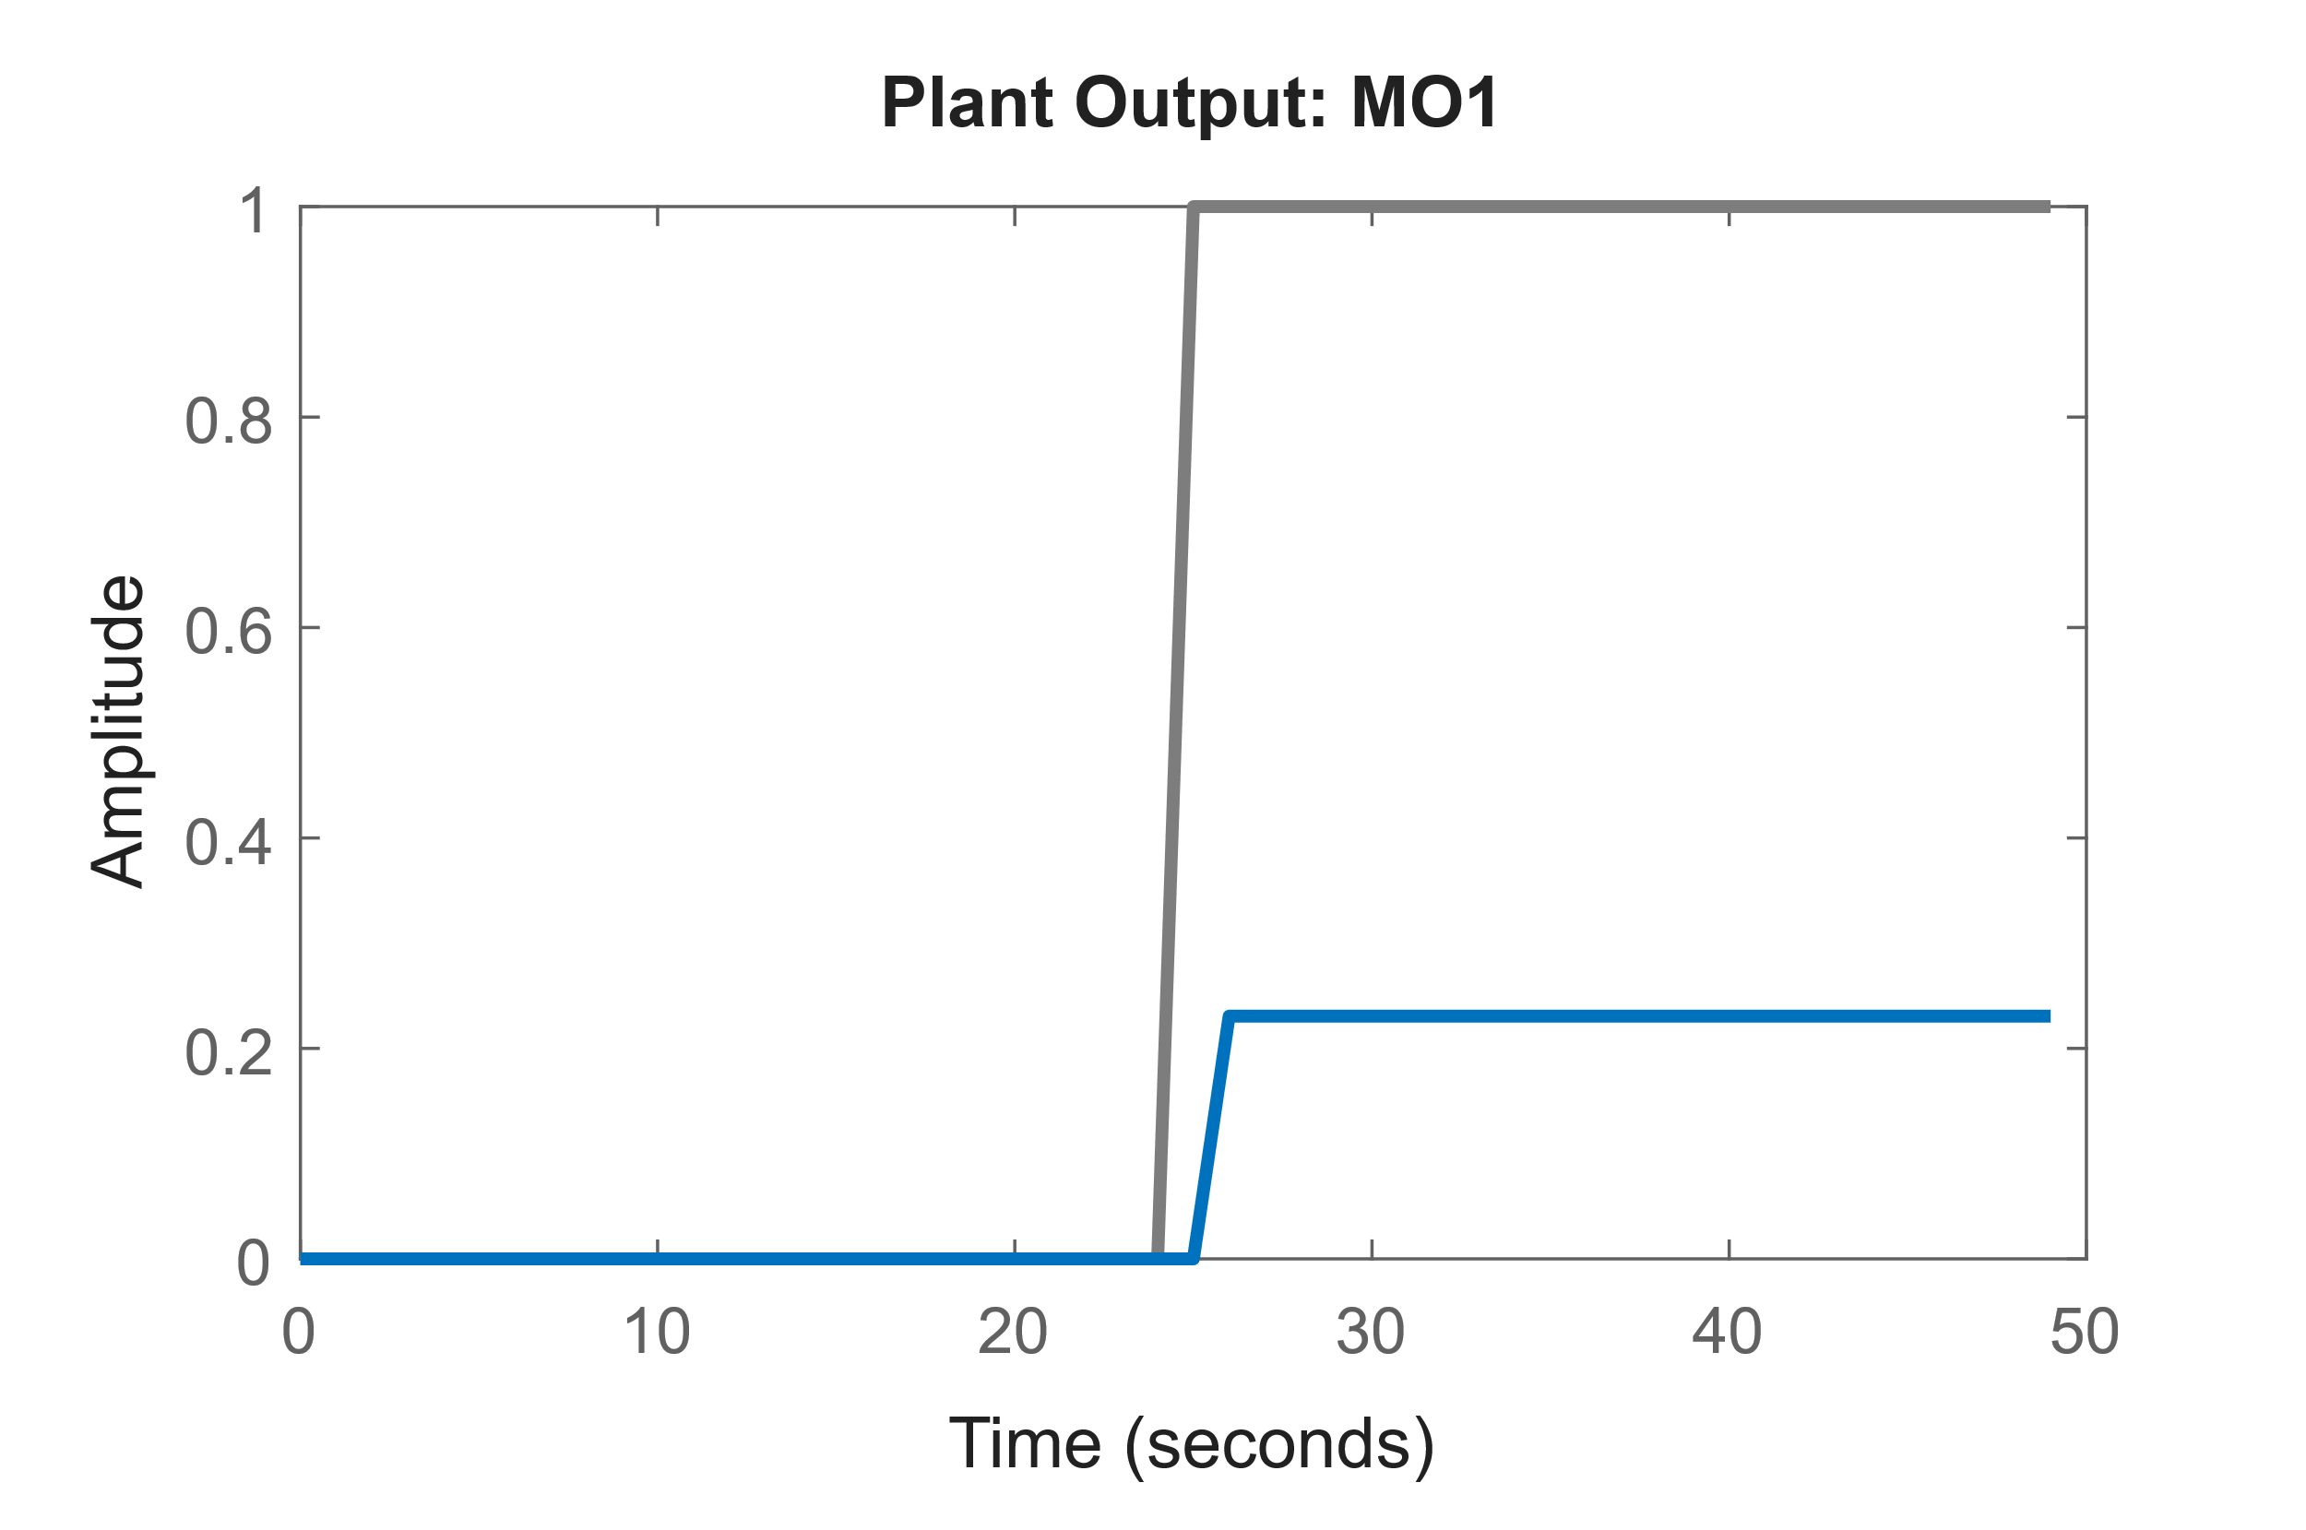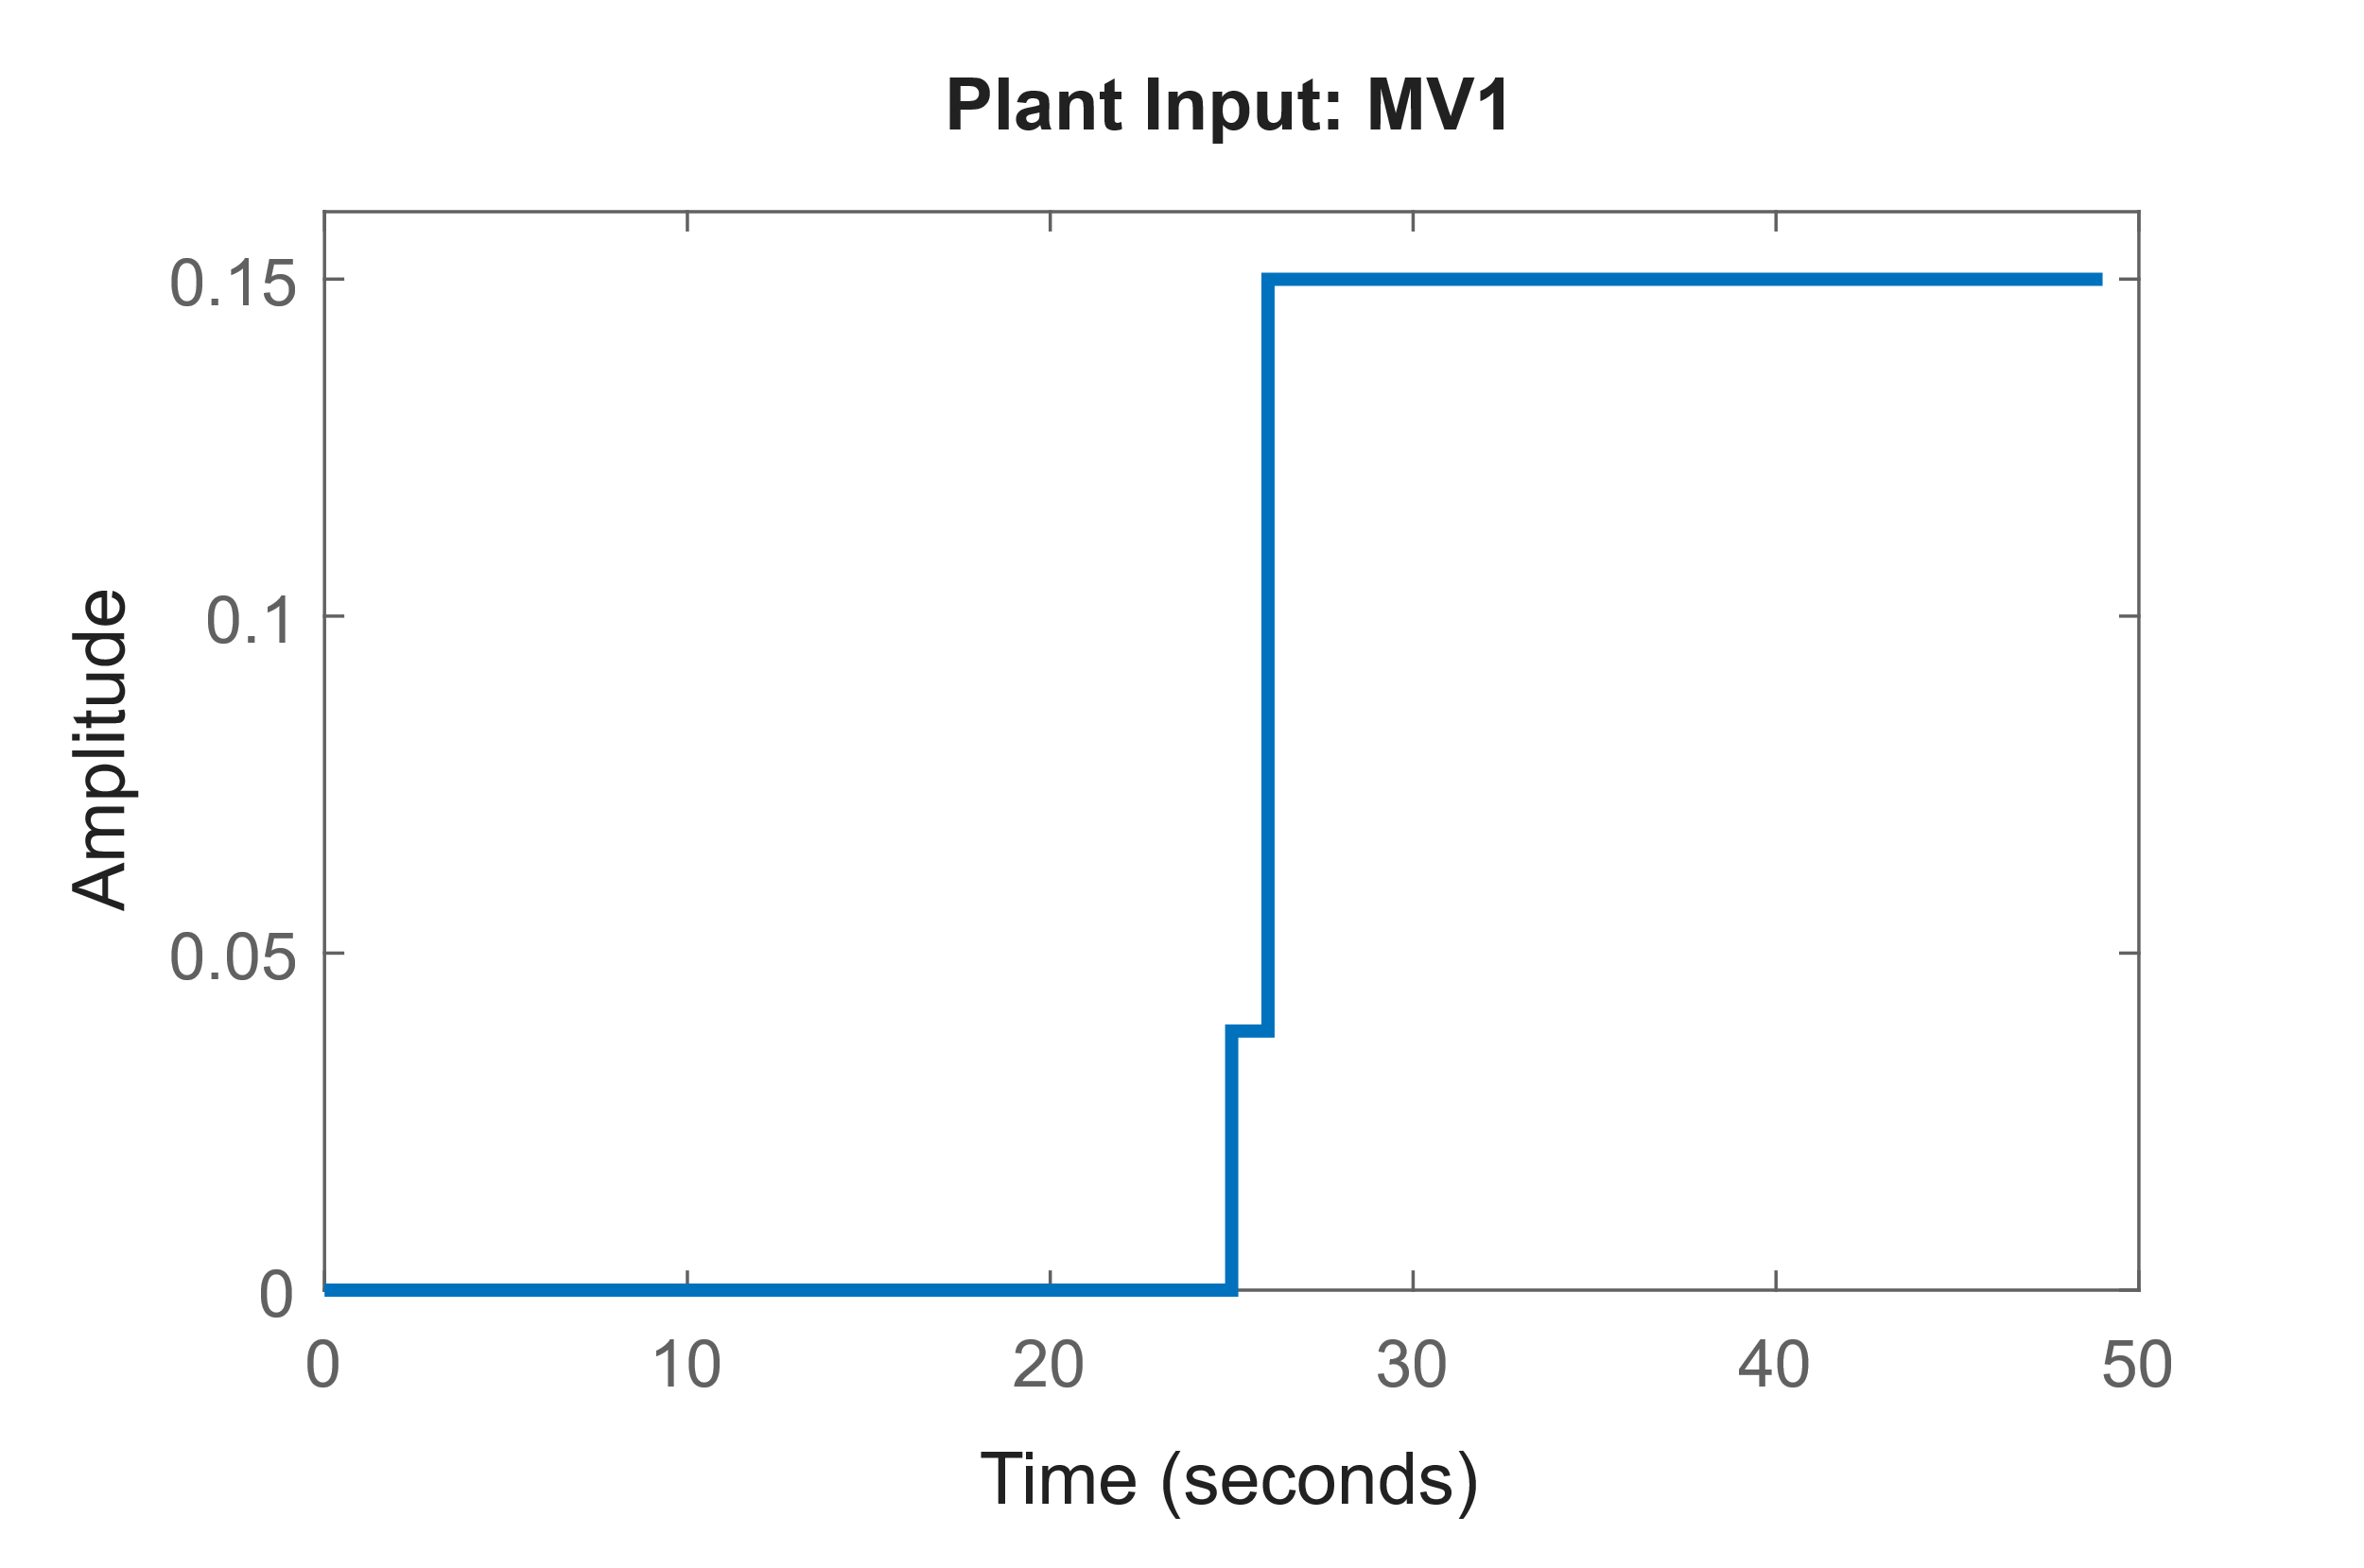

(a)

(b)

Fig . Simulation results under continuous-time MPC for DO control in Tank 5. (a) The manipulated variable remains zero during the initial steady-state period (days 0–25), then increases within bounds to meet the higher DO demand after the setpoint change. (b) The measured output shows a smooth response to the +1 mg/L setpoint step at day 25, converging to the new target of 3 mg/L. These plots demonstrate the MPC’s capability for effective setpoint tracking, constraint satisfaction, and disturbance rejection.

**5 Grey-Box System Identification**

The goal of this stage is to derive accurate, physically interpretable continuous-time models key WWTP subsystems, including activated sludge reactors and nutrient removal units. A grey-box model of BSM1 based on the ASM1 equations is derived in the following:

**I. ASM1 ODEs (White-Box Core)**

We formulate a set of continuous-time ordinary differential equations (ODEs) for the main biochemical species, including heterotrophic biomass , autotrophic biomass , inert components, substrate , ammonium , nitrate , and dissolved oxygen , among others.

**II. System Identification and Parameter Estimation (Continuous-Time)**

* Input–output data is collected either from the real plant or a high-fidelity BSM1 simulation.
* Kinetic parameters such as are estimated using nonlinear least squares techniques. This involves solving an optimization problem:

where represents the parameter vector. MATLAB’s lsqnonlin combined with an ODE solver like ODE45 is used for this task. Multiple shooting methods can also be applied to improve robustness.

**III. Neural ODE Augmentation**

Continuous-time modeling is critical in capturing the inherent dynamics of a dynamical system, which often exhibit nonlinear and time-varying behavior. In this approach, the system dynamics is inferred directly from the input-output data. Online learning such as adaptive approximation-based or neural-network based schemes are widely utilized in the literature to identify unknown terms of system dynamics [Farrell2006]. To capture unmodeled dynamics (e.g., temperature effects, sensor nonlinearities), we augment the grey-box model with a learned neural term:

where is a neural network trained to minimize model mismatch using frameworks such as Neural ODE (e.g., neuralNet blocks in MATLAB or PyTorch-based toolkits).

**IV. Validation**

* The identified model is validated against unseen data by comparing predicted outputs (e.g., effluent , , and DO profiles) with actual measurements.
* Root Mean Square (RMS) error and statistics are computed. Model refinement is repeated until the residual dynamics are sufficiently small for use in MPC.

**6 Data-Driven Augmentation**

To complement model-based approaches, I will also explore modern data-driven system identification techniques that leverage machine learning, reinforcement learning (RL), and statistical tools to uncover dynamics without assuming a predefined model structure.

**7 Objectives and Expected Contributions**

This proposal aims at achieving the following objectives:

1. **Continuous-Time Grey-Box Modelling**
   1. Derive continuous ODEs from ASM1/BSM1, estimate parameters via advanced identification (multiple shooting, neural ODE)
   2. Provide a validated MATLAB toolbox for continuous-time WWTP identification (BSM1 test case)
2. **Resilient Control:**
   * Synthesize nonlinear and model predictive controllers that guarantee effluent quality and constraint satisfaction under uncertainties, disturbances and sensor noise.
   * Demonstrate setpoint tracking, disturbance rejection, and constraint satisfaction under influent swings
3. **Fault-Tolerant Layer**
   * Develop real-time residual-based fault detection/isolation for DO sensors and aeration blower faults
   * Integrate reconfiguration logic within the designed controller (update constraints and substitute sensor readings from the observer)
   * Investigate FTC under various actuator (e.g., valves, aeration blowers) and sensor faults, ensuring continued operation with minimal performance degradation.
4. **Data-Driven Augmentation**
   * Design adaptive neural network observers to learn residual dynamics
   * Incorporate a reinforcement-learning module to adapt the designed controller weighting for long-term operational cost minimization
5. **Digital Twin Prototype**
   * Provide end-to-end flowcharts, block diagrams, continuous-time equations, and simulation results (MATLAB figures)
   * Compare performance of: nominal MPC, fault-tolerant controller, and RL-augmented MPC on BSM1 simulation data

**Expected Contributions:**

* **MATLAB Toolbox:** A validated MATLAB toolbox for identification in WWTP systems, validated on BSM1.
* **Novel Control Architecture:** integrating RL-augmented adaptive MPC with digital-twin feedback.
* **Fault-Tolerant Layer:** A fault-tolerant control layer suitable for digital twin implementation.
* Detailed flowcharts and block diagrams illustrating the integrated framework.

**8 Milestones and Timeline**

| **Months** | **Tasks / Deliverables** |
| --- | --- |
| 1–3 | Literature review on ASM1/BSM1 modelling, continuous-time identification methods, MPC in WWTPs. Acquire BSM1 data & code. |
| 4–6 | Develop continuous-time grey-box model of BSM1: parameter estimation, validation on historical/simulated data. Submit the result in a suitable journal(s) /conference(s). |
| 7–8 | Design continuous-time controller for Tank 5 DO: ODE linearization, discretization, cost & constraints. Implement in MATLAB; simulate DO tracking under nominal and disturbance scenarios. Submit the result in a suitable journal(s) /conference(s). |
| 9–10 | Implement residual-based observer for fault detection/isolation of DO sensor & blower. Integrate reconfiguration logic into MPC. Publish at a control conference. Submit the result in a suitable journal(s) /conference(s). |
| 11–12 | Develop adaptive NN observer for residual dynamics; integrate into digital twin. Implement RL-based MPC weight tuning. Submit the result in a suitable journal(s) /conference(s). |
| 13–14 | Conduct comparative simulation studies: (a) nominal MPC, (b) fault-tolerant MPC, (c) RL-augmented MPC. Evaluate energy use, effluent quality, robustness to modeling errors & faults. |
| 15–16 | Refine algorithms, finalize MATLAB toolbox (identification + MPC + FTC), prepare journal paper detailing continuous-time framework and case studies on BSM1. |
| 17–18 | Finalize documentation, flowcharts, and block diagrams for digital twin; submit project report; prepare open-source release on GitHub with tutorial. |

**10 References**

1. **Alex et al. (2008)**  
   J. Alex, L. Benedetti, J. Copp, K. V. Gernaey, U. Jeppsson, I. Nopens, M. N. Pons, L. Rieger, C. Rosen, J. P. Steyer, P. Vanrolleghem, S. Winkler,  
   *Benchmark Simulation Model 1 (BSM1).* IWA Task Group on Benchmarking of Control Strategies for WWTPs, 2008.
2. **Vanrolleghem (1994)**  
   P. A. Vanrolleghem, “On-line modelling of activated sludge processes: development of an adaptive sensor,” Ph.D. dissertation, Univ. of Gent, Belgium, 1994.
3. **Lopez (2015)**  
   I. Santín López, *Application of control strategies in wastewater treatment plants for effluent quality improvement, costs reduction and effluent limits violations removal*, Ph.D. thesis, Universitat Autònoma de Barcelona, 2015.
4. **Shen, Chen, Pons, Corriou (2009)**  
   W. Shen, X. Chen, M. N. Pons, J. P. Corriou,  
   “Model predictive control for wastewater treatment process with feedforward compensation,” *Chemical Engineering Journal*, vol. 155, no. 1–2, pp. 161–174, 2009.
5. **Raissi, Perdikaris, Karniadakis (2019)**  
   M. Raissi, P. Perdikaris, G. Karniadakis,  
   “Physics-Informed Neural Networks: A Deep Learning Framework for Solving Forward and Inverse Problems Involving Nonlinear Partial Differential Equations,” *Journal of Computational Physics*, vol. 378, pp. 686–707, 2019.
6. **Isermann (2006)**  
   R. Isermann, *Fault-Diagnosis Systems: An Introduction from Fault Detection to Fault Tolerance*, 2nd ed., Springer, 2006.
7. **Farrell & Polycarpou (2006)**  
   J. A. Farrell, M. M. Polycarpou, *Adaptive approximation based control: unifying neural, fuzzy and traditional adaptive approximation approaches*, Wiley, 2006.
8. **Tejaswini et al. (2021)**  
   ESS Tejaswini, S. Panjwani, U. B. B. Gara, S. A. Rao,  
   “Multi-objective optimization based controller design for improved wastewater treatment plant operation,” *Environmental Technology & Innovation*, vol. 23, 101591, 2021.
9. **Rodríguez-Alonso, Pena-Regueiro, García (2024)**  
   C. Rodríguez-Alonso, I. Pena-Regueiro, Ó. García,  
   “Digital twin platform for water treatment plants using microservices architecture,” *Sensors*, vol. 24, no. 5, 1568, 2024.
10. **IWA BSM1 Tech Report**  
    IWA Task Group on Benchmarking of Control Strategies for WWTPs, “BSM1 General Description,” 2008. Available: <https://iwa-mia.org/wp-content/uploads/2019/04/BSM_TG_Tech_Report_no_1_BSM1_General_Description.pdf>