Final Year Project Report
Interim Submission – Final Report

Genetic Algorithm
Hameed Roleola

A report submitted in part fulfilment of the degree of
MSci (Hons) in Computer Science
Supervisor: Dr Eduard Eiben

Department of Computer Science
Royal Holloway, University of London

Declaration
This report has been prepared on the basis of my own work. Where other published and unpublished source materials have been used, these have been acknowledged.

Word Count:

Student Name: Hameed Roleola

Date of Submission:

Signature: Hameed Roleola
Table of Contents
Contents
Abstract 4
Project Specification 5
Chapter 1: Introduction 6
1.1 How to use this template 6
1.2 Genetic Algorithms 6
1.2.1 Constraint Satisfaction Problems: 7
1.3 Encoding 7
1.4 Theory of coalescence and Genetic Drift 7
Chapter 2: Genetics Overview 8
2.1 Theory of coalescence and Genetic Drift 8
Chapter 3: Design patterns 9
3.1 MVC Design Pattern 9
Chapter 4: Technical Aspect 10
4.1 Technical Decisions 10
4.2 Planning 10
4.3 Software development 10
4.4 Software Engineering 10
4.5 Proof of concept 10
4.6 Next term aims 10
Chapter 5: Project Plan 11
Chapter 6: Summary of project diary 12
Bibliography 13

Abstract
This document serves as a layout and formatting template for your project report. It does not tell you how to write it, or what it should contain. It explains how it should be formatted and typeset. Please refer to your project booklet for information about report sizes, contents and rules.
NOTE: in your report, you should replace this with an appropriate Abstract for your project report.

Project Specification
Your project specification goes here.

Introduction

How to use this template
The simplest way to get started with your report is to save a copy of this document. First change the cover page to match your details (remember to specify if it is the Interim or Final Report). If you are doing the project as a half unit, change the relevant line in the cover page. Delete the unneeded sections and start adding your own sections using the styles provided. Before submission, remember to fill in the Declaration section fields.

Genetic Algorithms
Charles Darwin's idea of natural evolution served as the foundation for the search heuristic known as the genetic algorithm.
The genetic algorithm is a method that utilises natural selection, the mechanism that propels biological evolution, for resolving both constrained and unconstrained optimization problems. A population of unique solutions is repeatedly modified by the genetic algorithm. The genetic algorithm chooses members of the present population to serve as parents at each stage and utilises them to produce the offspring that will make up the following generation. The population "evolves" toward the best option over the course of subsequent generations. The genetic algorithm can be used to tackle several optimization problems, including those where the objective function is discontinuous, nondifferentiable, stochastic, or highly nonlinear and are not well suited for typical optimization algorithms. When some components must only have integer values, mixed integer programming problems can be solved using the evolutionary algorithm.
A genetic algorithm uses three main rules when creating the next generation from the current population, which are selection, crossover, and mutation.
- Selection rules choose the parents, who will contribute to the population of the following generation.
- Crossover rules combine two parents to create the next generation's offspring.
- Mutation rules subject each parent to random modifications.
Genetic algorithms are good at taking large search spaces and navigating through them looking for the most optimal combinations. Ordinarily these problems are very difficult to solve and can be very exhaustive.

Constraint Satisfaction Problems:
Problem definition
A CSP consists of:
- A set if variables X = {X1,…,Xn};
- For each variable xi, a finite set Di of possible values (domain)
- Set of constraints restricting values that the variables can take

The following form can be used to define a constraint satisfaction problem (CSP) in a (finite domain). Find values for the variables that satisfy each constraint given a collection of variables, a finite set of possible values for each variable, and a list of constraints. An example of this occurs in production scheduling. To ensure that each work is finished by the specified deadline, jobs must be processed on machines that can only handle one job at a time. Additional examples follow from the notion that an optimization problem can be stated as a series of CSPs. The solution to a CSP includes consistent and complete assignment. Where a consistent assignment dictates that an assignment does not violate any constraints and a complete assignment is where every variable is assigned.

Encoding
Encoding is frequently the most difficult component of using genetic algorithms to solve a problem. The typical approach to express a solution in genetic algorithms is as a string of zeros and ones; this is the most frequent encoding method, as the initial genetic algorithm research employed this style of encoding.

Theory of coalescence and Genetic Drift

Genetics Overview

Theory of coalescence and Genetic Drift

Design patterns

MVC Design Pattern

Technical Aspect

Technical Decisions

Planning

Software development

Software Engineering

Proof of concept

Next term aims

Project Plan
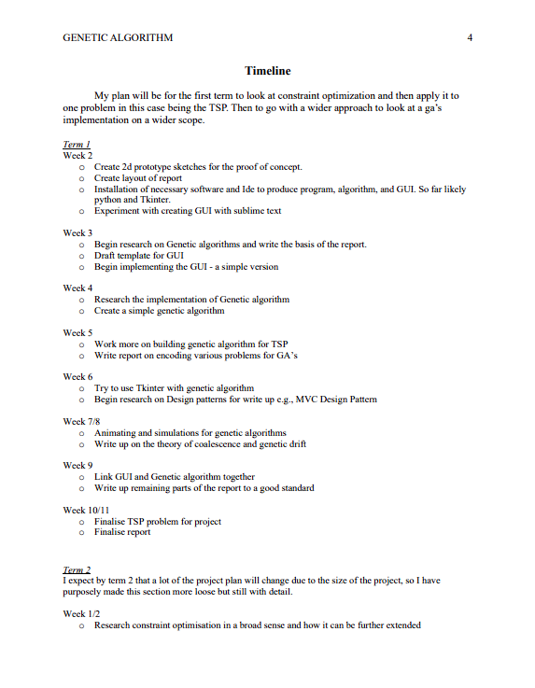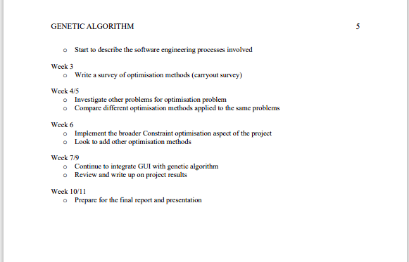

Summary of project diary

Bibliography
[1] - En.wikipedia.org. 2022. Genetic algorithm - Wikipedia. [online] Available at: <https://en.wikipedia.org/wiki/Genetic_algorithm> [Accessed 22 September 2022].

[2] - En.wikipedia.org. 2022. Genetic algorithm - Wikipedia. [online] Available at: <https://en.wikipedia.org/wiki/Genetic_algorithm> [Accessed 22 September 2022].

[3] - Cs.mcgill.ca. 2022. [online] Available at: <https://www.cs.mcgill.ca/~dprecup/courses/AI/Lectures/ai-lecture05.pdf> [Accessed 27 September 2022].

