OnTime — Appointment Tracking System: Phase 2 Design & Prototype
Project Name: Appointment tracking system
Group Number: 13
Team Lead: Hamidat Oloko
Team Members: Hamidat Oloko, Nesna Prasai , Genesis Enemuoh, Asif Khan
Sponsor Name (If Applicable): Not Applicable

1. New Requirements Identified
The following requirements were identified during the design phase and added to the project backlog:
• NR5: System shall allow users to view their upcoming appointments.
• NR6: System shall display available appointment slots in real time.
• NR7: System shall allow users to update their contact information.

2. Schedule Updates
Task | Original Date | Updated Date
Requirements Analysis  System Design  Wireframe  Prototype Development  Testing  Final documentation | Week 1  Week 2  Week 2  Week 3  Week 4  Week 5 | Completed week 1  Completed week 2  Completed week 3  In progress  Planned  Planned

3. Trello / Project Plan Updates
• Added wireframe tasks
• Assigned prototype tasks
• Updated backlog with new requirements.
• Updated sprint planning

4. Annotated Wireframes (30 pts)
The annotated wireframes below define the structure and organization of each screen. They identify the location and purpose of major interface elements, while the separate prototype in Section 5 demonstrates the finished visual appearance of the system.
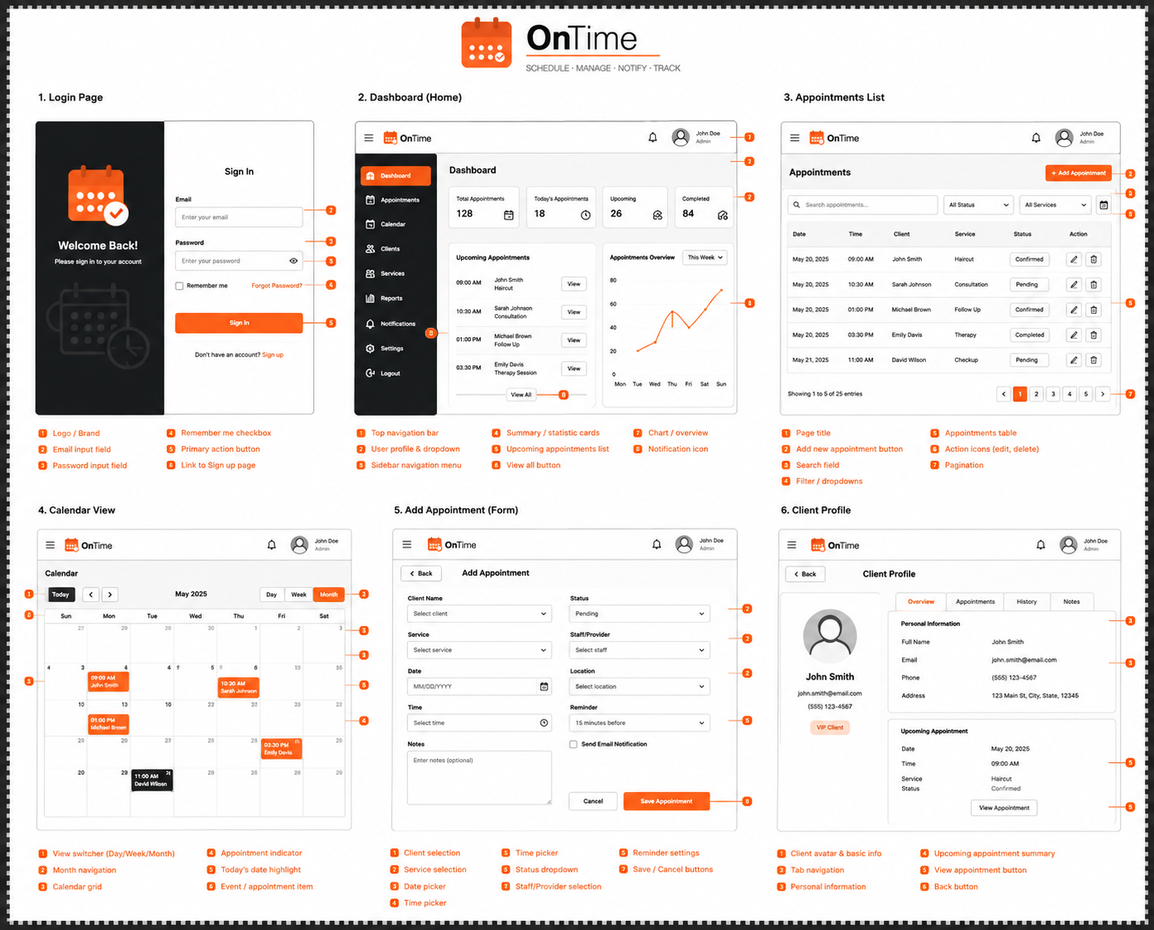
Dashboard
The Dashboard provides an overview of appointment activity, including total appointments, upcoming appointments, completed appointments, and notifications. The sidebar menu can be used to navigate to other system functions.
Appointments List
The Appointments List screen allows users to search, filter, edit, delete, and manage appointments. This screen supports efficient appointment tracking and administration.
Calendar View
The Calendar View displays appointments in a monthly, weekly, or daily format, helping users visualize their schedules and identify available time slots.
Add Appointment
The Add Appointment screen enables users to schedule new appointments by selecting a client, service, provider, date, time, and notification preferences.
Client Profile
The Client Profile screen stores customer information and appointment history, allowing users to manage client records efficiently.

5. Non-Interactive Prototype (30 pts)
Unlike the wireframes, which focus on page structure, layout, and the placement of interface elements, the non-interactive prototype below presents the polished visual design of the Dashboard (Home), Appointments List, Calendar View, and Add Appointment screens. It includes the final color scheme, typography, branding, and visual styling.
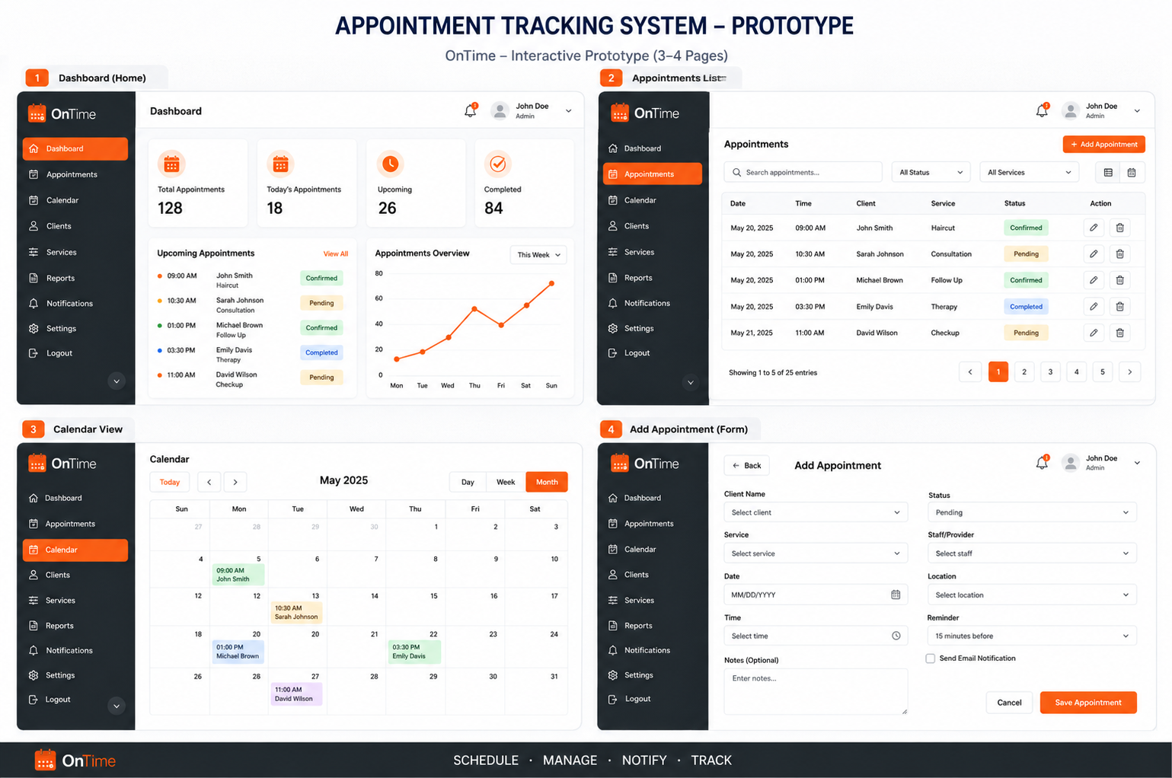

6. Application Logo (30 pts)

Logo Name: OnTime
The OnTime logo combines a calendar icon with a verification checkmark to represent appointment scheduling, organization, and reliability. The orange color scheme communicates energy, efficiency, and accessibility, while the modern typography reflects professionalism and ease of use. The slogan "Schedule • Manage • Notify • Track" summarizes the application's core functionality and reinforces the system's purpose.
The logo establishes a recognizable brand identity that will be used consistently throughout the application.

7. Design Summary
The wireframes, non-interactive prototype, and logo are separate design artifacts that collectively establish a cohesive design foundation for the OnTime Appointment Tracking System and satisfy the Phase 2 deliverable requirements.
The annotated wireframes serve as structural blueprints for the six user-interface pages by showing the intended layout, information hierarchy, element placement, and interaction purpose without representing a completed application. The non-interactive prototype is a separate, higher-fidelity design artifact that applies the selected colors, typography, branding, spacing, and visual styling to demonstrate how the finished interface is expected to look. The OnTime logo establishes a consistent brand identity that will be applied across the application, email notifications, and project documentation. Together, these distinct design artifacts reduce implementation ambiguity, improve team communication, and prepare the project for the development phase of the Software Development Life Cycle (SDLC).

