**Number of Twitter users in the United Kingdom (UK) from 2012 to 2018 (in million users)**

<https://www.statista.com/statistics/271350/twitter-users-in-the-united-kingdom-uk/>

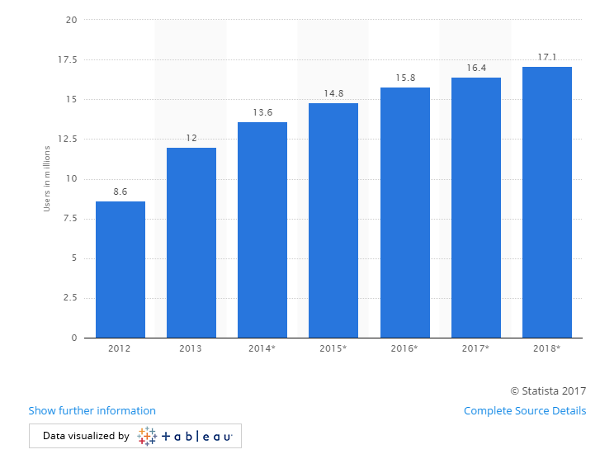

**Distribution of Twitter users in the United Kingdom (UK) 2015, by age group**

<https://www.statista.com/statistics/271351/twitter-users-in-the-united-kingdom-uk-by-age/>

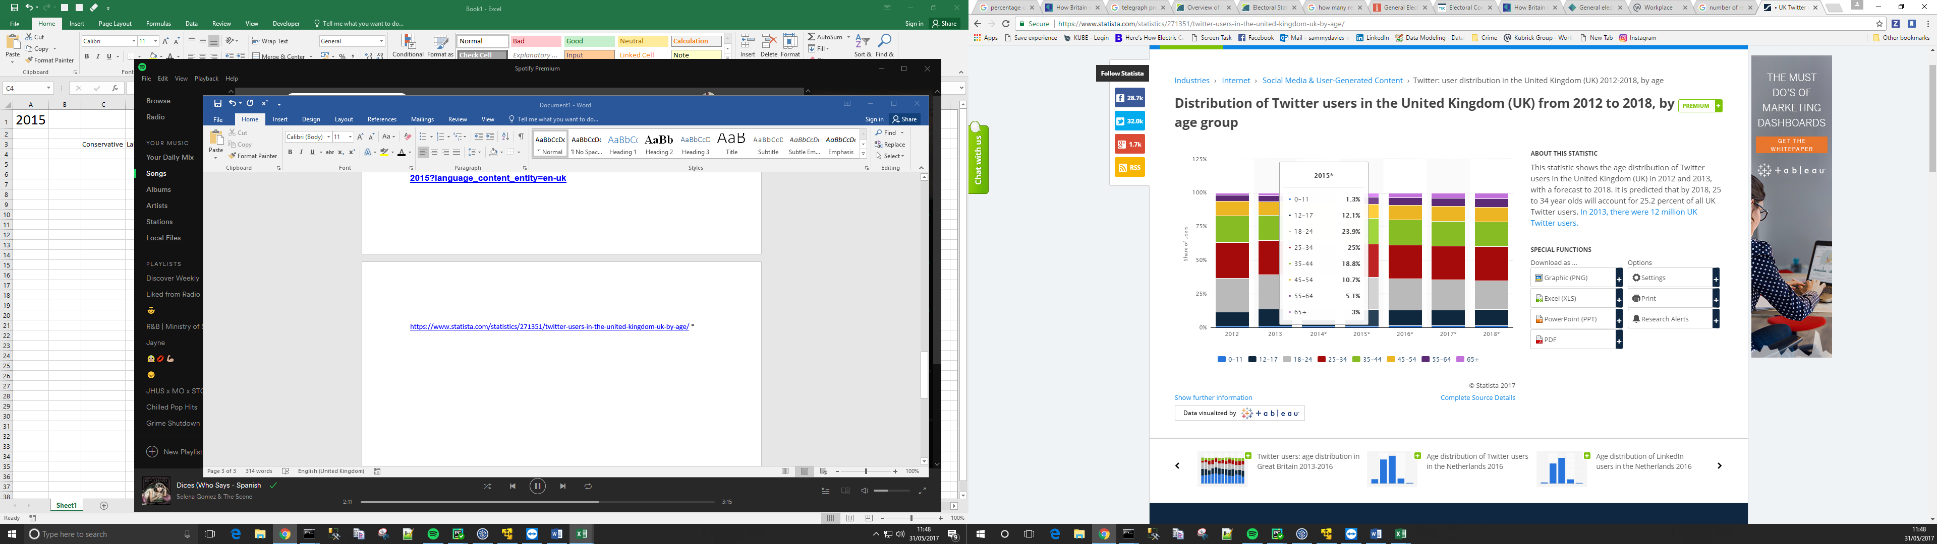

**How Britain voted in 2015**

<https://www.ipsos.com/ipsos-mori/en-uk/how-britain-voted-2015?language_content_entity=en-uk>

