This is Telerik Word inspired template.

This is Normal Text Style.

**This is Strong Text Style.**

**Heading 1 Style Paragraph**

**Heading 2 Style Paragraph**

**Heading 3 Style Paragraph**

***Heading 4 Style Paragraph***

Heading 5 Style Paragraph

This is [Hyperlink](http://www.telerik.com) style.

**Conditional Table Style**

|  |  |  |  |
| --- | --- | --- | --- |
| **Header** | **Header** | **Header** | **Header** |
| First Row | Cell 1 | Cell 2 | Cell 3 |
| Second Row | Cell 4 | Cell 5 | Cell 6 |
| Third Row | Cell 7 | Cell 8 | Cell 9 |

RadRichTextBox for Silverlight/WPF

**Overview**

RadRichTextBox is a control that offers Microsoft Word-like authoring and editing in your applications using a familiar interface for end users. The experience is enhanced by the support of multilevel bullet and numbered lists, tables, inline and floating images. More advanced options include external and in-document hyperlinks, bookmarks and comments.

The control can preview and edit text in various languages thanks to the Input Method Editor and the Right-to-Left support, which makes it an appropriate choice in a wide range of applications. Even more sweetness is added by the integrated spell-checker and image editor allowing immediate detection and correction of spelling mistakes and in-place tweaking of images.

**MS Word-like Authoring**

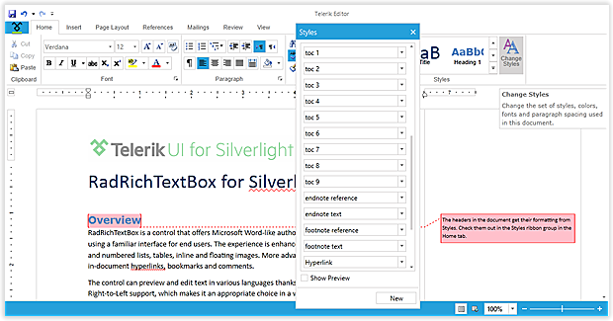

Provide Microsoft Word-like authoring and editing in your applications using a familiar interface for your end users.

**Rich Document Model Support**

Get a more complete rich text editing experience with support for Lists, Tables, Inline and Floating Images, Hyperlinks, Bookmarks and Comments.

**With SpellChecker & Image Editor**

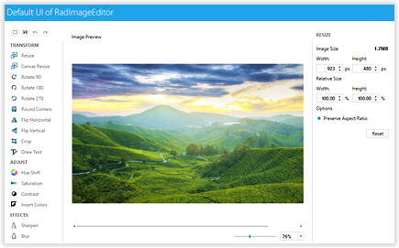With integrated SpellChecker and ImageEditor, provide on-the-fly proofing and tweaking of images, all without leaving the document UI.

**Markup & Navigation**

[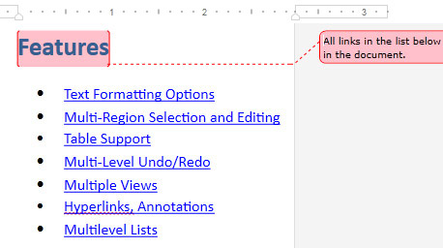](http://www.telerik.com/products/silverlight/richtextbox.aspx)

Markup your documents with Word-like comments and enable document navigation with a built-in Bookmark system.

**Import & Export**

Import and export to and from Docx, RTF, HTML, XAML and Txt, as well as export to PDF - all without writing a single line of code.

**Document Protection**

Define different editing restrictions and enforce them on different parts of the document. Import and export protected documents in the supported file formats.

**VS Wizard**

Add a fully featured rich text editor to your solution in under a minute thanks to the click-through interface provided by Visual Studio's wizard.

**Different Views & Printing**

Use a standard TextBox-like layout or a Paged view with various sizes and Headers and Footers. Utilize the printing functionality that comes out of the box.

**Mail Merge**

Create or open existing templates and fill in different data taken from database, spreadsheet or any other source. Preview the results in the RichTextBox or proceed with exporting.

**RTL and IME**

Allow entering text in various languages thanks to the built-in Input Method Editor and Right-to-Left support.

**Intuitive Editing Experience**

Provide an intuitive editing experience thanks to the integrated RibbonView, context menus, mini toolbars and dozens of dialogs designed to gear the functionality of the control.

**Performance**

Ensure quick loading even of larger documents. Further editing can be performed without significant performance hit due to the built-in UI Virtualization.