WTF

CH

23 4 2021

Table of Contents

## R Markdown

This is an R Markdown document. Markdown is a simple formatting syntax for authoring HTML, PDF, and MS Word documents. For more details on using R Markdown see <http://rmarkdown.rstudio.com>.

1. asdf
2. asdf
3. asdf
4. asdf

When you click the **Knit** button a document will be generated that includes both content as well as the output of any embedded R code chunks within the document. You can embed an R code chunk like this:

summary(cars)

## speed dist   
## Min. : 4.0 Min. : 2.00   
## 1st Qu.:12.0 1st Qu.: 26.00   
## Median :15.0 Median : 36.00   
## Mean :15.4 Mean : 42.98   
## 3rd Qu.:19.0 3rd Qu.: 56.00   
## Max. :25.0 Max. :120.00

## Including Plots

You can also embed plots, for example:

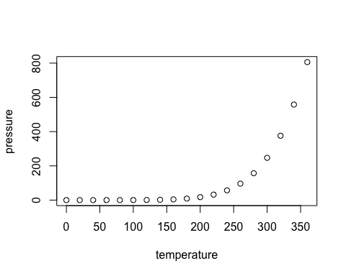

Note that the echo = FALSE parameter was added to the code chunk to prevent printing of the R code that generated the plot.

* Ponalagusamy and Priyadharshini (2017)
* Altersberger et al. (2020)

irgendeineFunktion <- function(file){}

Altersberger, Valerian L., Rolf Sturzenegger, Silja Räty, Christian Hametner, Jan F. Scheitz, Solène Moulin, Sophie A. Berg, et al. 2020. “Prior Dual Antiplatelet Therapy and Thrombolysis in Acute Stroke.” *Annals of Neurology* 88 (4): 857–59. <https://doi.org/10.1002/ana.25850>.

Ponalagusamy, R., and S. Priyadharshini. 2017. “Nonlinear Model on Pulsatile Flow of Blood Through a Porous Bifurcated Arterial Stenosis in the Presence of Magnetic Field and Periodic Body Acceleration.” *Computer Methods and Programs in Biomedicine* 142 (April): 31–41. <https://doi.org/10.1016/j.cmpb.2017.02.014>.