Nutrien_stats

mahafujul_hamid_ananda

2024-01-07

This is a Statistical Analysis of Fertilizer Sales of Nutrien from first Quarter of 2018 to third Quarter of 2023. The dataset as been extracted from Nutrien’s website.

Loading the libraries

library(openxlsx)  
library(readxl)  
library(tidyverse)

## ── Attaching core tidyverse packages ──────────────────────── tidyverse 2.0.0 ──  
## ✔ dplyr 1.1.4 ✔ readr 2.1.4  
## ✔ forcats 1.0.0 ✔ stringr 1.5.1  
## ✔ ggplot2 3.4.4 ✔ tibble 3.2.1  
## ✔ lubridate 1.9.3 ✔ tidyr 1.3.0  
## ✔ purrr 1.0.2   
## ── Conflicts ────────────────────────────────────────── tidyverse_conflicts() ──  
## ✖ dplyr::filter() masks stats::filter()  
## ✖ dplyr::lag() masks stats::lag()  
## ℹ Use the conflicted package (<http://conflicted.r-lib.org/>) to force all conflicts to become errors

library(dplyr)  
library(tidyr)

Now i will be loading the dataset from my directory to the Rstudio and select the Segment Summary (Q) sheet and Income Statement (Q) sheet to perform statistical analysis.

# Load the workbook and select the relevant sheets  
workbook <- loadWorkbook("dataset/nutrien.xlsx")  
sheetNames <- getSheetNames("dataset/nutrien.xlsx")  
sheetNames

## [1] "Metrics (Q)" "Metrics (Y)" "Income Statement (Y)"  
## [4] "Income Statement (Q)" "Balance Sheet (Y)" "Balance Sheet (Q)"   
## [7] "Cash Flow (Y)" "Cash Flow (Q)" "Segment Summary (Y)"   
## [10] "Segment Summary (Q)" "Retail (Y)" "Retail (Q)"   
## [13] "Potash (Y)" "Potash (Q)" "Nitrogen (Y)"   
## [16] "Nitrogen (Q)" "Phosphate (Y)" "Phosphate (Q)"   
## [19] "ESG Metrics (Y)"

segmentSummary <- read.xlsx(workbook, sheet = "Segment Summary (Q)")  
incomeStatement <- read.xlsx(workbook, sheet = "Income Statement (Q)")

After selecting the sheets to work on, I am extracting the rows and columns for quarters, potash, nitrogen, phosphate, and net earnings.

# Extract specific rows and columns for quarters, potash, nitrogen, phosphate, and net earnings  
quarters <- segmentSummary %>%  
 slice(1:1) %>%   
 select(Q1.18:Q3.23)  
  
potash <- segmentSummary %>%  
 slice(27:27) %>%  
 select(Q1.18:Q3.23)  
potash <- as.integer(potash)  
  
nitrogen <- segmentSummary %>%  
 slice(46:46) %>%  
 select(Q1.18:Q3.23)  
nitrogen <- as.integer(nitrogen)  
  
phosphate <- segmentSummary %>%  
 slice(65:65) %>%  
 select(Q1.18:Q3.23)  
phosphate <- as.integer(phosphate)  
  
netEarning <- incomeStatement %>%  
 slice(20:20) %>%  
 select(Q1.18:Q3.23)  
netEarning <- as.integer(netEarning)

Now i will combine the extracted data and prepare it for plotting and analysis by first transposing the data and then changing the data types of columns.

# Combine extracted data into a single data frame  
fertilizerQuarterlyData <- rbind(quarters, potash, nitrogen, phosphate, netEarning)  
rownames(fertilizerQuarterlyData)[which(rownames(fertilizerQuarterlyData) == "1")] <- "Quarters"  
rownames(fertilizerQuarterlyData)[which(rownames(fertilizerQuarterlyData) == "2")] <- "Potash"  
rownames(fertilizerQuarterlyData)[which(rownames(fertilizerQuarterlyData) == "3")] <- "Nitrogen"  
rownames(fertilizerQuarterlyData)[which(rownames(fertilizerQuarterlyData) == "4")] <- "Phosphate"  
rownames(fertilizerQuarterlyData)[which(rownames(fertilizerQuarterlyData) == "5")] <- "Net_Earning"  
  
# Prepare the data for plotting  
fertilizerQuarterlyDataFlipped <- t(fertilizerQuarterlyData)  
fertilizerQuarterlyDataFlipped <- as.data.frame(fertilizerQuarterlyDataFlipped)  
  
# Convert Quarters to date format and rename columns  
fertilizerQuarterlyDataFlipped$Quarters <- as.Date(fertilizerQuarterlyDataFlipped$Quarters, format="%m/%d/%Y")  
fertilizerQuarterlyDataFlipped$Quarters <- format(fertilizerQuarterlyDataFlipped$Quarters, "%Y-%m")  
  
# Convert data types  
fertilizerQuarterlyDataFlipped$Potash <- as.integer(fertilizerQuarterlyDataFlipped$Potash)  
fertilizerQuarterlyDataFlipped$Nitrogen <- as.integer(fertilizerQuarterlyDataFlipped$Nitrogen)  
fertilizerQuarterlyDataFlipped$Phosphate <- as.integer(fertilizerQuarterlyDataFlipped$Phosphate)  
fertilizerQuarterlyDataFlipped$Net_Earning <- as.integer(fertilizerQuarterlyDataFlipped$Net_Earning)  
  
# Prepare data for plotting - pivot longer  
fertilizerQuarterlyDataFlippedMerged <- pivot_longer(fertilizerQuarterlyDataFlipped, cols = c("Potash","Nitrogen","Phosphate"), names_to= "Fertilizer", values_to = "Sales" )

After preparing the data, i am plotting a bar chart for the fertilizer sales throughout the quarters

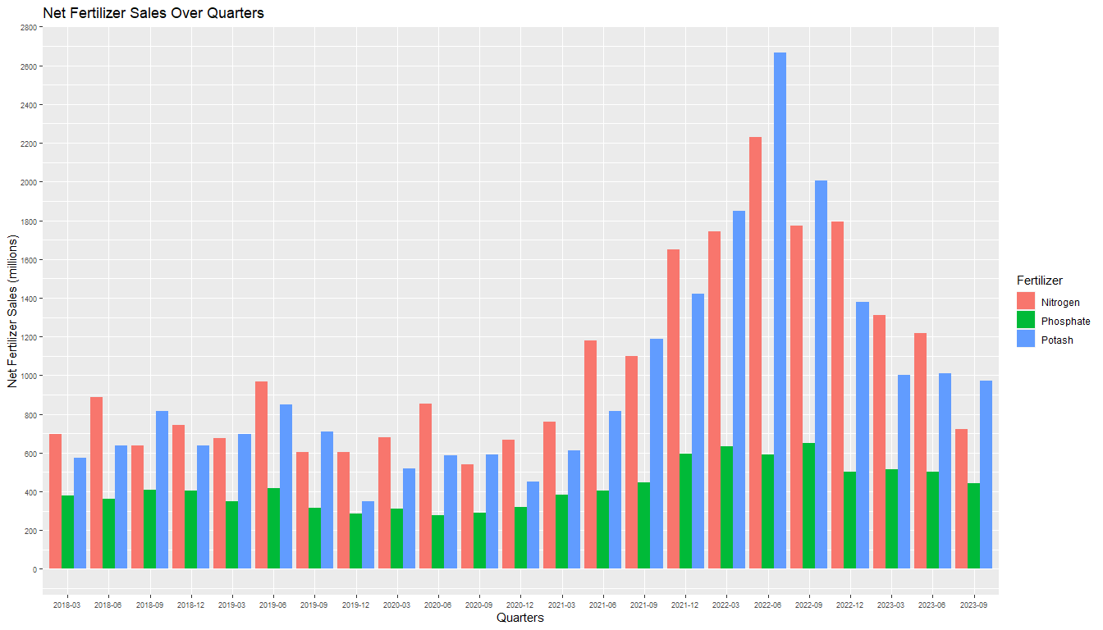

Now, I am creating a line graph to analyze the revenue trend

## Warning: The `<scale>` argument of `guides()` cannot be `FALSE`. Use "none" instead as  
## of ggplot2 3.3.4.  
## This warning is displayed once every 8 hours.  
## Call `lifecycle::last_lifecycle_warnings()` to see where this warning was  
## generated.

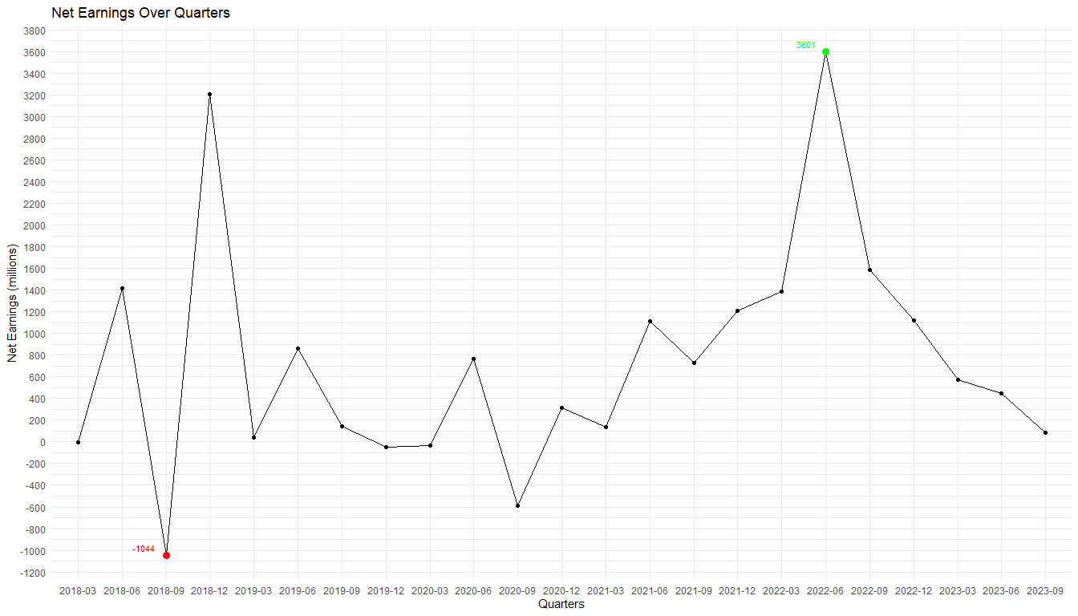

After plotting the graphs, i will now do some statistical analysis, such as the mean, maximum and minimum sales of fertilizers as well as the mean, maximum and minimum earnings,on the data i gathered from Nutrien.

# Calculate and display statistical information for Net Earnings  
averageNetEarnings <- mean(netEarning)  
cat("The mean Net Earning is", averageNetEarnings, "millions", "\n\n")

## The mean Net Earning is 738.9565 millions

maxNetEarning <- max(netEarning)  
maxEarningColumnIndex <- which(fertilizerQuarterlyData[5, ] == maxNetEarning)  
maxSalesQuarterEarning <- fertilizerQuarterlyData[1, maxEarningColumnIndex]  
cat("Maximun Net Earning was" , maxNetEarning , " millions, and the Earning Quarter is" , maxSalesQuarterEarning, "\n\n" )

## Maximun Net Earning was 3601 millions, and the Earning Quarter is 06/30/2022

minNetEarning <- min(netEarning)  
minEarningColumnIndex <- which(fertilizerQuarterlyData[5, ] == minNetEarning)  
minSalesQuarterEarning <- fertilizerQuarterlyData[1, minEarningColumnIndex]  
cat("Minimun Net Earning was" , minNetEarning , " millions, and the Earning Quarter is" , minSalesQuarterEarning, "\n\n" )

## Minimun Net Earning was -1044 millions, and the Earning Quarter is 09/30/2018

# Calculate and display statistical information for Potash sales  
averagePotashSales <- mean(potash)  
cat("The mean Potash sales is", averagePotashSales, "millions", "\n\n")

## The mean Potash sales is 971.087 millions

maxPotashSale <- max(potash)  
maxPotashColumnIndex <- which(fertilizerQuarterlyData[2, ] == maxPotashSale)  
maxSalesQuarterPotash <- fertilizerQuarterlyData[1, maxPotashColumnIndex]  
cat("Maximun Potash sale was" , maxPotashSale , " millions, and the Sales Quarter is" , maxSalesQuarterPotash, "\n\n" )

## Maximun Potash sale was 2668 millions, and the Sales Quarter is 06/30/2022

minPotashSale <- min(potash)  
minPotashColumnIndex <- which(fertilizerQuarterlyData[2, ] == minPotashSale)  
minSalesQuarterPotash <- fertilizerQuarterlyData[1, minPotashColumnIndex]  
cat("Minimun Potash sale was" , minPotashSale , " millions, and the Sales Quarter is" , minSalesQuarterPotash, "\n\n")

## Minimun Potash sale was 350 millions, and the Sales Quarter is 12/31/2019

# Calculate and display statistical information for Nitrogen sales  
averageNitrogenSales <- mean(nitrogen)  
cat("The mean Nitrogen sales is", averageNitrogenSales, "millions", "\n\n")

## The mean Nitrogen sales is 1044.609 millions

maxNitrogenSale <- max(nitrogen)  
maxNitrogenColumnIndex <- which(fertilizerQuarterlyData[3, ] == maxNitrogenSale)  
salesQuarterNitrogen <- fertilizerQuarterlyData[1, maxNitrogenColumnIndex]  
cat("Maximun Nitrogen sale was" , maxNitrogenSale , " millions, and the Sales Quarter is" , salesQuarterNitrogen, "\n\n" )

## Maximun Nitrogen sale was 2229 millions, and the Sales Quarter is 06/30/2022

minNitrogenSale <- min(nitrogen)  
minmaxNitrogenColumnIndex <- which(fertilizerQuarterlyData[3, ] == minNitrogenSale)  
minSalesQuarterNitrogen <- fertilizerQuarterlyData[1, minmaxNitrogenColumnIndex]  
  
cat("Minimun Nitrogen sale was" , minNitrogenSale , " millions, and the Sales Quarter is" , minSalesQuarterNitrogen, "\n\n" )

## Minimun Nitrogen sale was 540 millions, and the Sales Quarter is 09/30/2020

# Calculate and display statistical information for Phosphate sales  
averagePhosphateSales <- mean(phosphate)  
  
cat("The mean Phosphate sales is", averagePhosphateSales, "millions", "\n\n")

## The mean Phosphate sales is 425.9565 millions

maxPhosphateSale <- max(phosphate)  
maxPhosphateColumnIndex <- which(fertilizerQuarterlyData[4, ] == maxPhosphateSale)  
salesQuarterPhosphate <- fertilizerQuarterlyData[1, maxPhosphateColumnIndex]  
  
cat("Maximun Phosphate sale was" , maxPhosphateSale , " millions, and the Sales Quarter is" , salesQuarterPhosphate, "\n\n" )

## Maximun Phosphate sale was 651 millions, and the Sales Quarter is 09/30/2022

minPhosphateSale <- min(phosphate)  
minmaxPhosphateColumnIndex <- which(fertilizerQuarterlyData[4, ] == minPhosphateSale)  
minSalesQuarterPhosphate <- fertilizerQuarterlyData[1, minmaxPhosphateColumnIndex]  
  
cat("Minimun Phosphate sale was" , minPhosphateSale , " millions, and the Sales Quarter is" , minSalesQuarterPhosphate, "\n\n" )

## Minimun Phosphate sale was 277 millions, and the Sales Quarter is 06/30/2020

From the data analysis we learned that on second quarter of 2022 we had the highest sales of Potash and Nitrogen and it was also the quarter where we had maximum Net Earnings!