**VISVESVARAYA TECHNOLOGICAL UNIVERSITY**

**“JnanaSangama”, Belgaum -590014, Karnataka.**



**PROJECT WORK-1 REPORT**

**on**

**PROJECT TITLE**

***Submitted by***

**NAME1 (1BM19CS111)**

**NAME2(1BM19CS112)**

**NAME3 (1BM19CS113)**

**NAME4 (1BM19CS114)**

***Under the Guidance of***

|  |  |
| --- | --- |
| **REKHA G S**  **Assistant Professor, BMSCE** |  |

***in partial fulfillment for the award of the degree of***

**BACHELOR OF ENGINEERING**

***in***

**COMPUTER SCIENCE AND ENGINEERING**



**B.M.S. COLLEGE OF ENGINEERING**

**(Autonomous Institution under VTU)**

**BENGALURU-560019**

**Sep-2020 to Jan-2021**

**B. M. S. College of Engineering,**

**Bull Temple Road, Bangalore 560019**

(Affiliated To Visvesvaraya Technological University, Belgaum)

**Department of Computer Science and Engineering**



**CERTIFICATE**

This is to certify that the project work entitled “**PROJECT TITLE**” carried out by **NAME1 (1BM19CS111), NAME2 (1BM19CS112), NAME3 (1BM19CS113) AND NAME4 (1BM19CS114)** who are bonafide students of **B. M. S. College of Engineering.** It is in partial fulfillment for the award of **Bachelor of Engineering in Computer Science and Engineering** of the Visveswaraiah Technological University, Belgaum during the year 2020-2021. The project report has been approved as it satisfies the academic requirements in respect of **Project Work-1 (19CS3PWPW1)**work prescribed for the said degree.

Signature of the Guide                 Signature of the HOD

REKHA G S Dr. Umadevi V

Assistant Professor Associate Prof.& Head, Dept. of CSE

BMSCE, Bengaluru BMSCE, Bengaluru

External Viva

Name of the Examiner                                                                                       Signature with date

1._____________________________ ________________________

2. _____________________________ _________________________

**B.M.S. College of EngineerinG**

**DEPARTMENT OF COMPUTER SCIENCE AND ENGINEERING**



***DECALARATION***

We, AAAA (1BM19CS001), BBBB (1BM19CS002), CCCC (1BM19CS003), DDDD (1BM19CS004), students of 3rd Semester, B.E, Department of Computer Science and Engineering, B. M. S. College of Engineering, Bangalore, here by declare that, this Project Work-1entitled "Project Title" has been carried out by us under the guidance of REKHA G S,Assistant Professor, Department of CSE, B. M. S. College of Engineering, Bangalore during the academic semester Sep-2020-Jan-2021

We also declare that to the best of our knowledge and belief, the development reported here is not from part of any other report by any other students.

Signature

AAAA (1BM19CS001)

BBBB (1BM19CS002)

CCCC (1BM19CS003)

DDDD (1BM19CS004)

1. Introduction

Website development for “Online Course Registration”

This online submission system supports following users

a. Student

b. CS Office staff

**Functionalities under Student login**

i. Can register for 3rd semester subjects through online application form

ii. Display of the list of subjects registered

**Functionalities under CS office staff login**

i. Addition of students for registration

ii. Deletion of students

ii.Display of the list of students registered

2. Design Layouts: Handwritten Screen Shots of Webpages

2.1: Login Webpage

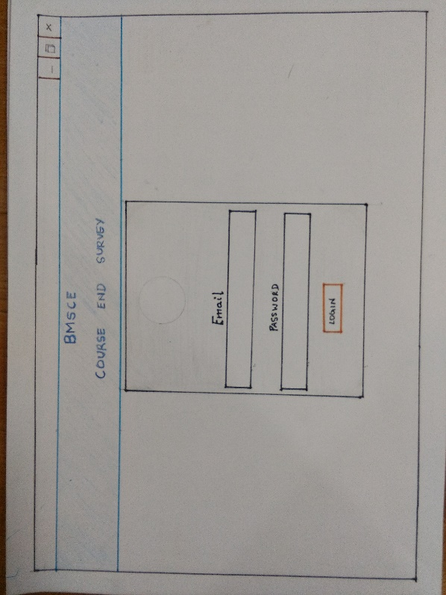

2.1: Home Webpage

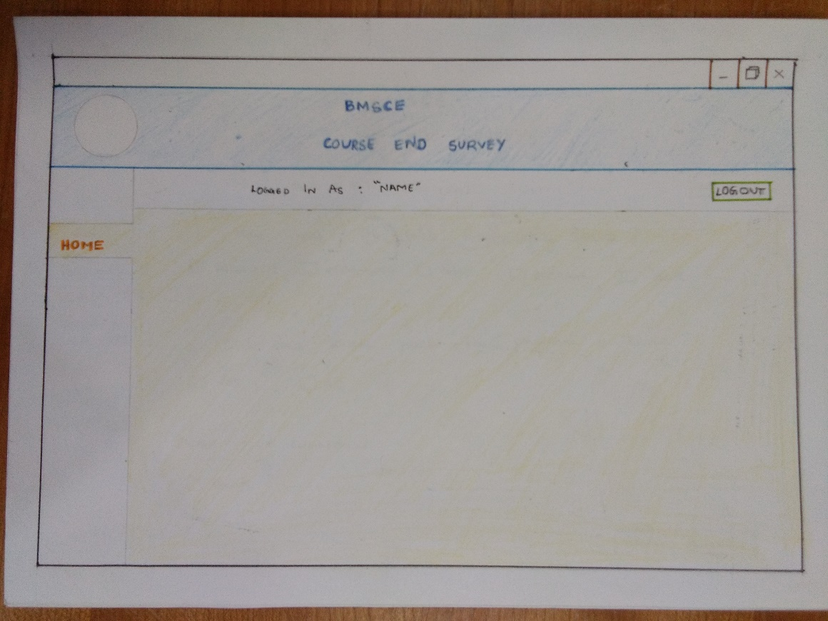

2.2: Course End Survey Webpage

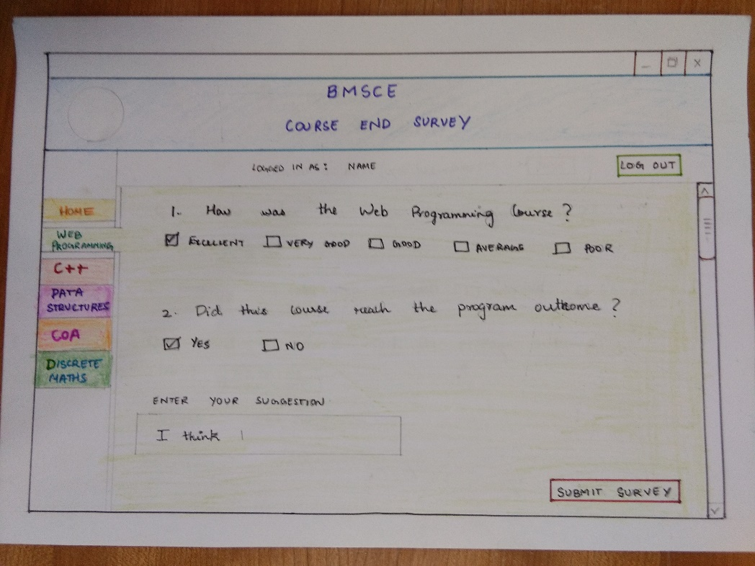

2.3 Course End Survey Questions display Webpage

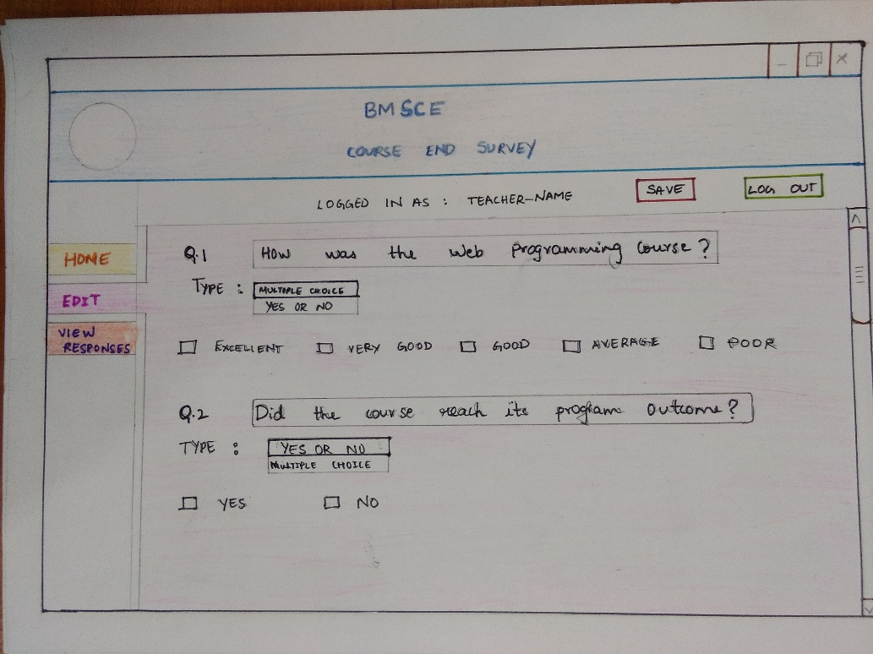

2.4 Responses Display Webpage

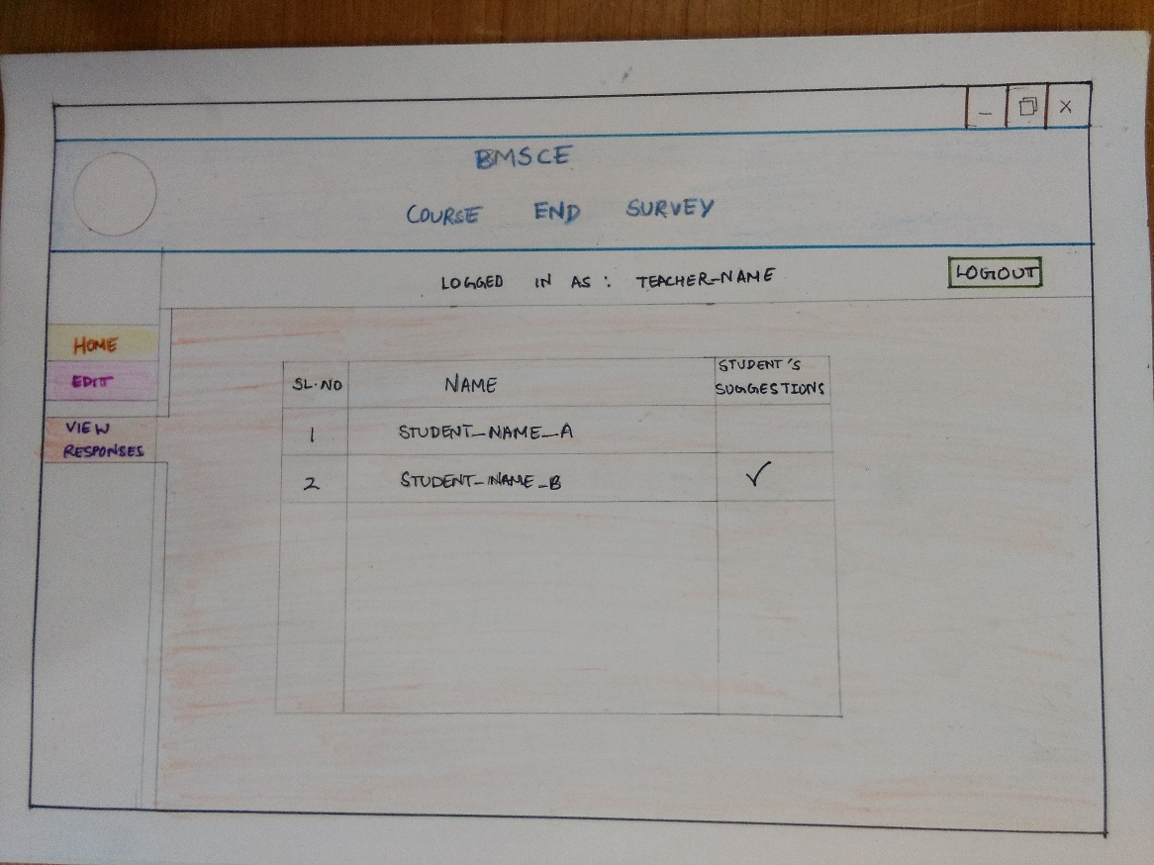

2.4 Responses Statistics Display Webpage

