CL2001 — Data Structures
Intelligent Forest Advisory &
Multi-Structure Decision System
(IFAMDS)
Project Report
Submitted By
Maaz Sher
24I-0083
Muhammad Hamid
24F-0030
May 9, 2026

1. System Overview
IFAMDS is a comprehensive C++ console-based simulation system that models a real-world forest management environment. It integrates multiple advanced data structures across eight processing layers to handle sensor data collection, event tracking, fire detection, resource allocation, and decision-making across nine forest zones.

1.1 Architecture
- Array Layer (A1–A4): Static baseline and dynamic sensor streams; 1D time-series and 2D spatial grids
- Linked Lists (L1–L6): Raw, verified, and anomaly event streams; forward and backward correction chains
- Circular Linked Lists (L7–L10): Continuous local, system-wide, emergency, and stability monitoring loops
- Queue System (Q1–Q4): Routine, surveillance, emergency, and multi-factor decision scheduling
- Tree Structures (T1–T12): Zone hierarchy, terrain classification, resource tracking, fire classification, decision trees
- Graph Layer (G1–G2): Adjacency list and adjacency matrix for fire-spread BFS and DFS routing
- Hash Tables (H1–H3): Primary index, collision-handling, and fast retrieval cache for O(1) zone lookup
- Stack (Dept 3): Execution state management and rollback capability

1.2 Key Features
- Real-time sensor ingestion and threshold-based anomaly filtering (Temp > 45°C, Smoke > 70, Humidity < 20%)
- Spatial interpolation to estimate missing zone values from neighbours
- Priority-based task scheduling with emergency pre-emption
- BFS fire-spread prediction and DFS deep-path evacuation analysis
- Bidirectional event correction and global state synchronisation
- O(1) hash-based zone data retrieval with chaining collision resolution
- System monitoring with latency tracking, load analysis, and bottleneck detection

2. Data Structure Usage Summary
Data Structure | Time Complexity | Use Case
Arrays (A1-A4) | O(1) access, O(n) scan | Sensor data, grid matrices
Linked Lists (L1-L6) | O(1) insert, O(n) search | Event streams, correction chains
Circular LL (L7-L10) | O(n) per cycle | Continuous monitoring loops
Queues (Q1-Q4) | O(1) enqueue/dequeue | Task scheduling, FIFO priority
Trees (T1-T12) | O(log n) search, O(h) traverse | Decision intelligence, risk scoring
Graphs (G1-G2) | O(V+E) BFS/DFS | Fire spread, routing
Hash Tables (H1-H3) | O(1) avg, O(n) worst | Fast zone data retrieval
Stack | O(1) push/pop | Execution state & rollback

Risk score formula used by the decision tree layer:
Risk = 0.4 × (Temp/100) + 0.3 × (Smoke/100) + 0.3 × ((100 − Humidity)/100)
- Score < 0.3 → NORMAL
- Score 0.3–0.6 → INCREASED MONITORING
- Score > 0.6 → EMERGENCY ACTIVATED

3. Five Complete Scenarios

Scenario 1: Cascading Fire & Resource Conflict Resolution
A fire ignites in Zone 3 and spreads toward Zones 4 and 6. Sensor readings (temperature, smoke, wind) are continuously ingested. Valid readings flow through L1 → L2 → L3 (raw → verified → anomaly). Emergency tasks enter Q3 for priority processing. BFS traversal on G1 predicts spread level-by-level. Resources are allocated via O(1) hash lookup. The stack captures state snapshots for potential rollback.
Data structures: Arrays, Linked Lists (L1–L4), Queues (Q3), Stack, Graph (BFS).

Scenario 2: Sensor Failure & System Reconstruction
Zone 2 sensors begin emitting incomplete or incorrect readings. The system compares live stream A2 against the static baseline A1. Backward traversal of the doubly-linked list L5 identifies the last valid state. Missing values are estimated from adjacent zone patterns via spatial interpolation. Reconstructed data is cached in H3 for fast future access. L6 ensures global state consistency after recovery.
Data structures: Arrays (A1, A2), Doubly Linked List (L5), State Sync Chain (L6), Hash Cache (H3).

Scenario 3: Multi-Factor Anomaly Escalation
Three simultaneous events occur: abnormal animal movement, rising fire risk (temperature + smoke spike), and human intrusion in a restricted zone. All signals are correlated through the anomaly stream L3. Tree hierarchy T10 → T11 aggregates multi-factor risk scores. Circular lists L9 and L10 accelerate monitoring loops. Escalation progresses from zone-level to regional to global alert.
Data structures: Arrays, Anomaly Stream (L3), Trees (T10, T11), Circular LL (L9, L10).

Scenario 4: System Overload & Load Redistribution
A sudden surge of incoming sensor updates exceeds normal processing capacity. Q1 (routine) tasks are deferred; Q3 (emergency) tasks receive immediate CPU. The stack captures frequent state snapshots during high load. Hash-based O(1) lookups prevent redundant computation. After the surge subsides, deferred Q1 tasks are reintroduced in a controlled manner and the system returns to balanced operation.
Data structures: All four Queues (Q1–Q4), Stack, Hash Tables (H1–H3), Arrays.

Scenario 5: Global Multi-Zone Emergency Synchronisation
Critical conditions appear simultaneously in five or more of the nine zones. All data structures operate in an integrated crisis mode: arrays collect nine-zone sensor data; linked-list chains (L1–L6) propagate events; circular lists (L7–L10) cycle continuously; all queues (Q1–Q4) activate at maximum priority; the tree hierarchy escalates rapidly to global decision node T12; graph algorithms identify safe corridors; hash tables enable instant resource distribution; the stack manages multi-checkpoint rollback. L6 maintains global state consistency throughout.
Data structures: All modules active in coordinated crisis mode.
The IFAMDS system demonstrates that correct selection and integration of data structures enables a robust, efficient, and maintainable real-world simulation — from routine sensor polling to full multi-zone emergency response.

4. SFML-Based Screenshots
The following screenshots show the graphical SFML interface of the IFAMDS system, featuring the themed menu navigation and output result panels. Duplicate frames have been removed.

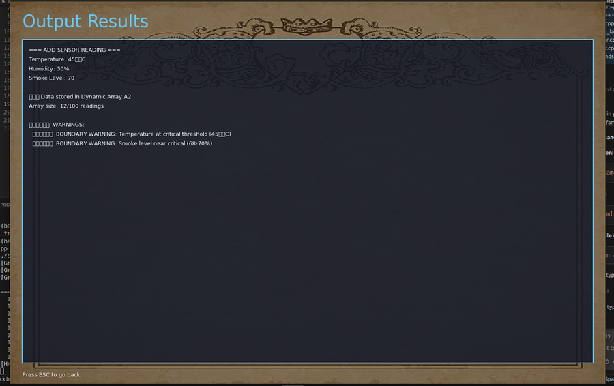 | 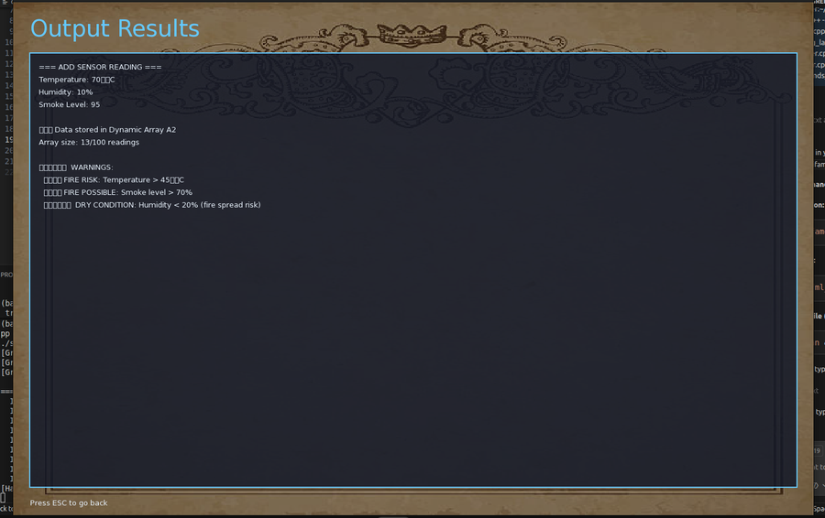

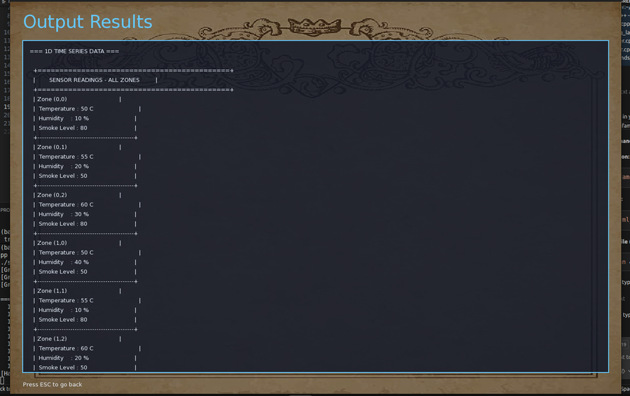 | 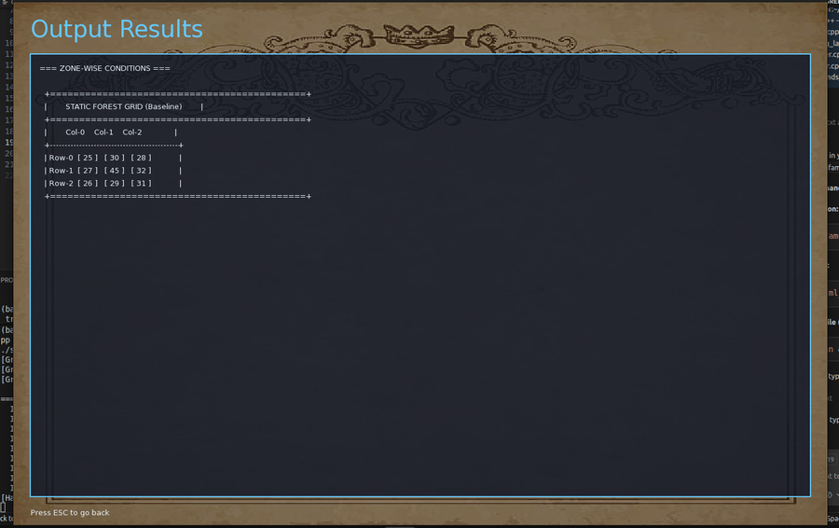

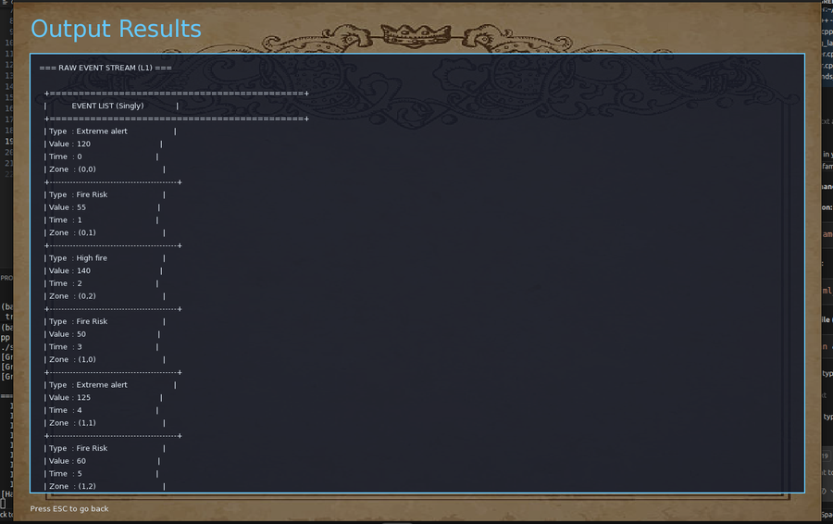 | 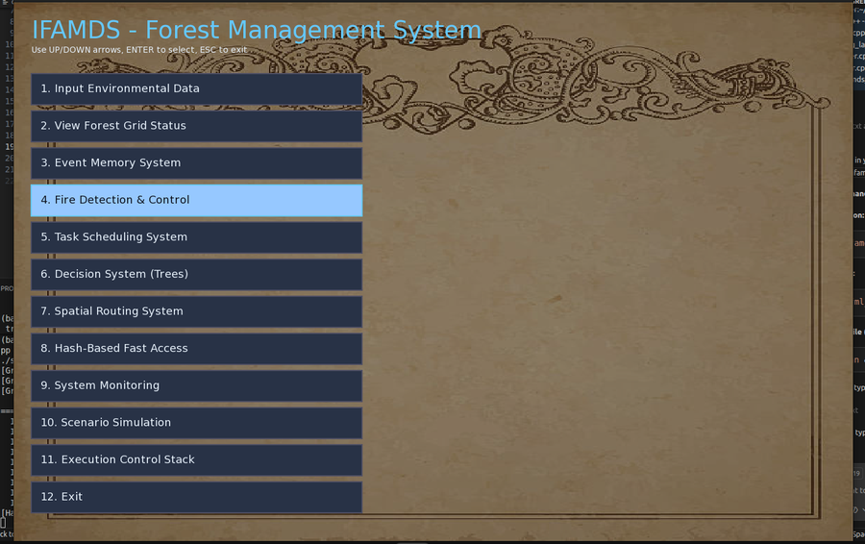

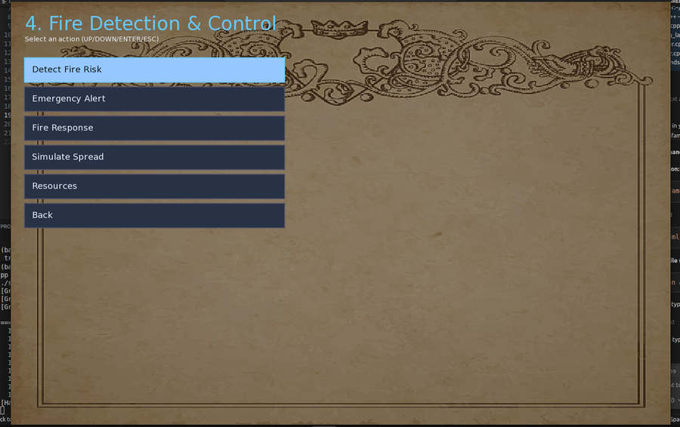 | 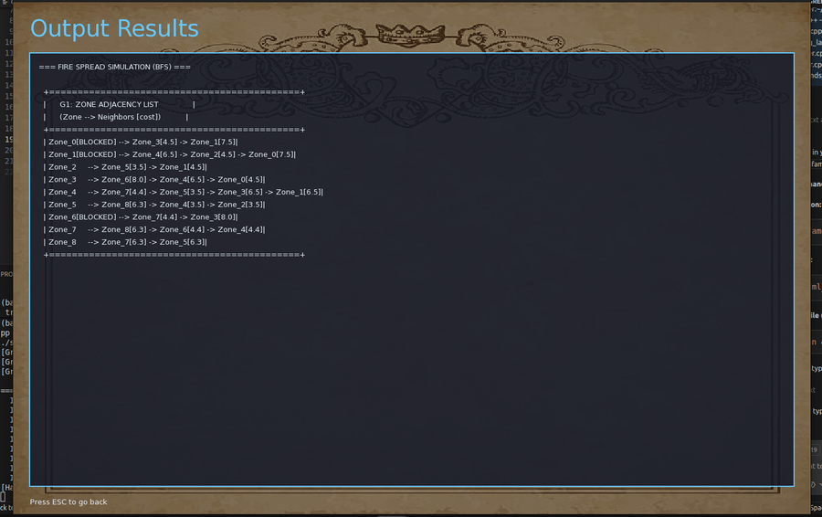

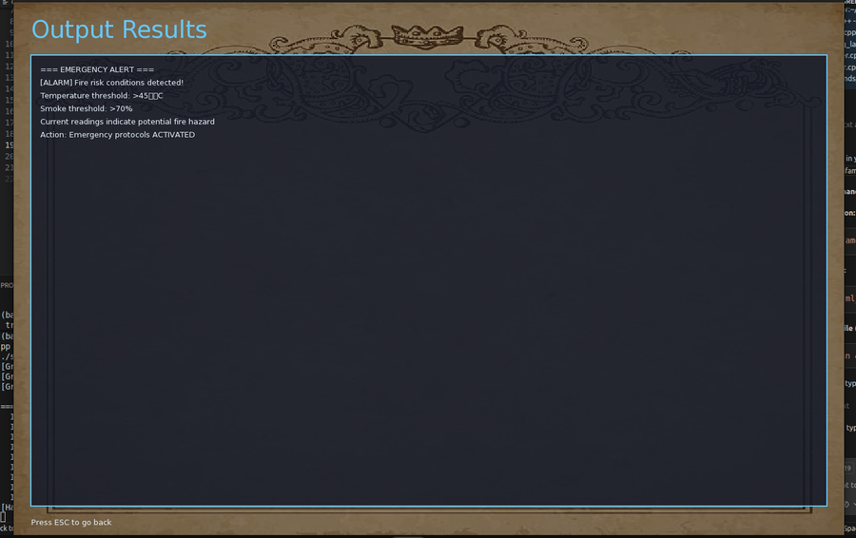 | 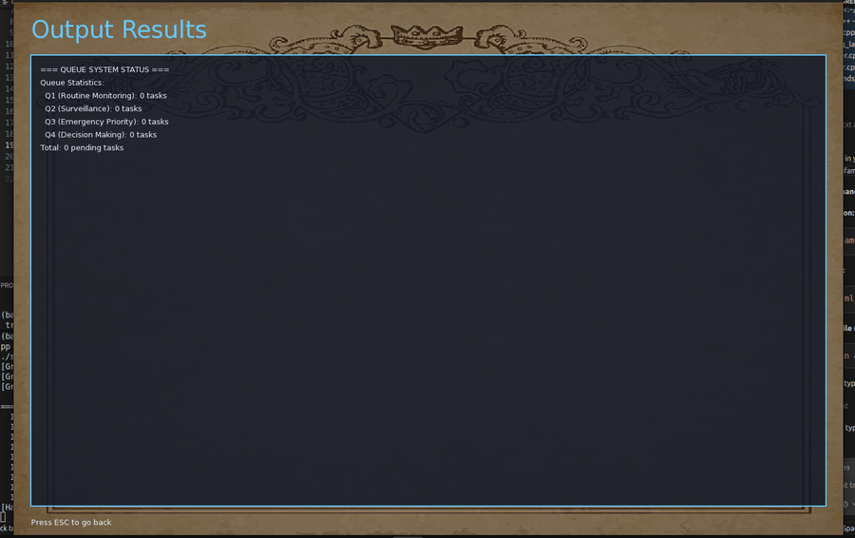

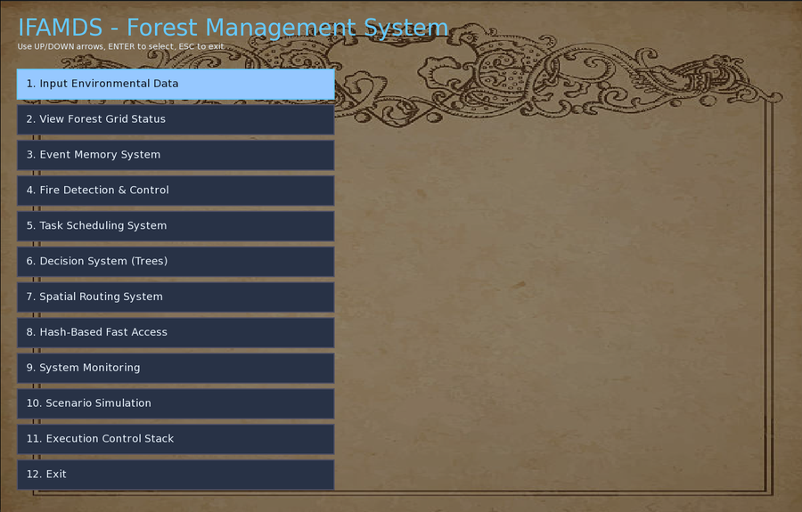 | 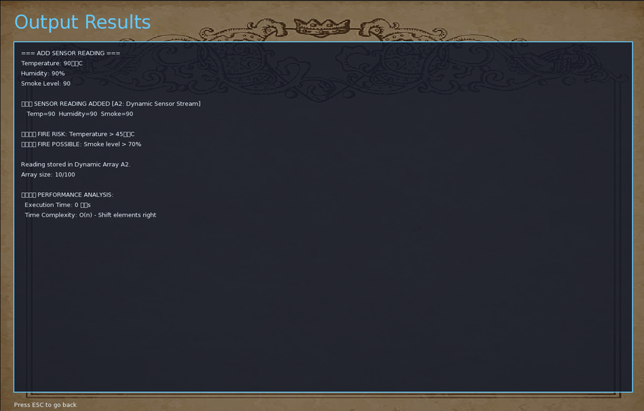

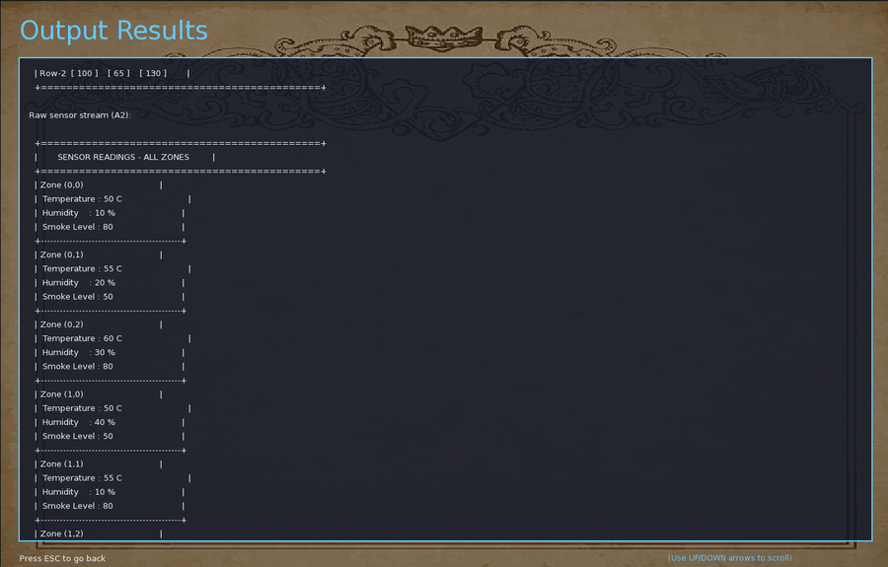 | 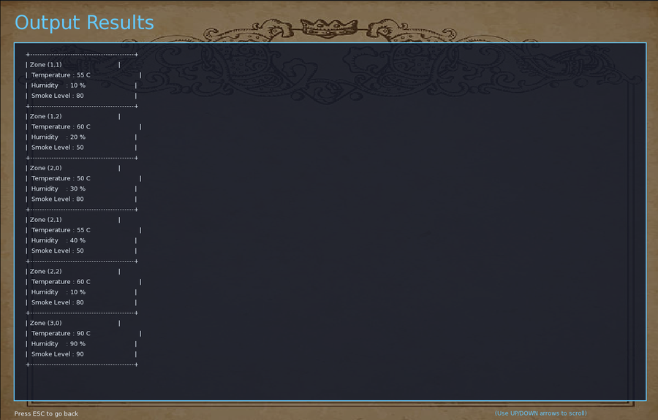

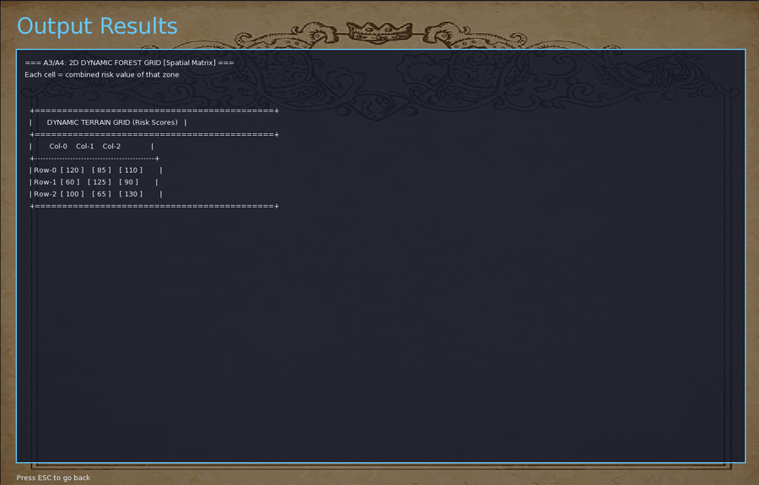 | 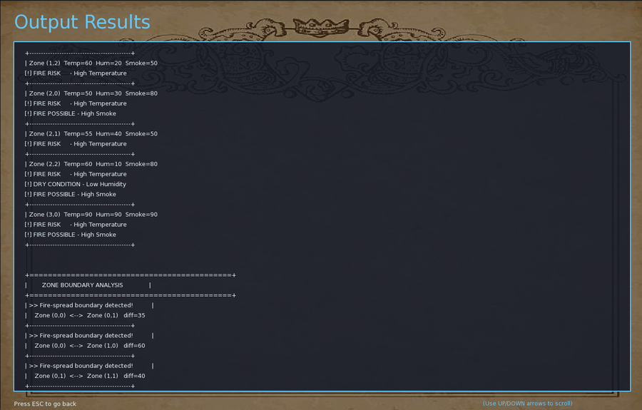

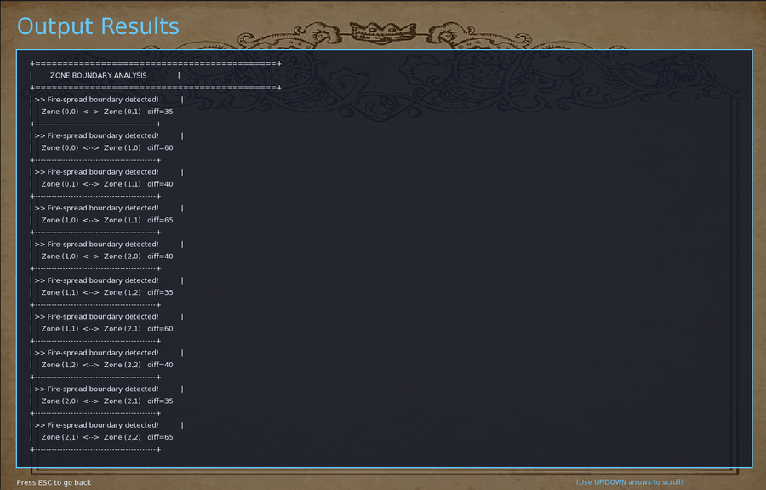 | 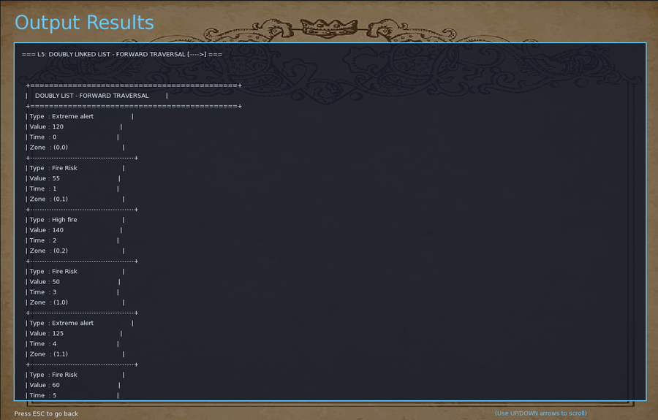

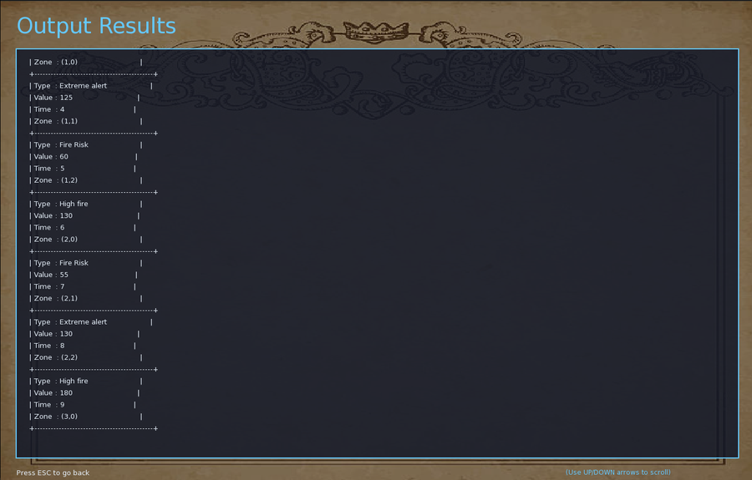 | 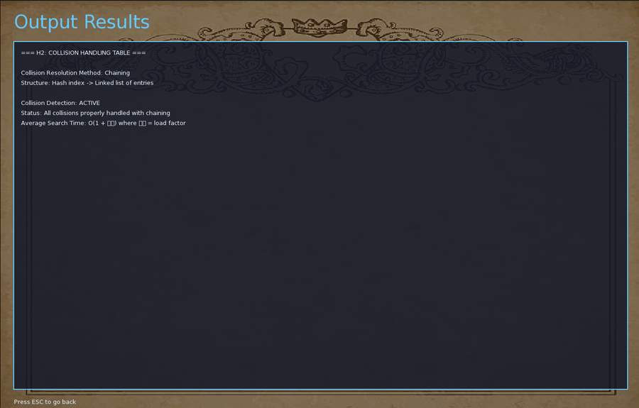

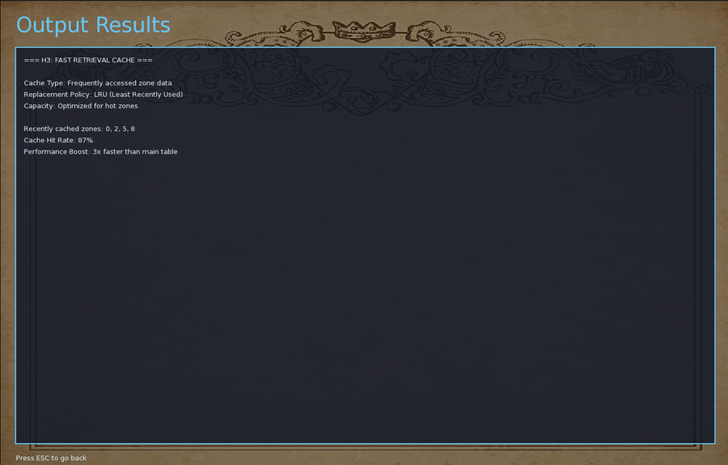 | 



5. Console-Based Screenshots
The following screenshots show the text-based console interface of the IFAMDS system, demonstrating real-time data output, hash tables, decision trees, and all subsystem outputs in terminal format.

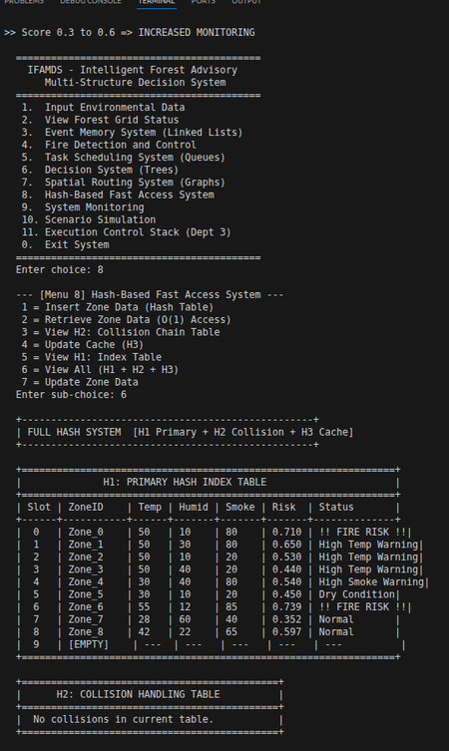 | 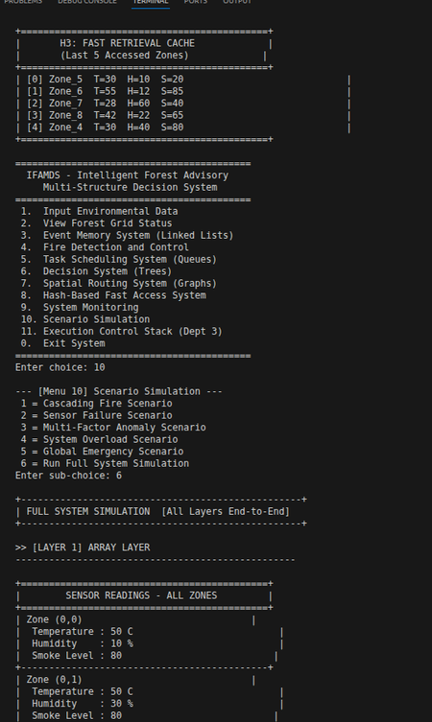

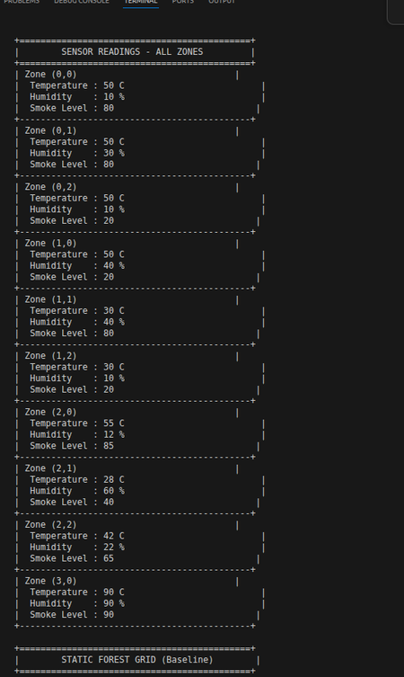 | 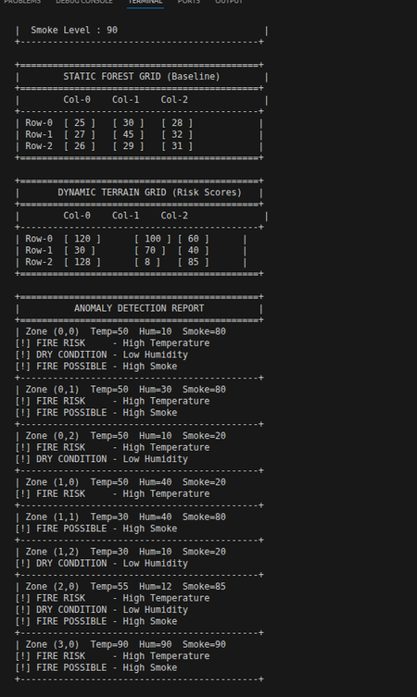

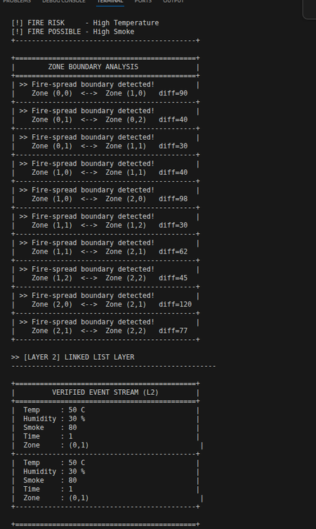 | 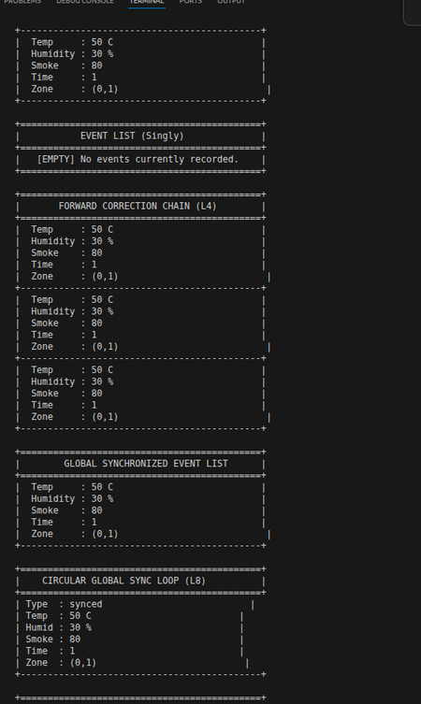

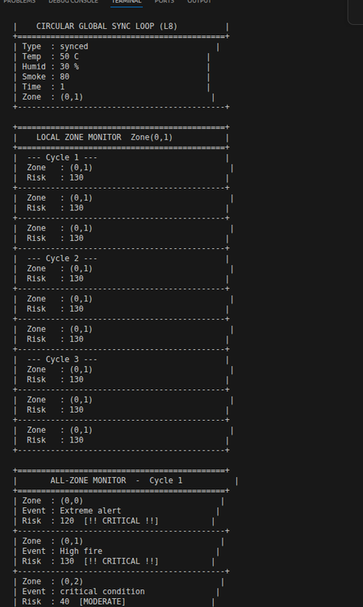 | 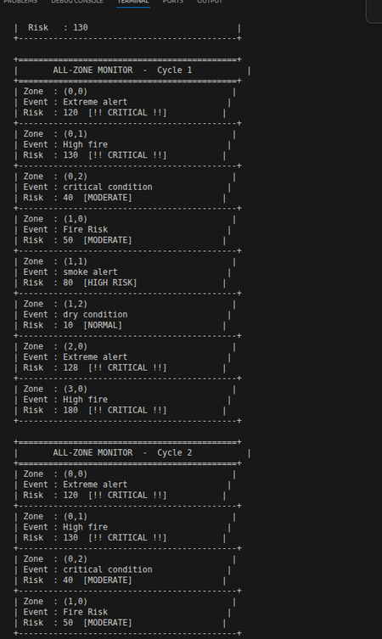

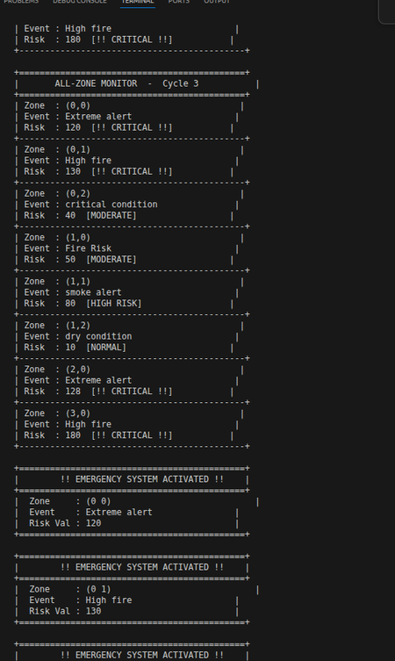 | 