Hamid Hooshmandi
Assignment 3
Thursday, March 7, 2013
Program Description:
The program contains following packages and classes:

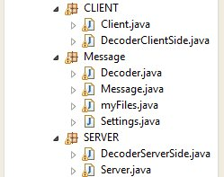

Server Package:
DecoderServerSide.java
Decode messages coming from the client
Client Package:
DecoderClientSide.java
Decode messages coming from the server
Message Package:
Decoder:
getMessage function:
  - gets the InputStream and returns a Message object containing message byte array
  - it also return back the inputstream, to be later used for reading messages with body contents

public static Message getMessage(InputStream in, boolean containsBody) throws IOException{
.
.
.
.
msg.setOutputStm(messageBuffer.toByteArray());
return msg;
}

Synchronization:
to synchronze files ,3 arraylists of myFile type is created

ArrayList<myFiles> filesListSnapshot
ArrayList<myFiles> filesListClient
ArrayList<myFiles> fileListServer

filled with files of client, server, and snapshot files,(Snapshot file is an xml file. Representing files on the client computer
) these files then compared together in the compareFileLists function.
The function does the following
compareFileLists function:
  - gets 3 arraylists of myFile type and compare them together,
  - it returns another arraylist of myFile type, with a code corresponding to each filename, indicating what has to be done to the file
  - example: 001 means file exists on the server but doesn't exist on the snapshot or the client

snapshot | Client | Server
1 | 1 | 0 | Delete file on the client
1 | 0 | 1 | Delete file on the server
1 | 1 | 1 | Compare
1 | 0 | 0 |  | File was deleted on both client and server
0 | 1 | 0 | Put file on the server
0 | 1 | 1 |  | File was created on both client and server
0 | 0 | 1 | Get file from the server

Test cases:
Login test
I tested clients and server on "localhost"
run the server with following command line arguments:
-p 20112

Run the client with the following command line arguments:
-d ./CLIENT_SHARE_DIR -p 20112 -u username -q password
Results:
 | Client | Server
 | -------SERVER------  DROP/1.0 LOG 200 ok | -------Client------  LOG DROP/1.0  Authorization:username:password
Synchronization Test
Synchronization is done manually with an "s" command from the client
Snapshot file | Client | Server
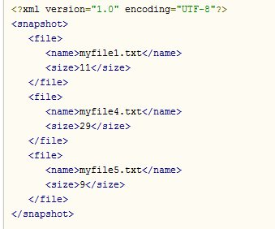 | 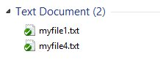 | 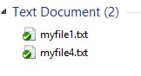
Next I created a new file on the client and issued the synch command
 | 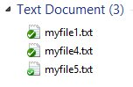
Results:
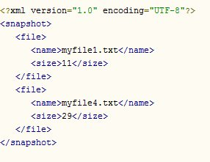 | enter command:s  -------SERVER------  DROP/1.0 DIR 200 null  size:32  lines:2  myfile1.txt:11  myfile4.txt:29  -------SERVER------  DROP/1.0 PUT 200 ok | -------Client------  DIR DROP/1.0  -------Client------  PUT myfile5.txt DROP/1.0  Bytes:9  some file
Next I created 2 new files on the server and 1 new file on the client
 | 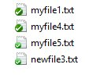  Created newfile3.txt | 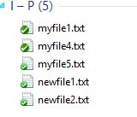  Created newfile1.txt  Created newfile2.txt
Result:
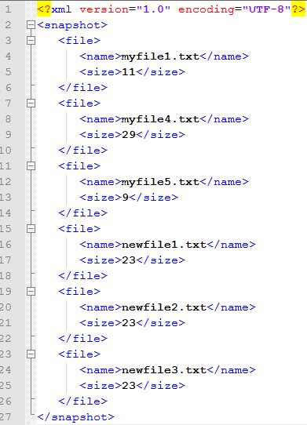  Snapshot file was updated by the client | enter command:s  -------SERVER------  DROP/1.0 DIR 200 null  size:81  lines:5  myfile1.txt:11  myfile4.txt:29  myfile5.txt:9  newfile1.txt:23  newfile2.txt:23  -------SERVER------  DROP/1.0 PUT 200 ok  -------SERVER------  DROP/1.0 GET 200 null  size:23  new file 1 text content  -------SERVER------  DROP/1.0 GET 200 null  size:23  new file 2 text content | -------Client------  DIR DROP/1.0  -------Client------  PUT newfile3.txt DROP/1.0  Bytes:23  new file 3 text content  -------Client------  GET newfile1.txt DROP/1.0  -------Client------  GET newfile2.txt DROP/1.0

