Gas Leakage Detector and Alert System

Group # 07

Sec- E

|  |  |
| --- | --- |
| 18-36064-1 | SAHA, AVISHEK |
| 18-37480-1 | BILLAH MOKABBERA |
| 18-36610-1 | SHAZIB, SHAHARIYAR |
| 18-36061-1 | ANTOR, HAMID AHMED |
| 18-36267-1 | SOPNIL, MD. NAYEM REZA |
| 18-37855-2 | SOBHAN, MD ABDUS |

Name of the Course Teacher

Md. Ali Noor

Lecturer

Fall Semester 2020-2021

December, 2020

Gas Leakage Detector and Alert System

*Abstract*— Safety and security have been major issue in today’s life. Accidents are on increasing day by day. Here, in this report discussed about those accidents that are being occurred due to combustible gases, i.e., LPG, CNG. Several people have been injured and some got dead. So, this project is for security purpose that will detect combustible gases and alert candidates. Now a day’s, LPG Gas leakage detectors come in the market with the LPG sensor that only senses any gas leakage and showed it on the display. It also indicates the presence of Gas by Red & green LED. In this paper, we are reviewing on the use of LPG Gas leakage detector along with the Arduino. The uses of the Arduino microcontroller with Arduino, provide a suitable platform for implementing an embedded control system and it is possible to modify it to meet our future requirements easily and quickly. This sensor can also sense is butane, propane, LNG and cigarette smoke. The report consists of a background into the area of Microcontroller.

*Index Terms*—*: Gas leakage, Simulink UNO Arduino, Logic toggle, Alpha Numeric LCD (LMO16L) Display, MQ2 Gas sensor.*

# Introduction

LPG Gas leaks have been increased from 0.72% of all kitchen accidents to 10.74% of all the kitchen accidents the small LPG cylinder of weight 5kg in which the burner is located immediately over the cylinder without using a rubber tube is seen to be safer than the one which uses a rubber pipe as this subway has the hazards of getting cracked which in turn can make way to leakage. A Gas leak detector is a simple device which is used to detect the leakage of gas and if the gas leak occurs, an equivalent message is conveyed by the means of an LCD screen.

The project entitled “LPG Leakage Detector using Arduino with SMS Alert and Sound Alarm”, will be a great help in terms of preventing any danger caused by gas leakage. This device is at its initial level of development and with modification in future this device will also trip off the mains supply to ensure better safety and surety. The purpose of this project is to detect the presence of LPG leakage as a part of a safety system. The gas leak detector device can find application not only at residential homes but also it is applicable to hotels, restaurants and even in industries where LPG gas is used for some or the other purposes. From the reference project we can clearly see the difference and short comings in our project. They use GSM module, buzzer for more safety and advanced security reason. As our main purpose is to give a similar kind of security in low and very affordable price so we haven’t use the GSM module. The people can be saved from a potential explosion caused by gas leakage.

# Literature Review

A gas detector is a device that detects the presence of gas in an area, often as a part of safety system. This type of equipment is used to detect gas leak or other emissions and can interface with a control system so a process can automatically shut down. A gas detector can sound an alarm to operators in the area where the leak is occurring, giving them opportunity to alert. These types of devices are important because there are many harmful gases that can be harmful to organic life such as humans and animals. Gas detectors can be used to detect flame- able, combustible and toxic gases and oxygen depletion. This type of device is widely used in industry and can be found in locations such as oil rings, to monitor manufacture process and emerging technologies such as photovoltaic. Gas leak detection methods become concern after the effects of harmful gases on human health is discovered. Before modern electronic sensors early detection methods relied on less precise detectors. Though the 19 and 20th centuries coal miners would bring canaries down to the tunnels with them as an early detection system against life –threatening gases such as carbon dioxide, carbon monoxide and methane. The first gas detector in industrial age was the safety lamp or day lamp was invented by Hunpohry Davy (of England) in 1815 to detect the presence of methane gas in the underground coal mines. The flame safety lamp consisted of an oil flame adjusted to specific height in the fresh sir. To prevent ignition with the lamps flame was contained within a glass sleeve with a mess flame arrestor. The flames height varied depending on the presence of methane or the lack of the oxygen. To this day in certain parts of the world flame safety lamp are still in service. The modern era of gas detection started in 1926-1927 with the development of catalytic combustion (LEL) sensor by Dr. Oliver Johnson. Their use in automobiles was initially for engine emission control, but now gas sensors may also be used ensure passenger comfort and safety. Carbon dioxide sensors are being installed into buildings as part of demand control ventilation systems. Sophisticated gas sensor systems are being researched for use in medical diagnostic, monitoring and treatment system, well beyond their initial use in operating rooms. Gas monitors and alarms for carbon monoxide and other harmful gases are increasingly available for office and domestic use, and are becoming legally required in some jurisdictions.

# BASIC IDEA OF PROJECT

The main of our project is to reduce the accident rate due to Gas leakage and save the gas from wastage. As our main purpose is to give the security in low and very affordable price. So, we use design a very compact design in order to make it very handy and easy to use and portable. We use least components to make it cheap but useful. It will automatically detect the presence of gas and notify the user by showing the message on the led display and we also use red and green led light to make the user understand whether the gas is leaking or not.

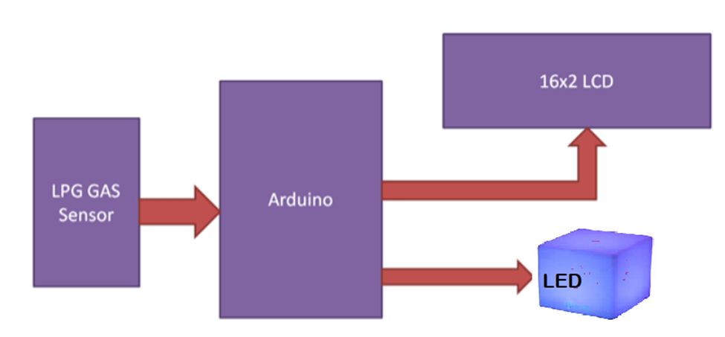

Figure:1 (Block Diagram of gas leakage detector)

# SOFTWARE IMPLEMENTATION FOR SEA DESALINATION

To detect the presence of a toxic gas, or smoke. We will process and display the results, using an LCD display and 2 indicator lights. The MQ2 gas sensor is used for the detection of gas leaks for equipment in the consumer and industrial markets. This sensor detects LPG, butane, propane, methane, alcohol, hydrogen and smoke.it has two outputs: analog and digital, for this project we use the digital output. Then we open Proteus, new project, we can name it gas sensor, find a place to save it, choose a default project, and follow the steps. Open the component library, search for Arduino Uno, or any other. Search for the Gas MQ-2 detector and place it after that we have to choose a resistance of 560 ohms, that we will put it in series with the witness lights. Then we have to Bring a green LED & a red LED. Then we have to search for the LCD display 2 lines and 16 columns, it is more than enough for this application & add a status indicator to indicate the presence of gas or smoke. We position our Arduino in the middle, then we slide the gas sensor, and the status indicator. We have to add a voltage source, we name it Vcc, And a mass, then we connect all that. The mass with the mass of the Arduino, and the sensor. Like for the voltage sources, then we connected the status indicator with the Test Pin input. We connect the OUT pin of the sensor with the digital pin 9 of the Arduino. Then place our LED , we start with the green in series with the resistance of 560 ohms. Then we put the red LED. If there is gas or smoke in the room, the red light will be turned on, and a message will appear. else, the green LED is turned on. Connect the red bulb with the digital pin 6, and the green bulb with the digital pin 7.Then c pins D4 to D7 of the display with the digital inputs / outputs of the Arduino 2 to 5 connected. The Pin E with 11, and RS with 12. Vss and RW connected with the mass. This wiring method is almost a convention, unless there are space constraints. Then we have to open the Arduino compiler, the first thing to do is to declare the

LIQUID CRYSTAL library which contains the functions of the display. Then, we call the LCD function which is used to initialize the digital inputs / outputs of the Arduino with the display, The two first parameters are the numbers of the digital pin Arduino, linked with the E and RS Pin of the LCD display. The other 4 parameters, are the Pin of Arduino connected with the Pin, D2 to D7 on the LCD display. All of these inputs / outputs are digital. Declare a Gas as an integer, which represents the number of the Pin that will read the state of the sensor. Declare 2 integers: red led and green led, which represent the digital output numbers of Pin connected with the red and green LED bulbs respectively. Then we have to configure the digital pin 9 as inputs, it will certainly have 2 states, that is HIGH which indicates the presence of a gas or smoke. Or LOW which indicates no Gas or Smoke.

Simulation of Gas leakage detector

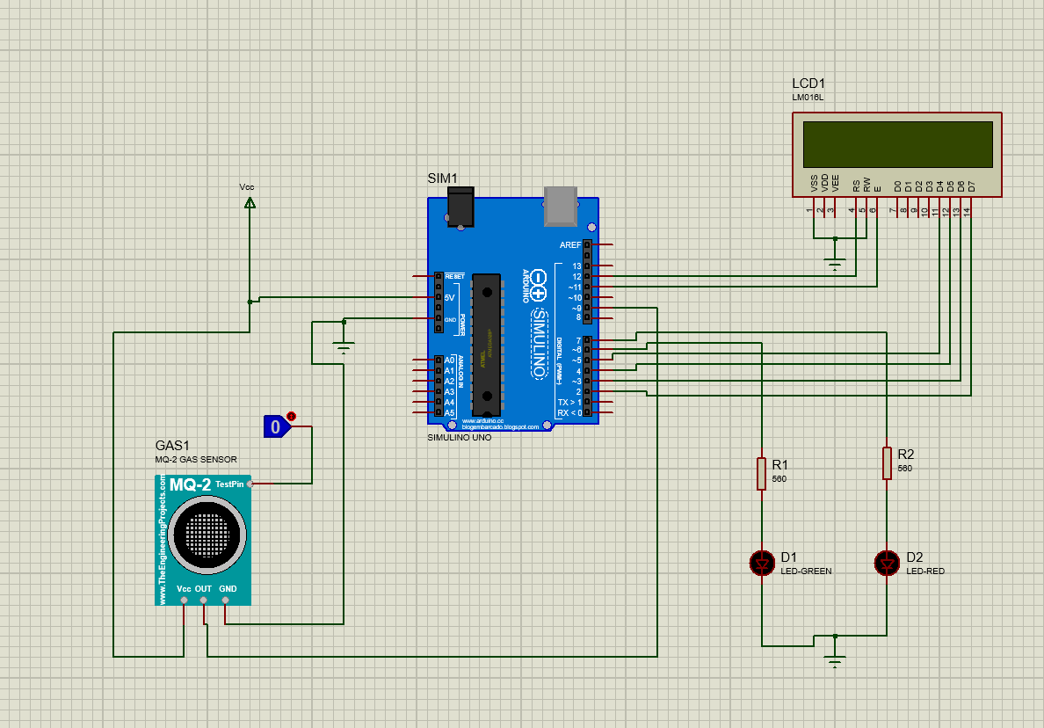

Figure: 2 (Simulation of Gas leakage detector)

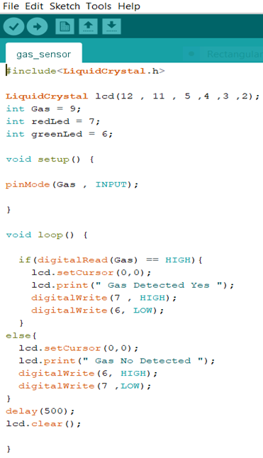

Figure: 3 (Arduino IDE code)

Figure 5 shows the hardware results of the sensor, when gas sensor senses a high logic / obstacle then via the Uno It displays the distance detected it the serial monitor.

# results and Discussion

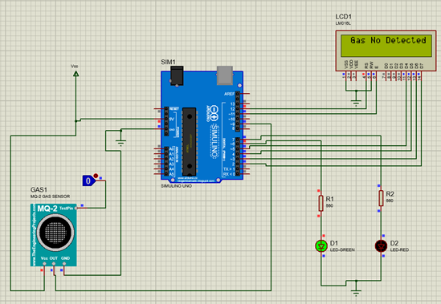

Figure: 4 (No Gas Detected)

If there is gas or smoke in the room, the red light will be turned on, and a message will appear. else, the green LED is turned on.

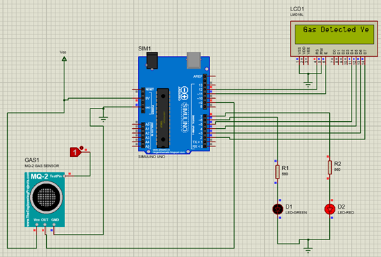

Figure: 5 (Gas detected)

This module contains a MQ2 sensor which actually detects LPG gas, a comparator (LM393) for comparing MQ2 output voltage with reference voltage. It gives a HIGH output when LPG gas is sensed. A potentiometer is also used for controlling sensitivity of gas sensing. This module is very easy to interface with microcontrollers and Arduino and easily available in market by name “LPG Gas Sensor Module”.

# FUTURE WORK / Society and Environmental Impact

Gas sensors using Arduino microcontroller is finally designed and implemented which is capable of detecting LPG leakage for home and industry safety purpose. The sensor also has a facility to detect other harmful gases in the air. An interesting future study might involve testing the LPG gases at different temperatures and using of GSM module for sending the gas leakage message to user’s Smartphone. A mobile gas sensing robot can be constructed to sense the leakage of gas through pipelines as the robot can move on a track which is situated along the length of pipeline.

# CONCLUSION

Its ability to warn its stakeholders about the leakage of the LPG gas. The future aspects of this detector include the GSM module and a tripper circuit which increases the efficiency of the system and provides more safety to the users. This detector is implemented successfully and is easy to use and also a low-cost product. Another advantage of this device is that even though if no one is there in the house and then gas leaks occurs, GSM module is there to send immediate messages to the stakeholders regarding the gas leak and thus it lowers the intensity of accidents. GSM module in this device ensures better safety regarding the gas leaks.

# References

1. A Shrivastava, R Prabhaker, R Kumar, R Verma, "GSM based gas leakage detection system." International Journal of Emerging Trends in Electrical and Electronics, vol. 3, no. 2, pp. 42-45, 2013.
2. Attia, Hussain A., and Halah Y. Ali. "Electronic Design of Liquefied Petroleum Gas Leakage Monitoring, Alarm, and Protection System Based on Discrete Components." International Journal of Applied Engineering Research, vol. 11, no. 19, pp. 9721-9726, 2016.
3. Apeh, S. T., K. B. Erameh, and U. Iruansi. "Design and Development of Kitchen Gas Leakage Detection and Automatic Gas Shut off System." Journal of Emerging Trends in Engineering and Applied Sciences, vol. 5, no. 3, pp. 222-228, 2014.
4. Mahalingam, A., R. T. Naayagi, and N. E. Mastorakis. "Design and implementation of an economic gas leakage detector." Recent Researches in Applications of Electrical and Computer Engineering, pp. 20-24, 2012.