The linear relationship between canopy structure and maximum light use efficiency across biomes

# Summary

* Dechant et al showed there is a linear relationship between temporal LUE and fesc.
* This relationship make more sense if we consider I) maximum LUE and II) over larger scales across biomes or sites, rather than temporally and in one site.
* We pulled 271 sites from AmeriFlux and FluxNet and showed that there is a strong relationship (R2=0.85) between LUEMax and fesc across biomes.
* A pattern emerged is that in open canopies tend to have less LUEMax and fesc and as the density of canopy increases and moving toward forests both of them increase.
* Multiplse scattering as linked to plant physiology implicitly explains the results.
* More mechanistic modeling work is needed to explicitly explain the results.

# Introduction

Light use efficiency (LUE) (Monteith 1972) is the efficiency with which plants convert absorbed radiation into fixed carbon. At the leaf scale, LUE can be defined as the initial slope (quantum yield) of the light response curve (Björkman 1981). At the canopy scale, LUE is defined as the ratio of canopy gross primary production (GPP) divided by absorbed photosynthetically active radiation (APAR) (Gitelson and Gamon 2015). Maximum LUE (εMax) is an important parameter that shows the potential of a plant to convert light to carbon. At the leaf scale, εMax is a function of leaf physiology and potentially has a small variation among different types of plants. For example, Bolton and Hall (1991) showed that εMax for green plants with two photosystems under ideal conditions and bright sunlight is 13%. However, at the canopy scale and within and between biomes, the theoretical εMax is influenced by environmental factors such as temperature, water, plant physiology and canopy strucrture (Medlyn 1998; Gan et al. 2021; Pei et al. 2022) leading to an apparent LUEMax. It is expected that LUEMax varies between different biomes and types of plants.

The variation in LUEMax is of interest as it provides critical information about the ecosystem's capacity for light to carbon conversion. It also serves as the foundation for LUE-based models used in estimating GPP (Pei et al., 2022). The variability in LUEMax has been attributed to a range of processes, from ecological evolution (Field, 1991) to factors such as water use efficiency, nitrogen availability, light quality, pigment distribution, vegetation type, and atmospheric CO2 levels (for a review, see Gitelson and Gamon, 2015; Gan et al., 2021).

One aspect highlighted as a primary driver of changes in LUE is canopy structure (Medlyn 1998; Dechant et al. 2020; de Mattos et al. 2020). Dechant et al. (2020) were the first to investigate the relationship between LUE and canopy structure estimated through remote sensing observations. They correlated the half-hourly and daily LUE values with the fraction of absorbed radiation that escapes the canopy (fesc). The variation in fesc is largely driven by the variation in canopy structure (Knyazikhin et al. 2013; Dechant et al. 2020).

While the findings of Dechant et al. provide valuable insights, there are a few challenges that limit the generalization of their results. First, the LUE is not equivalent to the LUEmax. There is evidence that LUE can vary significantly throughout the day due to changes in factors such as photosynthetically active radiation (PAR), as well as seasonally due to factors like canopy structure, stress, and environmental conditions (Gitelson, Arkebauer, and Suyker 2018; Gamon and Berry 2012). As a result, the relationship between fesc and LUE in Dechant et al. likely confounds the impact of canopy structure with other dynamic factors. In contrast, LUEmax is a more stable metric (Medlyn 1998) and better represents the inherent capacity of plants or biomes to convert light into carbon. Furthermore, the LUE-fesc relationship reported in the study is based on a limited dataset of just three crop sites. A more comprehensive, global study on the relationship between LUEmax and fesc would provide deeper and more generalizable insights.

The main objective of this study is to address the challenges mentioned and examine the relationship between fesc and LUEmax across larger spatial scales. Dechant et al. (2020) demonstrated that up to 80% of the variation in gross primary production (GPP) can be explained by:

$GPP=APAR∙fesc$ (1)

Here, APAR represents absorbed photosynthetic radiation, which can be calculated as:

$GPP=APAR∙ {LUE}_{Max}$ (2)

Where PAR is the photosynthetic absorbed radiation, and fPAR is the fraction of absorbed photosynthetic radiation. The variable fesc can be approximated by (Yelu et al.):

$fesc≈\frac{NIRV}{fPAR}$ (3)

Where NIRV can be acquired by multiplying the normalized difference vegetation index (NDVI = (NIR - RED) / (NIR + RED)) by the reflectance values in the near-infrared region of the spectrum (i.e., NIRV = NDVI * NIR). On the other hand, from the classical approach (Monteith 1972), we have:

$GPP=APAR∙{LUE}_{Max}$ (4)

# By comparing equations 1 and 4, we hypothesize that there is a strong relationship between fesc and LUEmax. This is because changes in canopy structure, and hence fesc, are more dominant spatially over larger domains rather than temporally over a specific site. To test this hypothesis, we utilized data from more than 270 eddy covariance sites along with remote sensing observations and investigated the relationship between the two variables across various biomes and within individual biomes.

# Materials and Methods

The eddy covariance (EC) data used in this study comes from two global EC networks, the FLUXNET2015 Dataset and AmeriFlux. Table S1 (in the supplementary material) provides more information on all the sites used in this study. Both datasets use the same pipeline to process the data (Pastorello et al. 2020). If a site was present in both datasets, we selected its data from AmeriFlux since they usually include the most recent updates compared to its counterpart in FLUXNET.

To calculate fesc, we required reflectance and fPAR data. In this study, we used MODIS products. The reflectance data was obtained from the daily MCD43A4 Version 6.1 Nadir Bidirectional Reflectance Distribution Function (BRDF)-Adjusted Reflectance product, and the fPAR data was obtained from the MCD15A3H Version 6.1 Fraction of Photosynthetically Active Radiation product. Both products have a spatial resolution of 500 meters, which we assume roughly matches the footprint of the EC towers. The fPAR product has a 4-day temporal resolution. To make it consistent with the daily reflectance and EC data, we resampled the fPAR data to daily using linear interpolation.

From the EC data, we only used GPP and PAR data that met the following criteria: 1) 20% or less of the data was gap-filled, 2) the net ecosystem exchange (NEE) uncertainties were less than 3 g C m-2 d-1, and 3) the GPP partitioned using day- and night-time methods differed by less than 3 g C m-2 d-1. We then took the mean of the day and night GPP estimates as the daily GPP (Joiner et al. 2018; Tramontana et al. 2016; Joiner and Yoshida 2020). For the reflectance data, we used the red and near-infrared (NIR) bands. We filtered the data to include only good quality observations where the main BRDF algorithm was used to process the data. Similarly, for the fPAR data, we only included observations where the main radiative transfer algorithm was used to derive fPAR, and there were no significant cloud cover issues in the scene. After the data pre-processing and quality filtering, we were left with 276 sites which include 212,552 days of data across 13 different biomes (see Table 1 for details).

Table 1. The number of site and observations for each biome.

|  |  |  |  |
| --- | --- | --- | --- |
| Biome | Abbreviation | Number of sites | Number of observations |
| Grasslands | GRA | 48 | 36969 |
| Mixed Forests | MF | 9 | 7272 |
| Evergreen Needleleaf Forests | ENF | 67 | 48402 |
| Open Shrublands | OSH | 25 | 18744 |
| Cropland/Natural Vegetation Mosaics | CVM | 1 | 270 |
| Permanent Wetlands | WET | 29 | 17134 |
| Woody Savannas | WSA | 4 | 12756 |
| Deciduous Broadleaf Forests | DBF | 38 | 31851 |
| Croplands | CRO | 38 | 24540 |
| Evergreen Broadleaf Forests | EBF | 6 | 4337 |
| Closed Shrublands | CSH | 5 | 4285 |
| Savannas | SAV | 5 | 5771 |
| Snow and Ice | SNO | 1 | 221 |

To calculate the maximum light-use efficiency (LUEmax) for each site, we first calculated the daily LUE as: $LUE = {GPP}/{PAR∙fPAR}$. We then identified the annual maximum LUE value for each site by looking for the day within a year where the daily LUE was highest. If a site had data for multiple years, we took the median of the annual maximum LUE values as the LUEmax for that site. We used Equation 3 to calculate the fraction of absorbed radiation that escapes the canopy (fesc) and chose the fesc values corresponding to the days when the LUE was at its maximum. Five sites showed fesc values slightly exceeding 1, which is theoretically impossible. We therefore dropped these sites from the analysis. Figure 1 shows the summary distribution of these key variables across the 271 remaining sites.

Figure 1. The distribution of LUEMax and fesc for each biome.

After the data pre-processing based on quality flags and calculating all the variables, we removed any outliers by calculating the standard deviation of each variable (GPP, PAR, reflectance, fPAR) for each site across all the days, and then only kept the data points that were within 2 standard deviations of the mean. To examine the relationship between fesc and LUEmax across different biomes, we first grouped the LUEmax and fesc data based on their respective biomes and calculated the median value for each biome group. We also investigated the relationship between fesc and LUEmax for individual sites within each biome. Additionally, we estimated the standard error for the LUEmax values by dividing the standard deviation of the LUEmax values by the square root of the number of observations presented in each biome or site. This provided a measure of the uncertainty associated with the LUEmax estimates.

# Results

Figure 2 shows a strong linear association between the biome-level median values of LUEmax and fesc (R2 = 0.86). A clear pattern emerges, where biomes with more open canopies, such as open shrublands and savannas, exhibit lower values of both fesc and LUEmax. In contrast, biomes with denser canopies, such as forested ecosystems, tend to have higher values of both fesc and LUEmax. In other words, as the density of the plant canopy increases, both fesc and LUEmax tend to increase together. This relationship observed at the biome level is much stronger compared to the findings of Dechant et al. at the site level. Indeed, when we correlated the daily LUE and fesc for all sites (excluding evergreen forests and closed shrublands), the R2 values are generally less than 0.5, with an average of around 0.3 (Figure sXXX). This suggests that the temporal correlation between LUE and fesc is mostly weak across the majority of individual sites, in contrast to the strong biome-level relationship.

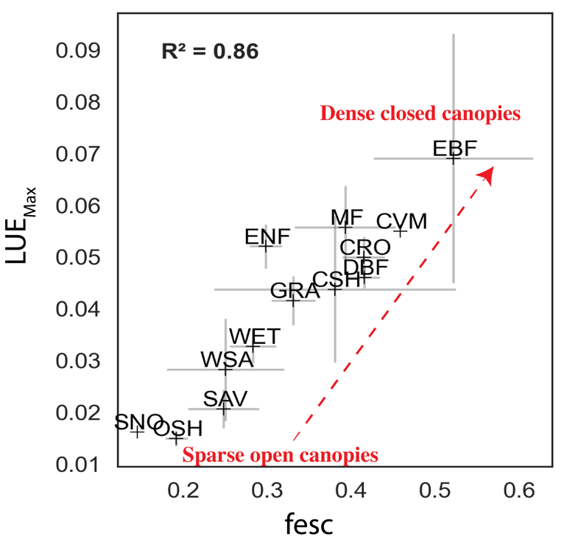

Figure 2. Relationship between fesc and LUEMax across various biomes. Refer to Table 1 for the definition of each biome abbreviation.

Figure 3 reveals a predominantly positive association between LUEmax and fesc when examined between sites within each biome. This trend is evident across most biomes. For example, closed shrublands and woody savannas exhibit a remarkably strong linear relationship, reflected by R² values exceeding 0.96. This signifies a robust positive correlation between these variables within these specific biome types. Within the forested biomes, evergreen broadleaf sites display the strongest positive correlation. It's important to note, however, that the number of sites represented within each biome is uneven. Consequently, directly comparing the strength of these relationships across biomes might be misleading due to variations in sample sizes. Rather, the positive relationship should be paid attention to within each biome, as it suggests a consistent association between canopy structure (as captured by fesc) and the maximum light-use efficiency (LUEmax) at the site level.

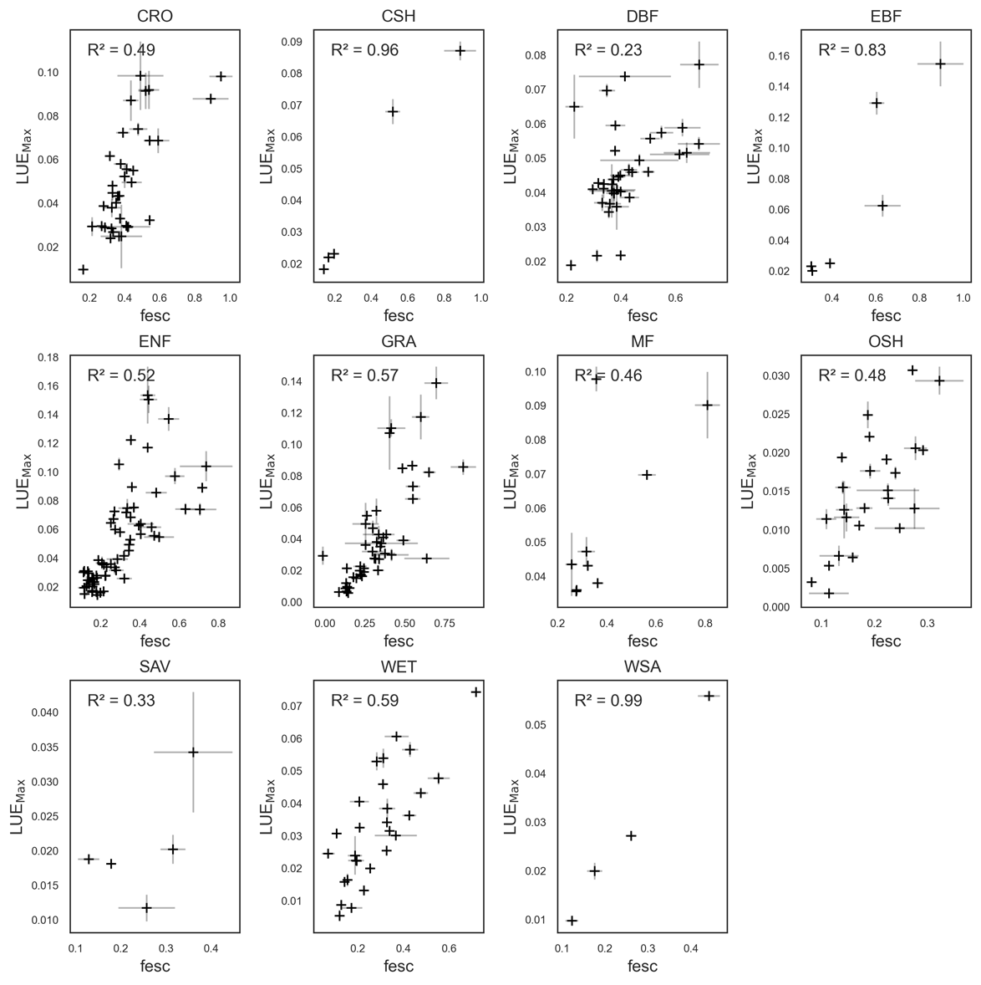

Figure 3. The relationship between fesc and LUEMax across different sites within each biome.

# Discussion

Our study builds upon prior research that found a positive link between temporal LUE and fesc (Dechant et al). However, we demonstrate a significantly stronger and more informative relationship by focusing on two key aspects: 1) using LUEmax, the annual peak in light use efficiency, for a more robust measure, and 2) analyzing the connection across both different biomes and individual sites within each biome. To our knowledge, this is the first study to directly link fesc, with LUEmax across a vast number of sites (>270) spanning diverse biomes. The observed strong linear association, particularly at the biome level, offers valuable insights into how variations in canopy structure influence the maximum light-use efficiency of different ecosystems.

The positive relationship observed between LUEmax and fesc can be explained from both remote sensing and plant physiological perspectives. In the lower left of Figure XXX, we observe biomes with open canopies. These open canopy systems are generally not limited by light availability, resulting in a lower overall LUE [XXX]. Additionally, the increased light penetration through open canopies potentially leads to more frequent multiple scattering of photons within the canopy, causing more photons to escape the canopy in various directions and reducing the number of photons that ultimately reach the sensor, as captured by the lower fesc values.

In contrast, denser canopies such as evergreen broadleaf forests represent closed canopy systems. In these environments, a significant portion of incoming photons is reflected from the top layers of the canopy toward the sensor without much multiple scattering in the lower canopy layers, leading to a higher fesc value. Additionally, leaves in the lower layers of such dense canopies often experience light limitation, indicating a greater capacity for converting the absorbed light into energy, resulting in higher LUEmax. The findings of this study underscore the significant link between canopy structure and optics, and canopy physiology, emphasizing the need for more explicit investigations that integrate both remote sensing observations and process-based models. Such studies could leverage 3D models of radiative transfer model with intergraded with plant physiology models, to further elucidate the mechanisms behind the observed fesc-LUEmax relationship across different biomes.

It’s important to emphasize that our study is observational. While we report a strong positive relationship between LUEMax and fesc, this correlation does not necessarily imply causation. We cannot definitively say that changes in fesc cause changes in LUEMax, or vice versa, without elucidating the underlying mechanisms. However, the observed strong relationship between these variables across various biomes can be used for constraining the estimation of LUEMax for various purposes. For example, many LUE based algorithms to estimate GPP, such as the GPP products from MODIS, [XXXX] consider fixed values for LUEMax for different plants based on land cover data. Our results suggests this approach is problematic as LUEMax changes within the same biome due to changes in canopy structure. Thus, canopy structure and explicitly fesc, is potentially a better candidate for constraining LUEMax than simply land cover type.

There are several challenges associated with this study that open new windows for future studies. Firstly, while fesc is commonly used as an indicator of canopy structure, its approximation using NIRv/fpar has certain limitations. Ideally, fesc should always be less than one, as it represents a fraction of photons escaping the canopy, which, if we ignore canopy fluorescence, cannot exceed the total incoming photons. However, during our analysis, we encountered five sites where fesc values exceeded one. This discrepancy could stem from various factors, ranging from data quality issues to underlying assumptions. For instance, it's conceivable that a site with a closed canopy might experience some level of stress, reducing its chlorophyll content and affecting fpar, while simultaneously exhibiting high NIRv values, leading to fesc values greater than one. Furthermore, in calculating fesc, we assume that soil does not contribute, and that red reflectance values of plants in the scene can be approximated with NDVI*NIR (Yang and van der Tol 2018; Zeng et al. 2019). However, these assumptions can be questioned in scenarios such as sparse canopy cover, where soil can impact both NDVI and NIR. Similarly, defining maximum LUE poses its own challenges. In this study, we simply chose the median of annual maximum LUE values for each site as the representative of LUEMax. However, this approach may overlook year-to-year variations in LUEMax due to factors such as stress. Nonetheless, we assume that given the large number of sites included in our analysis, any changes in LUEMax due to environmental factors would be minimal.

We envision our results open new windows toward bridging plants physiological processes with plants optical properties.

# References

Dechant, Benjamin, Youngryel Ryu, Grayson Badgley, Yelu Zeng, Joseph A. Berry, Yongguang Zhang, Yves Goulas, et al. 2020. “Canopy Structure Explains the Relationship between Photosynthesis and Sun-Induced Chlorophyll Fluorescence in Crops.” *Remote Sensing of Environment* 241 (May): 111733. https://doi.org/10.1016/j.rse.2020.111733.

Gamon, J.A., and J.A. Berry. 2012. “Facultative and Constitutive Pigment Effects on the Photochemical Reflectance Index (PRI) in Sun and Shade Conifer Needles.” *Israel Journal of Plant Sciences* 60 (1–2): 85–95. https://doi.org/10.1560/IJPS.60.1-2.85.

Gitelson, Anatoly A., Timothy J. Arkebauer, and Andrew E. Suyker. 2018. “Convergence of Daily Light Use Efficiency in Irrigated and Rainfed C3 and C4 Crops.” *Remote Sensing of Environment* 217 (November): 30–37. https://doi.org/10.1016/j.rse.2018.08.007.

Gitelson, Anatoly A., and John A. Gamon. 2015. “The Need for a Common Basis for Defining Light-Use Efficiency: Implications for Productivity Estimation.” *Remote Sensing of Environment* 156 (January): 196–201. https://doi.org/10.1016/j.rse.2014.09.017.

Joiner, Joanna, and Yasuko Yoshida. 2020. “Satellite-Based Reflectances Capture Large Fraction of Variability in Global Gross Primary Production (GPP) at Weekly Time Scales.” *Agricultural and Forest Meteorology* 291 (September): 108092. https://doi.org/10.1016/j.agrformet.2020.108092.

Joiner, Joanna, Yasuko Yoshida, Yao Zhang, Gregory Duveiller, Martin Jung, Alexei Lyapustin, Yujie Wang, and Compton J. Tucker. 2018. “Estimation of Terrestrial Global Gross Primary Production (GPP) with Satellite Data-Driven Models and Eddy Covariance Flux Data.” *Remote Sensing* 10 (9): 1346. https://doi.org/10.3390/rs10091346.

Knyazikhin, Yuri, Mitchell A. Schull, Pauline Stenberg, Matti Mõttus, Miina Rautiainen, Yan Yang, Alexander Marshak, et al. 2013. “Hyperspectral Remote Sensing of Foliar Nitrogen Content.” *Proceedings of the National Academy of Sciences* 110 (3): E185–92. https://doi.org/10.1073/pnas.1210196109.

Mattos, Eduardo M. de, Dan Binkley, Otavio C. Campoe, Clayton A. Alvares, and Jose L. Stape. 2020. “Variation in Canopy Structure, Leaf Area, Light Interception and Light Use Efficiency among Eucalyptus Clones.” *Forest Ecology and Management* 463 (May): 118038. https://doi.org/10.1016/j.foreco.2020.118038.

Medlyn, Belinda E. 1998. “Physiological Basis of the Light Use Efficiency Model.” *Tree Physiology* 18 (3): 167–76. https://doi.org/10.1093/treephys/18.3.167.

Monteith, J. L. 1972. “Solar Radiation and Productivity in Tropical Ecosystems.” *Journal of Applied Ecology* 9 (3): 747–66. https://doi.org/10.2307/2401901.

Tramontana, G., M. Jung, C.R. Schwalm, K. Ichii, G. Camps-Valls, B. Ráduly, M. Reichstein, et al. 2016. “Predicting Carbon Dioxide and Energy Fluxes across Global FLUXNET Sites with Regression Algorithms.” *Biogeosciences* 13 (14): 4291–4313. https://doi.org/10.5194/bg-13-4291-2016.

Yang, Peiqi, and Christiaan van der Tol. 2018. “Linking Canopy Scattering of Far-Red Sun-Induced Chlorophyll Fluorescence with Reflectance.” *Remote Sensing of Environment* 209 (May): 456–67. https://doi.org/10.1016/j.rse.2018.02.029.

Zeng, Yelu, Grayson Badgley, Benjamin Dechant, Youngryel Ryu, Min Chen, and J. A. Berry. 2019. “A Practical Approach for Estimating the Escape Ratio of Near-Infrared Solar-Induced Chlorophyll Fluorescence.” *Remote Sensing of Environment* 232 (October): 111209. https://doi.org/10.1016/j.rse.2019.05.028.