Connection between leaf photosynthesis, fluorescence and optics1

Team (in no particular order): Hamid Dashti, Min Chen, Jen E Johnson, William Woodgate, Nastassia Vilfan, Troy Magney, Yelu Zeng, Joseph A Berry

Summary:

This document is only about the project description which explains the main objectives, data, method, and progress. The resulting manuscript will be in a different document. The main goal of this study is to investigate the link between photosynthesis, pulse amplitude measurements (PAM), solar-induced fluorescence (SIF), leaf reflectance, and transmittance. The methodology is based on linking the recently developed photosynthesis model (Johnson and Berry, 2021) with Fluspect-CX (Vilfan et al., 2018) and Ball-Berry stomatal conductance model (Ball et al., 1987). The datasets included in this study are provided by Woodgate, Vilfan, and Magney. In summary, the main steps are I) develop an integrated model, II) test the integrated model on the datasets, and III) run a set of simulations to answer some questions regarding the link between leaf photosynthesis, fluorescence, and optics. So far the integrated model is developed and we are in phase II during which we parametrize and test the model. There are some challenges mostly related to the parameterization of the model which I discuss at the end of the document in the challenges section. Note that in this document we refer to the fluorescence (PAM and SIF), reflectance, and transmittance collectively as leaf optics.

# Introduction

*(Please note this introduction is just to give us some perspective on what the project is about. It will be completed when we have the final results and writing the main manuscript.)*

Recent studies highlights some of the challenges associated with the mechanisms deriving the feedback between leaf chemistry, photosynthesis and optics (e.g. Porcar-Castell et al. 2021; 2014; Van Wittenberghe et al. 2021). At the leaf scale, most of the challenges are related to the ways that leaf chemistry impact different aspects of leaf photosynthesis and the feedback of changing photosynthesis to the leaf optics. For example, the first three challenges associated to chlorophyll fluorescence recognized by (Porcar-Castell et al., 2021) are the role of APARg (PAR absorbed by green pigments), distribution of excitation energy between PSI and PSII and their relative contribution to fluorescence and the energy partitioning in PSII. All of these are are related to the photosynthesis. These challenges impose limitations on the interpretation of leaf optics in relation to the photosynthesis mostly due to the lack of a mechanistic linkage between photosynthesis and leaf optics.

The work done by (Magney et al., 2017) using novel instrumentation and measurements shows the empirical links between some aspects of this integrated system. (Vilfan et al., 2019). Later Vilfan et al., 2019 integrated the photosynthesis model developed by (van der Tol et al., 2014) with the Fluspect-cx radiative transfer model (RTM) to estimate the maximum photosynthetic capacity (Vcmax) using optical data. The coupling of the two models in their work involves parametrization of Fluspect-cx by quantum efficiencies of fluorescence and non-photochemical quenching (NPQ) through an empirical relationship between NPQ and the photochemical reflectance parameter employed by Fluspect-cx to account for xanthophyll cycle. Recently, Johnson and Berry, 2021 developed a new photosynthesis model developed for C3 plants. This model provides a unique mechanistic approach to the radiative processes in the leaf which sets it apart from more empirical photosynthesis models (e.g. Collatz et al., 1991; Farquhar et al., 1980; van der Tol et al., 2014). This improvement leads to a better interpretation of the photosynthesis gas exchange and the associated radiative processes which makes it a suitable candidate for integration with the leaf radiative transfer models (RTMs) for remote sensing purposes. Recently this model extended to C4 and C3-C4 intermediate photosynthesis pathways to describe how photosynthesis responds to light, carbon dioxide, and temperature. The response of plants to environmental conditions and its feedback to plant optics is of great interest to the communities interested in the integration of ecophysiology and optical remote sensing.

Previous studies significantly improved our understanding of leaf optics and photosynthesis. However, there is a lack of a comprehensive study that shows how photosynthesis, leaf chemistry and structure, and leaf optics are mechanistically linked. Recent advances in modeling (Johnson et al., 2021; Johnson and Berry, 2021; Vilfan et al., 2018) and simultaneous measurements of gas exchange, PAM, SIF, reflectance, and transmittance (Magney et al., 2017; Vilfan et al., 2019) provide a unique opportunity to shed more light on this complex issue. **Thus, the main research questions are 1) What are the main relationships between leaf optics, photosynthetic processes, and leaf chemistry and structure? And 2) How do factors such as temperature and relative water content impact these relationships? Answering these questions involves three main phases: I) developing an integrated, mechanistic model; II) testing the model using various datasets and; III) performing a set of simulations to tease apart different aspects of the leaf optics-photosynthesis system.**

# Materials and Method

## Datasets

In this study, we use three datasets. The first one is provided by Woodgate (ref TBD) from a recent field campaign in Australia. Light and CO2 response curves using a modified Li-6800 were collected on 8 leaves at the Tumbarumba research site in April 2022. Combined gas exchange, PAM fluorescence, reflectance and transmittance (400-650nm), and spectral fluorescence both forward- and back-scattered (660-850nm) observations were collected for each light and CO2 level. The second dataset is provided by (Vilfan et al., 2019). This dataset also includes the light and CO2 response curves, PAM, and gas-exchange measurements; however, the optical measurements are limited to transmittance and downward SIF. The last dataset is provided by Magney from miscellaneous experiments. The measurements are mostly leaf gas exchange and downward SIF. It is worth to note that data provided by Vilfan and Magney include water treatment which might help us to further investigate the role of water in regulating leaf optics-photosynthesis relationships.

## Phase1: Model development

Figure 1 shows the general model structure. We assume that either we know leaf chemistry or it can be reliably retrieved using inversion of leaf RTMs such as Fluspect-CX and measured reflectance and transmittance. The process starts with calculating the fraction of PAR absorbed (fPAR) by the leaf using Fluspect-CX and leaf chemistry and structure. We then use chlorophyll content to approximate the Vcmax and regulate photosynthesis by relative water content (RWC). Multiple studies show that RWC regulates photosynthesis (Lawlor and Cornic, 2002; Trueba et al., 2019). Leaves tolerate the water deficit up to a threshold and photosynthesis continues without significant change. If the water deficit passes the tolerance threshold, photosynthesis reduces mostly due to regulating the stomata. If water continues to drop, then the changes in photosynthesis are mostly related to photochemical processes such as electron transport, etc. (Lawlor and Cornic, 2002; Zivcak et al., 2013). After a critical threshold photosynthesis completely shuts down. With the assumption of knowing the saturated water content and using the water content input to the Fluspect-CX model, the relative water content can be estimated. Then similar to ecosystem models such as CLM 4.5 (Bonan et al., 2014) we apply the water deficit using a piecewise function to the intercept of the Ball-Berry stomatal conductance model and also Vcmax. Figure 2 shows an example of how photosynthesis response to water deficit would look like. Note in this figure the slope and critical points are free parameters. After parameterizing the photosynthesis model using fPAR, Vcmax, and RWC, we simulate the gas exchange and PAM observations. Then similar to (Vilfan et al., 2018), the Cx and quantum yields of fluorescence in Fluspect-CX are estimated to calculate the reflectance, transmittance, and backward and forward SIF.



Figure 1. *The diagram of integrated model.*

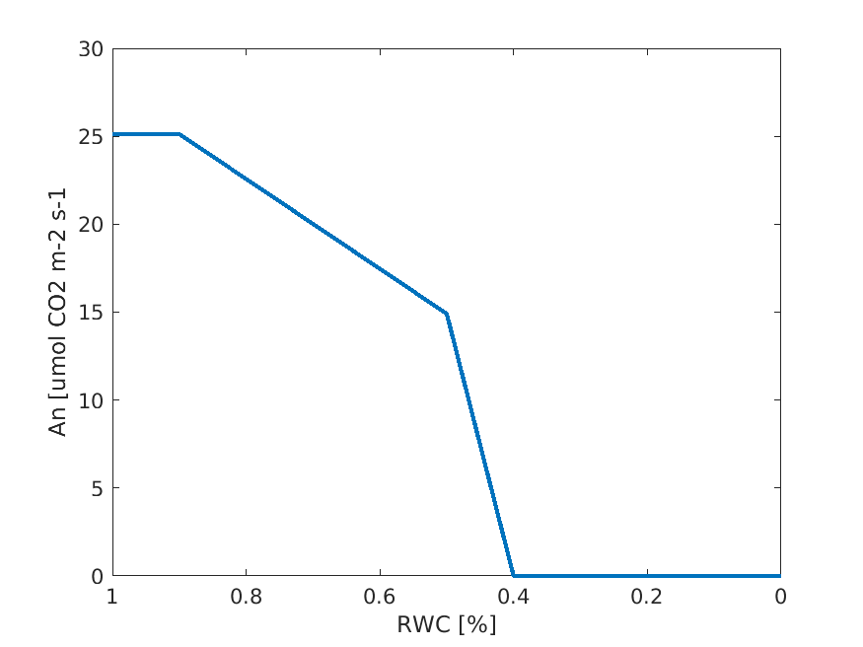

Figure 2. *A conceptual figure representing the response of the photosynthesis to the water deficit in the model.*

### Inversion of the photosynthesis model

One of the key challenges is the inversion of the photosynthesis model to estimate some of the kry parameters. We try to invert the model using the data collected by Woodgate, 2022 and the framework developed by Johnson et al, 2021. Table 1 shows all the fixed parameters. The free parameters are the Maximum activity of Cyt b6f (Vqmax), Maximum activity of rubisco (Vcmax) the two weighting factors that account for emission spectra of PS I and PS II, the escape ratio of fluorescence as a function of wavelength, and the spectral response of a given PAM detector. We fitted the model to the photosynthesis, steady state fluorescence (Fs) and NPQ (Kn2 values in the model). Fs values were scaled to the minimum fluorescence (Fo) in both observation and model (Vilfan et al, 2018).

|  |  |  |  |
| --- | --- | --- | --- |
| Parameter | Value | Unit | Description |
| Q | 0 to 2500 | umol PPFD m−2 s−1 | Photosynthetically active radiation |
| C | 0 to 1300 | mol mol-1 | CO2 in chloroplast |
| T | 25 | ◦C | Leaf temperature |
| O | 209 | mbar O2 | O2 in chloroplast |
| a | 0.85 to 0.95 | mol mol-1 | Total leaf absorbance to PAR |
| a1, a2 | 0.41, 0.44 | mol mol-1 | Absorbance cross-section of PS I & PS II |
| Rd | 0.05 | % | Dark respiration scaled to Vmax Rubisco |
| KF1, KF2 | 0.05 | ns-1 | Rate constant for fuorescence at PS I & PS II |
| KD1, KD2 | 0.55 | ns-1 | Rate constant for constitutive heat loss at PS I & PS II |
| KP1 | 14.5 | ns-1 | Rate constant for photochemistry at PS I |
| KP2 | 4.5 | ns-1 | Rate constant for photochemistry at PS II |
| KU2 | 2 | ns-1 | Rate constant for excitation sharing at PS II |
| Kq | 300 | mol PQH2 mol−1 sites s−1 | Catalytic constant for PQH2 for Cyt b6f |
| nL | 0.75 | mol ATP mol−1 e− | Coupling efciency of linear electron flow |
| nC | 1.0 | mol ATP mol−1 e− | Coupling efficiency of cyclic electron flow |
| kC | 3.6 | mol CO2 mol−1 sites s−1 | Catalytic constant for CO2 for Rubisco |
| ko | 0.9 | mol O2 mol−1 sites s−1 | Catalytic constant for O2 for Rubisco |
| KC | 260 | ubar | Michaelis constant for CO2 for Rubisco |
| KO | 179 | ubar | Michaelis constant for O2 for Rubisc |

## Phase 2: model testing

This phase is designed to answer the first question of this study: what are the main relationships between leaf optics, photosynthetic processes, and leaf chemistry and structure? In summary, we drive different relationships between the observations and investigate if the model can reproduce those relationships. We also compare these relationships with those reported in other observational studies (Hikosaka, 2021; Hikosaka and Tsujimoto, 2021; Magney et al., 2017). Figure 3 shows the general flowchart of this phase. Currently, our focus is on the CO2 and light curve experiment data provided by Vilfan and Woodgate. The Woodgate dataset does not have leaf chemistry; however, it provides the measured reflectance and transmittance. We used this data to invert the Fluspect-CX model to estimate the leaf chemistry and structure. In the next steps, there are some free parameters related to the photosynthesis model that need to be estimated. So far, we only inverted the model to estimate Vcmax and Vqmax (maximum Cyt b6f activity). The cost function minimizes the difference between measured and simulated photosynthesis (i.e., An). Other parameters are set fixed based on (Johnson et al., 2021; Johnson and Berry, 2021). The inversion method is called Covariance matrix adaptation evolution strategy (CMAES). We attempted to invert the photosynthesis model using multiple objective optimizations using both photosynthesis (An) and steady-state fluorescence (Fs) and NPQ (i.e., Kn2 in the model). We normalized Fs to minimum fluorescence (Fo) in both model and observations. As we will discuss in the challenges section (below), our results for multiple objective functions does not look great and we are working on it.

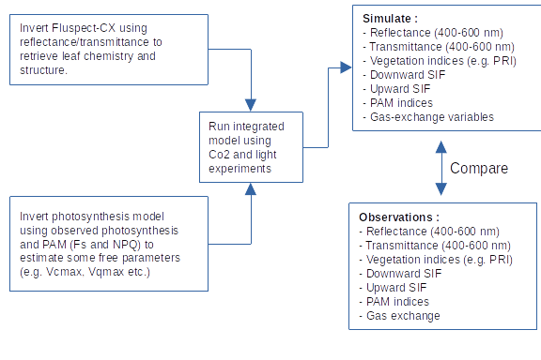

Figure 3. Flowchart of steps regarding the testing of the integrated model.

## Phase 3: Simulations

The objective of this section is to answer the second question of the study: How do factors such as temperature and water content would impact these relationship? To answer this question, we run the integrated model while changing RWC and temperature. Similar to (Johnson et al., 2021) we setup different scenarios in which we change the environmental conditions and investigate how these changes affect the relationships derived and observed during phase 2.

# Preliminary results

# Observations

### Dataset 1

This dataset is provided by Woodgate (2022). We plotted the data for both CO2 and light response curve (LRC) experiments. Figures 4 and 5 show the gas exchange for the CO2 and LRC, respectively. By comparing the two experiments we can observe that the key variables such as photosynthesis and electron transport rate (ETR) follow the same patterns in both experiments. However, some variables behave totally different between the two experiments. For example, the photochemical quantum yield of PSII (PhiPS2) increases as CO2 increases and remains fixed after some point (Figure 4). However, the same variable with increasing PAR shows an opposite pattern (Figure 5). There are other examples such as NPQ, qL, and Fm.

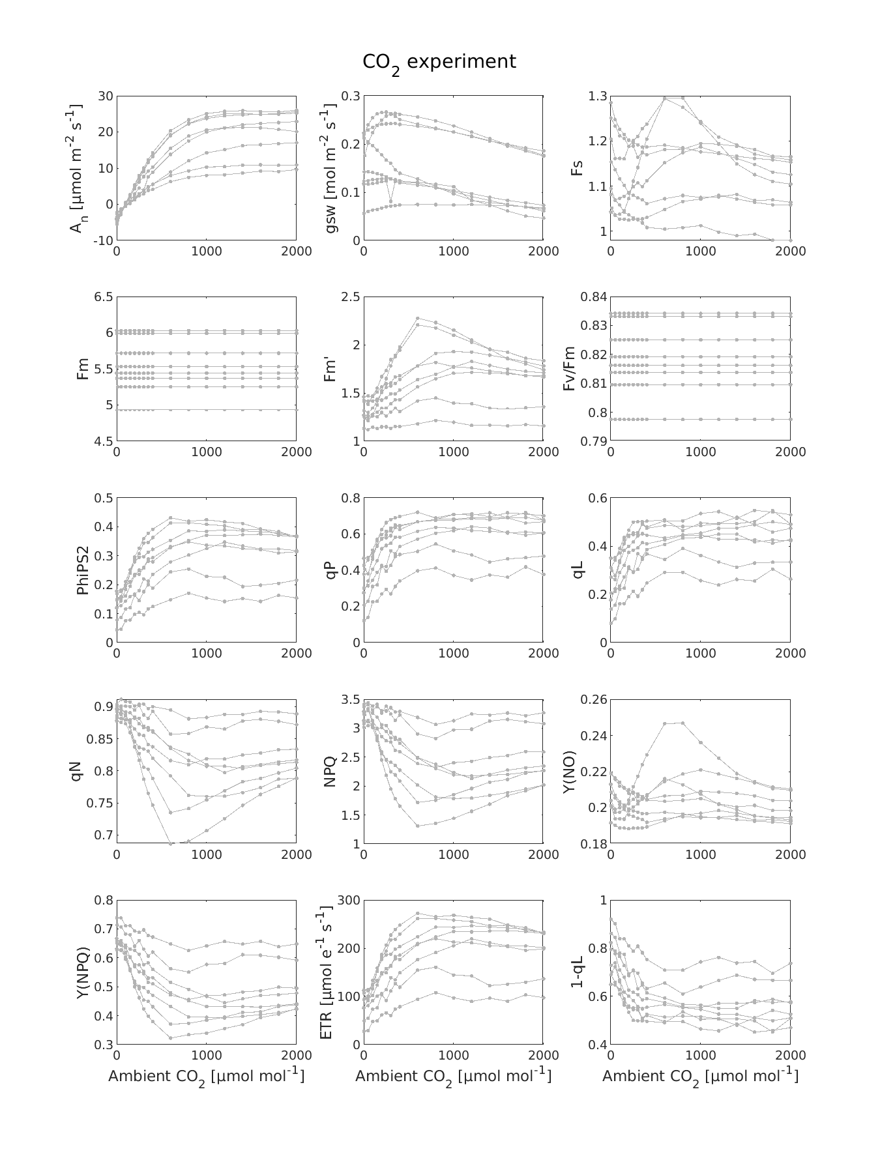

Figure 4. *Gas-exchange variables for CO2 experiment. Measurements are from 8 leaves labeled as L1-L8.*

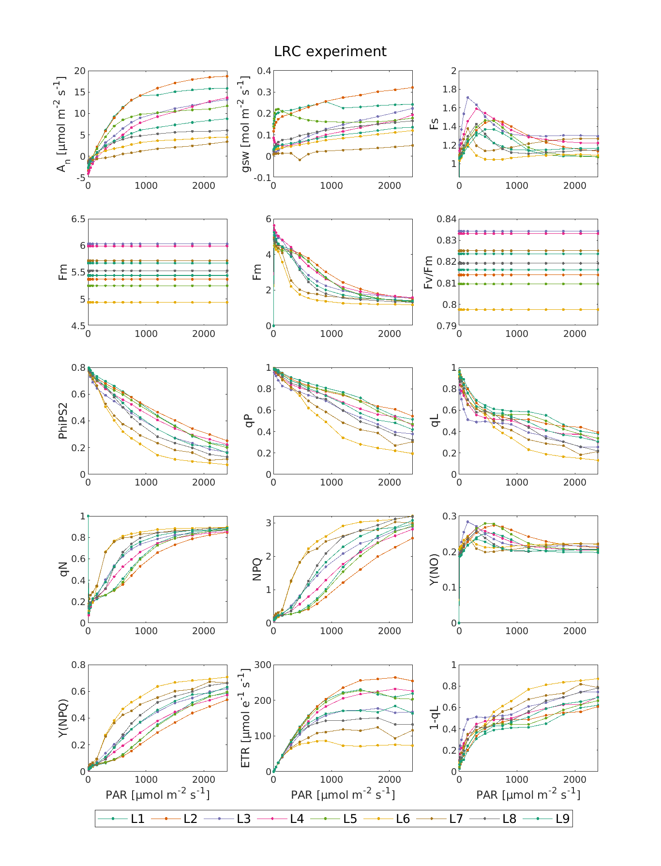

Figure 5. *Gas-exchange variables for CO2 experiment. Measurements are from 8 leaves labeled as L1 to L9.*

Figures 6 shows the reflectance (ρ), transmittance (τ), maximum (Fmax), minimum (Fmin) and steady state (Fs) fluorescence in backward and forward directions as subscribed by f and b. Figure 7 show similar variables for LRC experiment. The reflectance and transmittance patterns are similar between the two experiments, however changes in LRC experiment are more notable. Interestingly, except Fmin which is noisy in both experiment, the patterns between Fmax and Fs are totally different. Increasing CO2 leads to an increase in Fmax, however increasing PAR decreases Fmax in both backward and forward direction. On the other hand, by increasing CO2, Fs first decreases up to ambient CO2 of ~100 ppm then Fs starts to increase and at around ~750 ppm a decreasing process starts.

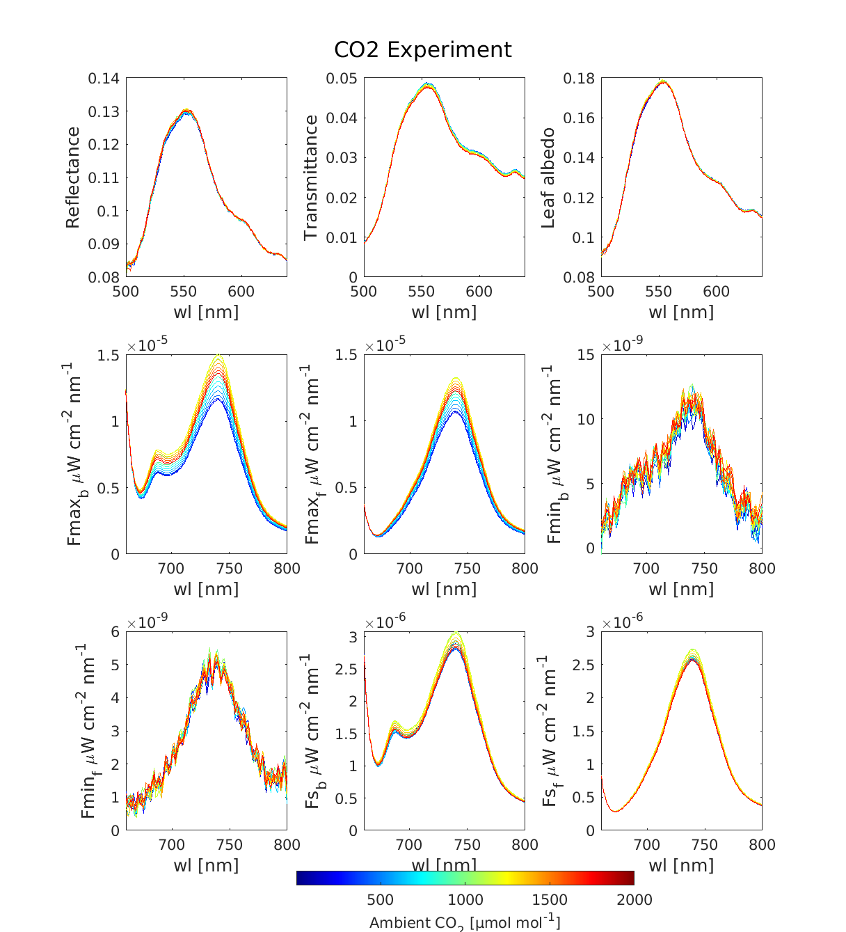

Figure 6. *Reflectance, transmittance and SIF measurements for CO2 and CO2 experiments.*

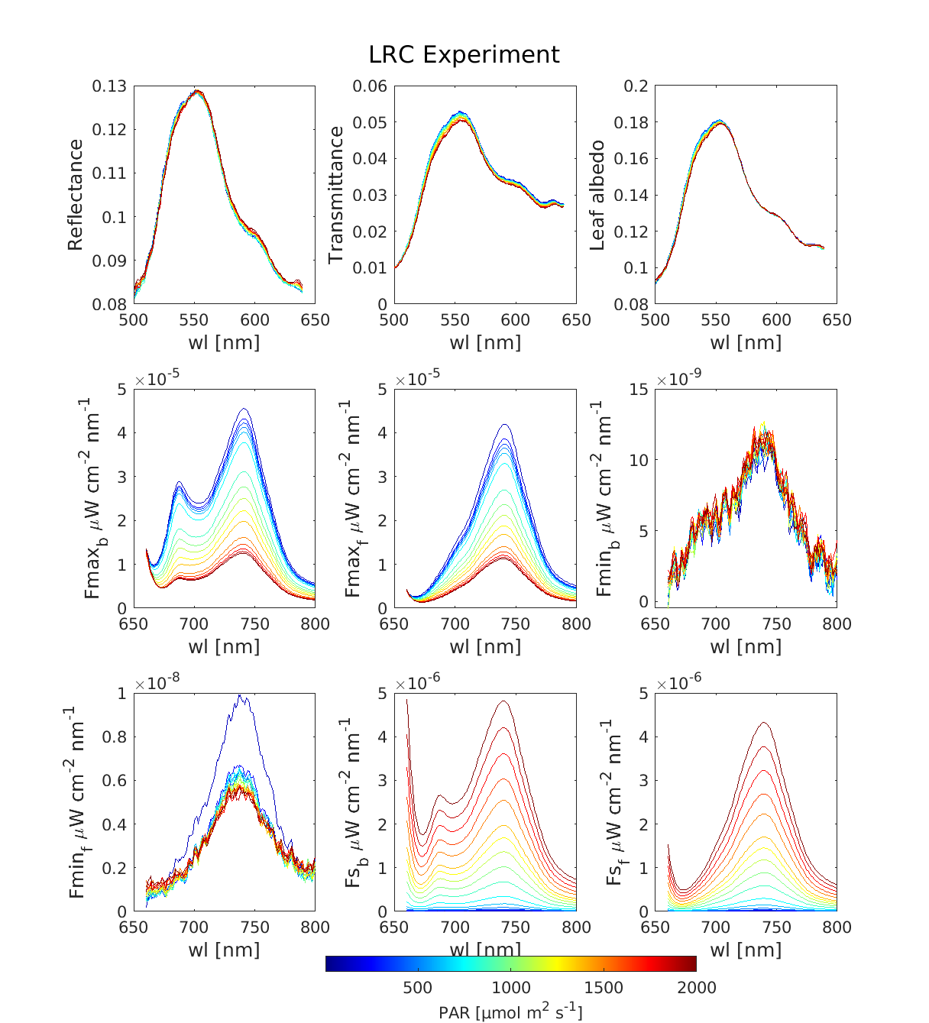

Figure 7. *Reflectance, transmittance and SIF measurements for CO2 and LRC experiments.*

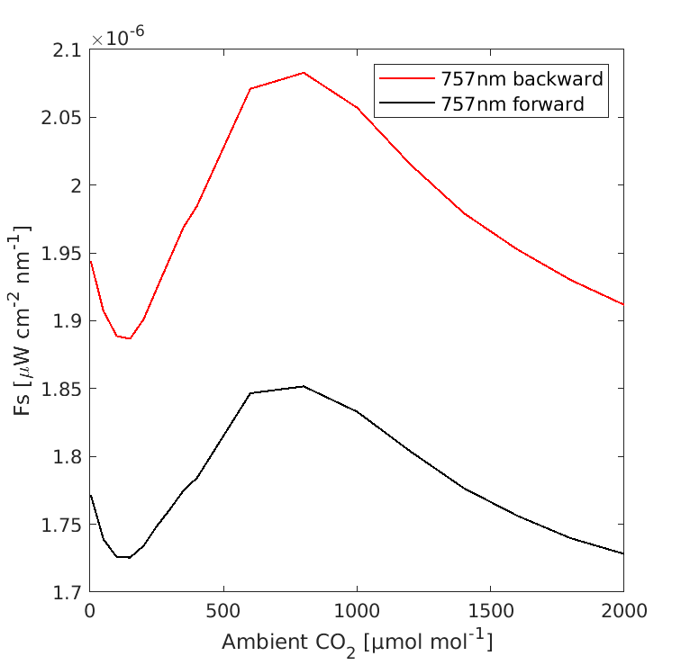

Figure 8. The measured backward and forward Fs for one spectral band (757 nm) as ambient CO2 increases. Up to 100 ppm there is a decline in Fs and then Fs increases as CO2 increases up to ~750 ppm and after that point Fs start to decrease again.

Finally figure 9 and 10 shows the PRI index for CO2 and LRC experiments, respectively. We calculated PRI based on reflectance, transmittance and albedo. Overall, there is a change in PRI as CO2 and PAR increases. The pattern, however, between the two is different. As CO2 increases, PRI slightly increases and then become stable. However, as PAR increases, PRI constantly decreases.

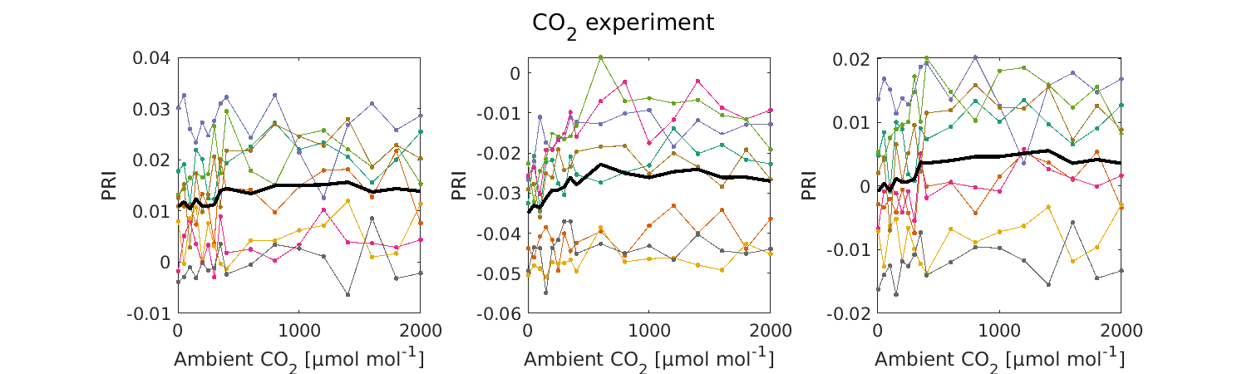

Figure 9. PRI values for CO2 experiment which are calculated based on (left) reflectance, (middle) transmittance and (left) albedo.

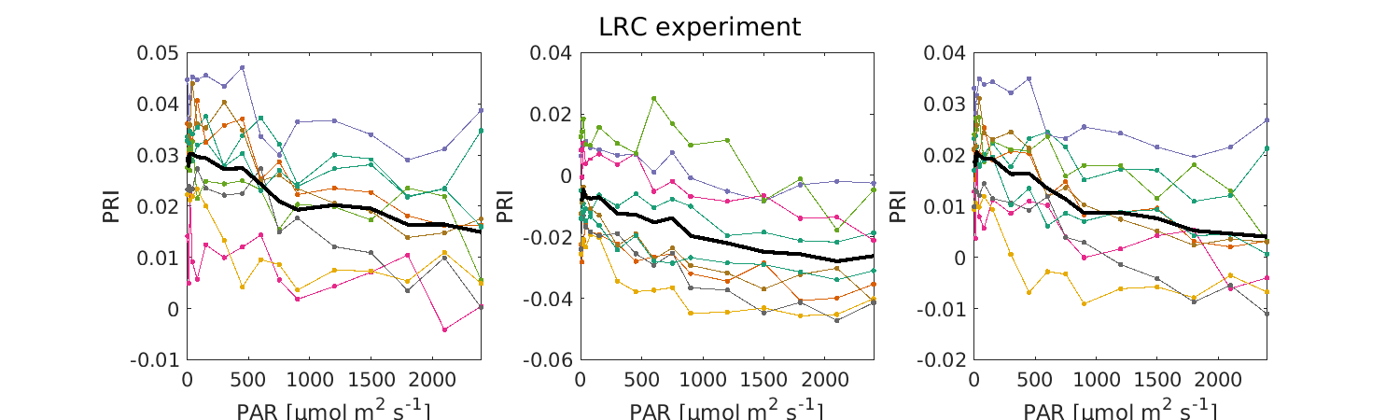\

Figure 10. PRI values for LRC experiment which are calculated based on (left) reflectance, (middle) transmittance and (left) albedo.

### Dataset 2 (To be completed)

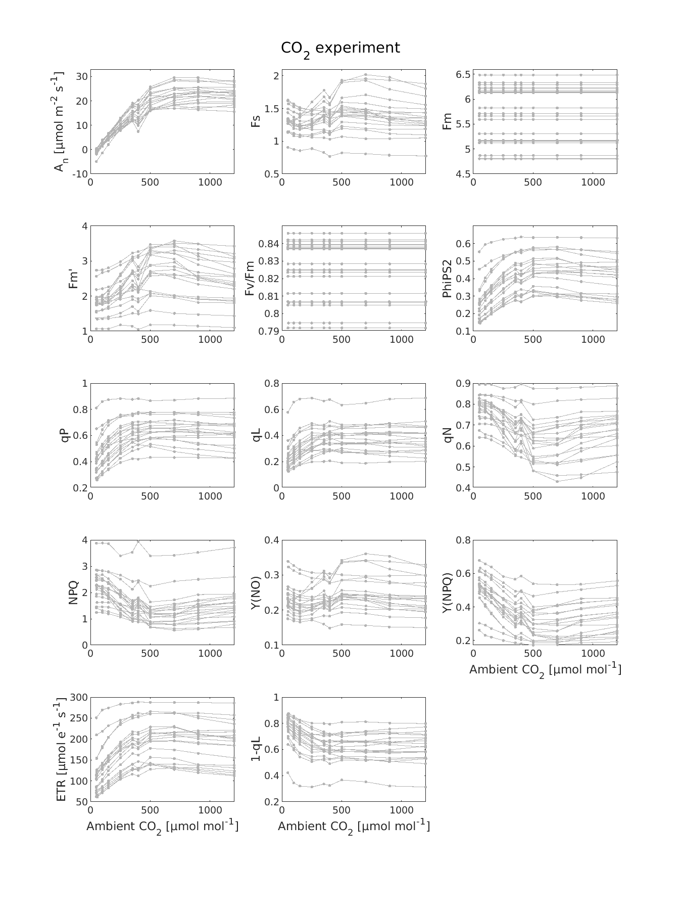

### Inversion

Figure 11 shows the quality of fit for the CO2 experiment in using Woodgate’s data. As we can see and expected, there is a strong positive correlation between the two variables.

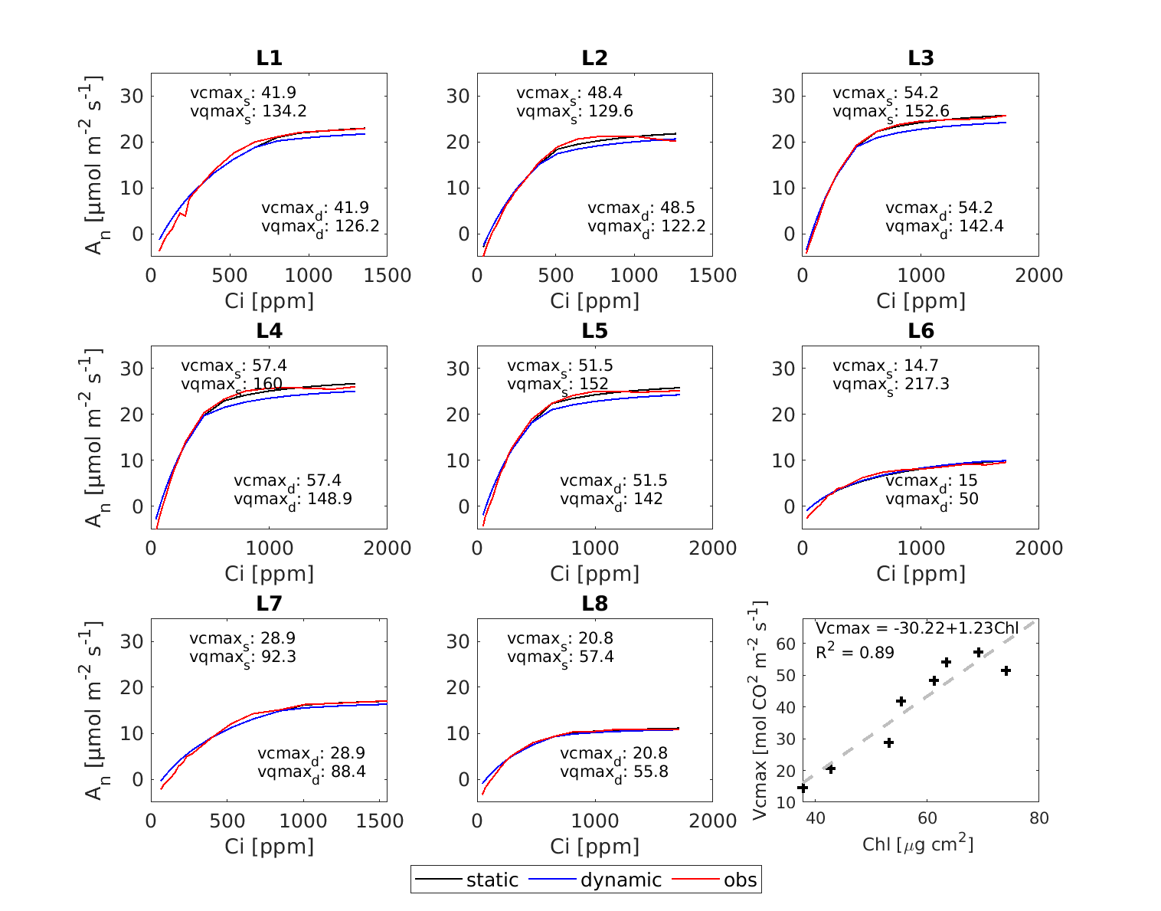

### Challenges:

Currently the big problem that we are working in the inversion of the photosynthesis model to estimate a number of model parameters. Currently, we are trying to implement the inversion scheme discussed in the Johnson 2021 publications. However, there are still some challenges such as:

* What parameter to consider free and what to consider fixed.
* What is the range of the free parameters and values of the fixed parameters.
* Is there any model constrain and how to incorporate that into the inversion scheme.

My plan is to contact Dr Johnson and discuss it in more detail. Any comment and suggestion are welcomed.

# References:

Ball, J.T., Woodrow, I.E., Berry, J.A., 1987. A Model Predicting Stomatal Conductance and its Contribution to the Control of Photosynthesis under Different Environmental Conditions, in: Biggins, J. (Ed.), Progress in Photosynthesis Research: Volume 4 Proceedings of the VIIth International Congress on Photosynthesis Providence, Rhode Island, USA, August 10–15, 1986. Springer Netherlands, Dordrecht, pp. 221–224. <https://doi.org/10.1007/978-94-017-0519-6_48>

Bonan, G.B., Williams, M., Fisher, R.A., Oleson, K.W., 2014. Modeling stomatal conductance in the earth system: linking leaf water-use efficiency and water transport along the soil–plant–atmosphere continuum. Geosci. Model Dev. 7, 2193–2222. <https://doi.org/10.5194/gmd-7-2193-2014>

Collatz, G.J., Ball, J.T., Grivet, C., Berry, J.A., 1991. Physiological and environmental regulation of stomatal conductance, photosynthesis and transpiration: a model that includes a laminar boundary layer. Agric. For. Meteorol. 54, 107–136. <https://doi.org/10.1016/0168-1923(91)90002-8>

Farquhar, G.D., von Caemmerer, S., Berry, J.A., 1980. A biochemical model of photosynthetic CO2 assimilation in leaves of C3 species. Planta 149, 78–90. <https://doi.org/10.1007/BF00386231>

Hikosaka, K., 2021. Photosynthesis, chlorophyll fluorescence and photochemical reflectance index in photoinhibited leaves. Funct. Plant Biol. 48, 815–826. <https://doi.org/10.1071/FP20365>

Hikosaka, K., Tsujimoto, K., 2021. Linking remote sensing parameters to CO2 assimilation rates at a leaf scale. J. Plant Res. 134, 695–711. <https://doi.org/10.1007/s10265-021-01313-4>

Johnson, J.E., Berry, J.A., 2021. The role of Cytochrome b6f in the control of steady-state photosynthesis: a conceptual and quantitative model. Photosynth. Res. 148, 101–136. <https://doi.org/10.1007/s11120-021-00840-4>

Johnson, J.E., Field, C.B., Berry, J.A., 2021. The limiting factors and regulatory processes that control the environmental responses of C3, C3–C4 intermediate, and C4 photosynthesis. Oecologia 197, 841–866. <https://doi.org/10.1007/s00442-021-05062-y>

Lawlor, D.W., Cornic, G., 2002. Photosynthetic carbon assimilation and associated metabolism in relation to water deficits in higher plants. Plant Cell Environ. 25, 275–294. <https://doi.org/10.1046/j.0016-8025.2001.00814.x>

Magney, T.S., Frankenberg, C., Fisher, J.B., Sun, Y., North, G.B., Davis, T.S., Kornfeld, A., Siebke, K., 2017. Connecting active to passive fluorescence with photosynthesis: a method for evaluating remote sensing measurements of Chl fluorescence. New Phytol. 215, 1594–1608. <https://doi.org/10.1111/nph.14662>

Porcar-Castell, A., Malenovský, Z., Magney, T., Van Wittenberghe, S., Fernández-Marín, B., Maignan, F., Zhang, Y., Maseyk, K., Atherton, J., Albert, L.P., Robson, T.M., Zhao, F., Garcia-Plazaola, J.-I., Ensminger, I., Rajewicz, P.A., Grebe, S., Tikkanen, M., Kellner, J.R., Ihalainen, J.A., Rascher, U., Logan, B., 2021. Chlorophyll a fluorescence illuminates a path connecting plant molecular biology to Earth-system science. Nat. Plants 7, 998–1009. <https://doi.org/10.1038/s41477-021-00980-4>

Porcar-Castell, A., Tyystjärvi, E., Atherton, J., van der Tol, C., Flexas, J., Pfündel, E.E., Moreno, J., Frankenberg, C., Berry, J.A., 2014. Linking chlorophyll a fluorescence to photosynthesis for remote sensing applications: mechanisms and challenges. J. Exp. Bot. 65, 4065–4095. <https://doi.org/10.1093/jxb/eru191>

Trueba, S., Pan, R., Scoffoni, C., John, G.P., Davis, S.D., Sack, L., 2019. Thresholds for leaf damage due to dehydration: declines of hydraulic function, stomatal conductance and cellular integrity precede those for photochemistry. New Phytol. 223, 134–149. <https://doi.org/10.1111/nph.15779>

van der Tol, C., Berry, J.A., Campbell, P.K.E., Rascher, U., 2014. Models of fluorescence and photosynthesis for interpreting measurements of solar-induced chlorophyll fluorescence. J. Geophys. Res. Biogeosciences 119, 2312–2327. <https://doi.org/10.1002/2014JG002713>

Van Wittenberghe, S., Sabater, N., Cendrero-Mateo, M.P., Tenjo, C., Moncholi, A., Alonso, L., Moreno, J., 2021. Towards the quantitative and physically-based interpretation of solar-induced vegetation fluorescence retrieved from global imaging. Photosynthetica 59, 438–457. <https://doi.org/10.32615/ps.2021.034>

Vilfan, N., van der Tol, C., Verhoef, W., 2019. Estimating photosynthetic capacity from leaf reflectance and Chl fluorescence by coupling radiative transfer to a model for photosynthesis. New Phytol. 223, 487–500. <https://doi.org/10.1111/nph.15782>

Vilfan, N., Van der Tol, C., Yang, P., Wyber, R., Malenovský, Z., Robinson, S.A., Verhoef, W., 2018. Extending Fluspect to simulate xanthophyll driven leaf reflectance dynamics. Remote Sens. Environ. 211, 345–356. <https://doi.org/10.1016/j.rse.2018.04.012>

Zivcak, M., Brestic, M., Balatova, Z., Drevenakova, P., Olsovska, K., Kalaji, H.M., Yang, X., Allakhverdiev, S.I., 2013. Photosynthetic electron transport and specific photoprotective