Connection between leaf photosynthesis, fluorescence and optics

Team (in no particular order): Hamid Dashti, Min Chen, Jen E Johnson, William Woodgate, Nastassia Vilfan, Troy Magney, Yelu Zeng, Joseph A Berry

Summary:

This document is only about the project description which explains the main objectives, data, method and progress. The resulting manuscript will be in a different document. The main goal of this study is to investigate the link between photosynthesis, pulse amplitude measurements (PAM), solar induced fluorescence (SIF) and leaf optics (i.e. reflectance, transmittance). The methodology is based on linking the recently developed photosynthesis model (Johnson and Berry, 2021) with Fluspect-CX (Vilfan et al., 2018) and Ball-Berry stomatal conductance model (Ball et al., 1987). The datasets included in this study are provided by Woodgate, Vilfan and Magney. In summary the main steps are I) develop the integrated model, II) test the integrated model on the datasets and III) run a set of simulations to answer some questions regarding the link between leaf photosynthesis, fluorescence and optics. So far the integrated model is developed and we are in the phase II which we parametrize and test the model. In the next section I start with an introduction to the objectives and questions to be answered and then I proceed to provided more detail on each step to address these questions. Note that in most cases in this document we refer to the fluorescence (PAM and SIF), reflectance and transmittance collectively as leaf optics

Introduction:
(Please note this introduction is just to give us some perspective on what the project is about. It will be completed when we have the final results and writing the main manuscript.)

Recent studies highlights some of the challenges associated with the mechanisms deriving the feedback between leaf chemistry, photosynthesis and optics (e.g. Porcar-Castell et al. 2021; 2014; Van Wittenberghe et al. 2021). At the leaf scale most of the challenges are related to the ways that leaf chemistry impact different aspects of leaf photosynthesis and the feedback of changing photosynthesis to the leaf optics. For example the first three challenges associated to chlorophyll fluorescence recognized by (Porcar-Castell et al., 2021) are the role of APAR_{g} (PAR absorbed by green pigments), distribution of excitation energy between PSI and PSII and their relative contribution to fluorescence and the energy partitioning in PSII which are related to the photosynthesis. These challenges impose limitations on the interpretation of leaf optics in relation to the photosynthesis mostly due to the lack of a mechanistic linkage between photosynthesis and leaf optics.
The work done by (Magney et al., 2017) using a novel instrumentation and measurements shows the empirical links between some aspects of this integrated system. (Vilfan et al., 2019). Later Vilfan et al., 2019 integrated the photosynthesis model developed by (van der Tol et al., 2014) with the Fluspect-cx radiative transfer model (RTM) to estimate the maximum photosynthetic capacity (Vcmax) using optical data. The coupling of the two models in their work involves parametrization of Fluspect-cx by quantum efficiencies of fluorescence and non-photochemical quenching (NPQ) through and an empirical relationship between NPQ and the photochemical reflectance parameter employed by Fluspect-cx to account for xanthophyll cycle. Recently Johnson and Berry, 2021 developed a new photosynthesis model developed for C3 plants. This model provides a unique mechanistic approach on the radiative processes in the leaf which sets it apart from more empirical photosynthesis models (e.g. Collatz et al., 1991; Farquhar et al., 1980; van der Tol et al., 2014). This improvement leads to better interpretation of the photosynthesis gas-exchange in relation to radiative processes which makes it a suitable candidate for integration with leaf radiative transfer model for remote sensing purposes. Recently this model extended to C4 and C3-C4 intermediate photosynthesis pathways to describe how photosynthesis responds to light, carbon dioxide, and temperature. The response of plants to environmental conditions and its feedback to plant optics is of great interest to the communities interested in integration of ecophysiology and optical remote sensing.
Previous studies significantly improved our understanding of the leaf optics and photosynthesis. However, there is a lack of a comprehensive study that shows how photosynthesis, leaf chemistry and structure and leaf optics are mechanistically linked. Recent advances in modeling (Johnson et al., 2021; Johnson and Berry, 2021; Vilfan et al., 2018) and simultaneous measurments of gas-exchange, PAM, SIF, reflectance, transmittance (Magney et al., 2017; Vilfan et al., 2019) provide a unique opportunity to shed more light on this complex issue. Thus, the main research questions are: 1) What are the main relationships between leaf optics, photosynthetic processes and leaf chemistry and structure? And 2) How do environmental conditions such as temperature and water content would impact these relationship? Answering this questions involves three main phases: I) developing an integrated, mechanistic model; II) testing the model using various datasets and; III) performing a set of simulations to tease a part different aspects of leaf optics-photosynthesis system.

Materials and Method

Dataset
In this study we use three datasets. The first one is provided by Woodgate (ref TBD) from recent field campaign in Asutralia. Light and CO2 response curves using a modified Li-6800 were collected on 8 leaves at the Tumbarumba research site in April, 2022. Combined gas exchange, PAM fluorescence, reflectance and transmittance (400-650nm), and spectral fluorescence both forward- and back-scattered (660-850nm) observations were collected for each light and CO2 level. The second dataset is provided by (Vilfan et al., 2019).This dataset also includes the light and CO2 response curves and PAM and gas-exchange measurments, however the optical measurements are limited to transmittance and downward SIF. The last dataset is provided by Magney from miscellaneous experiments. The measurements are mostly leaf gas-exchange and downward SIF. It worth to note that data provided by Vilfan and Magney include water treatment which might help us to furthur investigate the role of water in regulating leaf optics-photosynthesis relationships.

Phase1: Model development
Figure 1 shows the general model structure. Our assumption is we know leaf chemistry or we can reliably retrieve them using inversion of leaf RTMs such as Fluspect-CX and measured reflectance and transmittance. The process starts with calculating fraction of PAR absorbed (fPAR) by the leaf using Fluspect-CX and leaf chemistry and structure. We use chlorophyll content to approximate the Vcmax. Multiple studies show that relative water content (RWC) regulates photosynthesis (Lawlor and Cornic, 2002; Trueba et al., 2019). Leaf tolerate the water deficit up to a threshold and photosynthesis continues without significant change. If the water defict passes the tolerance threshold, photosynthesis reduces mostly due to biophysical changes by regulating the stomata. If water continue to drop, then the changes in photosynthesis are mostly related to photochemical process such as electron transport etc (Lawlor and Cornic, 2002; Zivcak et al., 2013). After a critical threshold photosynthesis completely shuts dowm. With the assumption of knowing the saturated water content and using the water content input to the Fluspect-CX model, the relative water content can be estimated. Then similar to ecosystem models such as CLM 4.5 (Bonan et al., 2014) we apply the water deficit using a piecewise function to the intercept of the Ball-Berry stomatal conductance model and also Vcmax. Figure 2 shows an example of how the response of the photosynthesis would look like. Note in this figure the slope is free parameter. After parameterizing photosynthesis model using fPAR, Vcmax and RWC, we simulate the gas-echange and PAM observations. Then similar to (Vilfan et al., 2018), the Cx and quantum yields of fluorescence in Fluspect-CX are estimated to calculate the reflectance, transmittance and backward and forward SIF.
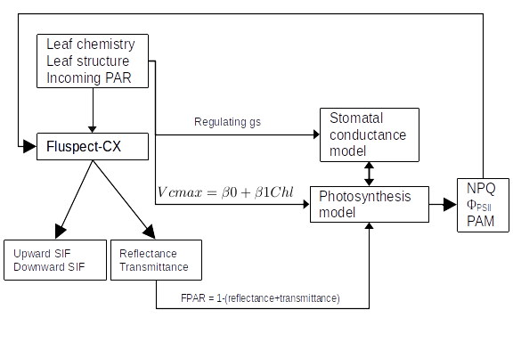Figure 1. The diagram of integrated model.

Phase 2: model testing
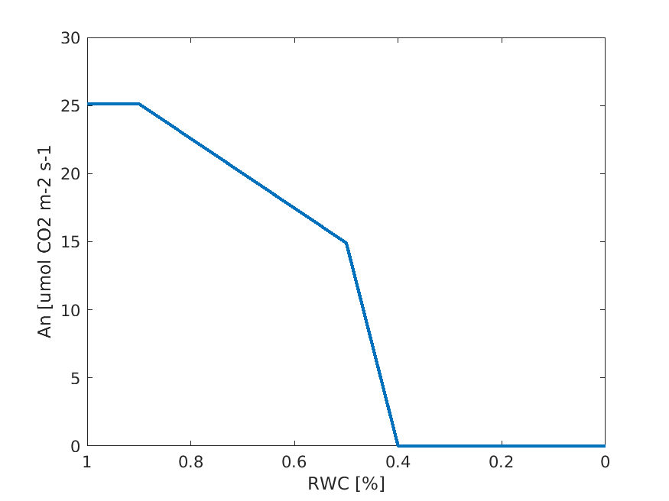Figure 2: A conceptual figure representing the response of the photosynthesis to the water deficit in the model.
This phase is designed to answer the first question of this study: what are the main relationships between leaf optics, photosynthetic processes and leaf chemistry and structure? In summary we drive different relationships between the observations and investigate if the model is able to reproduce those relationships. We also compare these relationships with those reported in other observatonal studies (Hikosaka, 2021; Hikosaka and Tsujimoto, 2021; Magney et al., 2017). Figure 3 shows the general flowchart of this phase. Currently, our focus is on the CO₂ and light curve experiment data provided by Vilfan and Woodgate. The woodgate dataset does not have leaf chemistry, however it provides the measured reflectance and transmittance. We used this data to invert the Fluspect-CX model to estimate the leaf chemistry and structure. In the next steps there are some free parameters related to the photosynthesis model that need to be estimated. So far we only inverted the model to estimate Vcmax. The cost function minimizes the difference between measured and simulated photosynthesis (i.e. A_{n}). Other parameters are set fixed based on (Johnson et al., 2021; Johnson and Berry, 2021). The iversion method is called Covariance matrix adaptation evolution strategy (CMAES). We attempted to invert the phtosynthesis model using multiple objective optimisation using both photosynthesis (A_{n}) and steady state fluorescnece (Fs) and NPQ (i.e. Kn2 in the model). We normalized Fs to minimum fluorescnece (Fo) in both model and observations. As we will discuss in the challenges section (below), our results for multiple objective function does not look great.

Phase 3: Simulations
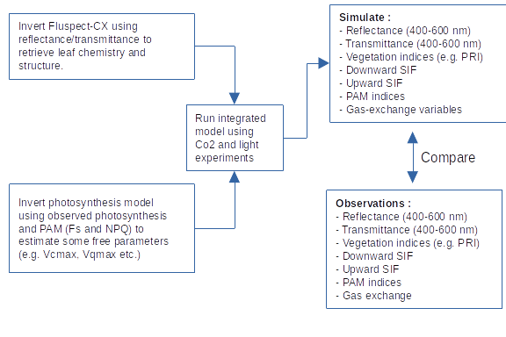Figure 3: Flowchart of steps regarding the testing of the integrated model.
The objective of this section is to answer the second question of the study: How do environmental conditions such as temperature and water content would impact these relationship? To answer this qustion we run the integrated model while changing RWC and tempreature. Similar to (Johnson et al., 2021) we setup different scenarios in which we change the environmental conditions and investigate how these changes affect the relationships drived and observed during phase 2.

Preliminary results

Observations
In this section we summarize the datasets and drive some relationships between leaf properties, leaf optics and photosynthesis.

Dataset 1:
This dataset is provided by Woodgate (2022). Figure 1 shows the

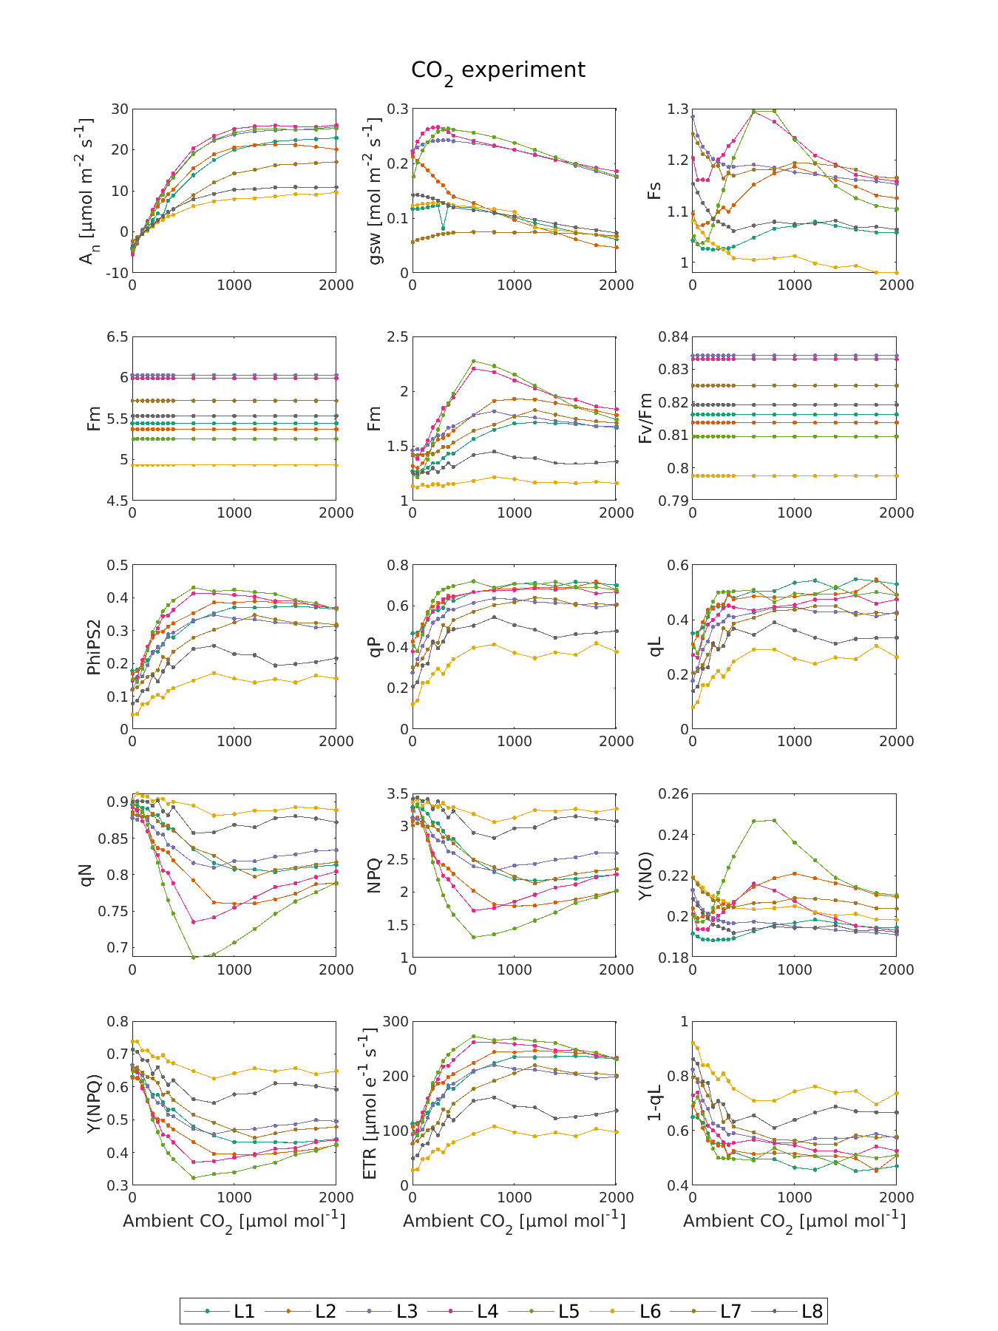
Figure …

Ball, J.T., Woodrow, I.E., Berry, J.A., 1987. A Model Predicting Stomatal Conductance and its Contribution to the Control of Photosynthesis under Different Environmental Conditions, in: Biggins, J. (Ed.), Progress in Photosynthesis Research: Volume 4 Proceedings of the VIIth International Congress on Photosynthesis Providence, Rhode Island, USA, August 10–15, 1986. Springer Netherlands, Dordrecht, pp. 221–224. https://doi.org/10.1007/978-94-017-0519-6_48
Bonan, G.B., Williams, M., Fisher, R.A., Oleson, K.W., 2014. Modeling stomatal conductance in the earth system: linking leaf water-use efficiency and water transport along the soil–plant–atmosphere continuum. Geosci. Model Dev. 7, 2193–2222. https://doi.org/10.5194/gmd-7-2193-2014
Collatz, G.J., Ball, J.T., Grivet, C., Berry, J.A., 1991. Physiological and environmental regulation of stomatal conductance, photosynthesis and transpiration: a model that includes a laminar boundary layer. Agric. For. Meteorol. 54, 107–136. https://doi.org/10.1016/0168-1923(91)90002-8
Farquhar, G.D., von Caemmerer, S., Berry, J.A., 1980. A biochemical model of photosynthetic CO2 assimilation in leaves of C3 species. Planta 149, 78–90. https://doi.org/10.1007/BF00386231
Hikosaka, K., 2021. Photosynthesis, chlorophyll fluorescence and photochemical reflectance index in photoinhibited leaves. Funct. Plant Biol. 48, 815–826. https://doi.org/10.1071/FP20365
Hikosaka, K., Tsujimoto, K., 2021. Linking remote sensing parameters to CO2 assimilation rates at a leaf scale. J. Plant Res. 134, 695–711. https://doi.org/10.1007/s10265-021-01313-4
Johnson, J.E., Berry, J.A., 2021. The role of Cytochrome b6f in the control of steady-state photosynthesis: a conceptual and quantitative model. Photosynth. Res. 148, 101–136. https://doi.org/10.1007/s11120-021-00840-4
Johnson, J.E., Field, C.B., Berry, J.A., 2021. The limiting factors and regulatory processes that control the environmental responses of C3, C3–C4 intermediate, and C4 photosynthesis. Oecologia 197, 841–866. https://doi.org/10.1007/s00442-021-05062-y
Lawlor, D.W., Cornic, G., 2002. Photosynthetic carbon assimilation and associated metabolism in relation to water deficits in higher plants. Plant Cell Environ. 25, 275–294. https://doi.org/10.1046/j.0016-8025.2001.00814.x
Magney, T.S., Frankenberg, C., Fisher, J.B., Sun, Y., North, G.B., Davis, T.S., Kornfeld, A., Siebke, K., 2017. Connecting active to passive fluorescence with photosynthesis: a method for evaluating remote sensing measurements of Chl fluorescence. New Phytol. 215, 1594–1608. https://doi.org/10.1111/nph.14662
Porcar-Castell, A., Malenovský, Z., Magney, T., Van Wittenberghe, S., Fernández-Marín, B., Maignan, F., Zhang, Y., Maseyk, K., Atherton, J., Albert, L.P., Robson, T.M., Zhao, F., Garcia-Plazaola, J.-I., Ensminger, I., Rajewicz, P.A., Grebe, S., Tikkanen, M., Kellner, J.R., Ihalainen, J.A., Rascher, U., Logan, B., 2021. Chlorophyll a fluorescence illuminates a path connecting plant molecular biology to Earth-system science. Nat. Plants 7, 998–1009. https://doi.org/10.1038/s41477-021-00980-4
Porcar-Castell, A., Tyystjärvi, E., Atherton, J., van der Tol, C., Flexas, J., Pfündel, E.E., Moreno, J., Frankenberg, C., Berry, J.A., 2014. Linking chlorophyll a fluorescence to photosynthesis for remote sensing applications: mechanisms and challenges. J. Exp. Bot. 65, 4065–4095. https://doi.org/10.1093/jxb/eru191
Trueba, S., Pan, R., Scoffoni, C., John, G.P., Davis, S.D., Sack, L., 2019. Thresholds for leaf damage due to dehydration: declines of hydraulic function, stomatal conductance and cellular integrity precede those for photochemistry. New Phytol. 223, 134–149. https://doi.org/10.1111/nph.15779
van der Tol, C., Berry, J.A., Campbell, P.K.E., Rascher, U., 2014. Models of fluorescence and photosynthesis for interpreting measurements of solar-induced chlorophyll fluorescence. J. Geophys. Res. Biogeosciences 119, 2312–2327. https://doi.org/10.1002/2014JG002713
Van Wittenberghe, S., Sabater, N., Cendrero-Mateo, M.P., Tenjo, C., Moncholi, A., Alonso, L., Moreno, J., 2021. Towards the quantitative and physically-based interpretation of solar-induced vegetation fluorescence retrieved from global imaging. Photosynthetica 59, 438–457. https://doi.org/10.32615/ps.2021.034
Vilfan, N., van der Tol, C., Verhoef, W., 2019. Estimating photosynthetic capacity from leaf reflectance and Chl fluorescence by coupling radiative transfer to a model for photosynthesis. New Phytol. 223, 487–500. https://doi.org/10.1111/nph.15782
Vilfan, N., Van der Tol, C., Yang, P., Wyber, R., Malenovský, Z., Robinson, S.A., Verhoef, W., 2018. Extending Fluspect to simulate xanthophyll driven leaf reflectance dynamics. Remote Sens. Environ. 211, 345–356. https://doi.org/10.1016/j.rse.2018.04.012
Zivcak, M., Brestic, M., Balatova, Z., Drevenakova, P., Olsovska, K., Kalaji, H.M., Yang, X., Allakhverdiev, S.I., 2013. Photosynthetic electron transport and specific photoprotective responses in wheat leaves under drought stress. Photosynth. Res. 117, 529–546. https://doi.org/10.1007/s11120-013-9885-3

