Project Option Trading — ML Research Review & Handoff
Sep 27, 2026 · @Tony

Overview
The conversation concludes that no single ML model wins in options trading; a layered system that predicts volatility, selects a strategy by regime, sizes and hedges positions, and trades only when the edge beats costs is the recommended design.
Source: the shared ChatGPT project chat "Project Option trading" (link). It contains four research exchanges plus a final request for a handoff file. This document summarizes each exchange, pulls out the decisions, and adds a critical review.
# | Question asked | Main output
1 | Top 20 profitable ML models, with evidence, and the factors that make an ML trading model succeed | Ranked list of 20 models, best models per task, 20 ranked success factors, a reference architecture
2 | Summary table of all 20 models, with suitability for intraday, daily, medium-term and long-term trading | Model × horizon matrix; six core model families selected
3 | Three best option-trading frameworks plus two institutional frameworks (#4, #5), with goals and rationale | Five-framework comparison; objective hierarchy; six-layer final architecture
4 | Add horizon suitability to the five-framework table | Framework × horizon table; daily + medium-term chosen as primary horizon
The chat references an earlier study on the "top 20 option strategies" that is not part of this shared link. The earlier handoff file ChatGPT produced was also flagged by ChatGPT itself as incomplete.

Discussion 1 — Top 20 ML models for options
XGBoost ranked #1 overall, but the key finding was that the best model is the one with a stable, after-cost, out-of-sample edge, not the lowest prediction error. A cited 2026 study on 18.2 million minute-bar S&P 500 call observations found lower pricing error did not translate into better trading P&L.
Rank | Model | Best use in options | Key evidence cited | Rating
1 | XGBoost / gradient-boosted trees | IV, returns, probability of profit, trade selection | Boosting beat Black-Scholes / Corrado-Su in option pricing; XGBoost and RF most accurate across regimes | 5
2 | LSTM / Bi-LSTM | IV/RV forecasting, sequential signals | 2026 equity-option study (2018–2023): LSTM MSE ~4.35%, R² ~53%; pooled "universal" models beat per-stock models | 5
3 | Transformer / Autoformer | Long-horizon, multi-source forecasting | Autoformer beat simpler NNs on all US stocks, 920 features, data from 1957 | 5
4 | LightGBM | IV surface, very large tabular data | VAE → LightGBM → Monte Carlo beat Black-Scholes on NIFTY50 options | 5
5 | Temporal Fusion Transformer | Multi-horizon, heterogeneous features | Built for multi-horizon forecasting with interpretable attention | 5
6 | GRU | Hedging, IV/RV | GRU-based hedging model beat benchmarks on S&P 500 options (J. Banking & Finance) | 4.5
7 | Random Forest | Robust baseline, classification | Strong in option pricing, but worst model in an FX-option IV study | 4.5
8 | MLP | Cross-sectional pricing / returns | Gu–Kelly–Xiu: NN timing Sharpe 0.77 vs 0.51 buy-and-hold; long-short Sharpe 1.35; best at ~3 layers | 4.5
9 | Graph Neural Network | Whole option chain / surface | GNN with momentum spillover improved RMSE ≥8.81% on SSE 50 ETF options | 4.5
10 | PPO (deep RL) | Dynamic hedging and trading | Among top performers in an 8-algorithm RL hedging comparison | 4.5
11 | DDPG / TD3 | Continuous hedge sizing | Beat Black-Scholes delta hedge under costs for American options | 4
12 | CNN | IV surface as a 2D image | Predicted IV surface on SSE 50 ETF options, beat backprop NNs | 4
13 | VAE | Distribution / surface compression | Reproduces skew, kurtosis, fat tails in the NIFTY50 framework | 4
14 | Neural SDE | Pricing, scenario generation | Compared with Black-Scholes, Dupire and Heston on real options | 4
15 | Gaussian Process / Deep Kernel | Small-data pricing with uncertainty | DKL beat Least-Squares Monte Carlo for high-dim American options | 4
16 | N-BEATS / N-BEATS-GAN | Time-series forecasting + risk | Limited option-specific evidence | 3.5
17 | Elastic Net | Benchmark, feature selection | Positive out-of-sample R² where OLS failed (Gu–Kelly–Xiu) | 3.5
18 | SVR | Small/medium nonlinear data | Used as benchmark in pricing and volatility studies | 3.5
19 | CatBoost | Categorical / mixed features | ML beat Black-Scholes/Heston in several configurations | 3.5
20 | Ensemble / stacking | Production robustness | DNN + GBT + RF combination was strongest in S&P 500 stat-arb study | 5*
Seven possible prediction targets were distinguished: direction, return, realized volatility, implied volatility, option fair value, probability of a profitable trade, and optimal action (the RL problem). Choosing the target was called the most important decision in the project.
Best models by task (top three of each list):
Task | 1st | 2nd | 3rd
Realized volatility | LSTM | XGBoost | LightGBM
Implied volatility | LSTM / Bi-LSTM | XGBoost | LightGBM
Option pricing | XGBoost | LightGBM | MLP
Stock direction | XGBoost | MLP | Random Forest
Dynamic hedging | PPO | Policy-gradient RL | DDPG / TD3
Recurring lesson: simple models often win with limited data; complex models only pay off as data quality and quantity grow. Finance has low signal-to-noise, nonstationarity and changing regimes.

Discussion 1b — What makes an ML trading model succeed
Data quality, leakage prevention, target definition, transaction-cost realism and out-of-sample validation were all rated 10/10 — judged more important than the choice between XGBoost and LSTM.
Rank | Factor | Score | Rank | Factor | Score
1 | Data quality | 10 | 11 | Model calibration | 9.5
2 | Leakage prevention | 10 | 12 | Objective / loss function | 9.5
3 | Target definition | 10 | 13 | Ensemble diversity | 9.4
4 | Transaction-cost realism | 10 | 14 | Interpretability | 9.0
5 | Out-of-sample validation | 10 | 15 | Computational efficiency | 8.5
6 | Regime robustness | 9.9 | 16 | Hyperparameter optimization | 8.5
7 | Feature quality | 9.8 | 17 | Retraining frequency | 8.5
8 | Position sizing | 9.8 | 18 | Uncertainty estimation | 8.5
9 | Tail-risk management | 9.8 | 19 | Execution infrastructure | 8.5
10 | Nonstationarity handling | 9.7 | 20 | Model governance | 8.0
Key points behind the factors
- Leakage: option data is especially prone to it — expiring contracts, IV derived from prices, asynchronous bid/ask, corporate actions, survivorship bias.
- Targets: predict future IV, IV change, mispricing, future RV, expected trade P&L or P(P&L > 0) rather than raw next-day option price. The last two are most useful for trading.
- Costs: a model forecasting +0.20% per trade is worthless at 0.35% cost. A cited walk-forward study found XGBoost, LSTM and iTransformer signals failed after a 10 bp cost until a cost-aware threshold was added.
- Metrics: track prediction metrics (RMSE, MAE, R², log loss, Brier, calibration) separately from trading metrics (net Sharpe, Sortino, Calmar, max drawdown, expected shortfall, turnover, profit factor).
- Features: ten families — price, volatility, options (ATM IV, 25Δ skew, term structure, IV-RV spread), Greeks, flow, liquidity, VIX complex, macro, sentiment. Gu–Kelly–Xiu found momentum, liquidity and volatility interactions most predictive.
- Universal models: one pooled model across all underlyings (with per-underlying embeddings) beat separate per-stock models.
- Surface modelling: treat the whole IV(K, T) surface as one observation (CNN for local patterns, GNN for contract links, VAE for compression).
- Calibration and distributions: a calibrated 70% probability is worth more than a raw point forecast; prefer predicting the distribution of returns. A +0.6% forecast at 92% confidence was preferred over +1% at 51%.
- LLMs: not for numeric prediction; use them to extract signals from news, earnings calls, SEC filings and central-bank language (consistent with IMF and BIS views).
- Institutional caution: the Bank of England notes firms mainly use autonomous AI for research, coding and surveillance, not autonomous trading. The IMF warns of correlated behaviour and crowding.
Validation protocol agreed
- Statistical layer — does it predict IV, RV, returns?
- Economic layer — positive expectancy, Sharpe, Sortino, drawdown?
- Execution layer — still profitable after spread, commission, slippage, impact, latency?
- Crisis test — 2008, 2020, 2022 and gap events separately.
Walk-forward example: train 2010–2018, validate 2019–2020, test 2021; then roll forward one year. Never random 80/20 splits.
Explicit "do not" list: LSTM on closing prices alone; trading whenever predicted price > market; accuracy as the main metric; optimizing Sharpe on one period; 500 unregularized indicators; ignoring bid/ask; one model forever.
Learning-capability criteria (ranked): nonlinearity, temporal memory, cross-sectional learning, regime adaptation, transfer learning, uncertainty estimation, online adaptation, robustness to missing data, interpretability, retraining speed.

Discussion 2 — Which model suits which trading horizon
Daily trading was named the largest opportunity: enough observations for ML without the extreme microstructure costs of intraday. Horizons mean the prediction/rebalancing horizon, not a promise of profit.
Star ratings from ChatGPT's final model × horizon matrix (5 = best). Medium term = 1–12 weeks; long term = 3–12+ months.
Model | Why it is good | Intraday | Daily | Medium | Long | Best role
XGBoost | Nonlinear interactions on tabular data, fast | 5 | 5 | 5 | 3 | IV/RV, trade selection, mispricing
LSTM / Bi-LSTM | Volatility persistence, sequences | 4.5 | 5 | 5 | 3 | IV, RV, option-price forecasts
LightGBM | Scales to huge option datasets | 5 | 5 | 4.5 | 3 | IV surface, cross-sectional ranking
Transformer / Autoformer | Long-range, many features | 3 | 5 | 5 | 5 | Multivariate forecasting
Random Forest | Robust, low tuning | 4 | 4.5 | 4 | 3 | Classification, regime, filtering
TFT | Several horizons at once | 3 | 5 | 5 | 5 | Multi-horizon IV/RV
GRU | Lighter LSTM | 4.5 | 5 | 4.5 | 3 | Hedging, IV/RV
MLP | Simple, strong with engineered features | 4 | 4.5 | 4.5 | 4 | Cross-sectional pricing
GNN | Links across strikes and maturities | 3 | 4.5 | 5 | 5 | Option chain / surface
CNN | IV surface as an image | 4 | 4.5 | 4 | 3 | Smile, skew, term structure
PPO | Learns decisions, not forecasts | 4 | 4.5 | 4 | 3 | Sizing, hedging, execution
DDPG / TD3 | Continuous actions | 4 | 4.5 | 4 | 3 | Dynamic hedging
Neural SDE | Learns the price process | 2 | 3 | 4 | 5 | Pricing, simulation
VAE | Latent factors, distributions | 3 | 4 | 5 | 5 | Surface compression
Gaussian Process / DKL | Uncertainty estimates | 2 | 4 | 4.5 | 4.5 | Pricing + confidence
N-BEATS | Dedicated time-series model | 3 | 4 | 4.5 | 4 | Volatility / returns
Elastic Net | Interpretable benchmark | 5 | 5 | 4 | 4 | Baseline, feature selection
SVR | Small/medium nonlinear data | 3 | 4 | 4 | 3 | Pricing / IV
CatBoost | Categorical features | 5 | 5 | 4 | 3 | Cross-sectional prediction
Ensemble / stacking | Offsets individual weaknesses | 5 | 5 | 5 | 5 | Final trade-ranking layer
Horizon short-lists
- Intraday: XGBoost, LightGBM, LSTM, GRU, RL — speed matters; a Transformer may predict better yet lose money on turnover.
- Daily: XGBoost, LSTM, LightGBM, Transformer, GNN.
- Medium term: LSTM, Transformer, TFT, GNN, XGBoost — time to exploit IV/RV divergence, regimes, term structure, earnings.
- Long term: Transformer, TFT, GNN, VAE, Neural SDE, simpler regularized models — few independent observations, so big deep models can underperform.
Corrected reading of the ranking: XGBoost wins general-purpose; LSTM wins sequential volatility; Transformers win large multi-source data; GNN wins option-chain structure; RL wins hedging decisions; Elastic Net is the benchmark.
Decision: narrow the experiment to six core families — XGBoost, LSTM, Transformer/TFT, GNN, PPO/deep hedging, Elastic Net — and keep the other 14 as secondary benchmarks. Separate the prediction layer from the decision layer.

Discussion 3 — Five frameworks, their goals and rationale
The Adaptive ML Volatility + Relative-Value framework ranked #1, but the final recommendation was to combine frameworks 1–3 and use 4 and 5 as institutional benchmarks. Frameworks 4 and 5 are public institutional archetypes, not proprietary bank systems.
# | Framework | Core philosophy | Main goal | Profit | Risk control | Why it was chosen
1 | Adaptive ML Volatility + Relative-Value + Risk Control | ML predicts IV/RV/returns → finds mispricing → picks strategy → sizes by risk | Maximize net risk-adjusted alpha | 5 | 4.5 | Strongest academic support: RFS study, 12M+ observations 1996–2020, ML option-return portfolios profitable after costs
2 | ML Multi-Strategy Regime-Switching | Detect regime → activate the strategy that fits it | Consistency across regimes | 4.5 | 5 | Option payoffs depend on regime; AQR found buying options only paid in the top decile of volatility changes
3 | ML + Deep Hedging / RL | ML finds opportunity; RL decides entry, size, hedge, exit | Maximize net P&L after costs and risk | 5 | 5 | Static IV fit and real hedging results diverge once costs and risk aversion are included
4 | Institutional VRP / Risk-Target | Systematically sell volatility with vol targeting and tail controls | Stable VRP harvesting | 4 | 4.5 | Mirrors public AQR, Parametric / Morgan Stanley and Man Group approaches
5 | Institutional Option-Overlay / Outcome | Options change a portfolio's risk/return (puts, covered calls, collars) | Optimize portfolio outcome | 3 | 5 | Mirrors BlackRock and Morgan Stanley overlay and income strategies
Framework details
- #1 targets: IV change, realized vol, IV-RV spread, expected option return, P(profit > 0), CVaR. Models: XGBoost (tabular), LSTM (sequences), Transformer (long-range), GNN/CNN (surface), Elastic Net (benchmark), meta-model (combine). Objective: maximize Sharpe + Sortino minus penalties for CVaR, max drawdown and turnover, within Greek and position limits.
- #2 regimes: low IV / low RV, high IV / falling RV, high IV / rising RV, bull, bear, crisis, earnings, liquidity stress. Example rules: high IV + stable RV → short-vol spreads; high IV + rising RV → cut short vol; extreme VIX → defined risk only; illiquid → no trade. Supported by the IMF 2026 GFSR on dealer gamma and 0DTE growth.
- #3 reward: P&L minus costs, CVaR, drawdown and turnover penalties — not raw P&L. RL is the decision engine, not the alpha engine.
- #4 caution: AQR warns sharp moves create meaningful VRP drawdowns, so sizing must reflect tail risk.
- #5 goal: reduce drawdown and volatility, generate income, protect concentrated positions — not maximum profit.
Scorecard highlights (5 = best): frameworks 2 and 3 score 5 on drawdown and CVaR control; #1 scores 5 on profit and Sharpe; #4 and #5 score highest on interpretability and institutional resemblance; #3 has the lowest interpretability and highest cost sensitivity.
Transaction-cost warning: a 2026 LSTM study saw raw profits eroded by bid/ask, with delta-hedged results turning negative at large spreads. The agreed rule: trade only if expected edge > bid/ask + slippage + commission + market impact; otherwise no trade.

Discussion 4 — Framework × horizon and the objective hierarchy
Daily plus medium-term was chosen as the primary research horizon, with intraday as a separate later module. ML-heavy frameworks fit daily and medium term best; institutional frameworks gain ground at long horizons.
Framework | Main goal | Intraday | Daily | Medium | Long
1 Adaptive ML | Net risk-adjusted alpha | 4.5 | 5 | 5 | 4
2 Regime-Switching ML | Consistency across regimes | 4.5 | 5 | 5 | 5
3 ML + Deep Hedging / RL | Dynamic P&L after costs | 4 | 5 | 5 | 4.5
4 Institutional VRP | Stable VRP harvesting | 3 | 4.5 | 5 | 5
5 Institutional Overlay | Portfolio outcome | 2 | 4 | 4.5 | 5
- Intraday: edge must beat bid/ask, slippage, commissions, impact and latency; favour fast models and a strict trade filter.
- Daily: best compromise. A July 2026 Federal Reserve paper using boosted trees on moneyness/maturity partitions cut one-month-ahead IV RMSE by 13% versus its benchmark.
- Medium term (1 week–3 months): Regime ML ranks first; more time to overcome costs.
- Long term (3 months+): Regime ML, Institutional VRP and Overlay lead; structural risk premia matter more than short-term signals.
Objective hierarchy agreed for the project
Priority | Objective | What is measured
1 | Survival | CVaR, stress loss, probability of ruin
2 | Risk control | Max drawdown, Greeks, concentration, liquidity
3 | Risk-adjusted profit | Sharpe, Sortino
4 | Net profit | CAGR / total P&L after all costs
5 | Efficiency | Return per unit of turnover, margin, capital
6 | Prediction quality | RMSE, MAE, AUC — supporting metrics only
Ultimate objective: maximum sustainable net risk-adjusted return, subject to predefined limits on CVaR, max drawdown, Greeks, turnover, liquidity and margin.

Recommended final architecture
The end state is a hybrid of frameworks 1, 2 and 3, validated against 4 and 5, where prediction, strategy choice, sizing, risk and execution are separate layers rather than one model deciding everything.
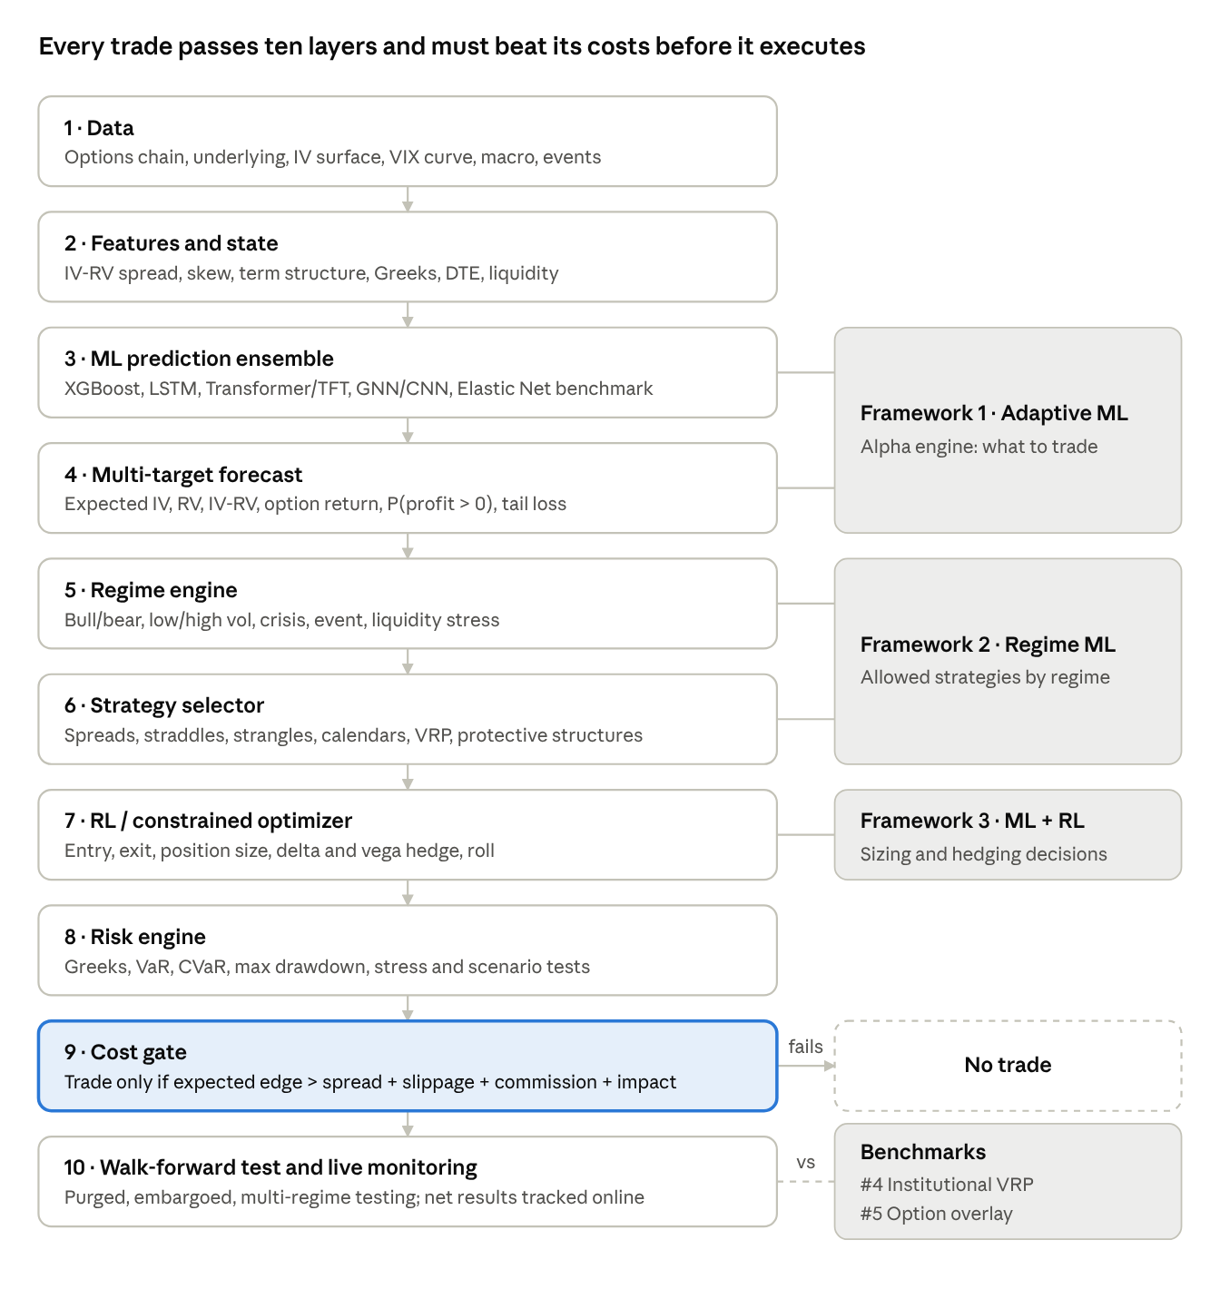
recommended ML options system · 10 layers, 3 frameworks, 2 benchmarks
Signals flow top to bottom; any trade whose expected edge does not clear total costs stops at the cost gate.
Decisions carried forward
- Core model families: XGBoost, LSTM, Transformer/TFT, GNN (or CNN), PPO/deep hedging, with Elastic Net as the control.
- Prediction layer and decision layer stay separate.
- Optimize net P&L after realistic costs, not RMSE.
- Primary horizon: daily + medium term; intraday as a separate later module.
- Institutional VRP and option-overlay frameworks act as benchmarks the ML system must beat.
- Planned next study: top 20 option strategies × top 20 ML models × features × DTE × delta × IV/RV × VIX regime × costs, tested walk-forward on Sharpe, Sortino, max drawdown, CVaR and probability of profit.

Critical review
The conversation's core logic is sound and matches mainstream quant practice, but its rankings are subjective, several numbers conflict internally, and many cited 2026 studies should be verified before they drive decisions.
Strengths
- Puts after-cost, out-of-sample economics ahead of prediction accuracy — the right priority.
- Strong emphasis on leakage, walk-forward testing, crisis tests and calibration.
- Separating prediction, strategy selection, sizing, risk and execution is a defensible design.
- Keeps simple benchmarks (Elastic Net, institutional VRP) that complex models must beat.
- Cites peer-reviewed and institutional sources (RFS, Gu–Kelly–Xiu, AQR, BIS, IMF, Bank of England).
Internal inconsistencies to resolve
Issue | Where it appears | Why it matters
Bi-LSTM called "best", yet its quoted MSE (4.65%) is worse than plain LSTM (4.35%) and ConvLSTM (4.44%) | Discussion 1, model #2 | Either the figures or the claim is wrong; check the source paper
Model order shifts: Transformer #3 and RF #7 overall, but LightGBM #3 and RF #5 in the tiered list | Discussion 1 | The ranking is opinion, not a stable result
Transformer marked green (suitable) for intraday in one table but 3/5 in the matrix | Discussion 2 | Use the matrix; state the latency caveat
PPO is in the "top five to build", yet also "not the first model" | Discussions 1 and 3 | Sequence it: build prediction and risk layers first, RL later
Nearly every model and framework scores 4–5 stars | All tables | Ratings do not discriminate; treat them as hypotheses to test
Success-factor scores (9.9 vs 9.8) imply false precision | Discussion 1b | Use tiers (critical / important / useful) instead
Claims that need verification
- Many cited items are 2026 papers, SSRN preprints or arXiv drafts; confirm each exists and says what is claimed before relying on it.
- Specific numbers to re-check: 18.2M minute-bar observations; LSTM R² ~53%; GNN ≥8.81% RMSE gain; 13% Federal Reserve IV RMSE reduction; RFS 12M+ observations study.
- Gu–Kelly–Xiu figures (Sharpe 0.77 vs 0.51; 1.35 long-short) come from US equities, not options; transfer to options is an assumption.
- The Sharpe/RMSE worked examples (e.g. Elastic Net 0.72 vs XGBoost 0.81) are illustrations, not results.
Gaps not covered
- Data sourcing and cost: which vendor (e.g. OptionMetrics, ORATS, CBOE DataShop), history length, and budget.
- Compute and infrastructure plan, especially for Transformers, GNNs and RL.
- Statistical safeguards against multiple testing (e.g. deflated Sharpe, White's reality check) — critical for a 20 × 20 grid.
- Margin, capital requirements and early assignment for American-style options.
- Concrete regime definitions (thresholds for VIX, IV/RV, term structure).
- The earlier "top 20 option strategies" study is referenced but not included here.
- Nothing guarantees future profitability; ChatGPT itself notes no cited study proves a live strategy will stay profitable.

Next steps
Build the simplest version end to end first, then add complexity only where it beats the benchmark after costs.
- Verify the key papers and numbers flagged in the review.
- Bring in the "top 20 option strategies" study so the strategy × model grid can be defined.
- Choose a data vendor and lock the dataset: underlyings, date range, frequency, bid/ask quality.
- Define targets (IV change, RV, IV-RV, P(P&L > 0), expected P&L) and write down regime thresholds.
- Build baselines: Elastic Net, institutional VRP rule, simple overlay.
- Add XGBoost/LightGBM, then LSTM; test walk-forward with realistic costs and the cost gate.
- Add regime engine and strategy selector; then Transformer/GNN; then RL for sizing and hedging.
- Apply multiple-testing corrections before calling any result an edge; paper-trade before any capital.

Sources
Source conversation: Project Option trading — shared ChatGPT chat. The references below are those ChatGPT cited; they were not independently opened for this review.
- Option-specific ML: Predicting option prices from their price history (Review of Derivatives Research, 2026); Option Return Predictability with Machine Learning and Big Data (Review of Financial Studies); Option pricing using Machine Learning (Expert Systems with Applications); Non-parametric option pricing before and during COVID-19; Forecasting implied volatilities of currency options with ML; GNN momentum spillover in option pricing (Journal of Futures Markets); CNN implied-volatility surface prediction; VAE option pricing on NIFTY50; Neural-SDE pricing and hedging; Gaussian-process and deep-kernel American option pricing; Learning sequential option hedging models (Journal of Banking & Finance); Deep RL algorithms for option hedging; Hedging American puts with deep RL; When Lower Pricing Error Trades Worse (SSRN, 2026).
- General financial ML: Gu, Kelly & Xiu, Empirical Asset Pricing via Machine Learning (RFS / NBER / AQR); DNN, gradient-boosted trees and random forests for S&P 500 statistical arbitrage; Transformers vs simple NNs for stock returns; ML stock-market volatility forecasting; Office of Financial Research 2026 forecasting benchmark; Federal Reserve July 2026 tree-based IV forecasting.
- Institutions: Bank of England Financial Stability Report (July 2026); BIS papers on ML for market monitoring and the expected-shortfall framework; IMF Global Financial Stability Report 2026 and AI-in-markets papers; AQR on the volatility risk premium and buying options; BlackRock on options and overlays; Morgan Stanley / Parametric VRP and Global Balanced Income; Man Group risk premia; MSCI on nonlinear factor effects; CFA Institute on deep learning and trade execution.

