**Public Relations in Afghanistan: The need to reread definitions and redefine functions**

**Explanation of a broad conceptual model based on relationship between “public” and “public”**

Diana Farzan[1]

**Abstract**

In Afghanistan, public relations, is rooted in developments over the past two decades. The knowledge of public relations in the country, is the product of efforts that have been produced and implemented in the scientific interactions of universities professors and agents in this field with the outside world for more than a decade. This knowledge, as a theoretical foundation, and at the same time a practical framework, is the "starting point" of this communication process in the country, and therefore, in itself, is an important achievement. The key problem here, however, is a kind of reductionist view of the position of this important field of communication. Public relations in Afghanistan is defined as "private" interaction with "private" and, most optimistically, "private" interaction with "public". In this promotional paper, in view of the above issue, I seek to reread the definitions of public relations in theoretical sources and at the same time redefine the functions, I seek to present the concept of "consistent with the existential logic" of public relations, with a broad view of theoretical definitions, I seek the application of public relations, both theoretically and practically, and I will explain its prestige as an interactive sphere in the larger social organization. I will try to provide a theoretical model in the country by re-reading the existing definitions in order to be effective in a new concept, albeit short, to expand the conceptual scope, as a field of "public-to-public" interaction.

**KEY WORDS: Public Relation, Public to Public, Socio-Cultural Companion.**

**Problem Statement**

Public relations in the position of "communication activity" is one of the important areas of our time. Many social interactions, from personal relationships to social relationships and from individual buying motives to motivations to participate in macro-national trends, are inevitably influenced by this area. In our time, it is seldom possible to define an action independently and without connection to motivation. These motivations, it seems, are always the function of "communicative" interactions and the product of "persuasive" actions; which these Actions are defined on the basis of "public relations".

From this perspective, I believe that public relations, before any other definition, is " relation from public to public "; A kind of two-way public connection that connects one "public" section to another "public" section. In other words, in this communication process, part of the "public", as the "representative" and as the "source" constantly seeks to establish a relationship with the other part of the "public", as the "destination" to manage individual and social power by "influencing" individual and social actions. This, of course, does not mean that the " destination Public" is passive, because its worldview, values, tastes, and many of its individual and social characteristics, as determining elements, Affects the sources, mechanisms, and persuasive forms of the "source public."

In Afghanistan, public relations, as a fledgling field, is rooted in developments over the past two decades. The knowledge of public relations in the country, both theoretically and practically, is the product of efforts that have been produced and implemented in the scientific interactions of universities professors and agents in this field with the outside world for more than a decade. This knowledge, as a theoretical foundation, and at the same time a practical framework, is the "starting point" of this communication process in the country, and therefore, in itself, is an important achievement because it lays the foundation for the interaction and connection of the two sectors. " "Public" and changing the position of "one-way" communication to the position of "two-way".

The key problem here, however, is a kind of reductionist view of the position of this important field of communication. This approach has distorted, and perhaps diminished, the importance of public relations, both theoretically and practically. Public relations in Afghanistan is defined in many theoretical definitions as "an organization's limited relationship with its subscribers / customers" and in an affirmative application, business organizations define it as "a very limited relationship between a public relations institution and customers to accept views, suggestions and "criticisms" have been used. This approach defines public relations as "private" interaction with "private" and, most optimistically, "private" interaction with "public".

This seems to be rooted in the lack of sufficient theoretical resources and the lack of effort to explain and expand the theoretical scope of application of this concept and at the same time, suffice to traditional definitions, and in some cases, influenced by the bias of influence and dominance of the economic field over other areas. Has social and especially cultural. Theoretical knowledge in this field is faced with a lack of production and a lack of a textual redefinition; So far, few scientific works have been produced in the country's universities that define the theoretical scope of the concept of public relations and explain the position of this field in national communications. At the same time, due to this issue, the available resources are more focused on the effects of public relations in the economic and sometimes political institution, and hence, the general understanding of the field in universities, based on this reductionist approach, it offers a "narrow and limited" definition of public relations.

In this promotive paper, in view of the above issue, I seek to reread the definitions of public relations in theoretical sources and at the same time redefine the functions, I seek to present the concept of "consistent with the existential logic" of public relations. In this paper, with a broad view of theoretical definitions, I seek the application of public relations, both theoretically and practically, beyond its application in organizational areas, especially commercial organizations, and I will explain its prestige as an interactive sphere in the larger social organization. In this way, I will try to provide a theoretical model in the country by re-reading the existing definitions in order to be effective in a new concept, albeit short, to expand the conceptual scope of this field, as a field of "public-to-public" interaction.

**Research questions**

In this study, by rereading the definitions of public relations and redefining the functions of this concept, I will seek an answer to the question of how a broad conceptual model can relate "public" to "public"?

**Literature review:**

**Rereading of Public Relation: Explanation of a broad definition**

Public relations has been defined in many approaches; “managing strategic relationships, persuader, advocate, educator, crusader, information provider, reputation manager, research, image making, counseling, managing, early warning, interpreting, communicating, negotiating” (Vercˇic *et.al*,2000: 378) “analysis and evaluation through research, Management counseling and achievement of good will” (Gordon, 1997: 59) But it is important to know which definition is closer to the existential logic of public relations.in a simple definition, “Public relations is the attempt, by information, persuasion and adjustment, to engineer public support for an activity, cause, movement or institution.” (Hutton, 2000: 200). But the function of public relations to provide information and persuade others is not limited and has a broader role in social change and can be constructive, as such mentioned in another definition of public relations as a “social construction” “public relations is the active participation in social construction of meaning” (Ibid).

When there is a belief in public relations participation in the social structure, this social structure requires public opinion to believe in this structure or social change. It also requires public relations to create or change public opinion, as mentioned in a definition of public relations, art and science of this skill. “Public Relations is the art and science of creating, altering, strengthening or overcoming public opinion.” (Ibid, 201).

This influence on public opinion transforms the process of public relations work and shows another aspect of public relations performance, like this definition “public relations as educator, creator and/or manipulator of symbols, news engineer,’ publicity doctor, perception manager,’ and middleperson.” (Hutton, 2007)

As Hutton points out, news engineering is now seen as part of a public relations function in which reporters broadcast news as sent by PR and that means leading of media Lee Edward (2012:2) also referred to this practice, “competitive pres­sures on resource-poor media organizations mean that journalists nowadays are more likely to accept and use public relations materials, often unedited, in their copy, giving PR practitioners the opportunity to lead, rather than merely respond to, the media agenda” Correspondingly, public relations has a cultural impact, as Edward Lee puts it. “, the impact of public relations on the cultural and social environment, and its potential to shape tastes and dispositions, is more direct, significant and visible than ever before and merits attention. (Ibid)

The role of public relations in creating culture can originate from the fact that public relations has a direct impact on changing people's attitudes and beliefs, as mentioned in Chinaka Nwodu (2014:101) definition; “Public relations is essentially about positively and systematically using actions and communications to influence people’s attitudes, opinions, belief, interest and behavior in a given or desired direction” this change in attitudes could be accompanied by the creation of policies and messages in this social context. As Chinka Nwodu (Ibid) also mentioned this definition to public relations “Public Relations is “the ethical and strategic management of communication and relationship in order to build and develop coalitions and policy, identify and manage issues and create messages to achieve sound outcomes within a socially responsible framework.”

Public relations need the support of public opinion to advance social affairs and that's why public relations can be defined this way; “deliberate use of organized actions and persuasive communications to influence opinions and actions and by so doing, secure public sentiments or sympathy in favor of a cause” (Ibid)

Public relations is at the service of the public and aims at social solidarity and plans according to the people’s point of view as MCKIE and Krishnamurthy (2014) have pointed out like this; “public relations is a social-technical-administrative discipline by which the opinion and attitude of the public is analyzed and evaluated and a continuous planned program is done with a reciprocal communication, based on the interest of the community, destined to maintain an affinity and beneficial understanding with the public” . as in the above definition, the principle of evaluating people ‘s views have been given importance; Mathew (Cabot, 2012) also has pointed to roles of public relations such as “Two--‐way Communication, Audience research/feedback for Purpose of Become more effective persuaders.”

When it comes to two-way communication, public relations focuses on purposeful conversation with the public, which in this definition refers to public relations as a strategic conversation. “Public relations is a strategic conversation. As a wide-ranging field, it is often misperceived as media relations, but it is far, far more, such as public affairs or labor relations.” (Bowen, *et.al*. 2019; 9) Two-way communication is the reason for the continuation of the relationship with audiences, because in case of any issue, it will resolve through conversation and mutual understanding will accrue. As Dhanesh (2017; 2) also mentioned this " “Public relations is founded on the principle that engagement requires an understanding of and dialogue with stakeholders.”

Today's world is a world of contradictions, yet in spite of public relations; Making decisions can be easy with understanding. This is how Heath (2005: 684) quotes public relations society of America “Public relations helps our complex, pluralistic society to reach decisions and function more effectively by contributing to mutual understanding among groups and institutions.” He also mentioned public relations like this; “the art and science of getting along well with other people.” (Ibid: 683).

**Redefine the functions: Public to Public relation**

Public relations is a cultural companion of a community, it strives to promote ethics in accordance with cultural values as Stevenson and colleagues (2017:9) mentioned, “Ethics: The science of moral duty in conformity with principles of conduct accepted in a culture” For culture building and moral principles in society, the focus is on public opinion and this is where Stevenson and colleagues (Ibid:11) believe that “public relations caring for public opinion”. This view; Represents a wider part of the public relations function that considers itself responsible to society which is called the function of social responsibility (ibid).

In a society where public opinion is under the control of public relations, public relations also strives to develop mutual understanding and acceptance. As Palaniappan (ND:3) mentioned this function to public relations “art or Science of developing reciprocal understanding and goodwill.”

In the process of creating mutual understanding and developing relationships in a community, there may be problems and disorders that also need guidance and problem solving by public relations. Which also Cahaya Putra (2009:4) mentioned the functions of public relations such as “Expert Prescriber, Communication Facilitator, Problem Solving Facilitator and Communication technician”.

To make connections in a community or solve a problem, the important issue is; Getting to know people, identifying the influential people in this community and the issues that may arise. As Grunig (2001:9) has said “Public relations practitioners identify consequences of decisions and the presence of publics by engaging in environmental scanning and issues management. Environmental scanning means that they do research and talk to community leaders, leaders of activist groups, or government officials to find out who the publics are and what issues these publics might create”.

By recognizing the different issues in a community, the main issue of the community is identified and then. Public relations consider the performance of issues management, how it solves it, and measures this issue from several dimensions, this dimensions can be “monitoring political, social, economic, and technological environment.” (Cahaya Putra, 2009: 52). It need to be searched to gather this information; “Public relations problems are not solved by guess work. PR practitioners carry out formal research h to obtain information that is vital to planning” (Olusegun, 2006: 9).

Social issues are not always a normal problem and sometimes turn into a crisis that needs to be managed and this requires the function of public relations crisis management, this is how Williams and Olaniran (1998;388) quote crisis management “the use of public relations to minimize harm to the organization in emergency situations that could cause the organization irreparable damage.”

Public relations has a consulting function, works with previous research fields and with sufficient knowledge to improve communication, as Olusegun (2006;4) “mentioned public relations counselling and has said; Providing advice to management concerning policies, relationships, and communication with its various publics.”

Public relations can work at a consulting level when it has researched at various levels and evaluated all relevant aspects. NG (2003; 15) was quoted as saying by Cutlip, Center and broom, Research in PR as “the systematic gathering of information to describe and understand situations and to check out assumptions about publics and public relations consequences.” Likewise, public relations function is “production, training and management; There are many sides to productions, and it can be a very demanding task. It includes designing communications through multimedia knowledge and skills, art, brochures designs, photography, reports, booklets, occasional publications, corporate advertisements, audio and video recordings and editing, and setting up audio-visual presentations.” (Iroha, 2019: 4).

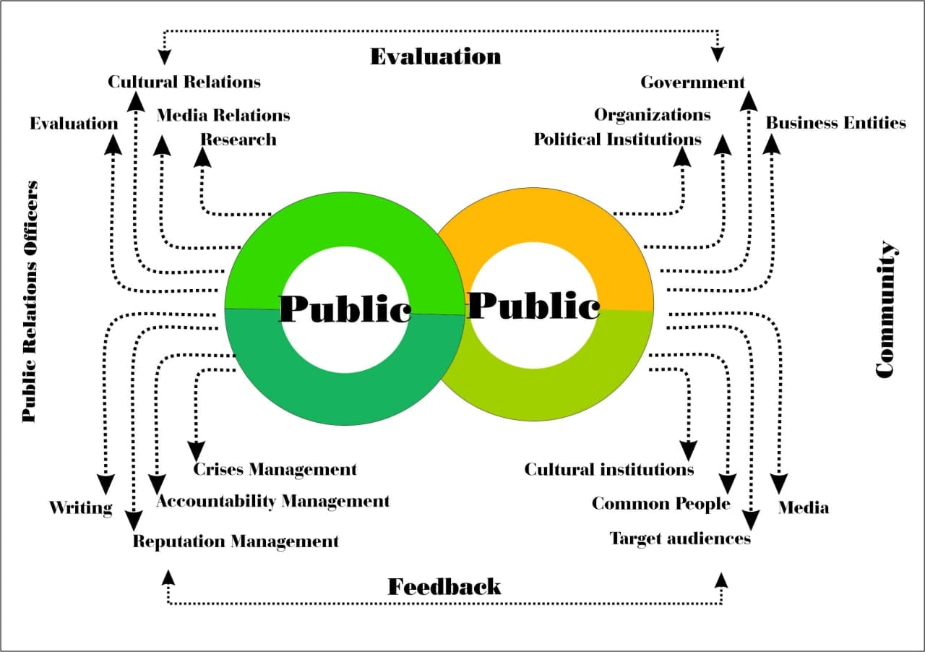

Figure 1. Public to Public Relation Model

**Conclusion**

So far, we have found that public relations is a large field that focuses on social organization communication before covering limited organizational communication, and is able to manage the process of social interaction by focusing on worldviews, values, and public tastes. The broad definition of public relations paves the way for this field to enter into macro-social interactions, and as a "culture maker" institution in various social fields, to use public resources for the public interest and the continuity of social life and, consequently, to achieve Considers social development necessary.

This definition considers public relations, like other areas of communication, to be the cause of widespread social change, and beyond that, it recognizes other communication structures as tools of public relations to accelerate and institutionalize these changes. For example, in the broader definition of public relations, the media is the messaging tool that performs a "public relations" activity. This approach is particularly important in underdeveloped and developing structures, such as Afghanistan, because the media are defined as the public relations tool of national structures to advance the national development program.

Based on the findings of this study, public relations, by managing the flow of information, expands participation in social activities and at the same time manages public tastes, beliefs, attitudes and public behavior in accordance with pre-determined goals, position and gives. This factor, as the "interpreter" of social relations, affects the public political, economic and cultural environment and gives meaning to concepts and changes in these areas. Public relations, at the same time, as a "facilitator" of social communication, connects socially active organizations and frames the product of joint efforts in the form of "public opinion".

Thus, according to the findings of this study, in response to the question "How can the broad conceptual model relate the 'public' to the 'public'?" It can be said that this model, through a reductionist approach, defines public relations, in accordance with existential logic, as both a factor for managing macro-social change and a consequence of these changes. In other words, on either side of these changes are two parts of the "public" that, in order to be in a communication process, as "source" and "destination", require a reciprocal relationship based on shared cognition rather than interaction to Generate a common circuit and therefore, the broad conceptual model, by providing this relationship, the cause of these changes is defined and with the expansion of the desired changes, is considered the result of these changes.

Therefore, to solve the problem in Afghanistan, I propose a comprehensive conceptual model, with the theoretical conditions and structure presented in this article, for the country's academic institution. This model, by crossing the existing narrow theoretical field, can provide the ground for explaining the "rational" concept of public relations in the country and by strengthening the theoretical basis, operationalize it in the practical field based on a macro view and based on establishing and expanding relationships. Facilitate the "public" with the "public".

**References:**

* Bowen, Shannon A. et.al, (2010), An **overview of the public relations function,** Business Expert Press.
* Cabot, Mathew. (2012), **Introduction to Public Relations**, San Jose State University.
* Cahaya Putra, kadek Dwi. (2009), Public Relations: Roles, Entry Requirements and Professionalism**, ILMU KOMUNIKASI.**
* Chinaka Nwodu, Levi. (2014), PUBLIC RELATIONS IN PRACTICE*,* National Open University of Nigeria.
* hanesh, Ganga S. (2017), **Public Relations Review**, Elsevier.
* Edwards, Lee**.** (2012), **Exploring the Role of Public Relations as a Cultural Intermediary Occupation:** Sage.
* Gordon, Joye**C.** (1997), **Interpreting definitions of public relations: Self-assessment and a symbolic interactionism based alternative,** JAI Press.
* Grunig, James E. (2001), The Role of Public Relations in Management and Its Contribution to Organizational and Societal Effectiveness, College Park, Maryland 20742 USA.
* Olusegun, Ojomo W. (2006), PRINCIPLES AND PRACTICE OF PUBLIC RELATIONS, National Open University of Nigeria.
* Mckie, David. & Sriramesh,Krishnamurthy. (2017), public relations, Research gate.
* Hutton, James G. (2007), **Defining the Future of Public Relations,** Sphera Pública.
* Hutto, James G. (1999), The definition, dimensions, and domain of public relations, Elsevier Science.
* Heath, Robert L. (2005), Encyclopedia of public relations, Sage publication.
* Iroha, George. (2019), Technology and Industry Public Relations, Research gate.
* NG, Edmond, (2003), Public relations, theory and practice.
* Palaniappan, Shri.N.(no.da)**, Training Programme** On **PUBLIC RELATIONS, ANNA INSTITUTE OF MANAGEMENT.**
* Stevenson et.al, K. (2017), Definition, Nature and scope of public relations, Egyankoosh.
* Vercˇicˇ*, et.al. (2001), On the definition of public relations: a European view, Pristop Communications, Trubarjeva 79, SVN-1000 Ljubljana, Slovenia.
* Williams, David E. and Olaniran, Bolanle A. (1998), **Crisis Planning Function: Introducing Elements of Risk Communication to Crisis Communication Practice,** JAI Press.

1. Public Relations dept. JMC Faculty

   dianafarzan@gmal.com