# Evaluation of Seismic Strengthening Techniques for High-Rise RC Masonry Infill Frame with Soft Ground Story

**Faqiri Amanollah , Jami Noorsayed**

*Department of Civil Engineering, Engineering Faculty*

*Herat University, Herat, Afghanistan*

# Abstract

In the seismically active regions, the reinforced concrete frame short, medium, and high rise buildings with masonry infill story and soft ground story are the most common type of construction. For this type of building there is not much information in the design codes for the analysis and design because of the non-linear behavior of the masonry infill panel and soft story. Structural engineers considering masonry as a non-structural element which means that the stiffness and strength of masonry are not taken into account during the design process, because masonry is much more brittle than the other frame elements. The most common and vulnerable problem arising from masonry infill reinforced concrete frame is the building with soft ground story as there is a discontinuity in the stiffness and strength along with the height of the building. To cope with this issue, the lateral strength and stiffness of such ground story column or overall building should be enhanced. Now, this modification in stiffness and strength can be achieved by increasing the shear capacity and moment capacity of first story columns and beams by changing the shear reinforcement the longitudinal reinforcement and changing sections of first story elements. The present study is focused on finding out a solution for the shear capacity and moment capacity of first story of the frames.

**Keywords**: Earthquake forces, masonry infill, medium-high rise buildings.

# 1. Introduction

The 2016, Afghanistan earthquake was a magnitude 6.6 which struck 39 km (24 miles) west-southwest of Ashkasham on April 10, at a depth of 210.4 km (130.7 miles). The shock had a maximum intensity of IV (Light). The tremors shook up Peshawar, Chitral, Swat, Gilgit, Faisalabad and Lahore. The Himalayas region is one of the earth's most seismically active regions. The tremors were felt in Delhi, National Capital Region, Kashmir and Uttarakhand. In Delhi, some 1,000 km (620 miles) from the epicenter, the Delhi Metro was temporarily halted. Figure 1 shows some damages during earthquake excitations. The four most common types of failure are (a) open story failure, (b) out of plane failure, (c) one side diagonal and shear crack, and (d) diagonal and shear crack. The first modern attempt to isolate a structure from earthquake ground motion was the use of rubber bearings without internal reinforcing steel plates by the Heinrich Pestalozzi School in 1969 in Skopje, Macedonia. The first large-scale application of seismic isolation was the use of lead rubber bearings for the William Clayton Building in 1981 in New Zealand, followed by the Foothill Communities Law and Justice Center in the USA in 1985. Due in part to the progress of computer analysis capabilities that can facilitate nonlinear dynamic structural analysis, which is essential to verify the effectiveness of isolation systems in buildings subjected to earthquakes.

Bertero and Brokken (1983) suggested that the incorporation of infill in the seismic resistant design has led to the formulation of two design philosophies. The first philosophy suggests neglecting the infill, whereas the second philosophy considers the infill to be tightly placed to increase the stiffness and resist lateral forces. The main principle for seismic resistant design is to avoid unnecessary masses, but if masses are to be considered, one should use them structurally. So, the authors have believed in the second philosophy and have suggested that attempts should be made to use these infills as structural elements if walls and partitions are needed. The infill and frame act in a fully composite structure at low lateral force, but with the increase in deformation, this composite behavior becomes more complex resulting deformation of frames and infill in two separate modes. The frame deforms in flexural mode while the panel deforms in shear mode (Pauley and Priestley, 1992). This causes the development of the diagonal compression strut on the compression diagonal and separation of the frame and the infill at the corners on the tension diagonal. Masonry infill causes change in the response of structures due to alteration in strength and stiffness. On one hand, the infill panel causes increase in the structural resistance against seismic action by increasing the stiffness and strength. On the other hand, the consideration of infill causes an irregularity in distribution of panels in plane. Along building height causing torsional effects, dangerous collapse mechanisms like soft or weak story, etc (Lazarov and Todorov, 2010), which may eventually cause the building to collapse.

Generally, the presences of masonry infill in the reinforced concrete frames changes the structural behavior in the form of lateral force transferring mechanism, i.e., the structural load transfer mechanism is changed. So far, it has not seen detailed investigation on the effect of increasing the shear and moment capacity of the first story by consideration of masonry infill. Therefore, the purpose of this study is to know that increasing the shear capacity and moment capacity of first story columns and beams of the reinforced concrete (RC) frames with the inclusion of masonry infill. The modeling of three RC frames (5, 10, and 20 story) with masonry infill is performed using commercial software. The modeling of the masonry is done by using single strut. The main objectives of this research are summarized as follows i) to investigate the interaction of masonry infill panels with frame elements; ii) to adopt the rational analytical method for modeling of masonry infill panel; iii) to check the seismic performance of masonry infill RC frames by pushover analysis, and iv) To develop the effective seismic retrofit technique.

# 2. Properties of Masonry Infill

Masonry is typically a non-elastic, non-homogeneous, and anisotropic material which is composed of bricks and mortar. These two materials are comparatively different in properties as bricks are stiffer while mortars are relatively softer. Along with these differences in properties, their regular distribution at regular intervals with weak bond between them is the main cause of masonry to be weak in tension. Henceforth, masonry resists only compressive force and not tensile force. The stress-strain relationships for construction materials such as concrete and steel are easily available in the design codes however such relationships are not easily available for masonry. Analysis and design of buildings with masonry require material properties of masonry. Likewise, the modulus of elasticity of masonry is required for linear static analysis, similarly material stress-strain curves of masonry are required for more detailed nonlinear analyses such as static pushover analysis. Kaushik et al., (2007 and 2009) experimentally obtained the stress-strain curve for masonry by experimenting with brick dimension of length, breadth and height as 230, 110 and 75 mm, respectively, and different grades of mortar (cement: lime: sand by volume) used as 1:0:6 (weak), 1:0:3 (strong) and 1:0.5:4.5 (intermediate). Based on the experimental observations, modulus of elasticity of masonry is found to vary between 250 and 1100 times the prism strength of masonry, so the average value of 550 is taken which is given by,

 (1)

where, Em and  are respectively the modulus of elasticity of masonry, and prism strength of masonry. Also, weak mortar exhibits brittle failure whereas the other remaining grade of mortar exhibit ductile and failure. Up to the linear region in both the cases of intermediate and strong mortar, the stress strain behavior is identical, but there is a significant improvement in the ductility of masonry in compression without any considerable compromise with the compressive strength.

|  |  |  |
| --- | --- | --- |
| Figure_4_Soft_Story_Failure_in_Golcuk_Turkey | | C:\Users\faqiry\AppData\Local\Microsoft\Windows\INetCache\Content.Word\images.jpg |
| 1. Open story failure | | 1. Out of plane failure |
| Capture1 |  | |
| 1. One side diagonal and shear crack | 1. Diagonal and shear crack | |

Figure 1: Buildings damaged during Earthquakes.

# 2.2 Seismic Strengthening

In the past, building codes were less stringent compared to today’s standards, so the existing RC infill frame buildings constructed prior to the existence of proper design codes should be modified by enhancing the strength to provide more resistance during the ground excitation. Sahoo (2008) reported that the RC infill buildings with open ground story is prone to damage during ground excitation due to the seismic activity. So, for the proper behaving of the structure seismic strengthening is a compulsion. Sahoo (2008) proposed strengthening technique both locally as well as globally. Local modification includes external steel caging, whereas global modification includes aluminum shear yield dampers to dissipate energy. Perera et al. (2004) experimentally and numerically verified the retrofitting scheme applied to the RC buildings, which were designed using old design codes. The author proposed to replace the selected infill panels with bracing provided with shear link. This modification had an upper hand over infill as its stiffness is also maintained while its low ductility is compensated with the use of energy dissipation capacity of the link element as the inelastic action of the system is confined to link element only. Also, with the use of shear link, the plastic deformation is transferred to the location where post-earthquake repair is easier. Singh et al. (2013) conducted experimental and analytical investigation of RC structure specimen with bottom story masonry retrofitted with Engineering Cementations Composite (ECC). The ECC was sprayed on each side of the wall in the presence of shear dowel connecting the ECC to the beam and bottom slabs.

Welded wire reinforcement (WWR) was also provided throughout the wall. After testing it was concluded that this process of strengthening significantly increased the stiffness, strength and exhibited good resistance to ground excitation.

# 3. Numerical Study

A typical 5, 10, and 20 story RC building located at seismic zone V with open ground story as shown in the Figures 2 and 3 (Sahoo and Rai, 2013) with building plan dimension as 24 m, and 30 m in the x-direction and y-direction respectively is adopted for the model verification. The height of the ground story is 3.6 m and the height of the remaining story is 3 m, making the total building height equal to 15.6 m. The thickness of the slab is 0.120 m and the thickness of masonry is 0.230 m. The building has open ground story and the remaining stories are provided with masonry infill. The design live loads are assumed as 3 kPa and 1 kPa on floors and roof, respectively. The remaining properties of concrete and masonry are listed in the Table 1. The total seismic weight of the building is calculated as 6110 kN and the target displacement is taken as 2% of the total building height. The designing is done as per Indian Standard IS1893 (2000). It is assumed that the concrete is of grade M25 and high yield strength deformed (HYSD) bar of minimum yield strength of 415 MPa is used as both longitudinal and transverse reinforcement. The stress-strain curve for both steel and concrete can be either user defined or can be of default value for the materials as given by the software itself. Also, the hysteresis model chosen for reinforced concrete is Takeda hysteresis model which is also the default model assigned in the software as concrete exhibits brittle failure. This model dissipates less amount of energy. On the other hand, the hysteresis model adopted for steel is the kinematic hysteresis model, which is also default assigned in the software. It is a ductile material and exhibits a significant amount of energy. The masonry is to be defined using the properties as given in Table 1. The significant role of masonry can be incorporated in this model by replacing masonry with the equivalent strut by either single strut or multiple strut.

The dead loads due to the slab and masonry are calculated and assigned to the beam members in the form of continuous load. Note that only the dead load of slab and masonry are assigned, whereas self-weight of column and beam were assigned automatically in this software by assigning the dead load factor to 1. The live load is also assigned in continuous load pattern. The other load case is to take care for the pushover analysis. This new pushover load case is defined in non-linear range with the target displacement as 3% of the building height.

The masonry can be incorporated in software either by modeling it using equivalent compression single strut or by multiple strut. First of all, defining the section properties of the masonry should be done. For single strut, the width of the masonry is 1.6775 m and the thickness of masonry is 0.230 m. But in case of multiple strut, for the mid-diagonal strut, the width is taken as half the width of single strut i.e., 0.84 m and in case for the off-diagonal strut, the width is taken as half the width of the mid-diagonal strut i.e., 0.42 m. The thickness of the masonry is same for both the mid-diagonal strut as well as off-diagonal strut.

Hinge is defined as the section in which all the fibers have yielded. Based on the post yield behavior of the members, there are two ways of modeling plastic hinges either as force-controlled or deformation-controlled. The flexural behavior of beams and columns of moment resisting frames are considered as deformation controlled, whereas the shear behavior of frames are considered as force controlled (FEMA 356, 2000). Also, the axial behavior of masonry infill is considered as force controlled as masonry is prone to brittle failure. In case of the column, basically, three hinge properties are assigned such as axial load-bending moment (P-M) hinge, moment-curvature (M-Φ) hinge and shear (V-ν) hinge. But in the case of beams, only two hinge properties are assigned such as moment curvature (M-Φ) hinge and shear (V-ν) hinge because the axial load in beam is very small and thus P-M hinge can be neglected. In FEMA-356 the performance points are: Immediate Occupancy (IO), Life Safety (LS) and Collapse Prevention (CP).

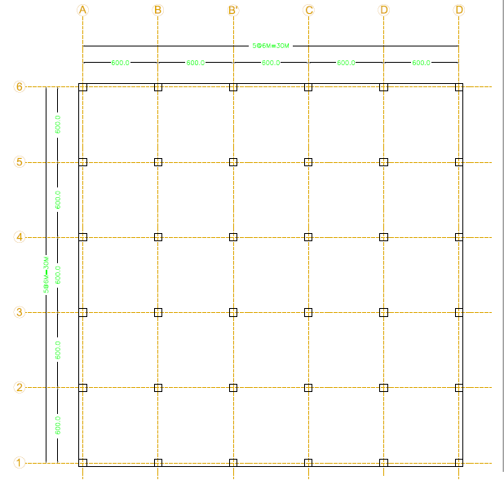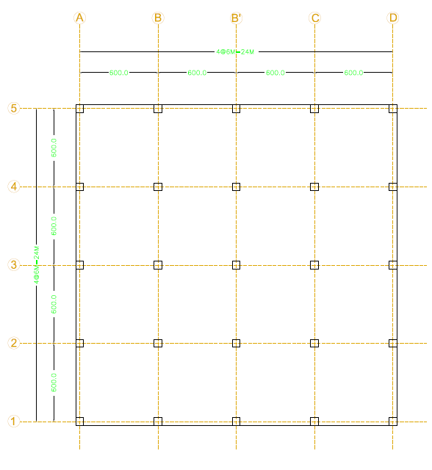

Figure 2: Plan for 5 story building. Figure 3: Plan for 10 and 20 story buildings.

Table 1. The remaining properties of concrete and masonry

|  |  |  |  |  |  |  |
| --- | --- | --- | --- | --- | --- | --- |
| **S.No** | **Particulars** | **Dimension/Size/Value** | | | | |
| **20 story** | **10 story** | | **5 story** | |
| 2 | Seismic Zone | (Zone-V with PGA of 0.36 g) | | | | |
| 3 | First Floor Height (m) | 3.6 | 3.6 | | 3.6 | |
| 4 | Floor Height (m) | 3 | 3 | | 3 | |
| 5 | Building Height (m) | 60.6 | 30.6 | | 15.6 | |
| 6 | Size of Column (m) | 0.9×0.9, 0.8×0.8, 0.7×0.7, 0.6×0.6 and 0.5×0.5 | 0.7×0.7, 0.6×0.6 and 0.5×0.5 | | 0.4×0.4 and 0.5×0.5 | |
| 7 | Number of Stories | 20 | 10 | | 5 | |
| 8 | Beams Size (m) | 0.4×0.5 and 0.4×0.6 | 0.4×0.5 and 0.4×0.6 | | 0.4×0.5 and 0.4×0.6 | |
| 9 | Walls Thickness (m) | 0.23 | 0.23 | | 0.23 | |
| 10 | Thickness of Slab (m) | 0.125 | 0.125 | | 0.125 | |
| 11 | Earthquake load | As per IS-1893-2002 | | | | |
| 12 | *E*c (GPa) | 25 | 25 | | 25 | |
| 13 | *E*m (GPa) | 4.5 | 4.5 | | 4.5 | |
| 14 | *F*ck (MPa) | 30 | 30 | | 30 | |
| 15 | Yield Strength of Rebar (MPa) | 415 | 415 | | 415 | |
| 16 | Masonry Compressive Strengths (MPa) | 8 | 8 | | 8 | |
| 17 | Poisson’s Ratio | 0.2 | 0.2 | | 0.2 | |
| 18 | Dead Load of Slab ( kN/m2) | 3.125 | 3.125 | | 3.125 | |
| 19 | Floor Live Load ( kN/m2) | 3 | 3 | | 3 | |
| 20 | Roof Live Load ( kN/m2) | 1.5 | 1.5 | | 1.5 | |
| 21 | Floor Finish ( kN/m2) | 1.00 | 1.00 | | 1.00 | |
| 22 | Specific wt. of RCC ( kN/ m3) | 25.00 | 25.00 | | 25.00 | |
| 23 | Specific wt. of Infill ( kN/ m3) | 20.00 | 20.00 | | 20.00 | |
| 24 | Material | Concrete M-30 and Reinforcement Fe-415(HYSD Confirming to IS-2002) | | | | |
| 25 | Reinforcement | High strength deformed steel Confirming to IS-2002. It is having modulus of Elasticity as 2 00 kN/ mm2 | | | | |
| 26 | Software | SAP2000 and Etabs | | | | |
| 27 | Moment Capacity of Beam (kN m) | 445 | | 445 | | 445 |

The designers can predict the behavior of structure while subjected to seismic excitation up to the yield point. After crossing of this point when once it reaches the non-linear region, the behavior is challenging to predict. The inelastic behavior of the RC infill structure under seismic loading is mainly governed by the formation of hinges. So, the analytical models for the pushover analysis may be divided into distributed plasticity (plastic zone) and concentrated plasticity (plastic hinge). Therefore, pushover analysis is a potent tool integrated in the design packaging software for analyzing the performance of structure in the post-yield stage. Under incrementally increasing loads, various structural elements may yield as indicated by the formation of plastic hinges due to the substantial loss in stiffness (Figures 4 through 6). The performance of the two-dimensional (2D) normal frame is compared with the 2D masonry frame, 2D masonry frame with increasing shear capacity (ISC), and masonry frame with increasing ISC and section. It is observed in these figures that the 2D frame having ten story experienced maximum damages as compared to the five and twenty story 2D frame. Also, it is noticed that the damages concentrated in the soft story by considering the masonry 2D frame, ISC, and ISC with increase in section. This concludes that the case where the combination of ISC and increase in section is considered shows the best seismic performance. In low to high rise buildings the damages will be much lower. Therefore, the study recommends the masonry frame with increasing ISC and section as an ideal option for practical usage

|  |  |
| --- | --- |
| Sap 5 Story Pic 1  a) 2D Frame | Sap 5 Story Pic 5  b) Masonry Frame |
| Sap 5 Story Pic 4  c) Masonry Frame ISC | Sap 5 Story Pic 3  d) Masonry Frame ISC+ Section |

Figure 4: 5 story frame collapse during Earthquakes.

|  |  |
| --- | --- |
| Sap 10 Story Pic1  a) 2D Frame | Sap 10 Story Pic2  b) Masonry Frame |
| Sap 10 Story Pic4  c) Masonry Frame ISC | Sap 10 Story Pic3  d) Masonry Frame ISC+ Section |

Figure 5: 10 story frame collapse during Earthquakes.

|  |  |
| --- | --- |
| Sap 20 Story Pic1  a) 2D Frame | Sap 20 Story Pic5  b) Masonry Frame |
| Sap 20 Story Pic4  c) Masonry Frame ISC | Sap 20 Story Pic6  d) Masonry Frame ISC+ Section |

Figure 6: 20 story frame collapse during Earthquakes.

Figures 7 through 9 show the pushover curve for 5, 10, and 20 story frames. The curve so obtained after performing pushover analysis is initially linear but starts to deviate from linearity to non-linearity due to the inelastic deformation of beams and columns. Furthermore, when the structure is pushed well into the inelastic range, the curve appears to be linear once again up to limited deformation but with a relatively smaller slope. This decrease in slope is because of the degradation in stiffness due to the formation of hinges in beams and columns. It also evident that frames with ISC and ISC with increase in section shows better performance in pushover analysis, infect, it is true for 5, 10, 20 story frames.



Figure 7: Push over curve 5 story frame. Figure 8: Push over curve 10 story frame.



Figure 9: Push over curve 20 story frame.

# 4. Conclusions

The present study aimed to find out a solution for the shear capacity and moment capacity of the first story of the frames. Results of the analysis leading to several conclusions, which are mentioned as below:

1. The pushover analysis is a relatively simple way to explore the non-linear behavior of structures.
2. The non-linear static analysis gives better understanding and more accurate seismic performance of building as failure or progression of damage can be traced.
3. The idea of the behavior of structure under the given seismic excitation can be predicted with the help of the results obtained in terms of the demand curve, capacity curve and the plastic hinge mechanism.
4. The RC infill frame construction with an open story is most vulnerable to damage and needs to be strengthened.
5. Even though, after strengthening by various schemes, ultimately there was a collapse of open story column. Thus, local retrofitting of open ground story column is recommended.

**References**

Bertero, V., and Brokken, S. (1983) “Infills in seismic resistant building” Journal of Structural Engineering, 109 (6), 1337-1361.

FEMA 356:2000, “Pre-standard and commentary for the seismic rehabilitation of buildings”, Washington, D.C. Federal Emergency Management Agency; November 2000.

Indian Standard, IS 1893: (2002) “Criteria for earthquake resistant design of structure”

Kaushik, B. H., Rai, C. D., and Jain, K. S. (2007) “Stress-strain characteristics of clay brick masonry under uniaxial compression”, Journal of Material Civil Engineering, 19 (9), 728-739.

Kaushik, B. H., Rai, C. D., and Jain, K. S. (2009) “Effectiveness of some strengthening options for masonry-infilled RC frames with open first story”, Journal of Structural Engineering, 135 (8): 925-937.

Lazarov, D, L., and Todorov, I, K. (2010) “Comments to Eurocode 8 recommendations in modeling and analysis of structures”, Paper presented at the 14th European Conference on Earthquake Engineering, Orhid, Republic of Macedonia.

Paulay, T., and Priestley, M. J. N. (1992) “Seismic design of reinforced concrete and masonry buildings”, John Wiley, New York.

Perera, R., Gomez, S., and Alarcon, E. (2004) “Experimental and analytical study of masonry infill reinforced concrete frames retrofitted with steel braces” Journal of Structural Engineering, 130(12), 2032-2039.

Sahoo, D. R. (2008) “Seismic strengthening of open ground story RC frame using steel caging and aluminum shear yielding dampers”, Ph.D. Thesis, Indian Institute of Technology Kanpur, India.

Sahoo, D. R., and Rai, C. D. (2013) “Design and evaluation of seismic strengthening techniques for reinforced concrete frames with soft ground story”, Engineering Structures, 56, 1933-1944.

Singh, B. P., Koutromanos, I., and Stavridis, A., (2013) “Seismic performance of masonry-infilled RC frames with and without retrofit”, Journal of Earthquake and Tsunami, 7 (3), 1350023.