**SEISMIC RETROFITTING AND STRUCTURAL PROTECTION OF THE HISTORICAL MONUMENT: REVIEW OF THE METHODS**

**Faqiri Amanollah**[1]

*Department of Civil Engineering, Engineering Faculty*

*Herat University, Herat, Afghanistan*

# Abstract

Historical monuments represent an important cultural heritage that needs to be preserved for future generations. Many of these structures were constructed before modern seismic design codes and may be vulnerable to damage during earthquakes. Seismic retrofitting is the process of adding external devices or systems to the structure to improve its resistance to seismic forces. This paper provides a comprehensive review of the methods used for seismic retrofitting and structural protection of historical monuments. The focus is on the most commonly used techniques, including base isolation, reinforcement of the foundation, energy dissipation devices, and seismic early warning systems. The paper also discusses the challenges associated with seismic retrofitting of historical monuments, including the need to balance preservation of historical integrity with the implementation of effective seismic retrofitting techniques. Additionally, the paper highlights the importance of using non-destructive testing techniques and structural health monitoring to assess the dynamic characteristics of the structure and evaluate the effectiveness of the retrofitting methods.

**Keywords**: Historical Monuments, Seismic Retrofitting, Base Isolation, Energy Dissipation Devices.

# 1. Introduction

Historical monuments are an important part of our cultural heritage and represent an important link to our past. They often have unique architectural and aesthetic features that make it challenging to implement traditional seismic retrofitting techniques without compromising their integrity and value [1]. Additionally, many of these structures were constructed before modern seismic design codes and may be vulnerable to damage during earthquakes.

Seismic retrofitting is the process of adding external devices or systems to the structure to improve its resistance to seismic forces. The aim is to prevent or minimize damage to the structure during an earthquake and ensure the safety of its occupants [2]. Seismic retrofitting can be achieved through various methods, including base isolation, reinforcement of the foundation, energy dissipation devices, and seismic early warning systems [3].

This paper provides a comprehensive review of the methods used for seismic retrofitting and structural protection of historical monuments. The paper is structured as follows: Section 2 provides an overview of the seismic hazard and its effects on historical monuments. Section 3 discusses the most commonly used seismic retrofitting techniques, including their advantages and disadvantages. Section 4 presents a discussion of the challenges associated with seismic retrofitting of historical monuments, including the need to balance preservation of historical integrity with the implementation of effective seismic retrofitting techniques. Section 5 discusses the importance of using non-destructive testing techniques and structural health monitoring to evaluate the effectiveness of the retrofitting methods. Finally, Section 6 provides a summary of the main findings of the paper and outlines potential future research directions.

# 2. Seismic Hazard and Its Effects on Historical Monuments

# 2.1 Seismic Hazard

A seismic hazard is a potential for ground shaking, ground failure, or tsunamis that can result from an earthquake. Seismic hazards are influenced by the location, magnitude, and depth of the earthquake, as well as the characteristics of the local geology and the structural design of the building. The seismic hazard can be quantified using various methods, including probabilistic seismic hazard analysis (PSHA) and deterministic seismic hazard analysis (DSHA) [4-6].

PSHA is a statistical method that considers the probability of ground shaking occurring at a particular location over a specified time period. The method uses a stochastic model to generate a set of ground motion time histories that represent the range of possible ground motions that could occur at the site. The seismic hazard is then quantified as the annual probability of ground shaking exceeding a certain level of intensity [4].

DSHA, on the other hand, is a deterministic method that considers the maximum credible earthquake that could occur at a particular location. The method uses a deterministic model to generate ground motion time histories that represent the expected ground motions that could occur during the earthquake. The seismic hazard is then quantified as the ground motion intensity that the structure is expected to experience during the earthquake [5].

# 2.2 Effects of Seismic Hazard on Historical Monuments

Historical monuments are often located in seismically active regions, and as such, are exposed to seismic hazards. The effects of seismic hazards on historical monuments can be catastrophic, causing severe damage or even collapse of the structure. The effects of ground motion on historical monuments are influenced by various factors, including the seismic hazard, the structural characteristics of the building, the foundation conditions, and the soil properties [7].

The structural characteristics of the building, including its height, mass, and stiffness, determine how the building responds to ground motion [8]. The foundation conditions, including the type of foundation and the soil properties, also influence the building response [9]. In addition, the location of the building with respect to the seismic source affects the severity of ground motion that it experiences [9].

The damage to historical monuments due to earthquakes can be classified into four categories: (i) cracking of the masonry and plaster, (ii) displacement of structural elements, (iii) collapse of the structure, and (iv) damage to non-structural elements. Damage to non-structural elements can have serious consequences, including the loss of valuable artifacts and damage to architectural features [10-12].

# 3. Seismic Retrofitting Techniques

Seismic retrofitting is the process of adding external devices or systems to the structure to improve its resistance to seismic forces. The aim is to prevent or minimize damage to the structure during an earthquake and ensure the safety of its occupants. Seismic retrofitting can be achieved through various methods, including base isolation, reinforcement of the foundation, energy dissipation devices, and seismic early warning systems [13, 14].

# 3.1 Base Isolation

Base isolation is a technique used to separate the structure from the ground motion by placing it on a flexible support system. The aim is to reduce the seismic forces transmitted to the structure and improve its seismic performance. The flexible support system typically consists of lead-rubber bearings, which provide a low-stiffness and high-damping response to the ground motion [15-20]. It mitigates the effect of a examining fundamentally confining the structure beginning with conceivably, unsafe ground movements. Seismic isolation will be a design strategy, which uncouples that structure for those hurting effects of the ground development (Figs. 1).

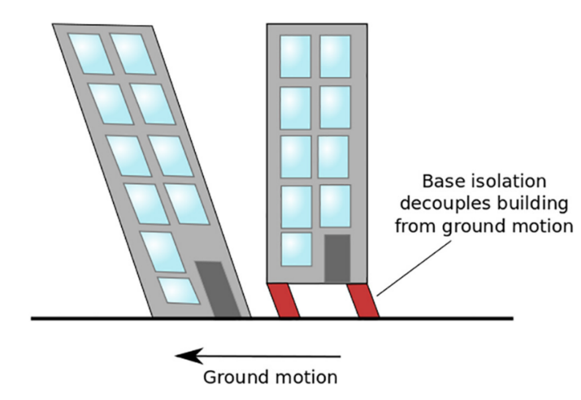

Fig. 1. Structural behavior of buildings using base isolators [19].

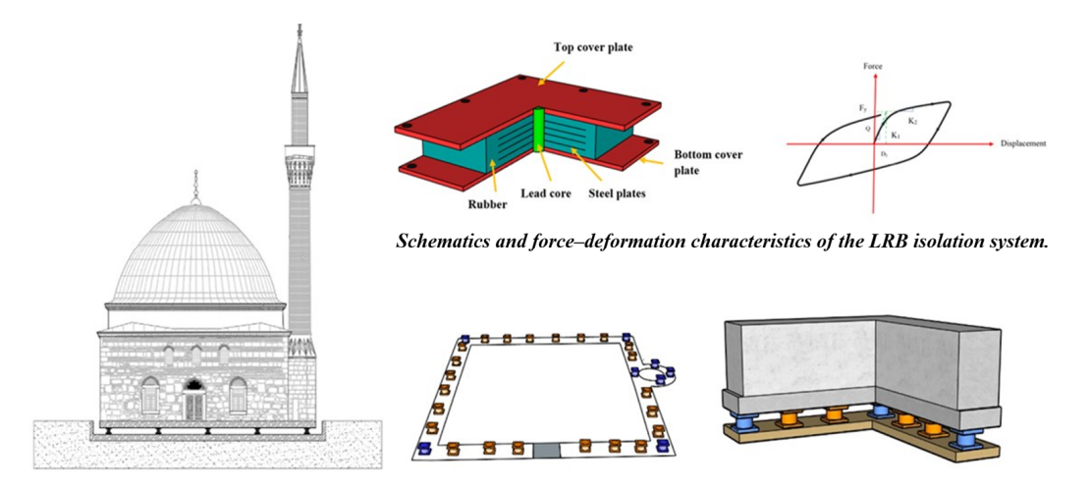Base isolation has been successfully used to retrofit historical monuments, including the Parthenon in Athens, Greece, and the Cathedral of Our Lady of the Angels in Los Angeles, USA. The retrofitting of the Parthenon involved the installation of a base isolation system to reduce the seismic forces transmitted to the structure during earthquakes (Figs. 2, 3 and 4). The retrofitting of the Cathedral of Our Lady of the Angels involved the installation of a base isolation system and a tuned mass damper to reduce the seismic forces [21-25].

Fig. 2. Representations of the historical mosque and the isolator details [22].

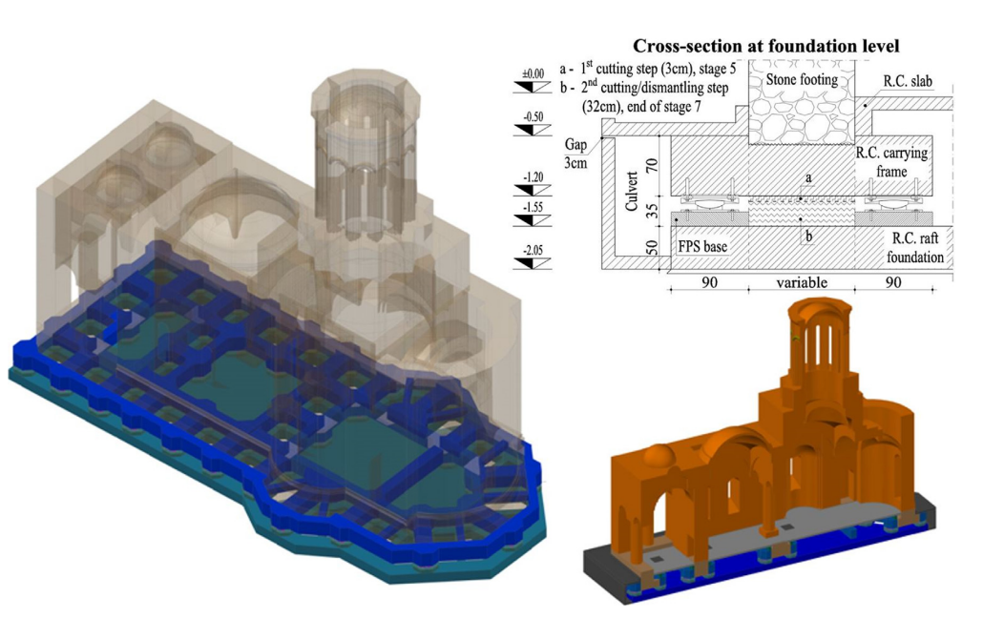

Fig. 3. Reinforced concrete carrying frame and raft foundation – isometric views and cross-sectional details [21].

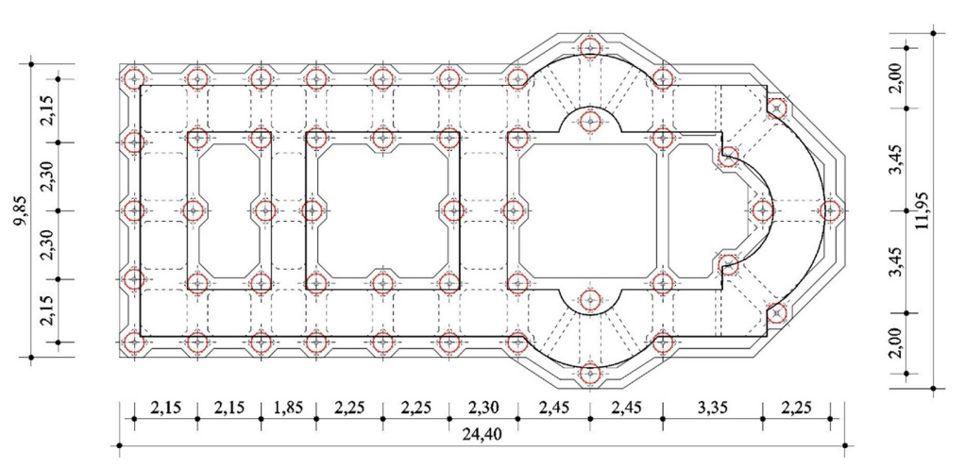

Fig. 4. Horizontal section – position of the FPS isolators [21].

# 3.2 Reinforcement of the Foundation

Reinforcement of the foundation is a technique used to improve the strength and stiffness of the foundation to resist seismic forces. The aim is to prevent the foundation from being damaged during an earthquake and to improve the seismic performance of the structure. Reinforcement of the foundation can be achieved through various methods, including the addition of concrete or steel elements to the foundation, the installation of micropiles or soil nails, and the improvement of the soil properties [26].

Reinforcement of the foundation has been used to retrofit historical monuments, including the Leaning Tower of Pisa in Italy and the Temple of the Inscriptions in Mexico. The retrofitting of the Leaning Tower of Pisa involved the installation of a new foundation system consisting of a concrete ring and a series of micropiles to support the leaning structure. The retrofitting of the Temple of the Inscriptions involved the installation of concrete beams and columns to reinforce the foundation and the structural elements of the monument [27-29].

# 3.3 Energy Dissipation Devices

Energy dissipation devices are devices that are installed in the structure to absorb or dissipate seismic energy during an earthquake. The aim is to reduce the seismic forces transmitted to the structure and improve its seismic performance. Energy dissipation devices can be classified into three categories: (i) passive devices, which do not require external power, (ii) active devices, which require external power, and (iii) hybrid devices, which combine the features of passive and active devices [30].

Energy dissipation devices have been used to retrofit historical monuments, including the Tower of London in the UK and the Taipei 101 Tower in Taiwan. The retrofitting of the Tower of London involved the installation of friction pendulum bearings and fluid viscous dampers to reduce the seismic forces transmitted to the structure during earthquakes. The retrofitting of the Taipei 101 Tower involved the installation of a tuned mass damper, a pendulum-like device, to reduce the lateral sway of the tower caused by wind and earthquakes [30].

# 3.4 Seismic Early Warning Systems

Seismic early warning systems are systems that use seismic sensors to detect and analyze seismic waves and provide advance warning of an impending earthquake. The aim is to provide enough time for people to evacuate buildings and for critical infrastructure to be shut down before the arrival of the seismic waves. Seismic early warning systems can be used to trigger automated shut-off systems for gas and water pipelines, power grids, and transportation systems [31-33].

Seismic early warning systems have been developed and implemented in various countries, including Japan, Mexico, and the United States. The early warning system in Japan, known as the Earthquake Early Warning (EEW) system, has been in operation since 2007 and has been credited with saving lives during major earthquakes, including the 2011 Tohoku earthquake. The early warning system in Mexico, known as the Seismic Alert System (SAS), has been in operation since 1991 and has been credited with reducing damage and casualties during earthquakes, including the 2017 Puebla earthquake [32, 34, 35, 36].

# 4. Conclusion

Historical monuments are important cultural and historical assets that are often located in seismically active regions. The effects of seismic hazards on historical monuments can be catastrophic, causing severe damage or even collapse of the structure. Seismic retrofitting is the process of adding external devices or systems to the structure to improve its resistance to seismic forces. Seismic retrofitting can be achieved through various methods, including base isolation, reinforcement of the foundation, energy dissipation devices, and seismic early warning systems.

The choice of retrofitting method depends on various factors, including the seismic hazard, the structural characteristics of the building, the foundation conditions, and the soil properties. The retrofitting of historical monuments requires a multidisciplinary approach that involves the collaboration of architects, engineers, geologists, and historians. The aim is to balance the preservation of the historical and cultural significance of the monument with the need to improve its seismic performance.

The retrofitting of historical monuments is a complex and challenging task that requires careful planning, design, and implementation. The success of a retrofitting project depends on various factors, including the quality of the design, the quality of the construction, and the effectiveness of the monitoring and maintenance program. A well-designed and well-executed retrofitting project can significantly improve the seismic performance of a historical monument and ensure its preservation for future generations.

In conclusion, the seismic retrofitting of historical monuments is an essential task that requires careful consideration and planning. The selection of the retrofitting method should be based on a detailed assessment of the seismic hazard, the structural characteristics of the building, and the foundation and soil conditions. The collaboration of a multidisciplinary team of experts is essential to ensure the success of the retrofitting project. Finally, the monitoring and maintenance of the retrofitting systems are essential to ensure their long-term effectiveness and the preservation of the historical monument.

# References

[1] VICENTE, R., LAGOMARSINO, S., FERREIRA, T. M., CATTARI, S., & MENDES DA SILVA, J. A. R. (2018). CULTURAL HERITAGE MONUMENTS AND HISTORICAL BUILDINGS: CONSERVATION WORKS AND STRUCTURAL RETROFITTING. STRENGTHENING AND RETROFITTING OF EXISTING STRUCTURES, 25-57.‏

[2] CAO, X. Y., SHEN, D., FENG, D. C., WANG, C. L., QU, Z., & WU, G. (2022). SEISMIC RETROFITTING OF EXISTING FRAME BUILDINGS THROUGH EXTERNALLY ATTACHED SUB-STRUCTURES: STATE OF THE ART REVIEW AND FUTURE PERSPECTIVES. JOURNAL OF BUILDING ENGINEERING, 57, 104904.‏

[3] D'AMATO, M., LAGUARDIA, R., & GIGLIOTTI, R. (2020). SEISMIC RETROFIT OF AN EXISTING RC BUILDING WITH ISOLATION DEVICES APPLIED AT BASE. FRONTIERS IN BUILT ENVIRONMENT, 6, 82.

[4] MCGUIRE, R. K. (2008). PROBABILISTIC SEISMIC HAZARD ANALYSIS: EARLY HISTORY. EARTHQUAKE ENGINEERING & STRUCTURAL DYNAMICS, 37(3), 329-338.‏

[5] MASE, L. Z. (2020). SEISMIC HAZARD VULNERABILITY OF BENGKULU CITY, INDONESIA, BASED ON DETERMINISTIC SEISMIC HAZARD ANALYSIS. GEOTECHNICAL AND GEOLOGICAL ENGINEERING, 38(5), 5433-5455.‏

[6] ANBAZHAGAN, P., VINOD, J. S., & SITHARAM, T. G. (2009). PROBABILISTIC SEISMIC HAZARD ANALYSIS FOR BANGALORE. NATURAL HAZARDS, 48, 145-166.

[7] DOUGLAS, J., SEYEDI, D. M., ULRICH, T., MODARESSI, H., FOERSTER, E., PITILAKIS, K., & LOLI, M. (2015). EVALUATION OF SEISMIC HAZARD FOR THE ASSESSMENT OF HISTORICAL ELEMENTS AT RISK: DESCRIPTION OF INPUT AND SELECTION OF INTENSITY MEASURES. BULLETIN OF EARTHQUAKE ENGINEERING, 13, 49-65.‏

[8] HOUSNER, G. W., MARTEL, R. R., & ALFORD, J. L. (1953). SPECTRUM ANALYSIS OF STRONG-MOTION EARTHQUAKES. BULLETIN OF THE SEISMOLOGICAL SOCIETY OF AMERICA, 43(2), 97-119.‏

[9] NGUYEN, Q. V. (2017). EFFECTS OF FOUNDATION CHARACTERISTICS AND BUILDING SEPARATION GAP ON SEISMIC PERFORMANCE OF MID-RISE STRUCTURES INCORPORATING SOIL-FOUNDATION-STRUCTURE-INTERACTION (DOCTORAL DISSERTATION).‏

[10] KORJENKOV, A. M., KAISER, D., & GROUPNER, S. (2005). PRELIMINARY ANALYSIS OF DAMAGES OF POSSIBLE SEISMIC ORIGIN TO HISTORICAL MONUMENTS IN NORTH-EASTERN GERMANY. ARCHEOSISMICITE & VULNERABILITE. PATRIMOINE BATI OUVERT AU PUBLIC. ACTES DES VIE ET VIIE RECONTRES DU GROUPE APS, 199-215.‏

[11] STEPINAC, M., LOURENÇO, P. B., ATALIĆ, J., KIŠIČEK, T., UROŠ, M., BANIČEK, M., & NOVAK, M. Š. (2021). DAMAGE CLASSIFICATION OF RESIDENTIAL BUILDINGS IN HISTORICAL DOWNTOWN AFTER THE ML5. 5 EARTHQUAKE IN ZAGREB, CROATIA IN 2020. INTERNATIONAL JOURNAL OF DISASTER RISK REDUCTION, 56, 102140.

[12] DOĞANGÜN, A., TULUK, Ö. İ., LIVAOĞLU, R., & ACAR, R. (2006). TRADITIONAL WOODEN BUILDINGS AND THEIR DAMAGES DURING EARTHQUAKES IN TURKEY. ENGINEERING FAILURE ANALYSIS, 13(6), 981-996.‏

[13] OLIVETO, G., & MARLETTA, M. (2005). SEISMIC RETROFITTING OF REINFORCED CONCRETE BUILDINGS USING TRADITIONAL AND INNOVATIVE TECHNIQUES. ISET JOURNAL OF EARTHQUAKE TECHNOLOGY, 42(2-3), 21-46.‏

[14] LOURENÇO, P. B., CIOCCI, M. P., GRECO, F., KARANIKOLOUDIS, G., CANCINO, C., TORREALVA, D., & WONG, K. (2019). TRADITIONAL TECHNIQUES FOR THE REHABILITATION AND PROTECTION OF HISTORIC EARTHEN STRUCTURES: THE SEISMIC RETROFITTING PROJECT. INTERNATIONAL JOURNAL OF ARCHITECTURAL HERITAGE, 13(1), 15-32.‏

[15] PRAJAPATI, M. K., & JAMLE, S. (2020). STRENGTH IRREGULARITIES IN MULTISTORIED BUILDING USING BASE ISOLATION AND DAMPER IN HIGH SEISMIC ZONE: A THEORETICAL REVIEW. INTERNATIONAL JOURNAL OF ADVANCED ENGINEERING RESEARCH AND SCIENCE, 2456-1908.‏

[16] POURMASOUD, M. M., LIM, J. B., HAJIRASOULIHA, I., & MCCRUM, D. (2022). MULTI-DIRECTIONAL BASE ISOLATION SYSTEM FOR COUPLED HORIZONTAL AND VERTICAL SEISMIC EXCITATIONS. JOURNAL OF EARTHQUAKE ENGINEERING, 26(3), 1145-1170.‏

[17] NOBARI AZAR, F. A., KARIMZADEH NAGHSHINEH, A., & SEN, M. (2022). PREPARATION AND CHARACTERIZATION OF NATURAL RUBBER–BASED NEW ELASTOMERS FOR HIGH-DAMPING BASE ISOLATION SYSTEMS. JOURNAL OF ELASTOMERS & PLASTICS, 54(6), 959-974.‏

[18] KIM, Y. C., SHAHRIYER, H., & HU, J. W. (2022). STUDY ON NUMERICAL SEISMIC PERFORMANCE EVALUATION OF 3D BUILDING FRAME WITH SMART SELF-CENTERING BRBS SYSTEM. CASE STUDIES IN CONSTRUCTION MATERIALS, 17, E01666.‏

[19] CHATURVEDI, R., SHARMA, A., & ISLAM, A. (2021). DESIGN ANALYSIS OF BRB ENERGY DISSIPATED DEVICES IN COMMERCIAL BUILDING STRUCTURES. MATERIALS TODAY: PROCEEDINGS, 45, 2949-2952.‏

[20] MAKRIS, N. (2019). SEISMIC ISOLATION: EARLY HISTORY. EARTHQUAKE ENGINEERING & STRUCTURAL DYNAMICS, 48(2), 269-283.‏

[21] LUPĂȘTEANU, V., SOVEJA, L., LUPĂȘTEANU, R., & CHINGĂLATĂ, C. (2019). INSTALLATION OF A BASE ISOLATION SYSTEM MADE OF FRICTION PENDULUM SLIDING ISOLATORS IN A HISTORIC MASONRY ORTHODOX CHURCH. ENGINEERING STRUCTURES, 188, 369-381.‏

[22] USTA, P. (2021). INVESTIGATION OF A BASE-ISOLATOR SYSTEM’S EFFECTS ON THE SEISMIC BEHAVIOR OF A HISTORICAL STRUCTURE. BUILDINGS, 11(5), 217.‏

[23] BEIRAMI SHAHABI, A., ZAMANI AHARI, G., & BARGHIAN, M. (2020). BASE ISOLATION SYSTEMS–A STATE OF THE ART REVIEW ACCORDING TO THEIR MECHANISM. JOURNAL OF REHABILITATION IN CIVIL ENGINEERING, 8(2), 37-61.‏

[24] FUJII, K., & MASUDA, T. (2021). APPLICATION OF MODE-ADAPTIVE BIDIRECTIONAL PUSHOVER ANALYSIS TO AN IRREGULAR REINFORCED CONCRETE BUILDING RETROFITTED VIA BASE ISOLATION. APPLIED SCIENCES, 11(21), 9829.‏

[25] ARTAR, M., COBAN, K., YURDAKUL, M., CAN, O., YILMAZ, F., & YILDIZ, M. B. (2019). INVESTIGATION ON SEISMIC ISOLATION RETROFIT OF A HISTORICAL MASONRY STRUCTURE. EARTHQUAKES AND STRUCTURES, 16(4), 501-512.‏

[26] BRUCE, D. A., DIMILLIO, A. F., & JURAN, I. (1997). MICROPILES: THE STATE OF PRACTICE PART 1: CHARACTERISTICS, DEFINITIONS AND CLASSIFICATIONS. PROCEEDINGS OF THE INSTITUTION OF CIVIL ENGINEERS-GROUND IMPROVEMENT, 1(1), 25-35.‏

[27] DANIEL, V., KRKLJUS, D., & PETRIȘOR, D. (2019). THE SPECIFICS OF USE OF COMPOSITE MATERIALS IN CONSOLIDATION OF HISTORICAL MONUMENTS. OVIDIUS UNIVERSITY ANNALS OF CONSTANTA-SERIES CIVIL ENGINEERING, 21(1), 25-33.‏

[28] HIGAZY, E. M. (2004). VULNERABILITY OF HISTORICAL MINARETS; INVESTIGATION OF THEIR SEISMIC ASSESSMENT & RETROFITTING. EMIRATES JOURNAL FOR ENGINEERING RESEARCH, 9(2), 59-64.‏

[29] GILANI, A. S., & MIYAMOTO, H. K. (2012, SEPTEMBER). BASE ISOLATION RETROFIT CHALLENGES IN A HISTORICAL MONUMENTAL BUILDING IN ROMANIA. IN PROCEEDINGS OF THE 15TH WORLD CONFERENCE ON EARTHQUAKE ENGINEERING, LISBON, PORTUGAL (PP. 24-28).‏

[30] SYMANS, M. D., CHARNEY, F. A., WHITTAKER, A. S., CONSTANTINOU, M. C., KIRCHER, C. A., JOHNSON, M. W., & MCNAMARA, R. J. (2008). ENERGY DISSIPATION SYSTEMS FOR SEISMIC APPLICATIONS: CURRENT PRACTICE AND RECENT DEVELOPMENTS. JOURNAL OF STRUCTURAL ENGINEERING, 134(1), 3-21.‏

[31] WIELAND, M., GRIESSER, M., & KUENDIG, C. (2000, FEBRUARY). SEISMIC EARLY WARNING SYSTEM FOR A NUCLEAR POWER PLANT. IN PROC. OF 12 WORLD CONFERENCE ON EARTHQUAKE ENGINEERING.‏

[32] GASPARINI, P., MANFREDI, G., & ZSCHAU, J. (2007). EARTHQUAKE EARLY WARNING SYSTEMS (P. 350). BERLIN: SPRINGER.‏

[32] SUÁREZ, G. (2022). THE SEISMIC EARLY WARNING SYSTEM OF MEXICO (SASMEX): A RETROSPECTIVE VIEW AND FUTURE CHALLENGES. FRONTIERS IN EARTH SCIENCE, 10, 196.‏

[33] GRASSO, V. F., BECK, J. L., & MANFREDI, G. (2007). SEISMIC EARLY WARNING SYSTEMS: PROCEDURE FOR AUTOMATED DECISION MAKING. EARTHQUAKE EARLY WARNING SYSTEMS, 179-209.‏

[34] SUÁREZ, G. (2022). THE SEISMIC EARLY WARNING SYSTEM OF MEXICO (SASMEX): A RETROSPECTIVE VIEW AND FUTURE CHALLENGES. FRONTIERS IN EARTH SCIENCE, 10, 196.‏

[35] KODERA, Y., HAYASHIMOTO, N., MORIWAKI, K., NOGUCHI, K., SAITO, J., AKUTAGAWA, J., ... & HOSHIBA, M. (2020). FIRST‐YEAR PERFORMANCE OF A NATIONWIDE EARTHQUAKE EARLY WARNING SYSTEM USING A WAVEFIELD‐BASED GROUND‐MOTION PREDICTION ALGORITHM IN JAPAN. SEISMOLOGICAL RESEARCH LETTERS, 91(2A), 826-834.‏

[36] MCBRIDE, S. K., BOSTROM, A., SUTTON, J., DE GROOT, R. M., BALTAY, A. S., TERBUSH, B., ... & VINCI, M. (2020). DEVELOPING POST-ALERT MESSAGING FOR SHAKEALERT, THE EARTHQUAKE EARLY WARNING SYSTEM FOR THE WEST COAST OF THE UNITED STATES OF AMERICA. INTERNATIONAL JOURNAL OF DISASTER RISK REDUCTION, 50, 101713.‏

1. Lecturer, amanollahfaqiri@gmail.com