Cost Estimation, Scheduling Analysis Using Building Information Model

**MOHAMMAD ZIA RAHIMI1*, HASIBULLAH KHAN2**

1*Graduate Student, Department of Building Architecture Construction Faculty, Kabul Polytechnic University, 5th District, Kabul, Afghanistan. Email: [zia.rahimy@hotmail.com](mailto:zia.rahimy@hotmail.com)

2Assistant Prof. Hasibullah Khan, Department of Building Architecture Construction Faculty, Kabul Polytechnic University, 5th District, Kabul, Afghanistan, Email: [h.khan@kpu.edu.af](mailto:h.khan@kpu.edu.af)

# Abstract

*Building Information Modeling (BIM) is one of the most promising developments in the architecture, engineering and construction (AEC) industries. BIM is both a technology and a process, with BIM technology, an accurate virtual model of a building is constructed digitally. Building information modeling (BIM) is a modern data information platform and management tool that promotes the development of green buildings. In this research, two building performance analysis software, Autodesk Takeoff and Navisworks including Revit to make BIM model have been used. First presented in this paper are the main concepts of BIM then a BIM model integration for cost estimation, and construction schedule are considered using the above BIM analyzing tools. in this paper, a comprehensive cost estimating, and scheduling methods using BIM model is presented. The model is integrated with BIM to provide the user with the capability of cost estimation, construction schedule analysis facilities.*

*The research methodology involved data collection, cost and schedule analysis. The results reveal significant Improvements of BIM model and its integration with other software and demonstrate the potential of BIM in promoting concise and digital model.*

**Keywords:** Building Information Modeling (BIM), Cost, Estimation, schedule, Autodesk, Model

# Introduction

Building Information Modeling (BIM) has been defined as “the act of creating an electronic model of a facility for the purpose of visualization, engineering analysis, conflict analysis, code criteria checking, cost engineering, as-built product, budgeting and many other purposes.” To foster better communication within the industry, it is important to define a consistent language to describe the focused use of BIM on a capital facility project. A BIM Use can be defined as “a method of applying Building Information Modeling during a facility’s lifecycle to achieve one or more specific objectives.”. [1]

However, neither the concept nor nomenclature of BIM is new—not as of 2007, not as of 2002, nor even 1997. The cost of building the model, estimated at about 0.1% of construction Cost. The concepts, approaches and methodologies that we now identify as BIM can be dated back nearly thirty years,while the terminology of the “Building Information Model” has been in circulation for at least fifteen years.During the early 1980s this method or approach was most commonly described in the USA as “Building Product Models” and in Europe—especially in Finland—as “Product Information Models”. [2]

BIM Model is an integrated with different software. A BIM model is sustainable, energy efficient, environmental protected, and a comprehensive representation of a building from construction to post construction phases. In this research a BIM model which is made using BIM tool Revit Architecture, then it analyzed using cost estimation of the project, the model is uploaded to Autodesk Takeoff. For construction scheduling analyzation the model is then imported to Navisworks. The general background of the study is to analysis BIM model, since it’s integrated the same model can be used to automatically analysis energy efficiency, cost estimation, and construction schedule. Each of the process is detailed described further in this research

BIM has its roots in computer-aided design research from decades ago, yet it still has no single, widely-accepted definition. BIM At the M.A. Mortenson Company is think of it as “an intelligent simulation of architecture.” To enable us to achieve integrated delivery, this simulation must exhibit six key characteristics. It must be: [3]

* Digital,
* Spatial (3D),
* Measurable (quantifiable, dimension-able, and query-able),
* Comprehensive (encapsulating and communicating design intent, building
* performance, constructability, and include sequential and financial

aspects of means and methods)

* Accessible (to the entire AEC/ owner team through an interoperable and

intuitive interface), and

* Durable (usable through all phases of a facility’s life).

# Literature Review

* 1. What are not BIM Technologies

1. Models that contain 3D data only and no object attributes.
2. Models with no support of behavior.
3. Models that are composed of multiple 2D CAD reference files that must be combined to define the building.
4. Models that allow changes to dimensions in one view that are not automatically reflected in other views. [4]
   1. Benefit of BIM

# Pre - Construction Benefits to Owner:

1. Concept, Feasibility and Design Benefits
2. Increased Building Performance and Quality [5]

# Design Benefits:

1. Earlier and More Accurate Visualizations of a Design
2. Automatic Low - Level Corrections When Changes Are Made to Design,
3. Generate Accurate and Consistent 2D Drawings at Any Stage of the Design,
4. Improve Energy Efficiency and Sustainability [5]

# Construction and Fabrication Benefits:

1. Synchronize Design and Construction Planning
2. Discover Design Errors and Omissions before Construction [5]

# Post Construction Benefits:

1. Better Manage and Operate Facilities
2. Integrate with Facility Operation and Management Systems,

# Owners can use a building information model to:

1. Increase building value through BIM - based energy design and analysis

to improve overall building performance

1. Shorten project schedule from approval to completion by using building

models to coordinate and prefabricate design with reduced fi eld labor time

1. Obtain reliable and accurate cost estimates through automatic quantity

take - off from the building model, providing feedback earlier in a project

when decisions will have the greatest impact

1. Assure program compliance through ongoing analysis of the building

model against owner and local code requirements

1. Produce market - ready facilities by reducing time between procurement

decisions and actual construction, allowing for the selection of the latest

technologies or trend finishes.

# Parametric Objects

The concept of parametric objects is central to understanding BIM and its differentiation from traditional 2D objects. Parametric BIM objects are defined as follows: [6]

* associated data and rules,
* non-redundantly,
* automatically modify associated geometries,
* different levels of aggregation,
* object feasibility

In parametric design, instead of designing an instance of a building element like a wall or door, a designer defines a model family or element class, which is a set of relations and rules to control the parameters by which element instances can be generated but will each vary according to their context. While in traditional 3D CAD every aspect of an element’ s geometry must be edited manually by users, the shape and assembly geometry in a parametric modeler automatically adjusts to changes in context and to high - level user controls. Conceptually, building information modeling (BIM) tools are object – based parametric models with a predefined set of object families, each having behaviors programmed within them, as outlined above. Some BIM design tools support parametric relations to complex curves and surfaces, such as splines and non - uniform B - splines (NURBS). These tools allow complex curved shapes to be defined and controlled similarly to other types of geometry. Several major BIM tools on the market have not included these capabilities, possibly for performance or reliability reasons. Parametric object modeling provides a powerful way to create and edit geometry. [5] Without it, model generation and design would be extremely cumbersome and error - prone, as was found with great disappointment by the mechanical engineering community after the initial development of solid modeling. [4] Designing a building that contains a million or more objects would be impractical without a platform that allows for effective low - level automatic design editing. Autodesk’s first BIM product Revit Architecture™ was introduced to the industry in 2002 [7] for the architectural design purpose and was quickly adopted by most architecture firms who were using BIM technology. After years of development, the Revit package has evolved into a product which can support multiple functions during the construction process—Revit Architecture™ for architectural design, Revit MEP™ for electrical engineering and plumbing design and Revit Structure™ for structural design. [7]

* 1. INTEROPERABILITY

The building lifecycle involves organizations with different responsibilities and functions and no BIM tools can support all the functions needed at all stages of the building lifecycle. Data exchange between applications is essential to the stakeholders, since other than architectural design of the building, there are structural and Mechanical, Electrical and Plumbing (MEP) design, energy analysis, fabrication, cost estimation, scheduling and other related activities. Each activity requires a different software application to support its function, thus data exchange at the software level is quite essential. According to the four ways are defined in which model information can be exchanged between two software tools: [2]

(1) Direct links between specific BIM tools

(2) Proprietary Exchange File Format

(3) Public Level Exchange Formats

(4) XML-based exchange formats

Using these open standards, BIM tools can export the intended file format which can be imported and read by another software tool. In Table 1, the common exchange formats in AEC applications, provides a summary of most commonly used exchange an estimator intends to use Autodesk Quantity Takeoff™

to generate the quantity takeoff list from a building model designed by Revit Architecture. The default format of the design is RVT which is not one of the file formats supported in Autodesk Quantity Takeoff (DWF or DWG). However, Revit Architecture™ allows users to export the drawing with different file formats, such as DWG, DXF, or DWF. [7] Thus, the estimator can export the drawing with the intended

file format and then import the file into Autodesk Quantity Takeoff to generate the accurate takeoff list. For supported file formats in different BIM software, more details will be discussed in the following section. [8] The interoperability of BIM allows users to pass a completer and more accurate

building model from computer applications used by one organization to another with less errors and omissions. Thus, all the involved organizations can share the consistent building model data at all stages during the building lifecycle.

Table 1 Common exchange formats in AEC applications [2]

|  |  |
| --- | --- |
| **Image (Raster) formats** | Descriptions |
| JPG, GIF, TIF, BMP, PIC, PNG, RAW, TGA, RLE | Raster formats vary in terms of compactness, number of possible colors per pixel, some compress with some data loss |
| **2D Vector formats** | Descriptions |
| DXF, DWG, AI, CGM, EMF, IGS, WMF, DGN | Vector formats vary regarding compactness, line widths and pattern control, color, layering and types of curves supported |
| **3D Surface and Shape formats** | Descriptions |
| 3DS, WRL, STL, IGS, SAT, DXF, DWG, OBJ, DGN, PDF(3D), XGL, EWF, U3D, IPT, PTS | 3D surface and shape formats vary according to the types of surfaces and edges represented, whether they represent surfaces and/or solids, any material properties of the shape (color, image bitmap, texture map) or viewpoint information |
| **3D Object Exchange formats** | Descriptions |
| STP, EXP, CIS/2 | Product data model formats represent geometry according to the 2D or 3D types represents. They also carry object properties and relations between objects. |
| **Game formats** | Descriptions |
| RWQ, X, GOF, FACT | Game file formats vary according to the types of surfaces, whether they carry hierarchical structure, types of material properties, texture and bump map parameters, animation and skinning |
| **GIS formats** | Descriptions |
| SHP, SHX, DBF, DEM, NED | Geographical information system formats |
| **XML formats** | Descriptions |
| AexXML, Obix, AEX, bcXML, AGCxml, IFCxml | XML schemas developed for the exchange of building data. They vary according to the information exchanged and the workflows supported. |

* 1. BIM Tools

As BIM evolves into one of the most advanced technologies in construction industry,

more software developers are applying their products into the prospective area in BIM. [9]

# Revit:

Revit Architecture is the best known and current market leader for the use of BIM in architectural design. It was introduced by Autodesk in 2002 [10] after the company acquired the program from a start - up. Revit is a completely separate platform from AutoCAD, with a different code base and file structure. The version reviewed here is 9.1. Revit is a family of integrated products that currently includes Revit Architecture, Revit Structure, and Revit MEP. It includes: gbXML interfaces for energy simulation and load analysis; direct interfaces to ROBOT and RISA structural analyses, and the ability to import models from Sketchup, a conceptual design tool, and other systems that export DXF files. Viewing interfaces include: DGN, DWG, DWF ™, DXF ™, IFC, SAT, SKP, AVI, ODBC, gbXML, BMP, JPG, TGA, and TIF. [10] Revit relies on 2D sections as a way of detailing most types of assemblies. [7]

# Revit’ s strengths:

It’ s easy to learn and its functionality is organized in a well - designed and user - friendly interface. It has a broad set of object libraries developed by third parties. It is the preferred interface for direct link interfaces, because of its market position. Its bi - directional drawing support allows for information generation and management based on updates from drawing and model views; it supports concurrent operation on the same project; and it includes an excellent object library that supports a multi - user interface. [7]

* + 1. Revit’ s weaknesses:

Revit is an in - memory system that slows down significantly for projects larger than about 220 megabytes. It has limitations on parametric rules dealing with angles. It also does not support complex curved surfaces, which limits its ability to support design with or reference to these types of surfaces. [11]

* 1. Strengths and Limitations of Object - Based Parametric Modeling

One major benefit of parametric modeling is the intelligent design behavior of objects. BIM is an enhanced parametric modeling technology which is called object-based parametric modeling. [6] This intelligence, however, comes at a cost. Each type of system object has its own behavior and associations. As a result, BIM design tools are inherently complex. Each type of building system is composed of objects that are created and edited differently. Effective use of a BIM design tool usually takes months to gain proficiency. Modeling software that some designers prefer, such as Sketchup, Rhino, and Form Z, are not parametric modeling – based tools. Rather, they have a fixed way of geometrically editing objects, varied only according to the surface types used; and this same functionality is applied to all object types. Object - based parametric modeling is a major change for the building industry that is greatly facilitating the move from a drawing - based and handcraft technology to one based on digitally readable models that can be exchanged with other applications. While object - based parametric modeling has had a catalytic influence on the emergence and acceptance of BIM, it is not synonymous with BIM tools or the generation of building models.

* 1. QUANTITY TAKEOFF AND COST ESTIMATING

5D model: 5D model is adding the 5th dimension—cost data to the 3D model. A 5D model links the cost data with the Quantity Takeoff (QTO) list, which is generated from the 3D model, to deliver more accurate project cost estimation. [6] Estimators utilize a variety of options to leverage BIM for quantity takeoff and to support the estimating process. No BIM tool provides the full capabilities of a spreadsheet or estimating package, so estimators must identify a method that works best for their specific estimating process. Three primaries’ options are:

**1.** Export building object quantities to estimating software

**2.** Link the BIM tool directly to the estimating software

**3.** Use a BIM quantity takeoff tool:

The third alternative, shown generically in Figure 1-2, is to use a specialized quantity takeoff tool that imports data from various BIM tools. This allows estimators to use a takeoff tool specifically designed for their needs without having to learn all of the features contained within a given BIM tool. Examples of these are: Exactal (Exactal 2007), Innovaya (Innovaya 2007), and OnCenter (OnCenter 2007). These tools typically include specific features that link directly to items and assemblies, annotate the model for ‘conditions,’ and create visual takeoff diagrams. These tools offer varying levels of support for automated extraction and manual takeoff features. Estimators will need to use a combination of both manual tools and automatic features to support the wide range of takeoff and condition checking they need to perform. Autodesk QTO™ can automatically extract QTO from the building model according to category information leveled on the object model and it also allows manual modification of the takeoffs based on the users’ own preference. After that, the QTO list can be exported to the MS Excel spreadsheet and users can associate the quantities with any suitable cost database. The QTO process in this approach can be finished automatically and categorize the objects based on the “Category” information leveled on the object model. After the automatic takeoff, users can also make some changes on the QTO list manually. One advantage of this approach is that users may not have to apply to the assemblies based on the specific cost estimating package; any suitable cost data can be mapped with the QTO list after the quantities are generated. However, compared to linking components to estimating software directly, this method may take more time on mapping the cost database Additional changes to the building model require that any new objects be linked to proper estimating tasks so that accurate cost estimates can be obtained from the building model, depending on the accuracy and level of detail already modeled.

|  |  |  |  |
| --- | --- | --- | --- |
| Product Name | Manufacturer | BIM Use | Supplier Web Link |
| QTO | Autodesk | Quantity Takeoffs | [www.autodesk.com](http://www.autodesk.com/) |
| Exactal | Exactal | Quantity Takeoffs | [www.exactal.com](http://www.exactal.com/) |
| Innovaya | Innovaya | Quantity Takeoffs | [www.innovaya.com](http://www.innovaya.com/) |
| Takeoff Manager | Vico | Quantity Takeoffs | [www.vicosoftware.com](http://www.vicosoftware.com/) |
| OnCenter | OnCenter | Quantity Takeoffs | [www.oncenter.com](http://www.oncenter.com/) |

Table 2 Software list—quantity takeoff tools

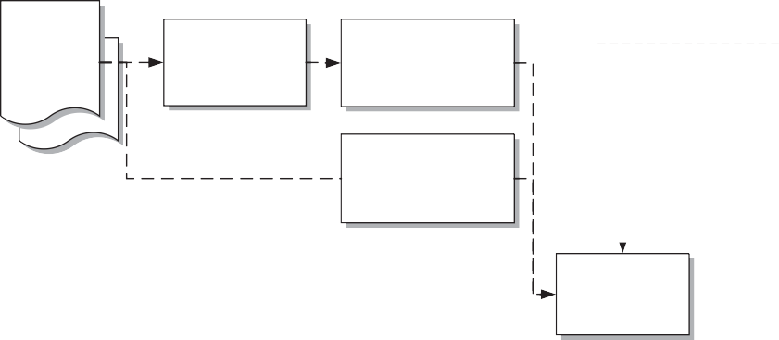

**estimate**

**associate with assembly items**

**auto-extract and associate with assembly items**

**extract quantities within BIM tool**

**manually extract quantities with specialized takeoff/ estimating tool**

**2D paper drawings from design/ engineering team**

**manual takeoff and manual check for “conditions”**

**Estimating Software**

**manually associate**

**takeoff information with assembly items**

**manual link, changes must be updated by estimator**

**digital links, changes are updated automatically**

**Traditional paper-based estimating process**

**associate digitized**

**takeoff information with component ‘assemblies’, ‘recipes’**

**cost**

**database**

**calculation of additional quantities item properties**

**3D/BIM**

**models from project team**

**supplier/ subcontractor pricing**

3D/BIM-based estimating process

FIGURE 1 Conceptual diagram of a BIM quantity takeoff and estimating process.

4 D Modeling Processes Similar to the options estimators have, schedulers can choose from a variety of tools and processes to build 4D models:

1. Manual method using 3D or 2D tools

2. Built - in 4D features in a 3D or BIM tool

3. Export 3D/BIM to 4D tool and import schedule

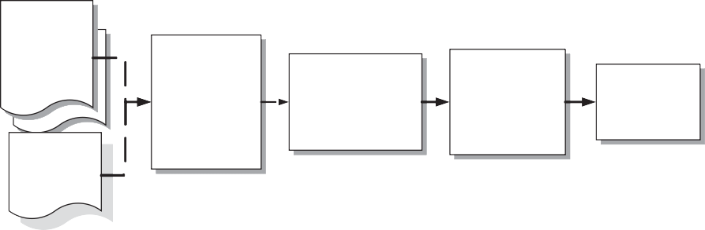

CAD Software

create 3D model per schedule scope adding temporary components as needed

manually turn on/off 'layers',

components for schedule date or period

create snapshot representing date or time period

2D paper drawings from design/ engineering team

4D snapshots/ animation

construction schedule, plan

Manual/CAD-based 4D process

4D model

group or reorganize model components

assign activity types for visual behaviors (construct, deconstruct, etc.)

manually or auto-link components or component groups to construction activities

4D tool/software

3D/BIM

models from project team

construction schedule or plan

manual link, changes must be updated by scheduler 4D Tool/BIM-based process digital links, changes are updated automatically

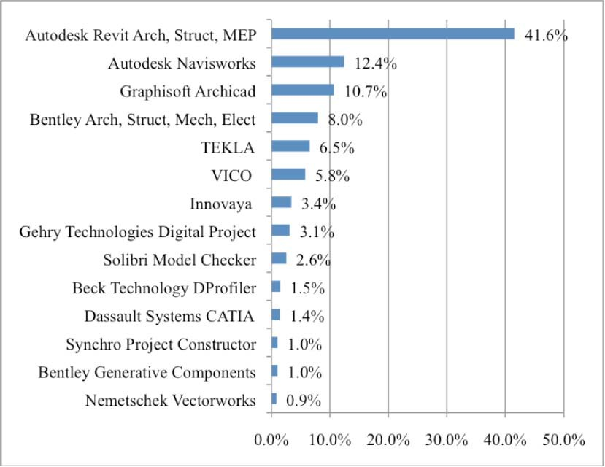

Figure 3 Percentages of market share of BIM tools which are used by construction firms [9]

* 1. Autodesk Navisworks™

4D model: 4D model is adding the fourth dimension--schedule to the 3D model. A 4D BIM model links the 3D elements with the project delivery timeline to provide users a virtual simulation of the project in the 4D environment. [6] For the schedule and cost controls, Autodesk has Navisworks™ which allows users to simulate and manage the construction process and Autodesk Quantity Takeoff Software that supports cost estimating function. Other than these, Autodesk™ also developed software tools such as Autodesk 3ds Max for model visualization and Autodesk™ Inventor for data exchange to benefit the users from higher control level. Most of the software tools from Autodesk™ can support multiple file formats which include: DGN, DWG, DWF, DXF, IFC, SAT, SKP, AVI, ODBC, gbXML, BMP, JPG, TGA, and TIF. The multiple file formats supporting function allows this software to be compatible with products from other software developers. Autodesk™ also provides free trial versions of the software and training webinars. Some BIM scheduling software tools may have the in-built function to define the schedule itself. Autodesk Navisworks™, which mean the imported schedule will be linked to the objects of the building model. In order to calculate the schedule, Vico Control™ links the quantities of the building objects to a “recipe” that contains the description of materials, labor, resource, cost and even location information. this integration of 3D model and project schedule is called 4D model. [10]

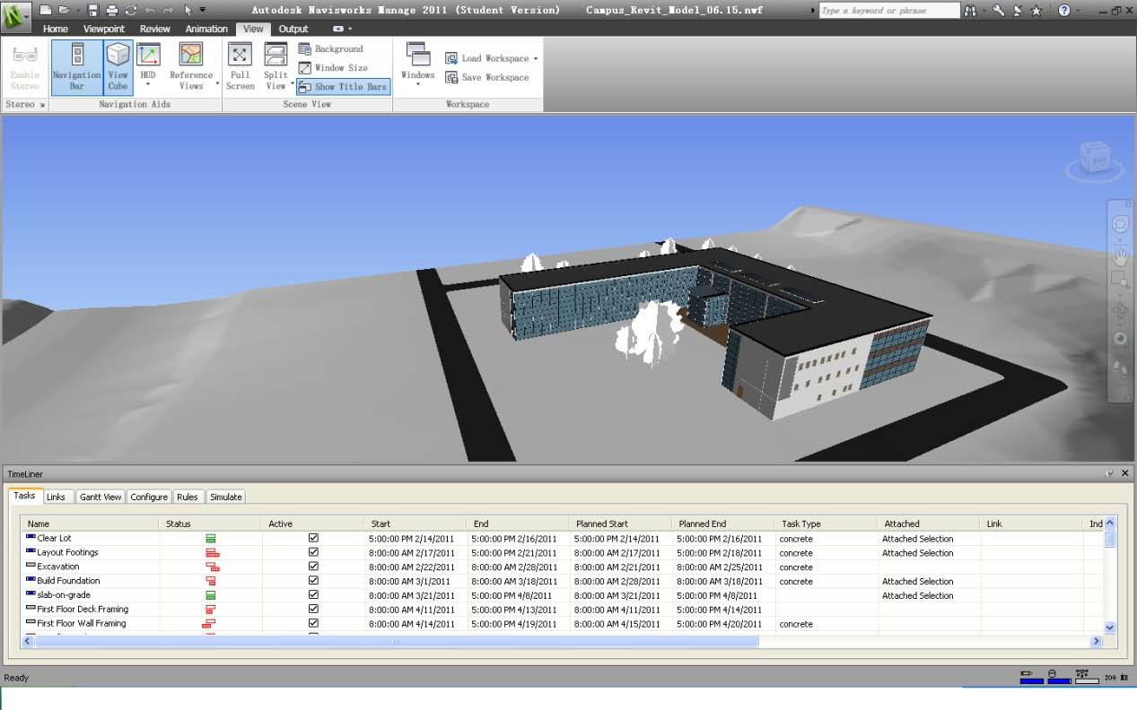

3D Virtual View

Schedule

Linked

Figure 4 Snapshot of a 4D software interface showing how schedule is connected to objects [7]

# Methodology

The methodology of this research contains multiple steps, Sample BIM model creation using BIM tool Autodesk Revit, the model is converted to a format DWF to be recognized by cost estimating (Quantity Takeoff) tool. Since BIM model is a digital model which is integrated to specific software, QTO generates its cost estimation spread sheet automatically. To know the time line of the project, we need to create a working schedule, for this reason the BIM model is imported to Autodesk Navisworks, the program gives us a thorough construction schedule. The below graph explains how the work has been done.

Using Revit

Sample BIM Model

Converting to DWF

Export to DWF

Generate Schedule

Import BIM Model

Using Navisworks

Generate Cost Estimation Spread Sheet

Import BIM Model

Using Takeoff

Figure5: illustrates the methodology

# Result and Discussion

Building Information Modeling (BIM) is an emerging technology in AEC industry. It provides users with more accurate and consistent project information throughout the lifecycle. In this research BIM tools and BIM application areas have been discussed with emphasis on scheduling and cost estimating. A careful review of the case study shows that BIM technology brings many advanced construction management skills to cost estimating, project scheduling and even project controls for contractors. In this case study, the QTO process is automatic and reliable, which is finished within 15 minutes, since the quantities of the building components are “read” by Autodesk QTO™ 2011 from the building model directly. This will save contractors substantial amount of time on cost estimating. On the other hand, the change of the design in the building model can be updated and reflected in the QTO list in minutes, which means that the owner (and in case of contracts where contractors are part of the team during design phase, contractors) can get a faster cost feedback on changes in design using BIM technology. The 4D BIM links the building components with tasks and simulate these tasks in the 4D environment—the design and the construction schedule are synchronized. In this case study, the tasks defined with planned and actual dates are represented in Gantt chart view. By comparing the planned and actual dates, the status bars can tell the contractor the progress of the project in an intuitive and simple way. The simulation of the progress can also help contractor to adjust the project schedule according to the design change in building model.

# References

|  |  |
| --- | --- |
| [1] | S. H. M. a. S. B. Azhar, Building Information Modeling (BIM):, Auburn University, Auburn, Alabama., 2008. |
| [2] | C. T. P. S. R. a. L. K. Eastman, BIM handbook:, Wiley, Hoboken, NJ., 2008. |
| [3] | M.A. Mortenson Company, "a construction contracting fi rm that has used BIM tools," 2006. |
| [4] | R. G. a. M. J. I. Kreider, The Uses of BIM, The Pennsylvania State University, University Park, PA, USA, 2013. |
| [5] | J. W. &. Sons, "A Guide to Building Information," in *BIM Handbook*, Hoboken, New Jersey, 2008. |
| [6] | X. Jiang, Developments in Cost Estimating and Scheduling in BIM technology, 2011. |
| [7] | San Rafael, Autodesk., CA,. |
| [8] | B. F. M. Koo, "Feasibility study of 4D CAD in commercial," *Journal of Construction Engineering and Management,* 2000. |
| [9] | B. a. S. R. Burcin, "The perceived value of building information," *Journal of Information Technology in,* 2010. |
| [10] | N. W. J. J. S. A. a. B. H. M. Yong, Building Information, SmartMarket Report, McGraw-Hill Construction, New, 2008. |
| [11] | Y. C. P. K. L. K. M. U. C. a. O. K. Arayici, Technology adoption in the BIM implementation for lean architectural, Automation in Construction, 2011. |
| [12] | C. J. Y. S. R. a. K. I. Eastman, "Exchange model and," *Journal,* vol. 24, no. 1, pp. 25-34, 2010. |
| [13] | E. T. D., Interoperability and the Structural Domain, Nishkian,, 2010. |
| [14] | D. a. M. L. Heesom, "Trends of 4D CAD applications for," *Journal of Construction Management and Economics,* 2004. |
| [15] | R. a. O. T. Jongeling, A method for planning of work-flow by, Automation in, 2007. |
| [16] | J. H. A. S. D. a. C. M. J. Kang, "Empirical study on the," *Journal Construction Engineering and Management,* 2007. |
| [17] | L. Khemlani, Visual Estimating: Extending BIM to Construction.”, 2006. [Online]. Available: <http://www.aecbytes.com/buildingthefuture/2006/VisualEstimating.html>. [Accessed 25 09 2023]. |
| [18] | R. Rundell, Revit: BIM and Cost Estimating, 2006. [Online]. Available: <http://www.cadalyst.com/cad/building-design/1-2-3-revit-bim-and-cost-estimatin. [Accessed 25 09 2023]. |

# Acknowledgement

The University of Kabul Polytechnic, as well as everyone who assisted the authors, are appreciated.

# Authors Profile:



**Mohammad Zia Rahimi** received his bachelor’s degree in Building Architecture (B.Sc) from Kabul Polytechnic University in 2019, He completed high school in 2014 and graduated from Sharjah American International School-Dubai Campus. He has been enrolled as master’s degree student in Building Architecture (MBAR) since 2022 at Kabul Polytechnic University. He has been employed at Kabul Municipality since 2020 as an architectural specialist.



**Assist. Prof. Hasibullah Khan,** studied architecture at Kabul Polytechnic University in Kabul and graduated in 2013. After graduating, he started his master's degree in the Department of Architecture at the Faculty of Architecture in Selçuk University, Turkey. He completed his master’s degree in Architecture in 2018. He is currently working as an Assistant Professor at Kabul Polytechnic University Department of Architecture. His areas of expertise include architecture design, sustainability, smart homes. He teaches architectural design and sustainability

**courses.**