**The Effects of the new legislation in Afghanistan on Urban parks design**

**HASIBULLAH KHALID1*, MOHAMMAD ZIA RAHIMI2, AHMAD ZUBAIR SEDIQI3**

**PROF. Ph. D AHMAD JAWAD NIAZI**4

1*Graduate Student, Department of Building Architecture Construction Faculty, Kabul Polytechnic University, 5th District, Kabul, Afghanistan. Email: [hasibbahrami198@gmail.com](mailto:hasibbahrami198@gmail.com)

2Graduate Student, Department of Building Architecture Construction Faculty, Kabul Polytechnic University, 5th District, Kabul, Afghanistan, Email: [zia.rahimy@hotmail.com](mailto:zia.rahimy@hotmail.com)

3Graduate Student, Department of Building Architecture Construction Faculty, Kabul Polytechnic University, 5th district, Kabul-Afghanistan, Email: [seddiqi3038@gmail.com](mailto:seddiqi3038@gmail.com)

4Prof. Ph. D Ahmad Jawad Niazi, lecturer of Department of Architecture Construction Faculty, Kabul Polytechnic University, 5th district, Kabul-Afghanistan, Email: [A.J.niazi@kpu.edu.af](mailto:A.J.niazi@kpu.edu.af)

# Abstract

*Urban parks have long been recognized as essential components of urban environments across the globe. They offer spaces for relaxation, socialization, and recreation, all while promoting environmental sustainability. In Afghanistan, where decades of conflict and instability have defined the landscape, urban parks have served as havens for communities, offering solace and a sense of normalcy. However, the recent legislative changes have raised questions about the future of these parks.*

*This paper examines the impact of new legislation in Afghanistan on urban parks, with a focus on how these legal changes have influenced the management, accessibility, and preservation of these vital green spaces. The study employs a qualitative research approach, including interviews, surveys, and document analysis, to gather data and insights from stakeholders and park users. By assessing the effects of the legislation, this research aims to shed light on the evolving role of urban parks in Afghan cities and their significance in fostering community well-being and environmental sustainability.*

*Urban parks are the supplements of the city and a crucial substance for living around it. And they have had an advancing part within the life of city home and nature, but with the modern legislations and absent from logical inquire about, it not as it were causing the avoidance of a gather from the society, but moreover causes the stop to be green and pale. Subsequently, there's a require for an unused arranging and planning methodology so that the parks can recapture their original status and advantage more, taking into consideration such unused enactment as in Today’s, Afghanistan and the current government.*

**Keywords:** Vital, legislation, Urban Park, Management, Accessibility, Policy changes

* Corresponding Author

# Introduction

# Urban parks play a crucial role in enhancing the quality of life for residents in cities around the world. They provide spaces for recreation, socialization, and respite from urban congestion, while also contributing to environmental sustainability. In the context of Afghanistan, these green spaces have historically served as essential retreats for communities, offering a sense of normalcy and tranquility amid decades of conflict and instability. However, the recent introduction of new legislation in Afghanistan has raised questions about the future of these urban parks and their ability to fulfill their vital functions. [1]

# In Afghanistan the creation of these unused open spaces is changing the lives of citizens and their relationship with their city. Open spaces are drivers for incorporation, social cohesion and gender uniformity. They shape the character of a zone and cultivate a sense of having a place and pride. They are places for all: ladies, men, kids, families, neighbors, seniors, understudies, businessmen. For numerous ladies and children, these parks offer modern conceivable outcomes and openings. In cities where there were already nearly no green spaces, they presently have gotten to open ranges that permit them to take an interest in open life. The arrangement of high-quality open spaces is an imperative piece of the progressing social and social transformation in Afghan cities. This chapter describes to begin with hand encounters of the recipients of these mediations [1]. Parks gotten to be most recent no-go zones for ladies in Kabul, their fathers with children sit on the rides with them, or see on, taking photographs - uncommon minutes of delight in Afghanistan. But moms are presently denied the correct to share within the recollections the children here are making. Ladies are prohibited from going by parks in Kabul by the hardline administering Taliban [2]. This legislation, often shaped by evolving political dynamics and governance structures, has the potential to significantly influence how urban parks are managed, accessed, and preserved. As such, it is crucial to examine the implications of these legal changes on the state of urban parks in Afghanistan and, by extension, on the well-being of its urban populations. This study seeks to provide a comprehensive analysis of the impact of the new legislation on urban parks, drawing on both qualitative data and relevant literature. [2] To achieve this, we will employ a mixed-methods approach, combining interviews with key stakeholders, surveys of park users, and a review of legal documents and policy papers. By exploring the experiences and perceptions of those directly affected by these legal changes, we aim to understand how the legislation has altered the management of urban parks, the accessibility of these spaces to diverse communities, and the preservation of their ecological and cultural significance. [3] The main aim of this study is to find out how to assess modern parks so that diverse approaches, conventions and convictions don't cause parts of the society and individuals to not advantage from seeing and profiting from it, and all bunches of children, ladies, men, and even from distinctive religions Don't use the stop and do not get within the way of planning to the stop. In conclusion, this research endeavors to contribute to a deeper understanding of the relationship between legal frameworks and urban park management in Afghanistan, shedding light on the challenges and opportunities that arise in the context of evolving governance structures. It is our hope that the insights gleaned from this study will inform future policy decisions and actions aimed at safeguarding the invaluable urban green spaces that serve as oases of solace and vitality in Afghan cities.

# Objectives

# As we know Urban parks are valuable assets to cities, providing green spaces for recreation, relaxation, and community gathering. So the main goal is how to allocate a large part of the park space to the female floor and the other part to the male floor And considering that the security of the female section is also included Also, the social relationship between separated families should be established The absence or creation of a larger space is also felt as a necessity Therefore, in the design stage of the park, issues such as these are felt

# Methodology

In this research, our work has been divided into multiple steps. First we saw many parks and investigated on them. Afterwards, the current park situations were analyzed in Kabul. Secondly, a thorough architectural study was done specifically on parks in terms of architectural norms and standards. The next step was to study history of Parks, the effects of new legislations, specifically before and after the new government in Afghanistan. Finally, the results were compared as shown in figure 1.

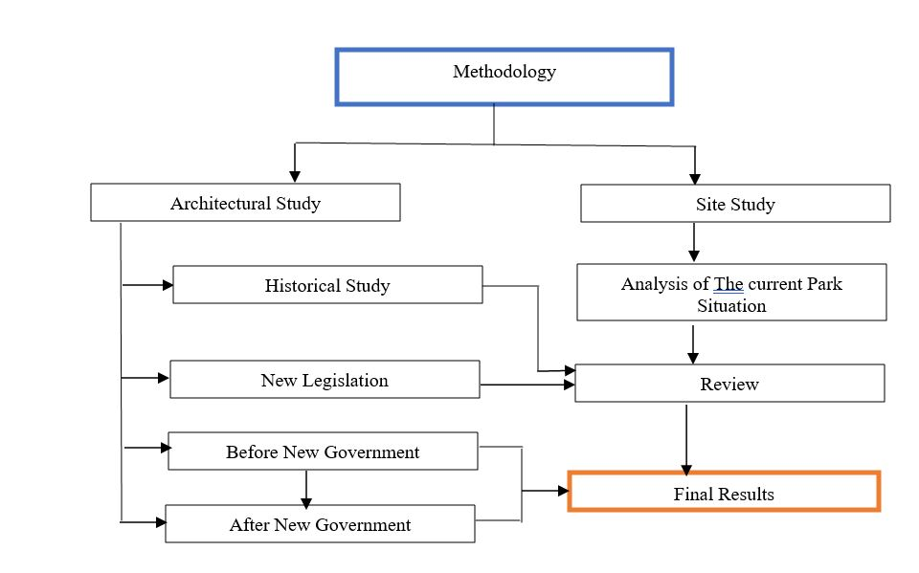

Figure

# Literature Review

The guidelines intend to serve as a guide for the minimum quality standards for the redevelopment of existing parks and for future park developments.

1. These guidelines (planning norms and design standards) shall be primarily applicable to parks and gardens in the public domain. This includes new development and redevelopment projects of Delhi.
2. ii. As far as open spaces of a particular property in private domain are concerned, it shall be dealt in accordance with the Development Code of [4] and [5]
3. iii. The design standards shall be met in order to gain approval during the design review process. However, the guidelines allow enough flexibility for innovation. The request for a deviation from these standards must show that it will improve the park and meet the overall intent of the design guidelines.

## **4.1 Security and Safety**

26 Natural Surveillance: Placement of physical features and activities in such a way as to maximize visibility and foster positive social interaction among legitimate users of public spaces.

•Use passing vehicular traffic as a surveillance asset.

•Provide surveillance through landscape design, especially in proximity to designated and opportunistic points of entry.

•Ensure that potential problem areas are well-lit: pathways, steps, entrances/ exits, parking areas, kiosks, children’s play areas, recreation areas, pools, storage areas, etc.

•Avoid too-bright security lighting that creates blinding glare and/ or deep shadows [6]

A. Afghanistan Cities with parks: This investigate was worn out two stages. The primary stage incorporates the places that incorporate parks which can be utilized by the open and the estimation of the zone of each stop within the indicated regions, whereas the moment stage incorporates the impacts of the unused laws on the spaces and parks that are most required and to a large degree by individuals and adjacent houses. utilized to it. In common, the most objective for the two-stage information collection is to adjust the openness of ladies and men to stop to keep the stop sounder and greener with the presence of unused rules.

Parks have been appeared to revitalize neighborhoods, increment financial improvement, and move forward open wellbeing. These benefits, and more, are why a satisfactory framework of parks is essential to Kabul’s sound improvement.

In spite of the fact that, Afghanistan has six urban stop which most guests interior Afghanistan conjointly from other nations. These parks are, band-e- Amir stop, Nuristan national stop, Qargha lake, bagh- e-babur,Dahla dam,Amir shaheed plant [3]. The working procedure is shown in a flow chart.

## **4.2 Band-e-Amir:**

Band-E-Amir could be an actually made bunch of lakes with uncommon topographical arrangements and structure, as well as characteristic and special excellence. Profundity isn't known, the color is immaculate blue. It has chronicled and common foundation which has not been exasperates until presently. For the fascination of the neighborhood and worldwide sightseers, Band-E-Amir is imperative, and is secured as a National Stop of Afghanistan. [4] 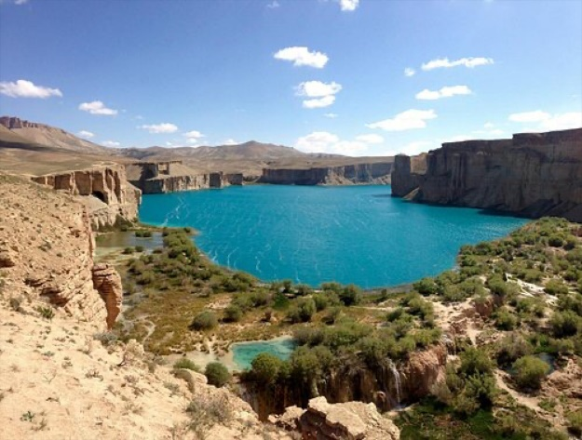

Figure

## **4.3 Nuristan National Park**

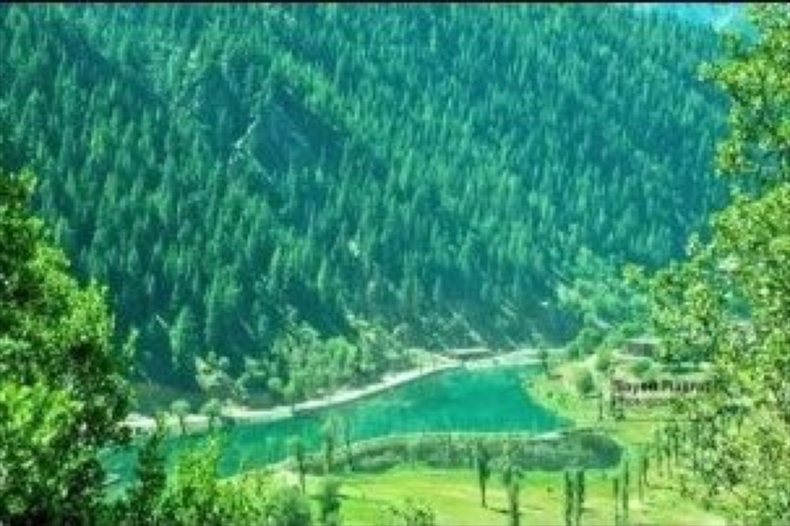Nuristan moreover spelled Nurestan or Nooristan, (Kamkata-vari: Nuristan) is one of the 34 domains of Afghanistan, arranged within the eastern piece of the nation. It is disconnected into seven zones and is Afghanistan's most un-crowded locale, with a mass of around 167, 000, [1] Parun fills in as the commonplace capital. Nuristan is skirted on the south by Laghman and Kunar locales, on the north by Badakhshan zone, on the west by Panjshir region [5]

Figure

## **4.4 Qargha Lake**

Qargha Lake is found nine kilometers from Kabul City. The range is encompassed by green slopes. This is often one of the leading puts for touring and excitement particularly for families from Walk till conclusion of October, Qargha draws in hundreds of nearby and remote tourists. Everyday scores of individuals go for excursion to Qargha Lake, but it gets to be a really active put Thursday and Friday. Qargha Lake had less offices amid the Taliban administration, since families were anxious of going exterior for excursion. After collapse of the administration, Qargha recaptured its verifiable put among individuals. I have gotten to be as a favorite touring goal, not as it were for inhabitants of Kabul City, but for all Afghans [6].

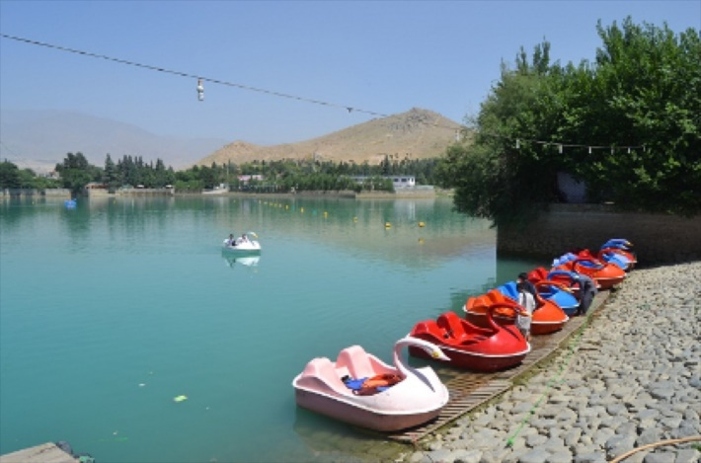

Figure

## **4.5 Baghe-e-babur**

Bagh-e Babur is found on the inclines of Kuh-e Sher Darwaza, southwest of the ancient city of Kabul. The plant is c. 11.5 ha huge and orchestrated in 15 patios along a central pivot in east west heading. From the best patio, the guest features a wonderful vista over the plant and its border divider, over the Kabul Stream towards the snow secured mountains.

Made by the author of the Mughal tradition, Ziihir ad-Din Muhammad Biibur (1483-1530), after his victory of Kabul in 1504, Bagh-e Babur is one of the most punctual surviving Mughal gardens [7].

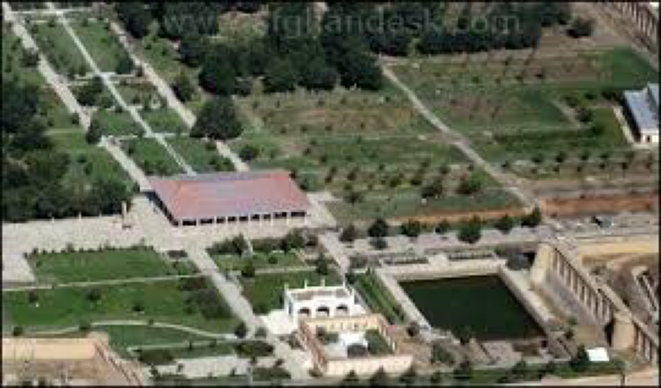

Figure

## **4.6 Dahla Dam**

The Dahla Dam is additionally known as Arghandab Dam. It is found within the Shah Wali Kot Locale of Kandahar Territory, Afghanistan. It was developed in 1952 by the USA. It is built on the Arghandab River. Dams built by India in Afghanistan: Pact for Development of Shahtoot Dam on Kabul River. Afghanistan-India Companionship Dam (Salma Dam). [8]

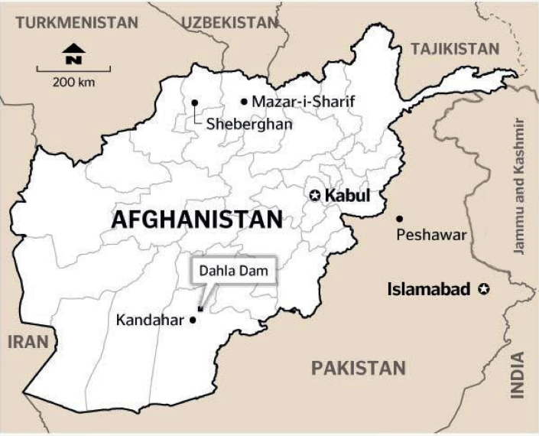

Figure

## **4.7 The Silent Revolution of urban parks**

The Quiet Transformation of Open Spaces in Afghanistan is the untold story of trust and peace in urban regions. The arrangement of open spaces in cities over Afghanistan is forming the lives of the citizens, particularly ladies and the destitute, and the relationship with their cities. It may be a social and social insurgency that has enabled ladies, made employments for the destitute and made strides the living standards of the citizens. It may be a quiet and tranquil transformation that has changed the individuals and the city.

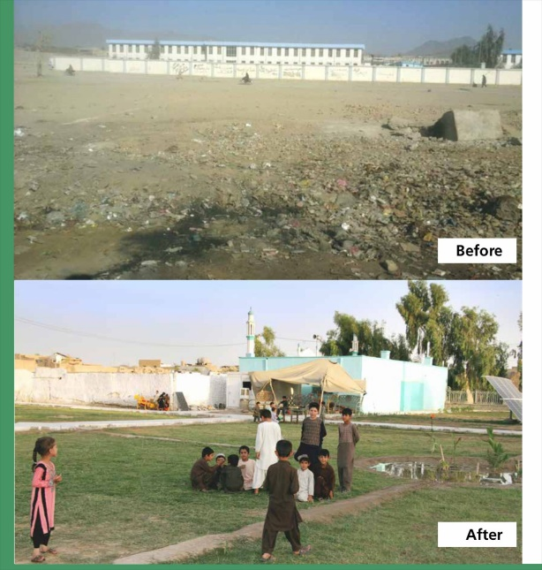

Figure

Building believe and certainty in open teach. For numerous ladies and children, these parks offer unused conceivable outcomes and openings. In cities where there were already nearly no green spaces, they presently have gotten to open zones that permit them to take part in open life. The arrangement of high-quality open spaces is a vital piece of the progressing social and social transformation in Afghan cities. This chapter describes to begin with hand encounters of the recipients of these mediations. [1]

## **4.8 Effect of new legislation on park in Afghanistan**

At to begin with It was not clear how broadly the confinements connected or how they influenced a past run the show from the MPVPV saying parks, counting open-air spaces, must be isolated by sex and certain days would be aside for ladies.

But it said; Afghan ladies were ceased from entering entertainment parks in Kabul on Wednesday after the Taliban's ethical quality service said there would be limitations on ladies being able to get to open parks. [9]

# Results and Discussion

After the publication of the new legislation the Park usage during design seems a new challenge for designers also to focus on Activities and amenities, Maintenance, safety and Effect of rarity of people on parks environments are must consider on design.

Although, these various aspects of urban park data, city planners and park managers can make informed decisions to enhance the park experience, improve maintenance, and ensure that parks meet the needs of the community they serve.

Afghanistan has been included in respectful wars for a few decades, and the individuals and the administering governments did not pay extraordinary consideration to urban parks, so the enormous cities of Afghanistan have endured in each respectful war. Individuals attempted to require asylum in secure places amid the war, particularly from 2004 to 2021, Afghanistan was included in war. and individuals fled from the towns and hazardous places to the cities, particularly to the city of Kabul, which was considered secure, and more individuals relocated and the city of Kabul caused non- standard development and the existing parks were not sufficient for the unused individuals who had moved, here we are talking approximately the city of Kabul as a case.

Kabul City has 65 working open parks involving a add up to of 309 ha. By embracing the already talked about four categories of urban stop region benchmarks and The Greenery Office of Kabul District proposition (see the comes about in Table 1), the three categories of this classification can be illustrated. Figure 1 outlines the area of existing parks in Kabul City’s region arrange. Table 1. Classification of parks in Kabul City. Categories are proposed by The Greenery Division of Kabul Region, insights are determined from the investigate. 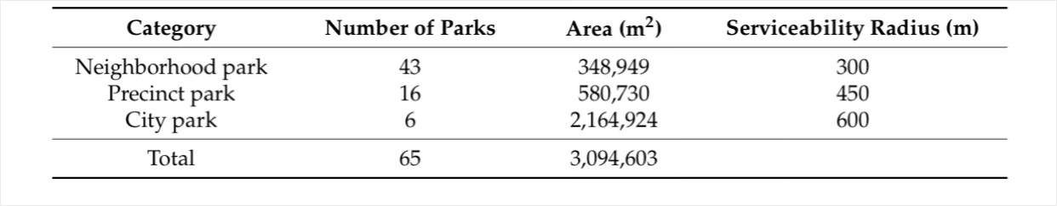

Figure 8

# Conclusion

This considers points to decide whether there's a way to avoid the disintegration and subsidence of parks. We know that with the entry of the Taliban government in Afghanistan, the parks have ended up purge and the reason for typically the need of individuals, since the Taliban and their modern law. which have ruined ladies and caused the parks to not be legitimately kept up and flooded, whether there's an elective way or not .In this sense, it can be an pressing need that we don't have comparative issues within the interaction and thought of existing and future arrangements, which the Designer and urban organizers ,related divisions and significant bodies pay uncommon consideration to such issues within the arranging and improvement of the modern and future stop and a circular Consider a great see that will illuminate future comparative issues. To have an extraordinary put for family, ladies and all kind of gender.

# References

|  |  |
| --- | --- |
| [1] | S. &. B. J. (. Azhar, "BIM Handbook," *a guide to BIM for owners,* 2013. |
| [2] | G. Das, "Advantages of green technology," *International Journal of Research – GRANTHAALAYAH,* pp. 1-5, 2015. |
| [3] | V. Feltes, "TOWARD SUSTAINABLE BUILDING – GREEN BUILDING DESIGN AND INTEGRATION IN THE BUILT ENVIRONMENT," America Washington State University, 2007. |
| [4] | M. 2021, (Chapter 17). |
| [5] | t. U. B. B.-L. (. 2016), (UBBL 2016), 2016. |
| [6] | D. o. P. a. R. P. &. D. Agency, Los Angeles, 2014. |
| [7] | U. N. E. Programme, *Green Technology for sustainable development,* 2020. |
| [8] | "World Green Building Council," 2018. |
| [9] | C. T. P. S. R. &. L. K. Eastman, "BIM Handbook," *A guide to builiding Information Modeling for owners, managers, designers, engineers, and contractors,* 2011. |
| [10] | P. W. L. Z. &. L. Y. C. Wong, "A review of solar photovoltaie PV Integration with building Integrated environment," vol. 12, 2019. |
| [11] | D. L. D. &. B. L. De Vecchi, "Energy performance and life cycle costing of photovoltaie systems for green roofs on office building," *sustainability,* vol. 12, p. 6633, 2020. |
| [12] | A. &. S. H. N. Tiwari, "Rainwater harvesting and its contributation in mitigating water scarcity and climate change impact," pp. 97-113, 2019. |
| [13] | J. Kuehmeier, Building Information modeling and its impact on design and constrcution firms,, MSc thesis, place of publication: USA University of Florida, 2008. |
| [14] | F. Salah, Investigation of strengths and weaknesses of 4D BIM software applications in managing construction projects,, Turkey: Turkey University of Gaziantep, 2018. |
| [15] | S. K. M. M. T. Azhar, "Building Information Modelling (BIM): now and beyond.," *Australasian Journal of Construction Economics and Building,* vol. 12, pp. 15-28, 2012. |
| [16] | D. a. S. S. Swarnkar, "ANALYSIS OF GREEN TECHNOLOGY APPLICATION IN CONSTRUCTION," *International Journal of Engineering Research & Management Technology,* vol. 2, no. 06, pp. 147-150, 2015. |
| [17] | S. Mueller, Green technology and its effect on the modern world, Finland: Thesis, Place of publication: Finland Oulu University of Applied Sciences, 2017. |
| [18] | A. a. L. S. Criminale, "Challenges with BIM Implementation: A Review of Literature," pp. 325-329, 2017. |
| [19] | N. L. K. Gu, in *Understanding and facilitating BIM adoption in the AEC industry.*, Automation in Construction, 2010, pp. 988-999. |
| [20] | I. Kamardeen, "Leeds, UK, Association of Researchers in Construction Management," in *8D BIM modelling tool for accident prevention through design. In: Egbu, C. (Ed) Procs 26th Annual ARCOM Conference,*, 2010, pp. 281-289. |
| [21] | R. M. J. Kreider, The Uses of BIM Classifying and Selecting BIM Uses. Version 0.9. Penn State, 2013. |
| [22] | "pajhwok," Air pollution reaches unhealthy level in Kabul, 2018. [Online]. Available: https://www.pajhwok.com/en/2018/04/24/air-pollution-reaches-unhealthy-level-kabul. [Accessed 12 04 2018]. |
| [23] | A. V. S. a. B. E. Monokova, "Possibilities of Green Technologies Application in Buildiing Design from Sustainability Dimensions," Vilnius Gediminas Technical University, Lithuania, 2017. |
| [24] | C. Kibert, "Sustainable Construction Green Building Design and Delivery Third Edition," USA: John Wiley & Sons, Inc., Hoboken, New Jersey, 2013. |
| [25] | Y. W. Z. C. R. L. Y. Lu, "Building Information Modeling (BIM) for green buildings," in *A critical review and future directions*, Automation in Construction, 2017, pp. 134-148. |
| [26] | H. JEONG, SUSTAINABILITY POLICY AND GREEN GROWTH OF THE SOUTH KOREAN CONSTRUCTION INDUSTRY, United States Texax A&M University, 2011. |

# Acknowledgement

The University of Kabul Polytechnic, as well as everyone who assisted the authors, are appreciated.

# Authors Profile:

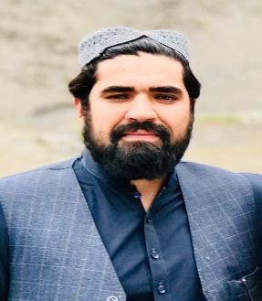

**Hasibullah Khalid** received his bachelor’s degree in Architecture (B.Arch) from India , UP, Lucknow , BBD University in 2017, He completed high school in 2011 and graduated from Habibya high School . He has been enrolled as master’s degree student in Building Architecture (MBAR) since 2022 at Kabul Polytechnic University. He has been employed at Kabul Municipality since 2021 as an LR/UR Director.

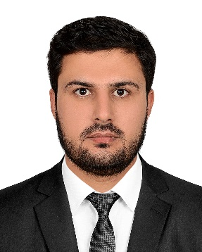

**Mohammad Zia Rahimi** received his bachelor’s degree in Building Architecture (B.Sc) from Kabul Polytechnic University in 2019, He completed high school in 2014 and graduated from Sharjah American International School-Dubai Campus. He has been enrolled as master’s degree student in Building Architecture (MBAR) since 2022 at Kabul Polytechnic University. He has been employed at Kabul Municipality since 2020 as an architectural specialist.

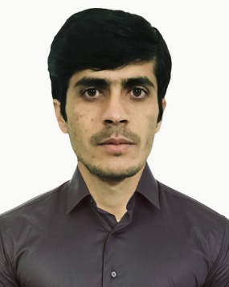

**Ahmadd Zubair seddiqi** received his bachelor’s degree in Building Architecture (B.Sc) from Kabul Polytechnic University in 2018, He completed high school in 2013 and graduated from Zarghoon Shaher high school He has been enrolled as master’s degree student in Building Architecture (MBAR) since 2022 at Kabul Polytechnic University. He has been employed at Kabul Municipality since 2021 as an architectural specialist.

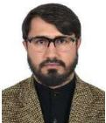

**Ahmad Jawad Niazi** received a B.S. degree in Architecture Engineering from

Kabul Polytechnic University in 2010 an M.S. degree in Civil and Industrial

Structures from KPU in 2013, M. Plan in Urban and Regional Planning from

UoP. Presently, Ph.D. in Architecture & Ekistics from OPJS. He is working as

an Associate Professor in Department of Architecture & Urban Planning, Kabul

Polytechnic University, Kabul, Afghanistan. His areas of research include

Ekistics, Urban Governance, Planning, Sustainable, and Islamic Architecture