Reconciliation Architecture

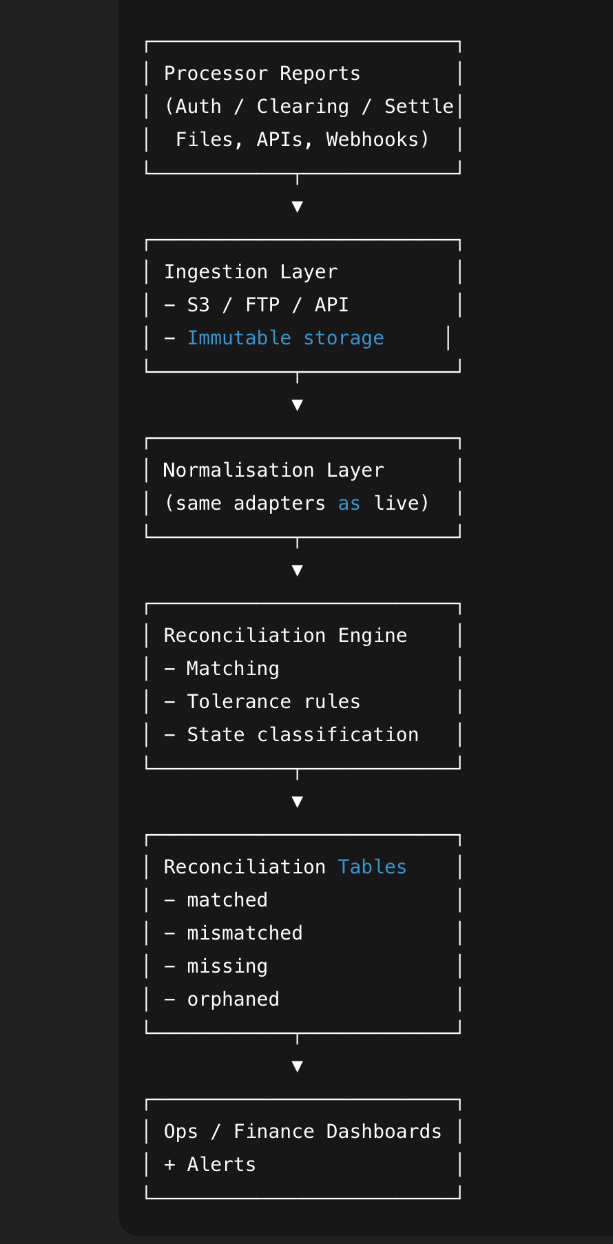

1️⃣ Reconciliation inputs (sources of truth)

A. Processor side
Depending on processor (e.g. CLOWD9):
- Authorisation reports
- Clearing / presentment files
- Settlement files
- Refund files
- Chargeback files
These are immutable inputs — never modified.

B. Elevate side (ledger truth)
Everything derives from:
payments.journals
payments.journal_lines
Key fields:
- event_id (scheme_auth_id)
- event_type
- amounts
- currency
- journal_date
- value_date

2️⃣ Canonical reconciliation record
Reuse CanonicalCardEvent model
Add a wrapper:
interface ReconciliationItem {
processor: string;
event_id: string; // scheme_auth_id
event_type: string;
scheme_amount: number;
scheme_currency: string;
wallet_amount?: number;
wallet_currency?: string;
fx_rate?: number;
source: 'PROCESSOR' | 'LEDGER';
raw: unknown;
}

3️⃣ Matching strategy (very important)

Primary key (strict)
(processor, event_id, event_type)
This matches:
- One processor event
- One journal

Secondary keys (diagnostics)
- card_id
- amount
- currency
- value_date
These are never primary (they change, processors lie, FX differs).

4️⃣ Reconciliation states (explicit taxonomy)
Every item must land in exactly one state:
State | Meaning
MATCHED | Processor and ledger fully agree
AMOUNT_MISMATCH | Same event, different amount
CURRENCY_MISMATCH | Same event, different currency
FX_MISMATCH | FX delta outside tolerance
MISSING_IN_LEDGER | Processor event not in ledger
MISSING_IN_PROCESSOR | Ledger event not in processor
DUPLICATE_PROCESSOR_EVENT | Same processor event twice
ORPHAN_LEDGER_EVENT | Ledger event with no processor reference
This classification is non-negotiable for ops clarity.

5️⃣ Tolerance rules (FX-aware)
We must not use strict equality for FX.
Define tolerances per dimension:
const tolerances = {
amount: 0.01, // minor currency unit
fx_rate: 0.0001,
fx_spread: 0.01,
};
Matching logic:
abs(proc.amount - ledger.amount) <= tolerances.amount
Everything else is a mismatch.

