Few days back I get a requirement to create .NET Core console application and give it to my test team as an exe application for their testing.

Then I created .Net Core console application, and written all the business requirement.

But when I open app, debug/release folder I did not found exe available there, as we were in dotnet framework application,

Then I found the solution for it, Which I would like to show how to create an exe from a .NET Core console application.

Let’s see it with example.

**Step1:** Create .net core console application and click on OK button, As I am showing in image.

Here I have created application, when I build this solution, my expectation is to exe file should be available in debug/release folder.

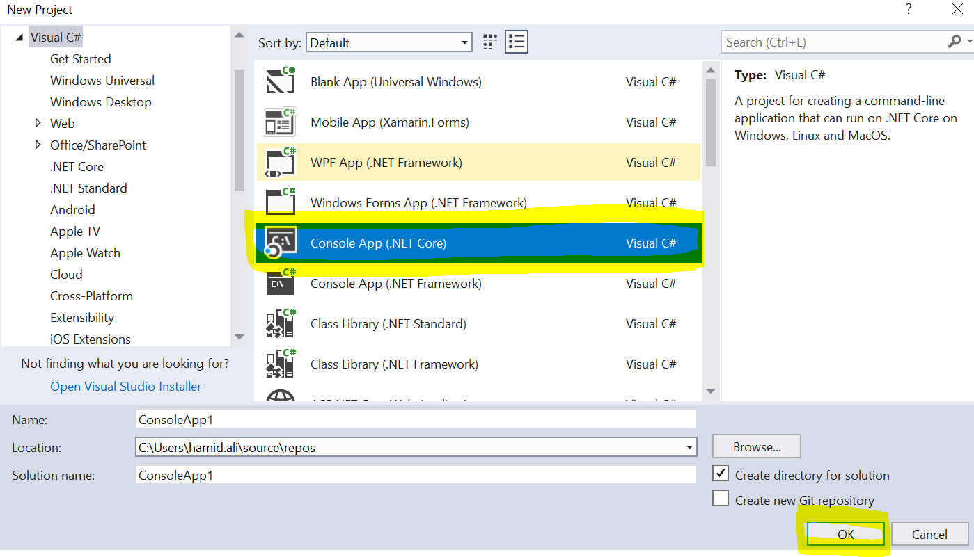

**Step2:** Build the solution and open corresponding folder just like this image

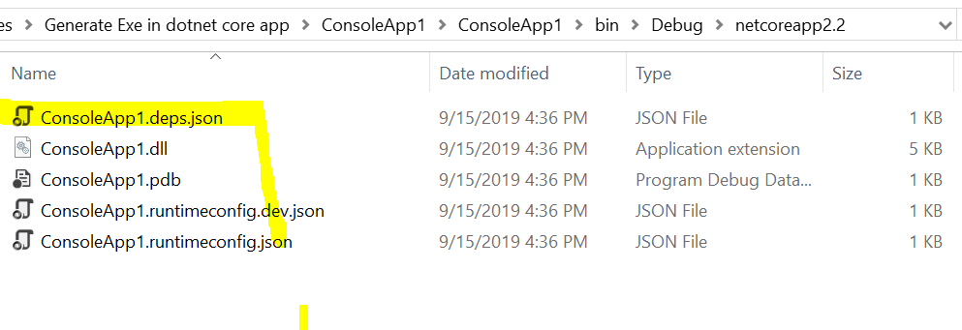

See in this folder we do not have any exe. But I would like to inform that this is not a bug, as in .Net core it rull the dll, so you have to just run the application by running the command dotnet run.

**Step3:** Open your command prompt and go to that folder when is your application persist.

Then just type only dotnet run (Your application Nane .dll)

For example in my case dotnet run ConsoleApp1.dll, see the attached screen.

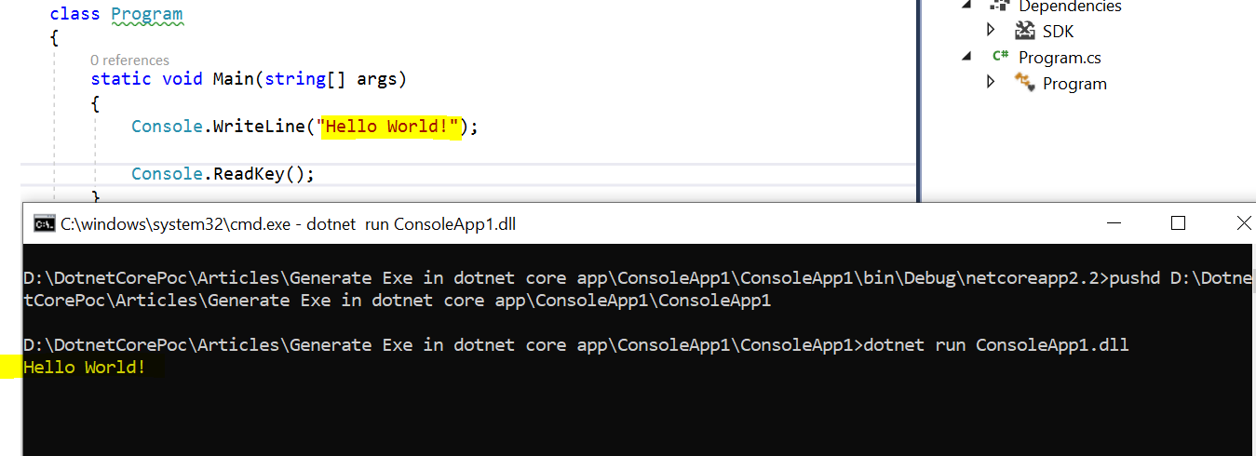

**Step4:** Now the steps come, if we want to generate exe for our Net Core console application, then we need to write some command. Or from VS UI we can gererate exe.

So let’s see with command here.

I have already moved on my console application location then I write this command on command prompt.

**dotnet publish -c Debug -r win10-x64**

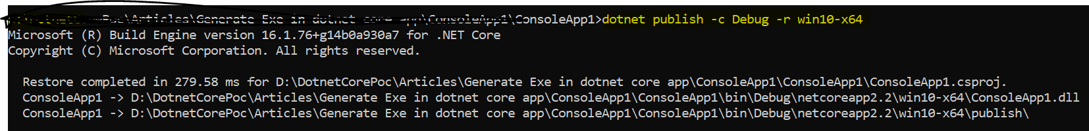

See the attached image, and we can now see the exe have been generated as in folder,

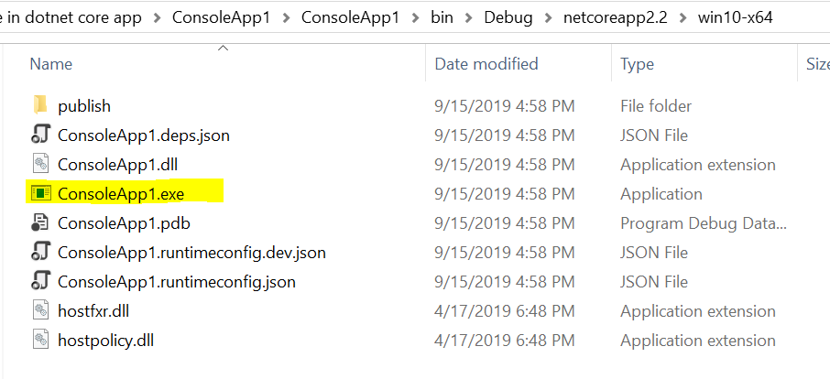

See in the above command I have created exe in debug folder, but if we want to created in release mode which is we can say for production, then we have change in command in place of debug, we have to written Release like this:

**dotnet publish -c Release -r win10-x64**

Now we have done our part of objective.

Here if we want to generate exe from VS UI as above I have told, then let’s see how we can achieve the same thing.

Step5: Right click on your project solution and click on publish Link, as attached image select folder and then click on publish button as available on buttom.

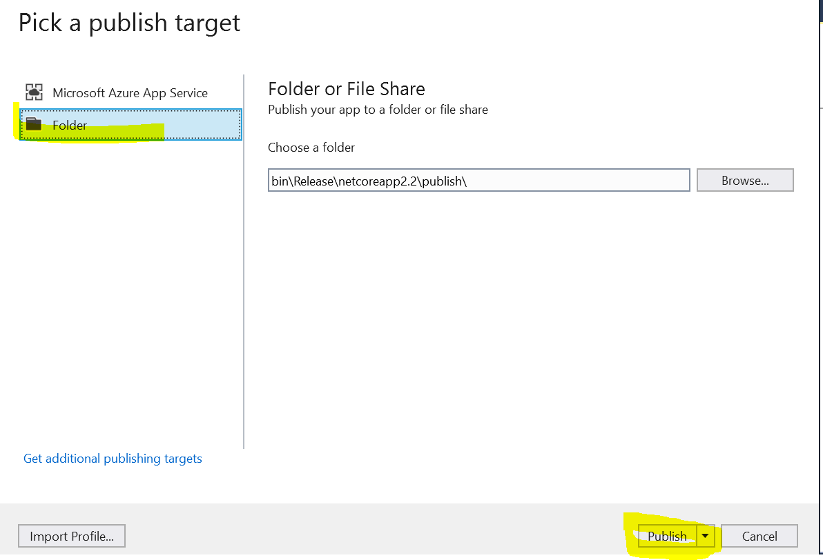

Then you will get another window like this

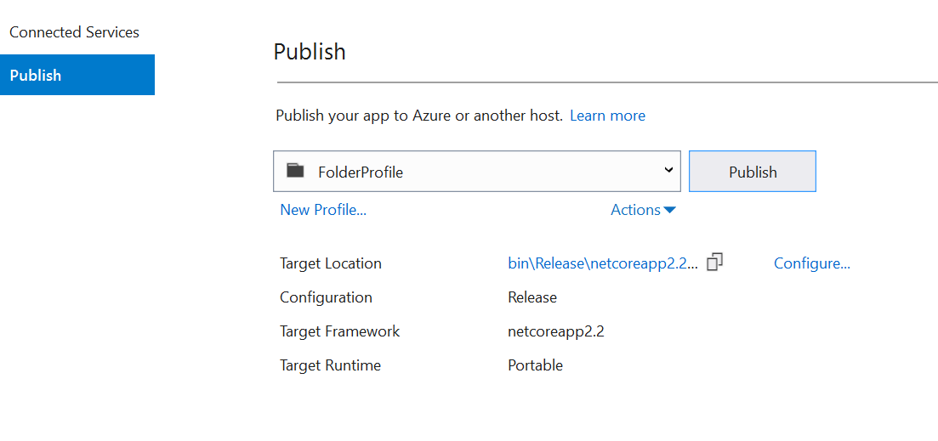

Here in this window click on configure link button, you will get another popup window just like this.

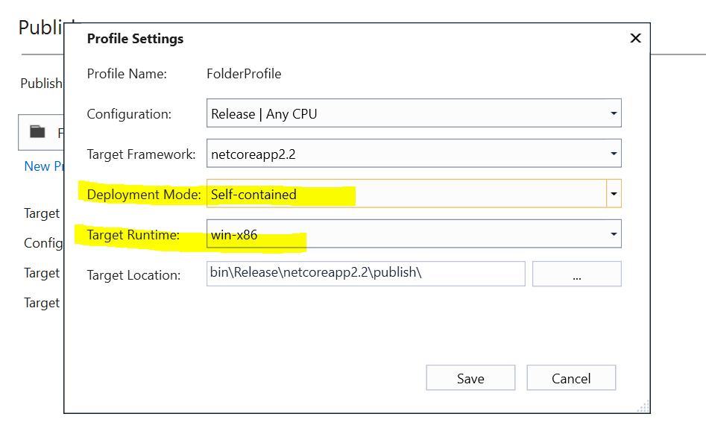

In this window make sure you have selected from dropdown Deployment mode: self-contained

And Target run time is win-86

Then click on save button, and finally publish it.

You will get same result.

Thanks for reading, hope this help.