Question_01
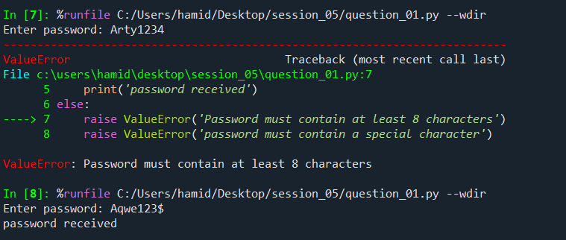
Question_02
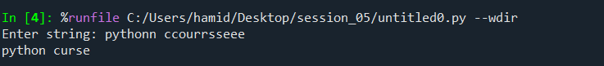
Question_03
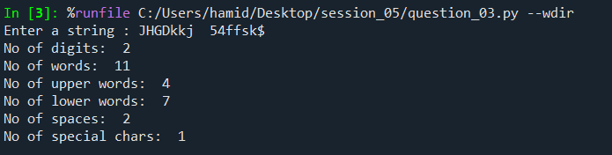
Question_04

Question_05
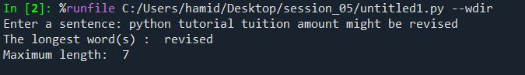
Question_06
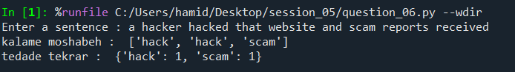
Question_07
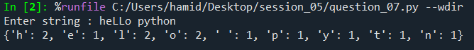
Question_08
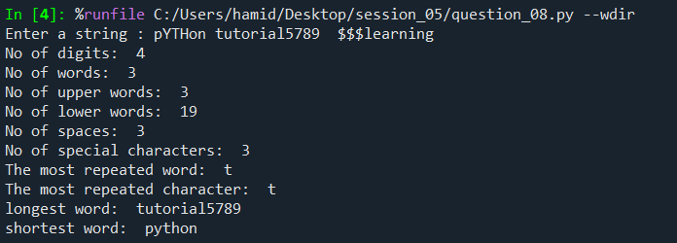

Question_09
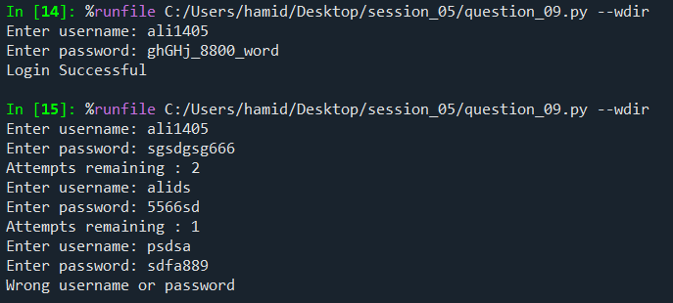
Question_10
