**Booth Multiplier**

Report of CA1

**Ali Saeizadeh 810196477**

**Hamid Salemi 810196479**

Contents

Controller Design 2

State Machine 2

Counter 2

# Controller Design

### State Machine

The state Machine of our controller can be seen in Figure 1.

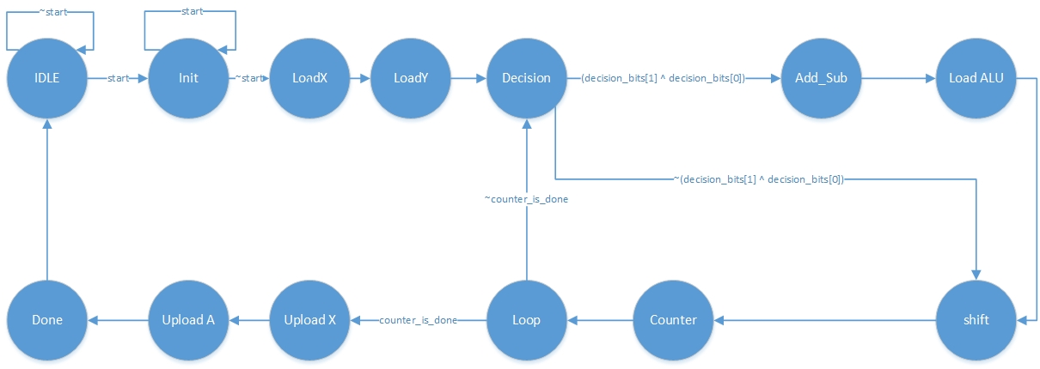

Figure 1

And All of Controller Signals Shown in Figure 2 and also we show that what happens to these signals in each state

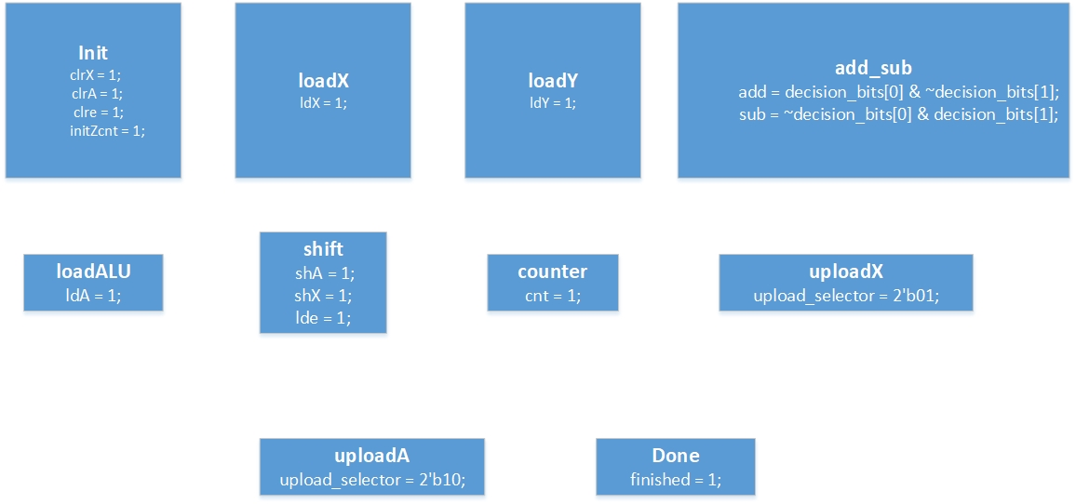

Figure 2

### Counter

A Counter has been added to this controller to control the loop state and finish the procedure in right time. Because the Multiplier has 6 bits so based on Booth Algorithm the iteration should be completed 6 time and this counter controls it properly.

# Data Path