One Last Run

Estimated time: 30-40 minutes
Laboratory Goals: Recall and distinguish core OOP concepts (abstraction, inheritance, composition) by applying them to concrete design scenarios, evaluate design decisions against SOLID principles, apply exception handling & serialization knowledge and finally, give a proper reasoning behind each selected answer.

Story Background
It’s 10:01 PM. The lights in the research lab are still on. A few hours ago, ARIS - the Autonomous Research Intelligent System went silent. ARIS is not just any system. She runs the university’s entire research grid from climate simulations to automated grading systems for every course in the faculty.

So, what exactly happened? A catastrophic design failure buried deep in her codebase. That’s what happened. Why? A single developer was working alone, under deadline pressure so they ignored eleven weeks of object-oriented principles and wrote everything as one 4k line God Class with no interfaces, no abstraction, and exception handling that consisted entirely of catch (Exception e) {}. When a routine file I/O operation failed at 8:05, the exception was silently swallowed. ARIS never recovered.

The senior engineering team is currently unreachable. They’re either on a conference in Oslo or on a vacation in Miami.

You are all that’s left.

The Chief Architect has left behind a diagnostic questionnaire (weird but why not) - 20 questions that probe every layer of the system. Each question represents a real decision point in ARIS’s codebase. You need to answer as many questions correctly as possible, explain your reasoning and the protocol to restore ARIS will have enough signal to rebuild her. You skip the reasoning and the protocol fails silently.

ARIS is counting on you. So is your 1 point for task 1. Your final chance.

Mission: Select ONE correct answer for each question and give a brief reason.

OOP Foundations & SOLID

Q1 | Inheritance & interfaces |  | Week 6 - 7
A Dog and a Robot both need a move() method. They share no fields and no implementation. What should they extend or implement?
☐ An abstract class Mover |  | ☐ A Movable interface
☐ A concrete class Mover |  | ☐ Nothing. Just duplicate the method
My reasoning:

Q2 | SOLID |  | Week 9
What's wrong with this code? Which SOLID principle is it violating?
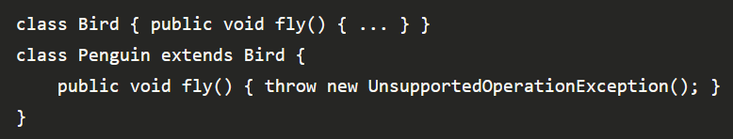
☐ Open/Closed Principle |  | ☐ Single Responsibility Principle
☐ Liskov Substitution Principle |  | ☐ Nothing. This is valid Java.
My reasoning:

Q3 | Abstraction |  | Week 6 - 7
You have 6 classes. All share 2 fields and a helper method, but each has a completely different core behavior. Best structure?
☐ Abstract class with shared fields + abstract method for core behavior |  | ☐ Interface only. Keep it flexible
☐ One concrete class with a type flag and if/else |  | ☐ 6 unrelated classes to avoid coupling
My reasoning:

Q4 | Composition |  | Week 6 - 7
A Car class needs an Engine. Which is the better design?
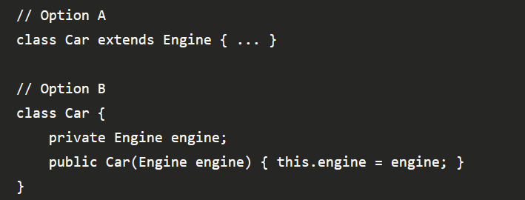
☐ Option A |  | ☐ Option B
☐ Both are the same |  | ☐ Option A if Engine is abstract, B otherwise
My reasoning:

Q5 | SOLID |  | Week 9
A Printer class implements MachineOperations which has print(), scan(), and fax(). The printer can't fax. What does it do?
☐ Nothing. It just doesn't override fax() |  | ☐ It extends the interface and adds a default
☐ It's forced to implement fax(), probably throwing an exception which is ISP violation |  | ☐ It implements only the methods it needs
My reasoning:

Generics, Lambdas & Iterators

Q6 | Lambdas |  | Week 11
Which line causes a compile error?
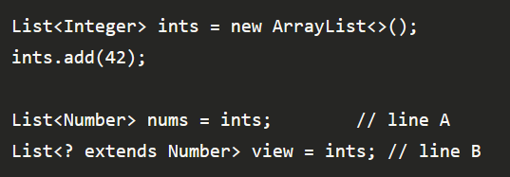
☐ Line A because generics are not covariant |  | ☐ Line B because wildcards are not allowed here
☐ Both compile fine |  | ☐ Neither because Java auto-widens numeric types
My reasoning:

Q7 | Lambdas |  | Week 11
You want to sort a list of names by length, shortest first. Which lambda is correct?
☐ (a, b) -> a.length() |  | ☐ (a, b) -> a.length() - b.length()
☐ a -> a.length() |  | ☐ (a, b) -> a.compareTo(b)
My reasoning:

Q8 | Iterator |  | Week 11
Your class implements Iterable<T>. What is the minimum you must provide?
☐ A get(int index) method |  | ☐ Both hasNext() and next() directly on the class
☐ An iterator() method that returns an Iterator<T> |  | ☐ Extending ArrayList
My reasoning:

Q9 | Generics + lambdas |  | Week 11
What does this method accept?
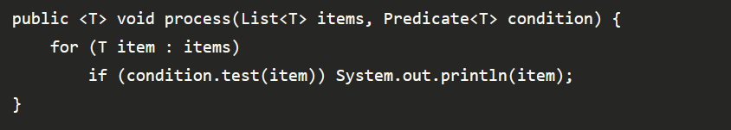
☐ Any list, and condition can be a lambda |  | ☐ Any list, but condition must be a named class
☐ Only lists of strings |  | ☐ This doesn't compile. It can't mix generics and lambdas
My reasoning:

Q10 | Big picture / Design decision |  | Week 1-11
A junior dev says: "I just use ArrayList everywhere and write logic directly in main(). It works, so why bother with all this OOP stuff?" What's the strongest counter-argument?
☐ It won't compile on larger projects |  | ☐ It's against Java conventions
- It works until requirements change. OOP makes change cheap |  | - It's slower at runtime
My reasoning:

Exceptions

Q11 | Exceptions |  | Week 10
This code compiles and runs. What actually prints?
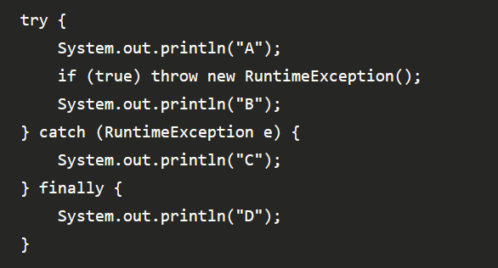
☐ A, B, D |  | ☐ A, C
☐ A, D |  | ☐ A, C, D
My reasoning:

Q12 | Exceptions |  | Week 10
You're writing a method that reads a user's age from input. The input is "abc". What's the right thing to do?
☐ Catch the exception and throw a custom |  | ☐ Return -1 as a sentinel value for invalid input
☐ Let the NumberFormatException crash the app. It’s the user's fault. |  | ☐ Use an if-statement to check every character manually instead
My reasoning:

Q13 | Checked vs unchecked |  | Week 10
Your method calls a file reader that throws IOException. You don't handle it. What must you do?
☐ Nothing. Java handles I/O exceptions automatically |  | ☐ Declare throws IOException in the method signature
☐ Wrap everything in a try/catch for Exception |  | ☐ Only handle it if the file might actually be missing
My reasoning:

Q14 | File I/O |  | Week 4
What is the advantage of wrapping a FileReader in a BufferedReader?
☐ It automatically closes the file when done |  | ☐ It reduces disk reads by reading chunks into memory at once
☐ It lets you read binary files as well as text |  | ☐ It handles encoding differences between operating systems
My reasoning:

Q15 | File I/O |  | Week 4
You try to serialize a Student object but get a NotSerializableException. What's most likely missing?
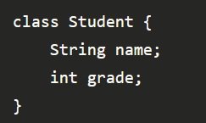
☐ A toString() method |  | ☐ A no-argument constructor
☐ implements Serializable |  | ☐ The fields must be public
My reasoning:

Q16 | Serialization |  | Week 4
A User class has a password field. You serialize it to a file. What should you do to prevent the password from being saved?
☐ Make the field private |  | ☐ Mark the field transient
☐ Set it to null before serializing |  | ☐ Serialize only the fields you want manually
My reasoning:

Android Studio

Q17 | Android Studio, ViewBinding |  | Week 8-11
Why is ViewBinding preferred over findViewById()?
☐ It's faster at runtime because it skips the XML parser |  | ☐ It lets you define views directly in Java without any XML
☐ It automatically updates the UI when data changes |  | ☐ It's null-safe and type-safe — no casting, no NullPointerException from wrong IDs
My reasoning:

Q18 | Android Studio, RecyclerView |  | Week 8-11
Why is ViewBinding preferred over findViewById()?
☐ RecyclerView reuses view holders, only visible items exist in memory |  | ☐ RecyclerView compresses the view data into fewer objects
☐ RecyclerView loads all views faster using multithreading |  | ☐ ScrollView can't handle more than 100 child views
My reasoning:

Q19 | Adapter pattern, Android Studio |  | Week 8-11
In a RecyclerView Adapter, what is the role of onBindViewHolder()?
☐ Creates a new ViewHolder object for each item |  | ☐ Fills a recycled view with data for a specific position
☐ Decides how many columns the list has |  | ☐ Inflates the XML layout for each row
My reasoning:

Q20 | RecyclerView, Android Studio |  | Week 8-11
A RecyclerView Adapter extends RecyclerView.Adapter<YourViewHolder>. Which OOP concept does this most directly demonstrate?
☐ Generics + inheritance |  | ☐ Composition
☐ Encapsulation |  | ☐ Interfaces
My reasoning:

