Amplifying Teachers Intelligence

in the Design of Gamified Intelligent Tutoring Systems

**Abstract.** Researchers are increasingly interested in using gamification along with Intelligent Tutoring Systems (ITS) to motivate action, promote learning, facilitate problemsolving, and to drive desired learning behaviors. In fact, although the desire of teachers to be active users of gamified ITS, these systems are not personalized according to teachers preferences. Several research problems might arise when trying to empower teachers in the design of gamified ITS, for instance, the high complexity and variability of features to manage, the need to consider theories and design practices, and the need of providing simple and usable solutions for them. In this work, we propose a gamified ITS authoring tool that supports authoring (fully or partially) of the domain, gamification and pedagogical models of gamified ITS by teachers. We investigate how different versions of the tool are perceived by users assuming the role of teachers. Our results indicate a positive attitude towards the use of the authoring tool, in which participants agreed that they are easy to use, usable, simple, aesthetically appealing, have a wellperceived system support and high credibility.

**Keywords:** ITS Authoring tools Gamification

Intelligent Tutoring Systems Gamified intelligent tutoring systems

# 1 Introduction

To enhance student motivation and engagement during instruction, researchers have been increasingly using gamification along with Intelligent Tutoring Systems (ITS) [1 4]. The use of gamification in ITS target achieving better results and to create enhanced solutions and experiences [5].

However, teachers are interested in actively using adaptive educational systems. For example, recent surveys of trainee teachers in the US [6] identified access to adaptive technologies as a key determinant of future teaching success,

while a survey of 1,000 public middleschool teachers in Brazil [7] found that 80% were interested in the potential of adaptive learning. Teachers also say that games enable them to differentiate instruction (60%) and to create classrooms that are more learnercentric (44%) [6] and that by using gamification they can motivate their students [8].

Moreover, as argued by Baker [9], we probably need tutors that are designed intelligently, and that leverage human intelligence (e.g., teachers), rather than relying only on artificial intelligence. But, to amplify the active participation of teachers in the design of gamified ITS combining teachers and artificial intelligence, we must face several research problems [10]. For instance, designing these systems include dealing with a huge variability [11] and all feature combinations might not be necessarily effective for learners [12]. Gamification, ITS theories, and design practices should also be considered to constrain the design space of gamified ITS [13] to aid designing more effective tutors. In addition, assuming that a teacher intends to customize such a complex system, it is imperative to make the design process simple, usable and not demanding advanced technical skills, e.g., on programming, artificial intelligence and/or software engineering [14].

In this work, we propose an authoring tool to design gamified ITS for teachers. It implements a process that leverages teachers intelligence in the domain, pedagogical and gamification models of the gamified ITS development process as well as supports extra configurations (e.g., reports presented, evaluation methods, and so on). It also allows the customization of gamified ITS features in two alternative flows, one creating a gamified tutor from scratch and the other applying a configuration template.

# 2 Authoring Gamified Intelligent Tutoring Systems

A gamified ITS development process was defined considering the four classic ITS components as well as a gamification model and extra ITS features. The activities are abstract enough to allow gamified ITS designers to use whatever subactivities they need to develop their systems. This flexibility might be important since there is no agreement in the literature regarding the types of ITS, features to consider, and technologies to use in the development of ITS [10].

The gamification model should consider all the features related to the inclusion of gamification in the ITS. For instance, game design elements (i.e., dynamic, mechanic and components [15]) to include in a gamified ITS and how these elements are connected (e.g., gamification design, i.e., activity loops [15]) to the learning contents, instruction and student knowledge behavior in the domain. Moreover, this model might also take into account strategies for personalizing the gamification and/or the tutor according to student characteristics (e.g., player type [16]).

An ontological model connecting gamification theories, frameworks and design practices to ITS concepts (e.g., the Gamified Tutoring Ontology [4]) aids the customization of gamified ITS by constraining the design space for the

teachers. Additionally, the role of such ontology for interoperating our authoring tool and a thirdparty gamified ITS (e.g., based on the architecture proposed by Dermeval et al. [17]) is twofold. First, it contains the knowledge about the domain model created by the teacher, which can be reasoned by a gamified ITS. Second, it also contains the decision on which a gamification target behavior is selected by a teacher which can be used by a gamified ITS to activate several activity loops in the system.

In the gamified ITS authoring tool, we incorporate features that allow reuse of previous ITS configurations (e.g., apply a template, reuse curriculum, and reuse educational resources) to decrease the effort required from teachers to author gamified ITS. We also include features that allow teachers to select a preconfigured set of game design elements by choosing a target behavior or to select particular game design elements to be included in the authored gamified ITS. Figure 1 illustrates the prototypes on which teachers may choose if they want to configure a tutor from scratch or apply an existing template configuration in the system (in the left). Figure 1 also shows how a teacher may select a gamification target behavior during the authoring process (in the right).

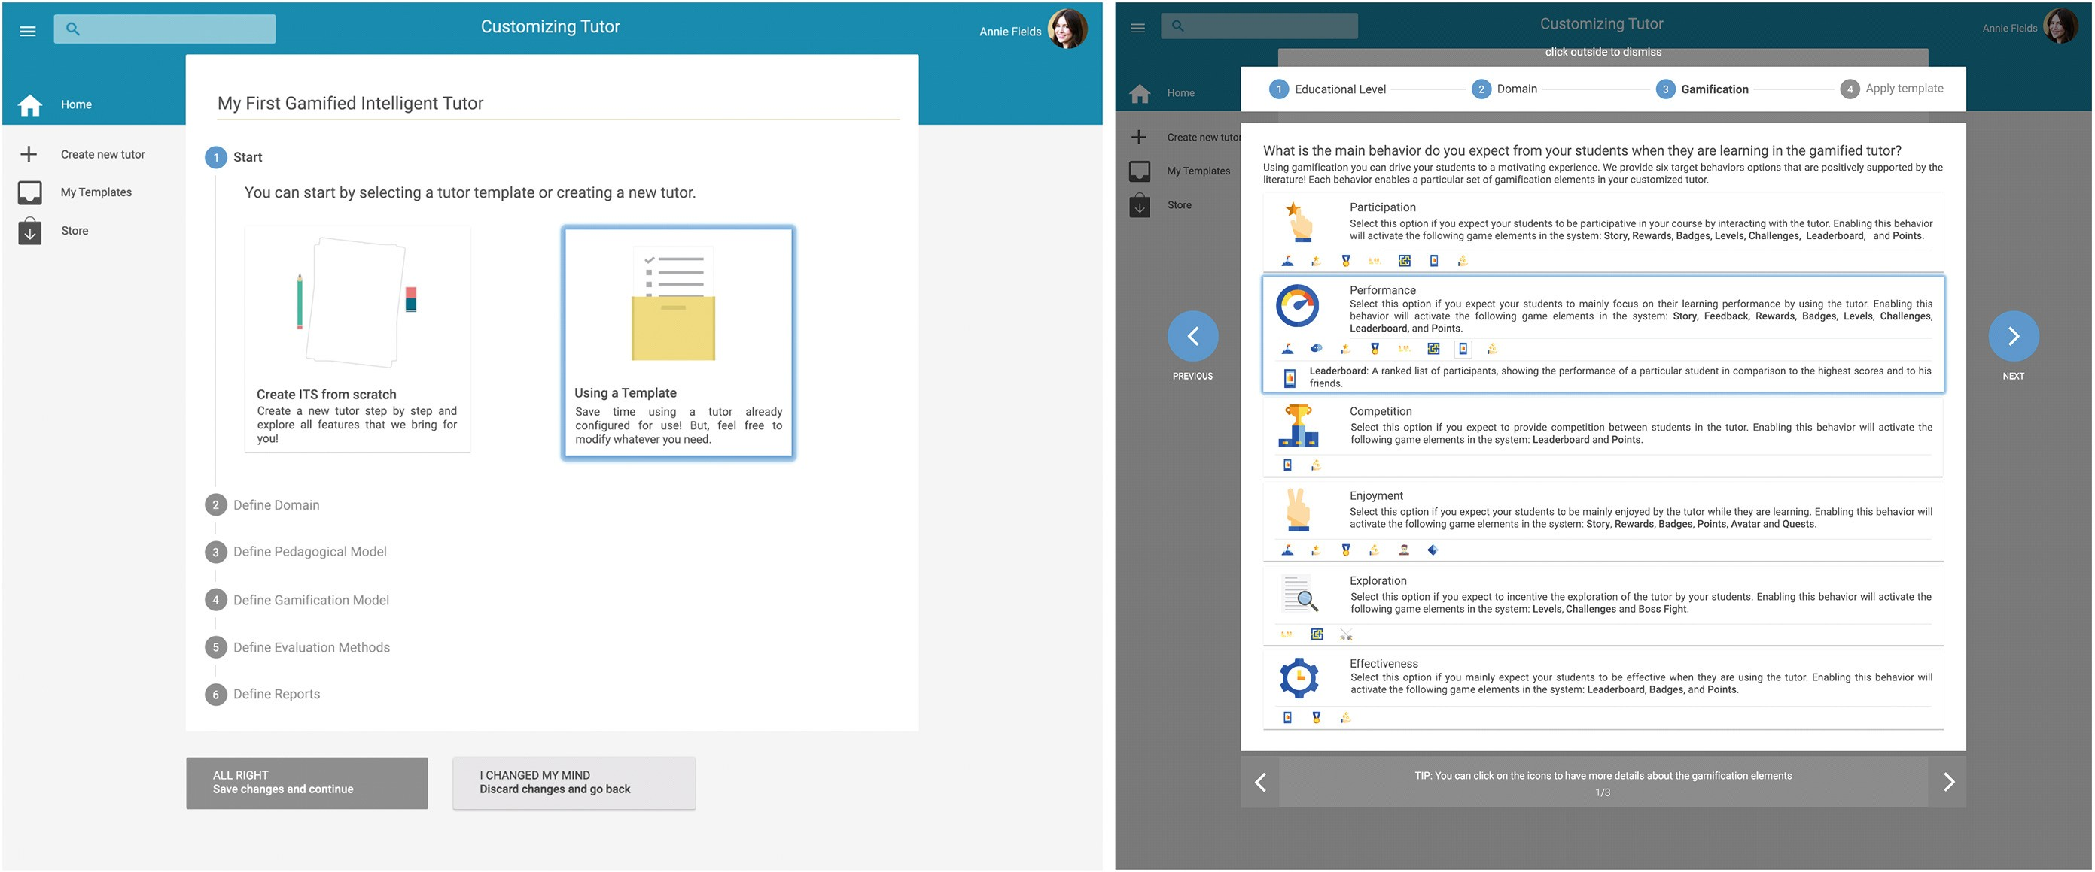

**Fig. 1.** Prototypes of the gamified ITS authoring tool

# 3 Experiment Design

Our experiment intended to analyze the prototypes combining two ways for authoring (template or scratch) vs. two ways for gamification authoring (selecting target behaviors or game design elements) to evaluate them with respect to several metrics such as perceived ease of use, perceived usability, complexity, aesthetics, novelty, unity, intensity, attitude towards use, perceived system support, and credibility from the viewpoint of teachers in the context of graduate students and researchers, from two research groups in Brazil and Canada, analyzing the prototypes and answering a survey1. A 22 betweensubjects design

1 Available at [https://fluidsurveys.usask.ca/s/agitssurvey/](https://fluidsurveys.usask.ca/s/agits-survey/).

was used, on which 57 participants were shown only one of the four possible versions of the prototypes. Note that the version in which a participant evaluated the prototypes were randomly allocated. Participants were asked to answer questions regarding the prototypes and a Likert scale was used for measuring the variables.

We identified that there is statistical significance for stating that the aesthetics (adjusted pvalue of 0.0333912) and perceived system support (adjusted pvalue of 0.0208950) of the version 1 (template and behavior) are better than of the version 2 (scratch and behavior). These results might suggest that the prototypes that present customization by template and gamification authoring by selecting a behavior (version 1) may be more aesthetically appealing as well as give more support to aid performing the task required than version 2, which includes prototypes for customizing features from scratch and authoring gamification by selecting a target behavior.

Although we could not identify statistical differences for the comparison between the four versions (regarding the other metrics), the scores received for all response variables might be considered positive. The median of all variables collected for the versions are above 5 (except for novelty in version 3), which might suggest that participants, in general, have a positive attitude towards the use of the authoring tool prototypes and somehow agreed that they may be ease to use, usable, simple, novel, unique and intense. Moreover, among the four versions, three versions (1, 3 and 4) present in terms of median a credibility with score 8, whereas version 2 presents a median credibility of 7. In addition, both prototypes for authoring gamification have a 6 score as the median for the understandability, information load and perceived system support metrics, which also suggest that participants are likely to agree with the designed prototypes regarding these metrics.

# 4 Conclusion

In this paper, we designed a gamified ITS authoring tool allowing teachers to codesign the domain, pedagogical and gamification models of gamified tutors. To empirically evaluate our solution, we conducted a controlled experiment varying some features of our authoring proposal. The experiment intended to analyze prototypes investigating four combinations of activated or deactivated features (authoring using or not template and gamification authoring by selecting target behaviors or game design elements) in the authoring process with respect to ten metrics in the context of students and researchers from two research groups in Brazil and Canada.

The results of this work might be of utmost importance to improve the authoring tool presented in this paper. In future works, we intend to conduct other empirical studies with teachers and to develop an integrated infrastructure that includes the authoring solution proposed in this work and a thirdparty gamified ITS system that may reason on teachers decisions to be reconfigured. We also intend to investigate the use of authoring tools to amplify the participation

of teachers by using artificial intelligence throughout the gamified tutor lifecycle, from the beginning of an ITS design (preinstruction) and at later stages of the execution of the tutor (i.e., during instruction and postinstruction).