A Theoretical Framework to Build Trust and Prevent Fake News in Social Media

Using Blockchain

Tee Wee Jing and Raja Kumar Murugesan(&)

School of Computing and IT, Taylors University, Subang Jaya, Malaysia

Abstract. This study aims to provide an insight of implementing blockchain technology on social media to build public trust on credible news spread via major social media platforms in order to determine the truthfulness of source, and prevent spread of fake news. This research uses blockchain technology with advanced AI in social media platforms to verify news content for its credibility. This study provides high impact preventing negative impacts on individuals, society, and the world that is becoming rampant today.

Keywords: Blockchain  Social media Trust Fake news

# 1 Introduction

In todays age of technological innovation, we embrace change every day by integrating and synergizing with disruptive and exponential digital technologies. In the coming age of Technological Singularity, the cyber arms race of powerful algorithms has become a signi*fi*cant battlefront among countries. For the survival of human race a transparent, trustable and reliable technology is very important. The advanced and common use of social media has enabled easy access and rapid dissemination of information. This on the other hand also enables fake news to be spread extensively. This phenomena is becoming very serious, as it would shake the foundation of human trust resulting in extremely negative impacts on individuals, society, and the world. In recent investigation [1], Cambridge Analytica was found to illegally use personal data of about 87 million Facebook users for a major political campaign during the Donald Trump US presidential election. Therefore, fake news detection and prevention on social media has recently become an emerging interdisciplinary research that needs great attention and solution. Blockchain is an emerging technology that is capable to disrupt the publishing industry and rebuild trust with the media. Blockchain has to do with trust, or the lack of trust, which makes it great especially for the social media industry [2].

In affective computing and sentiment analysis, automatic fake news detection is a challenging problem in deception detection and establish the truth, that is essential in protecting democracy and civil liberties [3, 4]. In this research [5], multiple prediction tasks have been performed on factchecked statements of varying levels of truth (graded deception) as well as a deeper linguistic comparison of differing types of fake

news e.g. propaganda, satire and hoaxes. It is shown that factchecking is indeed a challenging task. However, various lexical features can contribute to our understanding of the differences between more reliable and less reliable digital news sources.

Social media is a doubleedged sword, where the pen is mightier than the sword [6]. The advance and wide use of social media by generation X, Y and Z has enabled extensive spread of fake news, which will cause extreme negative impacts to our society and the world today. As a result, fake news detection on social media has recently become an emerging and important research area. Fake news detection and prevention on stateoftheart social media presents unique challenges that make existing algorithms used in current news media not effective. As a result, extensive research need to be conducted in order to *fi*nd new and effective algorithms to detect and prevent fake news. We humans pride ourselves on being rational and logical thinkers with an inherent sense of morality and consciousness that guides our thoughts and actions towards the greater good. These virtues hold true across all levels of society, but collectively on a global scale, we as human beings often make selfdestructive decisions. Among the many challenges related to studying credibility on social networks [7] are as follows:

1. The complexity of social networks and the web creates dif*fi*culty in identifying resources for use in studying and assessing credibility and identifying fake news.
2. Online Social Networks (OSNs) evolve dynamically over time and become very large in size, with various structures that make it dif*fi*cult to obtain the relevant information to assess the credibility of users.
3. The credibility of users are influenced continuously by various factors, for example changes in the topography, user preferences, and context.
4. Malicious activities can evade and bypass existing spam *fi*lters through various means.
5. The process of evaluating solutions is also a problem in terms of resources, because most researchers are limited in terms of the extent to which they can test their algorithms and solutions.

# Literature Review

With the advent of Web 3.0 and evolution of social media, people are savvier to express their emotions and share their opinions on web and social media regarding daytoday activities and global issues. Affective Computing is computing that relates to, arises from, or deliberately influences emotion or other affective phenomena [8]. The emerging

*fi*elds of affective computing and sentiment analysis leverage on human computer interaction, information retrieval, and multimodal signal processing for distilling peo

ples sentiments from the exponential growth of big data from online social data. Sentiment analysis aka opinion mining, is used extensively in brand management and product promotion. In recent years, sentiment analysis has shifted from analyzing online product reviews to social media texts from Twitter and Facebook [9]. Many topics beyond product reviews like stock markets, elections, disasters, medicine, software development and cyberbullying extend the utilization of sentiment analysis [10].

Most recent application in affective computing and sentiment analysis is in the context of political factchecking and fake news detection [11]. Recent analysis shows that there is a branch labeled as the Truth, which contains research about detecting fake and spam opinions. Media and social media factchecking remains to be an open research question in order to determine the truthfulness of source. Gartner top strategic predictions for 2018 and beyond is that IT leaders need to quickly develop Arti*fi*cial Intelligence (AI) algorithm to solve counterfeit reality and fake news [12]. By 2022, it is predicted that the majority of individuals in mature economies will consume more false information than true information [13].

Blockchain is an emerging technology and has disrupted multiple industries including *fi*nance and real estate. As the technology becomes more matured in these industries, it will begin to disrupt other industries as well. Publishers can use blockchain technology to verify news content, streamline advertising, and rapidly adjust to trends. The main features of blockchain are trust and transparency, and decentralization, which is uniquely suited to help with social media ecosystems. As fake news spreads across the Internet and people question their trust with the media, blockchain media applications can be used to help ensure the information that is shared and published is credible. This could help organizations come up with new business models for the way publishing can work.

AI has grown exponentially in recent decade and has created many disruptive and innovative opportunity in various *fi*elds. Cryptocurrencies and blockchain, are topics of big conversation today. In this study, we provide an insight to converge blockchain and nextgeneration arti*fi*cial intelligence technologies to rebuild trust and prevent fake news on social media. The seven reasons blockchainbased approach is bene*fi*cial to social networking are as follows:

* 1. Users Data are Protected

The exponential growth of social networks requires heavy investment in infrastructure. In order to sustain growth, platform owners need to use users data to analyze and predict new market opportunity, esp. through various advertisement sales. Users are not the product, and should not be traded for pro*fi*ts. A decentralized approach to social networking with blockchain technology can ensure better privacy and protection for users. Blockchain enabled social networking platforms have the potential to achieve more outcomes and pro*fi*ts in the right terms and conditions with smart contracts and disruptive applications, and is also highly effective and ef*fi*cient in ecommerce, mcommerce, ucommerce and crowdfunding transactions.

* 1. User Control Over Contents

Blockchain can also be implemented in social networking platform to give the power and control of the contents back to the users themselves by establishing a decentralized approach to network connectivity. Current social networking uses a centralized approach. Without the central servers, monitoring and exploitation over usergenerated contents will not be controlled and owed by companies. With blockchain, users now

have the full control over their own contents, and they can decide to share and not to share their information. With decentralized system, companies cannot use users contents for analytic, prediction, and advertising.

* 1. Improved Privacy and Security

Current social networking platforms have the risks of compromising users privacy and security. There are serious risks, like eavesdropping on users through smartphone microphones and visual access via smartphone video recorder. Government secret agents and agencies in some countries have used these platforms to monitor and detect criminals and terrorists. To solve this problem, the decentralized system of the blockchain ensures better privacy and security through a distributed consensus mechanism.

* 1. Freedom of Speech

Current social networking platforms are under surveillance by companies and government agencies in the interest of national and international security. Although the monitoring of behavior, activities, or other changing information of users on social networking for the purpose of influencing, managing, directing, or protecting people have some merits, this approach in the same time prevents freedom of speech, and in some occasions, it suppresses basic human rights. In this regards, a blockchainbased approach to social networking offers the bene*fi*ts of secure authentication whilst still ensuring anonymity and freedom of speech.

* 1. The Silver Bullet for Crowdfunding

The problem with traditional crowdfunding companies is that they are centralized organization, charging high fees and also influencing the projects. Blockchainbased crowdfunding has great potential to facilitate and enhance crowdfunding websites. This include Kickstarter, Indiegogo and other companies as it decentralizes the funding model. In fact, this is a more pure form of crowdfunding because it removes any intermediaries standing between the backers and the startup. Recently, blockchain crowdfunding has grown in popularity for funding innovative startup ideas in comparison with traditional model of seed funding and venture capital.

* 1. A Better Payment Method

Other than communication between peers, another potential business model of social networking is peertopeer commerce. Some current social networking platforms also implement some form of payment mechanism through their messaging services. With blockchainbased approach to messaging and social network, users can easily exchange coins or tokens through the same social network because cryptocurrencies are blockchainbased. On top of this, smart contracts and zeroknowledge proofs [14] in blockchain technology makes social networks function as a trusted network, where users can make actual business deals without third party through cryptographicallysigned smart contracts with secured and fast peertopeer transactions.

* 1. The Verifiable Truth on the Internet

Since the recent election in United States, Facebook has come under intense scrutiny from the technology world, the government, and users alike, due to multiple accusations that Facebook did not actively try to curb the fake news pertaining to the presidential candidates that was spread over the social platform. Facebook CEO, Mark Zuckerberg had recently apologized for the Cambridge Analytica scandal, which was a major breach of trust among Facebook users [15]. While Facebook has pledged to accelerate AI research in order to prevent similar scenarios from becoming regular practices, blockchain capabilities stand out as superior methods for controlling the distribution of unveri*fi*ed information, particularly that has signi*fi*cant realworld consequences when read by users.

# Research Theoretical Framework and Methodology

In this research, blockchain with advanced AI is used to build trust and prevent fake news in social media. A blockchain is a digitized, decentralized, publicly shared immutable ledger of all transactions that minimizes any security risk [16]. Referring to below theoretical framework of blockchain (see Fig. 1), transactions are contained in blocks, which are linked together through a series of hash pointers. Tampering of a block will cause the hash pointer to be invalid. In blockchain, there is no centralized system, the multiple copies of all valid transactions are held by the users in the community. Users are rewarded for their effort through unique algorithm that can result in payment. The consensus on what types of blocks and transactions is valid can be automatically reached when the majority of the blockchain users accept newly proposed blocks. In this way, a blockchain can provide a trustable, reliable, transparent, veri*fi*able, distributed and secure fundamental platform for all transactions [17].

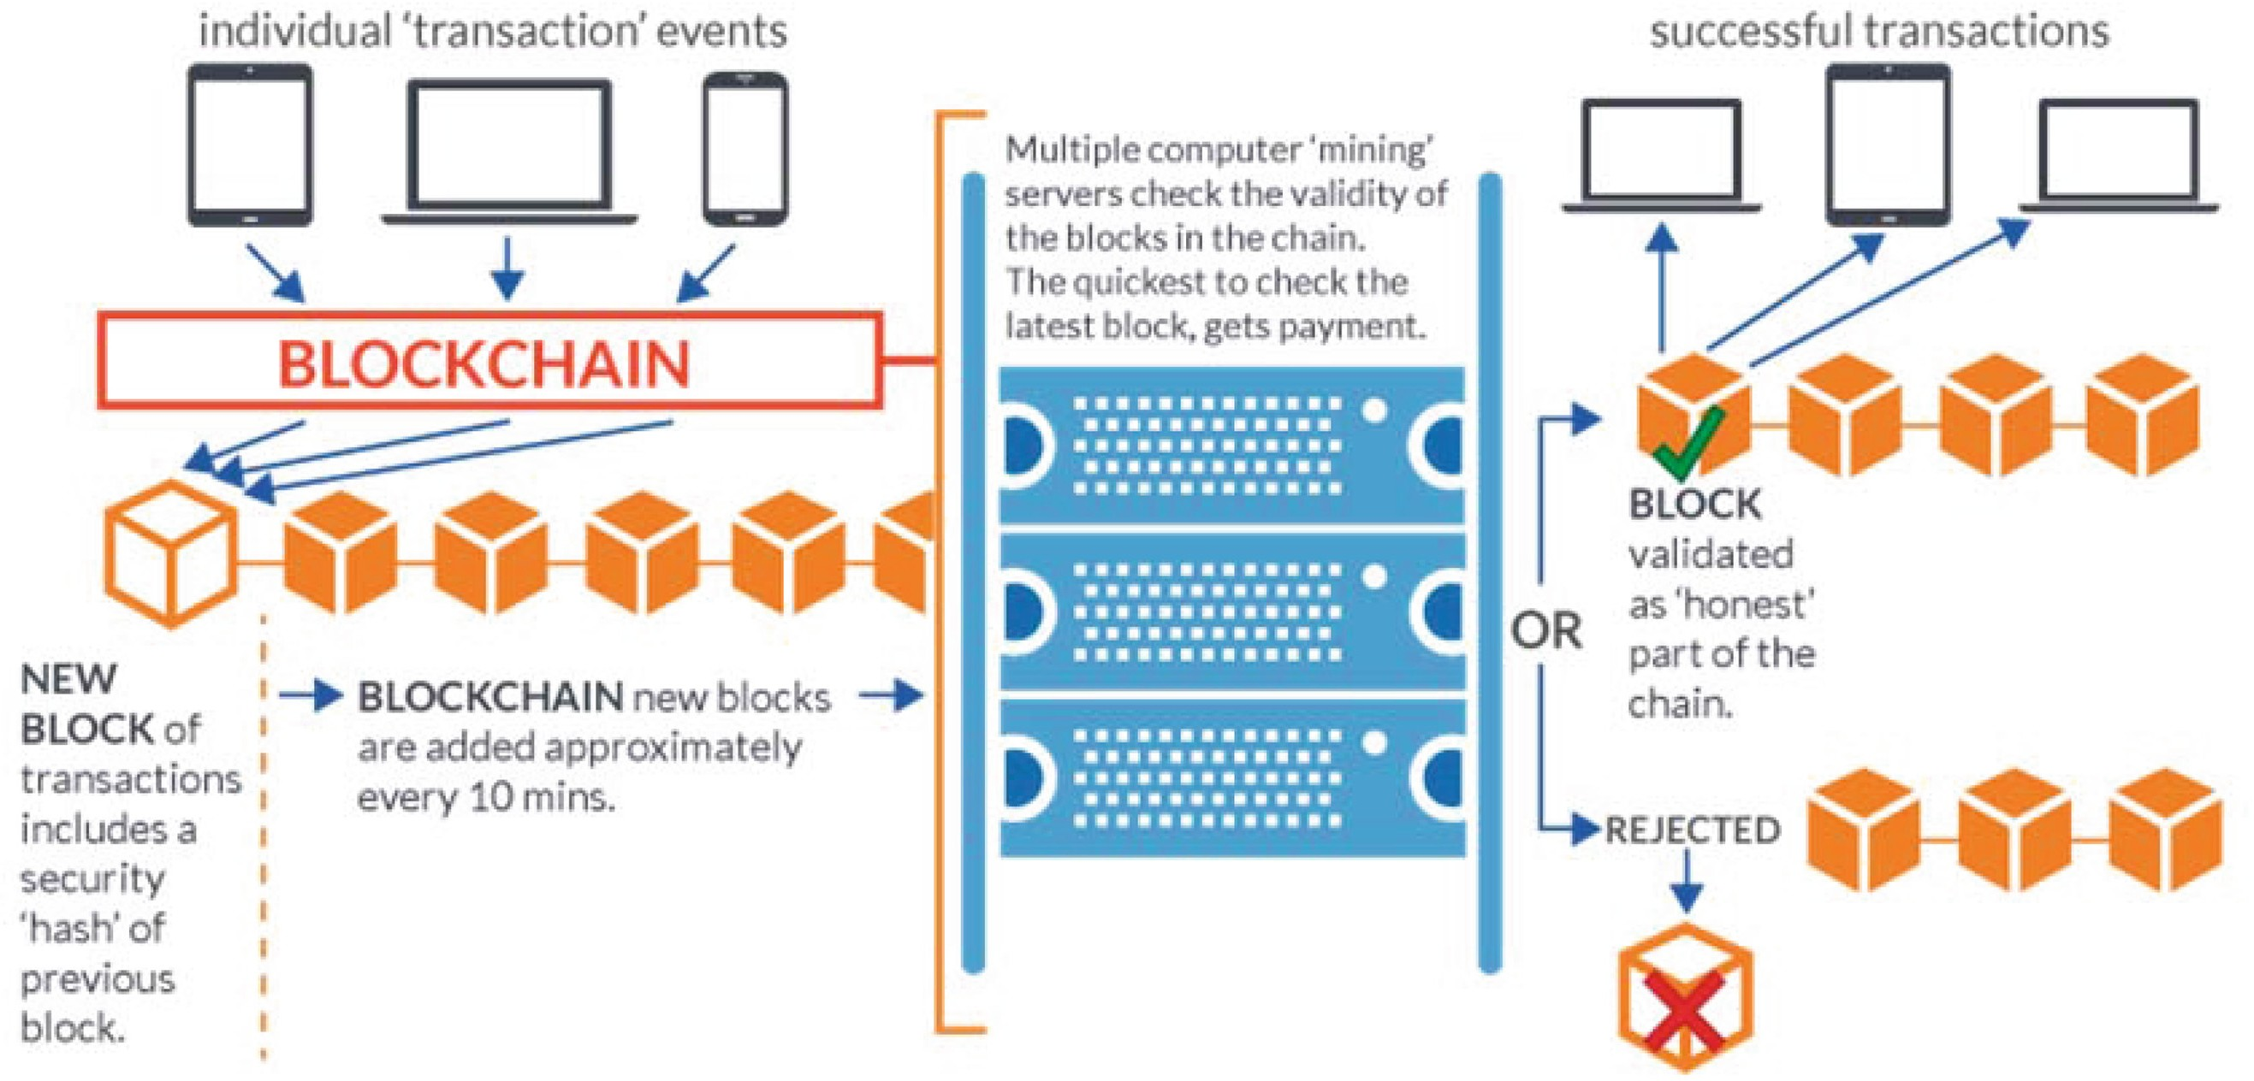

Fig. 1. Theoretical framework of blockchain

The proposed research design is to implement blockchain technology with advanced AI in social media platforms to verify news content, streamline advertising, and prevent fake news. This research aims to develop a new hybrid algorithms that utilizes the principles and methods of blockchain to create transparent and publicly auditable content networks and ranking algorithms that use digital tokens as ranking signals for social media to detect and prevent fake news. A novel theoretical framework will be designed to implement blockchain technology in social platform using simulation. The effectiveness and performance of the hybrid algorithms will be validated in the blockchainenabled social network in preventing and detecting fake news with numerical simulation results with valid datasets, and results compared with current social network that is not implementing blockchain technology. For further understanding of this new ecosystem of information on blockchainenabled social network, qualitative survey on focus groups will also be carried out in order to understand users sentiments on the convergence of blockchain and social media to rebuild trust and prevent fake news.

# Research Impact and Vision

In this research, when we pair blockchain with advanced AI to *fi*ght fake news, there are tremendous opportunities that we can create transparent and publicly auditable content networks. As a result, information or news shared by web or social media users are credible and trustworthy. Startups running news portal on blockchain will ensure a decentralized system which relies on the wisdom of the crowd and return the powers to the people in order to provide people with high quality and veri*fi*able news. It will generate more trust in the quality news ecosystem. This is as opposed to entrenching the popular idea that the government is controlling and totalitarian even further. With the emergence of a decentralized Web 3.0 powered by blockchain, individuals will *fi*nally be fully in control of their assets and identity online.

Web 3.0 will overcome the shortcomings of Web 2.0, i.e. the siloes, walled gardened, centralized power, where users identity are culled and collected, scrutinized, monetized, bought, stolen and sold. On the current Web 2.0 technology, whether users are streaming videos, sharing articles with friends, commenting on a forum, banking, or buying groceries, and various fragments that collectively constitute users online identity are owned by centralized institutions. In this scenario, all users favorite platforms and services are subject to legal processes that require them to report the information on demand to governments and other empowered agencies.

In contrast, on Ethereum, NEO and Cardano, the current major global blockchain platforms of the decentralized Web 3.0, any user or organization can establish usercentric or selfsovereign identity. Users can combine usercentric identity with the ability to control blockchainbased assets, i.e. tokens of value, money, capital, and the full scope of what the Internet offers. Users can also selectively encrypt elements of that identity, or choose to reveal them when users deem it in their best interest. This return the power back to the citizens or users and incentivize users to pursue the actions and behavior patterns that deliver the best outcomes to themselves and to the communities in which they are embedded.

These blockchain networks enable us to become more than a citizen of the country where we were born. We can establish our own global virtual country, which we can organize by topics of interest or shared principles. Through code, governance can happen by group consensus. We can out*fi*t our global country with an alternate voting system to reflect the values our community shares and agrees upon, safeguarded from interference by corruption, or dominance by a vocal minority. As for the leadership for the next era in blockchain technology, good governance of such distributed global innovation is not the role of government alone, nor can we leave it to the private companies. In fact, everyone one of us, as a global citizen, should collaborate and provide leadership via principles and consensus.

# Conclusion

As a conclusion, this study has provided preliminary insights in the convergence of blockchain and social media to build trust and prevent fake news. There are many challenges in verifying news content and prevent fake news on social media. Extensive research is needed in this area to reap the potential bene*fi*ts. This research area has tremendous realworld political, economy and social impacts. With blockchain technology that are evolving and upgrading continuously, there are many untapped opportunities for disruptive innovation in current and future ecosystem of social media in order to rebuild a more trustable, reliable, transparent, and secure fundamental fabrics for our modern society.