## Abstract

Governments and public health institutions across the globe have set social distancing and stayathome guidelines to battle the COVID19 pandemic. With reduced opportunities to spend time together in person come new challenges to remain socially connected. This essay addresses how the pandemic has changed peoples use of digital communication methods, and how inequalities in the use of these methods may arise. We draw on data collected from 1,374 American adults between 4 and 8 April 2020, about two weeks after lockdown measures were introduced in various parts of the United States. We first address whether people changed their digital media use to reach out to friends and family, looking into voice calls, video calls, text messaging, social media, and online games. Then, we show how age, gender, living alone, concerns about Internet access, and Internet skills relate to changes in social contact during the pandemic. We discuss how the use of digital media for social connection during a global public health crisis may be unequally distributed among citizens and may continue to shape inequalities even after the pandemic is over. Such insights are important considering the possible impact of the COVID19 pandemic on peoples social wellbeing. We also discuss how changes in digital media use might outlast the pandemic, and what this means for future communication and media research.

## Keywords

digital communication, digital inequality, COVID19, social connection

At the moment of writing, the world is in the midst of a global disease outbreak caused by a coronavirus, SARSCoV2, also known as COVID19. Governments and public health institutions across the globe have set social distancing and stayathome guidelines to battle the COVID19 pandemic (World Health Organization, 2020). While specific restrictions vary between countries, government policies to handle the coronavirus outbreak often involve closing schools, nonessential physical shops and businesses, and limiting public transportation and spaces, as well as social gatherings. Under these circumstances, public interaction has drastically decreased. With the change in opportunities to meet in person, new challenges arose to remain socially connected. This essay reports on peoples changes in digital communication based on data collected approximately two weeks into the pandemics widespread US outbreak, and the societal and scientific ramifications thereof.

During the first months of the pandemic, industry reports showed that digital media use tremendously increased as people spent more time at home due to coronavirus lockdowns (Kemp, 2020). Such increases were especially prevalent for social media and messaging apps, but particularly remarkable was the unprecedented uptake in video conferencing apps and programs. Given peoples widespread reliance on information and communications technologies (ICTs) for social interaction under such stayathome circumstances, this bears further examination. In this essay, we will address the following questions: How did peoples digital communication practices change during the COVID19 pandemic? Who was more likely to increase and decrease their digital communication during these times? And what do

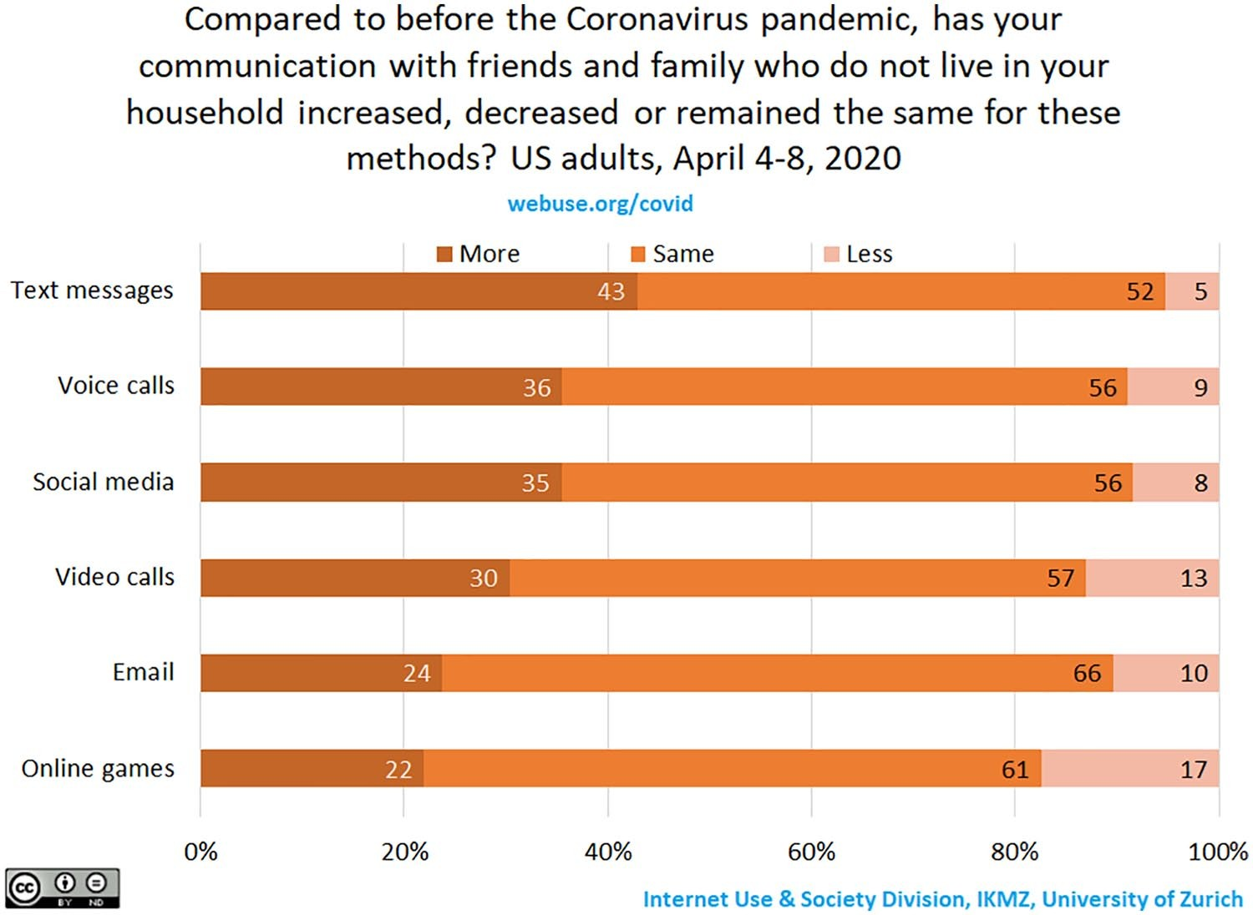

**Figure 1.** Changes in peoples digital communication behaviors during the Coronavirus pandemic. Based on data from 1,374 US adults, 4 8 April 2020.

these changes in peoples digital communication mean for society and for scholarship on digital media use after the pandemic?

We first present findings on peoples digital communication during the COVID19 pandemic. Between 4 and 8 April 2020, we collected survey data from 1,374 US adults with an online questionnaire administered through the Cint survey firm (for more information about the project, see Supplemental material). We set quotas for age, gender, education level, and region to obtain a sample representative of US Census figures. Our final sample includes people aged 18 82 (*M* = 46 years), with 54% identifying as female, about half with no more than a high school degree, and from all 50 states of the United States plus the District of Columbia. We asked people whether their communication with friends and family outside of their household excluding workrelated communication had increased, stayed the same, or decreased for a range of methods since the coronavirus pandemic (Figure 1). Overall, we observed a vast increase in digital communication. The data show that 43% of respondents used text messaging more often. This was followed by an increase in voice calls (36%), social media (35%), and video calls (30%). Almost a quarter of people more frequently used email (24%), and just over one fifth played online games more often (22%). Taking all modes together, 46% of respondents had *only* increased their digital communication, without decreasing any of the methods.

There are also people who reduced their digital communication during the pandemic. While a small minority (5%) used text messages less often, more people reduced their communication over social media (8%), voice calls (9%), email (10%), video calls (13%), and online games (17%). Taking all modes together, 9% of respondents had *only* decreased digital communication, without increasing any of the methods. At a time when facetoface social interactions are restricted, these decreases in digital communication suggest that certain groups of individuals may be missing out on social connections.

When breaking the results down by age (lowest versus highest quartile), gender, whether people live alone, whether they worry about Internet access, and Internet skills (lowest versus highest quartile), distinct patterns emerge (see Figures 2 and 3). The youngest quartile of the sample was more likely to have increased any type of digital communication compared to others. In contrast, the oldest quartile of the sample was more likely to have reduced digital communication compared to other age groups. Women, those living alone, and those worried about their Internet access were more likely to increase digital communication. While Internet skills did not make a significant difference in peoples increase of digital communication, more among the least skilled had decreased their digital communication during the pandemic.

# Is the Pandemic Widening or Bridging Digital Inequalities?

The changes in digital communication observed in our data have implications for digital inequality scholarship. Digital inequality research suggests that people vary in their quality

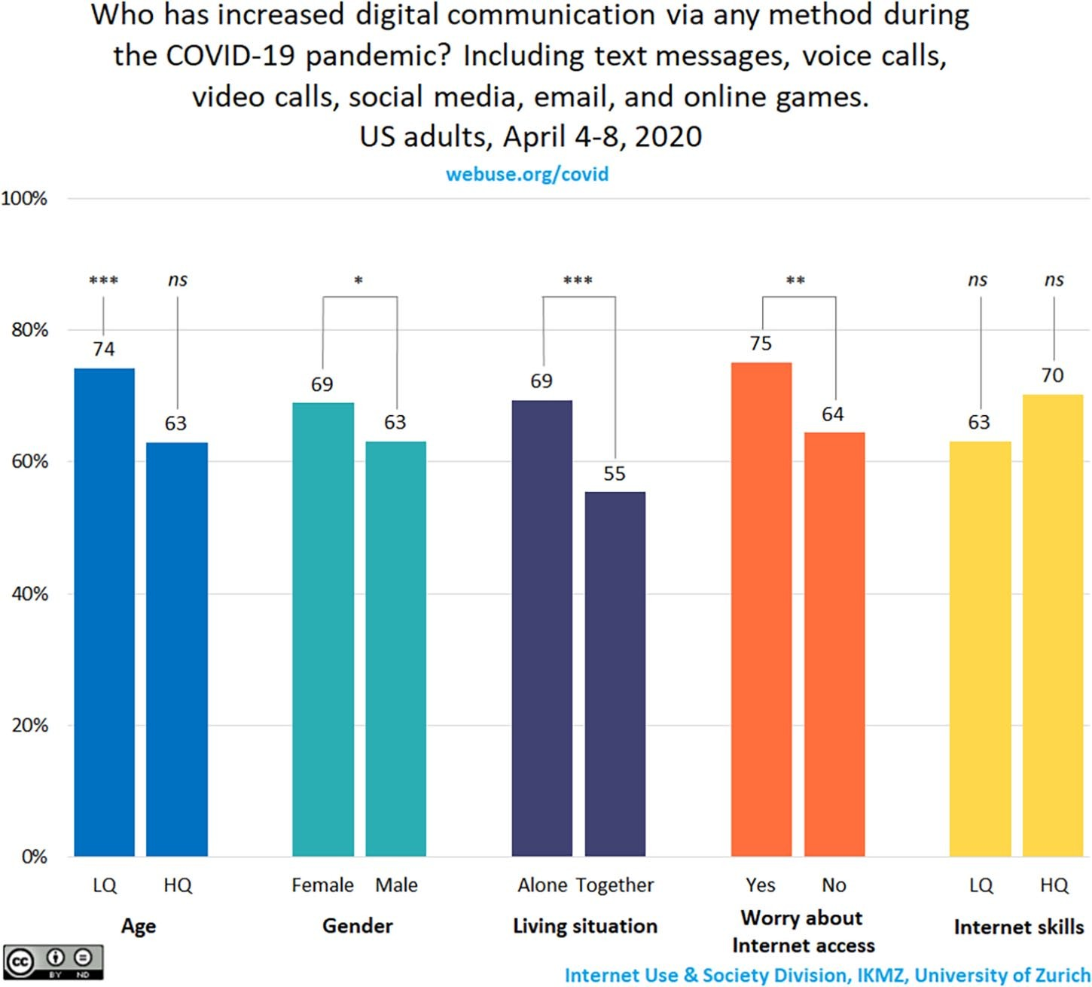

**Figure 2.** Increase in digital communication behaviors during the Coronavirus pandemic. Based on data from 1,374 US adults, 4 8 April 2020. Differences between groups are tested with Chisquare tests. For age and Internet skills, the lowest (LQ) and highest (HQ) quartiles were compared with the rest of the sample.

*Note. ns* = nonsignificant.

of Internet access and skills, which then may influence the benefits they can reap from communication technologies (e.g., DiMaggio et al., 2004). In the United States, a quarter of the population does not have broadband Internet service at home, and almost one fifth does not own a smartphone (Pew Research Center, 2019b, 2019c). Among lowerincome Americans, these numbers are even higher, with 44% of people lacking home broadband Internet service and 29% not owning a smartphone (Pew Research Center, 2019a). Beyond access quality, other challenges to engage with technology include unstable Internet connections as well as difficulties in maintaining the functionality of devices (Gonzales, 2016; Marler, 2019). Furthermore, some might lack the knowhow to use digital media effectively in replacing facetoface communication during the pandemic (Hargittai & Micheli, 2019). People who rarely use messaging, voice, and videoconferencing apps must learn how to download and install these on their devices, and then figure out how to use them. Less techsavvy people might also find it more difficult to identify and participate in new digital communication methods, like throwing a virtual birthday party or playing board games over a video call. As such, in times when inperson interaction is diminished due to distancing guidelines, certain groups are more at risk of becoming disconnected from their social environment than others.

During the COVID19 pandemic, digital inequalities may be further reinforced by a lack of (access to) digital support. As the world heavily relies on digital technology for communication, the less techsavvy might be more in need of support than ever. People mostly rely on family and peer networks for digital support (Eynon & Geniets, 2016; Hunsaker et al., 2019; Micheli et al., 2019). Social distancing and stayathome guidelines may be making it more difficult, especially for those who rely mainly on facetoface social connections, to receive digital support. Our data show that older people, as well as those with lower Internet skills, are more likely to reduce digital communication during the pandemic. While the Internet may also function as a digital support source (e.g., search engines, social network sites, forums), these sources are mostly used by those with greater Internet experience and skills (Micheli et al., 2019). The less techsavvy may become increasingly disconnected from

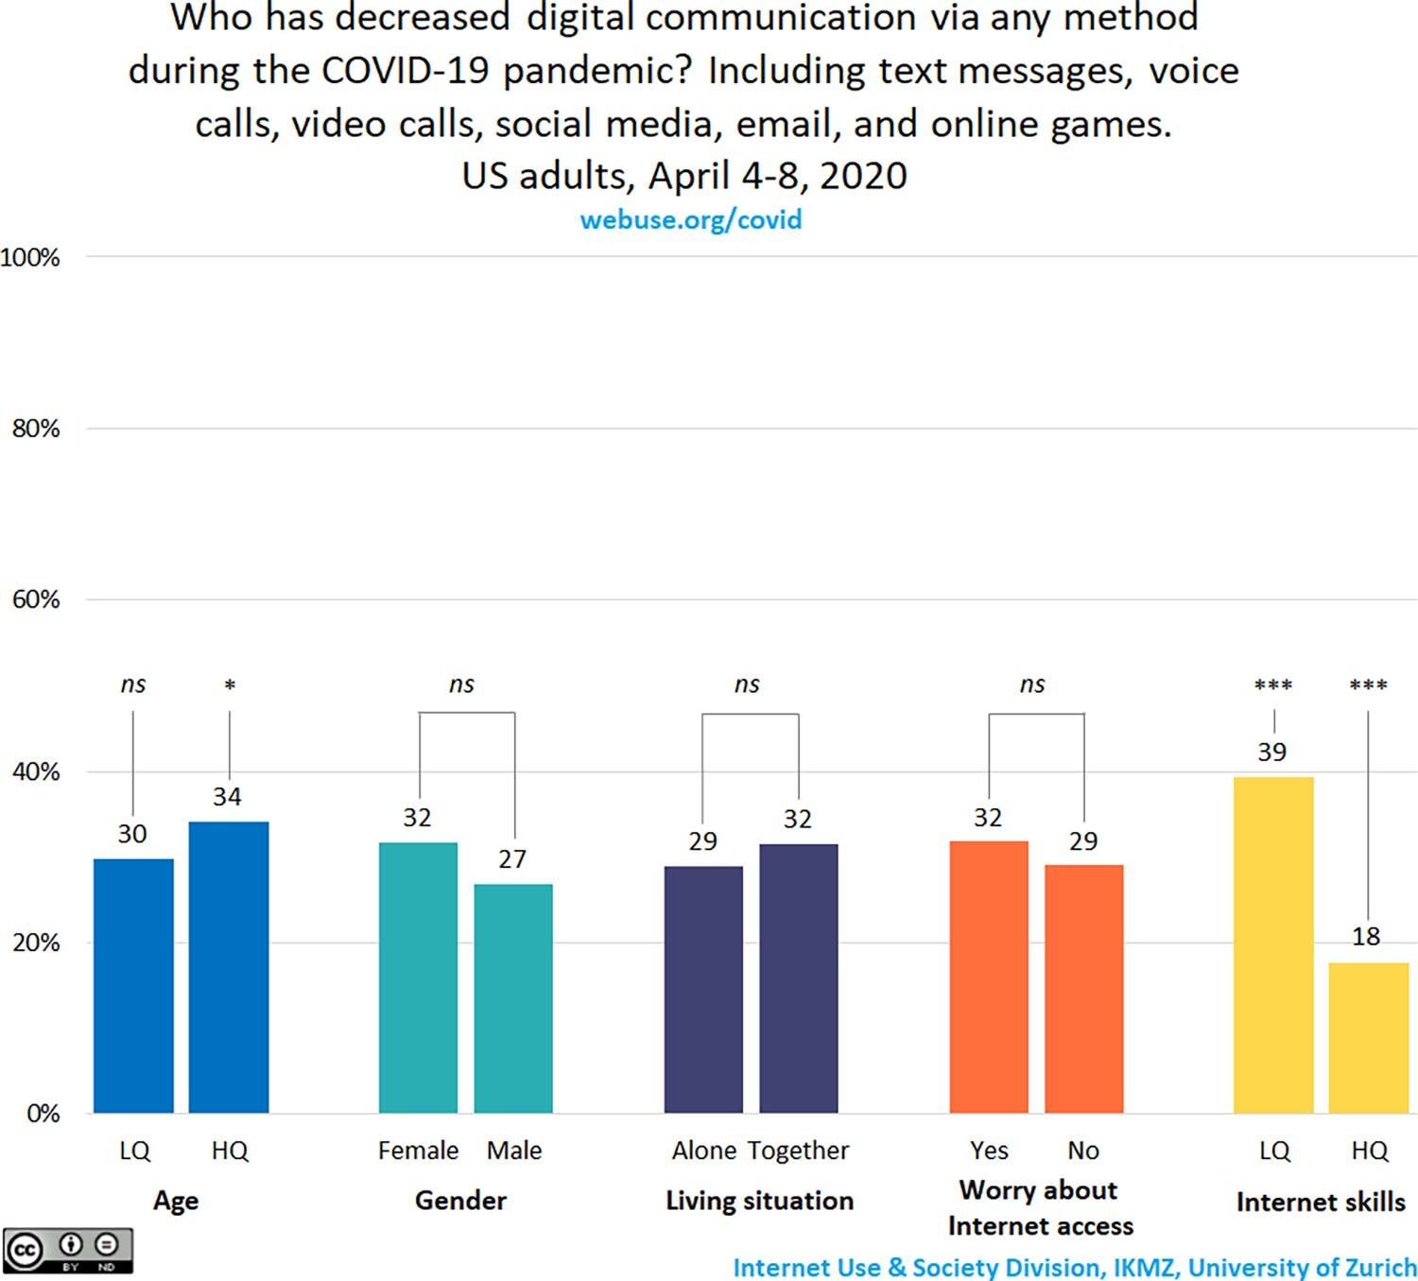

**Figure 3.** Decrease in digital communication behaviors during the Coronavirus pandemic. Based on data from 1,374 US adults, 4 8 April 2020. Differences between groups are tested with Chisquare tests. For age and Internet skills, the lowest (LQ) and highest (HQ) quartiles were compared with the rest of the sample. sources of support for establishing new ways of communicating.

At the same time, as inperson interactions are limited to a minimum, a different trend is taking place where people are now increasingly connecting through video chat apps and services for communication for the first time (Kemp, 2020; Koeze & Popper, 2020). Such an uptake might predominantly occur among the more techsavvy. However, these new adopters may also include people who typically use digital technology less often and with less skill, but now experience a push to connect online (e.g., from their social network). Our data show that among those with lower Internet skills, 63% report an increase in their digital communication using any of the listed methods. On a global scale, facetoface digital interaction via videoconferencing software has shown increasing uptake in the past months, and in countries where lockdown measures are more strict, these numbers are even higher (Kemp, 2020; also see webuse.org/covid for comparisons with Italy where lockdown measures were stricter than in the United States). In that sense, the pandemic with its lockdown measures may be an opportunity for people to overcome motivational barriers (van Dijk, 2005) to trying out and adopting novel ways of communicating. A question then arises: could this trend mean a small step forward in decreasing digital inequalities?

# Studying Digital Communication After the End of the Pandemic

At the time of this writing, we cannot yet know whether peoples new digital communication patterns will continue once stayathome, distancing, and lockdown measures are lifted, and people are able to meet in person again. However, given the major impact the coronavirus pandemic has had on peoples increase in digital communication behaviors worldwide (GlobalWebIndex, 2020), digital media researchers should consider how the pandemic may shape our discipline and research questions in the future.

The new patterns of communication that have emerged during the pandemic have different potential implications for how things will develop in the future. On the one hand, it may be that peoples digital communication increased because of the desire to check in with friends and family more often during this particular health crisis and because inperson means of communication are less possible. It could also be that people have more time available to spend on such communications because of lockdown measures and stayathome guidelines. Digital communication behaviors may then revert back to how they were before once the crisis has ended and people become less concerned about their loved ones minutebyminute situations and facetoface communication is possible again. On the other hand, as people adopt new digital communication methods, they may develop preferences for these new approaches and retain them longer term. In short, the motivations unique to the time of the pandemic may result in habits that outlast the outbreak itself.

Will people who previously did not rely on digital technology for communication, but now adopted novel digital methods to stay in touch with friends and family, continue to use these in the future? It could very well be that video calls will become more mainstream after the pandemic. The same question holds for other digital communication methods that have increased during the pandemic, such as the use of text messages, voice calls, social media, email, and online games. A report by GlobalWebIndex (2020, pp. 99 100) shows that many people expect to continue with new digital media behaviors even after the pandemic ends, but only time will tell how the pandemic shapes peoples media uses in the long run.

The COVID19 pandemic has raised novel questions for scholars of digital communication. As a discipline, our work is more relevant than ever, which is reflected by the many research efforts related to COVID19 and media and communication (e.g., European Association for Communication in Health care, 2020; Matias & Leavitt, 2020). At the same time, we must think about the longerterm implications that the pandemic might have on our studies of digital media uses. One way to explore longterm implications is to examine how the pandemic has given shape to digital inequalities. In this essay, we reported on patterns of uptake as well as decreases in digital communication, and how these patterns relate to sociodemographic factors as well as concerns about Internet access and skills. Based on these findings, even long after the pandemic, differential digital media use behaviors might continue. Older adults, those with Internet access insecurity, and people with lower Internet skills may be getting left out of this uptake in digital communication methods at a time when using such communication may be especially critical. Addressing these disparities becomes all the more imperative as we face ongoing uncertainties around the reopening of our communities.

The pandemic is leading many to identify and adopt novel digital communication methods. The pandemic also opens up possibilities for and affects how we use digital media in all other aspects of our lives. If these changing patterns hold long term, we should be explicit when discussing and comparing findings preand postthe coronavirus pandemic when it comes to studying digital communication and media use. Moreover, these trends should be explored over time, including their implications for political communication and journalism, education and learning, health communication, science communication, and a myriad of other domains. As digital media become more fundamental to everyday life a process that has been accelerated by the global pandemic the study of peoples communication and media behaviors is likely to become increasingly important.

## Declaration of Conflicting Interests

The author(s) declared no potential conflicts of interest with respect to the research, authorship, and/or publication of this article.

## Funding

The author(s) received no financial support for the research, authorship, and/or publication of this article.